PROFESSIONAL EXPERTISE OF CIRCUMSTANCES AND EARLIER DETERMINED FACTS CONCERNING THE CASE OF EXPLOSION AT „KAPIJA“ SQUARE IN TUZLA ON 25th OF MAY 1995.

COURT CASE no. X-KR—O7/394 OF THE B&H COURT IN SARAJEVO

FINDINGS, OPINION AND PROFFESIONAL CONCLUSION

ANALYSIS OF „KAPIJA“ CASE

In Belgrade, 07.01.2015.

Author:
gen-lieutenant colonel ret.
Ilija Branković

1. INTRODUCTION
GENERAL DATA GATHERED FROM THE COURT DOCUMENTS
A) Case: „Kapija“ in Tuzla city
B) Date and time: 25th of May 1995., 20:55h
C) Brief contents according to the prosecution records: Allegedly, one TF shell with contact detonator, fired from a 130mm M46 cannon, from distance of 27.1±0.38km, exploded on „Kapija“ square, hitting the cobblestone on which were several hundred civilians (estimated: 1000-1500 people), killing at least 64 and wounding more than 150 people. Final losses increased to 71 dead and 150 or even 240 with light or serious wounds. Age of victims was from 3 to 27 years.
D) Projectile hit the street covered with stone granite cubes. The distance between left edge of the building named „NIK“ and center of explosion was 2.65m. Explosion happened next to the front right tire of parked Gold Mk.1 car. Center of explosion was at a distance of max 20cm from the right headlight of the car.
Significant damage to the surroundings has occured- diameter of the crater was ~50cm with depth ~20cm. Over 30 granite cubes were ejected from the crater. Volume of the cube is around 1dm³. Numerous buildings sustained damage.
E) Taking into account known tactical-technical data of the 130mm M46 cannon, projectile OF482M, projectile azimuth range of 271⁰ ^{± 2,5}, minimal angle of fall from 62⁰, which were determined by prof. dr. Berko Zečević prosecution expert, as also alleged topographic data, according to which it stems that firing position was ~30m above the center of explosion, and together with the atmosphere conditions and other materials, ballistic calculation which expert of prosecution did, allegedly has shown that firing position was at a minimal topographic distance D_{М}:
D_{М} = 27 100 ± 380m
which corresponds to the wider area of Panjik hamlet near one and only solid road. Prosecution expert in his expertise, faced with numerous contradictions, positively admitted that Angle of Fall was probably several degrees higher than 62⁰. Aforementioned firing position (FF) was marked on a topographic map by the same prosecution expert with a white star and corresponded to a FP with a distance of 26 665m.
(Objection: marked FP was out of above defined sector, i.e. D_{М} = 27 100 ± 380m)
F) Based on aforementioned proffesional expertise, false data and evidence gathered by prosecution expert prof. dr. Berko Zečević, B&H Court condemns commander of tactical unit under whose command was, among many other units, a platoon of 130mm M46 cannons, first on 25 years in prison, and after repeated trial on 20 years.

1.1. TASK OF THE EXPERTISE

In a request for engagement from 31st of July 2014., defense attorney Konstantinović Milorad from Belgrade requests: that after sentencing of the accused Novak Đukić by B&H Court, in case no. X-KR-07/394, be performed an additional professional expertise and analysis of available court files and evidence of the prosecution, and facts connected to alleged explosion of 130mm projectile which happened on 25th of May 1995. ~20:55h on “Kapija” square in Tuzla, with the following tasks:
1. Analysis of available court documents, especially professional expertise of prosecution;
2. Analysis and assessment of possible firing positions (further- FP) from which the allegedly 130mm M46 gun projectile could have been fired, from tactical, technical, topographic and ballistic view, with a special review on Angle of Fall of the projectile on place of alleged Point of detonation (further- PD), as well as from theory of firing point of view;
3. Determining of basic firing elements, from all tactically possible firing positions in mentioned firing sector defined by maximal and minimal distance of firing with main focus on Angle of Fall of the projectile on the place of alleged PD;
4. Short review of existing terminal ballistic and travelling indicators on the PD and on surrounding objects;
5. Spatial determination of Coordinate Law of destruction which characterizes 130mm projectile while applying spatial dimensions of Coordinate Law of destruction on dimensions of mentioned square in Tuzla, in conditions of very high people concentration on a limited space.
1.2. SUBJECT OF EXPERTISE
Subject of expertise are available prosecution documents, results from earlier investigations with their documents, earlier expertises and especially expertise by prof. dr. Berko Zečević named: “Анализа увјета који су довели до масакра особа на тргу „Капија” дана 25.05. 1995. год. у 20⁵⁵ сати”.
Additional base for this expertise are results from experiments made in three month period (June- September 2014.) at Nikinci proving ground of Serbian Army - by defense team of Novak Đukić.
1.3. GOAL OF THE EXPERTISE
Goal of the expertise is scientifically based, from the position of good artillery praxis, theoretically and practically grounded deriving of findings, opinions and professional conclusions which cast additional light of mentioned tragedy on “Kapija” square on 25th of May 1995.

Looking at court documents, primarily on “ЗАПИСНИК О УВИЂАЈУ” done by higher court in Tuzla, No. cri. 29/95, during 25th and 26th of May 1995 with according photo-documentation of 75 pictures, and then at rest of attachments which constitute that record and especially the report- expertise of prosecution expert:
“Анализа увјета који су довели до масакра особа на тргу „Капија” дана 25.05. 1995. год у 20⁵⁵ сати”, also at report of Mixed commission of MIA(Ministry of Internal Affairs) and military observers of UN, and in relation to shelling of Tuzla from 25th of May 1995., with thorough research of conditions set by defined tasks for this expertise, gives enough data for a grounded opinion and professional conclusion.

Additional outlines for this expertise were taken from reference literature, as follows:

„Стрельба наземной артиллерии” КНИГА I, Военное издательство, Министерства Обороны ССР, Москва 1960;

Robert L. McCoy: “Modern Exterior Balistic, The Launch and Flight Dynamics of Symetric Projectiles“, Schiffer Military History, Atglen, Pa. 1998;
Group of authors– professors and associates of Leningrad Military Artillery Academy, under general redaction:
Генерал–майор артиллерии А.И. Матвеев: „ Tеория стрельбьі наземной артиллерии”, учебник, Ленинград – 1966;
Таблице гађања за топ 130 мм М46, ССНО, УА –156/2, Војно издавачки завод 1984.г.;
„Таблицы стрельбы 130 мм пушки М–46”, ТС/ГАУ N₀ 265, издание третье, Главное артиллерийское управление, Военное издательство Министерства обороны СССР, Москва – 1961:
Др Александар Стаматовић: уџбеник, „Физика експлозије”, Београд 1996. године:
Др Александар Стаматовић: уџбеник, „Конструисање пројектила”, Београд 1995;
В. Д. Бољшаков: „Теорија грешака посматрања са основама теорије вероватноће”, превод са руског, Научна књига Београд, 1970;
Е. С. Вентцель: „Теория верояатностей”, Москва 1962. године;
Data from more rules and regulations which regulate life, work and combat actions of artillery units;
Computer software for ballistic computer of 130mm M46 cannon

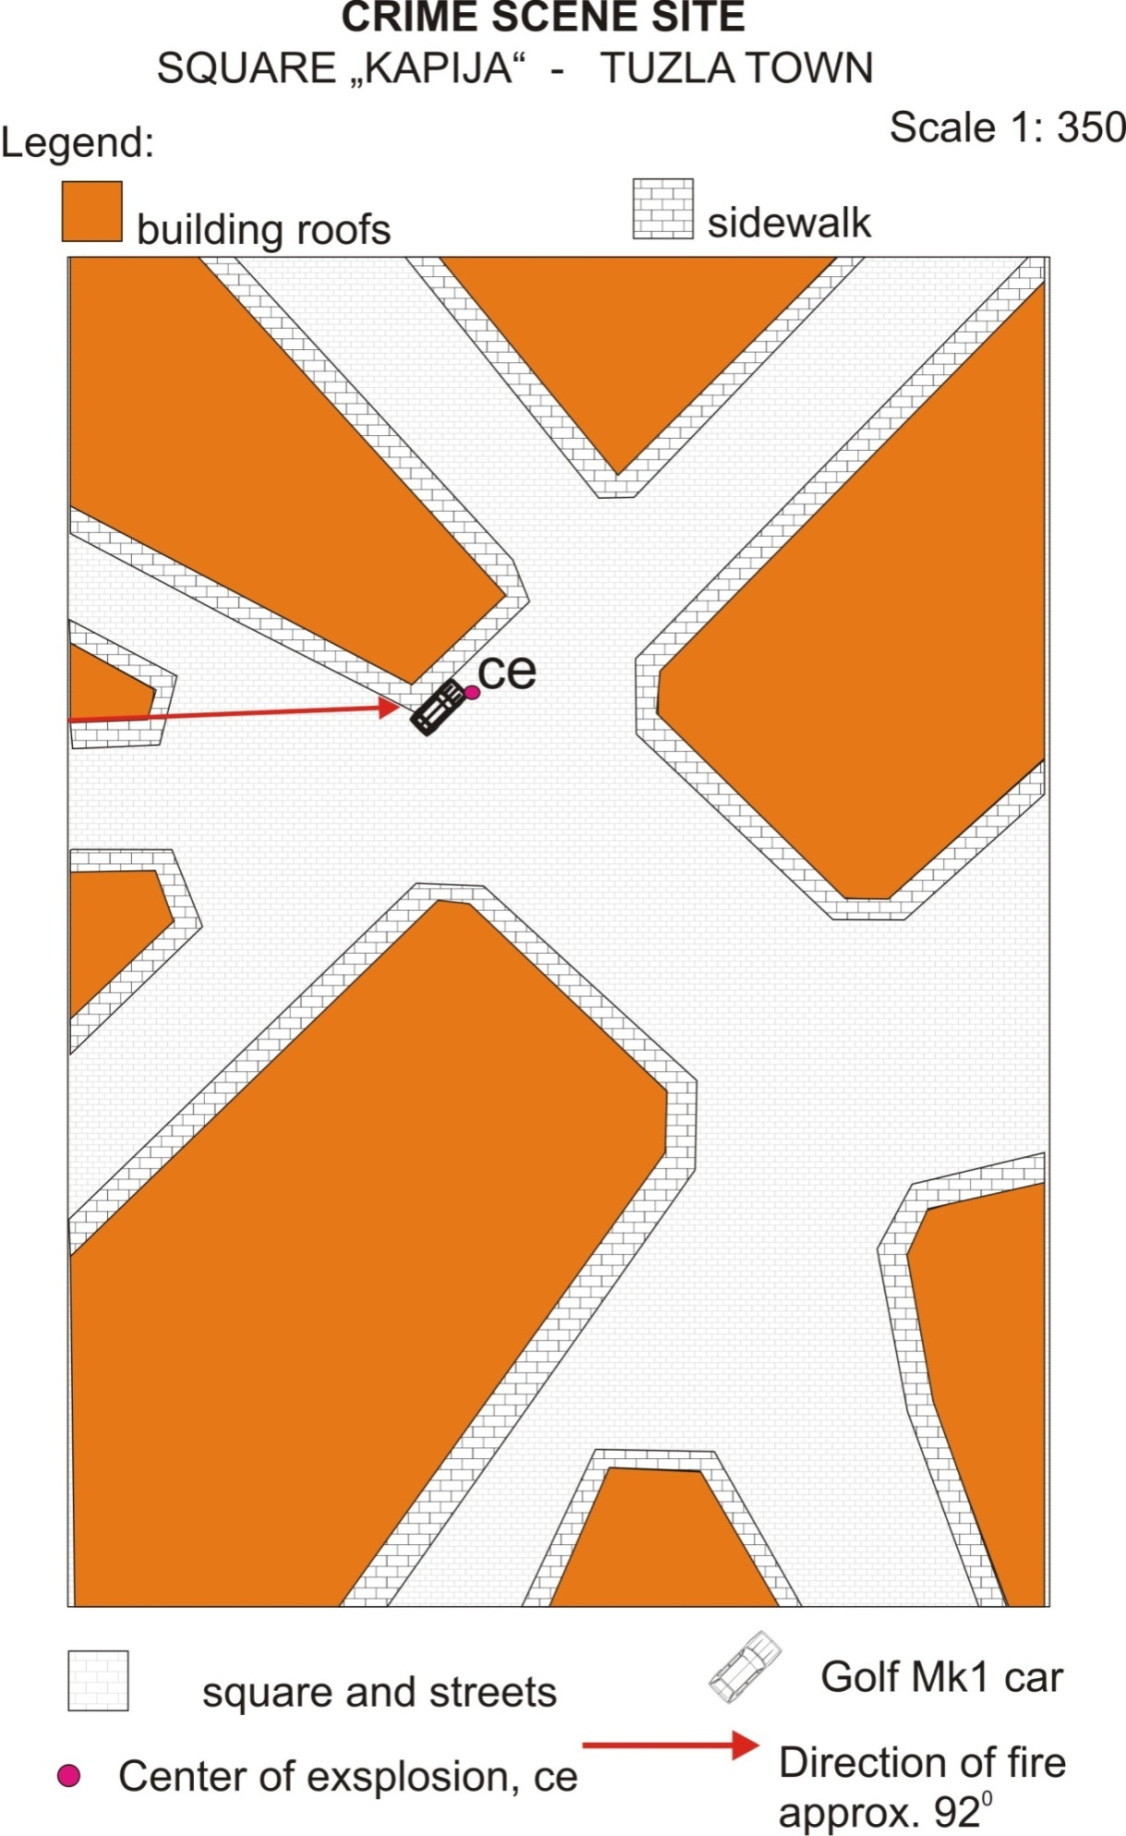
Sketch of the crime scene site N⁰1
2. THE ASSESSMENT OF FULFILMENT OF THE REQUIREMENTS FOR THE FIRING POSITIONS IN THE RELEVANT AREA AND POSSIBILITY OF ARTILLERY ENGAGEMENT

In the present case, the prosecution has set the following statements:
Deadly 130mm projectile flew from the sector that is limited by distances of 26 720 and 27 480 m and azimuth 268.5 and 273.5 degrees.

This means that the most probable distance from which the mentioned projectile was launched amounts to 27 100 m, minimum distance 26 720 and the maximum- 274 80 m. This also means that the FP could be anywhere within these boundaries.

During cross-examination the prosecution expert claims once again, quote: "Yeah look, we are calculate here for different launch angles 38, 39, 45 degrees is not it, to determine which are the angles of fall to the obstacle based on the fact that the weapon was 30 meters above the horizon of the explosion ... .. "- Unquote.
Only two paragraphs earlier in the same transcript reads: "No, no, if you are well studied what I wrote I am a very careful person you have never seen in any exact to say it must be so, and I have said azimuth is in the range of 268.5 and 273.5 that to say the range of azimuth was firing position weapons and I drew it and I just said that there likely means probable zone of the village Panjik never said launch zone village Panjik that's a big difference."- Unquote.
The keywords above are: "the weapon was 30 meters above the horizon of the explosion"," said azimuth is in the range of 268.5 and 273.5", and " I drew it".
Certainly someone drew it. Who was the draftsman nobody knows. Everyone can conclude that prosecution expert was not the one who drew it.
If it had been drawn on the map by prosecution expert himself, he would have to notice that the heights of the possible Firing Positions at a distance of 27 100 m are much greater than +30m in relation to the alleged PD and that amounts more than +100m.
Figure 2.0
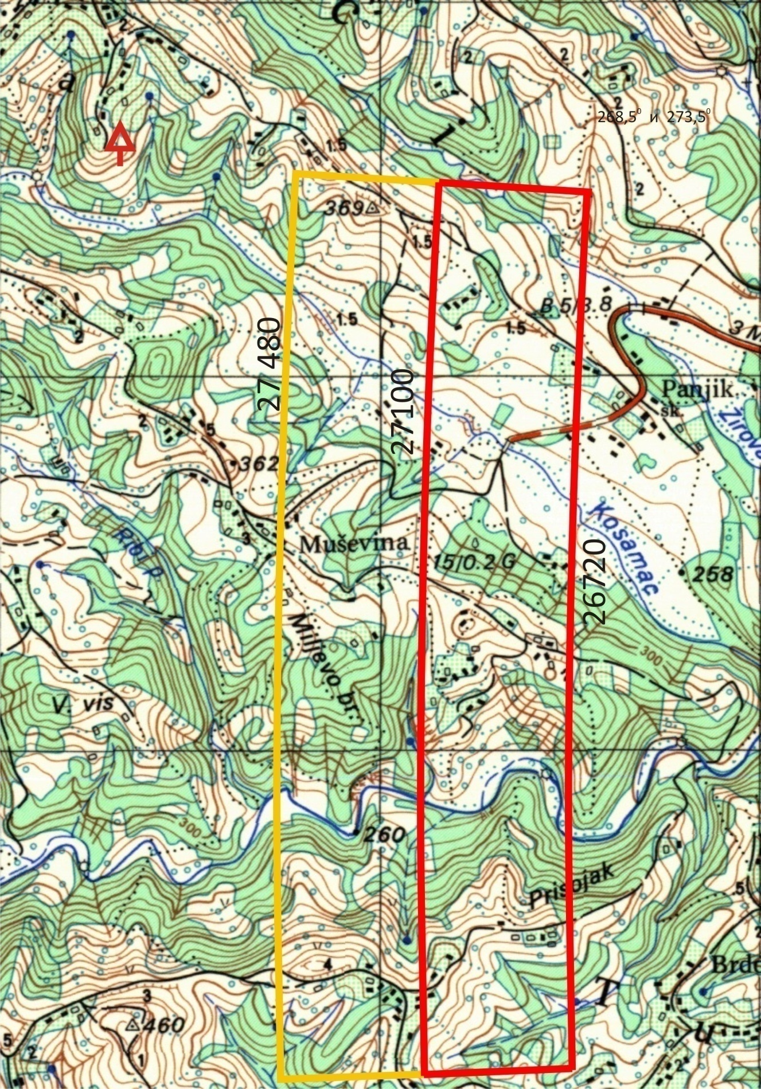
Figure 2.0

On the same way, during such a drawing (see Sl. 87, page 74 from prosecution expert report) he would have to remark the existence of labels for height "362", of the hill without name which denotes the elevations over +120m in relation to the alleged PD, at a distance of 27 480 m (see Figure 2.0)

Prosecution expert did not once check to see if his placed potential Firing Positions can be approached and whether, in general, these Firing Positions can be occupied physically. In this expert analysis later will be discussed more than 30 potential sites for Firing Positions at a distance up to 27 480m in relation to the alleged point of detonation and between specified azimuth limit and it is hard to find one acceptable Firing Position.

This does not mean that there is no suitable Firing Positions on other, shorter distances, but there are none at distances of 27 480m.
Measured from square "Kapija" within radius of 27 480m is located the non-maneuverable, extremely hilly ground with an altitude of 350m and above with the exception of many valleys and river-creek beds to which it is not possible to descend with 8t heavy cannon so here they are not of interest, with a conspicuous and prominent front and rear slope of the terrain without access roads. One who never set firing position on such land, with instrument of nearly 8 tons mass can't be qualified for expert testimony in this case. (Figure 2.1.)
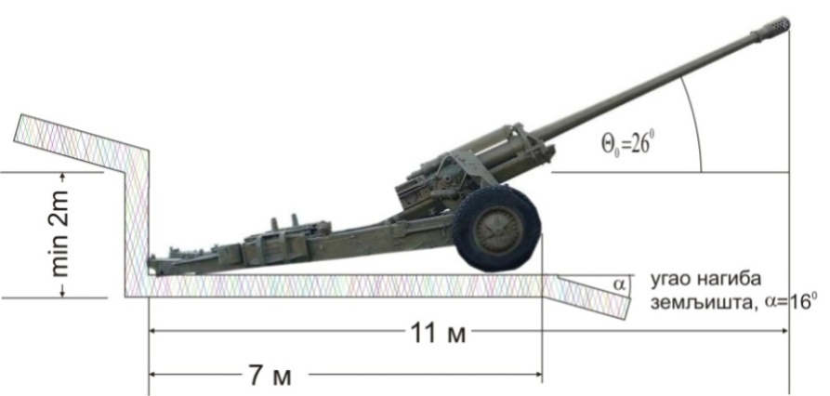
Figure 2.1
The good example for a such a FP at distance of 27 480m and adequate bearing of ≈ 272⁰ looks just as shown in Figure 2.1. There is no road to the firing position (FP). The front slope is not particularly sharp, slope angle α is, α = 16⁰.
In these conditions, to level cannon platform, one needs to do excavation (trail support) with minimum height of $7∙tg\left({16}^{0}\right)=7∙0,2867=2 m,$, which is the minimum (7 x 2 x 5) / 2 = 35 m³ of earth and stones. And when you get to the excavation the gun cannot be put down to the platform, nor pulled from it, while the cannon shelter remains only tentative.
If by some magical procedure the weapon was put down to the platform, firing procedure is impossible because collimator (device for aiming at the direction) cannot be placed behind the cannon and sighting device may not be used at all, especially angle of site device (part of sighting device which is used for leveling angles of site and height differences between basic and other artillery pieces and other individual deviations from the standard conditions).
This last part of the sighting device can be rotated at a maximum altitude ± 18⁰, which is not enough to work with it in these circumstances.
From the above it is evident that the process by which prosecution expert seeks firing positions is incorrect and extremely simplified, where the terrain is considered as a sheet of paper or sea surface. It could also be allowed when the actual altitude of the terrain was introduced as a necessary key variable, but it is not.
It is obvious that this respected prosecution expert, who „witnesses“, has never approached the subject cannon, least fired a round.
On what basis can such a seemingly rude statement be raised?
He who dares to, at will and without any prior specific checks and surveillance, set or place orders to set firing position of 130 mm cannon M46, on such type of ground, never saw what was happening with careless operators of cannon upon firing weapons which, due to personal negligence, protrude parts of their bodies outside the shield cradle – so, did not see blood dripping from all the uncovered parts of the body: hands, nose, eyes, ears and face, as it remains without eyebrows, hair and clothes, he looks like scorched land in front of the gun barrel after firing two full charge projectiles, when almost 13 kg of gunpowder gets burned.
So the least cannon crew needs is to have a two-meter high wall behind them, from where the hot gunpowder gases will be rejected. The situation is much worse if the tool finds the identical, even milder rear slope. In order to clearly present, flip the gun on Figure 2.1. horizontally (wrap for 180⁰). Then it would be impossible to put down the cannon tube below a certain elevation, whereby due to the smallest obstacle in front of the tube a premature explosion with tragic consequences can occur.
In order to avoid these consequences there is need to extend the displacement of cannon for at least 10 m in front of the tube and 2 m behind the spades of split trail to prevent gun sliding backwards down the slope due to recoil. By artillery norms average cannon/howitzer shelter radius is 3,65 m, unlike for 130 mm cannon M46 where radius is 4,25 m, so it is necessary (4,25² x π x 3/2) = 85m³ of excavation, and additionally a minimum of 30m³ for tube maneuver per direction i.e. at least 115 m³ of excavation, and the situation is getting worse because now reflecting walls are in front of the tube and parking.
If the distance of the Firing Position of the peak elevations is less than 12 m (approximate length of cannon in the firing position) it is necessary to level the top of the hills literally to settle gun platform, and it represents the excavation the volume of which is equal to the volume of the European average three-room apartment, and such cannon shelter cannot be naturally aligned for decades.
Same problem with the sighting device remains equally insolvable.
In short, the 130 mm cannon M46 is not a mortar or mountain gun and for Firing Position it needs at least 70 m2 of flat of area without any physical obstacles in front of the tube. This artillery piece is primarily intended for flat ground, or with stationary fortified positions in the role of coastal artillery, as well as from ships. It is natural to the subject (towed) artillery. Its self-propelled version has better performance in terms of mobility and choice of FP, but this is not the subject of discussion.
No matter where you set FP of a cannon, in given conditions, at a distance of 27 480 m, it will be found at an altitude much greater than thirty (30) meters in relation to the alleged PD in the square "Kapija". This will subsequently be analyzed further.
A statement of the prosecution expert expertise is particularly unprofessional - citing:
unquote, page 85. from prosecution expert expertise with a picture Fig. 104.
This statement, above, together with the table is not only inaccurate - it is shameful and unworthy of institution where it was made, and it would be much better if it was never written. It is illogical, arithmetically disastrously incorrect and probabilisticly impossible. Denote the columns as follows - the second such event A, the third such event B, the fourth such event C, the fifth as the event D, the sixth such event E, and seventh, possibly extreme deviation in range indicated as ΔR_{ext};
then:
ΔR_{ext} =A∩(B /A) ∩B∩C∩D∩E
and the probability of such an event, P (ΔRext), is equal to:
P (ΔR_{ext}), = P (A) x P (B / A) x P (C) x P (D)) x P (E)
and since P (D) represents the probability that from the factory came out 130 mm cannon tube with an initial muzzle velocity exceeding 10 m/s than projected, that nobody has ever heard of, registered, seen, written, read or assumed, which means that the probability of this event, P (D):
P (D) = 0,
and then:
P (ΔR_{ext}) = 0,
by which event, represented as in Figure 104. by prosecution expert [(possible extreme deviation range, ΔRext)], is not only proven impossible but also absurd, and also points to the extreme lack of knowledge of subjects which he interprets as expert witness.
This event is not only impossible; presentation of it indicates the basic arithmetic ignorance. For possible extreme deviation range, ΔR_{ext} in a positive sense, it is necessary for ballistic deviations (air temperature, the temperature of gunpowder) to be positive, and weather deviation partially positive (tail ballistic wind) and partially negative, i.e. barometric pressure should be reduced by 10 mbar, and at the same time the temperature must be for ten degrees (10⁰C) higher, which is not often the case. Conversely, for a possible shortfall extreme, it is necessary that all those ballistic deviations are negative and weather deviations as follows – head wind (frontal), therefore makes substantive reduction of the range, and the barometric pressure must be 10 mbar increased.
Event in Figure 104. (ΔRext = 1991 m) is impossible, therefore, also arithmetically.
A contradiction located in the core of the said another quote, is extremely important itself, because it is extremely abusive and humiliating for the one who has written it- a quote above mentioned Figure 104. (A row above the table – unbolded letters).
Unquote!
It can therefore be far worse than what is indicated in the data of Fig. 104!
But how did they then hit targets so accurately twice in the span of a year? By which means 130mm M46 cannon crew may establish control over the parameters of the atmosphere or of the degree of wearing of the gun barrel, which prosecution expert’s offices continuously treated as absolutely new, just out of the factory line?
Cannon crew has in its formation only squad leader’s hand compass and firing tables. Artillery compass is the battery instrument; battery thermometer thru name implies the formation level at which it can be found. Accessories Pzk for measuring the extension of gunpowder chamber was also at the level of the battery, and by information that is easy to check not a single copy more was purchased than the number of purchased batteries of 130 mm M46. The anemometer is at the level of artillery battalion, and to equip three cannon crews with it, one should exclude all anemometers from regiment of artillery pieces 130 mm M46.
Also prosecution expert shows that from the seized documents of the 1st KK., he found that fired 130 mm cannon platoon does not act as a whole, but is dispersed in space and cannon crews operate individually. One cannon with the azimuth of the basic directions of 18-00 (108⁰) is therefore not directed towards Tuzla, but the northern rim of Modrac Lake, while the second focuses on the southwest with the main bearing of 36-00 (216⁰).
Note:
Basic direction of 1800 Russian mills – 100 Russian mils equal 6 degrees, 1800 mills equals 108⁰
Basic direction of 3600 Russian mills – 100 Russian mils equal 6 degrees, 3600 mills equals 216⁰
If the situation is as written by the prosecution expert, and it was so, these crews need at least four (4) battery radio device (no mobile phone at the time) one of which is at the platoon commander and the other with the squad leader (platoons had no radios per formation level), and three new radio devices that are only on the divizon (divizon = artillery battalion, not a division) level and mixed Artillery Regiment, to communicate with the superior command, in order to obtain an adequate state of the atmosphere.
Who has crippled and disabled combat Artillery Regiment of 130 mm cannon M46 that shared all these instruments and assets with higher levels of formation of five degrees to the cannon crew that does not have the manpower trained in using these instruments?
Eventually, what is the subject of discussion?
From where data on the state of the atmosphere and the gun barrel for cannon crew that in the period of one year could send their projectiles with deadly precision which corresponds to the size of 0.1 probable error in range on the square "Kapija"? If the crew of incriminated 130 mm cannon firing at a target near Tuzla at a distance of 1991 m from the square "Kapija" and hit the wheel of a Golf Mk1 car on the square "Kapija", then all consequences of this act can be characterized as mass manslaughter due to negligence.

If not, also this "criminal" 130 mm cannon crew had square "Kapija", "as generally accurate sic! target!" how prosecution expert overwrites from "expert" Mixed Commission of UNPROFOR and MUP B&H, who and how secured such extremely sophisticated tools to monitor the cannon tube status and state of the atmosphere to them.
Quote from page 81. of prosecution expert expertise:
-end quote.
To prosecution expert, prof. dr. Berko Zečević everything is “according to U.S. military terminology”! How unprofessional! Americans, too, use Circular Probable Error (CEP) for assessing the dispersion of unguided rocket projectiles, assessing efficiency of Anti-Aircraft Artillery, for their favorite sport- bombing from airspace, as well as for other needs (assessing accuracy of coordinates etc.), so, the same as us.

For that, but not for measuring of dispersion of artillery weapons!
Respected prosecution expert should be pointed on the sources he really likes, such as "FT 8–J–4, Firing tables Cannon, 8–inch Howitzer M2 and M2A1 on Howitzer, heavy Self–Propelled", Headquarters, Department of the Army, where on pages XIV and XV is explained nicely what is "probable error in range at impact" as well as "probable error in deflection at impact", respectively probable deflections by distance and direction, the same as it is done in Europe, Asia, Africa, both Americas and in Australia.
Quote from page 81., last paragraph from prosecution expert’s expertise:
-end quote.
Again U.S. military terminology! There, it is even written that also exists a dispersion of deflection around projectile median point of impact… As well as dispersion by range, deviation by direction and height, but all of that related to median point of impact or explosion. And in relation to what is prosecution expert’s CEP measured if not in relation to median point of impact or explosion?
No dispersion is a measure in artillery, not in U.S. nor anywhere, and dispersion as translated by prosecution expert is simply translated out of context (dispersion= scattering, dissipation, spreading), and not dispersion as second central moment of a incidental value, respectively unit of measure. it is known that:
Vd =$ρ∙\sqrt{2Dd}=$0,67449·$σ_{D}$
is probable deflection by distance, so Vd=0,67449·$σ_{D},$ (median squared deviation of hits by distance or standard = $σ$), and also Vd is equal to multiplying constant $ρ=0,4769$ with double square root value of dispersion of impacts by distance:
Vpr =$ρ ∙\sqrt{2Dpr} =$0,67449 ·$σ_{pr}$
Probable deflection by direction; therefore, Vpr= 0,67449 · $σ_{pr},$ (median squared deviation of impacts by direction (standard= $σ_{pr}$));
Unlike CEP where inside of circle with r radius is 50% of hits, in unit rectangle 4 x Vd x Vpr is only 25% of hits, inside of unit ellipse with axis a= Vd and b= Vpr is 20.3%, while in half-unit rectangle with Vd x Vpr dimensions is only 4 x 0,13² =6,76% of hits, and link between probable deflection by distance and radius CEP, p, is given by a relation:
$$e^{-{\frac{r^{2}∙ρ}{{Vd}^{2}}}^{2}}= 0,5$$
or:
r$≈1,75 Vd$

And just when one starts believing that it was “lapsus calami”, prosecution expert is there to disperse those beliefs, judging by next quote from page 85. of his expertise:
-end quote.
How can CEP here serve as measure when Vd is seven (7) or more times greater than Vpr, and are the projectiles dispersing just because we defined CEP or are we are using that probable error as a measure to describe a natural occurrence?
So, ballistic expert- prosecution expert definitely does not know measures which are used in artillery for assessing of hits dispersion and probability to hit targets, because from quoted it is obvious that it was transcribed without any control or understanding and from a wrong source.
Prosecution expert derives his ballistic calculation using software 3-DOF to precisely establish distance of FP from alleged projectile Point of Detonation for given state of the weapon and ammunition (but for the last he has no evidence except pure guesses and speculations).
This software does not count for corrections of distance and rotation of Earth nor corrections of distance because of its curvature, nor the value of derivation, but for establishing distance of firing and reverse calculation of topographical distance, corrections of distance because of Earth’s rotation and its curvature are necessary to implement into calculation, which prosecution expert has not done.
Since there is a mark of explosion on Tuzlan “Kapija” and that prosecution expert considers that “Kapija” itself was a generally accurate (sic) target, it is possible to fully exclude all corrections of direction, considering that crew of the gun included them all very correctly, but to gain a “hit” also should correctly include in all the corrections of distance.
Here should be noted that corrections of direction due to Earth’s rotation are figured in the very Firing Tables that prosecution expert mentions as the source in a footnote on page 16. of his expertise, and are necessarily counted in all the distances of firing D_{r} › 20 km, (according to Firing Rules then, t.114). He (prosecution expert) did not include this correction, and why would he when without it every Angle of Fall gets higher 0,2⁰ for distance lower than real by 50m!
On page 273., in Firing Tables for starting (elevation) angle of 38⁰, correction of distance equals – 54m.
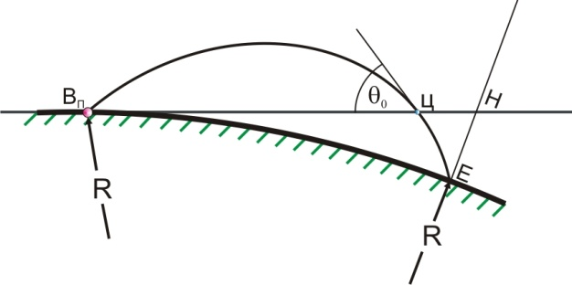
Corrections of distance due to Earth’s curvature are not figured in Firing Tables because they, by Rules of Firing then, are not counted for distances of firing up to 25 km, and for only two additional kilometers of range instrument should not be offered to the executor of firing to try to fire at maximum range. By the way, ever since mid-seventies, since these weapons were bought, and all the way until the end of war, no one has fired these weapons at maximum range, not even in coastal artillery. The above mentioned correction of distance is calculated by form (Figure 2.2):
Figure 2.2.

ΔD_{c} =$– \frac{D_{т}^{2}}{2∙R}∙ctgΘс$ ,
where:
ΔD_{c} – correction of distance due to Earth’s curvature (in meters)
D_{T} – topographic distance of firing › 20 km (in kilometers)
R – Earth’s median radius, R= 6371 km (counted in thousands of kilometers, so 6,371km)
$Θс$ - real Angle of Fall of projectile in given meteo-ballistic conditions
(see: «Стрельба наземной артиллерии», книга I, Военное издательство, Министерства Обороны СССР, Москва 1960, pages 217-219.). In this book for artillery officers is stated that this correction is a must in elements of firing for distances over 25km, according to the above given form.
To simplify the calculation, Earth’s median radius is taken, calculated as square root product of radius of curvature by the prim vertical, N:
and radius of curvature of meridian ellipse at the end of arch, M:
so, as:
$$R=\sqrt[2]{MN}$$
For a sphere which was described as Besel’s ellipsoid, for the area of former SFRY of R=6378 km, the result ΔD_{c} ≈ CN (Figure 2.2.) would be insignificantly different, but only by millimeters, which is of no practical use.
On the other hand, in his capital work: „Modern Exterior Ballistic, The Launch and Flight Dynamics of Symmetric Projectiles“, Schiffer Military History, Atglen, Pa. 1998., author Robert L. McCoy, gives a much harsher recommendation, showing that this correction should be taken into consideration on all distances of firing of over 2000 yards (see Figure 9.17 on page 191. of the same book), and also gives a slightly higher correction of distance by taking Earth’s median radius ~6357km.
And there, for the same entry values, is derived almost the same, negligibly different result.
Correction, naturally, always has a negative sign (-).
Example: topographical distance of firing D_{t}= 27000, given meteo-ballistical conditions, as well as condition of weapon and ammunition, Angle of Fall Θ=60,8⁰,. calculated ΔD_{c} is:

$$∆D_{C}= – \frac{{27}^{2}}{2∙6,371}∙0,559=–32 m$$
So, together with correction of distance of – 54m, total correction of distance is -86m, which changes elevation for at least 0,6⁰, and with it also the corresponding Angles of Fall.

Table 2.1.
Elevation,  Е⁰ | Range, R (m) | Angle of Fall,  Θ⁰ | Elevation,  Е⁰ | Range, R (m) | Angle of Fall,  Θ⁰ | Summary difference of range  (m)
According to Figure 90 from page 76. of prosecution expert |  |  | Same conditions with all corrections counted in
38 | 26 507 | 59,8 | 38 | 26 587 | 59,5 | –80 $\frac{–33}{–52}$
39 | 26 729 | 60,6 | 39 | 26814 | 60,3 | –85 $\frac{–32}{–53}$
40 | 26 938 | 61,4 | 40 | 27 021 | 61,0 | –83 $\frac{–32}{–51}$
41 | 27 128 | 62,1 | 41 | 27 204 | 61,8 | –76 $\frac{–31}{–45}$
42 | 27 302 | 62,8 | 42 | 27 377 | 62,5 | –75 $\frac{–31}{–44}$
43 | 27 458 | 63,5 | 43 | 27 534 | 63,1 | –76 $\frac{–30}{–46}$
44 | 27 597 | 64,1 | 44 | 27 673 | 63,8 | –76 $\frac{–30}{–46}$
45 | 27 717 | 64,7 | 45 | 27 796 | 64,4 | –79 $\frac{–29}{–50}$
In Table 2.1. calculations are in the same conditions as done by prosecution expert (with FP above the target by 30m), which results in differences in range (last column of Table 2.1., which shows minimal error of prosecution expert in each of his calculations, expressed in meters, which is later only enlarged by him).
Since prosecution expert is conducting calculations under assumption that FP is over the target by 30m, and real life differences are from 45 to 208m, according to Firing Tables for 130mm cannon, УА–156/2, ССНО, 1984. point 128., he additionally makes a mistake in establishing distances in distribution of barometric pressure for real heights of firing positions from 2mbar to 23mbar. In range it represents a difference from (–2 х 20,5 =–41) and to (–23 х 20,5 =–471). If the median value of range difference is taken (-79m, from Table 2.1.) with median difference from previous row of -256m (-471-41)/2=–256), then it is obvious that prosecution expert has enlarged all of his calculations of firing distances averagely by 335 (79+256)m, as well as all Angles of Fall by, averagely, 1.31⁰.
This makes all of calculations done by prof. dr. Berko Zečević very wrong, and they cannot be taken as reference when making conclusions about actual conditions and consequences related to the tragedy which happened in Tuzla on 25.05.1995.
Further on, into the calculation it is entered with air temperature of 17.2⁰С , but with a Table temperature of gunpowder of 15⁰С, despite the claims that on that day city of Tuzla was fired upon with multiple projectiles (9), so ammunition should have been prepared earlier, so, exposed to rising temperature of gunpowder to air temperature, which would contribute to new correction of distance of -90m, and such a temperature of gunpowder should have definitely been an entry variable for calculation.
All the meteorogical variables in subject case are increasing the firing distance, (temperature higher than in standard conditions for any Fp, tail ballistic wind, barometric pressure is lower because position is above the target) which can be checked on page 76. of prosecution expert’s analysis, by comparing with Table for Table Firing Conditions (same, page 75.). From where did prosecution expert derive a conclusion that minimal distance of FP is

X_{Fp} = 27.100 ± 360m (same, page 76.),

which in final conclusion turns to

X_{Fp} = 27 100 ± 380m,

is really hard to explain, because maximum value 4 Vd in given conditions of atmosphere and weapon does not go over 328m, so, it should be:

X_{Fp} = 27 100 ± 328m

and from where comes the data about probable deflections by distance, Vd = 95m, (4 x 95 = 380), when such data does not exist in Firing Tables, and also it is being fired on trajectories with enlarged energy potential, during which Vd does not go over 82m, prosecution expert did not explain, but could be reconstructed.

These heavily wrong values are completely incorrect, even if prosecution expert considers that his higher values of probable deflection by distance Vd, are product of using one and the same value of Vd applied to the whole azimuth range, where Vd would be correlatively tied with probable deflection by direction Vpr, and definitely enlarged by small scale, something like centimeters, and not tens of meters. Sector of 50 by direction is, however, too narrow to justify such action.

Anyhow, it is well known that image of spread over distance is sloped by around 3⁰ in relation to plane of firing, so it would be well suited to firing azimuth of 273,5⁰. But, prosecution expert does not have any images of dispersion, he operates with one incidental event over which he, unforgivably for any academic citizen, builds and (mis)uses statistical functions and uses their moments (chosen in the same manner in which parameters for deriving projectile Angle of Fall were chosen)– for granted.

By claiming that maximum distance of Firing Position was X_{FP}= 27 480 m, prosecution expert makes his calculation completely meaningless because vector value X_{FP}= 27 480 m with end in alleged point of explosion positions end of that vector to such heights over sea level that such FP positions, related to alleged point of explosion, are in range of 111 to 208 m above, and calculations of prosecution expert were done with Δ_{Z} =30 m, so, wherever he moves FP on hilly ground, he considers the height of FP unchangeable and enters such variables into his calculations, based on which he derives completely false and completely incorrect data.

Prosecution expert wrote several pages in his analysis in order to explain to Court the differences between correctness and accuracy of firing, which is, mostly correct, transcribed off Internet and suits reality.

However, this is true for all except prosecution expert, because he uses terms “precise” and “accurate” however he wants- one moment from a hard methodological-terminological point of view, and next from point of view of sports commenter. That is best seen from next quotes from his expertise – quote from bottom of page 4:

- end quote
How many times and with what did they determine the height of that building so prosecution expert knew it? 20 times? 2000 times? Does an inaccurate measurement have to give an incorrect result? Does prosecution expert not know that Eratosten of Alexandria measured Earth’s circumference, literally, with a stick in Alexandria, rope (or caravan hodograph- it doesn’t matter) to Sienna and Holy well on a distance of 833km, and that he has gotten result which is, by accuracy, 19 centuries ahead of his time? Measurement can be imprecise but that is why starting and central moments exist, which characterize incidental values like errors in measurement, which show us how much trust can we give to ending, derived, measurement result. With what are data from Firing Tables not in tune- with itself, or to wishes of prosecution expert?
On page 3 of his expertise again something special- quote:

-end quote.
this, however, prosecution expert transcribes from Mixed UNPROFOR Commission and Bosnian civil authorities.
Whose terminology is this now, and what is the point of using it?
What is an accurate target now? How and how much can a target be accurate? Which is the measure that describes dispersion of targets around some “accurate” target and with what is it defined?
Such unbearable ease of jumping from known terms to colloquial speech cannot be characterized as manipulation. The same thing happens with setting claims which are often changed without any ground, so that he would immediately return to previous, or some other, even less grounded claim.

2.1. THE ASSESMENT OF TACTICAL AND TEHNICAL CONDITIONS FOR FIRING POSITIONS AND FIRING POSSIBILITES
Instead of the complex procedure of determining FP places, how prosecution expert did it- by use of probable errors in range, Vd, which results in rapid divergence of numerical values of the interval distance with equally rapid change in the probability of each hypothesis, the choice of possible positions of the130 mm M46 weapon is much easier than it might be expected because of the possibility of finding an adequate FP on the eastern and south-eastern slopes of Mount Ozren is tactically very limited.
Firing Position, in addition to the many factors that are unnecessary here, should meet the following requirements:
- The gun displacement should be largely flat and drowned in the general coloring of the environment;
- FP must be located near the road, preferably not on the road, and if it must, then it is done solely on the basis of a special approval of superiors;
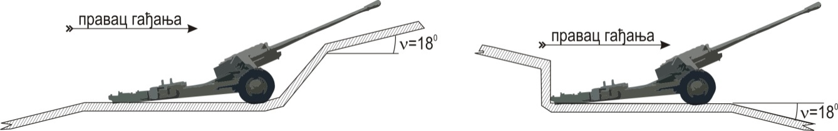
Figure 2.1.1 | Figure 2.1.2

- Firing position must not be at the rear (Figure 2.1.1 - obviously why), and also not on the front slope (Figure 2.1.2).
- If the slope of the land is equal to or greater than 18⁰, it is impossible to adequately set the collimator and, maneuvers are not possible neither is work with other sighting devices – with angle of site device. Displacement of the gun requires multiple over-excavations of soil and, and if somehow would be possible to set it on this FP, a gun is almost impossible to get away from FP without heavy cranes;
- FP should have good access - ordered setting and the abandonment of FP must always be carried out without delay, regardless of the change in weather or other conditions that might occur between the time of occupying it to the moment of leaving it;
- The tow truck should be close to the gun and well camouflaged
- FP may not be directly in front of the forest or close physical barriers (landforms, buildings, or telephone transmission towers), because in some cases (especially when guns are in action) it may prevent shooting up to 2/3 range, and more, and can and cause dangerous fires in the vicinity of unspent gunpowder charge Figure 2.1.3).

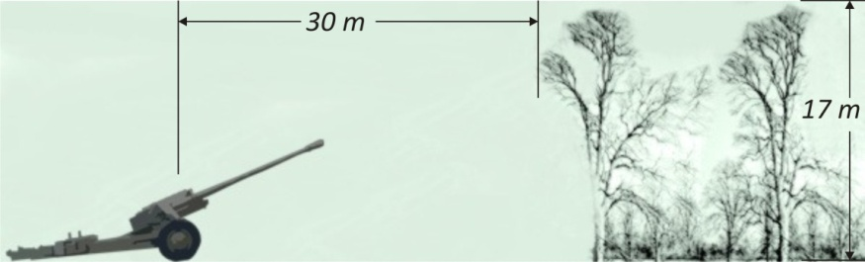
Figure 2.1.3

Example: 130 mm gun M46, Charge N⁰_1 (Max range 21 477 m), standard ballistic and metheorogical conditions, the position of the gun as shown in Figure 2.13.
- Can't be fired at distances of less than 20 km;
- It is not allowed to place FP near the village, because it enormously increases the possibility of extraordinary events, and safety issues of the crewmembers as well as local residents;
- FP must not be on either side slope of the ground, because it is impossible to set a gun to FP or get it out. The exception is the FP on the side slope of the terrain, but on the flat road that winds its way around hills (only by special approval of superiors, because it requires cutting the trafic and the destruction of the substrate to a depth of 30-40 cm).
The gun platform requires also twice the excavation area. Because of the depth of cover per direction maneuver tube is slightly reduced and the rocky soil (cut) is often impossible in one half of the sector. Part of the road, where such FP is set must be completely flat without axial tilt. This is especially true for heavy guns. (Figure 2.1.4).
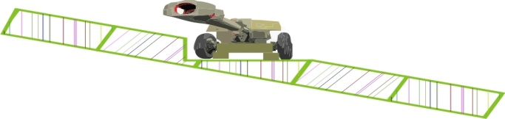
Figure 2.1.4.

- There is still a lot of additional conditions that FP site must satisfy but they are not of interest here.
When you look at a topographic map (Figure 2.0.) that shows the arc in the sector with the lower boundary a distance of 27 100 m and 27 480 m, with a range of azimuth of 271 ^{± 2.50}, which is defined by prosecution expert, near the surface 0.9 km² it is possible to find only a few FP which partially meet the above criteria.

Two of the potential FP from this sector (for a distance less than 27 200 m) are along the road which from the hamlet Panjik leads to the northwest across the tt. 369, to the elevation of 438.

Along the whole of that road to the tt. 369., the land falls steeply to the southwest and northeast, and FP in the above-defined sector is possible to put only just up the road. (Figure 2.0), and the east.369 of the mild enlargement around the road and down the road southeast of the same trig point (mark the height of the cut height- 1.5).

The map also shows that on west of the road markings for type V 5 / 3.8, slightly south setting of several possible FP, but these FP (by distance) are outside the currently defined above sectors and will be discussed later.

West of the bridge on the r. Kosamac it is impossible to put any FP, because there is no access road (forest intermittent or continuous streams that flow into the r. Kosamac without the bridge). The gravel road leads through the high forest to the west, a bend in the road at the crossing over intermittent watercourses, in the woods, 21-m tractor-trailer combination of 130mm gun could not overcome it, and no bridge over water stream can not bear the weight of the towing of over 23 t. Below path enters a deep cut that does not allow any detour until leaving the upper limit of the distance defined sector (27 480 m). After crossing the bridge to r. Kosamac, on a bend in a curve from southwest sharply to the west separates path (.... .to The map). It is, however, in 1995. and today, the time, even better than the one that leads to the west, and it could be put down to the south of the hamlet Muševina, where the position of "M" of the inscription Miljevo hill, and to the east, in given sector could well have location of three (3) FP (today they can not be accessed without extensive forest clearing).

Thus, in sector as a whole in Figure 2.0. there are two small and one central area of possible Firing Positions, whereby in its northern and most southern part there is one possible FP, and in the middle, large, three (see more detailed Figure in Chapter 3.).

The entire remainder of the sector is completely unsuitable for Firing Position of 130mm M46 guns. South of the 3 possible FP is completely impassable terrain and on end of given sector where you can choose only one position northeastern of tt.460 (label 4 - the height of the wall cuttings). Access to this FP will not be commented here.

In Figure 2.0 is also shown the upper limit of the sector with FP places belonging to the maximum distance. On the maximum limit of the northern part of the sector at a bearing 273.5⁰ and at a distance of 27 480 m, it is impossible to set up of FP (fall of the terrain of 60m at a distance of 225m ≈ or 15⁰ or 27%.

For azimuth of 272⁰ and the maximum distance (27 480 m), FP is in the woods and on the front slope - therefore, impossible to set, which is true for all other FP marked as follows 271_max, 270_max and 268,5_max, with two on the huge rear slope, and the third in the bed of the Bukovica river (270_max). Figure 2.0. The designation "max" indicates the maximum topographic distance in relation to the alleged Point of Detonation that is 27 480 m, and the number of points ahead of the corresponding azimuth with an alleged fall points to the alleged site FP measured from the north in the sense clockwise. (See Figure 2.a)

Figure 2.a only confirms the facts that are presented on a topographic map in Figure 2.0 but they added a completely different dimension - view unencumbered by unnecessary facilities which currently offers printed material such as a topographical map, and for those people who may not be accustomed to the use of topographic material.

On the other hand, the satellite image in Figure 2.a. (dated 2013 year) gives a clearer insight into the configuration of the terrain, showing and what can not be seen on the map, since the underlying topographic map 1:25 000 Doboj_4_3 and 1995. was on the verge of obsolescence.
For example, a large area of possible Firing Positions, where in 1995. (map from 1988.) was possible setting of three FP, until 2013. (since when is satellite imagery - Figure 2.a) is completely overgrown with thick forest in which it is hard to enters, so field path south of the inscription "Muševina" in Figure 2.0 is no longer seen from the air.

South of the points marked 272_max is observed relatively wide fairways, which extends eastward at about 250 m west of the road for about 150 m. West of the land falls (last slope in relation to the alleged direction of shooting), but this should not significant here because the distance and on the road is greater than the maximum (27 480 m).
Eastern of labels 272_max, distance potential FP are at a distance, less of 27 480 m in relation to the alleged PD. Muševina hamlet is located southwest of labels 272_max, and there a setting of FP is impossible.

The first FP that satisfied default criteria should be to the west of the road leading to the mark 271_max, therefore, again on the sharp back slope. Figure 2.a (satellite image) shows; up to the maximum possible distance to the upper edge of the sector with azimuth of 273.5⁰ (273.5⁰ _ max), then the maximum distance possible FP an azimuth of 272⁰, 272_mah), and the arc that connects the 273.5 mark and 272_max, 271,5_max, i.e. at a maximum distance and the propagation of the Muševina hamlet.

The image clearly shows that FP can't be north and west of the road that intersects the arc maximum distance, just south - at the rear slope. Northeast and east of the port maximum distance of settiing FP is possible but still have a distance of less than 27 480 m, so currently we are not interested.

When you look at Figure 2.a (its lower part) where the arc intersects the maximum distance path that leads to the southeast entrance to the (now) a dense forest, which was not there in 1995.

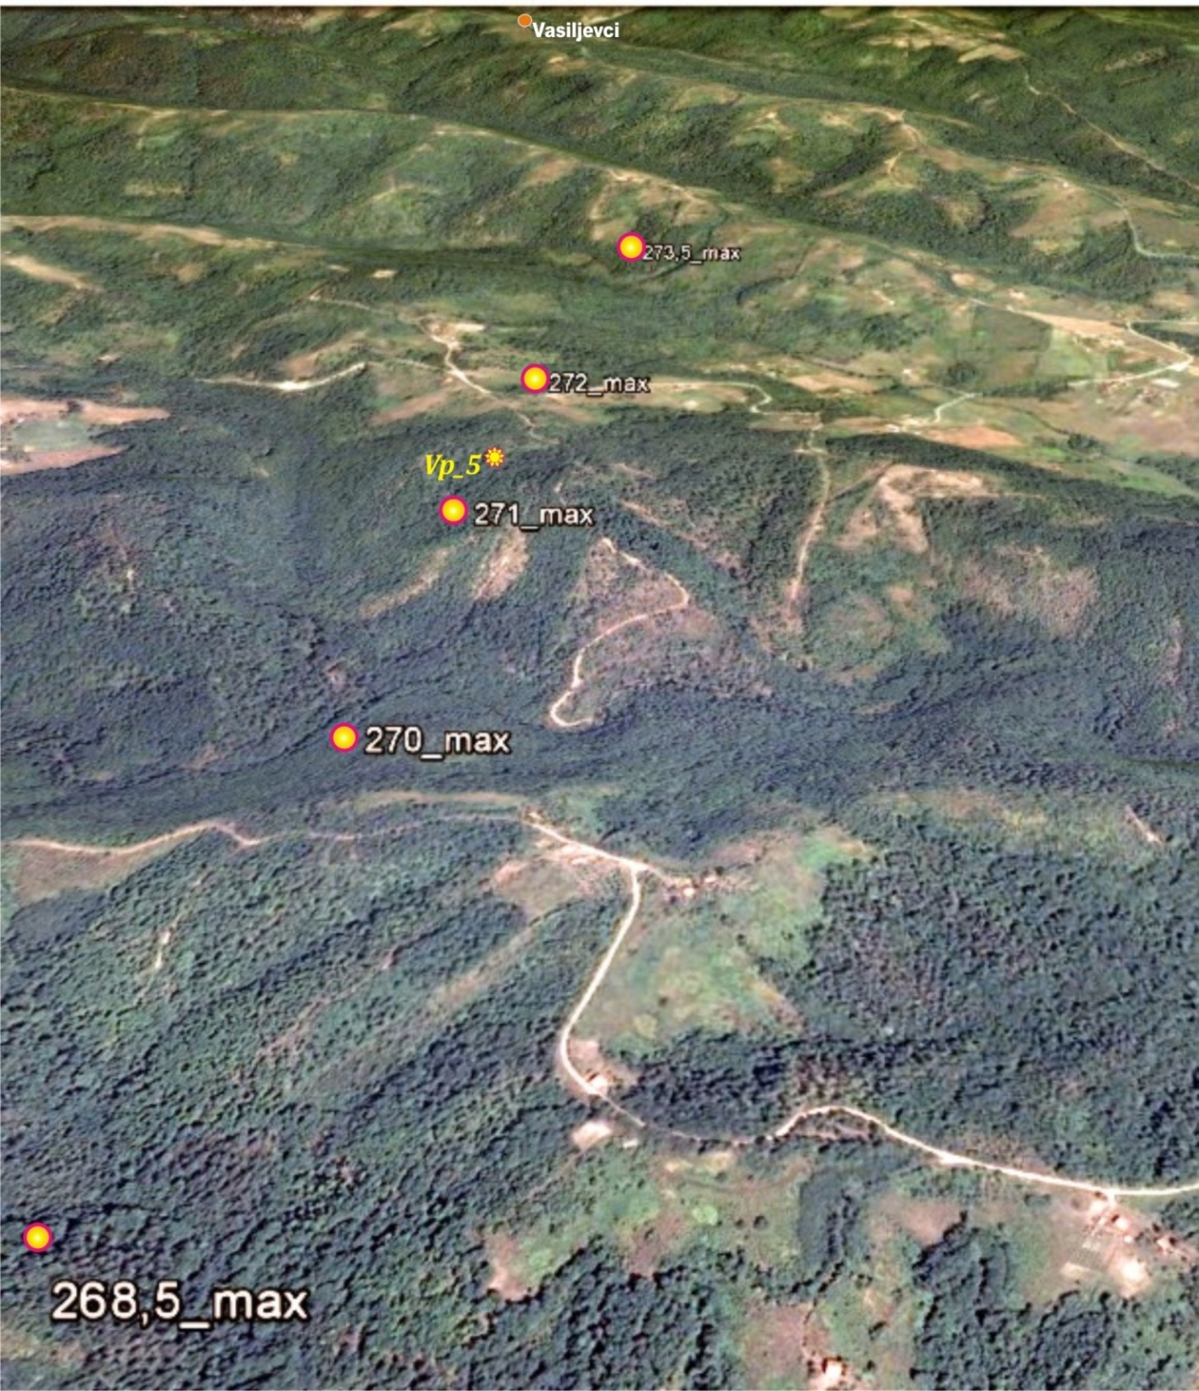
Figure 2.a.

Then, as noted above, could descend south of the Mućevina hamlet, where the position of "M" signs Miljevo hill.

To the east, in a given sector one might set three (3) FP for single gun only.

Two of them are at distances of less than 27 480 m and the third potential FP falls to the area where then was empty abandoned building.

Just in these buildings is a place which corresponds to a distance of 27 480 m from the alleged Point of Detonation. Of course, the FP can't be on these buildings as well as towards west direction (huge rear slope).

Overview of possible FP in the range of 26720 to 27100m, and possible firing positions in the range of 27100 m to 27480 m and azimuth between 268.5⁰ and 273.5⁰, shows only five (5) Firing Positions in a given sector of 27100m to 27 480 m, and 7 (seven) in a given sector of 26 720 m to 27 100 m, according to the Table 2.2:
"Coordinates of possible firing positions inside the sector defined by expert prosecution" with topographical elements for the interval of distances of the FP in relation to the alleged PD from nearly 27 100 m to 27 480 m, and the extreme southern azimuth of 268.5⁰ and 273.5⁰.
Firing Elements from the real firing position in May 1995 for allegedly PD are obtained using ballistic computer.
Table 2.2
Coordinates of possible FP inside the sector defined by prosecution expert
For interval of FP distance related to alleged point of detonation from 27 100 m to 27 480 m, and for ending south azimuth of 268.5⁰ and northing of 273.5⁰
Firing position no. | Coordinates of Firing positions
Firing position no. | X_{FP} | Y_{Fp} | Z_{Fp}
1. | 33 498 | 26 829 | 364
2. | 34 421 | 27 050 | 355
3. | 33 407 | 27 058 | 340
4. | 32 433 | 26 842 | 437
5. | 33 384 | 26 752 | 375
6. | 33 368 | 26 916 | 358
For FP distance related to alleged PD from 26 720 m to 27 1000 m, and for south azimuth of 268.5⁰ and north of 273.5⁰ (down, next figure)
Note: X denotes "Northing", Y denotes "Easting", Z denotes "height above medium sea level",
Firing position | Coordinates of Firing position |  |  | Topographical elements
Firing position | X_{Fp} | Y_{Fp} | Z_{Fp} | А_{z}F (0–00) | R_{T} (м) | AoS(0–00)
F_{P_1} | 34 055 | 27 391 | 292 | 15–43 | 26 855 | –0–02
F_{P_2} | 33 899 | 27 413 | 279 | 15–38 | 26 826 | –0–02
F_{P_3} | 33 726 | 27 723 | 280 | 15–32 | 26 510 | –0–02
F_{P_4} | 33 637 | 27 379 | 270 | 15–28 | 26 851 | –0–01
F_{P_5} | 33 707 | 27 198 | 284 | 15–31 | 27 034 | –0–02
F_{P_6} | 34 368 | 27 195 | 340 | 15–54 | 27 066 | –0–04
F_{P_ст} | 33 328 | 27 254 | 360 | 15–17 | 26968 | –0–05

Elements for firing from real Firing position from May 1995. for alleged point of explosion gained by using ballistic computer

Firing position | QE - AoS | False Angle of site | Elevation  Е ⁰ | Angle of Fall Θ⁰ | Angle of Fall  0–00
F_{P_ст} | 6–47 | 29–95 | 38.52⁰ | 60.5⁰ | 10–08
Angle of Fall is significantly lower than 62⁰!

Table of needed starting elements – Table 2.2.1

Elements for firing from possible Firing Positions for alleged Point of Detonation gained by using ballistic computer from 26 720 m to 27 100 m, and for ending south azimuth of 268.5⁰ and north of 273.5⁰

Firing position | Range finder | Angle of site device | Elevation  Е ⁰ | Angle of Fall Θ⁰ | Angle of Fall  0–00
F_{P_ст} | 6–47 | 29–95 | 38,52⁰ | 60.5⁰ | 10–08
F_{P_1} | 6–54 | 29–98 | 39,12⁰ | 60.4⁰ | 10–07
F_{P_2} | 6–48 | 29–98 | 38,76⁰ | 60.2⁰ | 10–03
F_{P_3} | 6–25 | 29–98 | 37,38⁰ | 59.0⁰ | 9–84
F_{P_4} | 6–51 | 29–99 | 39,00⁰ | 60.3⁰ | 10–05
F_{P_5} | 6–64 | 29–98 | 39,72⁰ | 60.9⁰ | 10–15
F_{P_6} | 6–46 | 29–95 | 38,46⁰ | 60.2⁰ | 10–03

Note: Looking at values of all Angles of fall from Table 2.2 gives information that there is no such Angle of fall, which would be at least close to 62⁰.

Partial conclusions:
A.) In entire sector marked by azimuths:
$${268,5}^{0}≤AzF≤273,5^{0}$$
with limit distances:
$$26 720 m≤R≤27 480 m$$

There is one and only one place that meets the requirements for a possible firing position, FP, the topographical distance of which, in relation to the alleged point fall in the market "Kapija", is close to distance of 27 480 m (27 471 m).

B.) In entire sector marked by azimuths:
$${268,5}^{0}≤AzF≤273,5^{0},$$
with limit distances:
$26 720 м≤R≤27 100 м$,

there is no firing position from which with firing in subject conditions one could get Angle of Fall Θ≥60,50, let alone one that would be Θ≥62⁰.

C.) If the firing position under A. does not provide the Angle of Fall of the projectile Θ»62⁰, prosecution expert's statement is completely untrue, and that means that the square "Kapija" was not influenced by a fired artillery projectile.

Firing positions from Table 2.2 for the sector of 26 720 m to 27 100 m, and for extreme southern azimuth of 268.50 and 273.50 of the north are marked with numbers F_{P1}...₆ , as well with markings Fp_Z and Fp_ST. The position is marked with Fp_Z is the one which was found and marked by prosecution expert - quote- "with high probability", while firing position marked FP_ST:

The actual Firing Position (marked in red) on which were three 130 mm gun from November 1994. to February 1995., when one of the cannon crews with gun was transferred, while the other two weapons were on the FP until the end of May 1995., also on the day of the tragedy of Tuzla.

If Tuzla was targeted from any FP, then this could be just this one that and none other!

Leaving scholastics aside, and accept for now all his claims, singling out hypothesis which is best for expert, according to which the maximum topographic distance of Fp, DTM = 27 480m, which is also the focal maximum range of tools in tabular conditions.

This is the distance at which, according to the prosecution expert, Angle of Fall was high enough for the projectile to safely fly over car Golf MK1, with Angle of Fall of approximately 63⁰ or more.

Put aside the fact that every artillery officer, who would be given any task, would set FP of subject weapons to this distance from the target, with almost no reserves in range, would be severely punished to degradation in rank, associated with loss of office.

Calculations with using software 3-DOF credited with distance corrections due to the rotation of the Earth and corrections of distance due to the curvature of the Earth's surface, taking into account the state of the atmosphere, which prosecution expert allegedly received from the weather station in Tuzla for the day 25.05.1995., and assuming that the barrel of 130 mm M46 was completely new, projectile of normal mass, and the temperature of gunpowder Tablic we get:

Firing positions that are "located" in the area of the hamlet Panjik (the distance from the point fall in the market „Kapija“ of 26 665 m and 26 720 m, as marked by prosecution expert), are at an altitude of 274 m (RRS = 274 m, ZC = 229 m)

Topographical range, D_{T} = 26 665 m, Z_{FP} = 274 m, Z_{C} = 229 m
Topographical range, D_{T} = 26 720 m, Z_{FP} = 274 m, Z_{C} = 229 m

Table 2.2.2
Distance, D_{т} in m | QE - AoS  (0–00) | (QE - AoS)⁰ | QЕ⁰ | AoS  ( 0–00 ) | Time of flight, T_{F} in sec | E_{R}  in м | Θ  0–00 | Θ⁰
26 665 | 6–37 | 38,22 | 38,10 | 29–98 | 77,9 | 77,3 | 9–94 | 59,6
26 720 | 6-40 | 38,40 | 38,28 | 29–98 | 78,3 | 77,5 | 9–97 | 59,8

Firing could not be achieved with these firing positions because the shell would explode on the upper side of the car Golf Mk1, Θ_{с}«62⁰ (minimum actual boundaries of distance).

See the last column of Table No. 2.2.2
Topographical range, R_{T} = 27 100 m, Z_{FP} = 282 m, Z_{C} = 229 m)

Table 2.2.3
Distance, D_{т} in m | QE - AoS  (0–00) | (QE - AoS)⁰ | QЕ⁰ |  | AoS  ( 0–00 ) |  | Time of flight, T_{F} in sec | E_{R}  in м |  | Θ  0–00 | Θ⁰
27 100 | 6–69 | 40,14 | 40,02 |  | 29–98 |  | 81,2 | 79,7 |  | 10-19 | 61.1
Firing could not have been accomplished not even from these firing positions – Θ_{с}«62⁰!

Topographical distance, Dt = 27 471 m, Z_{Вп} =375 м, Z_{Ц} =229 м) –– FP no.5 Table 2.2

Table 2.2.4.
Distance, D_{т} in m | QE - AoS  (0–00) | (QE - AoS)⁰ | QЕ⁰ | AoS  ( 0–00 ) |  | Time of flight, T_{F} in sec |  | E_{R}  in м | Θ  0–00 |  | Θ⁰
27 471 | 6-84 | 41,10 | 40,80 | 29–95 |  | 80,3 |  | 80,8 | 10–32 |  | 61.9⁰
Firing could not have been accomplished not even from this FP because projectile would explode on the Golf Mk1 car and not next to it.
(maximum actual boundaries of distance)
.

Data from these tables show that the minimum Angle of Fall of 62⁰ or higher can not be obtained until the limit distance of the firing position of the target, where the Angle of Fall of projectiles is close to the value of 62⁰, but that Angle of Fall can not provide overflight of Golf Mk1 car without hitting the bonnet, which prosecution expert himself claims, and expressly acknowledges on page 64 of his findings and opinions:
("Analysis of the circumstances that led to the massacre of the people in the 'Kapija' square on 25th ofMay 1995 at 20:⁵⁵ hours“ ), that – quote

„it is likely that the angle of descent was higher by a few degrees.“ -unquote

If we consider that the temperature of gunpowder was close to the temperature of air, (17⁰) which is very likely due to the fact that at the beginning of expertise:

("Analysis of the circumstances that led to the massacre of the people in the 'Kapija' square on 25.05. 1995 at 20:55 hours "), claims that on the same day in the period from 20:55 to 21:00 hours in the city fired several shells (9) which implies a realistic assumption that the ammunition for shooting was previously prepared and exposed to ambient temperature, we get:

Table 2.2.5.
Distance, D_{т} in m | QE - AoS  (0–00) | (QE - AoS)⁰ | QЕ⁰ | AoS  ( 0–00 ) | Time of flight, T_{F} in sec | E_{R}  in м | Θ  0–00 | Θ⁰
27480 | 6-77 | 40,62 | 40,32 | 29–95 | 82,4 | 80,3 | 10–28 | 61.7⁰
So, not even on maximum firing distance his minimum Angle of Fall is not provided, with condition that temperature of gunpowder was close to the air temperature, which is not very meaningful because on that position, which is 27 480 m away from alleged point of detonation, one cannot put FP!

Along the earlier mentioned way to the northwest toward 438 hill, where firing positions can be their altitude is 295 to 340 m (66 to 111 m, or 2.2 to 3.7 times higher than that used in calculation of the expert prosecution, i.e. +30 m), or the distance less than or equal to 27 100 m, or outside the specified sectors such as. positions 4 and 5

On the terrain, southeast and east of the hamlet Panjik, towards village Stupar (hamlet Nešići, hamlet Blagojevići) land is a far better choice for FP, but it is not considered here for the reasons set out above.

It is particularly important that the shooting distance with the actual position in the hamlet Katanići (end of 1994.), the coordinates: H = 33583, U = 29342, Z = 260 m, the hamlet Blagojevići (1993./1994.), coordinates: X = 33620, Y = 29405, Z = 260 m, are such that the distance of firing was less than 25 km, and from the region Ugarci, out of sector by range and azimuth, so here those positions were not even looked at.

All Firing Positions listed in Table 2. can be seen with according coordinates and firing elements from those FP, as follows, from table 2.2.6.:
Table 2.2.6.
FP | Coordinates of Firing positions and elements for firing from them
FP | X_{Fp} | Y_{Fp} | Z_{Fp} | AzF | R_{T} | AoS | Θ (0−00) | Θ⁰ | Еl⁰
1. | 33 498 | 26 829 | 364 | 15-23 | 27 397 | -0-05 | 10-29 | 61,7⁰ | 40,50⁰
2. | 34 421 | 27 050 | 355 | 15-56 | 27 214 | -0-04 | 10-19 | 61,1⁰ | 39,78⁰
3. | 33 407 | 27 058 | 340 | 15-20 | 27 166 | -0-04 | 10-17 | 61,0⁰ | 39,66⁰
4. | 32 433 | 26 842 | 437 | 14-86 | 27 379 | -0-07 | 10-19 | 61,1⁰ | 39,48⁰
5. | 33 384 | 26 752 | 375 | 15-19 | 27 471 | -0-05 | 10-32 | 61,9⁰ | 40,80⁰
6. | 33 368 | 26 916 | 358 | 15-19 | 27 307 | -0-05 | 10-24 | 61,4⁰ | 40,14⁰

Note: FP1 is not possible to set up - it was previously shown, but elements will be calculated for that FP, although all other positions at such distances have already been proven to have trajectory with corresponding Angle of Fall of «62⁰.

FP No. 3 today could not be used because the ground is covered with dense forest, but the region during 1995. was parching and accessible. The same is true, to a lesser extent for FP number 6. However, according to the conditions in 1995. (see topographic map 1: 25 000 Doboj 4_3), these places have been possible to use, and will continue to be taken into account both of these positions. (Colored blue).

We now need to look at how prosecution expert determined the sites of possible Firing Positions in his report (mandatory to see Chapter 3.)

In his report, on page no. 90, the prosecution expert said that it was the former place FP (minimum distance shooting Dgmin = 26 720 m) and found "with high probability" in the area of the hamlet Panjik. Where are the FP-s from 27100 meters, and also those in interval of 26 720 m to 27100 m, and also those in the range of 27 100 m to 27 480 m?

On Figure No. 90 he marked that position in the region Panjik with a big star with a lot of creative vagueness - in the scale of the map that sign is 200 m wide and 128 m high, with an area of 1.23 ha. (Picture no. 90).

The coordinates of the place expert nowhere stated, but they can still be determined, by georeferencing, bringing map that is itself attached to a geodetic expert program or the traditional way of artillery (coordinometer, cross-measurer with a compass, etc.), and the values of these coordinates are as follows:
Х_{FP} = 33780, Y_{FP} =27570, Z_{FP}= 274m.
From this data follows:

R_{T}= 26 665 m, alleged Azimuth of firing, Аz_{f} = 15-34 (92⁰ 2' 24" or 92.04⁰).

On this point has never been any firing position, but it does not affect the calculations, because it approximately fits the above range of alleged firing range [-55 m in relation to the minimum distance of firing which was confirmed by the prosecution expert in one place , Dfmin = 26 720 m, or -75 m, as elsewhere is the distance between the range of possible (according to him) Fp, of 27100-360 = 26 740 m)].
Prosecution expert then cites two other places of FP (DT = 27 100 and 27 480 m), but avoided to write whether it is on the same azimuth of fire with the first fire positions in the hamlet Panjik (AZ = 15-34 (92⁰2'24’'or 92,04⁰), in reverse azimuth, i.e., 92⁰ 2' 24 " + 180⁰ = 272⁰ 2’ 24 ", or on some other azimuth in range of 268,5⁰ to 283,5⁰.

Figure 2.a (satellite image) shows that setting up FP in the range of 27 100 to 27 480 m, and the azimuth of 272⁰2'24" is impossible without the enormous work on the development of a dedicated bridge and road Therefore, Figure 2.a lists possible more distant firing positions, primarily those labeled as 1, then 2 until 5. All firing positions are determined so as to be in the range of azimuth from 272⁰ to 283,5⁰ and are located along the road towards the 438 hill.

The same Figure also shows that setting up FP south of the aforementioned road is totally impossible because of the steep side slope that descends towards the river.

For all FP positions north, the same applies – all are impossible to set all the way to the road that leads from the hamlet Panjik to the village Vasiljevci but positions there (according to the analysis of the prosecution expert) could not be, because they are out of the range of the maximum upper azimuth of 273.5⁰.

Based on these data, presented by the prosecution expert, the final report was derived (page 93, "Analysis of the circumstances that led to the massacre of the people in the square 'Gate' on 25.05. 1995 at 20:55 hours") that FP of incriminated 130 mm M46 was at the distance from the place of the alleged explosion (point of fall of alleged projectile):

X_{fp} = 27 100±380 m,

from where, with corresponding Angles of Fall, we get:

26720 ≥ X_{Fp} ≤ 27 480
62⁰ ≤ Θ ≤ 67⁰ 41'

Interval of 380 m (27480-27100 m) is obtained by multiplying the probable deflection by distance, Vd, relative to the median trajectory with 4. Here has been taken that the Vd = 380/4 = 95m, and how this information is obtained we can see later.

This probable deflection by distance does not exist in the Firing Tables for tabular, let alone the actual shooting conditions. In actual firing conditions, and considering the previously outlined the fact that the value of spread of projectiles around the center of impact is defined in relation to the trajectory of the actual topographic and meteo-ballistic conditions and not in relation to the trajectory in tabular firing conditions, probable deflection of trajectories by distance, for topographical distance of FP of 27 100 m does not exceed 80 m, so:
27 100 м ≥X_{fp} ≤ 27 480 м
transformes into:

27 100 м ≥X_{vp} ≤ 27 420 м.

It is not clear why prosecution expert used this method of shifting the firing position according to probable deflection of projectiles by distance instead of running an analysis of possible target hitting with a hypothetical FP for assumed favorable Angle of Fall. It was enough to conclude that FP was away from the target from 27 100 m to 27 480 m.

From the above it is easy to conclude that the above-specified range of possible distances of FP are grossly erroneous.

Status of prosecution expert in the academic community and the status of the institution that stands behind him does not allow the above assertion to be justified by accidental omission. He can not help but be aware that the value of spread of projectile fall points around around the median trajectory is defined in relation to the trajectory of the actual topographic and meteo-ballistic conditions and not in relation to the trajectory in tabular shooting conditions. The same is true for the Angles of Fall.

Therefore, it is unacceptable to determine the topographic place of FP under real meteo-ballistic conditions and choosing Angles of Fall and probable deflections according to tabular shooting conditions.

In Figure 90, page 76. of prosecution expert expertise:
("Analysis of the circumstances that led to the massacre of the people in the "Kapija" square on 25.05. 1995 at 2055 hours") - it is actually a table of ballistic calculation - the author shows that for accepted set of shooting conditions, from Firing Position 30 m above relative to the PD, at a distance of 27 128 m, AoF Θ is Θ = 62⁰ 5 '52.8''(62.098⁰), and the distance Xvp = 27 100 m gives angle lower than 62⁰, and much smaller, Θ << 62⁰, if the FP OCH or ΔΖ >> + 30 m.

Table 2.2.7

Firing position number | Topographical elements
Firing position number | F_{P} height over alleged point of detonation, Δ_{Z} ( m ) | D_{Т} (m) | AzF in mil and (⁰) | С mil
1. | 135 | 27 397 | 15–33 (91,98⁰) | – 0-05
2. | 126 | 27 214 | 15–56 (93,36⁰) | –0–04
3. | 111 | 27 166 | 15–20 (91,20⁰) | –0–04
4. | 208 | 27 397 | 14–86 (89,16⁰) | –0–07
5. | 146 | 27 471 | 15–19 (91,14⁰) | –0–05
6. | 129 | 27 307 | 15–21 (91,26⁰ ) | –0–05

In Table 3.0.6. for all positions in the Table of coordinates (Table 3), were specified topographical distances DT from individual FP to alleged points of explosion in the market „Kapija“, and the corresponding azimuths of firing, local angles and elevation.

There is not one Firing Position the elevation of which, above the square "Kapija", was Δ_{Z}= 30 m, so there is no Θ of Fall that would be, Θ ≥62⁰!

Partial expert conclusions:

- All possible FP in azimuth range from 268.5⁰ to 273.5⁰ with the topographical distance, DT, in the interval of DT = 27 166 m to the DT = 27 471 m, have OCH Δ_{Z}, ranging from +208 to + 45m;

- All other possible assumed firing positions with smaller OCH, are on the topographic distance equal to or less than 27 100 m, have OCH over alleged point of detonation greater than 30 m, which in his calculations uses prosecution expert;

- At the same time, to topographical distance of Firing Position in relation to the alleged point of detonation equal to or less than 27 100 m, as prosecution expert himself shows (see Fig. 90.page 76 of his expertise), Angle of Fall is less than 62⁰, which can not provide the projectile to fly over the engine department of Golf Mk1 car.

- All of the ballistic calculations prosecution expert performs under assumption that OCH FP in relation to the alleged point of detonation in the square „Kapija“, was only 30 m, which makes all his calculations grossly wrong.

This error(s) is cardinal for any ballistic calculation. FP height itself exerts considerable influence on the range under all other things being equal, but in addition further changes range from the purely geometrical reasons - FP above the target requires further reduction in firing distance for the value of the product of the local angle and Tabular corrections of range of actual firing conditions, according to applicable Firing Tables.

In the usual manner of theoretical external ballistics prosecution expert “shoots” Tuzla from the south, from Plahovići village region, west from Kladanj, and not from Ozren, all of the time not being concerned by height of FP (to him it is always +30m from point of detonation), and also he is not worried by the fact that he is “shooting” from west to east. In such a case it is needed to count the negative fixes in distance, because of Earth’s rotation, and also the negative fixes in distance, due to Earth’s roundness, no matter the azimuth of shooting. Both are negative, so, it is actually needed to shorten the distance.

If the targeting is towards east from west, we are getting more range with the same base values than if the targeting is taking place from west to east. Ballistics-expert must know that, but obviously he is neglecting it.

Controverse way of determining possible FP places is also extremely doubtful.

Now data should be taken from Table 2.2. FP_5. at maximum distance from the alleged point of detonation, with its OCH which is most favorable to the prosecution expert. As shown in Table 3.0.5 can be seen that it is FP No. 5, coordinates of which are as follows:

FP number 5. (N) X_{FP} = 33 384; (E) Y_{FP} = 26 752; Z_{FP}=375

Under the same conditions of atmosphere that expert in his report presented as data obtained from weather stations in Tuzla for the day 25.05.1995., and for the same condition of 130 mm weapon and ammunition, we get:

R_{T}= 27 471 m, А_{z}=15–19 (91.14⁰), AoS= –0–05

QE - AoS ––––––––––––––––––– 6–85, (41.1⁰),
Angle of Site ––––––––––– AoS = - 0-05, AoSD =29–95,
ЕLevation ––––––– Е⁰ = 6–85 –0–05 = 6–80 х 6 =40.8⁰,
Time of flight–––––––––––– Т_{f}= 83 s,
Probable error in range ––––––– P_{d}=81 m,
V_{k} =349 m/s,
Angle of Fall––––––––––––––––– Θ₀=10–32 (61.92⁰).

If the distance increases for 9 m from 27 471 to 27 480 m, we obtain the Angle of Fall of 61.96⁰, or a result that is extremely unfavorable for prosecution expert, because it shows that even at maximum range can not be achieved the minimum angle of descent of 62⁰, and certainly not "a few degrees higher", as he himself claims, because he knows that the falls at an angle of 62⁰ projectile can not fly over Golf Mk1. However, this increase in distance of 9 m is illustrative only, since the firing position at this point can't be set up.

If we take into account a realistic assumption that the temperature of gunpowder was equal to the air temperature, Angle of Fall, in the entire sector from 26700 to 27480 m and in the range of azimuth of ${271}^{{±2,5}^{0}}$is still significantly below 62⁰, Θ << 62⁰.

From until now shown, and on the basis of the calculations done, the analysis and the results of numerous experiments, it is shown that it is possible to derive a few new but far more general partial premises of different nature.

The first is artillery-specialist in nature and is determined by the applicable Firing Tables that the expert stated in a footnote on page 16 of his expertise:

1) From each FP which was away from alleged the point of detonation of projectile on the square „Kapija“, of 27 100 m up to 27 480 m on a given fall direction, at a given state of the atmosphere and weapon, it is possible to shoot at almost every point in the market „Kapija“, excluding three-meter narrow eastern corridor covering the building which, roughly speaking, provide general direction north-south, for example building of the former store „Kapija“.

Second partial premise (question) is of logical nature:

2) Why would the crew of 130 mm M46 gun (maximum 10 people including the driver), move its eight-ton gun, over the hilly terrain with a well-established and masked FP, in imminent threat of war, with a completely undisturbed, superior air armada over their heads, when the actual position can shoot almost every point in the market „Kapija“? Is it just to find such a distance of FP with which the angle of descent be such as to meet the needs of prosecution expert and fly over Golf Mk1 car?

The third partial premise - a proven fact is of tactical-physical nature:

3) For the given azimuth of flight of projectile, primarily given, ≈272 °, which prosecution expert himself determined and later did not change, and in the range of 27 100 m up to 27 480 m, tactically, in subject terms, it is impossible to set operational Firing Position of the weapon.
Explanation:
For the given azimuth of flight of projectile which prosecution expert found, and in given interval of 27 100 m up to 27 480 m, it is tactically impossible to set up a firing position of the tool without weeks of military engagements of road-bridge and pioneering company, which was not part of the light brigade and in the full composition of such units were not at the level 1.KK (thick and tall forests, rivers, streams and gullies without bridges, wasteland).

The fourth premise partial statements is of topographic-ballistic nature:
4.) Ballistics calculations of prosecution expert were partially invalid, partly due to arbitrary grossly erroneous variables are entered into the calculation and other used real and omitted variables, which results in severe faults, both in terms of the range as well as to the value of AoF.
Explanation:
Firing Position at a distance of 27 100 is impossible to reach without a road and bridge construction or use of heavy cargo launch bridge over 23t. FP is the minimum height 282m (RRS = 282m). Altitude difference in relation to the point of detonation is 53 m (ΔZvp = 53m), because the alleged point of detonation on the square „Kapija“ is at an altitude of 229 m (Zs = 229m), not 240 meters as claimed by the prosecution expert.
The same expert conducts all his calculations for OCH of FP over the alleged target of 30 m, which makes these calculations invalid. The situation is even worse on the alleged FP at a distance of 27 480 m (this distance prosecution expert depicted in Figure 87, page 74).
Elevation of named FP is 325 m, z =325 m, and height difference compared to the point of detonation is 96 m (ΔZvp = +96 m). Prosecution expert also for this FP derives calculation for the altitude difference of +30 m, completely ignoring the topographic conditions that have been previously determined, which makes this grossly erroneous calculation, particularly in terms of the value of Angle of Fall, and completely ignored the actual topographical situation on the ground. After all, this FP is not possible without the possession of enormous engineering works that are impossible to justify.
The third and fourth premise stem from data provided by the topographic map 1:25 000, Doboj 425_4_3, second edition in 1988., and the amendments of 1987. Firing Position at a distance of 27 100 m, as indicated is in place without any access road of any quality.

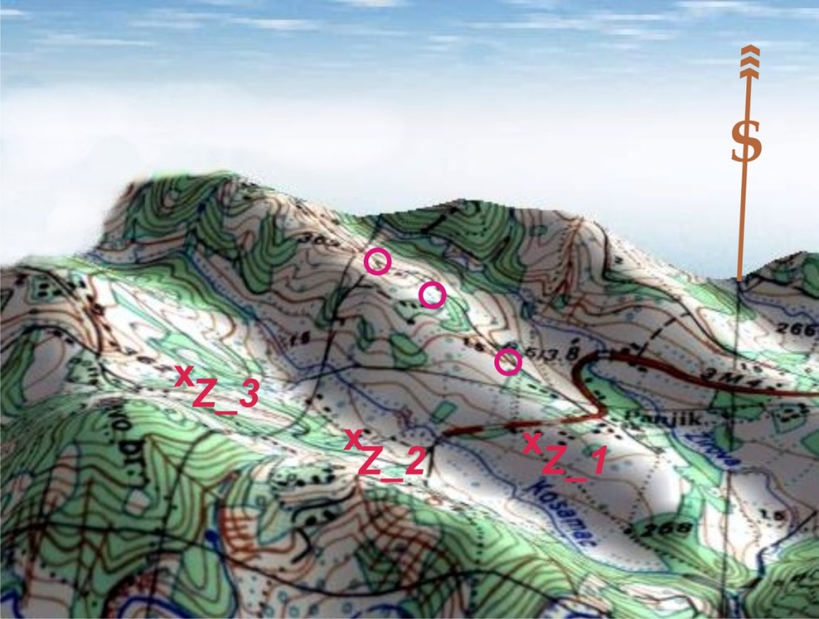
Figure 2.b

In fact, the prosecution expert put himself in an untenable situation, since FP allegedly found with "high probability" in the area of the hamlet Panjik. Because of this "discovered" FP cannot provide the angle of descent ≥62⁰, the next only firing positions, on greater distance, can be found the west and northwest.

Ignoring the topography, prosecution expert has done it, by choosing positions XZ_2 and XZ_3 (Figure 2.b) located in the heart of the sign X denotes also the place of FP on the map, and also where the Firing Positions for the 130 mm M46 can't be put.

The choice of FP toward the northwest (FP indicated by red circles) is shown as extremely inconvenient - already at 260 m distance from the intersection of roads in the hamlet Panjik altitude over sea level is 300 m, and distance when firing from these position hardly exceeds 27 100 m. Such OCH requires reducing distance of firing for the next 150 m - 250 m, thereby reducing the corresponding Angle of Fall of the projectile that falls significantly below the value of the 62⁰

After bridge on Kosamac river, a gravel road continues from where FP is the only accessible if you bridge the ravine which is occasionally filled with water, which is impossible without adequate bridge. If continued in the same direction, provided that the tractor-trailer combination of 130 mm cannon, 21 m long, crosses the bridge over the ravine through on this road north-east of the hamlet Muševina, should continue to break through the forest without appropriate roads. This forest in 1987. was classified as a 10 / 0.2 / G, which means that the average diameter of trees was 20 cm, height 10 m and that it is dense forest.

It is natural to expect that for 7 years the forest increased in height and diameter of trees. It was not cleared, indicating its present condition. From the tactical point of view setting such a position with enormous physical difficulties related to this action is meaningless except as a last resort which, in this present case can not be proven.

As far as FP, which is at a distance of 27 480 m, at a bearing ≈272 °, in relation to the alleged point of detonation, it was possible to set it there with great effort and engineering troops work, but it was impossible to fire from it because it is directly in front of the high woods and on the front slope. It is tactically impermissible and utterly unnecessary adventure for which there is no justification. In the end - it is easy to check that in this area has never been any firing position, because the inhabitants of the hamlet Muševina, village Mičijević would very well remember, and place of the gun shelter would still be well visible.

Since the expertise ("Analysis of the circumstances that led to the massacre of the people in the 'Kapija' square on 25th of May 1995 at 2055 hours"), repeatedly handled probability distribution function and its moments in a malicious way, here should be shown that this is a game with this function, which is built on a random event (the alleged hit of the projectile) and that it does not specify what is the probability of some set of hypotheses.

What is prosecution expert telling us here?

According to him, the evil maleficious cannon department which, by the way, over a period of one year, sent its missiles with the spread of 1/10 Vd on the market „Kapija“ turned into a bunch of ignoramuses who seized artillery and they do not operate sighting device for obtaining appropriate firing elements, but they would rather push 8-ton weapon on the field to get what prosecution expert needs, changing the distance of the firing position for almost 400 meters without changing the elements of fire, i.e. FP placed at a distance of 27 480 m from the alleged target, firing with the elements which correspond to topographic distance of 27 100 m or even with those that correspond to topographic distance of 26 720 m, so that the entire upper, with relation to the center of dispersion, half dispersion outsourced to 4 or even 6 through Vd in front of or behind the target.

By placing FP at subject firing conditions, at a distance of 26 720 m from the alleged target on „Kapija“ square may, in praxis (and the theory of firing) very correctly, in the area of the target expect 50% overshoot and 50% underperformance in interval of 27 100 ± 306 m (± 4VD), in given conditions. When Fp is placed at a distance of 27 100 m, a new path is calculated, which is equal to Vd = 80 m, and is now expected to overshoot 50% and 50% underperformance in the range of 27 100 ± 316 m (± 4VD) . And finally, with the FP, which is at a distance of 27 480 m, the same applies - it is expected to overshoot 50% and 50% underperform in the range of 27 480 ± 324 m (± 4WD).

Where did prosecution expert get his enormous probable deflection by distance, Vd, of 90 and 95 m is nowhere explained, but can be seen in Chapter 3.)

It is true that this deviation may in praxis be higher than the Tabular ones with firing regime that is close to the maximum, at extreme temperatures, dust, sand or gross negligence of crew, but such conditions can't be proven here.

Dispersion of points of detonation of projectiles related to center of impact (mean trajectory), like all other elements of the trajectory, which belong to this and only this median path and not other. So FP places do not disperse around median path. FP is where it is and only with one hypothetical FP we can explore the probability of hitting of possible, arbitrary small intervals inside which are points of explosion.

New FP distancing from the target results in a new value of Vd (E_{R}), requires a new trajectory and its calculation, has different initial elements, different probable deviations, and all other elements of the trajectory, so the position can again and again again be moved until it is completely relocated outside
of the maximum range in specific firing conditions.
On the other hand, square "Kapija" explosion occurred and it is beyond any doubt. But if the explosion is interpreted as an explosion of artillery projectile 130 mm, then wherever FP was event occurred (overshot Golf Mk1 and explosion next to the car), which has very small probability.

No matter how this probability was small by its value, it was the largest individual probability of all other hypotheses about the possible distance of median trajectory from the alleged point of detonation that we can set. This, at the same time, means that after the explosion, which is interpreted as an explosion of artillery projectile 130 mm, most likely place of firing position (FP) was at such a distance from alleged point of detonation where, in real terms, elements correspond with which it was allegedly fired. Any other FP position, within certain limits of ± 4VD and ± 4VP, is possible but the probability that it is is rapidly decreasing, because with every change of distance all the parameters of trajectory also change.

Wherever the firing position was, in order to obtain the alleged "hit“, the elements should be specified with an incredibly high accuracy. To accept that such a hit was made with some of the projectiles which deviated from its median trajectory by ± 4VD or more, and after such parameters look for Fp, is highly unprofessional.
To calculate the probability of hitting commonly is used distribution function of the normal distribution, F(x), adjusted for the median probable error:

$$F(x)=\frac{ρ}{√π}\int_{–∞}^{x_{i}}{e^{-ρ^{2}∙x^{2}}}dx$$

gained via density of normal distribution $φ(x)$:

$$φ(x)=\frac{ρ}{Вд√π}∙e^{\frac{-ρ^{2}∙x^{2}}{{Вд}^{2}}}$$

or, If Vd is taken as the measuring unit:

$$φ(x)=\frac{ρ}{√π}∙е^{-ρ^{2}∙x^{2}}$$

function of such a form:

$$F(x)=\frac{ρ}{√π}\int_{–∞}^{x_{i}}{e^{-ρ^{2}∙x^{2}}}dx$$

where ρ = 0.4769 (constant), x_{i} represents the upper limit of the required calculatory interval measured by probable deflections by distance (direction) depending on which probabilityis currently calculated,, while x represents the distance of individual random trajectories in relation to its mathematical expectation (mean path), also measured in the probable erors in range (direction) - cannot be expressed through elementary functions, so these types of tasks are solved by numerical integration or the value of the function is given as tables of probability value, and are found mainly in documents such as Firing Tables and manuals for artillery officers. In the literature there are plenty of records for the distribution function, above all primarily derived function by Laplace (probability integral) for median probable error, F * (x), such as:

$$Ф^{*}(х)=\frac{2∙ρ}{√π}\int_{0}^{x}{e^{-ρ^{2}∙t^{2}}}dt$$

so, during calculation it is necessary to have in mind that:

Ф*(х)= 2· F(x)−1
and:

F(x )=$\frac{1}{2}+\frac{1}{2}$ Ф*(х)

After all, the value of Tables of integral probability can be found in any textbook on the theory of probability, as well as on the Internet, and sources need not be mentioned.

Here, however, there is no need for numerical integration or for tabular interpolation.

The hitting probability problem with which we meet here is extremely well known in the praxis and it is very often seen. When an elemental target, D, is of small size in relation to the probable deflection (less than or equal to 0,5 -1 probable deflections in the direction of axis of the spread, (in the present case is much smaller, i.e. 0.0125 Vd and 0.045 Vp)), the probability of it being hit can be quite accurately determined even without the use of probability integral:

As:
$$P\left(\left(X,Y\right)⊂D\right)=\iint_{(D)}{f(x,y})dxdy$$

where P ((X, Y) ⊂D) - the probability that the median path by the distance X and direction Y does not come out of line dimension D target, then it follows immediately:

$$P\left(\left(X,Y\right)⊂D\right)=f\left(x_{0,}y_{0}\right)\iint_{(D)}{dx dy=f(x_{0,}y_{0}})S_{D}$$

where (x0, y0) is some point within the area of D and Sd is surface area of D. Area of D, Sd, due to the limitations of its size, can be viewed as an elementary surface Sd = dxdy, and the calculation of probability, in this case, comes down to calculating elements of probability. After a short transformation by replacing the density function of normal distribution in the plane $f(x_{0,}y_{0})$, the function derived for the median probable error, we get:

$$P\left(\left(X,Y\right)⊂D\right)=\frac{{ρ^{2}S}_{D}}{Vd⋅Vp∙π}∙e^{- \frac{{ρ^{2}x}_{0}^{2}}{{Vd}^{2}}-\frac{{ρ^{2}y}_{0}^{2}}{{Vp}^{2}}}$$

However, the probability of hitting the respective target D, P (D) is calculated directly, because prosecution expert determined possible distance of the mean trajectory from the target (mathematical expectation of that distance) in the range of ± 4VD = 380 m. How could he get that, is a totaly different matter, and can be seen in Annex No. 2. From this it immediately follows that:

$$P\left(\left(X,Y\right)⊂D\right)=P\left(D\right)=\frac{ρ^{2}∙1}{77⋅11∙π}∙e^{- \frac{ρ^{2}∙{380}^{2}}{{77}^{2}}-\frac{ρ^{2}∙0^{2}}{{11}^{2}} =}$$

$$=0,00008548∙e^{-5.53996}=0,000000336=3,36∙{10}^{-7}$$

From the Theory of firing it is known to be likely to hit at least once, P1, firing N times, is equal to:

$$P_{1}=1-{\left(1-P(D)\right)}^{N}$$

or:

$${\left(1-P(D\right))}^{N}=1-P_{1}$$

so needed number of fired projectiles, N, equals:

$$N=\frac{\log\left(1-P_{1}\right)}{\log\left(1-P(D)\right)}$$

For P, we take 0.95, which means we are looking for needed number of projectiles N, so in these conditions we would get at least one hit with 95% chance :

$$N=\frac{\log\left(1-0,95\right)}{\log\left(1-P(D)\right)}=8924626.6≈ 8 924 627 projectiles$$
To hit with a probability of 95%, one should fire 24 451 projectiles every day from May 1994 until May 1995, and 61 times each day drive the weapon for a general overhaul that would have changed the barrel.

By numerical integration or by using the computer program MATLAB or MATHCAD, almost identical results are obtained, P(D) = 3.37 x 10⁻⁷, which is not surprising since the upper, simplified form, belongs to A.N. Kolmogorov and his famous calculation method of firing efficiency of elementary targets. (Page 359.-367. of textbook "Theory of Firing of the field Artillery", Leningrad - 1966, and is located in the famous book and E.S. Ventceljʹ: " Теория верояатностей" Moscow 1962, page 157.-158. and 195.-196.) as well as in reprinted in year 2000.

This result, at the best artillery praxis, sets hitting the target D in the set of practically impossible events, but also this result raises the same event and theoretically in a collection of impossible events, but it clearly shows: either FP was not there, or if it was there hitting the target could not have happened.

If the above statement is denied, it refutes the principle of practical security (certainty), under which virtually impossible and practically certain events are introduced as axioms in probability theory, theory of measurement errors, statistics and other disciplines to modern particle physics. The aforementioned principle plays a major role in the theory of probability; on it are based all the practical applications of that science.

This principle states:

If the probability of a Q event in a very large number of experiments, E, is very low, it is possible to practically certainly argue that when performinng the experiment E once, a Q event will not happen.

If such an empirically derived probability of event Q in a given experiment is very small, approaching the experiment we organize our actions as though the event Q impossible; so we do not count on the possibility of its occurrence.

People, quite unconsciously, constantly use this principle in everyday life; they organize their journey by trains as railway accidents do not occur, although some very small probability for it exists, regardless of the probability of railway accidents is much, much greater than the probability that a particular trajectory deviates ± 5VD, where in entire civilization praxis, to our great misfortune, the number of fired artillery projectiles is much higher than the number of railway departures.

Every branch of human activity associated with the mass phenomena that have stochastic character has its own, scientifically proven many times, definitions of practically safe and virtually impossible event. Thus, for example, in most of the firing theory, from whatever part of the world they originate, is the scientifically based practical determination based on the limit theorems of probability theory and measurement errors (Bernoulli, Moavre, Laplace's, Chebyshev, Poisson's, Markov, Bernstein etc.) which reads as follows:

"If the mean trajectory (mathematical expectation of a distance of center of impact) is moved relative to the target by more than ± 4 Vd, the target will not be affected by artillery fire no matter what amount of missiles was fired."

In several firing theories written in extremely high mathematical level, with which, in terms of understanding and reinterpretation, even graduates who study pure mathematics have problems, figures somwehat stricter interval of deflection of median trajectory from the target of ± 5 Vd, which means that, with such a deflection of median trajectory, practically (and theoretically) hitting is almost impossible event, and just with such deviation of the mean trajectory from the target we meet in the expertise by prosecution expert.

We need to add a few additional explanations: hit probability, in the subject case, in reality is much less than the above calculation, because it is obtained under the assumption that the situation does not change the tube until it fired a specified maximum number of projectiles with full charge, and it is naturally impossible.

Otherwise, if the barrel of the 130 mm M46 gun changes periodically, after every 400 rounds fired missiles at full charge, then comes a situation where the number of missiles fired exceeds the number 200. After that, when firing the next 200 missiles until new change of the barrel, not from one of subject FPs a projectile cannot even reach the alleged point of detonation.

Thus, the results of the calculations do not take into account that the normal firing at full charge tube changes, while at the same time, the median trajectory continuously moves by the distance approaching to the cannon; however, although the probable deviation due to wearing of cannon tube is constantly growing, also there is constant changing and by reducing the probability of hitting it approaches theoretically completely impossible event as, say, hitting the city of Vienna, with a stone thrown by a human hand from the area of Budapest.

The probability of hit with one shot, which requires daily firing of 24 451 projectiles (68 hours a day rapid fire ???) for a period of one year, from May 1994. to May 1995. to have at least one hit with 0,95 probability, but for that to happen, one should (impossible), i.e. should be able to 61 times a day change the tube, and in fully equipped workshop with the necessary professional staff it takes more than 4 working hours, and this result shows all the groundlessness of the method used by the prosecution expert to determine the sites of possible firing positions.

Also, one should always have in mind that it’s not artillery brigade, or division, or battery or platoon doing the firing – a single gun is firing, so one should not count on significant increase in value of spread.

With the previously given remarks about the inability to toss to the finish line after 200 rounds fired at full charge, the above calculation shows how practically and theoretically absurd and unreal was assertion and calculation by prosecution expert that the distance of the FP was:

Xvp = 27 100 ± 380 m.

From the point of view of anyone that looks at subject tragedy in Tuzla on 25.05.1995, under the conditions as specified in the court documents, one views theoretically and practically impossible event. Particularly interesting are the numerous contraindications related to the subject car Golf Mk1.
Without it - hitting the space in front of the "NIK" is a very probable event but human losses are unusually large. With this car at the scene everything that happened is an impossible event; and can't be attributed to the explosion of artillery projectile - people survived, even without serious injuries, at a distance of 2 m from the center of the explosion, almost undamaged car and projectile flew over car body with an Angle of Fall that is both practically and theoretically, impossible to get.
In the bibliographic data for the card, on the first page of prosecution expert’s expertise, entitled "Summary," says -quote:
unquote!
and on page 93. of the same expertise, entitled "Conclusions" reads -quote:
-unquote!

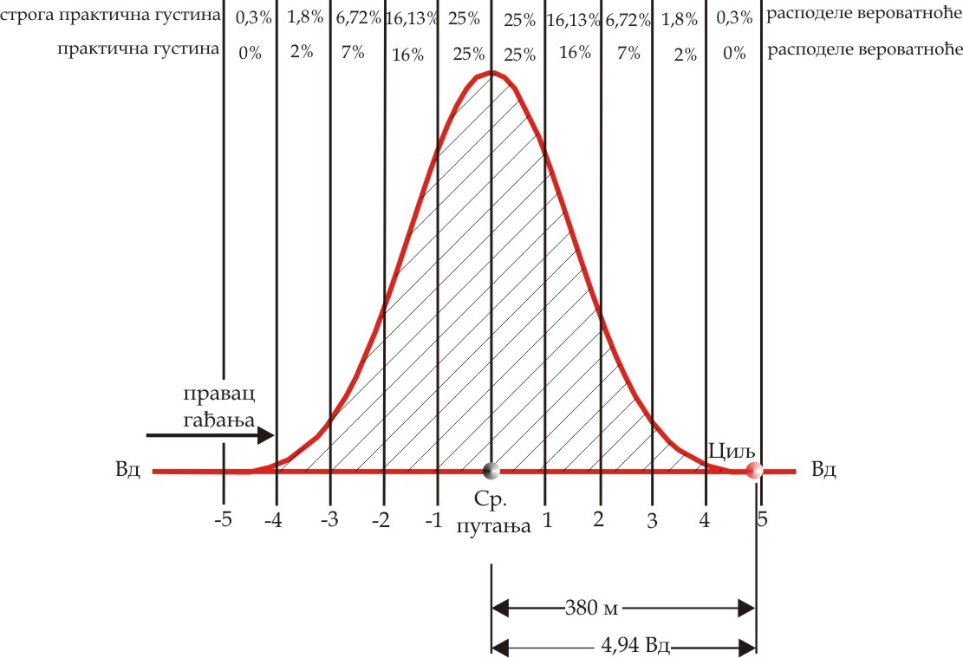
Figure 2.c

This means the following:

Firing position was probably at a distance of about 27 100 m. Since there is natural dispersion of hits, FP, too, could have been at a distance of 26 720 m from the alleged point of detonation, but also at a distance of 27 480 m. Nowhere prosecution expert did explain what are the possibilities for such conclusions.

Up has been shown what are the possibilities that this happens if the FP was at a distance of 26 720m.

Figure 2.c approximately illustrates a situation in which was carried out the previous calculation of probability to hit when shooting with the one position that the prosecution expert allegedly "discovered" with "high probability" and the distance of which from the alleged targets equasl to 26 720m.

When firing in the actual firing conditions at the distance of 27 100 m Vd = 79.8 m≈ 80 m, Vp = 12 m and the median trajectory is on the center of target Vd, so the probability of hitting PD₁ in one shot is in these conditions:
$$P\left(D_{1}\right)=\frac{ρ^{2}∙1}{80⋅12∙π}=0,0000754=7,54∙{10}^{-5}$$
from where, to achieve at least one hit, it is required:

$$N1=\frac{\log\left(1-P_{1}\right)}{\log\left(1-P(D_{1})\right)}≈39718 projectiles$$

which requires firing of 109 projectiles a day every day from May 1994. until May 1995., for such an event to occur at least once, with changing the barrel twice in one week. This is also the most favorable case for the prosecution expert, but from a position at that distance cannot be achieved Angle of Fall Θ ≥62⁰, but only the Angle of Fall which is such that Θ = 59.7⁰, and with such an angle of fall Golf Mk1 car would be hit from above.

With the topographic firing distance of 27 480m, Vd = 82 m, Vp = 12 m, the distance of mean trajectory (center of impact) was at a distance of −4,634 Vd (380/82), so:

$$PD_{2}=0,0000484=5,56∙{10}^{-7}$$

$$N2=\frac{\log\left(1-P_{1}\right)}{\log\left(1-4,84·{10}^{-7}\right)}≈5 385 619 projectiles$$

so, 5,385,619 projectiles need to be fired, or 14 755 projectiles a day every day from May 1994. until May 1995., so that such an event with a probability of 0.95 could occur at least once, with the replacement of the gun barrel 37 times during the day. And if this event happened, Angle of Fall which, in these conditions, Θ << 620, would cause hitting the car from above.

In accordance with the praxis, deflections over 4 Vd are considered serious precedent and are treated as practically impossible (extraordinary) events that are subject to rigorous investigation!

Since there is no operational firing position at a distance of 27 480 m from where the firing would be done, and that, due to the altitude of such potential firing position of over 340 m, Angle of Fall was less than that defined by the prosecution expert witness (62⁰), hitting the subject place by firing from such distances, with conditions set by prosecution expert, represents – an impossible event.

At all lower distances of firing position, Angle of Fall is much smaller than that defined by the prosecution expert (Θ <62⁰), and obtaining described subject „hit“ by firing from those distances, in subject circumstances, as set by prosecution expert, is also - an impossible event.

Now it is possible to form three capital premises:

I. From each Firing Position that was at a distance of, alleged point of detonation of projectile projectile on „Kapija“ square, 27 100 m up to 27 480 m, at a given azimuth direction from which the alleged projectile flew, which is in the range of 268.5⁰ to 273.5⁰, and the given state of the atmosphere, weapons and ammunition, it is possible to shoot at each point in the square „Kapija“.
II. From neither one firing position distanced from the alleged detonation point of the projectile on the square „Kapija“ of 27 100 m up to 27 480 m, at a given flight direction which is in the range of 268.5⁰ to 273.5⁰, with given state of the atmosphere and weapons and ammunition is not possible to obtain the required minimum angle of descent ≥ 62⁰, which would allow to throw over car Golf Mk1, let alone find the Angle of Fall which would satisfy the requirement by the prosecution expert „likely that this angle was greater for a couple of degrees".
III. In the interval of topographic distance of 26 720 m up to 27 100 m, Angle of Fall of projectile Θ, is always considerably smaller than 62⁰, Θ << 62⁰, so the firing can't throw the projectile over the subject car.
From here, it follows unequivocal:

EXPERT FINDINGS

The subject trajectory which could throw the projectile over the Golf Mk1 car with Angles of Fall of 62⁰ or higher does not exist in given topographic conditions, with given state of weapons, ammunition and atmosphere, so subject firing was not performed from any firing position, nor at any firing azimuth, on any firing distance specified by the prosecution expert, and therefore consequences of the explosion in the „Kapija“ square cannot be caused by any action of firing a projectile.

3. ANALYSIS OF "KAPIJA“ CASE FROM TOPOGRAPHIC-SPATIAL VIEW

Other than aforementioned, the basis for this analysis are:
Topographic map 1:25 000 Doboj, 425_3_4;
"Sketch of the crime scene site" made by crim. technician Irfan Džinović, "Sketch of the crime scene site" by inspector of CSB Tuzla nedim Mutapčić, as well as the documents of the prosecution in this case, and in particular the analysis of the prosecution expert.

By careful consideration of documents from available court records it is possible to establish that in this analysis of the prosecution at least 6 huge groups of mistakes were made:
1. Arbitrary using of variables needed for reconstruction and ballistic calculation as well as manipulating the crucial evidence;
2. Complete ignorance about the procedures concerning artillery fire in praxis;
3. Showing impossible events as possible or even very likely to happen;
4. Negligence of important ballistic parameters needed for exact calculation of the projectile trajectory, and completely ignoring of crucial topographic parameters;
5. Forging of key variables crucial for ballistic calculation;
6. Contradictory use of colloquial terms, methodology apparatus and use of measuring units which are inadequate for given physical processes and phenomena.
According to existing documents, circumstances and relative to the terrain, topographic ̶ and spatial as well as from balistic standpoint the mentioned prosecution assertions are completely unfounded, arbitrary, unproved and therefore unsustainable.

It is easy to prove, opposing following statements from prosecution expert:
1. In the table (Figure 88) states: "Normal conditions y0 = +30 m" – unquote; which should mean that the Firing Position was above the PD of the projectile +30 meters. It also writes under the table in the text, quoted: "taking into account that altitude difference between the firing position and the explosion" - unquote.
2. In the table (Figure 90), he also says: "Normal conditions y0 = +30 m" ̶ unquote, which confirms the information, set forth under 1;
3. Immediately below is ̶ quote: "Taking into account the influence of the atmosphere and other parameters and the position of the FP was above the explosion of about 30 m, the minimum distance of the firing position (position slightly behind Panjik village is marked with an asterisk) is:
X_{VP}= 27,100 ± 360 m“ - unquote
4. Seeking the place of the alleged firing position, the prosecution expert says ̶ Quote: "When considering the possible start zone from the fact that guns dragged from trucks or tracked, that their mass in a marching position around 8000 kg and therefore firing position must be close to the road, it's easy access and firm ground." - Unquote.
5. In its concluding comments, on page 93 and 94 of its expertise, expert says prosecution-cited: "The Guns of 130 mm M46 are weapons that are pulled by trucks or vehicles with caterpillars. The mass of weapons is around 8t, so they can be transported over very firm ground and firing position must be close to the road."
"Taking into account the known data on the projectile, impact angle, supposed atmospheric parameters as on May of 25th 1995, taking into account the position of the firing position was above the explosion of about 30 m an trajectory path was calculated using 3-DOF software to determine the minimum distance of the firing positions, and it is:
X_{VP} =27.100±380 m.
"With the topographic maps of region, in a particular area and the azimuth range of 271 ± 2.5, one can clearly see that that in the immediate vicinity there is only one road and village called Panjik." - Unquote.
Despite the fact that in two places (including 5 places) exist the phrase "about 30 m" which refers to the height of the firing position in relation to the plateau of the "Kapija" square, all calculations are performed by the prosecution expert with an input variable which had altitude difference of the Firing Position of true +30 m in respect of the alleged detonating point (hereinafter PD) and the word "about" completely loses its meaning. Reasonable people would accept that the term "about 30" may represent values ranging from 25 to about 35, but "45", "106" or "197" can't be interpreted by the term "about 30".
During cross-examination the prosecution expert claims once again: cited: "Yeah look, we are calculate here for different launch angles 38, 39, 45 degrees is not it, to determine which are the angles of fall to the obstacle based on the fact that the weapon was 30 meters above the horizon of the explosion ... .. "- Unquote.
Only two paragraphs earlier in the same transcript reads: "No, no, if you are well studied what I wrote I am a very careful person you have never seen in any exact to say it must be so, and I have said azimuth is in the range of 268.5 and 273.5 that to say the range of azimuth was firing position weapons and I drew it and I just said that there likely means probable zone of the village Panjik never said launch zone village Panjik that's a big difference."- Unquote.
From the above given oral and written statements we can directly derive four following irrevocable prosecution claims which have the force of ultimate condition "sine qua non":

A.) The FP from which "Kapija" square was allegedly targeted was in the sector limited to the North with azimuth of 273.5⁰ and 268.5⁰ South, and distances: minimum 26 720 and maximum 27 460m, i.e. in the range 27 100 ± 360 m. (From where occurs, in the conclusion, the statement 27 100 ± 380 meters will be discussed later, it is already here and now an insignificant difference);

B.) The alleged firing position exceeds the alleged PD to 30 meters;

V.) In the vicinity of the said firing position there must be a road, very solid ground and easy access.

G.) For the first three conditions resulting fourth whose character is essentially ballistic, i.e. the minimum angle of fall (hereinafter AoF ) of 62⁰ (per module) who the expert prosecution marked in the subject case.

These conditions are very closely interrelated and any possible absence of any of these individual conditions removes any remaining and so jeopardize the general assertion.
Excerpt N^{O} 1.
Met. Cond. N^{O} 2, у0 =30 м | QE | Time of Flight | Term. velocity | Angle of Fall | Range | Max. ordinate | Deflection
Met. Cond. N^{O} 2, у0 =30 м | 40 | 80,942 | 346,79 | -61,3761 | 26937,8 | 8203,9 | 43,0
Met. Cond. N^{O} 2, у0 =30 м | 41 | 82,594 | 348,31 | -62,0980 | 27128,2 | 8518,9 | 43,8
Met. Cond. N^{O} 2, у0 =30 м | 42 | 82,236 | 349,85 | -62,7924 | 27301,8 | 8836,2 | 44,6
Incompleteness of some of these statements ̶ conditions significantly changes the other and so endangers the general prosecution hypothesis that the tragic event at the "Kapija" square is caused by the explosion of the 130 mm M46 projectile in the present topographic and spatial conditions.
There is no defense that would be able to shake some of these statements as hard as the prosecution expert. He did it himself and thereby does that very effectively. Thus, e.g. Prosecution expert says - quoted, Excerpt N^{O} 1:
Range=27 128,2 m; AoF=62.028⁰
On the other hand, writting about the AoF, in its expertise, prosecution expert says - quote:
"Since it is a boundary angle, and really this type of projectile is gyro stabilized system and rotates very rapidly about its longitudinal axis and thereby performs the motion characterized with precession and nutation, it is more probably that the angle of descent was higher for a few degrees." – Unquote
From the above statement emerge two undeniable conclusions:

Conclusion No. 1) To obtain an AoF equal to or "a few degrees higher" (per module) from the AoF of 62.098⁰ (displayed in the above table Excerpt Nº. 1), the distance (firing range) should be equal to or greater than 27 120 meters, and opposite, at distances of less than 27120 m, there is no the AoF (per module) equal to or greater than 62⁰. This is directly written by the prosecution expert.
Of course, the height difference must remain unchanged i.e. +30m.

Conclusion No. 2) Being that expert prosecution broken down his own previous statement, (in A), that the firing position was at a distance XVP = 27 100 ± 360 m, this claim is also to be treated as invalid and the next possible firing positions should not be sought at distances of less than 27 128 m respectively of the alleged PD. On the basis of the claims of the prosecution expert the firing position could only be within the interval denoted as XVP = 27 100 + 360 m.

Why did the prosecution expert seek the firing position and allegedly found it "with high probability" outside the sector which he itself defined, and at an altitude difference respective to the alleged PD which is +45, remains unexplained and may be interpreted, mainly, only one way.

Because of the apparent contradictions that the prosecution accepted, according outlined here, the sector, in which the firing position allegedly was, should be changed. The new sector should be sought within the area bounded by: south azimuth of 268.5⁰, north azimuth 273.5⁰, and within the distances of 27 100 and 27 460 m, respectively.

Again: also in this newly-defined sector the altitude difference must remain unchanged i.e. should be +30 m for the ballistic calculations of the prosecution expert to remain at least a little authentic and conditions (A to G) at least partially fulfilled.

In the data for bibliographic card, in the very beginning of his analysis, prosecution expert claims that „Kapija“ square was shelled from the area of Panjik hamlet from the distance of aroud 27100m. Then, on ~20 pages of text claims that it could be, as follows:

26500m, 26720m, 26740m. 27100m, 27480m, and, judging by conclusions, from the distance 27100±380m (mentioned analysis, page 93, number 13), but yet again from Panjik?

Eventually, during cross-examination, he claimed that „probable firing position“ was hamlet Panjik.

Why if the position of that toponim doesn’t suit the conditions defined?

Panjik, firstly, is not a village, even though its residents managed (true - for a very short time) to make it a municipality. It is a hamlet belonging to village Vasiljevci.

Area of Panjik hamlet is less than 120ha and in the west its border is river Kosamac.

Therefore it is justifed to ask where are the distances of mentioned FP, while being in the mentioned hamlet?

Any FP at a distance greater than 27 000m in relation to „Kapija“ square is out of Panjik boundaries!

This will later be shown.

Prosecution needed a hard road and appropriate ground for FP. Only such road is in wider area of Panjik hamlet.

The second solid road, in sector which prosecution expert marked, is in the area of Muševina hamlet, village Mičijevići, but it is almost impossible to find and adequate FP there, and even if it were possible, that FP would be higher than “Kapija” square at least 4 times more than what prosecution expert used in his calculations.

In the south another acceptable road exists with hard base in the area of Tumare village, but possible firing positions next to that road are over 400m above msl, which is at least 6 times higher than what prosecution expert used in his calculations.

Sector marked by prosecution expert had a width of 2397m, while looking at it in north-south direction. In such a marked region are also parts of villages Vasiljevci, Kosa, Mičijevići and Tumare.

Aware that from region of Panjik hamlet he couldn’t provide needed angle of fall Θ, Θ≥62⁰, prosecution expert widens that sector to almost 2km², but still in his conclusion claims that “Kapija” square was shelled from Panjik hamlet.

Prosecution expert doesn’t even look at the terrain and topography; wherever 130mm cannon FP were, no matter how far from “Kapija” square and alleged PD it was, it is always at the same height and it is always in the Panjik village region.

Now we need to look at the appropriate topographic map and the information that can be obtained using the same map.

Short data about maps used here:

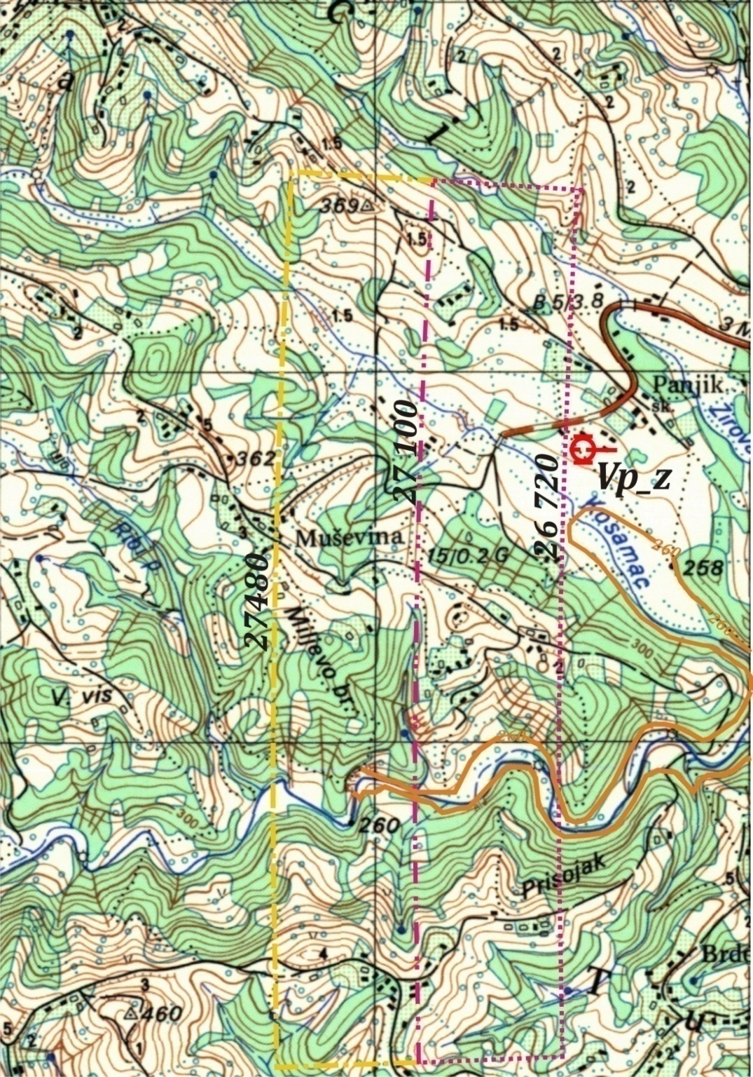
Figure 3.1. The spatial situation described by the prosecution expert: - Bold orange line - 260th contour line +31 m above the square "Kapija", Vp_Z - Firing position which prosecution expert allegedly found "with high probability" and marked on the map, neon red dotted line - an arc distance of alleged PD within distances of 26 720 to 27 100 m, respectively.

Figure 3.1. clearly shows:

- For firing distance of 26 720 to 27 100, the points that have the altitude difference of +30 m in respect of the alleged PD at the "Kapija" square is entirely situated deep in the canyon of the Bukovica river and Kosamac river, without any possibility to drop the 8-tone heavy cannon at such altitudes. After all, it would take only a slight, physical effort, i.e. walking effort to check it out at the same time when looking for the firing position who an expert prosecution was allegedly found "with high probability"- this effort would be very fruitful, because if someone miraculously landed the relevant cannon at any of these points (intersection of 260th contour lines with distances depicted by the prosecution expert i.e. (within range of 26720 to 27128 m), the subject cannon would still be there, because in BiH there is no crane which could take it from there.

Where is: "the simple access and solid, firm ground?";
Where is: "over very firm ground and firing position must be near to the road?".
Where is the weapon that is: "+ 30" meters above the horizon of the explosion?"
Naturally it's not there. With an altitude of 300 m, a width of 200 meters north and south of the stream of Bukovica river the terrain fall to the river bed for over 50 meters. There is not any road, just a few fishing trails that descend to the level of water in the river. So, the sector described by the prosecution expert, in the interval distance of 26 720 m and 27 128m, should be completely rejected for two reasons:
† There is no place in the mentioned sector at a height of 260 m on which was possible to set a operational firing position of the 130mm M46 gun. That also means that the altitude difference of such a firing position can't be +30 m in respect of the alleged PD. These altitudes must be significantly higher;
† According to what prosecution expert himself wrote (see Excerpt No. 1), and according to what is presented here, there is no firing position at the distance below 27 128 m, assuming that the altitude difference of such a Firing Position was +30 m in respect of the alleged PD. This also means that the targeting in the present circumstances, isn’t possible with the given AoF of the projectile equal to or greater than 62⁰. (So, for now, two of the four conditions are not fulfilled).

When the part of the sector of the Figure 3.1. be accordingly thrown away (the lower part of the sector that does not meet the set requirements dotted drawn and colored neon red), and the lower limit of the upper sector at the same time be moved from 27 100 m to 27 128 m, we get a new image (Figure 3.2.) which clearly points out:

①At the bottom of the sector (at the distance of 27 128m) can be found only three places where operational launching site of 130 mm M46 gun could be set up, but their heights are as follows: north one 350 m, central one (Vp_1) 335 m (Vp_2) and south one 406 m (Vp_3), with corresponding altitude differences in respect to the alleged fall point at the "Kapija" square of +121, 106 and 177 m, respectively;

②Firing position which the prosecution expert allegedly found "with high probability" and marked on the map (Vp_z), remained outside the sector 463 meters in a closer way, but this FP is at the altitude of 274 m (+45 m above the alleged target). Taking this fact into acount, this FP must be irrevocably excluded out of further consideration, because it does not come into consideration as a real option.

Based on Figure 3.2. the each better artillery corporal in contract or junior sergeant would be able to make a brief analysis to estimate the firing elements, using only Firing Tables, paper and pen, taking primarily the position with the lowest altitude (Vp_2), which is also most convenient per prosecution expert. Taking Firing Tables, and after the order to assess the firing possibility at a range of 27 128 m, when the target is below of the cannon 106 meters, he should do the following operations:
Opens Page 298th of valid Firing Tables, and enters the Table XIb, where finds:
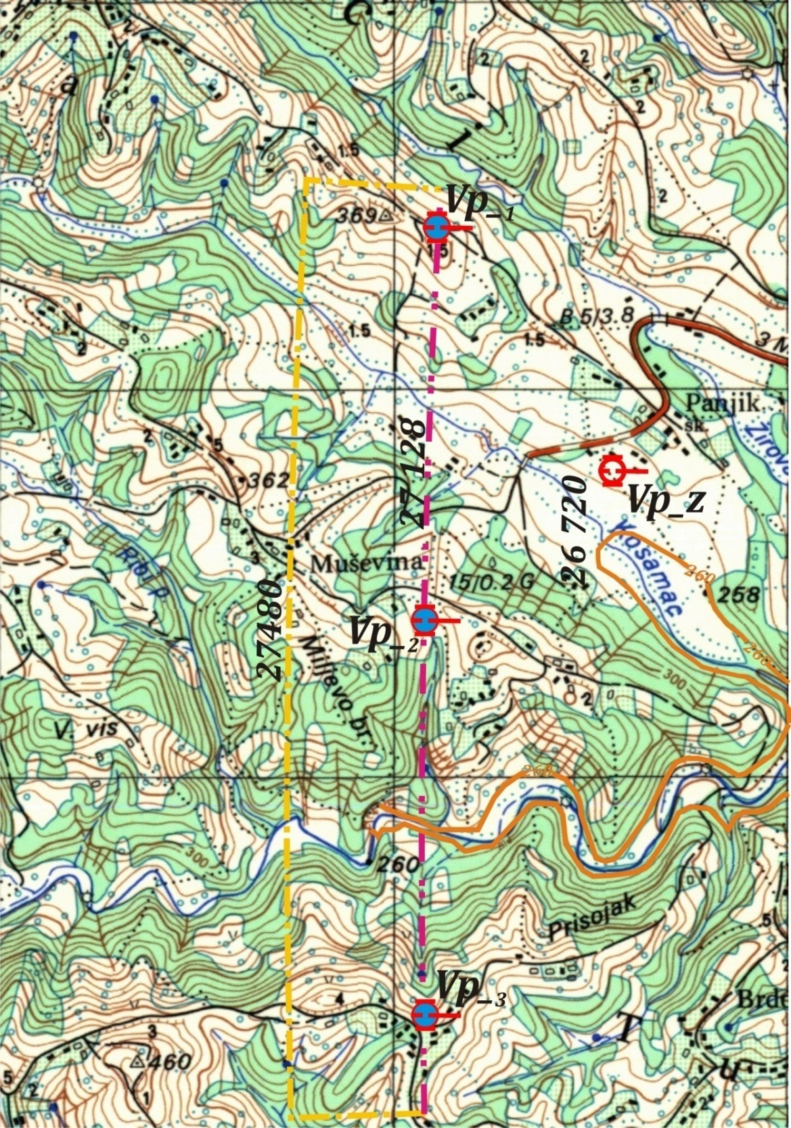
Figure 3.2. After discarding the sector that can't meet the conditions which the prosecution exper has set upt, a situation is obtained as in this picture.

❶ The firing position is above the meteorological station about 95m. The station, according to the prosecution assertation, broadcasted H=980mbar. At the height of FP, the table pressure therefore is 969 mbar or ≈ ̶ 31 mbar compared to the tabular distribution;
❷ By the Firing Tables, page 115th, for a distance of 27 128 m, the deviation in range because of the difference of the barometric pressure Δ H, Δ H = 10 mbar, amounts (187 + 2.6) ≈ 190 m, or 19 m for 1 mbar. From there it is: ̶ 31 x19 = ̶ 589 m. This results is an improved firing range D_{P} = 27128 ̶ 589 = 26539 ≈26540 m, then D_{P} ≈26540 m. Based on the rounded corrected distance D_{P} = 26540 m, we use the basic Firing Tables looking for the other corrections. These Firing Tables allow such a procedure, see Page 86. t.191. When the FP altitudes are over 250 m, fire control unit needs to use the Mountain Firing Tables to determine the elevation; for all other corrections the primary Firing Tables are valid. So finally QE is 680 mil, and Aof amounts, Θ=1029 mil or Θ= 61,7⁰!
However, because all of other corrections are negative the AoF will continuosly get smaller and smaller than Θ= 62⁰, and therefore, this calculation should be considered as complete.
❸The second FP at a distance of 27128m relative to the alleged PD is on a altitude of 350m above msl. By applying the procedure marked as ❶ the result will be as follows:
The FP is above the metheorogical station by 110m. The station was broadcasting H=980mbar. In position, therefore, was tabular pressure of 967mbar or ~-33mbar, so the difference in range is 33x19= -627m. Therefore, we get adjusted targeting distance of D_{a} = 27128 – 627= 26501≈26500m. By the basic Firing Tables, and angle of site, this distance corresponds with elevation of 671mil and angle of fall of Θ=10-22 or Θ= 61,3⁰!
❹ The third FP at a distance of 27128m relative to the alleged PD is on a altitude of 406m above msl. By applying the procedure marked as ❶ the result will be as follows:
The FP is 166m above the metheorogical station. The station was broadcasting H=980mbar. In position, therefore, was tabular pressure of 967mbar or ~-39mbar, so the difference in range is 39x19= -741m. Therefore, we get adjusted targeting distance of D_{a} = 27128 – 741= 26387≈26390m. Because of of the higher altitude of FP angle of site s, s= -0-07, so the real elevation is 658mil. This elevation corresponds with angle of Θ=10-14 or Θ= 60,8⁰!
❺ The FP at a distance of 27480m relative to the alleged PD is on a altitude of 425m above msl. By applying the procedure marked as ❶ the result will be as follows:
The FP is above the metheorogical station by 185m. The station was broadcasting H=980mbar. In position, therefore, was table pressure of 959mbar or -42mbar, so the difference in range is 41x20.5= -861m. Therefore, we get adjusted targeting distance of D_{a} = 27480 – 861= 26619m. Because of of the higher altitude of FP angle of site s, s= -0-07, so the real elevation is 679 mil. This elevation corresponds with angle of fall, Θ=10-29 or Θ= 61,7⁰!
❻ It should now compare the obtained data with the data from the table Excerpt Nº1.
The elevation of =41⁰ corresponds D_{GP}=27610m, while the prosecution offers for the same elevation a distance about 27128m.

The difference is about 482m just because the prosecution and its expert established the arbitrarily selected altitude difference between the firing position and alleged PD of +30 m, which proves to be physically impossible and unreal!

As mentioned before, the Firing Positions Vp_4 and Vp_5 (at the same distance i.e. 27480 m), have a much higher altitude. The AoF obtained by the targeting from these FPs become less than 62⁰, as confirmed by the calculations obtained by ballistic computer.

Total meteorological&ballistic correction of distance, in the considered case, is ̶ 840 m.

(In reality the correction due to the differences in altitude of the firing position and the target is also an meteorological correction).

Such an amount of mentioned corrections, which reaches even more than half a mile, does not confuse the prosecution expert (also the ballistic expert). During the cross-examination he declared in cold blood:

"Yeah look, we are here to launch different angles 38, 39, 45 degrees ate so, the calculation determine what are the angles of the point of impact in the obstacle and the fact that the weapon was 30 meters above the horizon of the explosion and I have asked the Hydro meteorological Institute of us to estimate what kind of drive parameters from the atmosphere were just for precisely not to play a major role but I took advantage of that system and I used the parameters of Firing Tables they allowed me to determine that the by the AoF of 62 degrees, about 62 the range was 27 km 128 meters, well that's it."

(Note: The above given statement is hardly corrupt considering also the native language, so it is hard to translate, but its meaning is quite clear.)

What would some measly 5⁰ differences in qudrant elevation mean something if we consider the cannon with a muzzle velocity of 930 m/s?

Consequently, even such a substantially reduced sector that an expert prosecution previously defined, as having more than half, does not meet the conditions set.

In fact, any of the spatial conditions set by the prosecution, hitherto, can't be met, especially concerning the AoF of the projectile and the height difference of the FP over the alleged target.

We needs to consider the possibility that the FP was at the most far Firing Table Range of 27 480 m, and still within the angular sector that was defined by the prosecution expert. Consideration of such features allows Figure 3.3.

The figure shows that at the maximum Firing Table Range of 27 480 m, (dotted ocher yellow line) is only one suitable place where is possible to set up a FP at the distance of 27 480 m from the alleged PD. (Figure 3.3.). This position is marked as Vp_4 and its altitude is 425 m.

The another FP near to such a distance, (labeled Vp_5) is located in the region of Miljevo hill, behind the remains of the former farm buildings. Its height is 375 m.

The remains of both farm buildings are on the back slope (subsequent pictures will show that in more detail) and this firing position can't be occupied.

Ocher colored arc that connects the points at the distance of 27 480 m in respect of the alleged PD, lies the west of these buildings - that is, to an even larger rear slope that does not allow setting the FP without enormous engagement of engineering units.

Such effort can under no circumstances justify one's effort to set the gun exactly at a certain point, i.e. just at a distance of 27 480 m, in respect of the alleged PD, although in the immediate vicinity there is enough space for the another firing position.

By setting the firing position eastern of the mentioned buildings would result in reducing the distance (about ten meters less than 27 480 m). This is not a big difference, so this FP (Vp_5) will be taken into consideration.

Figure 3.4. shows the topographic map 1: 25,000, applied to satellite derived elevation model (DEM or Digital Elevation Model), V = 83.4% Exagg.

If the FP is pulled back (to the West) just 10 m it will be at the significant rear slope of the terrain and could not be occupied, and for just ten meters to the East a FP distance would be less than 27 480 m for about 10 meters. Indeed, if the FP appointed to this position in advance of the building distance (eastern), would be 27 471 m distant from the alleged PD, as will be shown and computed.

And truly, if FP was set up to that place, in front of those buildings, distance would be 27471m from alleged point of impact, which will later be shown by calculation.
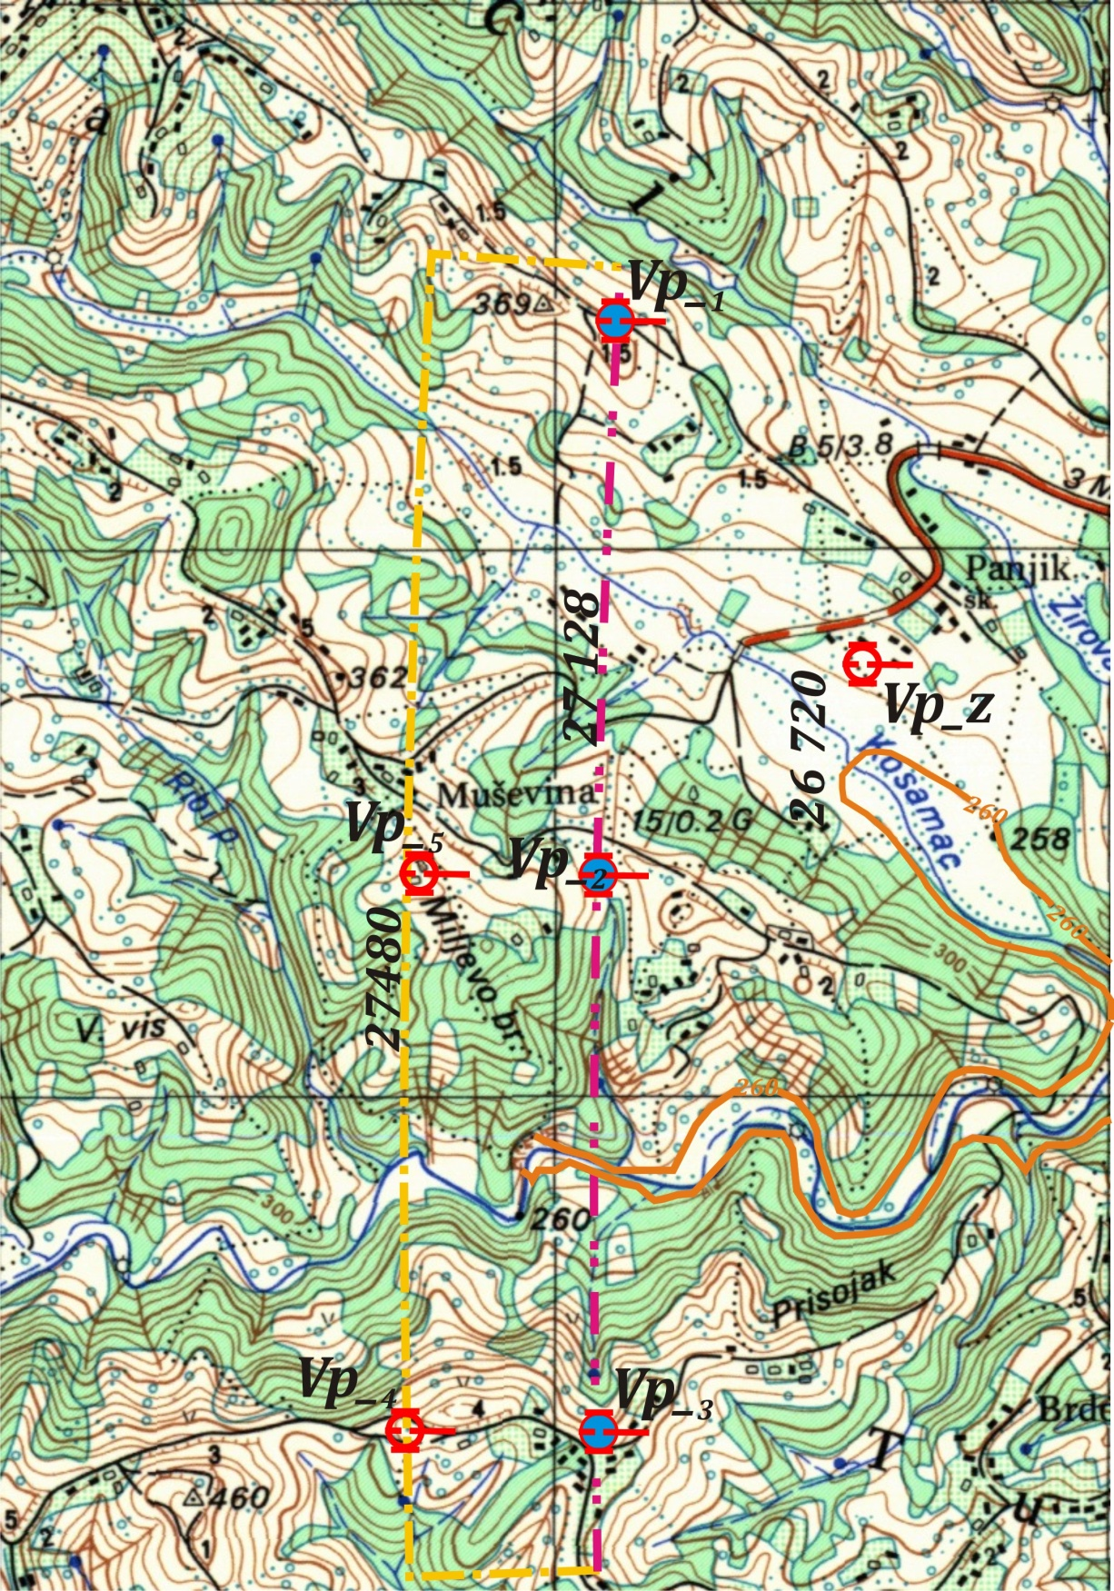
Figure 3.3.Firing positions Vp_₄ and Vp_₅ at the distance of 27 480(Vp_₄) and 27470 м(Vp_₅ ) in relation to alleged PD.
Just a careless look at the data offered by map clearly shows that on ocher line which connects all the points inside given azimuth range, and at a distance of 27 480m, simply there is not more than one place where one could set up an operational position of the mentioned weapon.

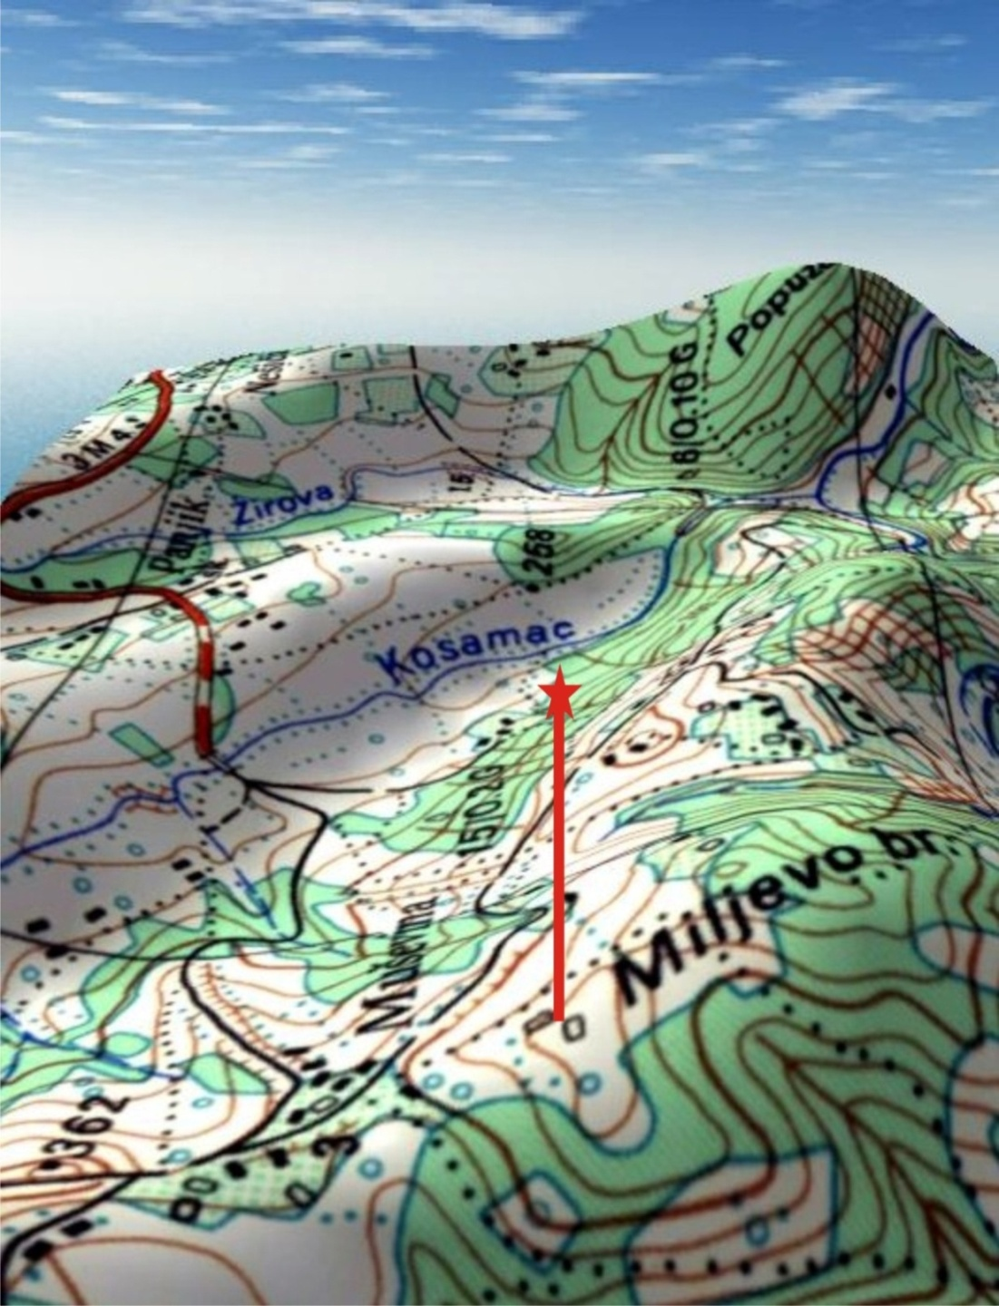
Figure 3.4. View towards the east (towards Tuzla) from the Miljevo hill. Direction East shows a red asterisk on top of the suspended rods. There are visible topographic signs for the remains of buildings. FP can't be on the buildings, or behind them, but only to the East. Moving to the West is not possible because the FP falls down on the rear slope .

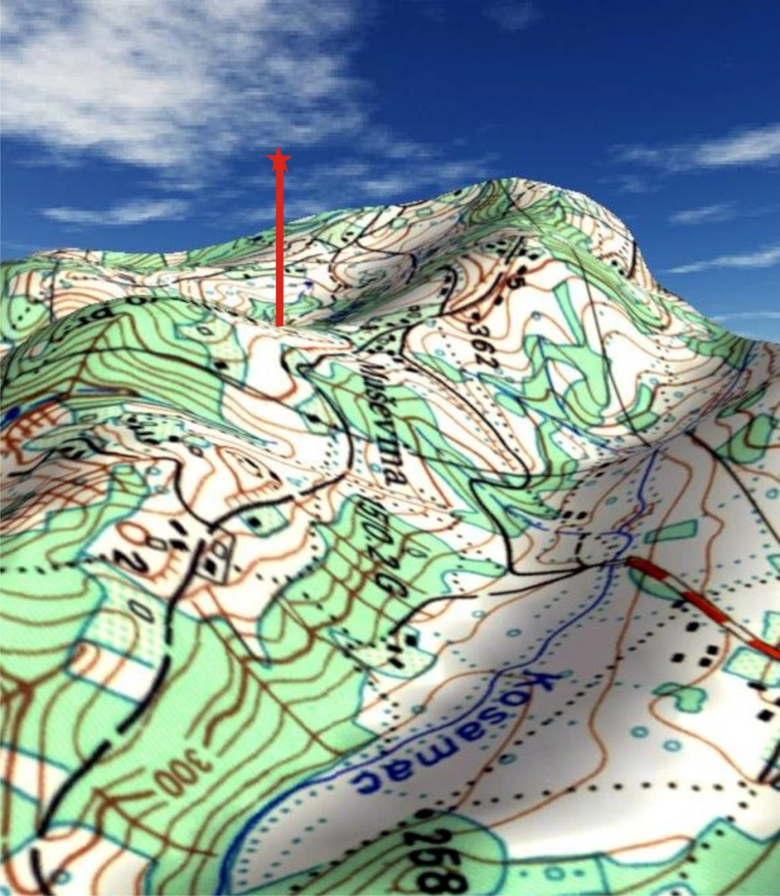
Figure 3.5. The same place with the previous image viewed from the east (from Tuzla to Ozren)

Figure 3.5. represents the same location as seen from the east (from Tuzla to Ozren), where it is obvious that the corresponding topographic signs for buildings here are not visible, because the FP position lies at the rear slope, and would have to move at least slightly to the East (from the asterisk to the observer), at the saddle between the peaks mp. 362 and Miljevo hill.
The map coordinates of this firing position (Vp_5) are as follows: N = 33 384; E = 26 752; z = 375 m, and topographic elements and elements for shooting as follows in Table 3.1-(following pages).

Figure 3._4_5 shows the upper limit of the sector in Figure 3.3, on the satellite image, with the Firing Positions (or FP) places belonging to the maximum firing distance. On the maximum boundary of the northern part of the sector at a bearing 273.5⁰ and at a distance of 27 480 m, is impossible to set the operational FP (the side slope ̶ 60 m at a distance of 225 m ≈ 15⁰ or 27%. For azimuth of 272⁰ and the maximum distance (27 480 m), the possible FP would be in the high dense wood and on the 16⁰ front slope, at the altitude of 325m - therefore, impossible to set, which is also true for all other FP marked as follows: 271_max, 270_max and 268.5_max, with two on the sharp rear slope, and the third deep in the Bukovica riverbed (270_max). The label "max" indicates the maximum topographic distance in relation to the alleged PD (27 480 m), and the number before the label "max" denote the corresponding azimuth from the alleged PD to the alleged FP, measured in degrees clockwise from the North. (See Figure 3._4_5).

Figure 3._4_5 This image combines data from previous figures. There is also Vp_5 shown, (completely confirms the facts obtained by Figures 3. 3, Figure 3.4, and Figure 3.5.). Vp_5 is obviously on the edge – displacement toward East, decrease the distance, to the West pushing the gun to the rear slope.
Figure 3._4_5 confirms the facts that are presented on a topographic map in Figure 3.3, Figure 3.4 and Figure 3.5, but they added a completely different dimension - view unburdened by unnecessary contents currently offered by printed material such as topographic map.
This is convenient for people who may not be familiar with the topographic material. On the other hand, the satellite image in Figure 3._4_5. (The snapshot 3 years ago) gives a clearer insight into the configuration of the terrain, pointed out to the facts witch on the map can't be seen, since the underlying topographic map 1:25 000 Doboj_4_3 at this, subject time, was on the verge of the obsolescence.
Table 3.1.

FP | The map coordinates of the FP's and corresponding firing elements
FP | N | E | Z | AZ | Range | AoS | Θ (0−00) | Θ | QE
4. | 32378 | 26742 | 425 | 14-84 | 27480 | -0-07 | 10-26 | 61,6⁰ | 40,14⁰
5. | 33 384 | 26 752 | 375 | 15-19 | 27 471 | -0-05 | 10-32 | 61,9⁰ | 40,80⁰
Note: The elements are obtained using ballistic computer!
The resulting conclusion:
Not even in the extreme range, there is no AoF equal to or greater than 62⁰!
The height difference in the firing positions are +196 and +146 m over alleged PD, rather than +30 m as claimed by the prosecution expert! Not one firing position could be within the originally defined sector under the conditions depicted by the prosecution expert!

This does not mean that some of the firing position was not within the specified sectors. It does not matter where the FP was. Wherever the FP was it can't satisfy pre-defined arbitrary conditions.

This clearly indicates that these conditions (conditions set before by the Prosecution) were determined according to specific, pre-defined needs and with strictly defined purpose.

Here is also clear, that someone had anticipated: the pre-calculated groups of conditions will not be seriously challenged in court, and if would be so; always remains the old-fashioneded way, to throw away any doubts as something unnecessary.

AoF in the entire sector is less than 62⁰!

There is no operational FP within the earlier originally defined sector, at the altitude +30 m above the plateau of the "Kapija" square!

Exactly as described, there is no any Fp within the sector defined by the prosecution which would simultaneously satisfy the conditions in terms of +30 m altitude difference as well as in terms of minimal AoF ≥ 62⁰, necessary to throw the projectile over Golf Mk1 car without the destruction of the engine or even passenger compartment.
This is not all!

There is a debt to be repaid. This debt requires a comparison of three claims presented by the prosecution expert witness in his analysis. The first statement is on page 76th. It reads:
XVP = 27 100 ± 360 m

The value of ± 360 m refers to ± 4V_{d}. It can be seen from the third statement below. V_{d} means probable error in range to impact, E_{R}, i.e. the one of the probability measurement unit of the distance between the single detonating point and the center of impact (the mean trajectory).
Therefore V_{d} should be, V_{d}= 90m.
From where originates such a value taken nobody knows. By the Firing Tables for range of 27 100 m, V_{d} = 84 m, but this is true only for standard firing conditions. In the actual, nonstandard subject conditions, V_{d} = 79 m. The range difference is: (90-79) x8= 88m!

This proves and shows the key evidence falsified. Ballistics expert should have known that firing in non-standard conditions is significantly different when compared to the standard conditions. The, non-standard subject conditions are such as to increase the range of over 800 meters. Therefore, the elevation must be considerably reduced.
With the decreasing of the elevation the AoF decreases as well. This prosecution expert is by profession, allegedly, also ballistics expert. Despite the well known fact that it is so, he doesn’t want the others to know.

So he deliberately increases the value that would have to decrease. That is not enough for him, so he writes a new, another statement: The second statement is on page 93, under number 7. It reads:
XVP = 27 100 ± 380 m.
V_{d} is now 380/4, V_{d} = 95 m. And where it is found, when it is not in Firing Tables? Where such a value is found he explains on the third statement. The third statement is also located on the page 93rd, number 13. He says, quote:

"For 130 mm and 130 mm M79 projectile in terms of complete knowledge of atmospheric parameters (temperature, pressure, humidity, wind speed), the mass of the projectile, wear of a gun tube, etc., it is possible to shoot at targets in the zone that is up to ±4 Vd in relation to point detonating (± 380 m in the range of 27 450m)" ...... unquote.
Where now just 27 450 m?
Not 27,100, not 27 128 not 27 480, but just 27 450! From where now just 27 450 m stems? It just shows that a Range of 27 450 in the Firing Tables, probably, springs great truth. Let's face it!
Excerpt N^{O}2.
Range | opt. durbine | mechanical | Qudrant elevation |  | Met-line heights | Maximum  Ordinate | Time of flight | Term. Velocity | Angle of Fall | Probable errors
 |  |  |  |  |  |  |  |  |  | In Range (Vd) | In Deflect. (Vp) |  | In Height (Vv)
Range | opt. durbine | mechanical | 1/6000 | degrees
m | notch |  | mills | 0 ' | m | m | s | m/s | mills | m | m |  | m
1 | 2 | 2а | 3 | 4 | 5 | 6 | 7 | 8 | 9 | 11 | 12 |  | 13
26000 |  | 520,1 | 634 | 37 59 | 9904 | 7422 | 76,6 | 342 | 994 | 77 | 10 |  | 132
26200 |  | 523,8 | 649 | 38 55’ | 10 283 | 7703 | 78,1 | 343 | 1006 | 78 | 11 |  | 137
26400 |  | 527,3 | 666 | 39 55’ | 10694 | 8007 | 79,8 | 344 | 1019 | 79 | 11 |  | 144
26600 |  | 530,8 | 684 | 41 0’ | 11152 | 8342 | 81,6 | 345 | 1033 | 80 | 12 |  | 151
26800 |  | 534,8 | 704 | 42 13’ | 11667 | 8718 | 83,5 | 347 | 1047 | 82 | 12 |  | 159
27000 |  | 540,3 | 728 | 43 37’ | 12276 | 9157 | 85,8 | 348 | 1063 | 83 | 13 |  | 169
27200 |  | 0,0 | 757 | 45 21’ | 13045 | 9710 | 88,5 | 351 | 1081 | 85 | 13 |  | 181
27400 |  | 0,0 | 801 | 47 53’ | 14144 | 10250 | 92,4 | 355 | 1105 | 88 | 15 |  | 200
27481 |  | 0,0 | 848 | 50 53’ | 15328 | 11487 | 96,9 | 360 | 1129 | 92 | 16 |  | 225
Excerpt from the firing tables for the 130 mm M46, full charge, V₀ = 930m / s, the HE shell M79 or OF-482m, with fuses UTIU M72 or RGM-2; respectively. Page 114.

So what is an expert prosecution just there "took over" the fact that the probable error in range, V_{d}=95 m (E_{R}= 95 m), and 4 E_{R}=4 V_{d} = 380m, or 4x95m = 380m.
And how was it received, V_{d}=95 m?
By catastrophic mistake, but hardly visible because of the man with the title of professor. dr. e.t.c. no one expected.
Taking the firing table (see Excerpt N^{O}2.) he asked the certain value to obtain the probable error in range, E_{R}= V_{d}, at a firing range of 27 450 m. (again wrongly but consistent). Unfortunately for him, he introduces to the calculation data from column 7 (yelow shaded columns) and not from column 11, in which are the probable errors in range, E_{R} = V_{d} values in meters are tabulated. And so, the expert performs direct interpolation for distance of 27 450 m, within a column 7, including:

$${Vd}_{\left(27 450\right)}=\left[\left(\frac{96,9-92,4}{81}\right)∙50\right]+92,4=95, 178≈95 m$$
and immediately after:

–4 · V_{d} + 27 100 = – 4 · 95 + 27 100 = 26 720 m,
and:
4 · V_{d} + 27 100 = 4 · 95 +27 100 = 27 480 m
Thus, and not otherwise, because there is no other parameters whose value was "95" on page 114. of the Firing Tables.
However, column 7 does not contain V_{d} values in meters but unfortunately the time of flight of the projectile, in seconds. So, after scientifically based and mathematically pronouncedly proven and very plausible (both pleaded by the Court) report- expertise which prof. dr. Berko Zecevic did, firing position may be at a distance:
Xvp = 27 100 meters - 380 seconds = 26 720 meters;
Xvp = 27 100 meters +380 seconds = 27 480 meters;
More than obvious is: The prosecution expert continually steals or increases the range, how when he needs! That's not good, because artillerymen know a wise proverb: " Who the distance is stealing must cannonballs over their head to expect, who the distance constantly increases should be not a hit to expect!"
This result shows not only the ultimate irresponsibility in the work of the prosecution expert, but also shows: nobody seriously read his expertise and no one has tried to evaluate this work. The prosecution expert obviously knew; no one will read his report. Otherwise the appearance of such a omission can't be justified, but leave at least a glimmer of hope. But if it was read and adopted so neglected, it is difficult for all of us that under beam scale the blind goddess standing!
The assumptions which prosecution expert had in the beginning of his investigation are incorrect not only on macro-topographic point of view. They are incorrect also on micro-topographical point, which will be will be shown and proven below.
Prosecution expert had only two misty leads in the beginning- first, alleged angle of fall of the projectile Θ, determined earlier (even more unclear) by the UNPROFOR personnel, and the second- data about wider area where he could find the possible firing position of the cannon 130mm M46.

At that time almost every resident had an idea about the location of Fp, but only few privileged ones knew the exact locations.
Therefore prosecution expert relatively easily „determined“ firing position from which allegedly 130mm OF482M could have come, as well as the alleged angle of impact.
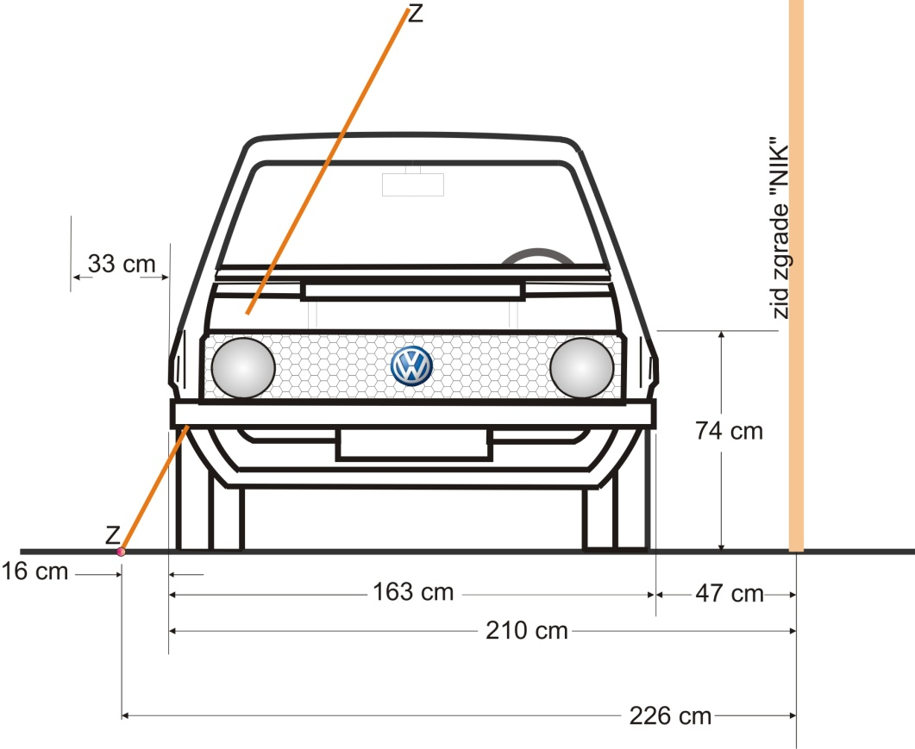
Figure 3.6.

Obviously, somebody told it to him before the investigation even began. And so, prosecution expert determined the minimal angle of fall at 62 degrees, Θ= 62⁰, taking into account the following parameters (see Figure 3.6.):

-Distance of the left side of the car Golf Mk1 from facade of „NIK“ building- 47cm;
-Width of Golf Mk1 car- 163cm (by some data 161cm because of different tire type, but at the moment toally irrelevant);
-Distance of the center of explosion to the „NIK“ building facade- 226cm.

Question: „How is it possible to set a projectile of 13cm diameter in 16cm space (from right side of car body and center of „crater“) while at the same time getting a 62 degree angle of fall, taking into account center of explosion, car body and the claim of prosecution expert that projectile flew over the car flying from its left side to the right?“

Obviously, such a possibility does not exist!

For explanation look at Figure 3.7. However, one might ask: Okay, but picture 3.7. shows cross-section, based on the poor spatial relations between objects. What if the projectile was at a greater distance from the car?

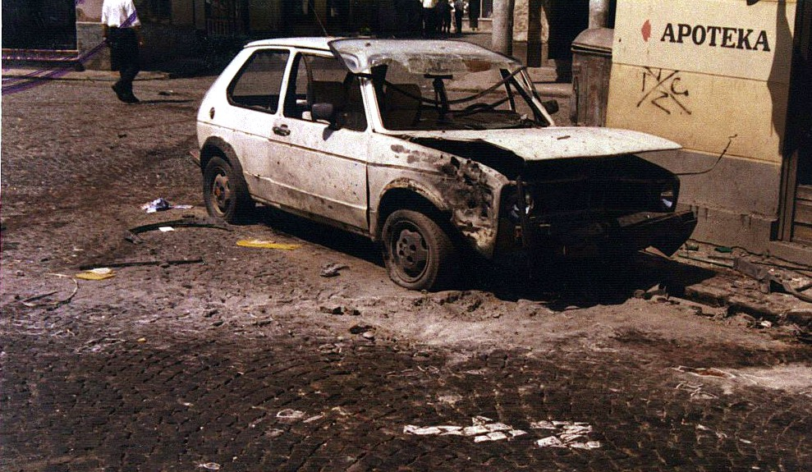
Figure 3.7.

On the 3.7. image it is possible to see looks of the car Golf Mk1 one day after the explosion (26th of May, 1995.) with alleged „shrapnel marks“ on its right fender. Crater „caused“ by the alleged explosion is also visible.

Reflector of the right headlight is undamaged, front tire is barely damaged, but aluminium rim is not damaged. Photography is from CSB Tuzla archives, which court accepted as authentic evidence.

Based on Figure 3.7., the whole (unpoliticized) court process could have ended by release of the accused, after answering one simple question:

Where was the car before the explosion?

All-around and several times repeated calculations done by explosives experts as well as the results derived from several repeated experiments of activating OF482M shells by the car of same brand and type, have shown:

A) If the explosion of 130mm M79 or OF482M shell happened at a distance of 1.45m from the front end of the technically correct Golf Mk1 and a with properly set up brakes, which was left at some level of transmission, the car would be pushed back at least 0.25m.

B) If the explosion of 130mm M79 or OF482M shell happened at a distance of 0.3m from the front end of the technically correct Golf Mk1 and a with properly set up brakes, which was left at some level of transmission, the car would be pushed back at least 1.35m.

C) Explosion of the same projectile as claimed by the prosecution expert: -left side of the car at 45cm from the wall of „NIK“ building; -front part of the car at 130cm from the left part of the building; - angle of fall in relation to the side of the car is 46 degrees: then the Golf Mk1 car, techinically correct, with properly set up brakes and left in some level of transmission would be pushed 47cm towards the building wall which will stop further movement in that direction, and pushed backwards at least 45cm.

If we move the car from the position on the picture (3.7) to the position at which it was before the explosion, orthogonal projection of the car will completely cover the „crater“ visible in front of the front right wheel, and no artillery shell will be able to explode and form such a „crater“ without exploding on the car hood.

In such a case, theoretically and practically, one could not measure any angle of fall of projectile which would make sense.

On the other hand, picture 3.7. shows us that the left side of the car stays on a much greater distance than 47cm from the building wall, but after the explosion.

Prosecution expert claims that a value of 47cm is the distance between car and „NIK“ building facade, but before the explosion. Such a claim was obviously done in an attempt to get a realistic and an angle of fall which would actually make sense.

In an attempt to overthrow already mentioned unjustified conviction, more than 25 engineers have, over the course of last 5 years, tried to, based on the spatial relation between following objects:
- „NIK“ building facade
- Position of Golf Mk1 car according to known parameters
- Center of explosion according to known parameters

set a 130mm projectile in such a position which would allow to have an angle of fall from 62 degrees in relation to the horizon.

Nobody has managed to put the projectile in such a position, during which angle of fall was always higher by 3.5 to 4.5 degrees than the one determined as minimal angle of fall by the prosecution expert (62 degrees).

As the prosecution expert, in his expertise, positively admitted that the angle of fall was probably higher for several degrees, these data tend to agree.

But ballistic calculations in realistic, non-table conditions for the distance interval from 26720m and up to the max range of 130mm M46 cannon (27480m), show us that there is no such angle of fall which is equal to or higher 62 degrees.
Simply, there is not!

Even at a maximum range of 130mm M46 gun, in real-life conditions, angle of fall of projectile is less than 62 degrees, and with the distance of shot less than 27480m that angle is incomparably smaller. That means that a projectile fired from any Fp during the fall to the near of real explosion would have hit and destroyed the body and bonnet of the Golf Mk1 car. It is known that this has not happened. It also means that prosecution expert has forged key evidence and facts.

It is not known whose data, concerning the position of the car towards buildings and the exact distance to explosion, has the prosecution accepted as reference data- whether it was data made by inspector of CSB Tuzla Nedim Mutavčić, or data made by criminalistic technician Irfan Džinović.

Criminalistic technician inspector of CSB Tuzla hasn’t testified in court, neither as an official nor as a witness. The reason for that is more than obvious: the same inspector made a statement in the night of the explosion: “This was below the car!”

Second document (1) named “ЦРТЕЖ ЛИЦА МЈЕСТА”, Subject: Shelling- sketch of the crater, no. 20-1/02-3-9-7-175/95 which was made by crim. technician of CSB Irfan Džinović during the 25./26. 05.1995., and which was not denied in court, literally shows that the place of explosion (Point of Detonation), is on the crossing of arches with adequate radiuses: r₁= 2,60m from left edge of building (observer looks at showcase) and r₂=5,60m from the right, respectively, and that “NIK” store building is 6.55m wide.

In the document “ЗАПИСНИК О УВИЂАЈУ” which was done by Higher court in Tuzla, no. cri. 29/95, during 25th and 26th 05.1995., page 3 second row from above, with the same dates marked, , r₁ =2.60m has transformed into r₁=2.65m.

Then on the scene steps prosecution expert prof.dr. Berko Zečević who changes the radius r₁ and the width of the “NIK” building, which he lowers from 6.55m to 6.5m, and takes r₁ from the mentioned record, so new r₁ =2.65m. It is obvious that he is trying to push the mentioned car towards the building while at the same time pushing the point of impact away from the building.

One might wonder, is mentioning some trivial 5cm this way or that way, at the time of such a big tragedy of Tuzlan youth, only splitting hairs?

Unfortunately, it is not splitting hairs, but a serious and deadly manipulation!

With radiuses of arches of 2.65m and 5.60m and the width of the “NIK” building of 6.5m, how that after 12 years, after total change of the looks and uses of the building, reconstructed by prosecution expert prof.dr. Berko Zečević, alleged point of impact is at a distance of 2.26m from the front of „NIK“ building, and by original data from the document „ЦРТЕЖ ЛИЦА МЈЕСТА“, r₁= 2.60m, r₂ = 5.60m and the width of the building of 6.55m, alleged point of impact is at a distance of 2.19m from the building front.

The difference is, therefore, 7cm.

What kind of consequences does that carry?

The height of the front part of the bonnet of Golf Mk1 is ~74cm, so, when using the difference of 7cm in distance, we get the difference in angle of fall, ΔΘ:

$$∆θ=\operatorname{arctg}\left(\frac{7}{74}\right)= atctg\left(0,0933\right)={5,4}^{0}$$

Unbelievable! Prosecution expert has, by planting arbitrary evidence (seemingly meaningless), made himself a range of possible angles of fall from that ~62 degrees, which in firing tables exists at distances of 26600m, and all the way the end of range in firing tables 27480m, so therefore he can decide angle of fall as he likes it.

It is not impossible that he does it, it is impossible that the court and defense overlooked it!

Since the other expert of CSB Tuzla, inspector Nedim Mutapčić made a quite different sketch with distances that the prosecution expert accepted and then declined, it can be forgiven, but it is impossible to forgive that he even later uses that sketch.

Since the spatial analysis done by prosecution expert is not based on official document accepted by court, this analysis should be rejected as unacceptable.

Even if center of explosion was at a place, as shown by prosecution expert, the car was, according to him, on the sidewalk of minimal height of 10cm. Height of the front part of bonnet (hood), h, equals h=74cm. These numbers show the consequential tilting of the car, and increasing its width ΔM as follows:
$$∆М=tg \left(\frac{10}{163}\right)∙h=0,06135∙74=4,5cm.$$

So we have additional change in possible angle of fall$∆θ_{1}$:

$∆θ_{1}= arctg\left(\frac{4,5}{74}\right)=arctg \left(0,0608\right)={3,48}^{0}$.

As any car driver knows, the side with less pressure (in this case, left) is rising even more, and the side with more pressure is pushed downwards, so counted change in angle of fall is even bigger.

Other than that, in common manner of theoretical outside ballistics, prosecution expert “shoots” Tuzla from the south, from Plahovići village region, west from Kladanj, and not from Ozren, all of the time not being concerned by height of FP (to him it is always +30m from point of detonation), and also he is not worried by the fact that he is “shooting” from west to east.

In such a case it is needed to count the negative correction in distance, because of Earth’s rotation, and also the negative correction in distance, due to Earth’s surface curvature, no matter the azimuth of shooting.

Both are negative, so, it is actually needed to shorten the distance.

Shortening the distance requires decreasing the elevation and with it the angle of fall goes down too.

If the shooting is towards east from west, we are getting more range with the same base values than if the shooting is taking place from west to east.

Ballistics-expert must know that, but obviously he is neglecting it, increasing the distance in almost all of his calculations, and with it, the angle of fall.

Anyhow, prosecution expert was not calculating, he was forged the results.

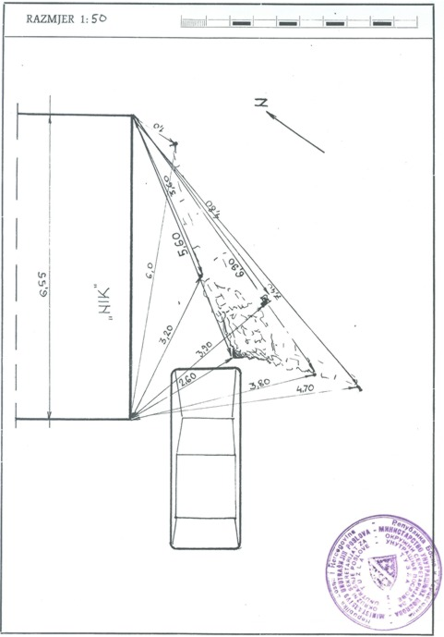
Figure 3.8. sketch of the scene by CSB Tuzla from 26. 05.1995., which was done by criminalistic technician Irfan Džinović
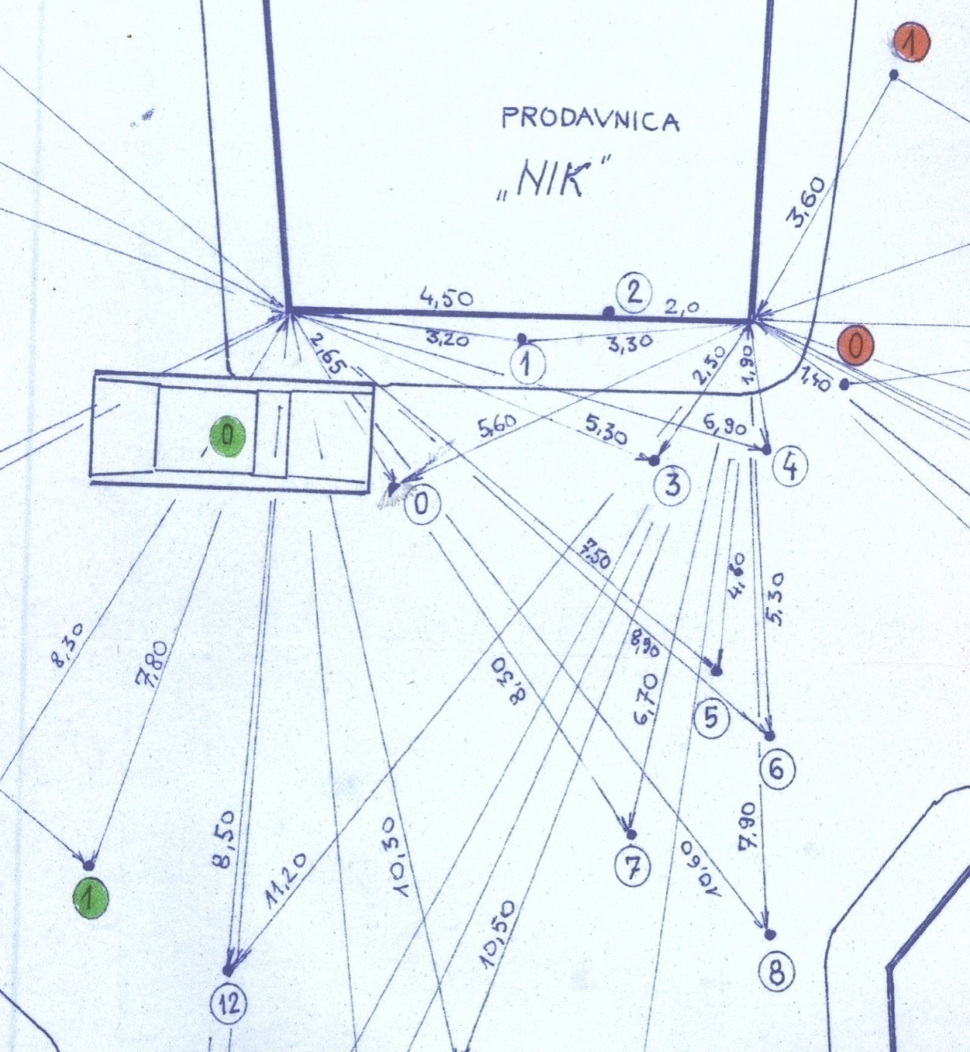
Figure 3.8.a sketch of the scene by CSB Tuzla from 26.05.1995., done by inspector of crim. tech. Nedim Mutapčić. The sketch is of lesser quality, but its authenticity can be confirmed in the documentation.

Only one fact really matters here.
Inspector marked the position of the Golf Mk1 car without any doubt after the explosion, because the left side of the car is leveled with the sidewalk.

That completely denies the claim of the prosecution that the car was at 47cm distance from the wall of the “NIK” building before the explosion. This sketch, in the same manner, proves that there was no possibility for the shell to fly ovet the car, both in a practical and theoretical aspect, because the angle of fall would have to be outside of physical boundaries for the mentioned projectile.

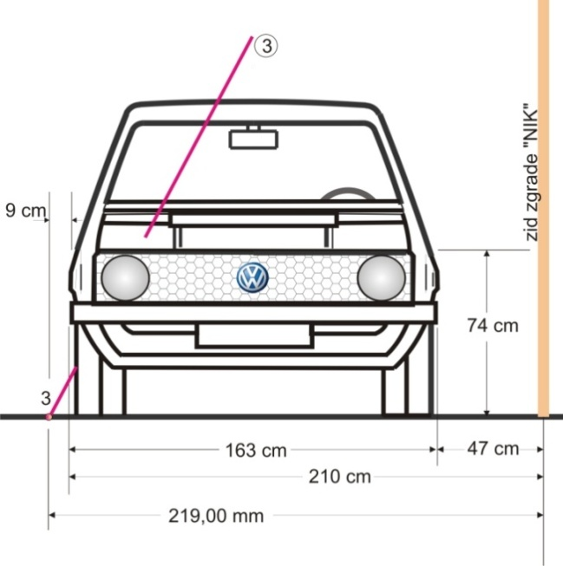
Figure 3.9.

It is therefore obvious that prosecution expert didn’t use the data provided from Nedim Mutapčić sketch, but from the sketch by crim. tech. Irfan Džinović, although he never mentioned that. Taking this into account, we get this situation (Figure 3.9.). Distance between the right side of the car and point of impact is only 9cm. In that area it is impossible to fit the projectile itself, let alone leave room for its angling towards the horizon.
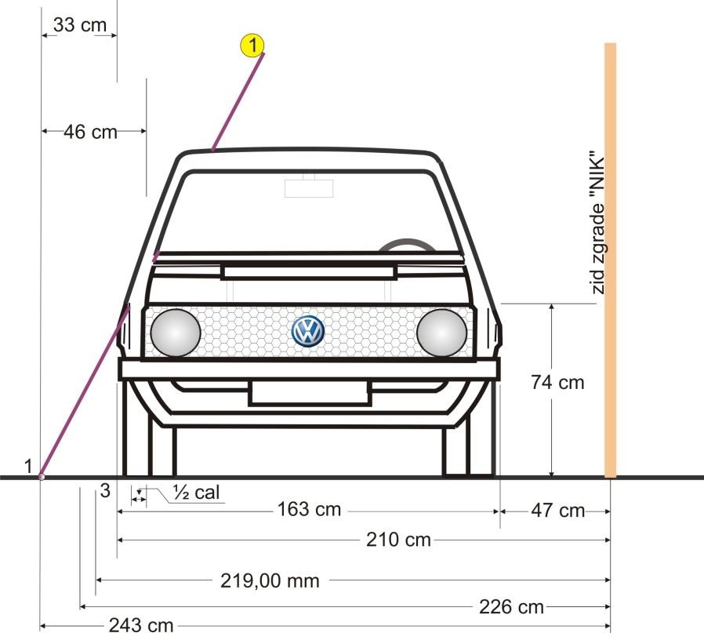
On the other hand, for the possibility for the projectile to fly over the car with an angle of fall of 62 degrees as expert and prosecution claimed, the situation should be (see 3.10.):

Figure 3.10.

During the fall, the projectile needs to be at a distance of minimum ½ calibers from the right side of cover of engine deck (at least 6.5cm). Then the distance of the center of explosion would be, as follows: 46cm from the right side of engine deck cover, and 33cm from the right, furthest, point of car body (fender). That, in full, is shown by orthogonal projection (Figure 3.11.).

In the Figure 3.11. it can be seen that alleged PD of the projectile is at a distance of less than 12cm in relation to front part of the fender (11.7cm) and about 16cm to the furthest front part of the car body. Inside that area of less than 20cm along the diagonal we can barely fit the projectile itself, let alone a rotating body which is doing a processional movement, especially when taken into account the direction of flight of the alleged projectile.
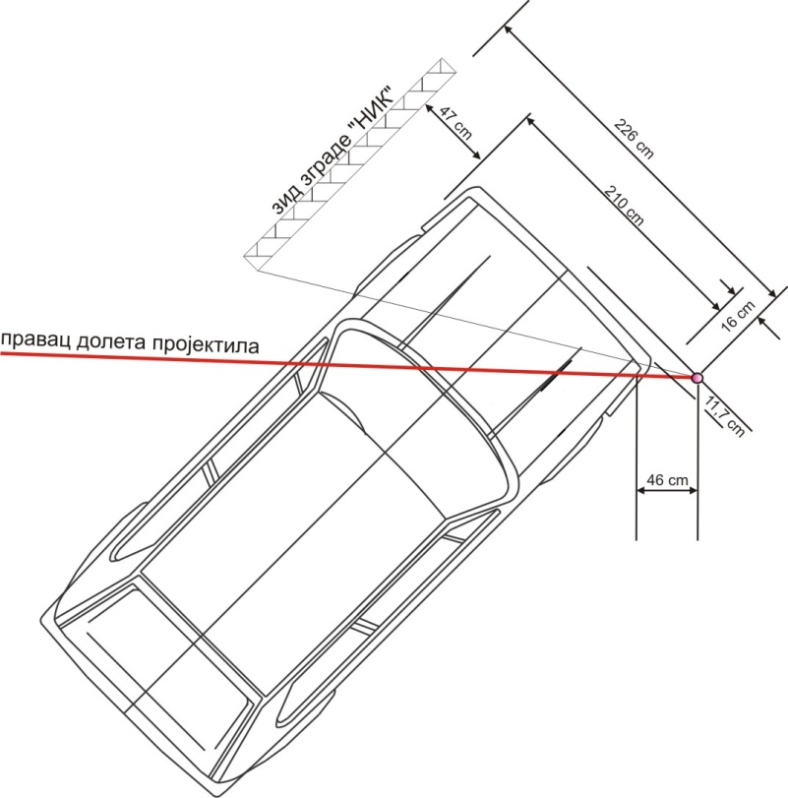
Figure 3.11.

These figures completely deny prosecution’s claims. The shell route which would result in such an ending is not possible to be shown ballisticaly nor graphically. The Figure 3.7, on the other hand, was shown that the distance of the car from the wall was more than 47cm even after explosion, and any incoming projectile with an angle of fall of 62 degrees, and even larger, would have hit the bonnet from above.

The fact that explosion of this projectile moves the car at least 47cm towards the wall and 45cm back, shows that mentioned car was next to the sidewalk with its left side, If the projectile flew in with an angle of fall of 62 degrees, bonnet of such a parked vehicle would have been completely torn apart by explosion. That did not happen, and from that we can deduce completely different conclusions to the ones made by prosecution.

A farce, called “a reconstruction”, which was conducted by prosecution expert, without presence of defense attorneys, 12 years after the events on “Kapija” square after the building was changed physically and internally, should have confirmed theses of prosecution about position of the car before the explosion. Figure 3.12. shows how did prosecution expert do it, and what did he gain by it:

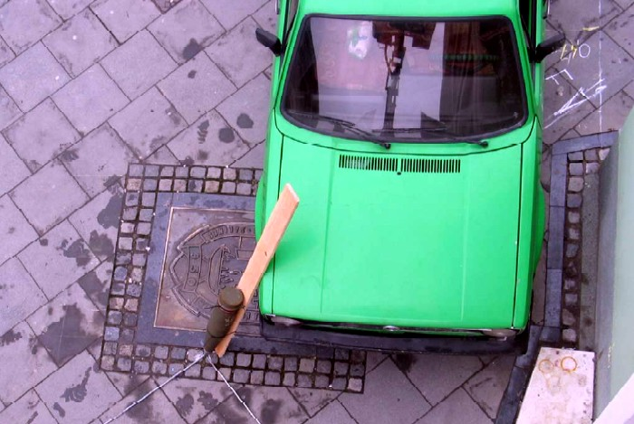
Figure 3.12.

On the upper image it is shown:
- After the tragedy, “Kapija” square was completely reconstructed, paved with stone instead of granite cubes, sidewalk was shortened to 47cm, and alleged place of impact is marked with a metal plate.
- It is obvious where center of explosion was, which doesn’t stop prosecution expert to move the tip of the projectile outside of the center of the plate.

Why would anyone put a memorial plate to a place which is ~20cm away from the actual place it should be?

It is quite normal this what prosecution expert has done during this “reconstruction”.

Moving the tip of the projectile to the edge of the memorial plate was the only way to achieve angle of fall even remotely close to 62 degrees.

Otherwise, if the tip of the projectile was put in the center of memorial plate, measured angle of fall would have been over 68 degrees, which does not exist in Firing Tables.

Generally looking, and being completely assured that employees of CSB Tuzla did a fair and professional job, many deeply rooted suspicions remain, which is best shown on the figure 3.13. (Picture no. 9 from photo-documentation of CSB Tuzla dated to 25.05.1995.)

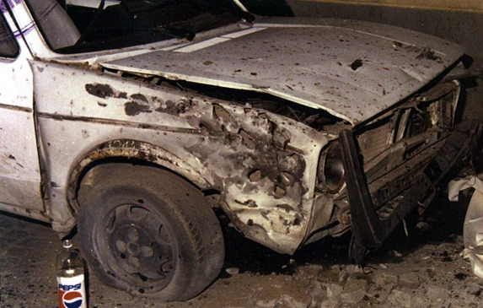
Figure 3.13. (Image no. 9 from photo-documentation of CSB Tuzla from 25.05.1995.)

On the image we can see the body of one of the unfortunate, and since all of the bodies and wounded were evacuated by 22:00h 25.05.1995., it is obvious that this picture was made before 22:00h on the same night the tragedy happened.

On this image we can clearly see a big gap between the front right door and the fender. Lower part of the fender is visibly bent towards the outer tire and down, so it nearly touches the ground.

Mentioned gap is meaningful for several reasons. If this was not an image made that night, 25.05.1995, right after the tragedy, one could find an acceptable explanation in terms that somebody tried to open the car door by force, therefore causing all the damage.

On the other hand, under the pierced right fender we can see parts of undamaged and even unscathed self-supporting body. Explosion of an artillery projectile doesn’t leave those kind of consequences, so the fender was additionally “worked over” during the night 25/26 05 1995.

However, on tommorow’s (during the day) picture Figure no 3.7. (Picture no. 12 from photo-documentation of CSB Tuzla from 26.05.1995.) there is no visible gap between right car door and fender, nor can we notice any bending of the egde of the fender towards the front.

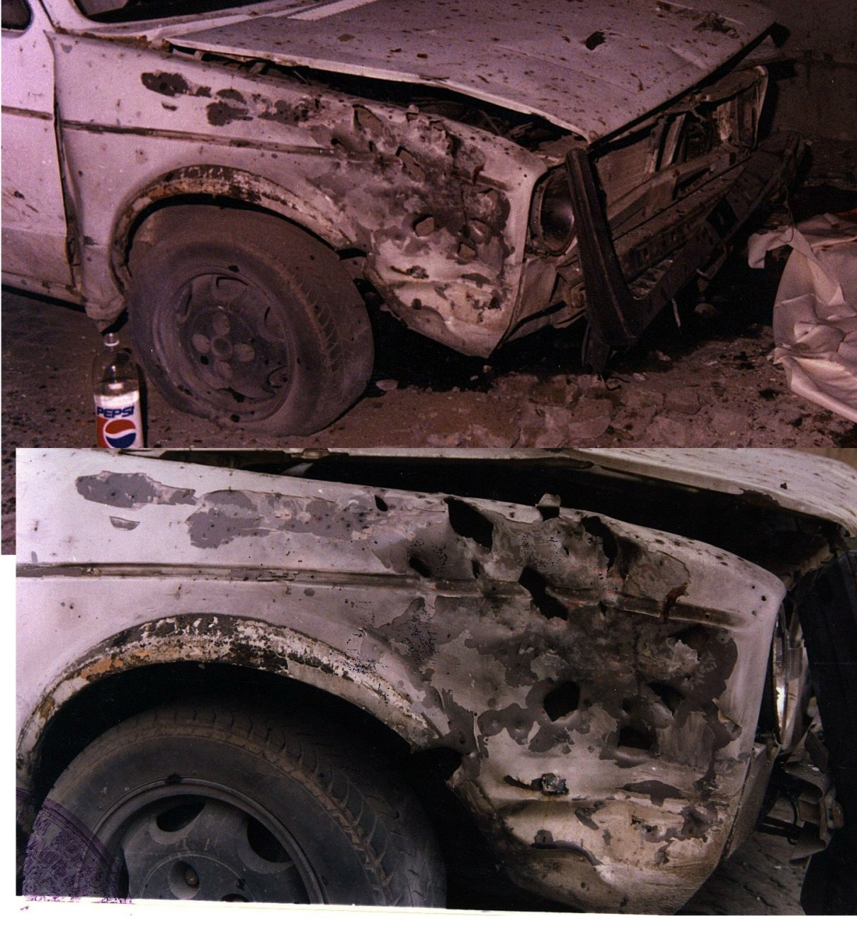
Figure 3.14. (Image no. 51 from photo-documentation of CSB Tuzla from 25.05.1995.)

Even more, lines of decorative battens and fender are a perfect match, even better than on most of cars which are in use. It is justifiable to ask a question:

“Who and why did, in the night 25/26 05 1995 straighten the mentioned fender?”

A special doubt on the credibility of this Golf Mk1 car as material evidence comes from simple comparing of these images (Figure 3.13. and Figure 3.14.).

Figure 3.14 represents a comparative way to see images no. 9 and no. 51 from photo-documentation of SCB Tuzla from 25./26. 05.1995.

On the upper figure 3.14. up (photo no.9), from photo-documentation of CSB Tuzla from 25.05.1995., we can see a fender of Golf Mk1 pierced on multiple places, underneath which we can see completely undamaged and unscathed parts of self-supporting body.

If a 130mm shell exploded next to the fender, fender would have been bent down, and complete right part of front suspension broken and heavily damaged, with the destruction of front-right part of car body, which can be seen in all of the repeated experiments. Explosion of a 130mm projectile at a distance of 0.3m from the headlight, without the destroying it, is an impossible event.

All of the so far mentioned cannot be seen on this picture, which was undoubtedly made in the night of the tragedy because in front of the car we can notice a body of one of the unfortunate people.

Beneath it is tommorow’s, daily, photograph, made from a bit different angle, but with a good sharpness in depth (at least 0.5m), and on it it is not possible to see unpierced parts of the car body.

This gives a base for a strongly based claim that this material evidence was set up towards someone’s needs, and that a piece of car body under the fender was removed. Nobody can prove that on this figure (3.14.) both up and down, are the same, untouched fender!

In this case everything is double or even triple: 1 projectile makes two craters, one bigger and other smaller, the distance between them 1.4m; car has two right fenders; at one point it is 47cm away from the wall, at the next 117cm, and then 120cm; FP can be anywhere in area of 2. 5km², only not there where it says „with a great probability“, one moment it is in Panjik, and next one a few kilometers away.

Projectile is one moment M79 and then OF482M! Respected colleagues from defense technology and prof. dr. Berko Zečević especially, took only a bit more time than needed to drive to Vogošća, so he even knew which steel and which projectile was used, especially considering his great experience in firing a great number of projectiles (more than 3 thousand mortar shells ), and not to mention his “extremely high experience” he has gotten, by his own statement (9) running away from the projectiles around Sarajevo.

Projectile inflicts blast injuries on the distances of over 15m, and spares people who were leaning on the same car, minimum angle of fall is 62 degrees, but also several degrees higher, while just by looking at the center of explosion shows that it was so much bigger that it was theoretically and practically impossible to achieve.

Putting the Golf Mk1 car to a position which was determined by CSB Tuzla inspector Nedim Mutapčić gives us a totally different situation.

Left side of the car is next to the sidewalk. No projectile could have exploded and made the marked “crater” without falling directly on the car bonnet.

Sketch was made, ofcourse, after the explosion, which was on a marked place, at a distance of 283.6cm away from the “NIK” building.

Explosion moved the car backwards and “crater” is visible now (hard-cased explosives do not form such a crater on a granite cube ground, but free explosives or those in very thin packaging do). Moving the car forward, where it was before the explosion completely explains the sentence which was said on that night by inspector Nedim Mutapčić:
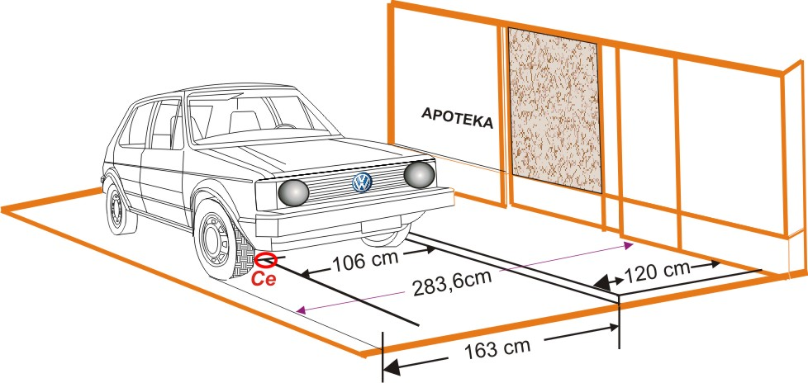
Figure 3.15.
“This was under the car!”
Anyhow, two photographs exist, actually one photograph and one video of the mentioned car Golf Mk1.
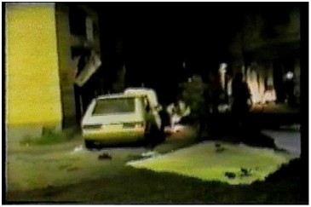
Video, by time, was undoubtedly made during the night in which the explosion happened, while the photograph was made during the day 26.05.1995.
Figure 3.16.

If there can be any scepse from the cutscene from video recording, here everything is clear. Left side of the car is next to the sidewalk, which is 115-120 cm wide and that is after the explosion. If the average width of the sidewalk is 117cm and the vehicle is up to 163cm wide (in total 280cm from the “NIK” building), where did prosecution expert come up with a conclusion that the detonation point of the projectile was 226cm away from the “NIK” building and how is it possible that in those conditions nose of the projectile was towards the side of the vehicle?
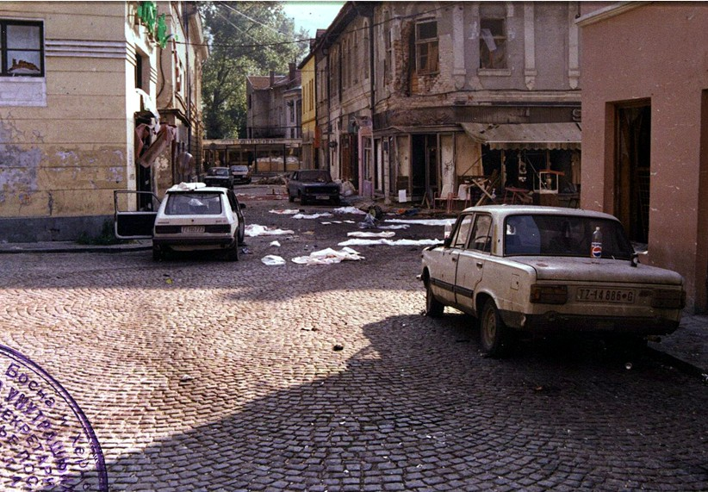
Figure 3.17.
How is it possible that the PD was on the arch of radius 2.65m with a center on the left corner of the building, while being next to the right side of the vehicle, when it can only be in front?

It cannot physically happen that way! Especially it is impossible from a ballistic view; regardless of the value of the angle of fall - the projectile would have hit the car from above.

We also cannot drop from sight that both figures (Figure 3.16. and figure 3.17.) show the position of vehicle after the explosion, which would mean moved vehicle. Before the explosion car was away from the sidewalk by a minimum of 10cm and by the same amount forwards. Keyword here is „minimum“ and it points out to a much lesser intensity of explosion than the one cause by a 130mm shell.

Even if the sidewalk was only 90cm wide PD would have been under the car, and if the vehicle was in such a position that 130mm projectile explosion happens in front of it, it would have been thrown back at least 1.4m (see figure 3.18.).

Both photo-documents clearly show that court wasn’t shown the evidence about the car’s real position after the explosion and that the prosecution expert has set up the mentioned vehicle in space, not minding the reality and real evidence.

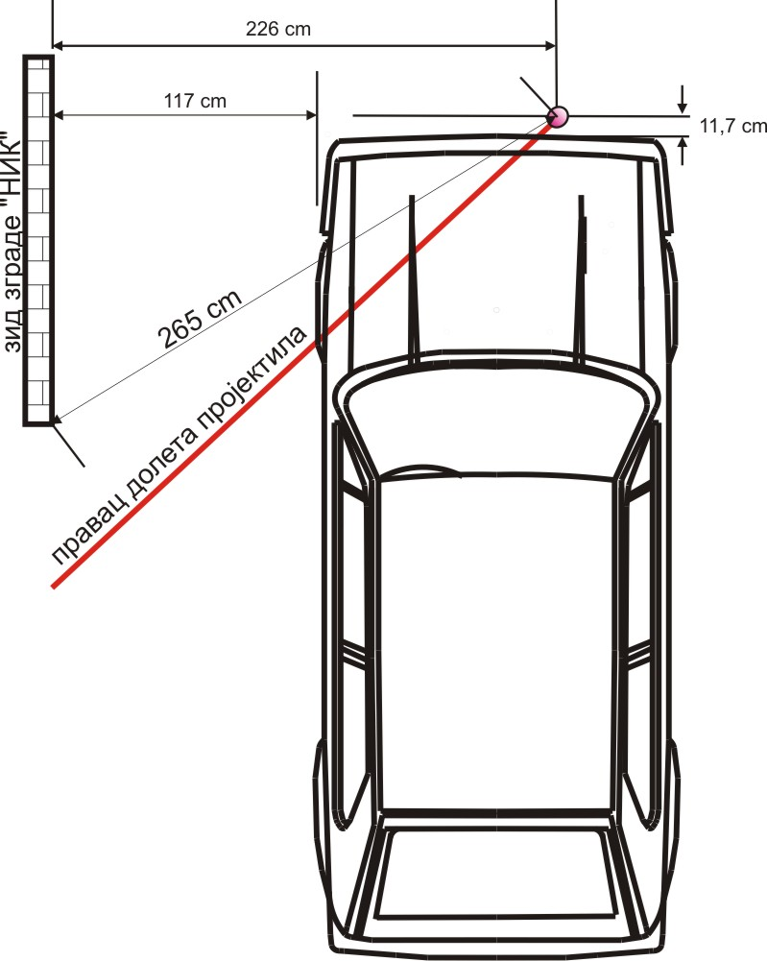
Figure 3.18.
All the existing photographs from the scene show same basic facts:

- Wherever the Golf Mk1 was, the 130mm projectile could not have flew over it and fall at the PD

- If next to a car (on some different distance than the one explained by prosecution expert) indeed a 130mm shell exploded, consequences and damage to the car would have been totally different

- In none of the mentioned cases car could have stayed in the same place it was before the explosion, not even in the case if only half the amount of explosives contained by 130mm shell did explode there

- All of the calculations were done with completely arbitrary variables and to suit someone’s upfront shown wishes and needs

- The later movements of the car front, backwards and sideways, with a lot of photo-proof, were not done with a goal to measure the corresponding spatial parameters, but it was obviously done so that any of those positions of the car could suit a known agenda.

Compilation of quotes by the prosecution expert
1.quote:
„When considering the possible start zone from the fact that guns dragged from trucks or tracked, that their mass in a marching position around 8000 kg and therefore firing position must be close to the road, it's easy access and firm ground.” –end quote
2.quote:
„The Guns of 130 mm M46 are weapons that are pulled by trucks or vehicles with caterpillars. The mass of weapons is around 8t, so they can be transported over very firm ground and firing position must be close to the road. ” –end quote
3.quote:
"Taking into account the known data on the projectile, impact angle, supposed atmospheric parameters as on May of 25th 1995, taking into account the position of the firing position was above the explosion of about 30 m an trajectory path was calculated using 3-DOF software to determine the minimum distance of the firing positions, and it is:
X_{VP} =27.100±380 m.
With the topographic maps of region, in a particular area and the azimuth range of 271 ± 2.5, one can clearly see that that in the immediate vicinity there is only one road and village called Panjik." -end quote
4.quote:
„Yeah look, we are calculate here for different launch angles 38, 39, 45 degrees is not it, to determine which are the angles of fall to the obstacle based on the fact that the weapon was 30 meters above the horizon of the explosion and I asked the Hydrometeorogical Service to give us assesement of the parameters of atmosphere, purely for more precise calculation. It doesn’t play a significant role, but I also used that system, I used parameters from firing tables and they allowed me to determine that with an AoF of 62 degrees, around 62 degrees, range was 27km 128m, that is it. ” – end quote
5.quote:
„No, no, if you are well studied what I wrote I am a very careful person you have never seen in any exact to say it must be so, and I have said azimuth is in the range of 268.5 and 273.5 that to say the range of azimuth was firing position weapons and I drew it and I just said that there likely means probable zone of the village Panjik never said launch zone village Panjik that's a big difference." -end quote
6.quote:
"Since it is a boundary angle, and really this type of projectile is gyro stabilized system and rotates very rapidly about its longitudinal axis and thereby performs the motion characterized with precession and nutation, it is more probably that the angle of descent was higher for a few degrees." – end quote

These are 6 quotes from analysis of the prosecution expert. All of them are in references.
Firstly 4. quote: „...with an AoF of 62 degrees, around 62 degrees, range was 27km 128m, that is it.” Then 6th: „...it is more probably that the angle of descent was higher for a few degrees." Then 5th: „...I have said azimuth is in the range of 268.5 and 273.5... ” Then third:
X_{VP} =27.100±380m.
So, altough the angle of fall is several degrees higher than 62 degrees, the distance on which it is gained can be even less.
To conclude: distance higher than 27100, angle of fall higher than 62 degrees, Fp anywhere between 268,5⁰ and273,5⁰, Panjik hamlet area, and: „....and firing position must be close to the road, have an easy access and solid terrain. ”
Here re all the above quotes graphically presented:

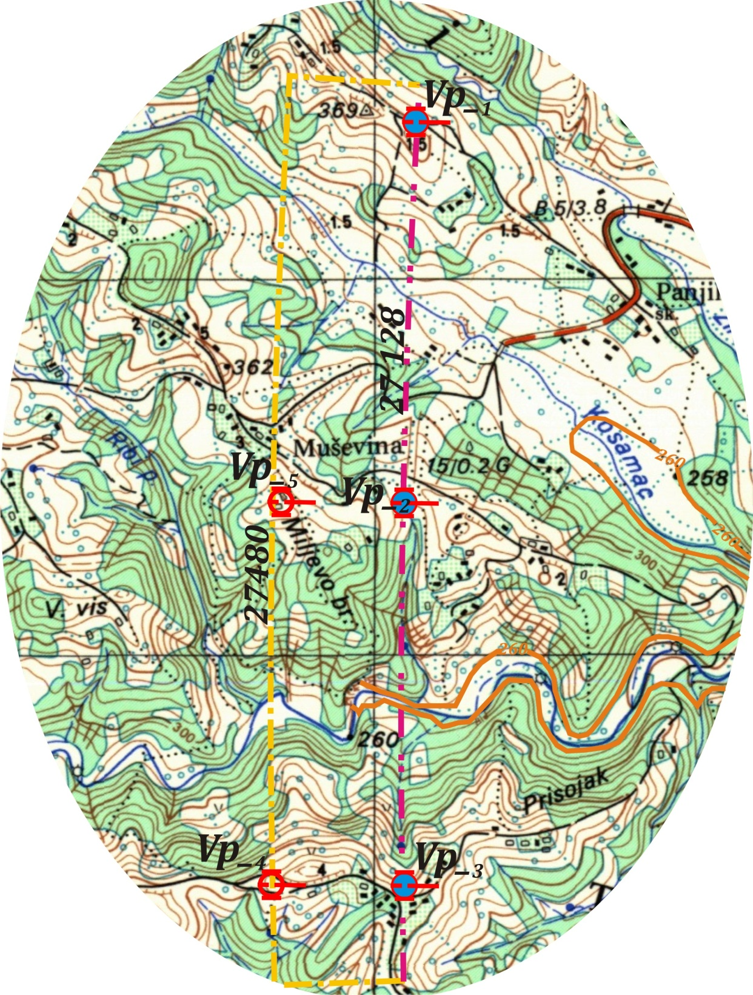

Picture 3.19.
Distance greater than 27100m, FP anywhere between 268,5⁰ and 273,5⁰. There the angle of fall should be higher than 62 degrees (and in no way it is), FP 30m higher (and in no way it is), Fp must be near a very solid road, with hard terrain and with simple access to the position (and in no way it is), and all of that being in Panjik area!

We can take some of this, but this thing about Panjik area is just too much for a „very careful person“!

Taking into account the facts and irrefutable spatial and topographic evidence:

The prosecution evidence, viewed from the topographic and spatial analysis standpoint, are completely unfounded, mutually contradictory, in the topographic relations, technical, tactical and physically impossible, which shows that they are fully implemented arbitrarily and without any study of the situation.

Faced with other subject facts, especially with the fact that the projectile flew in from the west, fly over the Golf Mk1 car and fell 16 cm away in relation to the eastern side of the same car, with the minimal level of damage, the prosecution asserts, alleged evidence and proofs should be completely ruled out because they are obviously false and unproven.

On this basis are given completely justified professional findings:

THE TRAGEDY AT THE "KAPIJA" SQUARE WAS NOT CAUSED BY ARTILLERY FIRED 130mm PROJECTILE.

Ova strana je namerno ostavljena prazna!
ovde ide Attachment 3.2 stampan u formatu a3, presavijen na format a4!

4. "KAPIJA" CASE STUDY FROM THE STANDPOINT OF THE THEORY OF FIRING
The calculation of fire for effect efficiency using the following formulas, is applied in cases where the firing is performed with the same quadrant elevation and deflection. Here, at the beginning, the formulas for calculating the probability of elementary target destroying will be shown. An elementary target is such a target which could not be divided to smaller units.
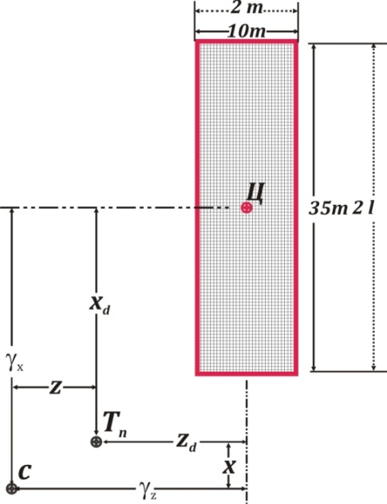
Let us see the firing performed on the rectangular target with 2lx2m dimensions with one artillery piece and with the general ammunition amount usage N. Linear dimensions of target are: 2l<Vd (Vd is probable error in range) and 2m<Vp (Vp is probable error in deflection). The fire for effect is performed with the same quadrant elevation and def-lection which were calculated to the aim point Tn. Tn point is distant from the center of the target for the value of magnitudes: x_{d} and z_{d}. (See Figure 4.1.).
Figure 4.1.
During the firing elements preparation, probable error with the values x, z, could occur and then the center of impact will be in the C point, which is away from the center of the target for the values γ_{x} and γ_{z}. Then the conditional probability of target disabling (the probability to get at least one hit from the N launching) is determined with the known formula:
$$P\left(γ_{x},γ_{z }\right)=1-{\left[1-p(γ_{x}γ_{z })\right]}^{N} 4.1.$$
where is:
$$P\left(γ_{x},γ_{z }\right)=\int_{γ_{x}-l}^{γ_{x+l}}{\int_{γ_{z}-m}^{γ_{z+m}}{φ(x,z)dxdz}} =$$
$$=\int_{γ_{x}-l}^{γ_{x+l}}{\frac{ρ}{Vd\sqrt{π}}∙e^{{-ρ}^{2}\frac{x^{2}}{{Vd}^{2}}}dx\int_{γ_{z}-m}^{γ_{z+m}}{\frac{ρ}{Vp\sqrt{π}}∙e^{{-ρ}^{2}\frac{z^{2}}{p}}dz 4.2}}$$
Under the specified conditions the probability to hit the target with the one launching $P\left(γ_{x},γ_{z }\right)$ could be approximately calculated using the composition of the normal and equitable probability distribution law. The appromaxative calculation of $P\left(γ_{x},γ_{z }\right)$is based on the composition of two laws - law of normal and and equitable probability distribution.If the first integral from the formula (4.2.) is multiplied and then divided with 2l, and second with 2 m, it follows:
$$P\left(γ_{x},γ_{z }\right)=2l\int_{γ_{x}-l}^{γ_{x+l}}{\frac{ρ}{2l∙Vd∙\sqrt{π}}∙e^{{-ρ}^{2}\frac{x^{2}}{{Vd}^{2}}}dx 2m\int_{γ_{z}-m}^{γ_{z+m}}{\frac{ρ}{2m∙Vp∙\sqrt{π}}∙e^{{-ρ}^{2}\frac{z^{2}}{p}}dz 4.3.}}$$
Every of the integral from the formula (4.3.) presents the distrubution law obtained as a result of the composition of the normal and equitable probability distribution.
Summary law shows the deviation comparing to normal law, but under the certain circumstances it could be very close to normal distribution law. The first condition which points out to such a circumstance is a 2l<Vd and 2m<Vp. In this particular case that condition is more than completely fulfilled, Vd= 4,686 · l, Vp=2,400·m, because the particular target dimensions§ are 2l·2m=35· 10 m, Vp=82 m,Vp=12 m.
Average probable errors of that new normal law are, as follows:
${Vd}_{l}$=$\sqrt{{Vd}^{2}+0,152∙{l }^{2 }} 4.4.$
${Vp}_{m}$=$\sqrt{{Vp}^{2}+0,152∙{m }^{2 }} 4.5.$
So, concerning all mentioned above, the formula (4.3.) , with satisfactory accuracy, and because of condition in subject case, even very accurate, can be written in a following form:
$$P\left(γ_{x},γ_{z }\right)=2l∙\frac{ρ}{{Vd}_{l}∙\sqrt{π}}∙e^{{-ρ}^{2}\frac{γ_{x}^{2}}{{Vd}_{l}^{2}}} 2m∙\frac{ρ}{{Vp}_{m}∙\sqrt{π}}∙e^{{-ρ}^{2}\frac{γ_{z}^{2}}{{Vp}_{m}^{2}}}$$
or:
$$P\left(γ_{x},γ_{z }\right)=S_{z}∙\frac{ρ}{{Vd}_{l}∙{Vp}_{m}∙\sqrt{π}}∙e^{{-ρ}^{2}\left(\frac{γ_{x}^{2}}{{Vd}_{l}^{2}} +\frac{γ_{z}^{2}}{{Vp}_{m}^{2}} \right) } 4.6$$
where S_{Z}=2l·2m.
The calculation of the conditional probability of hitting of the target (4.6.) will be more accurate if the linear dimensions of target are smaller compared to the characteristic of the dispersion of the fall point (average probable errors). Conditionality of calculated probability to hit the target is determined with possible positions on which the center of impact or the average trajectory is.
It is obvious that in this particular, subject case, this condition is more than fulfilled, see denoted paragraph§.
By setting the formula (4.6.) into expression (4.1.) we obtain:
$$P\left(γ_{x},γ_{z }\right)=1-{\left[1-S_{z }∙φ_{1}\left(γ_{x},γ_{z }\right)\right]}^{N}$$
The probable errors of firing elements preparation could take any value in the $±∞$interval (in praxis in the ±5 probable errors X_{d} and Z_{d} of firing elements), so the complete probability is determined by the following expression.
$P=\int_{-∞}^{+∞}{\int_{-∞}^{+∞}{φ(γ_{x}-x_{d}, }}γ_{z}-z_{d}$)$P\left(γ_{x}, γ_{z }\right){dγ}_{x}{dγ}_{z } 4.7.$
where is:
$$P(γ_{x}-x_{d },γ_{z}-z_{d})=\frac{ρ^{2}}{E_{x}E_{z }π}∙e^{-ρ^{2}∙\left[\frac{{(γ_{x}-x_{d})}^{2}}{E_{x}^{2}} + \frac{{(γ_{z}-z_{d})}^{2}}{E_{z}^{2}}\right]}$$
normal probability distribution law of firing preparation errors written in relation to the origin which presents the center of the target.
From the expression (4.7.) it could be seen that the function $φ(γ_{x}-x_{d}, γ_{z}-z_{d})$ appears as a differential function of probability which is subjected to the normal law, meanwhile the function $P\left(γ_{x},γ_{z }\right)$ is not the differential function of probability of stochastic values $γ_{x}$и$γ_{z}$.
Assuming that the function $P\left(γ_{x},γ_{z }\right)$ represents the differential function (function of density of probability) of values $γ_{x}$и$γ_{z},$the expression (4.7.) would represent the composition of two distributions. Here it is not the case, but in this particular case the composition of two distributions could be used. To do this in expression (4.7.) it is needed to introduce a new function$g\left(γ_{x},γ_{z }\right)$ instead of $P\left(γ_{x},γ_{z }\right),$ which will be bonded with the function $P\left(γ_{x},γ_{z }\right),$ and at the same time it will have the character of the function of the distribution. The new $g\left(γ_{x},γ_{z }\right)$ function has a form:
$$g\left(γ_{x}, γ_{z}\right)=\frac{P\left(γ_{x},γ_{z }\right) }{g\left(γ_{x},γ_{z }\right)} 4.8.$$
where is:
$$C_{1}=\int_{-∞}^{+∞}{\int_{-∞}^{+∞}{\begin{aligned} \\ \end{aligned}}} P\left(γ_{x},γ_{z }\right){dγ}_{x} {dγ}_{z.}$$
The function $g\left(γ_{x},γ_{z }\right)$ has the character of differential function because:
a)$g\left(γ_{x},γ_{z }\right)>0$, because numerator and denominator on the right side of the expression (4.8.) could not be less than zero
b)$\int_{-∞}^{+∞}{\int_{-∞}^{+∞}{g\left(γ_{x},γ_{z }\right)}}{dγ}_{x} {dγ}_{z}=\frac{\int_{-∞}^{+∞}{\int_{-∞}^{+∞}{\begin{aligned} \\ \end{aligned}}} P\left(γ_{x},γ_{z }\right){dγ}_{x} {dγ}_{z}}{\int_{-∞}^{+∞}{\int_{-∞}^{+∞}{\begin{aligned} \\ \end{aligned}}} P\left(γ_{x},γ_{z }\right){dγ}_{x} {dγ}_{z}}=1$

During the firing with the same quadrant elevation and deflection, the function $g\left(γ_{x},γ_{z }\right)$ will be close to normal law whith characteristics (average probable errors) denoted as $E_{x_{t }}$ and $E_{x_{t .}}$
From the expression (4.8.) arises:
$$P\left(γ_{x},γ_{z }\right)=C_{1}∙g\left(γ_{x},γ_{z }\right)$$
So the expression (4.7) could be written in following form:
$$P=C_{1}\int_{-∞}^{+∞}{\int_{-∞}^{ +∞}{φ\left(γ_{x}-x_{d} , γ_{z}-z_{d}\right)g(γ_{x },γ_{z}){dγ}_{x}{dγ}_{z} }} 4.9.$$
The expression (4.9) represents the summary law of distribution ${ φ}_{2}(x_{d}{, z}_{d})$ obtained as a composition of two laws$φ(γ_{x}-x_{d}, γ_{z}-z_{d}$) и $g\left(γ_{x},γ_{z }\right)$, i. e.
$$\int_{-∞}^{+∞}{\int_{-∞}^{ +∞}{φ\left(γ_{x}-x_{d} , γ_{z}-z_{d}\right)∙g(γ_{x },γ_{z}){dγ}_{x}{dγ}_{z} }={ φ}_{2}(x_{d}{, z}_{d})}$$
To simplify the calculation of P value the summary law ${ φ}_{2}(x_{d}{, z}_{d})$ is substituted with the normal law with probable errors${ Ex}_{d} и {Ez}_{d}$, as characteristics of this law, so we set:
${ φ}_{2}(x_{d}{, z}_{d})≈φ(x_{d}{, z}_{d})$ $=\frac{ρ^{2}}{π∙{Ex}_{d}{Ez}_{d}}∙e^{-ρ^{2}\left(\frac{x_{d}^{2}}{{Ex}_{d}^{2}} + \frac{z_{d}^{2}}{{Ez}_{d}^{2}}\right)}$
Error of such a substitution would be smaller with the increase of firing preparation errors E_{X} and E_{Z} related to probable error in range and deflection. This condition is completely fulfilled, so the calculation would show very high results agreement related to the results obtained by the incomparable complicated numerical integrations.
The expression for the probability of hitting the elementary target could be written now:
$P≈C_{1∙}φ(x_{d}{, z}_{d})$ $=C_{1}∙\frac{ρ^{2}}{π∙{Ex}_{d}{Ez}_{d}}∙e^{-ρ^{2}\left(\frac{x_{d}^{2}}{{Ex}_{d}^{2}} + \frac{z_{d}^{2}}{{Ez}_{d}^{2}}\right)} 4.10.$
Analysis of expression (4.10.) shows that after the application of method of two distributions an expression for calculation of probability of target destroying is obtained. Additionally, it is needed to find out value of coefficient C₁ as well as the values of probable errors${ Ex}_{d} и {Ez}_{d}$.
As it has already been written:
$$C_{1}=\int_{-∞}^{+∞}{\int_{-∞}^{+∞}{\begin{aligned} \\ \end{aligned}}} P\left(γ_{x},γ_{z }\right){dγ}_{x} {dγ}_{z}=$$
$$=\int_{-∞}^{+∞}{\int_{-∞}^{+∞}{\left\{1-{\left[1-\frac{S_{z}∙ρ^{2}}{{Vd}_{l}∙{Vp}_{m}∙π}∙e^{-ρ^{2}\left(\frac{γ_{x}^{2}}{{Vd}_{l}^{2}} + \frac{γ_{z}^{2}}{{Vp}_{m}^{2}}\right)}\right]}^{N}\right\}}}{dγ}_{x}{dγ}_{z}.$$

After variable substitution $\frac{γ_{x}}{ {Vd}_{tl}}=η$ $\frac{γ_{z}}{ {Vp}_{m}}=u$, it is obtained:
$$C_{1}={Vd}_{l}{Vp}_{m}\int_{-∞}^{+∞}{\int_{-∞}^{+∞}{η^{2}\left\{1-{\left[1-\frac{{S_{z} ρ}^{2}}{{Vd}_{l}∙{Vp}_{m}∙π}∙e^{-ρ^{2}\left(η^{2}+ u^{2}\right)}\right]}^{N}\right\}}d}ηdu.$$

Concerning that 2l<Vd и 2m<Vp, and value $\frac{{S_{z} ρ}^{2}}{ {Vd}_{l}∙{Vp}_{m}∙π}e^{-ρ^{2}\left(η^{2}+ u^{2}\right)}$, which represents the conditional probability of hitting in the first launch, is very small (almost negligible in the subject case) it could be written, without any significant error:
$$C_{1}={Vd}_{l}{Vp}_{m}\int_{-∞}^{+∞}{\int_{-∞}^{+∞}{\left\{1-e^{-N∙\frac{{S_{z} ρ}^{2}}{{Vd}_{l}∙{Vp}_{m}∙π}∙e^{-ρ^{2}\left(η^{2}+ u^{2}\right)}}\right\}}d}ηdu.$$
For determination of value of C₁ coefficient the table of function values ε(t) is composed and it could be found at the end of this appendix as a sample for the comparison with the values calculated with the integral written bellow.
$$ε(t)=\frac{ρ^{2}}{π∙t}\int_{-∞}^{+∞}{\int_{-∞}^{+∞}{\left\{1-e^{{-te}^{-^{ρ^{2}}\left(η^{2}+ u^{2}\right)}}\right\}}d}ηdu.$$
where the argument is:
$t=\frac{NS_{z}ρ^{2}}{{Vd}_{l}{Vp}_{m}∙π}$ 4.11.
which implies:
$$C_{1}=S_{z}∙N∙ε\left(t\right) 4.12.$$
There is also a need for determination of average probable errors${ Ex}_{d} и {Ez}_{d }$of normal law$φ(x_{d}{, z}_{d})$, which substitute the normal law ${ φ}_{2}\left(x_{d}{, z}_{d}\right).$ . The characteristics of this law (average probable errors) will be determined by expressions:
${Ex}_{d}=\sqrt{E_{x }^{2}+E_{x_{t}}^{2}}$ 4.13.
${Ez}_{d}=\sqrt{E_{z }^{2}+E_{z_{t}}^{2}}$ 4.14.
The average probable errors of the firing elements preparation E_{X} и E_{Z} are known so it is needed to determine the values $E_{x_{t}}$ и $E_{z_{t}}$. The average probable errors${ E}_{x_{t}}$ и $E_{z_{t}}$ could be found by general rules over the dispersion of the stochastic values ${ γ}_{x}$ и ${ γ}_{z}$ with the distribution$g\left(γ_{x},γ_{z }\right)$. So, for example the square of average probable error ${ E}_{x_{t}}$ will be:
$$E_{x_{t}}^{2} =2∙ρ^{2}∙σ_{x_{t}}^{2}=2∙ρ^{2}\int_{-∞}^{+∞}{\int_{-∞}^{+∞}{γ^{2}}}g\left(γ_{x},γ_{z }\right){dγ}_{x}{dγ}_{z}=$$
$$=\frac{{2∙ρ}^{2}}{C_{1}}\int_{-∞}^{+∞}{\int_{-∞}^{+∞}{γ_{x}^{2}\left\{1-{\left[1-\frac{S_{z} ρ^{2}}{{Vd}_{l}∙{Vp}_{m}∙π}∙e^{-ρ^{2}\left(\frac{γ_{x}^{2}}{{Vd}_{l}^{2}} + \frac{γ_{z}^{2}}{{Vp}_{m}^{2}}\right)}\right]}^{N}\right\}}}{dγ}_{x}{dγ}_{z}$$
After substitution $\frac{γ_{x}}{ {Vd}_{l}}=η$ $\frac{γ_{z}}{ {Vp}_{m}}=u$, we obtain:
$$E_{x_{t}}^{2}={2∙ρ}^{2}∙\frac{{Vd}_{l}^{3}{Vp}_{m}}{C_{1}}\int_{-∞}^{+∞}{\int_{-∞}^{+∞}{η^{2}\left\{1-{\left[1-\frac{{S_{z} ρ}^{2}}{{Vd}_{l}∙{Vp}_{m}∙π}∙e^{-ρ^{2}\left(η^{2}+ u^{2}\right)}\right]}^{N}\right\}}d}ηdu.$$
Thinking in a same way as during the C1 coefficient determination, we could write:
$$E_{x_{t}}^{2}={2ρ}^{2}∙\frac{{Vd}_{l}^{3}{Vp}_{m}}{C_{1}}\int_{-∞}^{+∞}{\int_{-∞}^{+∞}{η^{2}\left\{1-e^{{-te}^{-^{ρ^{2}}\left(η^{2}+ u^{2}\right)}}\right\}}d}ηdu,$$
And concerning the fact that:
$$t=\frac{NS_{z}ρ^{2}}{{Vd}_{l}{Vp}_{m}∙π}$$
$$λ(t)=\frac{2ρ^{4}}{π∙t∙ε(t)}\int_{-∞}^{+∞}{\int_{-∞}^{+∞}{η^{2}\left\{1-e^{{-te}^{-^{ρ^{2}}\left(η^{2}+ u^{2}\right)}}\right\}}d}ηdu.$$
Expression for ${ E}_{x_{t}}$could be written as:
$${ E}_{x_{t}}={Vd}_{l}∙\sqrt{λ\left(t\right),}$$
and analog to that:
${ E}_{z_{t}}={Vp}_{m}∙\sqrt{λ\left(t\right) }$.
In the same table in which we could find the values ε(t), we could also find the values $λ\left(t\right)$for t argument.
Putting the values ${ E}_{x_{t}}$ и $E_{z_{t}}$ in the expressions (4.13.) and (4.14.), we obtain:
$$E_{x_{d}} =\sqrt{E_{x}^{2}+{Vd}_{l}^{2}∙λ\left(t\right)} 4.15.$$
$$E_{z_{d}} =\sqrt{E_{z}^{2}+{Vp}_{m}^{2}∙λ\left(t\right)} 4.16.$$
Putting the values C₁ from the expression (4.12.) into expression (4.10.) we obtain the final formula for calculation of probability of elementary target destroying:
$$P=\frac{NS_{z}ρ^{2}ε(t)}{π∙{Ex}_{d}{Ez}_{d}}∙e^{-ρ^{2}\left(\frac{x_{d}^{2}}{{Ex}_{d}^{2}} + \frac{z_{d}^{2}}{{Ez}_{d}^{2}}\right)} 4.17.$$
where $x_{d}$и $z_{d}$ are coordinates of the point for which initial firing elements are calculated, at the end of preparation of firing elements (the aiming point).
In the case where for the point of aiming, the point which corresponds to the center of the target is taken, $x_{d}$ =0, $z_{d}=0$ (error of firing elements preparation are absent or are negligibly small), the calculation of probability of disabling the target (neutralization, the functional denial, destroying), which is equal to the probability of at least one hit, would have the form:
$$P=\frac{N{∙S}_{z}∙ρ^{2}ε(t)}{π∙{Ex}_{d}{Ez}_{d}}$$
Above used expressions and relations are suitable for the calculation of the mathematical expectation of percent of disabled elementary targets from the group target frame, if the firing is conducted under the same firing elements (without changing of quadrant elevation and deflection during the fire for effect).
Suppose that the certain group target is unshielded people. Dimensions of target are: Depth of target${ D}_{c }=35 m$, Front of target is $F_{c}=10 m.$ For the firing is approved a number of N =1 projectiles. The Front of target is perpendicular to the direction of fire. On the surface of the group target ${ F}_{c}∙D_{c }$ there are k = 800 elementary targets of same kind which coresponded to the number of people which covered the "Kapija" square at the time of alleged shelling. Each of the targets has a derived linear dimension 2l ·2m with the derived surface S_{Z}, S_{Z}=2l ·2m. As it is known the surface S_{Z} doesn’t represent the physical surface of that target. On the contrary, this surface represents the area on which the same elementary target will be disabled or destroyed if it is on that surface in the time of explosion, and opposite will be spared if it is out of that surface.
For the subject 130 mm OФ482M projectile the above mentioned zone surface S_{Z,} is 800 m², apropos 2l ·2m=20х40=800м².
The position of i^{th} elementary target is characterized with the shifts x_{d} and z_{d} compared to center of the group target.
If the firing of that target is conducted with N projectiles without changing of quadrant elevation and deflection during the firing (when we are using one projectile only, it can't be different), the probability of the disabling i^{th} elementary target will be calculated according to expression (4.17).
It is known that mathematical expectation of percent of disabled elementary targets is equal to average arithmetical probability of disabled elementary targets. For the subject case the arithmetical probability will be:
$${ P}_{sr}=\frac{\sum_{i=1}^{k}{P(x_{d}{, z}_{d})}}{D_{c}F_{c}} 4.18.$$
If we allow that the probability of disabling some of elementary targets is very close in comparison to the probability of disabling of another similar elementary target (it is completely allowed in subject case), the summing into expression (4.18.) could be changed with the integration with the variables $x_{d}$and $z_{d}$ in areas of the group targets. Then the mathematical expectation of percent of disabled elementary targets will be:
$$M\left[a\right]=100∙P_{sr }=$$
$$=100∙\frac{N{∙S}_{z}∙ρ^{2}ε(t)}{π∙{Ex}_{d}{Ez}_{d}D_{c}F_{c}}\int_{-∞}^{+∞}{\int_{-∞}^{+∞}{e^{-ρ^{2}\left(\frac{x_{d}^{2}}{E_{x_{d}}^{2}} + \frac{z_{d}^{2}}{E_{z_{d}}^{2}}\right)}}} {dx}_{d}{dz}_{d}, 4.19.$$
well, it is:
$$\frac{ρ^{2}ε(t)}{π∙{Ex}_{d}{Ez}_{d}}\int_{-∞}^{+∞}{\int_{-∞}^{+∞}{e^{-ρ^{2}\left(\frac{x_{d}^{2}}{E_{x_{d}}^{2}} + \frac{z_{d}^{2}}{E_{z_{d}}^{2}}\right)}}} {dx}_{d}{dz}_{d}=$$
$$=ϕ\left(\frac{0,5D_{c}}{E_{x_{d}}}\right)ϕ\left(\frac{0,5F_{c}}{E_{z_{d}}}\right).$$
and finally it will be:
$$M\left[a\right]=100∙\frac{N{∙S}_{z}∙ε(t)}{D_{c}F_{c}}ϕ\left(\frac{0,5D_{c}}{E_{x_{d}}}\right)ϕ\left(\frac{0,5F_{c}}{E_{z_{d}}}\right) 4.20.$$

Before the final calculation, it is necessary to add a few words concerning the ability of the artillery squad (10 man → chief of section, driver, 7 crewmembers, radio operator at the same time in the role of fire control man) to accurately determine the initial elements for the firing. At the time of the events at the Tuzlan "Kapija" square by the book: "Field artillery firing rules", the most accurate way of calculation of firing elements (without any prior fire for corrections) was so called Complete Preparation of Initial Elements- CPIE ( the most complete coverage of all known TMBAM data).
This method of initial elements preparation for firing has been and remains the privilege of the artillery battalions of Army and partly Corps artillery brigade. In formation of these brigades was at this time the artillery reconnaissance battalion with topographic, ground and aerial photographic units, as well as meteorological, optical, sound tracking, rangefinders, calculation units, even the air observers.
The best result that can be achieved by the above mentioned method (CPIE) results in a average probable error for range of 1% from the firing distance and 4 mills per deflection, apropos, E_{X}=0,01Range and E_{Z}=4xRange_{(km)} per deflection, also in a subject case E_{X} = 274 m and E_{Z}=110 m. When to these huge average probable errors is joined secondary natural probable error of 82 m in range (V_{d}) and 12 m in deflection (V_{p}), considering that the two last errors reflect the natural deviation of detonating points around the center of impact, there is no question of any serious probability of hitting the target from distances which are mentioned in the subject case.
We have to, however, assume that local geodetic personnel enabled guns to fix their own positions exactly i.e. to determine the accurate coordinates of the firing position of the subject cannon. Taking also into account that many of these geodetic assistants previously worked in the same civil service and were also able to obtain the target coordinates from the appropriate county register.
Even when the exact coordinates of the target and the gun are known, inaccuracies still remain. Without the help of the aforementioned units of artillery reconnaissance battalion, the crewmember of one artillery weapon or platoon together, is helpless. Ahead of them are series of technical obstacles without any techniques to overcome them.
These obstacles are related to the gathering of weather data and calculations which would eliminate the effects of weather conditions, together with calculations of air and propellant temperature, barometric pressure, monitoring for the wear on gun barrel as well as the variations in the mass of the projectile within the same series of projectiles.
Holding on on the assumption that the crewmember of the cannon determined the firing elements itself and uses the same elements to make the subject incriminating result is imposible, even absurd. For any rational possibility of the above mentioned hitting chance, the probable errors of the calculated firing elements should at least be halved.
This is possible in only two ways:
a) Assuming that the gun crewmember recorded all their firing positions and detonating points of the each launched projectile during two years as well as the current state of atmosphere and material in any such a launching case, and then sent the obtained data somewhere for treatment from where those returned back as the refined firing elements (such a procedure needed serious number of highly skilled people with high education and a relatively long time, (maybe the services of the entire there nonexistent Ballistic Institute) is the first way;
b) Anyone else, far outside the war zone held the firing with the same type of gun in different conditions, after which all the obtained data was refined, and sent back to be used in new specific weather, material, ammunition and barell tube wear circumstances. Then the average probable error of the initial elements could be at the level of 0.0047 · D_{G} and 1.9 · D_{G} _{(km)}, or 129 m and 52 m in range and deflection, respectively. Only with these values, appalling for any professional, there is a minimal chance of hitting in the subject case.
The foregoing calculation method was checked up many times with parallel calculation methods of numerical integration by hand and using the computing machines.
Calculations by this method showed that his error is less than 1% if the initial firing elements errors are larger than the deviation errors and the scale of the group target does not exceed the dimensions of the unit ellipse deviation. Both requirements are fulfilled, even the subject group target at a distance of 4.63 times smaller than the requested size, and by deflection 1.2 times smaller, so the error in the calculation is less than 0.4%.
The calculation is reduced to elementary arithmetical operations and to the use of the Tables Collection and usually could be ended before the computer operator entered the initial variables into the program (if that kind of program existed).
Due to many reasons, one gun can’t be a tool to achieve noticeable effects on the target except perhaps in the immediate firing from a small distance, firing with one cannon is rarely encountered in praxis. Usually the firing is performed with larger units where the calculation of firing efficiency becomes more complex, almost exponentially. Therefore, starting from the end of the third decade of the 20th century, extensive measures in finding a method of calculation are taken and those measures would be able to help people to predict the effectiveness of firing within strictly categorized conditional situations likely to be encountered in praxis.
These works, based on the scientific achievements of the famous St. Petersburg school of theory of probability, (P.L.Chebischev, A.A. Markov, and A.M. Lyapunov), are intensively continued during and after the Second World War and mostly completed by the 70's of the last century. Then begins an era of massive use of computing machines that are initially enabled hitherto unprecedented concentration of artillery fire control function.
When the firing is performed e.g. by the Artillery battalion, it was followed by four groups of errors
♣repeatable errors that occur during normal firing by any weapons from the artillery battalions;
♣repeatable battery errors which are to apply for one battery in the battalion, while for the other batteries are not repeatable;
♣repeatable errors of artillery piece which are valid for one cannon and not repeatable for other cannons;
♣unrepeatable errors of each of the cannon from the Artillery battalion, respectively.
In doing so, each subsequent, repeated, projectile launching is characterized by errors that are correlative mutually related, such as there are correlative and associated with each individual launching of each gun from the any battery within the artillery battalions as well as in the combination with all cannon and battery average probable errors, respectively. Correlations make that the random errors cease to be independent and go beyond the normal error distribution including many other laws of probability distribution.
In addition, the vast majority of input data and functions are based on formulas that can’t be expressed in terms of elementary functions, which is why it is required from the computers to use the lots of numerical integration methods, using enormous processor time.
Trying to get all these conditions into the calculation were led to a form of which had stumbled also the largest computing machines until the end of the 20th century, so all other classical calculations from the late 60s of the same century remain actual.
In the next 40 years the situation has been changing rapidly, the fire control functions are distributed to the gun with automated and computerized aiming devices, as well as to the projectile fuse which is equipped with a GPS device, with radar transceivers and many other sensors and devices guidance on the target. Therefore, it is observed significant delay in finding a calculation method with which the efficacy of fire for effect could be predicted. Nevertheless, many of the more recent doctoral thesis were based on conduction of the aforementioned calculation, but now with the use of powerful computers. It is important to note that great progress was made by these calculations, but the results did not change earlier achievements from the 60s and 70s of the 20th century, whose authors are A.N. Kolmogorov, А. Ya. Khinchin, B.V. Gnedenko, E.S.Ventcelj and others.

Thus, E.S. Ventcelj proved: If some mathematical expectation and dispersion of the number of the hits will be found in the presence of only two groups of errors (repeatable and unrepeatable), which are close to the mathematical expectation and dispersion of which are following the fire with several groups of errors, then the coefficients of efficiency of fire for effect calculated by use of these laws will be mutually close.
Here the generation of formulas will not be displayed, but merely result in the form of a table and a graphic display. Both documents will be used for comparison of results.
Table 4.1.
The characteristics of more group of errors in the plane reduced to the two groups
${Ed}_{o } and {Vd}_{o } (in \% of Range), {En}_{o } and$ ${Vp}_{o }( in mills )$
System | R (in % of R_{max}) | Full preparation  or using of the correction weapon |  |  |  | Short preparation |  |  |  | Fire transfer on  topographic (geodetic) basis
Rifled tubes, muzzle velocity V₀>400 m/s | R (in % of R_{max}) | Ed₀ | Еn0 | Vd₀ | Vp₀ | Ed₀ | Еn0 | Vd₀ | Vp₀ | Ed₀ | Еn0 | Vd₀ | Vp₀
Rifled tubes, muzzle velocity V₀>400 m/s | 20 | 2,76 | 7,3 | 0,82 | 2,2 | 2,83 | 9,4 | 0,81 | 2,7 | 2,74 | 6,4 | 0,87 | 2,0
Rifled tubes, muzzle velocity V₀>400 m/s | 30 | 1,64 | 50, | 0,59 | 2,1 | 1,73 | 7,0 | 0,59 | 2,4 | 1,72 | 4,4 | 0,70 | 1,8
Rifled tubes, muzzle velocity V₀>400 m/s | 40 | 1,16 | 3,9 | 0,51 | 1,8 | 1,30 | 6,0 | 0,48 | 2,2 | 1,26 | 3,4 | 0,59 | 1,6
Rifled tubes, muzzle velocity V₀>400 m/s | 50 | 0,99 | 3,3 | 0,46 | 1,8 | 1,19 | 5,7 | 0,44 | 2,1 | 1,02 | 2,9 | 0,52 | 1,5
Rifled tubes, muzzle velocity V₀>400 m/s | 60 | 0,91 | 3,0 | 0,45 | 1,7 | 1,18 | 5,8 | 0,41 | 2,0 | 0,87 | 2,7 | 0,49 | 1,5
Rifled tubes, muzzle velocity V₀>400 m/s | 70 | 0,86 | 2,8 | 0,46 | 1,6 | 1,19 | 5,6 | 0,41 | 2,0 | 0,79 | 2,6 | 0,46 | 1,5
Rifled tubes, muzzle velocity V₀>400 m/s | 80 | 0,84 | 2,8 | 0,46 | 1,7 | 1,30 | 6,0 | 0,40 | 1,9 | 0,76 | 2,6 | 0,46 | 1,6
Rifled tubes, muzzle velocity V₀>400 m/s | 90 | 0,85 | 3,0 | 0,46 | 1,7 | 1,30 | 6,3 | 0,40 | 1,9 | 0,76 | 2,8 | 0,45 | 1,7
Rifled tubes, muzzle velocity V₀>400 m/s | 100 | 0,86 | 3,2 | 0,47 | 1,7 | 1,34 | 7,2 | 0,41 | 2,1 | 0,78 | 3,2 | 0,47 | 1,9

The two numbers marked in yellow in the last row of the Table 4.1. indicate the accuracy of the initial firing elements for the subject 130mm cannon, which was practically unattainable for separate artillery platoon or battery, as well as for the many artillery battalion at this time, let alone for the crew of an isolated artillery piece which was firing at maximum range.

Despite this fact, such an extraordinary accuracy will be allowed here, regardless to the fact that it would not accept even one properly educated artillery officer in the world.

All subsequent calculations will be done with such accuracy of the initial firing elements and then would be declined almost to the accuracy of guided projectiles for the purpose of considering and analyzing the results.

Without of the mentioned increased accuracy, the entire calculation is meaningless – the probability of the target strike is near to 0 or negligible small, and, consequently, the effect on the target approaching to be close to the zero .

The calculation of mathematical expectation of percent of the disabled elemantary targets by the E.S. Ventcelj metod
As can be seen, here are the average probable errors of the preparation initial elements for targeting significantly reduced in comparison to the earlier calculations. This reduction is brought to the maximum accuracy. Such a accuracy conventional weapons can scarcely achieve even in optimal conditions. This means that here the incriminated 130 mm cannon is classified as a part of the elite unit artillery .
The method is fully usable if the number of launching is more than 10. As can be seen here, the number of launching has taken a value N = 16, as provided by the field artillery rules at that time for this type of targets. Considering firing of one weapon, size Vd₀ is almost equal to the value of a probable error in Range Vd, while the size of the VP₀ is slightly increased with respect to at such a great distance, the weapon can't be directed to the target with an probable error in deflection less than 1.1 mills, because one mills (0-01) at a distance 27 480 m carries 27.5 m of lateral deflecting.
The average probable error of the panoramic telescope calibration, even when it is brand new, amounts 0.7 mills. Perhaps the skilled marksman could set the deflection with resolution of a 0.5 mills (0-00,5), but this is not allowed because the command demands to round the deflection on the whole mills. In addition, the probable error in direction even with the use of gyrocompass or astronomical orientation can't be less than 0.5 mills, and with the standard artillery compass no less than four mills (0-04). By the way, artillery compass does not exist as an accessory of the gun, and not to mention the gyrocompass or instrument with the astronomical extension.
Also, after determining the value N_{T} and η (above) we enter the Figure 4.3. with argument N_{T}. Inside the family of the shown curves, we found the curve denoted as, N_{T} = 10 (9,055 rounded to a nearest greater number). From the point where the N_{T} curve found its intersection with the value of η the new line retreats horizontal left to the intersection with the left ordinate where we read the value of the mathematical expectation in percent of the neutralized (functionally precluded, incapacitated, easily or heavily wounded, or even totally destroyed) elementary targets, in concrete case 8.7%.
As can be seen, calculation results are fully consistent with previous method:
"II Mathematical expectation of number of destroyed elementary targets"
but with the consumption of 16 projectiles, i.e. all 16 must fall at the same time, because in a single firing, after the third firing in the market would no longer be anyone. This means that, here too, the effect of fire is intentionally increased compared to the factors describing the mentioned tragic event from 1995. After all, according to these formulas and practical experiences were derived tables of ammunition consumption (Tables 4.2. And 4.3.), which existed in the rules of field artillery in force for more than 35 even 50 years.
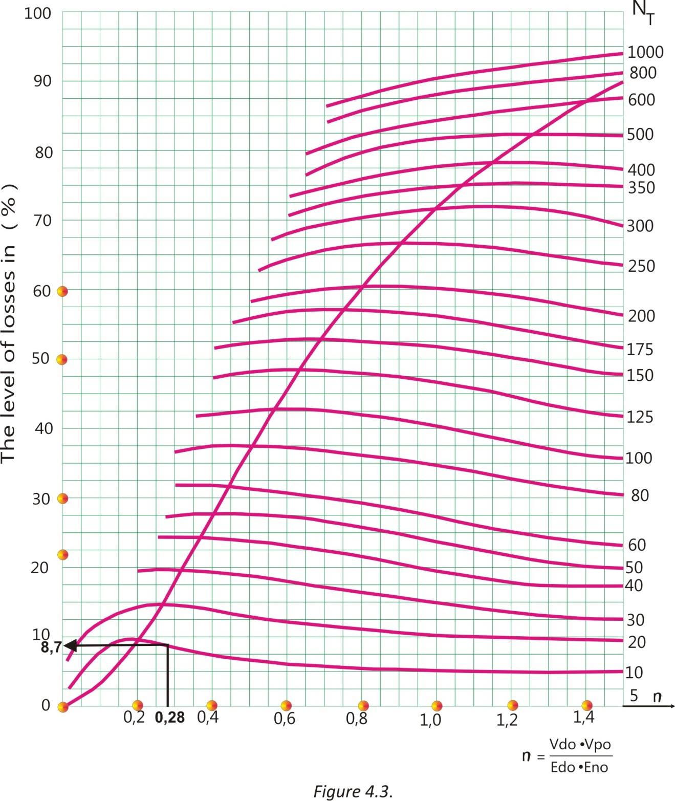
Calculation of the firing efficiency level expressed as a percentage of losses when artillery firing follow only two groups of probable errors, by E.S.Ventcelj

Table 4.2.
The average projectile consumption to neutralize unshielded people in an area of 1 ha
Values | Rifled cannons  And howitzers |  |  |  | Mortars |  |  |  | MLRS
Values | Caliber in mm |  |  |  |  |  |  |  | Medium | Heavy.
Values | 100 | 122 | 130 | 152 |  | 120 | 160 | 240 | Medium | Heavy.
Consumption of  projectiles | 45 | 30 | 20 | 15 |  | 10 | 8 | 4 | 8 | 5

For the destruction of the targets of this kind, the degree of causing losses should be 50-56%, while consumptions in Table 4.2. provide a degree of causing losses of 25-30%. As is well known, for increasing the level of causing losses of 30% on the degree of 50-56%, it is necessary to increase the amount of the projectile 2 to 3 times, respectively, while shooting for the destruction of living force, the spending listed in Table 4.3. should be increased 2 to 3-fold. These are the norms of consumptions of ammunition by the Soviet firing rules dated 1975. The JNA firing rules from 1991, requires spending according to Table 4.3.
Тable 4.3.
The average projectile consumption to neutralize unshielded people in an area of 1
ha under JNA firing rules from 1991, p. 190 -191
Values | Rifled cannons  And howitzers |  |  |  |  | Mortars | MLRS
Values | Caliber in mm
Values | 76-90 | 105 | 122-130  130 | 152-155 | 203 | 120 | 128
Consumption of  projectiles | 40 | 24 | 16 | 12 | 4 | 8 | 10

It should be considered that the norms of both the upper (Table 4.2. and (Table 4.3.) apply to the firing distances up to 10 km, while the firing distances over 10 km add 1/10 every 2 next kilometer of increasing distance, and over 20 km on each additional 1km, adittional 1/10. (see t. 265. APG on pages 190 and 191). If the final firing elements (fire for effect elements) are not originated from earlier fire for correction directly to the target or fire transferring, (so called, known corection) the spending norm should be increased even by 25%.
What we have available after all the above considerations?
1. Shown are theoretically calculated losses in killed people, assuming that on the "Kapija" square really exploded one (1) fired artillery projectile of 130 mm;
2. The number of the projectiles 130 mm needed by the Theory of Firing that, in the subject case, should detonate on the "Kapija" square to make the lethal - effect close to real one.

It should be taken into account that both calculation methods, ostensibly, exclude the increasing of the projectiles consumption with increasing firing distance as well as reducing of the target surface which demand the practical recommendations and the the rules of the artillery. In fact, strictly speaking, both methods take into account such dependence over the values of probable errors of preparation. These values directly depend on the targeting distance. This distance is very large so in the real case the theoretically negligible probability of the hitting would be obtained, and such a set of conditions requires firing tens of thousands of shells for achieving at least one hit.

As this did not happen in subject court case, calculations in the actual conditions consistently show the zero level of causing losses. Therefore, it was necessary to find the minimum value of the mentioned errors (maximum accuracy) that would have been possible to perform whatever serious calculation.

3. The amount of the 130 mm projectiles for such an effect. The needed amount is extracted from practical regulations and existing rules of the two Armies, for 1 ha of surface on which are unshielded people. The surface of the "Kapija" square is about 30 times smaller than 1 ha, and such an area would strike barely one projectile after the artillery battalion salvo.

This means that the amount of ammunition should be significantly higher i.e. at the level shown in the tables above. It should be taken into account that the probable errors of the 130 mm gun, in the preparation of the initial elements were decreased to the limits that were practically unattainable for most of the artillery units of this time.

Comparing the two theoretical models, i.e. the one written by A.N. Kolmogorov and others written by E.S. Ventcelj, we get absolutely consistent results - losses amount to 72 or 70 people, but only if on the "Kapija" square was launched artillery battalion salvo. One cannon, even at high speed firing with 16 projectiles (3 minute of rapid-fire), can't achieve such an effect on the target, because such procedure involves mobility of the target.

Regarding the calculation under 1. assuming that on the "Kapija" square really exploded one (1) fired artillery projectile of 130 mm, there would be a maximum of 6 people killed.
Is this a fictitious calculation hidden behind heavy integrals?

There are two ways to get an answer to this question; one is to disprove the A.N. Kolmogorov formulas, and another to show that there was a calculation implemented incorrectly.
Before that we need to look at the comparison of the results from Table (4.4.) and (4.5.) and earlier calculated data as well as data from practical recommendations (Rules of Firing). Table 4.4. is actually a review of hundreds of terrorist attacks with explosives derived from 1968 to 2010. Events are taken randomly and were not specially targeted.
Table 4.4.
The review of terrorist attacks which used explosives from 1968, 1995, 2004, 2005 and 2010 with the numbers of the dead and wounded by one single explosion
State | Type of attack | Dead | Wounded | By no. of explosions |  | Remark
 |  |  |  | Dead | Wounded | Remark
Afghanistan | Suicide bombing | 19 | 23 | 19 | 23 | Car bomb
Algeria | Bombing | 9 | 104 | 9 | 104 | Car bomb
Algeria | Bombing | 0 | 16 | 0 | 16 | Car bomb
Algeria | Bombing | 0 | 63 | 0 | 63 | Car bomb
B&H | Bombing | 1 | 5 | 1 | 5 | Car bomb
Burma | Bombing | 9 | 170 | 3 | 56.66 | 3 explosions
Cambodia | Bombing | 8 | 36 | 8 | 36 | Train attack
Greece | Bombing | 0 | 0 | 0 | 0 | Parliament
Greece | Bombing | 0 | 1 | 0 | 1 | Thessaloniki 1 attack
Israel | Bombing | 0 | 1 | 0 | 1 | 1 attack
Israel | Bombing | 1 | 0 | 1 | 0 | 1 attack
India | Bombing | 0 | 0 | 0 | 0 | 1 attack
Canada | Inc. bomb | 0 | 0 | 0 | 0 | Royal Bank
Colombia | Bombing | 6 | 30 | 6 | 30 | Car bomb
Colombia | Bombing | 29 | 205 | 29 | 205 | Bomb in a music concert
Croatia | Bombing | 1 | 29 | 1 | 29 | Car bomb
France | Bombing | 0 | 14 | 0 | 14 | Car bomb
France | Bombing | 8 | 80 | 8 | 80 | IED
N. Ireland | Bombing | 0 | 1 | 0 | 1 | IED
France | Bombing | 0 | 29 | 0 | 29 | Bomb thrown on a train
Great Britain | Suicide bombing | 52 | 770 | 13 | 193 | 4 suicide bombers at London transit system
Guatemala | Bombing | 0 | 0 | 0 | 0
India | Bombing | 1 | 42 | 1 | 42
India | Bombing | 7 | 52 | 2.33 | 17.33 | 3 bombs
India | Bombing | 17 | 100 | 17 | 100 | Motorcycle bomb at a marketplace
India | Suicide bombing | 16 | 30 | 16 | 30
India | Bombing | 13 | 25 | 6.50 | 12.50 | Two car bombs
Iran | Suicide bombing | 28 | 300+ | 14 | 150 | 2 suicide bombers
Iraq | Suicide bombing | 2 | 5 | 2 | 5 | Motorcycle bomb
Iraq | Bombing | 33 | 0 | 33 | 0
Iraq | Bombing | 17 | 35 | 5.66 | 11.66 | 3 attacks
Iraq | Bombing | 12 | 20 | 12 | 20 | Car bomb
Israel | Suicide bombing | 5 | 32 | 5 | 32 | Suicide bombing a bus
Israel | Suicide bombing | 5 | 100 | 5 | 100 | Bombing the bus
Israel | Suicide bombing | 8 | 50 | 4 | 25 | 2 suicide bombers
Lebanon | Suicide bomber | 0 | 22 | 0 | 22 | suicide bomber
Yemen | Suicide bomber | 0 | 2 | 0 | 2 | suicide bomber
Nigeria | Bombing | 12 | 17 | 6 | 8.50 | 2 car bombs
Northern Ireland | Bombing | 0 | 0 | 0 | 0
Pakistan | Suicide bombing | 38 | 250 | 12.66 | 83.33 | 3 bombings
Pakistan | Bombing | 2 | 13 | 2 | 13
Pakistan | Suicide bombing | 10 | 70 | 10 | 70 | Attack of convoy
Pakistan | Suicide bombing | 25+ | 30+ | 25 | 30
Table 4.4. Continued
Pakistan | Bombing | 17 | 60 | 17 | 60
Pakistan | Bombing | 32+ | 117 | 32 | 117 | Car bomb outside a department store
Pakistan | Suicide bombing | 19 | 40+ | 19 | 40 | Truck filled with explosives
Palestine | Suicide bombing | 19 | 61 | 19 | 61
Russia | Bombing | 11 | 60+ | 11 | 60 | Car bomb at a bazaar
Russia | Bombing | 3 | 0 | 3 | 0 | Car-bomb
Russia | Suicide bombing | 34 | 0 | 17 | 0 | 2 suicide attacks
Russia | Bombing | 0 | 0 | 0 | 0 | 1 attack
Russia | Bombing | 2 | 0 | 1 | 0 | 2 bombers
Russia | Bombing | 0 | 4 | 0 | 2 | 1 attack
Russia | Bombing | 0 | 0 | 0 | 0 | Café shop bombing
Russia | Bombing | 7 | 37 | 2.33 | 12.33 | 3 separate attacks
Russia | Suicide bombing | 40 | 100+ | 20 | 50 | 2 attacks
Russia | Suicide bombing | 12 | 25 | 6 | 12.50 | Car bomb + suicide bombing
Russia | Bombing | 1 | 30 | 1 | 30 | Bomb on a hippodrome
Russia | Bombing | 8 | 42 | 8 | 42 | Bomb inside cafeteria
Russia | Bombing | 4 | 17 | 4 | 17 | Metro bombing
Russia | Suicide bombing | 12 | 9 | 6 | 4.5 | 2 attacks
Russia | Suicide bombing | 40 | 100+ | 20 | 50 | 2 attacks in metro
Rwanda | Bombing | 0 | 16 | 0 | 8 | 2 attacks
Saudi Arabia | Bombing | 7 | 0 | 7 | 0
Serbia | Mine explosion | 0 | 14 | 0 | 7 | 2 mine explosions
Serbia | Bombing | 1 | 11 | 1 | 11
Serbia | Bombing | 1 | 85 | 1 | 85 | Explosion in cinema
Spain | Bombing | 6 | 0 | 6 | 0
Spain | Bombing | 2 | 52 | 2 | 52 | Car(van) bomb
Sri Lanka | Suicide bombing | 15+ | 59 | 7.50 | 29.50 | Two suicide bombers
Sweden | Suicide bombing | 1 | 2 | 0.5 | 1 | Car bomb + suicide bombing
Turkey | Bombing | 0 | 15 | 0 | 15
Turkey | Bombing | 1 | 3 | 1 | 3
Turkey | Bombing | 5 | 12 | 5 | 12
Turkey | Bombing | 12 | 3 | 12 | 3
Turkey | Suicide bombing | 0 | 32 | 0 | 16
Turkey | Bombing | 0 | 1 | 0 | 1 | Car bomb
USA | Bombing | 0 | 0 | 0 | 0 | New York
USA | Bombing | 0 | 0 | 0 | 0 | Florida
Total |  | 703 | 3770 | 6.65 | 32.85

As the data above shown (Table 4.4.) the average number of the victims per attack is 6.65 people and wounded 32.85 people, or 7:33, respectively. In one part of the cases the average numbers of dead and wounded is obtained over the attacks which were committed by individual explosive attacks with explosives quantity approximately equal to or greater than the mass of explosives located within a 130 mm projectile, while the second part of the average results from the attacks committed the much larger amount of explosives.
For example, in the London subway bombing ̶ bombers carrying rucksacks with 4.5 kg of explosives within the layer of sharp metal waste, while women suicide bombers in the Moscow metro wore belts with 1.5 to 2 kg of explosives also wrapped with a layer of metal waste. Such attacks are devastating because of the high concentration of people and because of explosions in small enclosed spaces such as the wagon platforms, places to embark, the passenger compartment in buses and the like. Even 18% of events have been caused by a car bomb ̶ with tens and even hundreds of kilograms of explosives. In more cases of deaths caused by people after several simultaneous explosions and that it is not specified how many of them, so these events are seen as a single event. More explosions were in stadiums, concerts, and places of Pilgrimages where the concentration of people overcame the stadium density. However, the average death toll was seven people, also almost identical in theory as well as in praxis - 6 or 7 people. (See: I Mathematical expectation of the number of destroyed elementary targets).
The number of fatalities by one explosion from 1990 to 2015 we can seen in Annex 4. 1. The average numbers per year is 6 people.
It can't be blind coincidence.
State | Type of attack | Dead | Wounded | By no. of explosions |  | Remark
 |  |  |  | Dead | Wounded | Remark
Algeria | Bombing | 42 | 286 | 42 | 286 | Car bomb
Iraq | Bombing | 76 | 123 | 76 | 123 | Car bomb in marketplace
Iraq | Suicide bombing | 42 | 224 | 14 | 74.66 | Car bomb
Iraq | Bombing | 85 | 145+ |  |  | Wave of bomb attacks
Iraq | Suicide bombing | 70+ | 400+ |  |  | Several attacks
Pakistan | Suicide bombing | 105 | 100+ | 105 | 100 | Car bomb on a volleyball match
Pakistan | Suicide bombing | 72+ | 190+ | 24 | 63.33 | 3 car bombs
Pakistan | bombing | 105 | 120+ | 105 | 120 | Suicide bombing at a tribal meeting
Spain | Bombing | 191 | 1800 | 14.69 | 138.46 | 13 train bombs
Uganda | Bombing | 74 | 70 |  |  | Several attacks on crowds watching the World cup
USA | Bombing | 168 | 800+ | 168 | 800 | (Oklahoma City bombing)
total |  | 1030 | 4258 | 68.59 | 213.18
Table 4.5.- The second group - large attacks with explosives

In 2011. there were 3,541 attacks with explosives use, causing 4,732 deaths (1.33 per attack).

According to Israeli experience, a state which fights terrorism on a daily basis, the initial time to medical treatment of casualties after a terrorist attack ranges between 20-60 minutes, and that up to 18 patients in 6 minutes can arrive to treatment. It is worth noting that in subject case all of injured and dead have been evacuated in 30 minutes, around 50 people per 6 minutes, which is an unprecedented record for Balkans in the 1990-ies.

Let us now see Table 4.5. This includes large attacks that were carried out even with up to 13 explosive devices or with more car bombs with hundreds or even tons of explosives (Oklahoma), in stadiums, tribal or religious meetings, on trains or buses. The common name for such a type of event is so called: "BLACK SWAN".

What is the result?
The result is an average of 69 people killed and 214 wounded by one tragic event. Is that not close to what happened on the square "Kapija"? The answer is offered, pointing out what happened in the square "Kapija"? So:

From the standpoint of the Theory and Practice of Artillery Fire:

THE TRAGIC EVENT IN THE "KAPIJA" SQUARE IS NOT A CONSEQUENCE OF THE EXPLOSION OF THE ARTILLERY PROJECTILE BECAUSE THE AMOUNT OF THE DEAD WERE EXAGGERATED.

OTHER FACTS AND EVIDENCE SHOWS: THE TRAGEDY IN THE "KAPIJA" SQUARE WAS A PRODUCT OF A LARGE NUMBER OF SIMULTANEOUS EXPLOSIONS CAUSED IN SEVERAL PLACES AROUND THE SQUARE WITH LARGE AMOUNTS OF EXPLOSIVES.

ANNEX 4.1
Number of fatalities by one explosion from 1990 to 2015 with average numbers per year
PLACE | DATE 1990. | FATALITIES | INJURIES | KIND OF EXPLOSION | AVERAGE NUMBER OF FATALITIES BY AN EXPLOSION
Colombia | January 6 | 0 | 0 | A car bomb | 0
Colombia | April 11 | 14 | 100 | A bomb | 14
Colombia | April 25 | 9 | 0 | A car bomb | 9
Colombia | April 25 | 6 | 36 | A bomb hidden in a dump truck | 6
Colombia | May 4 | 4 | 20 | A bomb | 4
Colombia | May 7 | 1 | 5 | A car bomb | 1
Colombia | May 13 | 25 | 160 | Two car bombs | 12,5
United Kingdom | May 16 | 1 | 4 | A bomb under a military minibus | 1
Colombia | May 17 | 0 | 20 | A bomb | 0
Colombia | May 25 | 4 | 0 | A suicide bomber | 4
Colombia | June 15 | 4 | 0 | A car bomb | 4
Colombia | June 29 | 14 | 30 | A car bomb | 14
Colombia | July 15 | 6 | 5 | A bomb | 6
United Kingdom | July 20 | 0 | 0 | A bomb | 0
United Kingdom | July 30 | 1 | 0 | A car bomb | 1
Soviet Union | August 10 | 20 | 33 | A bus was blown up | 20
Colombia | December 13 | 7 | 23 | A remote control bomb | 7
The average number of fatalities from one explosion in 1990. |  |  |  |  | 6,088

PLACE | DATE 1991. | FATALITIES | INJURIES | KIND OF EXPLOSION | AVERAGE NUMBER OF FATALITIES BY AN EXPLOSION
Colombia | January 6 | 3 | 7 | A bomb | 3
United Kingdom | February 7 | 0 | 0 | mortar shell | 0
Colombia | February 16 | 22 | 0 | A 440-pound car bomb | 22
Lebanon | March 18 | 8 | 21 | A car bomb | 8
Colombia | May 13 | 9 | 0 | A car bomb | 9
India | May 21 | 1 | 0 | A bomb | 1
Spain | May 29 | 10 | 0 | A bomb | 10
Soviet Union | May 30 | 11 | 8 | A bomb in train | 11
Colombia | July 12 | 0 | 0 | A bomb | 0
United Kingdom | November 15 | 2 | 0 | A bomb | 2
The average number of fatalities from one explosion in 1991. |  |  |  |  | 6,6
PLACE | DATE 1992. | FATALITIES | INJURIES | KIND OF EXPLOSION | AVERAGE NUMBER OF FATALITIES BY AN EXPLOSION
United Kingdom | January 17 | 8 | 0 | A bomb | 8
China | February 5 | 3 | 29 | Two bus bombs | 1,5
United Kingdom | February 28 | 0 | 29 | A bomb | 0
Denmark | March 16 | 1 | 0 | A bomb | 1
Argentina | March 17 | 29 | 242 | Truck loaded with explosives | 29
United Kingdom | April 10 | 3 | 91 | A massive bomb | 3
Italy | May 23 | 6 | 4 | A bomb | 6
Peru | July 16 | 18 | 140 | A dynamite bomb | 18
Italy | July 19 | 6 | 20 | A simulation time bomb | 6
Algeria | August 27 | 9 | 128 | A bomb | 9
Colombia | September 1 | 9 | 7 | A car bomb | 9
United Kingdom | October 12 | 1 | 4 | A bomb | 1
Colombia | November 11 | 1 | 35 | 9 bombs | 0,11
Colombia | December 3 | 10 | 4 | A bomb | 10
Colombia | December 29 | 0 | 52 | A car bomb | 0
The average number of fatalities from one explosion in 1992. |  |  |  |  | 6,77

ANNEX 4.1 CONTINUED
PLACE | DATE 1993. | FATALITIES | INJURIES | KIND OF EXPLOSION | AVERAGE NUMBER OF FATALITIES BY AN EXPLOSION
Colombia | January 7 | 2 | 39 | A car bomb | 2
Turkey | January 24 | 1 | 0 | A car bomb | 1
Colombia | January 30 | 20 | 0 | A bomb | 20
Colombia | February 11 | 14 | 25 | A bomb | 14
Colombia | February 22 | 4 | 100 | Two powerful car bombs | 2
United States | February 26 | 6 | 1000 | A truck bomb | 6
India | March 19 | 1 | 10 | A bomb | 1
Colombia | April 15 | 15 | 100 | A bomb | 15
Israel | April 16 | 2 | 0 | A car bomb | 2
United Kingdom | March 20 | 2 | 0 | A bomb | 2
United Kingdom | April 24 | 1 | 44 | A huge truck bomb | 1
Sri Lanka | May 1 | 2 | 0 | Suicide bomber | 2
Italy | May 27 | 5 | 40 | A car bomb | 5
Spain | June 21 | 7 | 29 | Military truck bomb | 7
United Kingdom | July 5 | 0 | 0 | (680 kg) car bomb | 0
Italy | July 27 | 5 | 0 | 3 car-bombs | 1,66
United Kingdom | October 23 | 10 | 50 | A time bomb | 10
The average number of fatalities from one explosion in 1993. |  |  |  |  | 5,39

PLACE | DATE 1994. | FATALITIES | INJURIES | KIND OF EXPLOSION | AVERAGE NUMBER OF FATALITIES BY AN EXPLOSION
Azerbaijan | March 19 | 14 | 49 | Suicide bomber | 14
Israel | April 13 | 5 | 0 | Suicide bomber | 5
South Africa | April 24 | 10 | 41 | A car bomb | 10
South Africa | April 25 | 9 | 0 | A bomb | 9
Iran | June 20 | 25 | 70 | A bomb | 25
Japan | June 28 | 7 | 660 | A gas attack | 7
Azerbaijan | July 3 | 13 | 42 | A bomb | 13
Panama | July 19 | 7 | 29 | Aircraft bomb | 7
United Kingdom | July 26 | 0 | 20 | A car bomb | 0
Israel | October 19 | 22 | 56 | Suicide bomber | 22
Israel | November 11 | 3 | 6 | Suicide bomber | 3
Philippines | December 11 | 1 | 0 | A bomb | 1
Israel | December 25 | 0 | 13 | Suicide bomber | 0
The average number of fatalities from one explosion in 1994. |  |  |  |  | 8,92

PLACE | DATE 1995. | FATALITIES | INJURIES | KIND OF EXPLOSION | AVERAGE NUMBER OF FATALITIES BY AN EXPLOSION
Guatemala | January 1 | 0 | 0 | A bomb | 0
Cambodia | January 2 | 8 | 36 | An explosive device in train | 8
Pakistan | January 2 | 2 | 13 | An explosive device | 2
United Kingdom | January 11 | 0 | 0 | A bomb | 0
Israel | January 22 | 19 | 61 | Suicide bomber | 19
India | January 26 | 7 | 52 | 3 bombs | 2,33
Algeria | March 11 | 0 | 63 | A car bomb | 0
Israel | April 9 | 8 | 50 | 2 suicide bombers | 4
Lebanon | April 25 | 0 | 22 | Suicide bomber | 0
Ankara | June 7 | 0 | 1 | A car bomb | 0
Colombia | June 11 | 29 | 205 | A bomb | 29
Algeria | June 22 | 0 | 16 | A car bomb | 0
India | July 20 | 17 | 100 | A bomb on a motor scooter | 17
Israel | July 24 | 5 | 32 | Suicide bomber | 5
France | July 25 | 8 | 80 | A gas bottle exploded | 8
India | July 26 | 1 | 42 | A bomb hidden in a motor scooter | 1
Israel | August 21 | 5 | 100 | Suicide bomber | 5
Algeria | August 31 | 9 | 104 | A car bomb | 9
India | August 31 | 16 | 30 | Suicide bomber | 16
India | September 5 | 13 | 25 | 2 car bombs | 6,5
ANNEX 4.1 CONTINUED
France | September 7 | 0 | 14 | A car bomb | 0
France | October 18 | 0 | 29 | A bomb | 0
Croatia | October 20 | 1 | 29 | A car bomb | 1
Sri Lanka | November 11 | 15 | 59 | 2 suicide bombers | 7,5
Saudi Arabia | November 13 | 7 | 0 | A bomb | 7
Iraq | November 16 | 12 | 20 | A car bomb | 12
Pakistan | November 19 | 17 | 60 | A bomb | 17
Russia | December 4 | 11 | 60 | A car bomb | 11
Spain | December 11 | 6 | 0 | A bomb | 6
The average number of fatalities from one explosion in 1995. |  |  |  |  | 6,66

PLACE | DATE 1996. | FATALITIES | INJURIES | KIND OF EXPLOSION | AVERAGE NUMBER OF FATALITIES BY AN EXPLOSION
United Kingdom | January | 0 | 0 | A bomb | 0
India | 3 January | 6 | 31 | A bomb | 6
United Kingdom | 9 February | 2 | 0 | A bomb | 2
Russia | 11 June | 4 | 12 | A bomb in train | 4
United Kingdom | 15 June | 0 | 0 | A bomb - 1500 kg of explosives | 0
Saudi Arabia | 25 June | 20 | 372 | A truck-bomb | 20
Turkey | 1 July | 6 | 30 | Suicide bomber | 6
United States | 27 July | 2 | 11 | A bomb | 2
France | 17 October | 0 | 28 | A bomb in train | 0
Turkey | 22 October | 3 | 0 | Suicide bomber | 3
Russia | 11 November | 0 | 0 | A bomb | 0
China | 25 December | 0 | 5 | A bomb | 0
The average number of fatalities from one explosion in 1996. |  |  |  |  | 3,58

PLACE | DATE 1997. | FATALITIES | INJURIES | KIND OF EXPLOSION | AVERAGE NUMBER OF FATALITIES BY AN EXPLOSION
Pakistan | January 19 | 25 | 100 | A bomb | 25
Algeria | January 19 | 21 | 60 | A powerful bomb | 21
Cuba | January | 1 | 0 | A bomb | 1
China | February 25 | 9 | 0 | 3 bus bombs | 3
Colombia | February 27 | 7 | 49 | A car bomb | 7
Israel | March 21 | 3 | 46 | Suicide bomber | 3
Russia | June 28 | 3 | 7 | A bomb in train | 3
Colombia | June 17 | 8 | 0 | A truck bomb | 8
Israel | July 30 | 16 | 148 | 2 suicide bombers | 8
Israel | September 4 | 5 | 180 | 3 suicide bombers | 1,66
India | November 19 | 23 | 31 | A car bomb | 23
The average number of fatalities from one explosion in 1997. |  |  |  |  | 9,42

PLACE | DATE 1998. | FATALITIES | INJURIES | KIND OF EXPLOSION | AVERAGE NUMBER OF FATALITIES BY AN EXPLOSION
Sri Lanka | January 25 | 17 | 0 | A bomb | 25
United States | January 29 | 1 | 1 | A bomb | 1
Sri Lanka | February 7 | 8 | 0 | Suicide bomber | 8
Latvia | April 2 | 0 | 0 | 2 bombs | 0
Russia | May 13 | 0 | 0 | A bomb | 0
Sri Lanka | May 14 | 3 | 0 | Suicide bomber | 3
Northern Ireland | August 15 | 29 | 220 | A car bomb | 29
Israel | October 29 | 1 | 3 | Suicide car bomber | 1
Israel | November 6 | 0 | 25 | 2 suicide car bombers | 0
The average number of fatalities from one explosion in 1998. |  |  |  |  | 7,44

ANNEX 4.1 CONTINUED
PLACE | DATE 1999. | FATALITIES | INJURIES | KIND OF EXPLOSION | AVERAGE NUMBER OF FATALITIES BY AN EXPLOSION
Turkey | March 4 | 0 | 4 | Suicide bomber | 0
Turkey | March 13 | 13 | 2 | 2 bombs | 6,5
Sri Lanka | March 16 | 4 | 0 | Suicide bomber | 4
Turkey | March 28 | 0 | 10 | Suicide bomber | 0
United Kingdom | April | 3 | 160 | A bomb | 3
Turkey | April 8 | 2 | 9 | Suicide bomber | 2
Russia | April 26 | 0 | 11 | An explosion inside an elevator | 0
Sri Lanka | May 29 | 3 | 0 | Suicide bomber | 3
Turkey | June 5 | 0 | 14 | Suicide bomber | 0
France | June 18 | 0 | 0 | Dynamite | 0
Sri Lanka | July 29 | 1 | 7 | Suicide bomber | 1
Colombia | July 30 | 9 | 38 | A car bomb | 9
Sri Lanka | August 16 | 10 | 0 | 2 suicide boat bombers | 5
Sri Lanka | September 2 | 1 | 0 | Suicide bomber | 1
Colombia | November 12 | 7 | 10 | A bomb | 7
Sri Lanka | December 18 | 23 | 100 | Suicide bomber | 23
Lebanon | December 30 | 0 | 12 | Suicide bomber | 0
The average number of fatalities from one explosion in 1999. |  |  |  |  | 3,79

PLACE | DATE 2000. | FATALITIES | INJURIES | KIND OF EXPLOSION | AVERAGE NUMBER OF FATALITIES BY AN EXPLOSION
Sri Lanka | January 2 | 2 | 3 | A bomb | 2
India | January 3 | 20 | 0 | A bomb | 20
Sri Lanka | January 5 | 7 | 30 | Suicide bomber | 7
India | January 6 | 0 | 22 | A bomb | 0
Sri Lanka | January 7 | 21 | 60 | Suicide bomber | 21
Algeria | January 10 | 1 | 2 | A bomb | 1
Sri Lanka | January 16 | 9 | 13 | Land mine | 9
Israel | January 17 | 0 | 20 | Pipe bomb | 0
Pakistan | January 17 | 8 | 14 | A powerful explosive device | 8
Spain | January 21 | 1 | 4 | A car bomb | 1
Spain | January 25 | 0 | 0 | A car bomb | 0
India | January 25 | 4 | 6 | Rocket attack | 4
Sri Lanka | January 27 | 10 | 20 | A parcel bomb | 10
Pakistan | January 27 | 2 | 7 | a bomb explosion | 2
Sri Lanka | January 27 | 8 | 70 | A bomb | 8
Sri Lanka | February 3 | 0 | 34 | A bomb | 0
Colombia | February 4 | 2 | 4 | A car bomb | 2
United Kingdom | February 6 | 0 | 0 | An explosive device | 0
Sri Lanka | February 7 | 1 | 51 | two bombs | 0,5
India | February 11 | 5 | 20 | a bomb | 5
India | February 12 | 4 | 26 | a bomb | 4
Spain | February 22 | 2 | 2 | a vehicle exploded | 2
Turkey | February 23 | 0 | 1 | A bomb | 0
United Kingdom | February 26 | 0 | 0 | A bomb | 0
Spain | February 28 | 0 | 0 | A bomb | 0
Philippines | March 4 | 1 | 17 | A bomb | 1
Greece | March 5 | 0 | 0 | a time bomb | 0
Spain | March 6 | 0 | 8 | A remote-controlled device | 0
Israel | March 6 | 6 | 9 | A bomb | 6
Spain | March 7 | 0 | 7 | A car bomb | 0
Algeria | March 12 | 1 | 13 | Two bombs | 0,5
India | March 16 | 0 | 5 | A bomb | 0
India | March 21 | 0 | 4 | an explosive device | 0
Russia | March 26 | 0 | 2 | A car bomb | 0
Colombia | March 30 | 4 | 19 | A car bomb | 4
Algeria | April 4 | 2 | 7 | A bomb | 2
Pakistan | April 7 | 0 | 4 | A bomb | 0
Pakistan | April 7 | 0 | 16 | A bomb | 0
Pakistan | April 8 | 0 | 16 | A bomb | 0
ANNEX 4.1 CONTINUED
Pakistan | April 8 | 0 | 5 | A bomb | 0
Algeria | April 11 | 0 | 4 | A bomb | 0
Sri Lanka | April 13 | 6 | 50 | A bomb | 6
Colombia | April 16 | 0 | 0 | A bomb | 0
Indonesia | April 18 | 8 | 18 | two explosive devices | 4
France | April 19 | 1 | 1 | An explosive | 1
India | April 20 | 3 | 35 | Suicide bomber | 3
Ukraine | April 20 | 3 | 5 | An explosive device | 3
Philippines | April 24 | 0 | 5 | a grenade | 0
Pakistan | April 25 | 0 | 11 | Three quick succession bombs | 0
Turkey | April 27 | 0 | 0 | A bomb | 0
India | April 29 | 1 | 8 | A bomb | 1
Venezuela | May 1 | 0 | 0 | An explosive device | 0
Turkey | May 11 | 0 | 0 | A time bomb | 0
Russia | May 12 | 3 | 18 | a remote-controlled mine | 3
India | May 15 | 5 | 0 | A bomb | 5
Colombia | May 15 | 2 | 3 | A 'collar' bomb | 2
Sri Lanka | May 17 | 29 | 80 | A bomb | 29
Sri Lanka | May 18 | 23 | 70 | A bomb | 23
Philippines | May 18 | 5 | 24 | A bomb | 5
Philippines | May 19 | 0 | 13 | A bomb | 0
Philippines | May 21 | 1 | 8 | A bomb | 1
India | May 23 | 0 | 0 | A bomb | 0
Indonesia | May 28 | 0 | 33 | A bomb in church | 0
Algeria | May 29 | 0 | 7 | A bomb | 0
United Kingdom | June 1 | 0 | 0 | An explosive device | 0
Sri Lanka | June 7 | 22 | 60 | suicide bomber | 22
South Africa | June 10 | 0 | 1 | A car bomb | 0
Germany | June 15 | 0 | 0 | A car bomb | 0
Algeria | June 16 | 13 | 42 | A bomb | 13
India | June 19 | 2 | 11 | Two bombs | 1
United Kingdom | June 21 | 0 | 2 | an explosive | 0
Spain | June 24 | 0 | 9 | A car bomb | 0
Philippines | June 24 | 1 | 36 | 6 bombs | 0,16
India | June 29 | 3 | 2 | A bomb | 3
United Kingdom | July 1 | 0 | 0 | A bomb | 0
Indonesia | July 4 | 0 | 0 | A bomb | 0
Spain | July 7 | 0 | 0 | An explosive device | 0
United Kingdom | July 8 | 0 | 0 | A car bomb | 0
Russia | July 9 | 6 | 18 | A bomb | 6
Spain | July 12 | 0 | 10 | a car bomb | 0
Pakistan | July 13 | 0 | 5 | A bomb | 0
Philippines | July16 | 2 | 23 | A powerful bomb | 2
Tajikistan | July 16 | 2 | 5 | A bomb | 2
Turkey | July 22 | 0 | 1 | 2 bombs | 0
Pakistan | July 23 | 6 | 22 | A bomb | 6
India | July 24 | 6 | 10 | a powerful bomb | 6
Spain | July 24 | 0 | 4 | a car bomb | 0
Philippines | July 26 | 0 | 19 | A grenade | 0
Indonesia | August 1 | 2 | 21 | A bomb | 2
Philippines | August 1 | 3 | 36 | A bomb | 3
Algeria | August 4 | 0 | 0 | 3 bombs | 0
Russia | August 6 | 2 | 3 | a car bomb | 2
Russia | August 8 | 12 | 97 | A bomb | 12
India | August 10 | 15 | 30 | A car bomb | 15
South Africa | August 11 | 0 | 2 | A car bomb | 0
France | August 13 | 0 | 0 | A powerful explosive | 0
Sri Lanka | August 16 | 2 | 5 | suicide bomber | 2
India | August 16 | 0 | 4 | an explosive device | 0
Latvia | August 17 | 1 | 35 | Two explosives | 0,5
Colombia | August 18 | 2 | 2 | A bomb | 2
Pakistan | September 3 | 3 | 4 | A bomb | 3
Colombia | September 4 | 0 | 8 | A bomb | 0
Pakistan | September 7 | 2 | 10 | A bomb | 2
Spain | September 10 | 0 | 0 | A bomb | 0
South Africa | September 12 | 0 | 7 | A bomb | 0
Indonesia | September 13 | 6 | 20 | A bomb | 6
ANNEX 4.1 CONTINUED
Sri Lanka | September 15 | 8 | 28 | A suicide bomber | 8
Sri Lanka | September 18 | 3 | 8 | A van bomb | 3
Cambodia | September 19 | 4 | 9 | a grenade | 4
Pakistan | September 19 | 19 | 90 | A deadly bomb | 19
Philippines | September 20 | 1 | 5 | A suicide bomber | 1
Colombia | September 24 | 1 | 4 | a grenade | 1
Philippines | September 25 | 2 | 15 | A bomb | 2
Spain | September 30 | 0 | 0 | an explosive device | 0
United Kingdom | October 1 | 0 | 1 | a pipe bomb | 0
Tajikistan | October 1 | 3 | 6 | A bomb | 3
Sri Lanka | October 3 | 26 | 49 | A bomb | 26
Colombia | October 4 | 0 | 2 | A low-powered bomb | 0
Sri Lanka | October 6 | 10 | 25 | A suicide bomber | 10
Uganda | October 9 | 9 | 60 | 2 grenade attacks | 4,5
Colombia | October 15 | 4 | 45 | A bomb | 4
Sri Lanka | October 20 | 3 | 21 | suicide bomber | 3
Spain | October 22 | 1 | 0 | A car bomb | 1
France | October 23 | 0 | 0 | A bomb | 0
Greece | October 23 | 0 | 0 | An explosive device | 0
India | October 26 | 1 | 30 | A bomb | 1
Gaza | October 26 | 1 | 1 | A suicide bomber | 1
Israel | October27 | 0 | 1 | A bomb | 0
Philippines | October 30 | 0 | 0 | A powerful bomb | 0
Spain | October 30 | 3 | 66 | A car bomb | 3
Pakistan | November 2 | 0 | 26 | A bomb | 0
Spain | November 2 | 0 | 2 | A car bomb | 0
Israel | November 10 | 0 | 1 | An explosive | 0
Tanzania | November 12 | 0 | 1 | A bomb | 0
Indonesia | November12 | 1 | 6 | An explosion | 1
Colombia | November 13 | 0 | 3 | A powerful explosion | 0
Colombia | November 14 | 1 | 4 | An explosion | 1
Colombia | November 15 | 1 | 1 | A car bomb | 1
Colombia | November 18 | 1 | 17 | A motorcycle bomb | 1
Haiti | November 22 | 1 | 14 | a homemade bomb | 1
Spain | November 25 | 0 | 0 | An explosive | 0
Sri Lanka | December 6 | 7 | 14 | a Claymore-type bomb | 7
Russia | December 8 | 3 | 15 | 2 car bombs | 1,5
Russia | December 9 | 21 | 30 | A car-bomb | 21
Sri Lanka | December 14 | 4 | 2 | A bomb | 4
Algeria | December 20 | 2 | 17 | A car bomb | 2
Israel | December 22 | 0 | 3 | A suicide bomber | 0
Philippines | December30 | 22 | 100 | 6 bombs | 3,66
The average number of fatalities from one explosion in 2000. |  |  |  |  | 3,05

PLACE | DATE 2001. | FATALITIES | INJURIES | KIND OF EXPLOSION | AVERAGE NUMBER OF FATALITIES BY AN EXPLOSION
Israel | January 1 | 0 | 50 | car bomber | 0
Colombia | January 10 | 0 | 50 | A car bomb | 0
Israel | February 14 | 8 | 21 | suicide bomber | 8
Israel | March 4 | 3 | 65 | suicide bomber | 3
Israel | March 27 | 1 | 30 | suicide bomber | 1
Israel | March 28 | 2 | 0 | suicide bomber | 2
Israel | March 28 | 1 | 4 | suicide bomber | 1
Israel | April 29 | 0 | 0 | A suicide car bomber | 0
Colombia | May 4 | 4 | 32 | A car bomb | 4
Colombia | May 17 | 20 | 50 | A car bomb | 20
Israel | May 18 | 5 | 100 | suicide bomber | 5
Colombia | May 24 | 4 | 0 | 2 bombs | 2
Israel | May 25 | 0 | 65 | Two suicide car bombers | 0
Israel | May 25 | 12 | 0 | 2 bombs | 6
Colombia | June 17 | 0 | 16 | A car bomb | 0
Israel | June 22 | 2 | 0 | A suicide bomber | 2
Israel | July 9 | 0 | 0 | A suicide bomber | 0
Israel | July 16 | 2 | 0 | A suicide bomber | 2
ANNEX 4.1 CONTINUED
India | July 31 | 5 | 8 | A remote control landmine | 5
United Kingdom | August 3 | 0 | 7 | A bomb | 0
Israel | August 8 | 0 | 1 | A suicide car bomber | 0
Israel | August 12 | 0 | 15 | A suicide bomber | 0
FYROM | August 22 | 0 | 0 | an explosion | 0
Colombia | August 23 | 1 | 39 | 10 bombs | 0,1
Colombia | August 23 | 15 | 0 | explosives | 15
FYROM | August 26 | 2 | 0 | An explosion | 2
Israel | September 4 | 0 | 15 | A suicide bomber | 0
Israel | September 9 | 3 | 90 | A suicide bomber | 3
Israel | September 9 | 0 | 17 | A suicide car bomber | 0
Afghanistan | September 9 | 1 | 0 | A suicide bomber | 1
Israel | November 26 | 0 | 2 | A suicide bomber | 0
Israel | November 29 | 3 | 0 | A suicide bomber | 3
Israel | December 1 | 10 | 188 | A car bomb and about 5 bombs | 2
Israel | December 2 | 2 | 0 | A suicide bomber | 2
Israel | December 5 | 1 | 3 | A suicide bomber | 1
Israel | December 9 | 0 | 8 | A suicide bomber | 0
Israel | December 12 | 2 | 3 | Two suicide bombers | 1
The average number of fatalities from one explosion in 2001. |  |  |  |  | 2,46

Place | Date 2002. | Fatalities | Injuries | Kind of explosion | Average number of fatalities by an explosion
Colombia | January 25 | 5 | 28 | A bomb | 5
Israel | January 25 | 0 | 25 | suicide bomber | 0
Israel | January 27 | 3 | 140 | a suicide bomber | 3
Israel | January 30 | 1 | 2 | suicide bomber | 1
Colombia | January 30 | 5 | 40 | A car bomb | 5
Israel | February 16 | 4 | 29 | suicide bomber | 4
Israel | February 18 | 2 | 0 | a suicide bomber | 2
Israel | February 27 | 1 | 3 | a suicide bomber | 1
Israel | March 2 | 12 | 50 | suicide bombing | 12
Israel | March 5 | 2 |  | a suicide bomber in the bus | 2
Israel | March 7 | 1 | 15 | a suicide bomber | 1
Israel | March 9 | 12 | 54 | a suicide bomber | 12
Israel | March 17 | 1 | 25 | a suicide bomber | 1
Israel | March 20 | 8 | 30 | a suicide bomber | 8
Israel | March 21 | 9 | 30 | A car bomb | 9
Peru | March 21 | 4 | 86 | a suicide bombing | 4
Israel | March 29 | 3 | 28 | a suicide bomber | 3
Israel | March 30 | 2 | 30 | a suicide bomber | 2
Israel | March 31 | 16 | 40 | a suicide bomber | 16
Israel | March 31 | 1 | 4 | a suicide bombing | 1
Israel | April 1 | 2 | 0 | a suicide bomber | 2
Colombia | April 7 | 12 | 70 | Two bombs | 6
Israel | April 10 | 9 | 22 | a suicide bombing | 9
Colombia | April 12 | 0 | 0 | A rocket | 0
Israel | April 12 | 7 | 140 | a suicide bomber | 7
Colombia | April 14 | 2 | 20 | bomb | 2
Colombia | April 19 | 3 | 10 | bomb | 3
United States | May 1 | 0 | 6 | Pipe bombs | 0
Israel | May 7 | 17 | 55 | a suicide bombing | 17
Pakistan | May 8 | 13 | 0 | A bus bomb | 13
Israel | May 8 | 17 | 60 | a suicide bomber | 17
Israel | May 19 | 4 | 59 | a suicide bomber | 4
Israel | May 20 | 2 | 0 | A suicide bomber | 2
Israel | May 22 | 3 | 40 | A suicide bomber | 3
Israel | May 24 | 1 | 5 | A car bomb | 1
Israel | May 27 | 3 | 37 | A suicide bomber | 3
Israel | June 5 | 18 | 38 | A car bomb | 18
Israel | June 11 | 2 | 15 | Pipe bombs | 2
Pakistan | June 14 | 12 | 0 | A car bomb | 12
Israel | June 18 | 20 | 74 | A suicide bomber | 20
Israel | June 19 | 8 | 50 | A suicide bomber | 8
ANNEX 4.1 CONTINUED
Saudi Arabia | June 20 | 0 | 0 | A car bomb | 0
Colombia | June 24 | 0 | 6 | Grenade | 0
Israel | July 16 | 9 | 20 | explosive charge | 9
Israel | July 17 | 5 | 40 | a suicide bombing | 5
Colombia | July 28 | 0 | 0 | A car bomb | 0
Israel | July 30 | 1 | 5 | a suicide bombing | 1
Israel | July 31 | 9 | 85 | Bomb | 9
Israel | August 4 | 10 | 50 | a suicide bombing | 10
Israel | August 5 | 1 | 1 | A bomb car | 1
Israel | September 18 | 2 | 3 | a suicide bombing | 2
Israel | September 19 | 7 | 70 | A bomb | 7
Israel | October 10 | 2 | 30 | a suicide bombing | 2
Philippines | October 18 | 3 | 22 | A bus bomb | 3
Russia | October 19 | 1 | 5 | A car bomb | 1
Israel | October 21 | 14 | 50 | A car bomb | 14
Colombia | October 22 | 3 | 11 | Bomb | 3
Israel | October 27 | 4 | 20 | a suicide bombing | 4
Israel | November 4 | 3 | 70 | a suicide bombing | 3
Israel | November 21 | 12 | 50 | a suicide bomber | 12
Colombia | December 9 | 0 | 50 | A car bomb | 0
Colombia | December 13 | 0 | 32 | A package bomb | 0
Colombia | December 17 | 1 | 20 | A bomb blast | 1
The average number of fatalities from one explosion in 2002. |  |  |  |  | 5,20
Place | Date 2003. | Fatalities | Injuries | Kind of explosion | Average number of fatalities by an explosion
Israel | January 5 | 23 | 80 | suicide bombers | 23
Colombia | January 16 | 4 | 27 | a car bomb | 4
Philippines | March 4 | 21 | 147 | Bomb | 21
Colombia | March 5 | 6 | 68 | A car bomb | 6
Israel | March 5 | 17 | 53 | suicide bomber | 17
Iraq | March 23 | 2 | 14 | grenade | 2
Israel | March 30 | 0 | 40 | suicide bombing | 0
Palestinian | April 10 | 1 | 9 | a bomb | 1
Israel | April 23 | 1 | 9 | suicide bomber | 1
Israel | April 30 | 4 | 50 | suicide bomber | 4
Colombia | May 8 | 3 | 0 | a bomb | 3
Saudi Arabia | May 12 | 26 | 160 | suicide bombing | 26
Russia | May 12 | 14 | 43 | suicide bomber | 14
Israel | May 17 | 2 | 0 | suicide bomber | 2
Israel | May 18 | 7 | 20 | suicide bomber | 7
Israel | May 19 | 0 | 3 | suicide bomber | 0
Israel | May 19 | 3 | 50 | suicide bombing | 3
Afghanistan | June 9 | 5 | 10 | suicide bomber | 5
Israel | June 11 | 16 | 100 | suicide bomber | 16
Israel | June 19 | 1 | 0 | suicide bomber | 1
Russia | July 5 | 15 | 40 | bomb | 15
Israel | July 8 | 1 | 3 | suicide bomber | 1
Israel | August 13 | 2 | 12 | suicide bombers | 2
Iraq | August 19 | 22 | 100 | Hotel bombing | 22
Israel | August 19 | 23 | 130 | suicide bomber | 23
Colombia | August 24 | 6 | 28 | a bomb | 6
Russia | September 3 | 7 | 90 | A bomb | 7
Israel | September 9 | 14 | 100 | suicide bombing | 14
Sweden | September 11 | 1 | 0 | A bomb | 1
Colombia | September 29 | 10 | 54 | A motorcycle bomb | 10
Israel | October 4 | 21 | 51 | suicide bomber | 21
Colombia | October 8 | 6 | 11 | A car bomb | 6
Palestine | October 15 | 3 | 1 | A bomb | 3
Saudi Arabia | November 8 | 17 | 122 | suicide car bomber | 17
Colombia | November 15 | 2 | 70 | A grenade | 2
Russia | December 9 | 6 | 11 | Suicide bomber | 6
Israel | December 25 | 3 | 0 | Suicide bomber | 3
Pakistan | December 25 | 14 | 50 | Two suicide truck bomber | 7
ANNEX 4.1 CONTINUED
Afghanistan | December 29 | 5 | 0 | Suicide bomber | 5
The average number of fatalities from one explosion in 2003. |  |  |  |  | 8,38

PLACE | DATE 2004. | FATALITIES | INJURIES | KIND OF EXPLOSION | AVERAGE NUMBER OF FATALITIES BY AN EXPLOSION
Indonesia | January 1 | 10 | 30 | an explosive device | 10
Iraq | January 1 | 8 | 35 | A car bomb | 8
Philippines | January 4 | 14 | 87 | A homemade explosive device | 14
Afghanistan | January 6 | 12 | 35 | car bombing attack | 12
France | January 10 | 0 | 0 | A high-powered explosive charge | 0
Indonesia | January 10 | 4 | 3 | An explosive device | 4
Iraq | January 14 | 4 | 14 | A car bomb | 4
Israel | January 14 | 5 | 12 | suicide bomber | 5
Israel | January 15 | 4 | 0 | suicide bomber | 4
Nepal | January 16 | 3 | 5 | A bomb | 3
Iraq | January 24 | 4 | 36 | A bomb | 4
Afghanistan | January 27 | 2 | 11 | suicide bomber | 2
Iraq | January 29 | 0 | 11 | A roadside bomb | 0
Israel | January 29 | 11 | 50 | suicide bomber | 11
Afghanistan | January 30 | 1 | 4 | suicide bomber | 1
Iraq | January 31 | 9 | 45 | A car bomb | 9
Russia | February 3 | 3 | 10 | An explosion | 3
Iraq | February 8 | 3 | 8 | A bomb | 3
Ukraine | February 9 | 0 | 11 | Two explosions | 0
Nepal | February 12 | 6 | 13 | 2 bombs | 3
Japan | February 18 | 0 | 0 | two explosions | 0
Israel | February 22 | 9 | 60 | A suicide bomber | 9
Iraq | February 23 | 10 | 45 | A suicide bomber | 10
Colombia | February 24 | 0 | 0 | A bomb | 0
Russia | February 26 | 6 | 7 | An explosive device | 6
Eritrea | March 1 | 3 | 12 | Two bombs | 1,5
Turkey | March 9 | 2 | 6 | Two suicide bombers | 1
Pakistan | March 10 | 0 | 6 | A bomb | 0
Israel | March 14 | 12 | 30 | 10 suicide-bombers | 1,2
Philippines | March 15 | 0 | 1 | an explosive device | 0
Greece | March 17 | 0 | 0 | three explosive devices | 0
Iraq | March 18 | 2 | 2 | a car bomb | 2
Iraq | March 18 | 7 | 35 | 1,000 pounds of explosives | 7
Chile | March 23 | 0 | 0 | A bomb | 0
Thailand | March 27 | 0 | 28 | An explosive device | 0
Bolivia | March 30 | 3 | 10 | A suicide bomber | 3
Iraq | March 30 | 3 | 10 | A suicide bomber | 3
Russia | April 2 | 0 | 0 | An explosion | 0
Nepal | April 3 | 1 | 2 | A bomb | 1
Russia | April 6 | 2 | 7 | A suicide bomber | 2
India | April 8 | 9 | 50 | A bomb | 9
Thailand | April 9 | 0 | 0 | An explosive device | 0
France | April 9 | 0 | 0 | A high-powered explosive | 0
India | April 12 | 26 | 0 | a landmine | 26
Israel | April 17 | 1 | 4 | A suicide bomber | 1
Israel | April 20 | 0 | 3 | rocket attack | 0
Saudi Arabia | April 21 | 5 | 148 | a suicide bomber | 5
India | April 25 | 4 | 45 | a grenade | 4
Iraq | April 27 | 6 | 0 | 3 suicide bombers | 2
India | April 28 | 3 | 59 | a hand grenade | 3
Gaza | April 30 | 1 | 4 | suicide car bomber | 1
Laos | May 1 | 1 | 3 | an explosive device | 1
Colombia | May 2 | 0 | 17 | Two bombs | 0
Pakistan | May 3 | 3 | 11 | a car bomb | 3
Greece | May 5 | 0 | 0 | Three explosive devices | 0
Pakistan | May 7 | 24 | 125 | a suicide bomber | 24
ANNEX 4.1 CONTINUED
Iraq | May 8 | 3 | 3 | A bomb | 3
India | May 9 | 1 | 21 | a grenade | 1
Russia | May 9 | 10 | 56 | A bomb | 10
Philippines | May 12 | 1 | 14 | a large explosive device | 1
Thailand | May 13 | 0 | 0 | A powerful explosive device | 0
Nepal | May 14 | 1 | 15 | A bomb explosion | 1
Iraq | May 17 | 7 | 7 | A suicide car bombing | 7
Afghanistan | May 20 | 0 | 4 | A newly-laid roadside bomb | 0
India | May 21 | 3 | 24 | A bicycle bomb | 3
Bangladesh | May 21 | 3 | 100 | A powerful bomb | 3
Colombia | May 22 | 6 | 82 | A bomb | 6
Iraq | May 22 | 5 | 13 | a suicide car bomb | 5
Iraq | May 23 | 2 | 1 | A car bomb | 2
Pakistan | May 25 | 2 | 2 | A bomb | 2
Pakistan | May 26 | 2 | 27 | Two bombs | 1
Nepal | May 27 | 1 | 2 | A homemade bomb | 1
Pakistan | May 31 | 21 | 50 | A bomb | 21
Iraq | June 1 | 11 | 18 | A suicide car bomb | 11
Iraq | June 1 | 25 | 7 | a car bomb | 25
Afghanistan | June 1 | 1 | 2 | a bomb | 1
Afghanistan | June 3 | 0 | 7 | A parcel bomb | 0
Russia | June 4 | 11 | 71 | An explosion | 11
United Kingdom | June 6 | 0 | 0 | A pipe bomb | 0
India | June 8 | 0 | 23 | a grenade | 0
Iraq | June 8 | 9 | 25 | three suicide bombers | 3
Italy | June 8 | 0 | 6 | An explosive device | 0
India | June 12 | 4 | 24 | a grenade | 4
Iraq | June 13 | 12 | 13 | A suicide car bomber | 12
Iraq | June 14 | 13 | 60 | A car bomb | 13
Iraq | June 16 | 9 | 10 | A car bomb | 9
Iraq | June 17 | 2 | 5 | a car bomb | 2
India | June 19 | 0 | 14 | A time bomb | 0
Bangladesh | June 21 | 0 | 70 | a bomb | 0
India | June 23 | 0 | 19 | a grenade | 0
Turkey | June 24 | 4 | 15 | An explosive device | 4
India | June 24 | 5 | 15 | a time bomb | 5
Afghanistan | June 24 | 4 | 0 | a remote-detonated bomb | 4
Afghanistan | June 26 | 2 | 11 | A bomb exploded inside of a bus | 2
Russia | June 27 | 1 | 3 | a mine | 1
France | June 28 | 0 | 0 | An explosive charge | 0
Israel | June 28 | 2 | 15 | two home-made Qassam rockets | 1
Israel | June 29 | 2 | 10 | Rocket | 2
Afghanistan | June 30 | 1 | 27 | A bomb | 1
Turkey | July 2 | 5 | 24 | A remote-detonated explosive | 5
India | July 2 | 6 | 5 | explosive device | 6
India | July 4 | 2 | 39 | a bomb | 2
Iraq | July 6 | 14 | 37 | suicide car bombing | 14
Afghanistan | July 8 | 1 | 6 | a landmine | 1
Sri Lanka | July 8 | 5 | 9 | suicide bomber | 5
Afghanistan | July 11 | 5 | 31 | a bomb | 5
Israel | July 11 | 1 | 32 | An explosive device | 1
Russia | July 14 | 1 | 3 | A bomb | 1
Iraq | July 14 | 10 | 4 | a car bomb | 10
Iraq | July 15 | 10 | 27 | A large car bomb | 10
India | July 16 | 0 | 7 | a hand grenade | 0
Iraq | July 18 | 2 | 2 | A car bomb | 2
Iraq | July 19 | 9 | 60 | a car bomb | 9
Russia | July 19 | 2 | 5 | An explosion | 2
India | July 20 | 5 | 50 | a bomb | 5
Russia | July 23 | 1 | 3 | A bomb | 1
Israel | July 25 | 0 | 6 | an anti-tank rocket | 0
India | July 26 | 1 | 30 | a hand grenade | 1
Nepal | July 29 | 0 | 12 | a pressure cooker bomb | 0
Pakistan | July 30 | 8 | 50 | a suicide bomber | 8
Iraq | August 1 | 12 | 37 | Six bombs | 2
Iraq | August 1 | 6 | 53 | A suicide bomber | 6
ANNEX 4.1 CONTINUED
Afghanistan | August 4 | 3 | 4 | The bomb | 3
Iraq | August 5 | 5 | 21 | A car bomb | 5
Bangladesh | August 7 | 0 | 25 | A bomb | 0
Spain | August 7 | 0 | 0 | A small explosive device | 0
Pakistan | August 8 | 9 | 50 | two bombs | 4,5
Colombia | August 8 | 0 | 35 | A bomb | 0
Iraq | August 9 | 1 | 6 | A car bomb | 1
Iraq | August 11 | 4 | 10 | A makeshift bomb | 4
Palestine | August 11 | 2 | 15 | An explosion | 2
India | August 14 | 0 | 20 | a bomb | 0
Spain | August 15 | 0 | 0 | A very small explosive device | 0
Iraq | August 17 | 7 | 42 | A mortar attack | 7
Afghanistan | August 19 | 0 | 14 | six rapid explosions | 0
Iraq | August 21 | 1 | 50 | An explosive | 1
Thailand | August 21 | 0 | 9 | Three bombs | 0
Turkey | August 24 | 0 | 7 | An explosive device | 0
Iraq | August 24 | 2 | 3 | An explosive | 2
Pakistan | August 25 | 0 | 0 | A powerful bomb | 0
India | August 26 | 2 | 2 | a grenade | 2
Thailand | August 26 | 1 | 25 | A remote-controlled explosive | 1
India | August 26 | 5 | 43 | Two blasts on bus | 2,5
Afghanistan | August 28 | 8 | 13 | a powerful bomb | 8
Spain | August 28 | 0 | 0 | An explosive device | 0
Afghanistan | August 29 | 10 | 22 | a bomb | 10
Russia | August 31 | 11 | 50 | suicide bomber | 11
Israel | August 31 | 16 | 85 | Two bombs in buses | 8
Iraq | September 4 | 21 | 30 | A suicide car-bomb | 21
Israel | September 7 | 0 | 1 | A rocket | 0
Indonesia | September 9 | 10 | 182 | suicide bomber | 10
Iraq | September 11 | 2 | 3 | a road-side explosive | 2
Afghanistan | September 11 | 0 | 0 | A time bomb | 0
Nepal | September 12 | 0 | 9 | a crude bomb | 0
Iraq | September 16 | 0 | 5 | an explosive device | 0
Iraq | September 16 | 0 | 5 | A bomb | 0
Iraq | September 17 | 5 | 20 | a car bomb | 5
Iraq | September 18 | 21 | 67 | A suicide bomber | 21
Iraq | September 22 | 5 | 10 | A suicide car bombing | 5
Israel | September 22 | 3 | 15 | A female suicide bomber | 3
Israel | September 29 | 2 | 17 | A Qassam rocket | 2
Iraq | September 30 | 10 | 60 | A suicide car bomber | 10
Iraq | September 30 | 4 | 16 | A car bomb | 4
India | October 2 | 13 | 23 | a bomb | 13
India | October 2 | 10 | 40 | a bomb | 10
India | October 2 | 12 | 60 | a bomb | 12
India | October 3 | 3 | 25 | a bomb | 3
Afghanistan | October 3 | 1 | 2 | a motorcycle bomb | 1
Iraq | October 4 | 10 | 76 | a suicide bomber truck | 10
Iraq | October 4 | 2 | 17 | a car bomb | 2
Nepal | October 5 | 0 | 6 | a bomb | 0
Afghanistan | October 6 | 2 | 4 | an explosion | 2
France | October 8 | 0 | 10 | An explosive device | 0
Pakistan | October 10 | 4 | 16 | a suicide bomber | 4
Iraq | October 15 | 6 | 10 | A car driven by a suicide bomber | 6
Russia | October 17 | 1 | 6 | A car bomb | 1
France | October 21 | 0 | 0 | A powerful explosive device | 0
Iraq | October 23 | 17 | 30 | A suicide car bomber | 17
India | October 24 | 0 | 7 | a bomb | 0
Turkey | October 24 | 0 | 6 | an explosive device | 0
Iraq | October 25 | 8 | 9 | Two suicide car bombs | 4
Pakistan | October 28 | 0 | 9 | an explosion | 0
Thailand | October 28 | 2 | 20 | A bomb | 2
Colombia | October 29 | 2 | 2 | A bomb | 2
Iraq | October 30 | 7 | 19 | A car bomb | 7
Israel | November 1 | 3 | 32 | suicide bomber | 3
Pakistan | November 2 | 0 | 4 | 20-25 kilos of TNT | 0
Iraq | November 2 | 8 | 29 | A car bomb | 8
Iraq | November 3 | 1 | 9 | A car bomb | 1
ANNEX 4.1 CONTINUED
Iraq | November 4 | 1 | 10 | A suicide bomber | 1
Iraq | November 8 | 4 | 45 | A car bomb | 4
Netherlands | November 8 | 0 | 0 | An explosive device | 0
Nepal | November 9 | 0 | 38 | A bomb | 0
Serbia | November 9 | 0 | 2 | A car bomb | 0
Iraq | November 11 | 19 | 15 | a suicide bomber | 19
Thailand | November 12 | 0 | 16 | A bomb | 0
Thailand | November 13 | 1 | 8 | A bomb | 1
Thailand | November 13 | 0 | 2 | A bomb | 0
United Kingdom | November 15 | 0 | 0 | A pipe bomb | 0
Afghanistan | November 16 | 4 | 5 | a homemade bomb | 4
Pakistan | November 17 | 2 | 29 | A bomb | 2
Iraq | November 19 | 2 | 10 | A suicide bomber | 2
Nepal | November 19 | 0 | 0 | a bomb | 0
Estonia | November 25 | 1 | 4 | A suicide bomber | 1
Afghanistan | November 26 | 0 | 3 | a bomb | 0
Iraq | November 26 | 6 | 15 | a rocket | 6
Iraq | November 28 | 6 | 5 | A car bomb | 6
Colombia | November 28 | 1 | 6 | A bomb | 1
Iraq | November 29 | 12 | 10 | A suicide bomber | 12
Colombia | November 30 | 3 | 8 | a fragment grenade | 3
Iraq | December 2 | 3 | 20 | A mortar attack | 3
Spain | December 3 | 0 | 6 | explosive device | 0
Iraq | December 3 | 0 | 10 | three mortar shells | 0
Iraq | December 4 | 9 | 38 | a minibus filled with explosives | 9
Iraq | December 4 | 15 | 25 | a bomb | 15
Spain | December 6 | 0 | 0 | An explosive device | 0
Thailand | December 6 | 0 | 1 | A bomb | 0
Spain | December 6 | 0 | 1 | an explosive | 0
Spain | December 6 | 0 | 2 | An explosive device | 0
Iraq | December 7 | 0 | 3 | Two bombs | 0
Iraq | December 8 | 1 | 5 | A bomb | 1
Russia | December 9 | 0 | 22 | An explosion | 0
Sri Lanka | December 11 | 2 | 19 | A bomb | 2
Philippines | December 13 | 15 | 58 | A bomb | 15
Colombia | December 14 | 0 | 3 | a small bomb | 0
Iraq | December 14 | 13 | 15 | A suicide bomber | 13
India | December 14 | 2 | 8 | Two explosions | 1
Iraq | December 14 | 7 | 13 | A suicide bomber | 7
Iraq | December 15 | 12 | 40 | An explosive | 12
India | December 15 | 0 | 12 | Four explosions | 0
India | December 17 | 1 | 11 | a grenade | 1
Iraq | December 19 | 14 | 50 | A car bomb | 14
Burma | December 21 | 0 | 1 | a bomb | 0
Iraq | December 23 | 9 | 13 | A suicide bomber | 9
Iraq | December 24 | 9 | 19 | A fuel tanker exploded | 9
Pakistan | December 25 | 2 | 7 | a bomb | 2
Colombia | December 28 | 0 | 0 | A bomb | 0
Iraq | December 29 | 1 | 10 | A suicide bomber | 1
Saudi Arabia | December 29 | 3 | 10 | A bomb | 3
The average number of fatalities from one explosion in 2004. |  |  |  |  | 3,94

Place | Date 2005. | Fatalities | Injuries | Kind of explosion | Average number of fatalities by an explosion
Indonesia | January 9 | 4 | 30 | Blast | 4
Thailand | January 16 | 1 | 50 | explosion | 1
Lebanon | February 14 | 21 | 0 | A car bomb | 21
Thailand | February 17 | 7 | 40 | a car bomb | 7
Colombia | February 22 | 0 | 2 | a car bomb | 0
Israel | February 25 | 6 | 0 | suicide bomber | 6
Thailand | March 15 | 1 | 3 | bomb | 1
Qatar | March 19 | 1 | 12 | a car bomb | 1
ANNEX 4.1 CONTINUED
Thailand | March 19 | 15 | 2 | two bombs | 7,5
Thailand | March 27 | 0 | 20 | Two bomb | 0
Thailand | April 3 | 2 | 54 | three explosion | 0,66
Egypt | April 7 | 4 | 17 | suicide bomber | 4
Afghanistan | May 7 | 1 | 5 | A suicide bomber | 1
Myanmar | May 7 | 19 | 160 | bomb | 19
Afghanistan | June 1 | 21 | 0 | A suicide bomber | 21
Iran | June 12 | 10 | 80 | Bomb | 10
Russia | July 1 | 10 | 7 | Blast | 10
Israel | July 12 | 6 | 0 | Suicide bombing | 6
United Kingdom | July 21 | 0 | 0 | four bombs | 0
India | July 28 | 13 | 0 | bomb | 13
Bangladesh | August 17 | 2 | 100 | 493 homemade bomb | 0,004
United States | October 1 | 1 | 0 | bomb | 1
Indonesia | October 1 | 20 | 129 | three suicide bomber | 6,66
Colombia | October 10 | 0 | 9 | a car bomb | 0
Iran | October 15 | 6 | 100 | Two bomb | 3
Iraq | October 24 | 20 | 0 | a car bomb | 20
Israel | October 26 | 7 | 26 | suicide bomber | 7
Turkey | November 9 | 1 | 5 | a grenade | 1
Afghanistan | November 14 | 9 | 0 | suicide bombing | 9
Israel | December 5 | 5 | 0 | A suicide bomb | 5
Afghanistan | December 11 | 0 | 3 | A suicide bomb | 0
Afghanistan | December 14 | 1 | 0 | suicide attack | 1
Afghanistan | December 20 | 1 | 3 | A suicide bomber | 1
The average number of fatalities from one explosion in 2005. |  |  |  |  | 5,69

PLACE | DATE 2006. | FATALITIES | INJURIES | KIND OF EXPLOSION | AVERAGE NUMBER OF FATALITIES BY AN EXPLOSION
Afghanistan | January 2 | 0 | 3 | A suicide bomber | 0
Afghanistan | January 5 | 10 | 50 | A suicide bomber | 10
Spain | January 5 | 0 | 0 | Two small bombs | 0
Spain | January 7 | 0 | 0 | A small bomb | 0
Afghanistan | January 14 | 0 | 1 | A suicide car bomb | 0
Afghanistan | January 15 | 3 | 13 | A suicide car bomb | 3
Afghanistan | January 16 | 26 | 34 | Two suicide bombers | 13
Spain | January 22 | 0 | 0 | A bomb | 0
Spain | January 26 | 0 | 0 | a 10 kg bomb | 0
Spain | January 29 | 0 | 1 | A rucksack packed with explosives | 0
Spain | February 1 | 0 | 0 | A bomb | 0
Spain | February 14 | 0 | 0 | A car bomb | 0
Spain | February 16 | 0 | 0 | A bomb | 0
Spain | February 22 | 0 | 0 | A bomb | 0
Spain | February 26 | 0 | 2 | A bomb | 0
Spain | February 27 | 0 | 1 | A bomb | 0
Spain | February 28 | 0 | 0 | A bomb | 0
Spain | March 7 | 0 | 1 | A bomb | 0
Israel | March 30 | 5 | 0 | suicide bomber | 5
Pakistan | May 11 | 6 | 12 | five bombs | 1,2
Transnistria | July 6 | 8 | 20 | a city minibus explosion | 8
Colombia | July 31 | 1 | 22 | a car bomb | 1
Colombia | August 4 | 5 | 0 | a car bomb | 5
Moldova | August 13 | 2 | 10 | Two grenades | 1
India | August 16 | 5 | 50 | A bomb | 5
Thailand | September 16 | 4 | 82 | six bombs | 0,66
Afghanistan | September 28 | 12 | 40 | A suicide bomber | 12
Colombia | October 19 | 0 | 5 | A car bomb | 0
ANNEX 4.1 CONTINUED
Colombia | October 28 | 2 | 4 | A car bomb | 2
Somalia | November 30 | 8 | 0 | A suicide bomber | 8
The average number of fatalities from one explosion in 2006. |  |  |  |  | 2,49

PLACE | DATE 2007. | FATALITIES | INJURIES | KIND OF EXPLOSION | AVERAGE NUMBER OF FATALITIES BY AN EXPLOSION
Iraq | January 4 | 13 | 25 | Two explosive devices | 6,5
Sri Lanka | January 5 | 6 | 30 | A bus is bombed | 6
Philippines | January 5 | 0 | 3 | a bomb | 0
Sri Lanka | January 6 | 15 | 24 | A bus is bombed | 15
Iraq | January 7 | 2 | 11 | A car bomb | 2
Philippines | January 10 | 7 | 27 | Three bombs | 2,33
Iraq | January 10 | 5 | 10 | A suicide bomber | 5
Iraq | January 10 | 2 | 2 | A bomb | 2
Afghanistan | January 13 | 0 | 0 | a bomb | 0
Iraq | January 14 | 1 | 6 | A roadside bomb | 1
Pakistan | January 14 | 4 | 5 | a bomb | 4
Myanmar | January 15 | 0 | 1 | a small bomb | 0
Thailand | January 15 | 0 | 2 | a bomb | 0
Iraq | January 16 | 6 | 11 | a bomb | 6
Iraq | January 17 | 9 | 43 | A suicide car bomber | 9
India | January 17 | 2 | 12 | A bomb | 2
Iraq | January 17 | 17 | 33 | A suicide car bomber | 17
Thailand | January 17 | 0 | 2 | a bomb | 0
Afghanistan | January 18 | 0 | 2 | a bomb | 0
Iraq | January 18 | 4 | 10 | A car bomb | 4
Pakistan | January 26 | 1 | 5 | A suicide bomber | 1
Pakistan | January 27 | 14 | 30 | A suicide bomber | 14
Israel | January 29 | 3 | 0 | A suicide bomber | 3
Afghanistan | February 3 | 23 | 20 | Airfield bombing | 23
Pakistan | February 17 | 15 | 24 | A suicide bomber | 15
Somalia | February 18 | 4 | 0 | A car bomb | 4
Colombia | March 1 | 0 | 10 | a car bomb | 0
Colombia | March 3 | 5 | 0 | A bomb | 5
Colombia | March 16 | 16 | 16 | A bomb | 16
Colombia | March 28 | 0 | 10 | A bomb | 0
Colombia | April 9 | 1 | 30 | A bomb | 1
Morocco | April 10 | 4 | 23 | Three suicide bombers | 1,33
Iraq | April 12 | 8 | 20 | suicide bomber | 8
Morocco | April 14 | 1 | 3 | Two suicide bombers | 0,5
Somalia | April 20 | 1 | 0 | A suicide car bomber | 1
Somalia | April 25 | 11 | 0 | A suicide bomber | 11
Iraq | April 28 | 28 | 35 | A car bomb | 28
Palestine | May 6 | 1 | 8 | a bomb | 1
Turkey | May 12 | 1 | 14 | a bomb | 1
Pakistan | May 15 | 24 | 25 | A bomb explodes in a restaurant | 24
Philippines | May 18 | 1 | 37 | a bomb | 1
India | May 18 | 16 | 100 | Pipe bomb | 16
Turkey | May 22 | 9 | 121 | A suicide bomber | 9
Somalia | June 3 | 7 | 20 | A car bomb | 7
Somalia | June 4 | 1 | 0 | A car bomb | 1
Thailand | June 8 | 1 | 28 | An explosion | 1
Pakistan | June 8 | 2 | 5 | A bomb | 2
Turkey | June 10 | 0 | 14 | A bomb | 0
Kenya | June 11 | 1 | 37 | A bomb | 1
Lebanon | June 14 | 10 | 0 | A car bomb | 10
Lebanon | June 24 | 6 | 2 | A suicide car bomb | 6
Yemen | July 2 | 10 | 12 | a suicide car bomb | 10
Russia | August 14 | 0 | 60 | Train explosion | 0
ANNEX 4.1 CONTINUED
Pakistan | September 4 | 21 | 74 | Two bombs | 10,5
Maldives | September 29 | 0 | 12 | A bomb | 0
Pakistan | October 1 | 15 | 22 | suicide bomber | 15
Afghanistan | October 2 | 13 | 0 | suicide bomber | 13
Somalia | October 11 | 3 | 0 | suicide bomber | 3
India | October 11 | 3 | 30 | Explosives kept in a Tiffin box | 3
India | October 14 | 6 | 20 | A bomb | 6
Annex 4.1 CONTINUE
United States | October 26 | 0 | 2 | A pair of improvised explosives | 0
Russia | October 31 | 8 | 50 | a bus bomb | 8
Philippines | November 13 | 2 | 9 | An explosion | 2
India | November 23 | 15 | 80 | 4 bombs | 3,75
Russia | November 23 | 5 | 13 | A bomb | 5
France | December 6 | 1 | 5 | A parcel bomb | 1
Lebanon | December 12 | 2 | 10 | A car bomb | 2
Pakistan | December 27 | 24 | 46 | A suicide bomber | 24
The average number of fatalities from one explosion in 2007. |  |  |  |  | 5,88

Place | Date 2008. | Fatalities | Injuries | Kind of explosion | Average number of fatalities by an explosion
Turkey | January 3 | 27 | 36 | a car bomb | 27
Iraq | January 7 | 19 | 50 | Six bombing | 3,16
Pakistan | January 10 | 23 | 58 | suicide bomber | 23
Myanmar | January 13 | 2 | 5 | A bomb | 2
Pakistan | January 14 | 11 | 55 | A bomb | 11
Afghanistan | January 14 | 6 | 6 | suicide bomber | 6
Lebanon | January 15 | 3 | 22 | A bomb | 3
Thailand | January 15 | 0 | 39 | bombed | 0
Iraq | January 16 | 9 | 6 | a vest lined | 9
Iraq | January 21 | 18 | 22 | Suicide bomber | 18
Lebanon | January 26 | 4 | 36 | car bomb | 4
Kenya | January 29 | 4 | 20 | a suicide bomber | 4
Afghanistan | January 30 | 6 | 18 | a suicide bomb | 6
Pakistan | February 1 | 6 | 0 | A suicide bomber | 6
Sri Lanka | February 2 | 20 | 50 | A bus bomb | 20
Sri Lanka | February 3 | 12 | 100 | suicide bomber | 12
Israel | February 4 | 1 | 9 | suicide bomber | 1
Sri Lanka | February 4 | 13 | 20 | two roadside bomb | 6,5
Somalia | February 5 | 25 | 90 | 2 separate bombs | 12,5
Afghanistan | February 9 | 27 | 50 | The bombing | 27
Iraq | February 11 | 25 | 40 | a car bomb | 25
Pakistan | February 11 | 10 | 13 | A suicide bomber | 10
Syria | February 12 | 1 | 10+ | in car | 1
Afghanistan | February 19 | 1 | 3 | car bomb | 1
India | February 20 | 0 | 0 | explosion | 0
Afghanistan | February 26 | 5 | 0 | bomb | 5
Pakistan | February 29 | 27 | 40 | Suicide bomb | 27
U.S.A. | March 6 | 0 | 0 | A bomb | 0
Iraq | March 10 | 3 | 0 | suicide bomber | 3
Spain | March 12 | 0 | 1 | A car bomb | 0
Spain | March 12 | 0 | 0 | Two bomb | 0
Burundi | April 8 | 1 | 0 | suicide bomber | 1
Iran | April 12 | 13 | 200 | a bomb | 13
Iraq | April 15 | 13 | 0 | suicide bombing | 13
Spain | April 17 | 0 | 7 | A bomb | 0
Israel | April 19 | 0 | 13 | Two bomb | 0
Spain | April 19 | 0 | 0 | Two bomb | 0
Sri Lanka | April 25 | 26 | 64 | The bombing | 26
U.S.A. | April 25 | 0 | 0 | A pipe bomb | 0
Yemen | May 2 | 15 | 55 | a bombing | 15
Chechnya | May 5 | 5 | 0 | A roadside bomb | 5
Sri Lanka | May 10 | 11 | 29 | A bomb | 11
Spain | May 14 | 1 | 4 | bombing | 1
Sri Lanka | May 16 | 9 | 93 | A suicide bomb | 9
ANNEX 4.1 CONTINUED
Pakistan | May 18 | 13 | 20 | A bomb | 13
Spain | May 19 | 0 | 0 | A bomb | 0
Ethiopia | May 20 | 6 | 0 | a bomb | 6
Sri Lanka | May 26 | 8 | 72+ | bombing | 8
Ethiopia | May 28 | 3 | 5 | A bomb | 3
Philippines | May 29 | 2 | 21 | a bomb | 2
India | May 31 | 0 | 0 | explosive | 0
Spain | June 1 | 0 | 2 | explosion | 0
Pakistan | June 2 | 8 | 30 | car bombing blast | 8
Sri Lanka | June 4 | 0 | 18 | A bomb | 0
India | June 4 | 0 | 7 | A bomb | 0
Sri Lanka | June 6 | 21 | 47 | A roadside bomb | 21
Sri Lanka | June 6 | 2 | 20 | bomb | 2
Spain | June 8 | 0 | 0 | A bomb | 0
Algeria | June 9 | 12 | 0 | Two explosions | 6
Nepal | June 15 | 2 | 12 | The bomb | 2
Turkey | June 15 | 0 | 8 | explosion | 0
Sri Lanka | June 16 | 12 | 40+ | explosion | 12
Afghanistan | June 20 | 6 | 4 | A suicide bomber | 6
Iraq | June 22 | 15 | 40+ | suicide bomber | 15
Thailand | June 24 | 0 | 10 | A bomb | 0
Iraq | June 26 | 18 | 25 | A suicide bomber | 18
Iraq | June26 | 18 | 80+ | A car bomb | 18
Belarus | July 4 | 0 | 50+ | A home-made bomb | 0
Pakistan. | July 6 | 11 | 22 | A suicide-bomber | 11
U.S.A. | July 20 | 0 | 1 | four bomb | 0
China | July 21 | 2 | 13 | Two bomb | 1
Iraq | July 24 | 8 | 24 | suicide bombing | 8
Philippines | July 24 | 3 | 24 | A bomb | 3
Palestine | July 25 | 6 | 15+ | bomb | 6
India | July 27 | 0 | 6 | a bomb | 0
Turkey | July 27 | 17 | 150+ | Two bombs | 8,5
Iraq | July 28 | 25 | 185 | A bomb | 25
Spain | July 28 | 0 | 0 | A bomb | 0
Algeria | August 3 | 0 | 25 | car bomber | 0
Pakistan | August 4 | 16 | 16 | A bomb | 16
Iraq | August 8 | 21+ | 70 | A bomb | 21
Colombia | August 10 | 0 | 10 | explosion | 0
Libya | August 13 | 18+ | 45 | A bomb | 18
Colombia | August 15 | 7 | 50 | a bomb | 7
Afghanistan | August 18 | 12 | 22 | A suicide bomber | 12
Turkey | August 19 | 1 | 19 | car bomb | 1
Algeria | August 20 | 11 | 31 | Two car bombs | 5,5
Pakistan | August 23 | 8 | 0 | A suicide bomber | 8
Turkey | August 23 | 0 | 19 | a car bomb | 0
Iraq | August 26 | 28 | 45 | a suicide bomber | 28
Sri Lanka | August 30 | 0 | 48 | bomb | 0
Colombia | September 1 | 4 | 26 | a car bomb | 4
Philippines | September 1 | 7 | 34+ | a passenger bus | 7
Iraq | September 2 | 7 | 7+ | A suicide car bomber | 7
Afghanistan | September 2 | 6 | 4 | a roadside bomb | 6
Ethiopia | September 3 | 6 | 24 | A bomb | 6
Myanmar | September 6 | 0 | 3 | a passenger bus | 0
Papua | September 14 | 0 | 0 | A bomb | 0
Iraq | September 15 | 22 | 32 | suicide bomber | 22
Ireland | September 15 | 0 | 0 | A bomb | 0
Colombia | September 15 | 0 | 0 | A bomb | 0
Yemen | September 17 | 16+ | 16+ | A car bomb | 16
Spain | September 21 | 1 | 12 | Three car bombs | 0,33
Israel | September 24 | 0 | 1 | a bomb | 0
Myanmar | September 25 | 0 | 7 | a bomb | 0
Syria | September 27 | 17 | 14 | a car bomb | 17
India | September 27 | 3 | 23 | a bomb | 3
Ethiopia | September 28 | 4 | 10 | A roadside bomb | 4
Lebanon | September 28 | 7 | 30 | A car bomb | 7
Algeria | September 28 | 3 | 6 | A suicide car bomber | 3
ANNEX 4.1 CONTINUED
Sri Lanka | September 29 | 0 | 5 | A bomb | 0
India | September 29 | 1 | 15 | A low-intensity bomb | 1
India | September 30 | 8 | 30 | Three bombs | 2,66
Iraq | October 2 | 20 | 60 | Suicide bombers | 20
Pakistan | October 2 | 4 | 7 | A suicide bomber | 4
Georgia | October 3 | 7 | 8 | A car full of explosives | 7
Spain | October 3 | 0 | 0 | explosives | 0
Sri Lanka | October 6 | 27+ | 80+ | A suicide bomb | 27
Pakistan | October 6 | 25 | 60 | A suicide bomber | 25
Iraq | October 7 | 1 | 5 | Two blasts | 0,5
India | October 8 | 0 | 5+ | A bomb | 0
Iraq | October 8 | 8 | ? | suicide bomber | 8
Pakistan | October 9 | 8 | 8 | A suicide bomber | 8
Pakistan | October 9 | 11 | 0 | A bomb | 11
Sri Lanka | October 9 | 1+ | 3 | A suicide bomb | 1
Iraq | October 10 | 15 | 39 | Three bombs | 5
Iraq | October 12 | 13 | 20 | A parked car bomb | 13
Iraq | October 13 | 1 | 6 | Two bomb | 0,5
Pakistan | October 13 | 0 | 5 | A remote-controlled bomb | 0
Nepal | October 14 | 13 | 0 | a bomb | 13
Afghanistan | October 14 | 19 | 1 | A roadside blast | 19
Pakistan | October 16 | 4 | 0 | A suicide bomber | 4
Iraq | October 17 | 3 | 7 | a bomb | 3
U.S.A. | October 17 | 1 | 4 | explosion | 1
Pakistan | October 19 | 4 | 6 | a bomb | 4
Iraq | October 19 | 2 | 27 | Two bombs | 1
Pakistan | October 20 | 0 | 2 | a bomb | 0
Iraq | October 20 | 4 | 7 | a roadside bomb | 4
Afghanistan | October 20 | 7 | 2 | suicide bomb | 7
Thailand | October 21 | 0 | 1 | A bomb | 0
India | October 21 | 17+ | 30 | A bomb | 17
Nepal | October 22 | 0 | 10+ | A home-made bomb | 0
India, | October 22 | 3 | 3 | a blast | 3
Iraq | October 23 | 11 | 22 | a suicide bomber | 11
Afghanistan | October 23 | 1 | 1 | a donkey-borne bomb | 1
Indonesia | October 23 | 0 | 0 | A grenade | 0
Colombia | October 23 | 0 | 16 | explosive | 0
Greece | October 24 | 0 | 0 | a homemade explosive | 0
Georgia | October 25 | 2 | 1 | explosion | 2
Pakistan | October 28 | 11 | 0 | A suicide bombing | 11
Pakistan | October 28 | 2+ | 12 | A car bomb | 2
Spain | October 30 | 0 | 21 | A car bomb | 0
Afghanistan | October 30 | 5 | 21 | A suicide bomber | 5
India | October 31 | 0 | 4 | a grenade | 0
Pakistan | October 31 | 9 | 21 | suicide bomber | 9
Pakistan | November 1 | 13 | 7 | mortar shell | 13
Iraq | November 3 | 9 | 33 | Three bomb | 3
Thailand | November 3 | 0 | 8 | A blast | 0
Thailand | November 4 | 1 | 71+ | Two bombs | 0,5
Pakistan | November 4 | 2 | 9 | A bomb | 2
Russia | November 6 | 11 | 41 | A bombing | 11
Iraq | November 6 | 4 | 0 | double-bomb | 2
Iraq | November 6 | 1 | 4 | bomb | 1
Iraq | November 6 | 0 | 9 | bomb | 0
Pakistan | November 6 | 16 | 31 | A suicide bomber | 16
Canada | November 8 | 0 | 1 | a bomb | 0
Iraq | November 9 | 28+ | 68 | A suicide bomber | 28
Georgia | November 10 | 2 | 3 | explosive | 2
Pakistan | November 11 | 2+ | 5+ | A suicide bomb | 2
Iraq | November 12 | 6 | 23 | A bomb | 6
Afghanistan | November 12 | 3 | 28 | A car bomb | 3
Bangkok | November 13 | 0 | 15 | a bomb | 0
Serbia | November 14 | 0 | 0 | explosive | 0
Eritrea | November 16 | 8 | 5 | a roadside bomb | 8
Eritrea. | November 19 | 0 | 0 | bomb | 0
Pakistan | November 21 | 5+ | 15+ | explosion | 5
Turk-Iraqi border | November 22 | 0 | 0 | explosion | 0
ANNEX 4.1 CONTINUED
Thailand | November 22 | 0 | 8 | grenade | 0
Yemen | November 27 | 3 | 4 | A bomb | 3
Iraq | November 28 | 11 | 19 | A suicide car | 11
Pakistan | November 28 | 7 | 14 | A suicide car bomb | 7
Pakistan | December 1 | 7 | 1 | A suicide car bomb | 7
Afghanistan | December 1 | 10 | 27 | A suicide bomber | 10
Turkey | December 1 | 0 | 5 | A bomb | 0
India | December 2 | 3+ | 29 | A bomb | 3
Afghanistan | December 4 | 1 | 0 | A suicide bomber | 1
Pakistan | December 5 | 6+ | 12 | A bomb | 6
Thailand | December 5 | 5 | 9 | A bomb | 5
Pakistan | December 5 | 29 | 100 | A car bomb | 29
Afghanistan | December 14 | 3 | 11 | A bomb | 3
Philippines | December 19 | 2 | 47 | Two explosions | 1
Russia | December 20 | 0 | 9 | a bomb | 0
Pakistan | December 24 | 1 | 4 | a bomb | 1
Iraq | December 25 | 4 | 13 | a car bomb | 4
Iraq | December 25 | 1 | 14 | a bomb | 1
Iran | December 29 | 4 | 12 | A suicide bomber | 4
The average number of fatalities from one explosion in 2008. |  |  |  |  | 6,28

PLACE | DATE 2009. | FATALITIES | INJURIES | KIND OF EXPLOSION | AVERAGE NUMBER OF FATALITIES BY AN EXPLOSION
Iraq | January 2 | 23 | 72 | a suicide bomber | 23
Sri Lanka | January 2 | 4 | 37 | a suicide bomber | 4
Ukraine | January 2 | 0 | 25 | A bomb | 0
Sri Lanka | January 3 | 0 | 3 | A bomb | 0
Pakistan | January 4 | 7 | 28 | suicide bomber | 7
Pakistan | January 8 | 1 | 2 | a bomb | 1
Afghanistan | January 9 | 12 | 20 | A car bomb | 12
Iraq | January 12 | 9 | 18 | Three explosions in a market | 3
Pakistan | January 14 | 1 | 15 | A remote control explosive | 1
Somalia | January 15 | 6 | 2 | A remote controlled landmine | 6
Spain | January 17 | 0 | 0 | a bomb | 0
Iraq | January 18 | 5 | 20 | a suicide bombing | 5
Afghanistan | January 18 | 0 | 4 | A bridge was blown up | 0
Afghanistan | January 20 | 2 | 2 | A bicycle bomb | 2
Iraq | January 21 | 4 | 10 | a car bomb | 4
Serbia | January 24 | 0 | 0 | Two explosions | 0
Somalia | January 24 | 14 | 30 | A car bomb | 14
Iraq | January 24 | 6 | 13 | a car loaded with explosives | 6
Philippines | January 24 | 0 | 0 | a grenade | 0
Nepal | January 26 | 2 | 6 | A bomb | 2
France | January 27 | 0 | 0 | Rocket attack | 0
Colombia | January 28 | 2 | 4 | An explosion | 2
China | February 1 | 3 | 40 | An explosive device | 3
Afghanistan | February 1 | 1 | 3 | a suicide bomber | 1
Afghanistan | February 2 | 22 | 8 | a suicide bomber | 22
Sri Lanka | February 3 | 4 | 24 | a bomb on a bus | 4
Iraq | February 4 | 1 | 4 | A bombing | 1
Iraq | February 5 | 15 | 15 | A bombing in a restaurant | 15
Iraq | February 8 | 2 | 11 | A roadside bomb | 2
Iraq | February 8 | 1 | 14 | An improvised explosive device | 1
Spain | February 9 | 0 | 0 | A van with 100 kg of explosive | 0
Iraq | February 11 | 16 | 43 | Two suicide car bombers | 8
Iraq | February 12 | 4 | 3 | A car bomb | 4
Thailand | February 12 | 3 | 1 | A roadside bomb | 3
Algeria | February 13 | 7 | 1 | A bomb | 7
Iraq | February 13 | 0 | 3 | a grenade | 0
Afghanistan | February 14 | 0 | 5 | An improvised explosive device | 0
Sri Lanka | February 14 | 1 | 13 | a hand grenade into a bus | 1
ANNEX 4.1 CONTINUED
Philippines | February 15 | 0 | 5 | An improvised explosive device | 0
Iran | February 18 | 0 | 0 | an explosive device | 0
Iraq | February 19 | 4 | 2 | a roadside bomb | 4
Iraq | February 20 | 3 | 2 | Two bombs | 1,5
Sri Lanka | February 20 | 4 | 50 | Two aircrafts packed with C4 | 2
Spain | February 22 | 0 | 0 | A bomb | 0
Egypt | February 22 | 1 | 2 | A bomb | 1
Somalia | February 22 | 13 | 15 | A car bomb | 13
Spain | February 23 | 0 | 0 | 10 kg of explosives | 0
Spain | February 24 | 0 | 0 | A bomb | 0
Afghanistan | February 25 | 2 | 8 | A motorcycle bomb | 2
India | February 27 | 0 | 0 | A bomb | 0
Iraq | February 28 | 4 | 6 | A bomb | 4
Afghanistan | March 1 | 1 | 6 | A suicide car bomber | 1
Pakistan | March 2 | 4 | 5 | A suicide bomber | 4
Iraq | March 3 | 1 | 9 | Two bombs | 0,5
Philippines | March 4 | 0 | 2 | An improvised explosive device | 0
Afghanistan | March 4 | 3 | 2 | A roadside bomb | 3
Iraq | March 4 | 4 | 22 | A blast at a restaurant | 4
Iraq | March 5 | 12 | 56 | a massive explosive | 12
Iraq | March 5 | 2 | 7 | A suicide car bomber | 2
Pakistan | March 7 | 7 | 15 | A blast targeting police | 7
Pakistan | March 7 | 5 | 5 | A suicide car bomber | 5
Turkey | March 7 | 0 | 9 | A bomb | 0
Iraq | March 8 | 28 | 57 | explosives at a police academy | 28
Sri Lanka | March 10 | 14 | 41 | A suicide bomber | 14
Afghanistan | March 10 | 4 | 6 | a roadside bomb | 4
Afghanistan | March 15 | 4 | 0 | A roadside bomb | 4
Afghanistan | March 15 | 2 | 14 | A suicide bomber | 2
Yemen | March 15 | 5 | 4 | A suicide bomber | 5
Afghanistan | March 15 | 2 | 0 | a roadside bomb | 2
Afghanistan | March 16 | 1 | 29 | explosives inside a police headquarter | 11
Pakistan | March 16 | 8 | 17 | A suicide bomber | 8
Yemen | March 18 | 1 | 0 | A suicide bomber | 1
India | March 18 | 1 | 12 | An explosive | 1
Greece | March 18 | 0 | 0 | A homemade bomb | 0
Afghanistan | March 19 | 4 | 0 | A roadside bomb | 4
Thailand | March 19 | 4 | 0 | A roadside bomb | 4
Afghanistan | March 20 | 4 | 8 | 2 roadside bombs | 2
Afghanistan | March 21 | 6 | 4 | A car bombing | 6
Philippines | March 22 | 0 | 7 | A bomb | 0
Iraq | March 22 | 2 | 8 | a booby-trap bomb | 2
Iraq | March 23 | 25 | 45 | a suicide bomber | 25
Iraq | March 23 | 9 | 22 | a roadside bomb | 9
Iraq | March 25 | 4 | 7 | A bomb | 4
Afghanistan | March 25 | 9 | 7 | an explosive device | 9
India | March 25 | 0 | 12 | a grenade | 0
Iraq | March 26 | 16 | 40 | a car bomb | 16
Pakistan | March 26 | 10 | 25 | A suicide bomber | 10
Spain | March 26 | 0 | 0 | a bomb | 0
Thailand | March 27 | 0 | 6 | an explosion | 0
Afghanistan | March 30 | 9 | 8 | A suicide bomber | 9
Iraq | March 31 | 8 | 21 | A suicide bomber | 8
Pakistan | April 5 | 22 | 50 | A suicide bomber | 22
India | April 6 | 7 | 60 | Two bombs | 7
Iraq | April 6 | 1 | 7 | a suicide bomber | 1
Iraq | April 7 | 8 | 14 | A car bomb | 8
Afghanistan | April 9 | 5 | 7 | a bomb | 5
Indonesia | April 9 | 5 | 0 | a bomb | 5
Iraq | April 10 | 7 | 18 | A suicide truck bomb | 7
Iraq | April 11 | 12 | 32 | A suicide bomber | 12
Afghanistan | April 14 | 1 | 4 | a roadside bomb | 1
Iraq | April 15 | 11 | 23 | A suicide car bomber | 11
Iraq | April 16 | 16 | 50 | A suicide bomber | 16
Pakistan | April 18 | 27 | 65 | a suicide explosion | 27
Iraq | April 20 | 4 | 20 | A suicide bomber | 4
Iraq | April 23 | 28 | 57 | A suicide bomber | 28
ANNEX 4.1 CONTINUED
Pakistan | April 25 | 11 | 6 | a bomb | 11
Philippines | April 26 | 1 | 3 | a bomb | 1
Turkey | April 28 | 0 | 0 | a small bomb | 0
Afghanistan | May 2 | 2 | 7 | A roadside bomb | 2
Afghanistan | May 3 | 4 | 7 | an explosive device | 4
Pakistan | May 5 | 4 | 8 | A suicide car bomber | 4
Iraq | May 6 | 10 | 30 | a bomb | 10
Spain | May 6 | 0 | 0 | Two bombs | 0
Afghanistan | May 7 | 12 | 34 | A suicide bomber | 12
Afghanistan | May 10 | 8 | 0 | a roadside bomb | 8
Iraq | May 10 | 0 | 1 | a car bomb | 0
Pakistan | May 11 | 10 | 7 | A suicide car bomber | 10
Greece | May 12 | 0 | 0 | a bomb | 0
Iraq | May 12 | 5 | 10 | A suicide car bomber | 5
Afghanistan | May 12 | 6 | 30 | Twenty Taliban suicide bombers | 0,3
Iraq | May 12 | 0 | 6 | an roadside bomb | 0
Russia | May 15 | 3 | 5 | a suicide bomber | 3
India | May 15 | 0 | 8 | A bomb | 0
Pakistan | May 16 | 10 | 20 | suicide car bomber | 10
Nepal | May 17 | 0 | 60 | a cylinder bomb | 0
Iraq | May 17 | 4 | 4 | A bomb | 4
Afghanistan | May 18 | 8 | 2 | A roadside bomb | 8
Sweden | May 20 | 0 | 1 | a bomb | 0
Afghanistan | May 20 | 2 | 8 | a suicide bomber | 2
Iraq | May 21 | 12 | 25 | A suicide bomber | 12
Iraq | May 21 | 8 | 7 | A suicide bomber | 8
Nepal | May 23 | 2 | 15 | An explosion | 2
Somalia | May 24 | 7 | 10 | suicide car bomb | 7
Iraq | May 24 | 1 | 38 | A suicide car bomber | 1
United States | May 25 | 0 | 0 | A small explosive device | 0
Iraq | May 26 | 3 | 2 | a roadside bomb | 3
Pakistan | May 28 | 8 | 100 | Two bicycle bombs | 4
Iran | May 28 | 19 | 80 | An explosion | 19
Ecuador | May 30 | 0 | 0 | two letter bombs | 0
Georgia | June 2 | 0 | 0 | A bomb | 0
Philippines | June 3 | 2 | 4 | an explosion | 2
Thailand | June 4 | 0 | 5 | an explosive device | 0
Spain | June 5 | 0 | 0 | A homemade bomb | 0
Spain | June 7 | 0 | 0 | a bomb | 0
Iraq | June 8 | 9 | 24 | A bomb attached to a minibus | 9
Pakistan | June 9 | 18 | 52 | A suicide bomb in a luxury hotel | 18
Iraq | June 10 | 28 | 40 | Car bomb in a crowded market | 28
Pakistan | June 11 | 2 | 13 | a grenade and suicide bomb | 1
Spain | June 15 | 0 | 0 | A homemade bomb | 0
Spain | June 17 | 0 | 0 | A bomb | 0
Somalia | June 18 | 20 | 37 | an insurgent suicide car bomber | 20
Spain | June 19 | 1 | 0 | a car bomb | 1
Iran | June 20 | 1 | 2 | A suicide bomb | 1
Spain | June 22 | 0 | 0 | A bomb | 0
Russia | June 22 | 4 | 5 | A suicide bomber | 4
Philippines | July 5 | 6 | 50 | A bomb | 6
Serbia | July 5 | 0 | 2 | Rocket-propelled grenade | 0
Spain | July 7 | 0 | 0 | A powerful bomb | 0
Philippines | July 7 | 6 | 40 | Two bombs | 3
Iraq | July 11 | 4 | 38 | a car bomb | 4
France | July 22 | 0 | 0 | A car bomb | 0
Russia | July 26 | 6 | 10 | A suicide bomber | 6
Spain | July 29 | 0 | 65 | 200 kilograms of explosives | 0
Spain | July 30 | 2 | 3 | A car bomb | 2
Iraq | August 13 | 22 | 30 | Two suicide bombers | 11
Afghanistan | August 15 | 7 | 91 | suicide car bomber | 7
Russia | August 17 | 25 | 164 | A powerful bomb | 25
Pakistan | August 17 | 6 | 8 | Car bomb | 6
Afghanistan | August 18 | 10 | 50 | A suicide car bomber | 10
Pakistan | August 18 | 4 | 8 | A suicide bomber | 4
Russia | August 21 | 4 | 1 | Two suicide bombers | 2
Russia | August 25 | 4 | 0 | A suicide bomber | 4
ANNEX 4.1 CONTINUED
Colombia | August 26 | 3 | 3 | A bomb | 3
Saudi Arabia | August 28 | 1 | 1 | A suicide bomber | 1
Greece | September 2 | 0 | 1 | A bomb | 0
Pakistan | September 12 | 1 | 2 | a suicide bomber | 1
Somalia | September 17 | 21 | 11 | Two suicide car bombers | 10,5
Afghanistan | September 17 | 16 | 59 | A suicide car bombing | 16
Iraq | September 17 | 3 | 3 | a suicide truck bomber | 3
Pakistan | September 28 | 4 | 11 | A suicide bomber | 4
Iraq | September 28 | 2 | 1 | an explosives accident | 2
Pakistan | October 5 | 5 | 4 | A suicide bomber | 5
Iraq | October 11 | 14 | 50 | Two car bombs | 7
Iraq | October 12 | 26 | 61 | 3 truck bombs | 8,66
Pakistan | October 20 | 6 | 29 | two suicide bombers | 3
Pakistan | October 23 | 8 | 28 | A suicide bomber | 8
Pakistan | November 8 | 12 | 35 | A suicide bomber | 12
Pakistan | November 9 | 3 | 5 | A suicide bomber | 3
Pakistan | November 10 | 24 | 100 | A car bomb hits a busy market | 24
Pakistan | November 13 | 17 | 56 | A suicide bombing | 17
Pakistan | November 14 | 10 | 25 | a suicide bomber | 10
Pakistan | November 16 | 4 | 20 | A suicide car bomber | 4
Afghanistan | November 19 | 10 | 13 | explosive device | 10
Pakistan | November 20 | 2 | 10 | A bomb | 2
Afghanistan | November 20 | 13 | 36 | A suicide bomber | 13
India | November 22 | 7 | 25 | two blasts on bicycle | 3,5
Afghanistan | November 24 | 6 | 3 | A bomb is remotely detonated | 6
Pakistan | November 26 | 0 | 3 | Remotely detonated roadside bomb | 0
Russia | November 27 | 26 | 90 | A bomb in train | 26
Pakistan | December 1 | 1 | 10 | a suicide bomb attack | 1
Pakistan | December 2 | 1 | 2 | Suicide bomber | 1
Somalia | December 3 | 24 | 60 | suicide bomber in hotel meeting hall | 24
Philippines | December 5 | 1 | 5 | A cell-phone triggered bomb | 1
Pakistan | December 7 | 10 | 44 | A suicide bomber | 10
Pakistan | December 7 | 2 | 2 | a remotely controlled bomb | 2
Iraq | December 7 | 8 | 25 | A bomb exploded at a school | 8
Thailand | December 8 | 2 | 9 | A motorcycle bomb | 2
India | December 10 | 4 | 17 | A bomb | 4
Iraq | December 11 | 6 | 20 | Two bombs | 3
Afghanistan | December 15 | 8 | 10 | A suicide bomber | 8
Somalia | December 15 | 3 | 0 | A roadside bomb | 3
Iraq | December 15 | 8 | 30 | Four car bombs | 2
Pakistan | December 18 | 12 | 28 | A suicide bomber | 12
Pakistan | December 22 | 3 | 17 | A suicide bomber | 3
Pakistan | December 24 | 4 | 12 | A suicide bomber | 4
Afghanistan | December 24 | 8 | 0 | A suicide bomber | 8
Iraq | December 24 | 23 | 0 | Three bombs | 7,6
Lebanon | December 26 | 3 | 3 | A car bomb | 3
Pakistan | December 27 | 6 | 0 | A bomb | 6
Pakistan | December 27 | 5 | 60 | A suicide bomber | 5
Afghanistan | December 31 | 8 | 0 | A suicide bomber | 8
The average number of fatalities from one explosion in 2009. |  |  |  |  | 5,54

PLACE | DATE 2010. | FATALITIES | INJURIES | KIND OF EXPLOSION | AVERAGE NUMBER OF FATALITIES BY AN EXPLOSION
United Kingdom | January 8 | 0 | 1 | a bomb | 0
Greece | January 9 | 0 | 0 | a bomb | 0
Philippines | January 21 | 0 | 1 | a bomb | 0
Pakistan | February 3 | 10 | 70 | A suicide bomber | 10
India | February 13 | 16 | 60 | A bomb | 16
Serbia | February 14 | 0 | 4 | an explosion | 0
Afghanistan | February 26 | 17 | 32 | A suicide bomber | 17
Iraq | March 4 | 17 | 35 | Three attacks | 5,66
Rwanda | March 5 | 0 | 16 | Two near-simultaneous grenade | 0
Israel | March 18 | 1 | 0 | Kassam rocket | 1
ANNEX 4.1 CONTINUED
Colombia | March 24 | 6 | 30 | A car bomb | 6
Russia | March 31 | 12 | 35 | A suicide car bomber | 12
Pakistan | March 31 | 6 | 15 | A suicide car bomber | 6
Russia | April 4 | 0 | 0 | an explosion | 0
Russia | April 9 | 2 | 0 | A female suicide bomber | 2
Thailand | April 10 | 0 | 0 | Three bombs | 0
Philippines | April 13 | 10 | 13 | Three bombs | 3,33
Burma | April 15 | 9 | 170 | Three explosions | 3
Pakistan | April 19 | 25 | 30 | A suicide bomber | 25
Yemen | April 26 | 0 | 2 | A suicide bomber | 0
Russia | May 1 | 1 | 30 | A bomb | 1
Turkey | May 8 | 2 | 0 | Two separate bomb explosions | 1
Russia | May 9 | 0 | 4 | Two suicide bombers in a car | 0
United States | May 10 | 0 | 0 | a pipe bomb | 0
Greece | May 14 | 0 | 1 | A bomb | 0
Russia | May 26 | 8 | 42 | A bomb | 8
Russia | May 27 | 0 | 0 | A bomb | 0
Afghanistan | May 31 | 19 | 23 | A suicide car bomber | 19
Turkey | June 8 | 0 | 15 | A bomb | 0
Iraq | June 9 | 2 | 5 | A suicide bomber | 2
Algeria | June 11 | 4 | 20 | A truck bomb | 4
Turkey | June 15 | 1 | 3 | A bomb | 1
Turkey | June 22 | 5 | 12 | A bomb | 5
Greece | June 24 | 1 | 0 | A bomb | 1
BIH | June 27 | 1 | 5 | a car bomb | 1
Serbia | July 2 | 1 | 11 | A bomb | 1
United Kingdom | July 10 | 0 | 0 | A bomb | 0
Argentina | July 13 | 1 | 0 | a home-made bomb | 1
Iran | July 15 | 28 | 300 | Two suicide bombers | 14
Oman | July 27 | 1 | 1 | an explosion | 1
United Kingdom | August 3 | 0 | 0 | A car bomb | 0
United Kingdom | August 10 | 0 | 0 | A car-bomb | 0
Colombia | August 12 | 0 | 9 | A car-bomb | 0
United Kingdom | August 14 | 0 | 3 | A bomb | 0
Russia | August 17 | 3 | 3 | a suicide bomber | 3
Pakistan | September 6 | 19 | 40 | an explosives-laden truck | 19
Denmark | September 10 | 0 | 1 | an explosion | 0
Turkey | September 16 | 12 | 3 | a remote-controlled device | 12
Nigeria | October 1 | 12 | 17 | Two car bombs | 6
United Kingdom | October 4 | 0 | 2 | A car bomb | 0
Turkey | October 29 | 0 | 32 | a suicide bombing | 0
Sweden | December 11 | 1 | 2 | Two explosions | 0,5
The average number of fatalities from one explosion in 2010. |  |  |  |  | 3,99

Place | Date 2011. | Fatalities | Injuries | Kind of explosion | Average number of fatalities by an explosion
Egypt | January 1 | 21 | 97 | A car bomb | 21
Nigeria | January 4 | 4 | 26 | A bomb | 4
Afghanistan | January 7 | 17 | 23 | A suicide bomber | 17
Pakistan | January12 | 2 | 7 | Two roadside bombings | 1
Pakistan | January 12 | 17 | 20+ | car-bomb | 17
Afghanistan | January 12 | 4 | 30+ | A suicide bomber | 4
Pakistan | January 13 | 4 | 9 | Two bomb | 2
Russia | January 14 | 4 | 8 | A car bomb | 4
Afghanistan | January 16 | 15 | 0 | roadside bombings | 15
Pakistan | January 17 | 18 | 11 | Bombing | 18
Peshawar,Pakistan | January 19 | 2 | 15 | A bomb | 2
Iraq | January 19 | 15 | 60+ | A suicide bomber | 15
Ukraine | January 20 | 0 | 0 | Two bomb | 0
Pakistan | January 22 | 3 | 7 | roadside bomb | 3
Pakistan | January 23 | 1 | 1 | roadside bomb, | 1
Iraq | January 23 | 12 | 34 | car bomb | 12
Iraq | January 24 | 25 | 70 | Two car bombings | 12,5
ANNEX 4.1 CONTINUED
Pakistan | January 25 | 17 | 50+ | Two suicide blasts | 8,5
Thailand | January 25 | 9 | 2 | roadside bombing | 9
Philippines | January 25 | 5 | 14 | A bomb | 5
Russia | January 26 | 4 | 6 | A car bomb | 4
Afghanistan | January 28 | 14 | 20 | roadside bombing | 14
Pakistan | January 28 | 8 | 17 | A suicide bomber | 8
Pakistan | January 31 | 6 | 14 | Two bomb | 3
Pakistan | February 2 | 10 | 20+ | A car bombing | 10
Pakistan | February 8 | 2 | 3 | remote-controlled explosive | 2
Iraq | February 9 | 7 | 78 | Three car bombings | 2,33
Iraq | February 10 | 9 | 39 | A car bombing | 9
Thailand | February 13 | 0 | 18 | A car bomb | 0
Afghanistan | February 14 | 2 | 2 | A suicide bomber | 2
Russia | February 14 | 3 | 25+ | suicide bombings | 3
Iraq | February 17 | 13 | 33 | A car bombing | 13
Afghanistan | February 18 | 11 | 40+ | car-bomber | 11
Somalia | February 21 | 17 | 20+ | car-bomber | 17
Iraq | February 21 | 13 | 25 | car-bomb | 13
Afghanistan | February 24 | 1 | 26 | car-bomber | 1
Iraq | February 24 | 11 | 18 | A suicide bomber | 11
Afghanistan | February 26 | 13 | 19 | roadside bombing | 13
Russia | February 26 | 1 | 0 | suicide bomber | 1
Afghanistan | February 27 | 14 | 20+ | Two bomb | 7
Pakistan | March 3 | 9 | 30+ | car-bomber | 9
Iraq | March 3 | 10 | 26 | suicide bomber | 10
Nigeria | March 3 | 13 | 11 | A bomb | 13
Madagascar | March 3 | 0 | 0 | a bomb | 0
Pakistan | March 4 | 11 | 40+ | A bomb | 11
Afghanistan | March 6 | 12 | 5 | roadside bomb | 12
Iraq | March 6 | 6 | 12 | roadside bomb | 6
,Pakistan | March 9 | 25 | 131+ | car-bomber | 25
Russia | March 9 | 0 | 0 | A bomb | 0
Afghanistan | March 10 | 5 | 10+ | suicide bomber | 5
Pakistan | March 10 | 3 | 13 | roadside bombing | 3
Russia | March 11 | 0 | 0 | Two bomb | 0
Iraq | March 14 | 10 | 29 | A suicide bomber | 10
Pakistan | March 23 | 1 | 11 | Two bomb | 0,5
Pakistan | March 24 | 8 | 25+ | car bomber | 8
Afghanistan | March 28 | 24 | 59 | car-bomber | 24
Iraq | March 28 | 9 | 16 | bomb | 9
Pakistan | March 30 | 13 | 20+ | suicide bomber | 13
Pakistan | March 31 | 12 | 40+ | suicide bomber | 12
Pakistan | March 31 | 7 | 0 | bomb | 7
Northern Ireland | April 2 | 1 | 0 | a car bomb | 1
Lower Dir, Pakistan | April 4 | 8 | 40+ | suicide bomber | 8
Pakistan | April 7 | 1 | 20+ | car-bomber | 1
Nigeria | April 8 | 10 | 20+ | A bomb | 10
Belarus | April 11 | 14 | 200+ | bomb | 14
Afghanistan | April 13 | 10 | 10+ | suicide bomber | 10
Indonesia | April 15 | 0 | 28 | a bomb | 0
Afghanistan | April 15 | 3 | 5+ | suicide bomber | 3
Afghanistan | April 16 | 10 | 8 | suicide bomber | 10
Iraq | April 18 | 9 | 25+ | car bombings | 9
Kabul,Afghanistan | April 18 | 3 | 7 | suicide bombing | 3
Thailand | April 18 | 1 | 25 | a car bomb | 1
Afghanistan | April 18 | 6 | 0 | bomb | 6
Afghanistan | April 21 | 3 | 6 | A bomb | 3
Pakistan | April 21 | 19 | 40+ | bombing | 19
Pakistan | April 23 | 5 | 5 | suicide bomber | 5
Nigeria | April 25 | 3 | 15 | explosion | 3
Pakistan | April 26 | 4 | 56 | Two bomb | 2
Pakistan | April 28 | 5 | 12 | bomb | 5
Morocco | April 28 | 16 | 20+ | suicide bombing | 16
Iraq | April 28 | 12 | 40+ | suicide bomber | 12
Thailand | April 30 | 2 | 9 | bombings | 2
Iraq | April 30 | 8 | 19 | suicide bomber | 8
Russia | May 3 | 0 | 1 | A bomb | 0
ANNEX 4.1 CONTINUED
Iraq | May 3 | 16 | 37 | A car bomb | 16
Turkey | May 4 | 1 | 2 | grenade explosion | 1
Iraq | May 5 | 21 | 75 | A suicide bomber | 21
Afghanistan | May 7 | 2 | 23 | suicide bombs | 2
Pakistan | May 8 | 2 | 10 | three bomb | 0,66
Pakistan | May 10 | 2 | 8 | a bomb | 2
Tikrit, Iraq | May 10 | 2 | 1 | Two bombs | 1
Pakistan | May 14 | 6 | 0 | roadside bomb | 6
Afghanistan | May 18 | 13 | 13+ | suicide bomber | 13
Iraq | May 19 | 29 | 90 | bomb | 29
Afghanistan | May 21 | 6 | 23 | suicide bomber | 6
Afghanistan | May 22 | 6 | 0 | suicide bomber | 6
Taji, Iraq | May 22 | 16 | 24+ | bomb | 16
Afghanistan | May 23 | 4 | 0 | A roadside bomb | 4
Iraq | May 24 | 4 | 15 | explosion | 4
Peshawar,Pakistan | May 25 | 6 | 26 | A car bomb | 6
Pakistan | May 28 | 8 | 11 | A suicide bomber | 8
Afghanistan | May 28 | 6 | 3 | suicide bomb | 6
Nigeria | May 29 | 10 | ~20 | a bomb | 10
Pakistan | May 30 | 1 | 8 | the blast | 1
Pakistan | May 31 | 17 | 0 | the bombings | 17
Iraq | June 3 | 21 | 60 | Suicide bombing | 21
Pakistan | June 5 | 6 | 10 | a bomb | 6
Pakistan | June 5 | 18 | 40 | suicide bomber | 18
Iraq | June 6 | 27 | 39 | suicide bomber | 27
Iraq | June 7 | 7 | 15 | bomb | 7
Iraq | June 8 | 5 | 13 | roadside bombings | 5
Narathiwat,Thailand | June 8 | 2 | 5 | a bomb | 2
Afghanistan | June 11 | 20 | 26 | roadside bomb | 20
Iraq | June 11 | 12 | 60 | car bombs | 12
Basra,Iraq | June 13 | 5 | 15 | suicide bomber | 5
Iraq | June 14 | 14 | 25 | car bomb | 14
Afghanistan | June 15 | 8 | 4 | Suicide bombing | 8
Abuja,Nigeria | June 16 | 6 | 7 | suicide bomber | 6
Kabul,Afghanistan | June 18 | 9 | 12 | Three suicide bombers | 3
Pakistan | June 20 | 12 | 12 | car bomb | 12
Iraq | June 20 | 6 | 19 | bombings | 6
Burma | June 24 | 0 | 4 | Four explosions | 0
Afghanistan | June 25 | 10 | 24 | bicycle bomb | 10
Maiduguri,Nigeria | June 26 | 25 | 12 | three separate bombs | 8,33
Kabul,Afghanistan | June 28 | 12 | 8 | nine suicide bombers | 1,33
Afghanistan | July 2 | 13 | 0 | roadside bomb | 13
Maiduguri,Nigeria | July 3 | 5 | 10 | explosion | 5
Iraq | July 5 | 21 | 28 | car bomb | 21
Pakistan | July 11 | 6 | 20+ | suicide bomber | 6
Mumbai, India | July 13 | 20 | 130 | bombings | 20
Turkey | July 14 | 20 | 7 | grenades | 20
Iraq | July 15 | 9 | 45 | Bomb | 9
Iraq | July 16 | 6 | 38 | bomb | 6
Algeria | July 16 | 4 | 20 | Two suicide bombers | 2
Afghanistan | July 17 | 2+ | 0 | suicide attack | 2
Afghanistan | July 20 | 11 | 15 | bicycle bomb | 11
Yemen | July 20 | 1 | 1 | car bomb | 1
Russia | July 24 | 3 | 1 | suicide bombers | 3
Yemen | July 24 | 9 | 21 | A suicide bomber | 9
Afghanistan | July | 1 | 0 | suicide attack | 1
Afghanistan | July 28 | 19 | 37 | six suicide bombers | 3,16
Tikrit, Iraq | July 28 | 15 | 30+ | car bomb | 15
Afghanistan | July 29 | 19 | 4 | exploded | 19
Afghanistan | July 31 | 10 | 12 | A suicide bomber | 10
India | August 1 | 5 | 7 | A bomb | 5
Afghanistan | August 14 | 26 | 34 | car bomb | 26
Afghanistan | August 18 | 3 | 9 | A suicide bomber | 3
Israel | August 18 | 17 | 40 | roadside bomb | 17
Pakistan | August 25 | 10 | 14 | bomb | 10
Turkey | August 28 | 1 | ? | bombing | 1
Iraq | September 14 | 17 | 55 | A car bomb | 17
ANNEX 4.1 CONTINUED
Italy | December 9 | 0 | 1 | bomb | 0
Nigeria | December 12 | 1 | 10 | bomb | 1
The average number of fatalities from one explosion in 2011. |  |  |  |  | 8,28

Place | Date 2012. | Fatalities | Injuries | Kind of explosion | Average number of fatalities by an explosion
Kandahar, Afghanistan | January 3 | 11 | 35 | A suicide bomber | 11
Peshawar, Pakistan | January 3 | 2 | 24 | A bicycle bomb | 2
Kigali, Rwanda | January 3 | 2 | 16 | grenade | 2
Iraq | January 3 | 3 | 13 | bomb | 3
Iraq | January 4 | 8 | 17 | 12 bombs | 0,66
Syria | January 6 | 26+ | 63+ | suicide bomber | 26
Iraq | January 9 | 21 | 92 | two car bombs | 10,5
Afghanistan | January 10 | 7 | 3 | Three suicide bombers | 2,33
Pakistan | January 10 | 29 | 50 | Car bombing | 29
Afghanistan | January 12 | 9 | 46 | suicide bomber | 9
Iraq | January 15 | 13 | 10 | suicide bomber | 13
Pakistan | January 15 | 18 | 20 | bombing | 18
Iraq | January 16 | 15 | 26 | car bomb | 15
Iraq | January 17 | 10 | 5 | bomb | 10
Afghanistan | January 18 | 17 | 22 | suicide bomber | 17
Iraq | January 19 | 15 | 50+ | suicide bomber | 15
Afghanistan | January 19 | 9 | 10 | suicide bomber | 9
Somalia | January 19 | 6 | 0 | bomb | 6
Nigeria | January 22 | 10 | 0 | bomb | 10
Iraq | January 24 | 20 | 87 | car bombs | 20
Rwanda | January 24 | 0 | 10 | grenade | 0
Iraq | January 28 | 7 | 10 | bomb | 7
Iraq | January 30 | 8 | 11 | suicide bomber | 8
Pakistan | January 30-31 | 6 | 20+ | Two suicide bombing | 3
Somalia | January 31 | 2 | 0 | suicide bomber | 2
Colombia | February 1 | 5 | 20 | A motorcycle packed | 5
Somalia | February 8 | 15 | 20+ | car bomb | 15
Syria | February10 | 28 | 235 | two suicide car bomb | 14
Pakistan | February 11 | 7 | 3 | bomb | 7
India | February 13 | 0 | 4 | Car bomb | 0
Pakistan | February 19 | 7 | 5 | bomb | 7
Iraq | February 19 | 19 | 26 | suicide car bomber | 19
Pakistan | February 23 | 12 | dozens | Car bomb | 12
Nigeria | February 24 | 12 | 1 | Bombing | 12
Yemen | February 25 | 26 | 30+ | car bomb | 26
Jos, Nigeria | February 26 | 2 | 43 | suicide bomber | 2
Afghanistan | February 27 | 9 | 23 | suicide bomber | 9
Nepal | February 27 | 3 | 7 | bomb | 3
Pakistan | February 27 | 6 | 14 | homemade bomb | 6
Turkey | March 1 | 0 | 6 | explosion | 0
Pakistan | March 2 | 7 | 5 | suicide bomber | 7
Syria | March 3 | 7 | 8 | explosion | 7
Algeria | March 3 | 0 | 23 | suicide bomber | 0
Iraq | March 7 | 14 | 23 | car bombing | 14
Russian Federation | March 7 | 5 | 0 | suicide bomber | 5
Thailand | March 7-9 | 7 | 12 | roadside bombing | 7
Kenya | March 10 | 6 | 68 | grenades | 6
Pakistan | March 11 | 15 | 37 | suicide bomber | 15
Nigeria | March 11 | 14 | 0 | car bomb | 14
Somalia | March 14 | 4 | 10 | suicide bomber | 4
Afghanistan | March 14 | 9 | 3 | motorcycle bomb | 9
Syria | March 17 | 27 | 140 | Two car bombs | 13,5
ANNEX 4.1 CONTINUED
Syria | March 18 | 3 | 25 | car bomb | 3
Somalia | March 26 | 2 | 8 | suicide bombing | 2
Kenya | March 31 | 1 | 24 | two explosion | 0,5
Thailand | March 31 | 16 | 321 | Three large bombs | 5,33
Afghanistan | April 4 | 10 | 20 | suicide bomber | 10
Somalia | April 4 | 6 | 10 | suicide bomber | 6
Somalia | April 9 | 12 | 18 | bomb | 12
Afghanistan | April 10 | 15 | 27 | Suicide bomber | 15
Nigeria | April 26 | 9 | 30 | Suicide bombers | 9
Ukraine | April 27 | 0 | 27 | four explosions | 0
Syria | April 27 | 9 | 26 | suicide bomber | 9
Kenya | April 29 | 1 | 10 | bomb | 1
Syria | April 30 | 9 | 100 | two explosion | 4,5
Somalia | May 1 | 9 | 12 | suicide bomber | 9
Thailand | May 1 | 3 | 7 | roadside bombing | 3
Russia | May 3 | 13 | 130 | Two suicide bombers | 6,5
Pakistan | May 4 | 20 | 45 | suicide bomber | 20
Colombia | May 15 | 2 | 39 | bomb | 2
Iraq | May 15 | 12 | 55 | suicide bomber | 12
Iraq | May 31 | 18 | 53 | car bomb | 18
Nigeria | June 3 | 15 | 42 | suicide bomber | 15
Afghanistan | June 6 | 22 | 50 | Three suicide bombings | 7,33
Pakistan | June 7 | 14 | 40 | motorcycle bomb | 14
Iraq | June 16 | 26 | 68 | two car bombings | 13
Pakistan | June 16 | 26 | 65 | bomb | 26
Nigeria | Jun 17 | 21 | 100 | Three suicide bombers | 7
Yemen | June 18 | 3 | 12 | suicide bomber | 3
Iraq | June 18 | 22 | 50 | suicide bomber | 22
Iraq | June 22 | 18 | 119 | Two bombings | 9
Iraq | June 25 | 14 | 29 | bomb | 14
Iraq | June 28 | 21 | 113 | roadside bombings | 21
Iraq | June 29 | 11 | 49 | Three suicide bomber | 3,66
Iraq | July 4 | 11 | 22 | car bomb | 11
Iraq | July 6 | 7 | 20 | car bomb | 7
Yemen | July 11 | 8 | 15 | Suicide bombing | 8
Nigeria | July 13 | 5 | 6 | suicide bomber | 5
Afghanistan | July 14 | 23 | 60 | Suicide bombing | 23
Bulgaria | July 18 | 7 | 34 | suicide bomber | 7
Syria | July 18 | 4 | 2 | bomb | 4
Russia | July 19 | 1 | 1 | car exploded | 1
Pakistan | July 21 | 9 | 15 | suicide bombing | 9
Iraq | July 22 | 23 | 74 | car bombs | 23
Iraq | July 31 | 24 | 61 | car bombs | 24
India | August 1 | 0 | 1 | bombing attacks | 0
Nigeria | August 5 | 8 | 9 | suicide bomber | 8
Russia | August 6 | 4 | 3 | suicide bomber | 4
Afghanistan | August 7 | 12 | 22 | bomb | 12
Iraq | August 7 | 21 | 30+ | car bomb | 21
Iraq | August 10 | 13 | 74 | bomb | 13
Yemen | August 18 | 20 | 13 | car bomb | 20
Balochistan | August 18 | 5 | 0 | suicide bomber | 5
Libya | August 19 | 2 | 2 | two car bombs | 1
Russia | August 19 | 7 | 15 | suicide bomber | 7
Turkey | August 20 | 9 | 69 | car bomb | 9
Russia | August 28 | 7 | 0 | Suicide bombing | 7
Syria | August 29 | 12 | 48 | car bomb | 12
Afghanistan | September 1 | 14 | 50 | Two suicide bombing | 7
Syria | September 7 | 5 | 3 | motorcycle bomb | 5
Afghanistan | September 8 | 6 | 4 | suicide bomber | 6
Pakistan | September 10 | 14 | 45 | car bomb | 14
Afghanistan | September 10 | 16 | 30 | suicide bomber | 16
Afghanistan | September 11 | 8 | 8 | suicide bomber | 8
Turkey | September 11 | 1 | 7 | suicide bomber | 1
Yemen | September 11 | 12 | 15 | car bomb | 12
Somalia | September 12 | 5 | 9 | two suicide bombers | 2,5
Turkey | September 15-16 | 12 | 9 | roadside bombing | 12
Iraq | September 17 | 8 | 31 | suicide bombing | 8
ANNEX 4.1 CONTINUED
Afghanistan | September 18 | 14 | 13 | suicide bomber | 14
Pakistan | September 18 | 10 | 29 | Two separate bombings | 5
Pakistan | September 19 | 12 | 25 | car bomb | 12
Somalia | September 20 | 15 | 20 | suicide bombing | 15
Thailand | September 21 | 6 | 40 | bomb | 6
Turkey | September 25 | 7 | 5+ | car exploded | 7
Syria | September 26 | 4 | 14 | Two bombs | 2
Syria | September 30 | 6 | 15 | suicide car bombing | 6
Kenya | September 30 | 3 | 3 | grenade | 3
Afghanistan | October 1 | 19 | 59 | suicide bomber | 19
Pakistan | October 14 | 15 | 30 | car bombing | 15
Lebanon | October 19 | 8 | 110 | car bomb | 8
Yemen | October 19 | 24 | 29 | car bomb | 24
Afghanistan | October 19 | 19 | 14 | roadside bombing | 19
Syria | October 21 | 13 | 29 | explosives | 13
Nigeria | October 28 | 10 | 100 | suicide bomber | 10
Syria | October 29 | 10 | 41 | car bombing | 10
Bahrain | November 5 | 2 | 1 | five homemade bombs | 0,4
Afghanistan | November 8 | 18 | 10 | suicide bomber | 18
Iraq | November 14 | 29 | 194 | bombings | 29
Afghanistan | November 16 | 17 | 14 | roadside bomb | 17
Russia | November 21 | 3 | 0 | bombings | 3
Israel | November 21 | 0 | 28 | bombing | 0
Pakistan | November21 | 18 | 41 | suicide bomber | 18
Nigeria | November 25 | 11 | 30 | suicide bombers | 11
Afghanistan | November 29 | 10 | 8 | roadside bomb | 10
Kenya | December 7 | 5 | 37 | grenade | 5
Syria | December 13 | 16 | 25 | car bombing | 16
Afghanistan | December 13 | 3 | 21 | suicide bomber | 3
Somalia | December 14 | 2 | 7 | suicide car bombing | 2
Pakistan | December 17 | 21 | 80 | car bombing | 21
Pakistan | December 22 | 9 | 30 | suicide bombing | 9
The average number of fatalities from one explosion in 2012. |  |  |  |  | 9,81

Place | Date 2013. | Fatalities | injuries | Kind of explosion | Average number of fatalities by an explosion
Pakistan | January 1 | 4 | 50 | A motorcycle bomb | 4
Syria | January 3 | 11 | 40 | A car bomb | 11
Pakistan | January 13 | 14 | 21 | A roadside bomb | 14
Iraq | January 15 | 7 | 6 | A suicide bomber | 7
Afghanistan | January 26 | 20 | 16 | Two bombs | 10
Yemen | January 28 | 11 | 17 | A suicide bomber | 11
Somalia | January 29 | 2 | 20 | A suicide bomber | 2
Pakistan | February1 | 27 | 55 | A suicide bomber | 27
Turkey | February 2 | 1 | 1 | A suicide bomber | 1
Iraq | February 4 | 22 | 44 | A suicide bomber | 22
Pakistan | February 8 | 16 | 27 | A blast at marketplace | 16
Iraq | February 9 | 6 | 42 | Rocket attack | 6
Turkey | February 11 | 13 | 28 | A car bomb | 13
India | February 21 | 17 | 119 | Two blasts | 8,5
Mali | February 25 | 7 | 5 | A suicide bomber | 7
Afghanistan | March 9 | 19 | 16 | Two bombs | 9,5
Afghanistan | March 13 | 10 | 10 | A suicide bomber | 10
Iraq | March 17 | 10 | 24 | A rare car bombing | 10
Somalia | March 18 | 10 | 20 | A car bomb | 10
Pakistan | March 21 | 15 | 40 | A car bombing | 15
Pakistan | March 23 | 26 | 36 | Two bombs | 13
Pakistan | March 29 | 10 | 31 | A suicide bomber | 10
Afghanistan | April 8 | 9 | 22 | A roadside bomb | 9
Syria | April 8 | 15 | 53 | A suicide bomber | 15
Thailand | April 11 | 2 | 6 | A roadside bomb | 2
Mali | April 12 | 4 | 8 | Two suicide bombers | 2
United States | April 15 | 3 | 264 | Two bombs | 1,5
Pakistan | April16 | 22 | 49 | Two bombs | 11
ANNEX 4.1 CONTINUED
India | April 16 | 0 | 16 | A bomb | 0
Pakistan | April 25 | 14 | 33 | Two bombs | 7
Syria | April 29 | 19 | 50 | Two bombs | 9,5
Somalia | May 5 | 8 | 20 | A suicide bomber | 8
Russia | May 20 | 4 | 52 | Two remote-controlled car bombs | 2
Pakistan | May 22 | 13 | 16 | A bomb hidden in a rickshaw | 13
Afghanistan | June 3 | 13 | 20 | A suicide bomber | 13
Afghanistan | June 6 | 7 | 9 | explosives-laden truck | 7
Syria | June 8 | 7 | 10 | A car bomb | 7
Afghanistan | June 11 | 17 | 40 | Two suicide bombers | 8,5
Somalia | June 15 | 7 | 12 | A bomb | 7
Pakistan | June 18 | 28 | 60 | A suicide bomber | 28
Somalia | June 19 | 22 | 20 | a car bomb | 22
Pakistan | June 21 | 15 | 25 | A suicide bomber | 15
Philippines | July 2 | 1 | 0 | an explosion | 1
Pakistan | July 6 | 4 | 47 | A bomb | 4
Somalia | July 9 | 0 | 5 | A bomb | 0
Lebanon | July 9 | 0 | 53 | A powerful car bomb | 0
Afghanistan | July 9 | 17 | 7 | Roadside bomb | 17
Pakistan | July 10 | 3 | 12 | suicide bomb attack | 3
Bahrain | July 12 | 0 | 4 | A home-made bomb | 0
Philippines | July 26 | 8 | 48 | A bomb exploded at a restaurant | 8
Somalia | July27 | 6 | 9 | A suicide bomber | 6
Iraq | July 28 | 8 | 9 | A suicide bomber | 8
Syria | July 30 | 1 | 0 | A car bomb | 1
Iraq | July 31 | 9 | 11 | Two bombs | 9
Afghanistan | August 3 | 9 | 22 | A suicide bomber | 9
Indonesia | August 4 | 0 | 3 | A bomb | 0
Pakistan | August 5 | 3 | 12 | A bomb | 3
Philippines | August 5 | 6 | 29 | Vehicle bomb | 6
Afghanistan | August 8 | 10 | 3 | A bomb | 10
Israel | August 11 | 0 | 0 | Missile | 0
Iraq | August 14 | 14 | 26 | two car bombs | 7
Lebanon | August 15 | 20 | 200 | Car bombing | 20
Libya | August 17 | 0 | 0 | A bomb | 0
Iraq | August 21 | 10 | 81 | 7 bombs | 1,42
Pakistan | October 20 | 7 | 10 | A bomb | 7
Russia | October 21 | 6 | 30 | A bus was blown up | 6
Syria | October 25 | 20 | 24 | A car bomb | 20
India | October 27 | 5 | 66 | Eight bombs | 0,62
Somalia | December 5 | 8 | 37 | A suicide car bomber | 8
India | December 17 | 1 | 9 | a crude bomb | 1
Lebanon | December 27 | 8 | 70 | A car bomb | 8
The average number of fatalities from one explosion in 2013. |  |  |  |  | 8,28

Place | Date 2014. | Fatalities | Injuries | Kind of explosion | Average number of fatalities by an explosion
Somalia | January 1 | 11 | 7 | Two car bombs | 5,5
Kenya | January 2 | 0 | 10 | grenade | 0
Lebanon | January 2 | 5 | 20 | car bomb | 5
Iraq | January 2 | 19 | 37 | truck bomb | 19
Egypt | January 4 | 1 | 2 | bomb | 1
Iraq | January 5 | 20 | 55 | Six explosions | 3,33
Iraq | January 7 | 2 | 55 | suicide truck bomb | 2
Iraq | January 9 | 23 | 25 | suicide bomber | 23
Syria | January 9 | 18 | 0 | car bombing | 18
Pakistan | January 9 | 4 | 4 | suicide car bombing | 4
Iraq | January 12 | 13 | 28 | car bomb | 13
Afghanistan | January 12 | 2 | 20 | suicide bomber | 2
Iraq | January 13 | 11 | 28 | car bomb | 11
Syria | January 15 | 26 | 0 | suicide car bomb | 26
ANNEX 4.1 CONTINUED
Lebanon | January 16 | 4 | 52 | suicide car bomber | 4
Pakistan | January 17 | 3 | 15 | bomb | 3
Thailand | January 17 | 1 | 35 | grenade | 1
Afghanistan | January 17 | 21 | 12 | suicide bomber | 21
Iraq | January 18 | 18 | 52 | car bombs | 18
Pakistan | January 19 | 20 | 24 | explosion | 20
Pakistan | January 20 | 13 | 18 | suicide bomber | 13
Iraq | January 20 | 24 | 58 | explosions | 24
Lebanon | January 21 | 4 | 35 | suicide car bomber | 4
Pakistan | January 22 | 17 | 11 | bicycle bomb | 17
Egypt | January 24 | 6 | 100 | truck bomb | 6
Iraq | January 25 | 6 | 12 | Two car bombs | 3
Iraq | January 25 | 3 | 5 | car bomb | 3
Madagascar | January 25 | 1 | 33 | grenade | 1
Afghanistan | January 26 | 4 | 22 | suicide bomber | 4
Afghanistan | January 26 | 6 | 13 | roadside bomb | 6
Iraq | January 27 | 4 | 21 | suicide car bomber | 4
Syria | January 27 | 13 | 0 | Two suicide car bomb | 6,5
Iraq | January 30 | 4 | 11 | car bomb | 4
Afghanistan | January 30 | 3 | 3 | suicide car bomb | 3
Nigeria | January 31 | 7 | 3 | explosive | 7
Lebanon | February 1 | 4 | 28 | car bomb | 4
Syria | February 1 | 25 | 0 | Two car bomb | 12,5
Pakistan | February 2 | 5 | 31 | two grenades | 2,5
Syria | February 2 | 16 | 20 | car bomb | 16
Iraq | February 3 | 9 | 28 | car bomb | 9
Iraq | February 3 | 7 | 20 | car bomb | 7
Lebanon | February 3 | 1 | 2 | explosive | 1
Yemen | February 4 | 2 | 10 | bomb | 2
Iraq | February 6 | 13 | 57 | car bombs | 13
Egypt | February 7 | 0 | 6 | Two bombs | 0
Pakistan | February 9 | 8 | 8 | grenades | 8
Somalia | February 10 | 0 | 4 | car bomb | 0
Pakistan | February 10 | 4 | 5 | suicide bomber | 4
Afghanistan | February 10 | 3 | 7 | suicide car bomber | 3
Iraq | February 10 | 3 | 11 | car bomb | 3
Peshawar,Pakistan | February 11 | 11 | 20 | three grenades | 3,66
Iraq | February 13 | 5 | 15 | Two bombs | 2,5
Somalia | February 13 | 7 | 19 | car bomb | 7
Pakistan | February 13 | 11 | 40 | suicide car bomber | 11
Egypt | February 16 | 4 | 33 | Roadside bus bombing | 4
Iraq | February 17 | 23 | 66 | Three car bombs | 7,66
Iraq | February 18 | 17 | 49 | Four car bombs | 4,25
Iraq | February 18 | 11 | 35 | Four car bombs | 2,75
Iraq | February 18 | 5 | 13 | car bomb | 5
Lebanon | February 19 | 7 | 100 | Two suicide bombers | 3,5
Afghanistan | February 20 | 2 | 4 | suicide bomber | 2
Syria | February 20 | 10 | 0 | suicide car bomber | 10
Somalia | February 21 | 14 | 0 | car bomb | 14
Afghanistan | February 21 | 4 | 4 | suicide car bomber | 4
Lebanon | February 22 | 4 | 15 | suicide bomber | 4
Syria | February 23 | 10 | 40-50 | suicide car bomb | 10
Pakistan | February 23 | 14 | 15 | bomb | 14
Iraq | February 23 | 9 | 29 | car bomb | 9
Pakistan | February 24 | 3 | 12 | suicide bomber | 3
Afghanistan | February 25 | 7 | 42 | suicide bomber | 7
Somalia | February 27 | 11 | 0 | suicide bombing | 11
Iraq | March 5 | 17 | 66 | car bombs | 17
Iraq | March 6 | 18 | 58 | car bombs | 18
Iraq | March 11 | 4 | 13 | bomb | 4
Afghanistan | March 14 | 6 | 0 | roadside bomb | 6
Iraq | March 14 | 8 | 26 | Three bombs | 2,66
Pakistan | March 14 | 10 | 37 | bomb | 10
Pakistan | March 14 | 9 | 43 | suicide bomber | 9
Lebanon | March 16 | 2 | 14 | suicide car bombing | 2
Libya | March 17 | 8 | 13 | car bomb | 8
Afghanistan | March 18 | 17 | 25 | suicide bomber | 17
ANNEX 4.1 CONTINUED
Israel | March 19 | 0 | 4 | roadside bomb | 0
Afghanistan | March 20 | 11 | 22 | Two bombs | 5,5
Iraq | March 20 | 12 | 38 | Suicide bombing | 12
Iraq | March 21 | 28 | 0 | suicide bomber | 28
Iraq | March 22 | 7 | 18 | roadside bomb | 7
Egypt | April 2 | 1 | 5 | Two bombs | 0,5
Afghanistan | April 2 | 6 | / | suicide bomber | 6
Yemen | April 2 | 11 | / | suicide bomber | 11
Pakistan | April 3 | 0 | 0 | bomb | 0
Pakistan | April 8 | 13 | 35 | bomb | 13
Pakistan | April 9 | 22 | 100 | bomb | 22
Iraq | April 13 | 8 | 10 | suicide truck bomber | 8
Egypt | April 15 | 0 | 3 | bomb | 0
India | April 24 | 8 | / | car bomb | 8
Abuja,Nigeria | May 1 | >19 | >60 | Car bombs | 19
Syria | May 2 | 18 | >50 | Car bombs | 18
Nigeria | May 18 | 4 | 0 | suicide car bomb | 4
Djibouti | May 25 | 3 | 15 | Two suicide bombers | 1,5
Syria | May 25 | 9 | 20 | car bomb | 9
India | May 29 | 2 | 19 | bomb | 2
Afghanistan | June 2 | 3 | 2 | suicide bomber | 3
Afghanistan | June 2 | 3 | 3 | suicide bombers | 3
Iraq | June 3 | 8 | 14 | suicide bomber | 8
Libya | June 4 | 4 | 3 | suicide car bomber | 4
Pakistan | June 4 | 5 | / | suicide bomber | 5
Iraq | June 8 | 13 | 60 | suicide bomber | 13
Iraq | June 9 | 16 | 110 | suicide truck bomber | 16
Mali | June 12 | 4 | 10 | a bomb | 4
India | June 14 | 0 | 2 | explosive | 0
Syria | June 14 | 8 | / | car bomb | 8
Tanzania | June 14 | 1 | 7 | explosive | 1
Yemen | June 14 | 5 | 10 | car bomb | 5
Iraq | June 15 | 9 | 20 | suicide bomber | 9
Iraq | June 17 | 10 | 25 | car bomb | 10
Nigeria | June 18 | 21 | 27 | suicide bomber | 21
Somalia | June 18 | 2 | 0 | bomb | 2
Pakistan | June 19 | 2 | 5 | suicide bomber | 2
Lebanon | June 20 | 1 | 32 | bombs | 1
China | June 21 | 13 | 3 | car bomb | 13
Afghanistan | June 21 | 4 | / | bomb | 4
Nigeria | June 23 | 8 | 12 | bomb | 8
Lebanon | June 23 | 1 | 12 | suicide bomber | 1
Nigeria | June 25 | >21 | >17 | bomb | 21
Iraq | June 25 | 13 | 25 | suicide bomber | 13
Lebanon | June 25 | 0 | 12 | suicide bomber | 0
Iraq | June 25 | >3 | 0 | suicide bomber | 3
Yemen | June 26 | 13 | / | suicide bomber | 13
Mali | September 2 | 4 | 0 | explosion | 4
Yemen | October 9 | 20 | 15 | suicide car bomber | 20
Nigeria | October 31 | 4 | 32 | Bombing | 4
Afghanistan | November 1 | 10 | / | suicide bomber | 10
Iraq | November 1 | 25 | >53 | suicide bomber | 25
Iraq | November 2 | 28 | 67 | car bombs | 28
Iraq | November 4 | 13 | 39 | car bomb | 13
Egypt | November 6 | 2 | 8 | bomb | 2
Pakistan | November 7 | 6 | 3 | Two roadside bombings | 3
Afghanistan | November 9 | 2 | 6 | suicide bombing | 2
Libya | November 13 | 0 | 5 | Car bombs | 0
Nigeria | December 1 | 5 | 47 | suicide bombers | 5
Pakistan | December 4 | 1 | 10 | bomb | 1
Nigeria | December 10 | 4 | 7 | Two suicide bombers | 2
Yemen | December 16 | 25+ | 0 | two bombs | 12,5
Pakistan | December 18 | 3 | 0 | roadside bomb | 3
Nigeria | December 22 | 27 | 60 | bomb | 27
Philippines | December 31 | 2 | 35 | bomb | 2
The average number of fatalities from one explosion in 2014. |  |  |  |  | 7,89

ANNEX 4.1 CONTINUED
Place | Date 2015. | Fatalities | Injuries | Kind of explosion | Average number of fatalities by an explosion
Nigeria | January 1 | 1 | 8 | Suicide bombing | 1
Mali | January 4 | 0 | 6 | Roadside bombing | 0
Pakistan | January 4 | 4 | 8 | Bombing | 4
Yemen | January 4 | 6 | 31 | Bombing | 6
Somalia | January 4 | 4 | 0 | Suicide car bombing | 4
Saudi Arabia | January 5 | 7 | 2 | Attack/Suicide bombing | 7
Egypt | January 5 | 0 | 4 | Bombing | 0
Afghanistan | January 5 | 3 | 5 | Suicide car bombing | 3
Iraq | January6 | 27 | 21 | Suicide bombings/Clashes | 27
Turkey | January 6 | 3 | 1 | Suicide bombing | 3
Lebanon | January 10 | 11 | 36 | Two suicide bombers | 5,5
Nigeria | January 11 | 7 | 46 | Two suicide bombers | 3,5
China | January 12 | 6 | 0 | Axe attack/Attempted bombing | 6
Philippines | January 23 | 1 | 48 | Car bombing | 1
The average number of fatalities from one explosion in 2015. |  |  |  |  | 5,07

The average number of fatalities from one explosion (1990.-2015.) | 6,034

Ova strana je namerno ostavljena praznom!

5. CHARACTERISTICS OF DIRECT ACTION AND LAW OF SUCCESSFUL EFFECT OF ARTILLERY PROJECTILE WITH SUPER QUICK FUSE

Direct action (momentarily action) of projectile (mine) is such an effect on target which is accomplished by fragments of projectile (mine) after an explosion.
Direct action of projectile (mine) is used mostly for neutralizing (destruction) of discovered living forces of an enemy, i.e. infantry in regions of gathering, on the march, gun crews etc. In further consideration, under the term “discovered (unprotected) living force” we mean a separated man (men) in standing or in laying position.
Simultaneously with fragments, when a projectile explosion occurs, there is also blast wave (pressure), which also inflicts damage on the target.
Radius of blast wave effect is significantly smaller than radius of lethal fragments effect (for discovered men). Therefore when considering direct (impact) action on discovered men, and also on some types of ordnance, only the effects of lethal pieces is considered, and effects of blast wave is not taken into account.

Direct action can happen on two types of fuse action: SQ or MTSQ for airburst (today also with modern radar fuses (so called "terrain following fuses or proximity fuses") as well as fuses with electronic timer. To achieve direct action the fuse should be set to such an action, or for delaying for acquiring ricochet. When setting the fuse for direct action, explosion is instant almost in the same moment of touching the ground or any other obstacle, or after a certain amount of time set prior to launching. During that time effect of projectile (mine) action depends on ground and land composition in region of target, and also it depends on an angle at which projectile hits an obstacle.

No matter on direct action of projectile when hitting the obstacle, in obstacle a crater is formed and a part of shrapnel enters its walls. The softer the ground, the deeper the crater will be, and weaker the effects of direct action projectile. The most suitable conditions for achieving the highest effects of direct action projectile are hard and flat ground in region of the target. Of course when a shell is activated by a time fuse (Airburst fuses) there will be no crater.

Effective action of direct action projectiles to a large degree depends on the angle at which projectile hits an obstacle. If an obstacle is a flat ground surface, then the effect of direct action projectile depends on value of angle of fall.
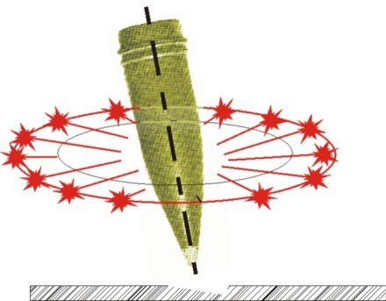
The most efficient action of direct action projectile is achieved by explosions on a horizontal surface at angle Θ near 90° or at angle Θ= 90°, (but not in praxis, because such actual angle of fall does not exist) because then lethal fragments are equally spread on a circle (Figure 5.1.).

Figure 5.1.
On hard surfaces (stone, concrete and asphalt road) a crater is usually not formed, but only minor damages to surface of ground can be noticed, because projectile falls to pieces even before it manages to enter the obstacle. Damage on surface is, usually, made by projectile fragments.

A crater of more significant dimensions is noticed only if the fuse was set to delayed function (fougasse action).

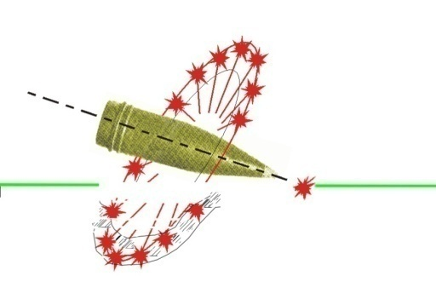
With decreasing angle of fall, suddenly number of lethal fragments acting on target decreases. That is explained by, with low angles of fall, fragments which fly down, enter the ground, and fragments which fly vertically up have a steep path and when falling lose impact energy because of overcoming drag force at climbing part of their path. Effect on target will be achieved only by fragments which fly sideways. Character of bursting of lethal fragments at low angles of fall is shown on the figure (Figure 5.2.).

Figure 5.2.

Direct action of projectile on different targets is assessed by Coordinate Law of successful effect, which establishes dependence between a certain degree of neutralizing (destruction) of the target and distance of projectile explosion from it.
Analytical form of Coordinate Law of successful effect with direct action of projectile is determined by calculation-experimental ways, based on results of investigations of explosions in the target region.
Methods of determining Coordinate Law of successful effect based on results of experimental shooting (explosion of projectile in target region) is formed with:

After preparing the necessary target situation, with specific four-side or six-side fence for accepting shrapnel after an explosion, experimental shootings are done (explosions are being provoked) in target region, in target diagram (scheme) area.
Other than fence experiments, earlier were conducted experiments on experimental animals, and in both cases inside the fence between test animal numerous instruments for measuring other meaningful parameters of explosion were set up.
Shootings (projectile explosions) are done by single-fire with such angles of fall which correspond given distances of firing. After each explosion caused neutralizing (destruction) of target is marked. A man is considered as put out of action if a lethal fragment has enough impact energy to pierce through a dry fir plank of 25mm thickness (kinetic energy of around 100J).
Knowing total number of targets and targets hit, frequency of hitting in each sector for all fences is determined. After analyzing data of a large number of experimental shooting (projectile explosions), frequency of hitting the target based on its distance from the point in which the explosion happened is calculated.
Frequency determined that way, based on Law of large numbers, is considered the probability to hit.
On Figure 5.3 spreading of probability to neutralize (destroy) the target (hitting the target) is shown, acquired from test shooting, when target is in the zone of spreading of lethal projectile fragments.

On the Figure for coordinate beginning is given the exact point of projectile explosion, in relation to which are shown parts of ΔSi area; when target is on those areas, probability of its hitting will equal to Pi. (Scale below, beside of Figure 5.4).

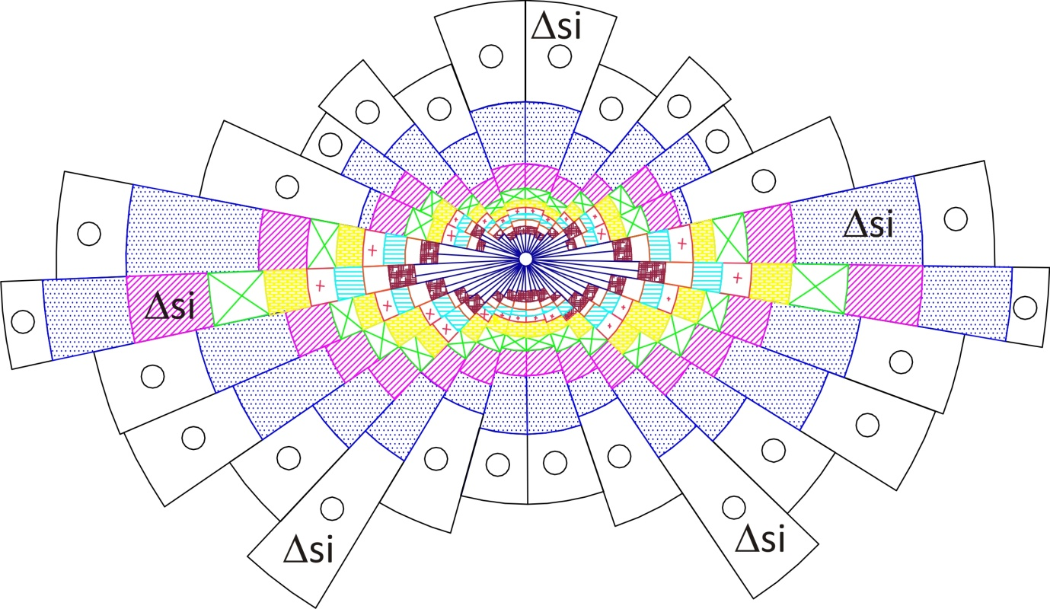
Figure 5.3.
If for coordinate beginning center of target is taken, and from points with coordinates Xi , Zi , which are suited to center of parts of elementary areas marked with ΔSi , and set up appropriate ordinates Pi, then the surface which combines pinnacles of those ordinates will represent Coordinate Law of successful effect on target, G(x,z), with direct action of projectiles (see Figure 5.4.)
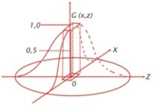 | 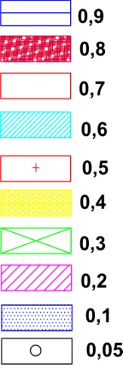
Figure 5.4.

Law of successful effect G(x,z), is the most complete characteristic of direct action projectiles, but for its use for assessing successful effect in praxis, and especially for expressing indicators of shooting efficiency, is tied with big difficulties.
Calculating the probability to hit and destroy requires hard-labor calculations with altering several stochastic variables which connection with function is not expressed via elementary functions, so methods of numerical integrations are used for achieving quality results. Integration step is very small, so calculation represents a demanding task even for modern computers.

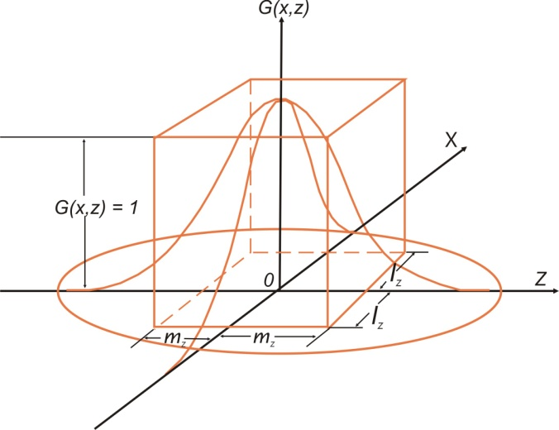
Figure 5.5.

When calculations are done and all indicators of Law of successful effect G(x, z) are obtained, their practical use for assessing of mass artillery actions and planning needed ammunition quantities is hindered, because the dimension of area which the lethal fragments cover, even for the most potent projectiles, is no more than one point on the map regardless of the map scale.
Although, when speaking about assessment of single projectiles, on a limited space, Law of successful effect G(x,z) gives the most complete and most reliable data.

Mentioned difficulties, connected to assessing of direct action of projectile and for calculating indicators of fire for effect efficiency, demanded to replace real Law of successful effect with the Law of successful effect with accuracy approximate to the real Law of successful effect.

Point of replacing, and by suggestion of V. E. Lebedeev, is in that the perimeter which is limited with area and plane X0Z from Figure 5.5 should be considered equal to the perimeter of parallelepiped, the height of which is equal 1, and that ratio of sides of rectangle which is in its base is similar to the ratio of areas on which really are lethal fragments, apropos:
After shown replacement of the real Law, analytical expression of the Law of similar accuracy could be written as:
Side of rectangle marked with 2lz, is usually called depth, and side marked with 2mz –derived front, while area Sz= 2lz·2mz is called derived area, or derived zone of direct action.

Starting from acquired dependence of approximate Law, one could derive its formulation in a following was: the target will definitely be neutralized (destroyed), if explosion does not occur outside of derived zone 2lz·2mz, and it will not be neutralized (destroyed) if explosion occurs out of boundaries of that zone.
Therefore derived zone of successful effect is also referred to as derived area of target, and line ratio of derived zone of successful effect – derived ratio of target (for instance, a man out of cover).

Since when hitting the derived area of target (derived zone of direct action), real target is put out of action, the probability to hit even with one shot into that area is, at the same time, the probability to neutralize (destroy) the target.

Calculating values of indicators of efficiency using Law of successful effect of similar accuracy, is significantly simpler than when using the real Law. This allows deriving a conclusion about possibility and usefulness of replacing the real Law with Law of successful effect of similar accuracy.
At that replacement, as a characteristic of direct action of projectile, the value of derived area Sz is taken.
For calculating the numerical meaning of Sz, the following procedure should be done: by knowing the spreading of probability of direct action in the zone of projectile (mine) fragments spreading (see Figure 5.4.), mathematical expectance of area on which the target will be destroyed is found, using the formula:
Where:
Sz – derived zone (area) of direct action;
ΔSi – part of area, within which’s boundaries the probability of destruction equals Pi.

When calculating indicators of efficiency of firing and when solving other issues, it is necessary to know not only size, but also line ratios of derived zone by front and depth. Therefore, they are presented as derivatives of front, 2mz, and depth, 2lz, apropos:
Values 2mz and 2lz are considered as such, so their ratio fits the real ratio of front and depth of zone of spreading fragments. For most projectiles (mines) that ratio is considered as:
On upper shown way calculated values of derived zones of successful action for different calibers are stated in Table (5.1.).
Table 5.1.
Values of derived zones of direct action for men out of cover
Type of  artillery | Caliber | Unshielded  men in standing position |  |  | Unshielded  men in laying position
Type of  artillery | Caliber | Front of zone  ( m ) | Depth of zone  (m) | Area Sz  (m²) | Front of zone  (m) | Depth of zone  (m) | Area Sz  (m²)
Rifled guns | 85 | 28 | 10 | 280 | 19 | 7 | 130
Rifled guns | 100 | 31 | 13 | 400 | 22 | 9 | 200
Rifled guns | 122-130 | 40 | 20 | 800 | 24 | 13 | 310
Rifled guns | 152 | 43 | 22 | 950 | 26 | 14 | 360
Mortars | 120 | 56 | 28 | 1570 | 39 | 19 | 740
Mortars | 160 | 63 | 36 | 2270 | 41 | 21 | 860
Mortars | 240 | 94 | 46 | 4330 | 58 | 34 | 1970
MLRS | middle | 43 | 21 | 900 | 36 | 18 | 640

Analysis of data from Table 5.1. allows deriving of following conclusion:
- Derived zones of direct action are enlarging with enlarging the caliber of projectile;
- Derived zones of direct action for mortars are about two times larger than derived zones for grenades of the same or similar caliber.

For instance, for a 122mm shell derived zone for a shooter in standing position equals 800m², and for a mine 120mm, Sz= 1570m².

This confirms advantages of mortars when firing on living force without cover. Acquired conclusion is, also, completely consentient with earlier established facts (Figure 2.2.1) that the most efficient action of direct action projectile is achieved with explosions on a horizontal surface with angle, Θ= 90⁰, (but not in praxis because such an angle of fall does not exist in praxis) because then lethal fragments are equally spread across the circle. Mortars are characterized by angles of fall near Θ =90⁰, fragments spread is uniform across the circle, and only a small portion is going upwards and downwards, so in these conditions a mortar of same or near caliber is more efficient.

These conclusions are expected and could have been assumed without special research and based on practical experience, but the real meaning of derived zone will be shown only in later considerations.

Upper considerations are almost wholly taken from a book of group of authors from Leningrad Military Artillery Academy under general redaction of general-major of artillery A. I. Matveev: "Теория стрельбы наземной артиллерии", учебник, Ленинград, 1966 and notes from two-year lectures on that academy 1982 – 1984.

All of this would not be important if, based on derived zones of destruction for different projectiles from Table 5.1., were not done all norms of projectile expenditure for achieving required effects on target and requirements for commitment of number of artillery units which can achieve those norms in a particular timeframe. Those norms exist, in a smaller or larger scale, in all large and modern armies.

Based on such derived zones of successful effect of projectile, defined are rules and practical recommendations for determining needed amounts of ammunition (norms of ammunition expenditure) for different distances of firing and for other specific conditions during the firing itself.

Even more important is that these recommendations were made in the country in which the 130mm weapon was produced, just as Firing Tables and ammunition, and that they are used by all who own those weapons in their arsenal, and are also used for other weapons from former Soviet Union, whether they were bought or produced by licensing.

The same norms are used for assessing of successful effect of projectile on different targets, and for projectiles wherever they were produced (there are not many manufacturers in the world- only about 20), and in praxis so far, mentioned norms did not show deviation from the shown Coordinate Law of successful effect.

The same Law of successful effect of projectile which is in all of mentioned rules and practical recommendations for calculation of needed quantity of ammunition for achieving required effects on target, is even today used in Russian Federation, Ukraine, China, India and many other countries which own artillery weapons made in former Soviet Union. Generally speaking- it is used in artillery force in bigger part of the planet.

As stated earlier, Coordinate Law of successful effect sets up a correlation between a certain degree of probability to neutralize (destroy) the target, and distance of explosion of projectile from it.

Derived zone, Sz (derived area of target), which is determined as a characteristic of Coordinate Law tells us that target (a man out of cover) will be put out of action if he is on the surface which fits to the area of that zone, but with a certain probability depending on his distance at the moment of explosion.

The term "put out of action", in no way means only causing lethal injuries. By experience, the division of war injuries shows up to 30% of deadly injuries, while the rest 70% is wounding. From this 70%, again in same ratio 30%: 70% are numbers of heavily wounded (irreversible losses) and easily wounded (reversible losses).

Coordinate Law of direct action projectile itself was made on such division by experience, for the degree of causing losses 22–25%.

Coordinate Law of effect was not made for cases of people in high-concentration in small areas, but is very good in characterizing effects of projectile action even in such case. High density of people acts in two ways: with increasing number of injuries, but also with protection of those who have other people in front of them. The people in 3rd or 4th row of crowd can't be considered as exposed.

In case of effects in explosion in “Kapija” square in Tuzla, one could write whole studies, but it will not be the case here, because here it is about the effects on “Kapija” square being completely opposite to effects which are expected from Coordinate Law of effect for artillery direct action shell.

- First: Fuse of projectile is set for direct action, and angle of fall is very high for a cannon, surface is granite cubes: – from where did this crater 50cm in radius and 20cm in depth come?;
- Second: The amount of material around subject crater is multiple times higher than the volume of crater itself;
- Third: Distribution of injuries on people and damages on buildings are diametrically opposite to effects derived from theoretical and practical knowledge about effects of artillery projectile. Where no significant effect should have occurred – maximum effect occurred, and vice versa – people who were less than two meters from center of explosion have survived, although they were exposed to deadly blast wave of explosion.

It is now possible to ask some questions:
– From where did prosecution expert take data about radius of 27m from center of explosion for 130mm projectile?;

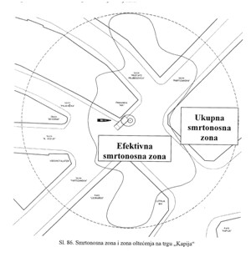
Figure 5.6. –– Figure 86 on page 72 of expertise by prosecution expert
– Based on what research according to SNO 5021 did he get that information, and have there ever been researches in former DFY, FPRY or SFRY of combat effectiveness of 130mm projectile or any artillery projectile (we don't speak about AR mortar projectile) and when did they and how did they do it, he or anyone else, on “Plave vode” proving ground or proving ground of “PRETIS” factory from Vogošća? Was it not only determining of radius for spread of lethal fragments for a vertically positioned 130mm projectile for fulfilling SNO 5021 standard, and for checking the correctness of Machine Park?
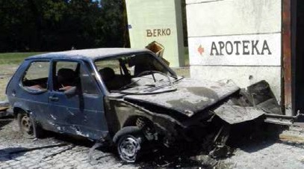
– Is the projectile with such a radius deadly for buildings also, as the prosecution expert shows on Figure 86 on page 72 of his expertise, and are the fragments patrolling around those buildings and inside of them? Was anyone killed inside of any of those building on that 25th of May 1995?
– Could the projectile with such a radius of effect cause damage to the “Borac” store and also on completely obscured showcase on south-east side of former street N. Tesla (today called Jevrejska Street)?
It is obvious that anything that is required is possible, with prosecution expert!
Figure 5.8 Damage to the Golf Mk1 car gained by experiment on 25th of August 2014 year - broken front right part of suspension, destroyed front tire, heavy damage to both right rims, all of glass surfaces destroyed, fragments inflicted damage on whole right side of car. None of results look like damage to the subject car.

A 27m radius from center of explosion gives an area of lethal zone 27² х π = 2290 m² which is more than derived zone of direct action mine for 160mm mortar, with more than double the amount of explosive and angles of fall over 75⁰.

Area of derived zone of direct action on manpower out of shelter, for 130mm projectile, equals, as seen in Table 5.1., Sz= 40 х 20 m = 800 m² and it is almost three times smaller than the one used by prosecution expert.
When image of Coordinate Law of effect is put on the plans of “Kapija” square (Attachment 1), based on facts from theory and praxis, the following can be expected:
- Lower beam of fragments is completely stopped by ground and car body, and rear beam by upper part of “NIK” building façade, left from showcase;

- Damages to Golf Mk1 car significant; heavy damage (up to the point of destruction) to the rims on right side of car and tearing the tires on them; piercing of all tires, by fragments, piercing right side of car body and doors, piercing the whole depth of the car up to brake lights, breaking of front right part of suspension and dropping front right side of the car on the ground, disintegrated front part of midfield sheet metal and lights, breakage of all glass surfaces on the car except, possibly, side mirrors;
- Damages on the “NIK” building” – facade (left) above the car Golf Mk1 heavily damaged, all front and right side windows on the building destroyed as well as a part of left side ones, nothing left in the storefront, dolls are broken and thrown around the store, right side of façade sustains heavy damage, as well as protruding part of building in Mustafa Mujebegović street towards Partizanska street, as well as part of facade in previous street, which would have been damaged by fragments which flew through north-west windows of “NIK” building;
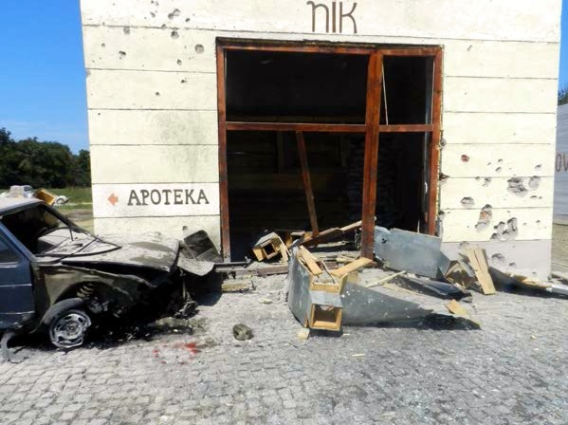

Figure 5.9. Experiment from 25th of August 2014: Center of explosion is within the red circle, front right part of suspension of the car destroyed, front part of vehicle lies on cobblestone, car thrown back 45cm and towards the wall 47cm where movement was stopped. Damage on “NIK” building facade is visible, completely destroyed store window without any dolls in it. None of what the experiment has shown looks like damage to the real “NIK” building and the subject car. There is no visible crater, let alone thrown out cubes!

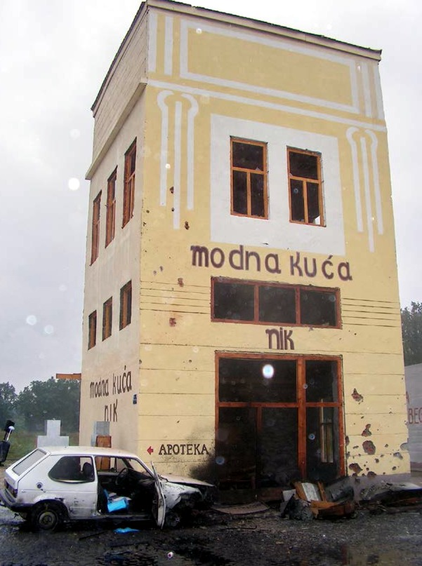
Figure 5.10: Experiment done on 04th of September 2014 – in front of international observers– damage to the “NIK” building and on the car set up in a way as done by prosecution expert; almost same effects are visible on both the car and on building as on Figure 5.9. There are no undamaged windows on the building.
- Upper beam of lethal fragments, pointed towards “Kapija” café general direction, and middle part of that beam will be above the café at 68m height, while above middle part of “Kapija” store building it will be at 19m. Since there were many people in this area, it is not possible to explain low-positioned damage by many fragments on “Kapija” store building and law office “Pašić” facade, and especially it is impossible to explain high damage to “Samoizbor” store;

- Damage to showcase in N. Tesla street and on “Borac” store are impossible events;

- Right (southern) part of beam of highly-efficient fragments will drop on façade of “Leonardo” café and down Partizanska street, and left equally efficient on right side of “NIK” store building, protruding corner of building in dr. Mustafa Mujebegović street, as well as corner of “Samoizbor” building;

- If considering 130mm projectile explosion, on the distance from center of explosion over 10m, and towards “Kapija” café, lethal fragments should not be expected;

- Damage to PZ 125 car would be significantly bigger than the ones that actually happened on the subject car;

- Damage of back window on the car near the end of Partizanska Street, during which its windshield remained untouched is an impossible eventј, because the windshields is facing towards beam of fragments.

- First look on Figure 5.11 points out sharp inconsistencies with consequences shown in subject explosion on “Kapija” square. The most expressed effect of side beam of fragments is pointed towards “Leonardo” café, and one should expect the highest effects there. However, in subject case, PZ 125 car is almost untouched, and damage to Golf Mk1 is disproportionately smaller than expected, as well as experimentally confirmed;

- Things standing out, as conspicuous inconsistencies, between experimental and real situation: victims at “Gulam” café, injuries to lower extremities on people at “Kapija” café, as well as a large number of low-positioned damages to “Kapija” store building, which cannot be explained by explosion on the ground, if assuming that a large number of people was between the center of explosion and that facade.

- Damage to the north-west side of facade of “NIK” building caused by sharp objects, which fly in a rising angle in relation to the building vertical, are caused by other explosion source and not from the one in front of “NIK” building, unless somebody wants to prove that artillery shell fragments caused by explosion can travel around, patrolling around the building or a quart.

All expected damages and possible consequences which are expected when Coordinate Law of destruction which characterizes 130mm projectile is applied onto real-life scene, are obtained by experiments which were done in experimental conditions with multiple real projectiles activated.

Terminally-ballistic and route indicators obtained by experiments and those from real-life scene are essentially different on two diametrically opposed details and in a way which is not met in artillery practice, which points out to scientifically based, theoretically and practically justified expert finding:

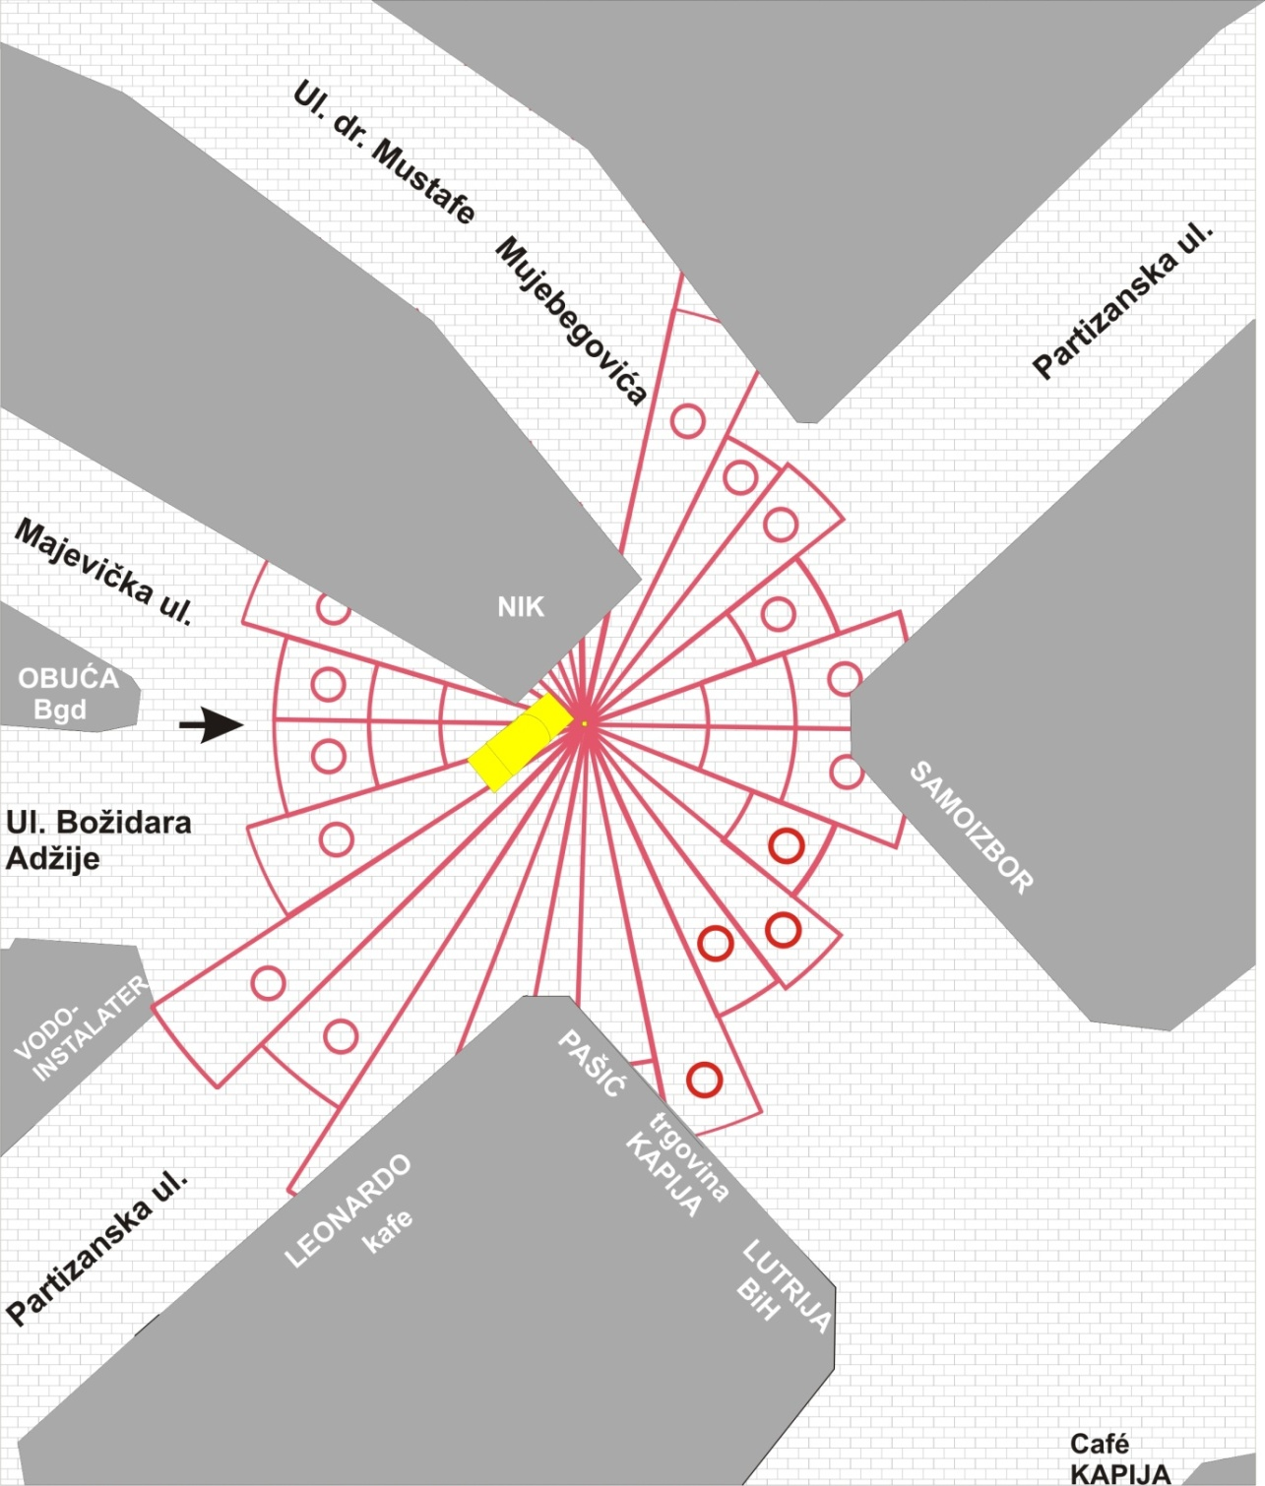
Figure 5.11.: Coordinate Law of direct action projectile on personnel out of cover – fan-like figure in red color, total dimensions 40m in north-south direction with 20m in east-west direction set on the center of explosion. Small red circles represent centers of ordinates 5% probability to inflict losses. Short black arrow represents the direction of flight of alleged projectile. Better illustration is located in Attachment 5.1 and Attachment 5.2.
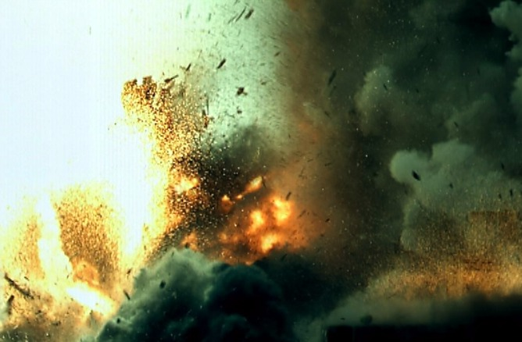
ЦЕ
Figure 5.12.: Looks of fragment beam of upper part of projectile, directed towards “Kapija” café, which illustrates the height of fragments on distance of 10m from center of explosion (right lower edge of image). Footage was made with ultrafast camera.

The effects of explosion in actual conditions on “Kapija” square are not at all matching to those effects shown by a fired 130mm artillery projectile.
This is proven by comparing the subject effects on “Kapija” square, theoretical considerations and many years of practical realizations as well as with effects acquired from several times done experiments, from which stems that:

Explosion on “Kapija” square cannot be attributed to a fired 130mm projectile.

Ова је страна је намерно остављена празном!
овде иду Attachment 5.2 и Attachment 5.3, штампани у формату А3, а пресавијени на формат А4!

6. TERMINAL - BALLISTIC INDICATORS, CLUES AND CONTRAINDICATORS

The effect of the projectile on the target leaves traces and clues that are a consequence of the explosion shock wave, thermal effects and fragmentation of the projectile. Here will only be considered parts of traces of fragmentation ацтион, that are in the photo-documentation CBS Tuzla, which are attributed to the alleged explosion of a 130mm projectile, on 25th of May 1995.
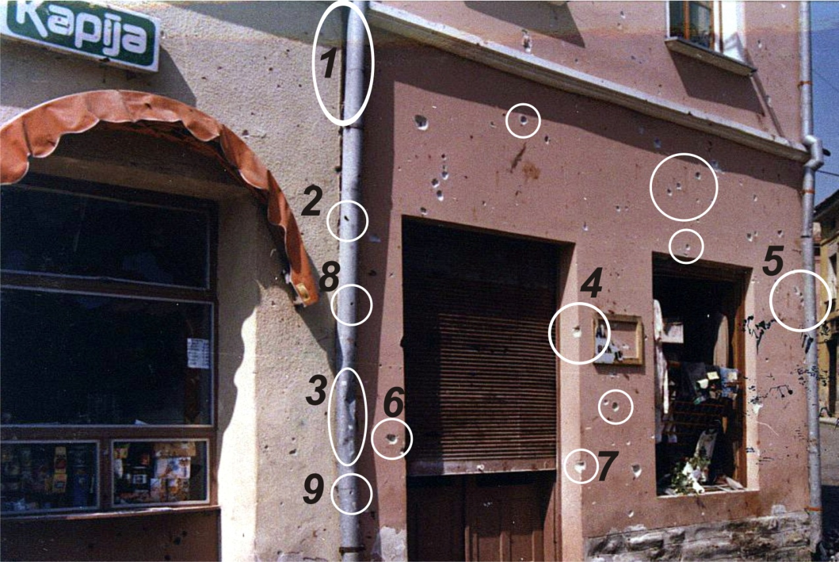
Figure 6.1 (photo N⁰ 36 from the photo-documentation of CBS Tuzla)
The traces on the facade of the former "Pašić" lawyer office which are attributed to the alleged action of the 130mm projectile.

There are 2 white numbered ellipses, 7 white numbered circles, 4 white circles without a number designation. These are tags that indicate on those traces (damage to the building facade) which completely exclude the possibility that due to the fact of, any artillery projectile, and particularly that of 130mm. There are following clues that completely exclude the possibility that the explosion of artillery projectile, and are indicated by numbered circles and no markings.

1. Gutter bent in the direction towards the source of the explosion;
2. Pierced gutter from the direction opposite to the direction of spread of the explosion;
3. Whichever explosion outside the "NIK" building that can cause such damage and to leave intact the edge of the wall that connects mark 4 and 7. These are also, undoubtedly, traces of action objects that flew in from the direction opposite to the direction of spreading of explosion;
4. Damage to the wall (mark 5) in a place that is concealed by gutter and without any visible sign of damage to the gutter on the side that faces the center of the explosion;
5. The openings of the gutter (marks 8 and 9) in the direction normal to the direction of spread of the explosion, the same applies to the mark 6. Such leads are completely uncharacteristic for the warhead fragmentation- round holes like those obtained by bullets of the small arms;
6. The battered gutter without breakthrough- which can't be attributed to the warhead fragmentation. Shrapnels of the shell at a distance of 10m from the center of the explosion still have a speed of over 700 m/sec and such damage to gutters can't be attributed to them. All experiments performed with the activation of the actual 130mm projectile show breakthroughs of gutters that are irregular in shape and with very sharp edges;
7. All other marks indicate the proper damage of round circular shape that could not be produced by the fragmentation of the shell body.
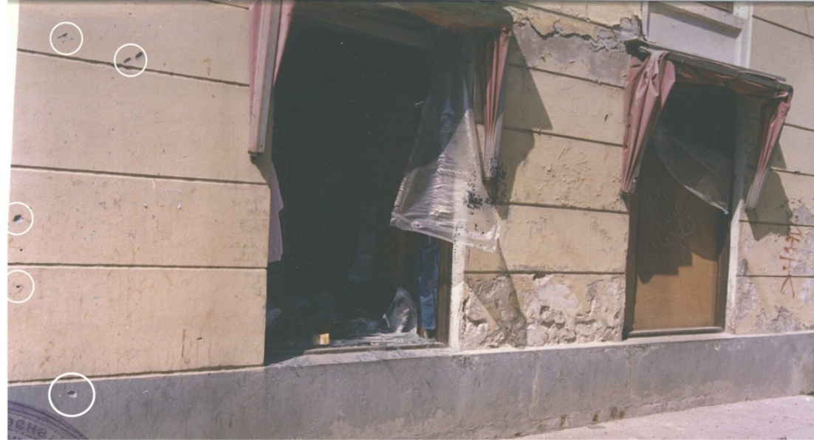
Figure 6.2 (photo N⁰ 45 from the photo-documentation of CBS Tuzla)

The figure above represents the wall of the building of the (then) fashion clothing "NIK", which extends north-west (South-East) direction. The windows are facing Dr. M. Mujebegović street. From where did the sharp pieces come, at an angle of about 50⁰ in relation to the ground and the right edge of the building, which left marked traces on the facade completely sheltered from the explosion?

The following photo (Figure 6.3, photo no. 37 from CSB Tuzla archive) is crucial evidence that shows the consequences that can't be attributed to the direct action of the artillery projectile.

The shock wave of the explosion comes, obviously, from the "NIK" building behind the man in the photography Nº 37 from the photographic documentation of CSB Tuzla.
What kind of a shock wave that throws the doll out of the shop window toward the "Kapija" cafe, ejectes trade shop paneling perpendicular to the shock wave explosion, bends pink table metal legs perpendicular to the shock wave, and the popcorn in the device and cans of drink rejected and not to the store "Samoizbor "? From where, from which direction came the explosion?
From physics of explosions it is known and in praxis has long been observed that when the pulse dilution is higher than the momentum compaction, it can lead to the breakage of glass, the pieces of which fall in opposite direction to the shock wave, (towards the center of the explosion, certainly not normal to the shock wave) but this is not the case because the amount of explosives in the missile is relatively large and the distance to the object of the relatively small. In particular, it does not apply to materials such as paneling and definitely not for metal legs of tables.
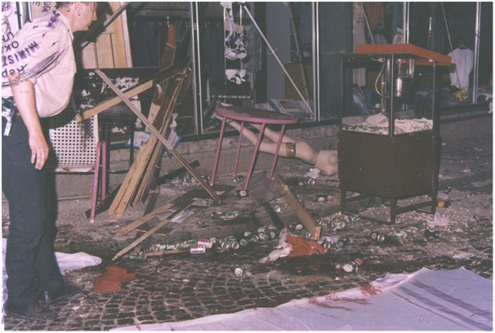
Figure 6.3 (photo N⁰ 37 from the photo-documentation of CBS Tuzla)

Only the blast which comes from a height of 0.5 meters or more can cause heavy damage to the lower parts of the opposite wall of the "Kapija" shop, because the uninhibited shrapnel of the upper beam of the alleged 130mm projectile that came from the front of the "NIK" building, at a distance of 10m from the center of the explosion would be already at a height of 17m.

Taking into account that the explosion in the vicinity of the car (max. 0.3 m from headlight) rejects the same car just a little bit (measured average by the hypotenuse, in each experiment minimum 0.7 m), we can conclude that Golf Mk1 car on the real crime site before the explosion was on a far greater distance than the one described by the prosecution expert. It also shows that the above mentioned Golf Mk1 car, before the RCS explosion, was in the position that did not allow to the projectile to hit the stone pavement without destroying the bonnet of the car or even wayfarers space of mentioned motor vehicle.

All the earlier expected damage and possible consequences that could be expected or predicted are expressed when Coordinate Law of destruction, which characterizes the lethality of the 130mm M46 shell, is applied to the simulated crime scene (during experiment). The experimental results in experimental conditions (near to RCS) were several times confirmed by activation more than 20 ОФ482М projectiles and by destroying more than 16 different functional, technically correct and properly registered cars of the same brand and type.

The difference between predicted and experimentaly expressed results are minimal, even negligible.

The terminal-ballistic indicators obtained by experiments and those from the RCS are substantially different and diametrically opposed to the last detail. The resulting events and consequences which until now are not recognized in the artillery praxis entirely justify a scientifically, theoretically and practically based professional findings which pointed out to the fact that the explosion at the "Kapija" square cannot be attributed to the 130 mm projectile.

The greatest fraud in the RCS court case refers to the number of victims, which is enormously high and cannot under any circumstances, according to previous and current human knowledge, be the effect of the explosion of a single simple shell of a rifled artillery.

We might be able to convince a few people who are not familiar with the fact and artillery firing practice that above mentioned casualties are possible, but this case was one of the three most notorious cases in Bosnia in which the explosion of a single classic arillery shell results in a number of dead ranged between 60 and 80.

We might be able to convince far more people in amount of above mentioned casualties. But this cannot be done because of the second inexorable fact. In all three cases that were notorious, effects were achieved not only with one single projectile, but in all three cases it was the first one of the fired projectiles.

This is extremely exaggerated, but that does not mean that we do not know from where something originates. There is common knowledge that the number of victims in the range of 60 to 80 in a single accident has a feature that activates the trigger of international public opinion. After such a appearance which stirs up public opinion nobody cares about whether there were tens of kilograms, hundreds of kilograms or perhaps more tons of explosives.

Therefore, these frauds may not longer be tolerated!

What are the chances that something like this would happen? The prosecution expert asserts that the distance between the FP and alleged point of impact was, as follow:

R_{M}=27 100±380m

The value of ±380m, as prosecution expert asserts, represents ±4 probable error in range, denoted here as E_{R}. For the distance, for example, from the 26 720 meters (lower range limit given by prosecution expert i.e. 27 100m – 380m =26 720m) in an actual nonstandard firing conditions, the рrobable error in range to impact is 77m and рrobable error in deflection at impact, denoted here as E_{D} , is 11m. Therefore, +380m is equal to 4.94 E_{R}, i.e. 380 :77≈4.94.

Considering that the center of impact (COI) or medium trajectory is now at the distance of 380m from the center of the target, probability of hit with the first fired projectiles may be calculated in different ways∗, but in this case there is no need for such a complicated calculation (O.K. today, with modern computers, this is not so complicated- just unjustified prolonged operation- today is more difficult to compile the correct formulated question than to get a satisfactory machine answer), because the problem is thoroughly examined, what derives from following consideration:

When we have, for example, the very small target so called „elementary target“ (for example one cannon between the others cannons at battery FP) denoted as target D with surface denoted as S, we can write∗:

$$P\left(\left(X,Y\right)⊂D\right)=\iint_{(D)}{f(x,y})dxdy$$
Where the term:
$$P\left(\left(X,Y\right)⊂D\right)$$
denotes the probability that the center of impact (COI or medium trajectory) will not be out of the surface S, whence arises:
$$P\left(\left(X,Y\right)⊂D\right)=f\left(x_{0,}y_{0}\right)\iint_{(D)}{dx dy=f(x_{0,}y_{0}})S_{D}$$
And after a brief transformation of formula with the aim to adapt it for the probable errors (also, probable erors E_{R} and E_{D} will be a measerement unit rather than mean square error σ) and after entering the starting value we will obtain∗∗:

$$P\left(\left(X,Y\right)⊂D\right)=\frac{{ρ^{2}S}_{D}}{E_{R∙}E_{D}∙π}∙e^{- \frac{{ρ^{2}x}_{0}^{2}}{E_{R}^{2}}-\frac{{ρ^{2}y}_{0}^{2}}{E_{D}^{2}}}$$
And respectively,
$$P\left(\left(X,Y\right)⊂D\right)=P\left(D\right)=\frac{ρ^{2}∙1}{77⋅11∙π}∙e^{- \frac{ρ^{2}∙{380}^{2}}{{77}^{2}}-\frac{ρ^{2}∙0^{2}}{{11}^{2}} =}$$
i.e.
$$P(D)=0,00008548∙e^{-5.53996}=0,000000336=3,36∙{10}^{-7}$$

So, the probability to hit such a target with a single shot is P(D)= 3,36·10⁻⁷.

From the theory of firing is known that the probability P₁ to get at least one hit during N launching is equal to:
$$P_{1}=1-{\left(1-P(D)\right)}^{N}$$
Or:
$${\left(1-P(D\right))}^{N}=1-P_{1}$$

And, consequently, the required number of projectiles fired, N, is equal to:

$$N=\frac{\log\left(1-P_{1}\right)}{\log\left(1-P(D)\right)}$$

Taken P₁=0.95, which means that we seek the required number of projectiles N, which in these conditions gets at least one hit with a probability of 95%, i.e.

$$N=\frac{\log\left(1-0,95\right)}{\log\left(1-P(D)\right)}=8924626.6≈ 8 924 627 projectiles$$

That means, if we want to obtain at least one hit with a probability of 95% we need to fire approx. 24 451 projectiles every day during 2 years and to drive a cannon with 8 tonn mass to change the barrel tube hither and thither 200 kilometers 61 times each day. Nonsense, is not it?

This result shows that these events are impossible in praxis as in theory. But, unfortunately, the above presented calculations do not imply the changes of canon barrel tube and replacing this part with new one, and also do not include the time required to do it.

Reading these lines someone could cry out: „You and only you do make these calculation meaningless - nobody but you, hitting the target of 1m² from a distance of 27 кm! ″

Let the man who cried out to be absolutely right.

Well, let that same man to be satisfied.

Think also about the entire square as a target (surface about 350²m)! Who said that? It was said by the prosecution expert explicitly, transcribing those lines from UNPROFOR authorities, literally∗∗∗.
Let’s see what are the chances to hit "Kapija" square with the first round? Concerning the range of firing of 27480 m: ER= 82 m, ED=12m. Exceptionally convenient for prosecution expert! After entering the starting value we will obtain:

$$P\left(\left(X,Y\right)⊂D\right)=P\left(D\right)=\frac{ρ^{2}∙350}{82⋅12∙π}∙e^{- \frac{ρ^{2}∙{380}^{2}}{{82}^{2}}-\frac{ρ^{2}∙0^{2}}{{12}^{2}} }=0.00019469≈2∙{10}^{-4}$$

Also, such a result shows that with the 0.95 probability hit by first round requires the firing of 15 386 rounds to obtain at least one hit. That means- more than 42 rounds each day to the each target during one year while the barrel tube must be replaced every 10 days.

Did anything like this happen? The answer is– not. According to human knowledge- not! By records– not! By court– the same answer (NOT!) is valid as well as for the prosecution. But how to interpret the opposite assertions? The answer should be given by the reader of these lines!

In any case, hitting the square is not completely impossible. But arrival of the projectile which was flying over Golf Mk1 car (from the west) and exploded in such a close proximity (16cm as on RCS) of the opposite (eastern) side of the right wheel with an angle of fall of 62 degrees is absolutely impossible. Even kids know, if we are looking for the happening of the two events, one probable and other absolutely impossible – we will look forever.

With above mentioned facts - many earlier reported single first-shot-direct-hit-70 killed and all that followed by such an enormous lethality, few more words are left to be said. The probability that one artilleryman achieves the same success three consecutive times in a time interval of three years in the different places using different crewmembers as well as artillery piece and ammunition, and as mentioned, with one and also the first one round, cannot be calculated. It is beyond human comprehension.
How can these things happen? In fact, there is an only one acceptable answer. In this area there was and still are a lot of blacksmiths. What did come out from their forge? The answer is obvious - the forgery.

In addition to the above, the court failed to appreciate the existence of many suspicious circumstances the weight of which will prevail at any average court.

A brief chronology: (available data from judical records, published without any shame)

(May 25 1995)
- 20⁵⁵h. The alleged explosion of artillery shell occured with prolonged interruption of electricity supply at the same time;
- 21³⁰-22⁰⁰h. Judicial and police personnel was alarmed. They were arriving gradually at the RCS in the interval between 21³⁰ and 22⁰⁰ hours;
- 22⁰⁰h. None of the victims was on the square- the wounded and dead were evacuated before investigating judge arrived– (see Tuzla High Court record);
- 23⁰⁰h. Despite the interruption of power supply, the entire mentioned personnel knew: it was the explosion of a Russian 130mm ОФ482М projectile, the projectile flew from the direction of 270^{±10} degrees and from a distance of 20 to 27km. Such data was stated in the court report, regardless of a fact that without the lights on the street, no one could make a professional assessment based on traces left by the explosion.

(May 26 1995)
07⁰⁰ h. On the RCS came again the judicial and police personnel; by noon same day the crime scene square was thoroughly cleaned and washed. All human remains were collected and buried together in the same grave.

The entire clothing of the victims was burned or otherwise destroyed. The personnel of Tuzla Medical-Clinic Center did not even made one complete autopsy nor even one detailed external examination of the deceased.

On at least two (2) dead bodies were seen traces of operational procedures which indicated that they died during or after surgery. The cause of death of these people was not listed. No single X-ray snapshot was made. Only extensive photographic documentation was made.

Nabil M. Elsayed, Ph.D, and James L. Atkins, MD, Ph.D. in the book: "Explosion and Blast-Related Injuries: Effects of Explosion and Blast from...", accent:

"According to Israeli experience, a state which fights terrorism on a daily basis, the initial time to medical treatment of casualties after a terrorist attack ranges between 20-60 minutes, and that up to 18 patients in 6 minutes can arrive to treatment".

Israel is a country that is struggling with terrorism for decades and on a daily basis. It is understood that they are adequately organized in such situations.

It is worth noting that in subject case all of injured and dead have been evacuated in 30 minutes, or around 50 people per 6 minutes, which is an unprecedented record for Balkans in the 1990-ies, because the evacuation capability overcame the Israeli experience almost 3 times. What kind of miracle?

All mentioned shows that the integrity of RCS had been hardly violated and contaminated and we met many illegal and inexcusable amateur guided operations in a manner that is contrary to all the rules of the profession.

The prosecution claims that they found the bottom of the 130mm projectile, pointing out to a piece of metal as a key evidence.

According to all subsequent measurements of found bottom plate of alleged 130mm projectile, it has a diameter that is, even after obvious deformation, 10% larger than the diameter of the 130mm projectile and probably belong to the 155mm shell.

According to a given brief chronology and manner of judicial and police authorities it is more than clear that with these procedures something enormously huge and shamefull was hidden in the background of this tragic event.

It is necessary, next to above listed facts, to mention two additional:

After the blast the whole "Kapija" square was covered with a layer of a red dust which was strongly standing out compared to the colors of the surrounding architecture and at the same time there was no significant clue pointing out to the massive bricks destruction in the vicinity.

Many objects that could not belong there were found in the immediate vicinity of the explosion. These items were not displayed in the court documents and during the trial were not even mentioned.

But in spite of that fact, these items were easy to see in the numerous photos from police archives. The diversity of these objects clearly shows that they could not been on this area before the explosion. There were, for example, a metal lever commonly used to tighten the wire, one metal palmshaped plate with welded shackle of the chain followed with door handles as well as the door locks and hinges of the crates.

Additionaly, there were discovered the relatively long chopped rods for concrete reinforcement and lots of pieces of the dark green colored, about 8 mm thick, plastic.

One of these items is very interesting. This is something which was found after pulling back the damaged Golf Mk1 car backwards and that item was beneath of the same car. It is an object which looks like the cover of air filter of the engine, but this item does not belong to the Golf Mk1 car.

The incomprehensible multitude of colorful objects was found there, but there is no more space for their description.

The bodies of people killed in a perimeter of about 7 m from the blast, were covered with a thick layer of black charcoal-like dust. Some particles of this dust were poppy seed-like and pierced the skin of the victims. There are many photos from Tuzla CSB archive; these photos show the same skin covering and puncturing.

It is very atypical and uncharacteristic because such a phenomenon (black sticky dust and large black dust particles) was never seen before in the explosion of known types of explosives which are used by filling of the artillery shells.

6.1 A LIST OF OTHER SUSPICIOUS AND EVEN IMPOSSIBLE EVENTS IN THE "KAPIJA" CASE

The case of "Kapija" square is just one characteristic example of how the Balkans great tragedy turns into a judicial farce. Despite of all the available evidence and the undeniable facts which were standing on the court table, the court did not want to see them, not to even speak about appreciation of these evidence and facts.

According to the testimony of many surviving witnesses, two men were at the time of the explosion located in a place where we can see the opened Golf Mk1 car door (Figure 6.1.1 ). They were leaning on the passenger compartment of the car and ate popcorn. A third man, under the influence of alcohol, was even closer (0.8m) to the blast. He danced on the bonnet of the same car.
All three men survived with minor injuries or just with scratches.

It is clear that this state of affairs exerts a series of practically impossible events that professional praxis will not accept and it cannot be accepted in any way. The case of "Kapija" square appears as a very, very dangerous judicial precedent with which from now on will be allowed to believe that the number of human losses as well as the facility damages increase with the increasing of distance from the blast site and vice versa. Therefore, from now onwards, a new, judicially established proffesional law is valid but just for Balkan Peninsula, and the same law reads as follows:

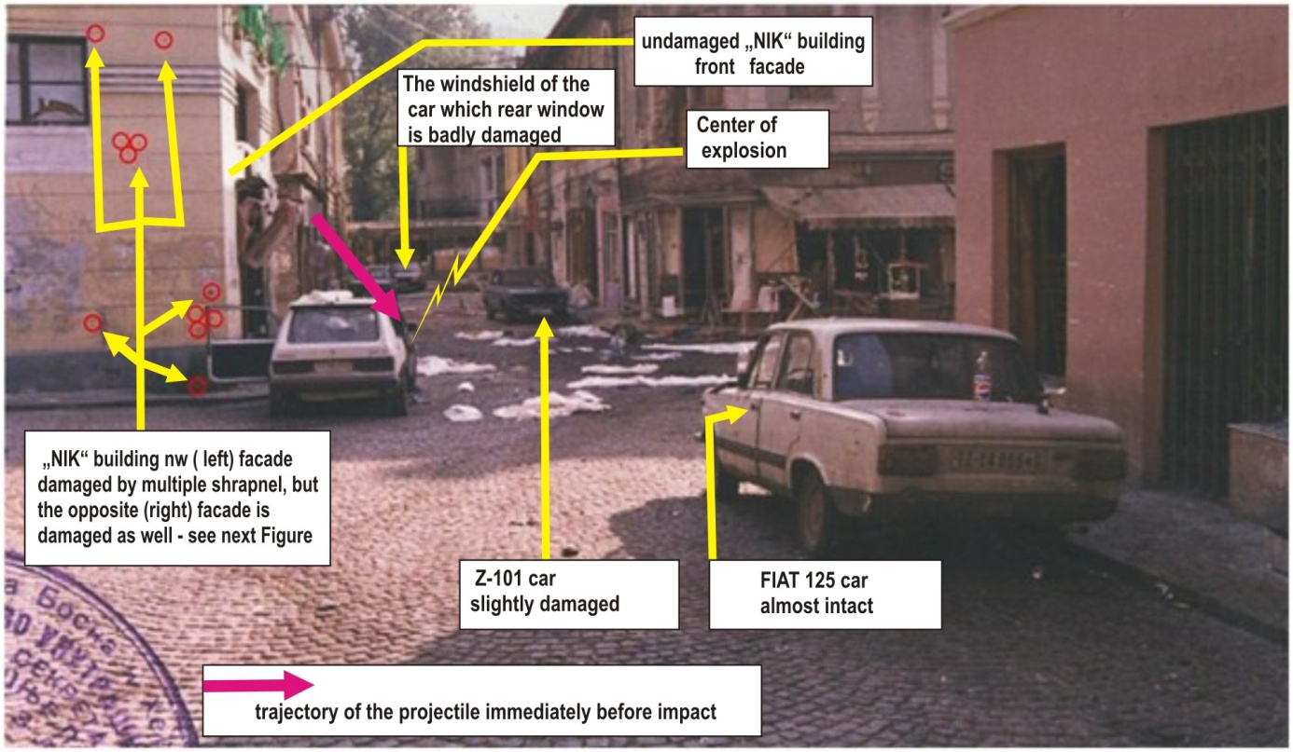
Figure 6.1.1
The spatial situation on the "Kapija" square on the day after the explosion. Left side of the front facade of the "NIK" building, just two meters away from the explosion has not been damaged, but the left facade of the same building beared many scars made by shrapnel from the bottom up to the top of the same facade. The figure above shows how huge are the mistakes, omissions and wrongdoing made by the court in this case.
The rule N⁰1 - "The artillery personnel must make the extraordinary efforts to miss their targets as much as possible to obtain the maximum effect on the target."

Figure 6.1.2 shows (middle photo) the frontal RCS facade of the "NIK" building. The part of that facade of the building left from the showcase is fully intact and free of scratches, (where ″APOTEKA″ is written - means „pharmacy“) while right positioned part of the facade (to the showcase) was partially damaged, but only to a height of 1.5 m. On granite stone pavement is pointed out with the point where the blast occurs (yellow-red).

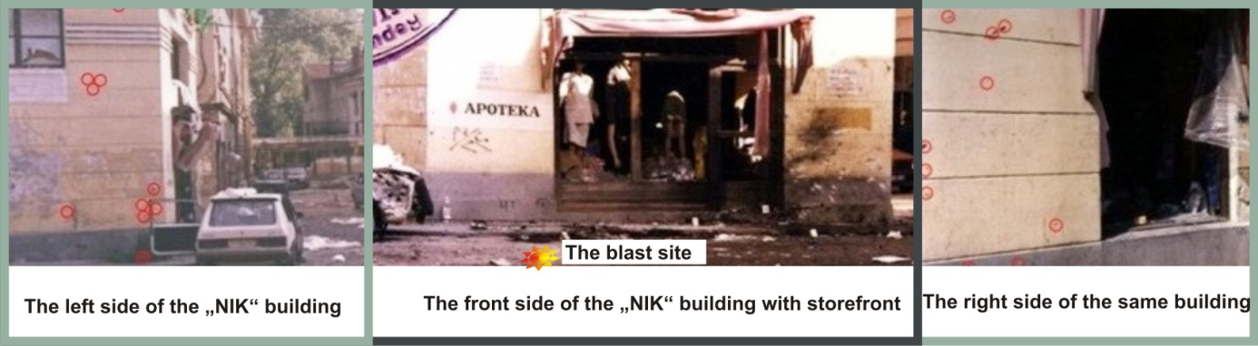
Figure 6.1.2
The left positioned photo shows the left side of the same building damaged by shrapnel from the bottom to the top, parallel with the vertical of the building.

Right photo shows the right side of the same building damaged by shrapnel which hit at a sharp angle uplifting from the ground to the first floor of the building. The shrapnel damages are marked with red circles (the much larger photo is also available).

The building is shaped as irregular trapezoid. It follows that the left side and the right side of the building are forming angles with frontal facade, each of them slightly greater than 90 degrees.

There is no any possibility that the merciful shrapnel and other different fragments spare the frontal side of the building and attacked both of the sides, unless someone wants to prove that the explosion of artillery shell formed fragments traveling slightly forward, then slightly to the left or to the right and all around the building and in the neighborhood.

However, the court and the prosecution agreed that such an event is entirely possible and fully realistic in the nature, in praxis as well as in theory.

If we blindfoldedly accept such a assertions of the prosecution and the court as accepted in this case as a precedent, then a new rule takes place and applies to the Balkan artillery only, and the new rule reads as follows:

Rule N⁰2.-"If you want to hit, at the same time, the eastern and western sides of the some facility, you take the shot on the southern side! More to the south - will be much sadder for squalid buildings and people in them - damage to the east and the west side of the mentioned facility will be considerably and even incomparable higher!"

There is no enough space to present numerous mistakes and wrongdoing made by the court in this case. Another review of suspicious and impossible events- see Annex 1 at the end of this article.

Let's look at the other suspicious or even impossible facts.

The first one - a direct implementation of the abovementioned rule N⁰1.

Where, during combat fighting in the immediate vicinity of the explosion, one could find just the heels of boots or hat of unfortunate people, there, in the present case, just an elbow away from the blast, people are dancing, drinking and eating popcorn.

So yes, the safest is in the center, exactly where the projectile exploded. And vice versa, at the far distances where people regularly survive, here they die from the shock wave.

Most of the dead and wounded were at places wher people were sitting, as much as it was away from the explosion. So, the lower the target the more it is endangered!
So in such a situation is the most important thing to climb over, for example, on a bar stool. At such a chair, his back to the window of the "Samoizbor" store, a man sat and sipped a drink. He looked at the face the terrible event- the explosion, immediately, from a distance of 8 meters, while the face and the front part of his body was directly facing the one of the most lethal, left, beam of fragments. And behold, not a single scratch from the front, but, perpendicular to the shock wave explosion flies out some paneling and planks from the store and he acquires multiple wounds on his back. And behind the panels that were made of these boards remain holes- can be seen that the panels are ejected from the store to the side towards the shock wave of explosion, see Figure 6.1.3.
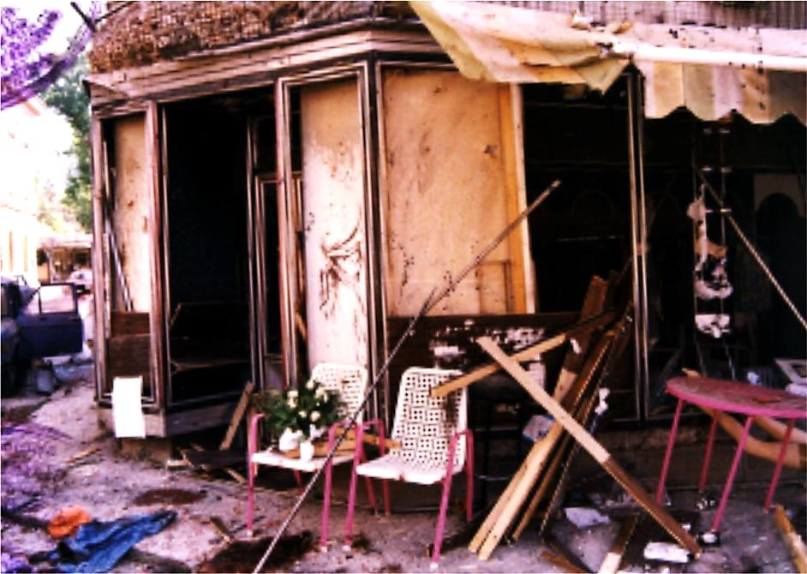

Figure 6.1.3 The appearance of the entrance to the store "SAMOIZBOR" after the explosion on 26th of May, 1995.
The area to the left and right of the entrance to the store "SAMOIZBOR" was covered by wooden panels (woodwork), the ruins of which can be seen thrown left and right (part was left in place to the left of the front door).
At the place where the panels are ejected, you can see the surface of an orange similar fabric, where holes are clearly visible, and show that the wooden panels were pulled in the direction from the store to the outside (significantly larger image is available).

Boards are thrown outward and crossed, and between them and the garden chairs with white seat, one can see that famous bar chair, where mentioned lucky man named Mujkanović Damir was sitting, who suffered multiple back wounds, but survived.

What is and from where came the force that wounded Damir on the back and spared from the front, throwing wooden panels from the store to the normal direction of the explosion, which was near the "NIK" building, which also bent feet of metallic pink table perpendicular to the direction of the explosion?

Where is the center of the explosion that acted in this way? Is not that a direct application of the rule which was appointed by the prosecution for the present case, Rule N^{O}2, which determines:

"Shoot north to tear down everything east and west; the northern part will be spared!"

And maybe it's something much more prosaic, and much more natural, because who swings from the front if he wants to attack someone (read: wound him) from behind?

6.2. PRACTICALY IMPOSSIBLE EVENTS

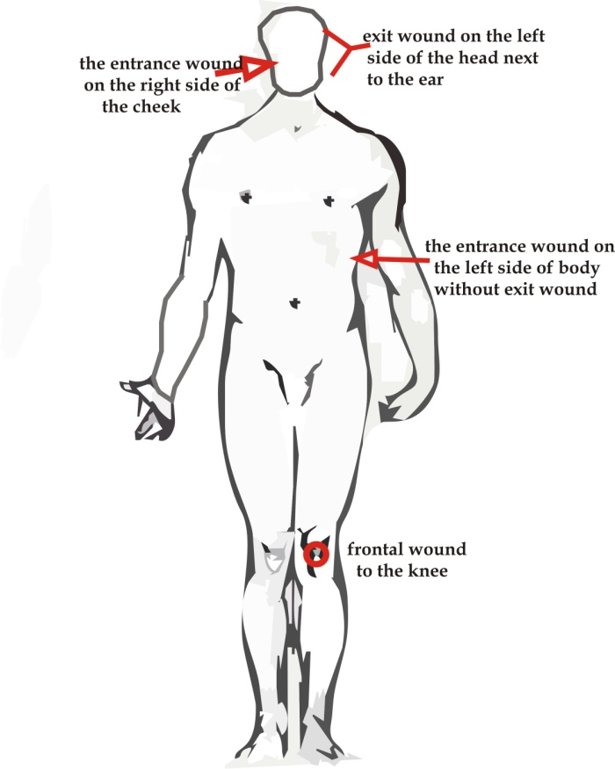
The case of deceased Mehanović Sulejman is one of the most significant, because it represents the crucial proofs and evidence rejected by the court. Nobody knows why. According to the medical "Record of external examination" which was written in Tuzla city Clinic Center and identification of those killed in the mentioned Tuzla tragedy, the deceased Mehanović Sulejman had the following injuries:
"The defect of skin about 1 cm in diameter on the right side of the cheek that communicates with a large hole about 4x10 cm located in the left rear outer crown of the head through which brain mass was pressed out. The fractured skull was present too. There was also defected skin on the outside of the upper right arm diameter of about 3 cm, and numerous small skin perforations on the right side of the back“.
Figure 6.2.1.
Description of the injuries presented in above mentioned record is not complete, because this victim had additional two heavy injuries, see Figure 6.2.1.
On the body of Mehanović Sulejman the wounds on the right shoulder and left knee were also observed, not recorded in the documents of the Tuzla Higher Court nor medical documentation, but these wounds are fully documented by many photos. The body of Mehanović Sulejman also had the entrance wound (approx. 2cm in diameter) on the left side of his chest. There was not exit wound. So, it is very clear that the knee wound implies impact in the body from the direction which is perpendicular or nearly perpendicular to the front of the body. The object which created the wound, the entrance of which was on the right side (cheek) and the exit next to the left ear, came obviously from the different right-side-direction in relation to the head of the victim.
The other two lateral directions, (chest and head) perpendicular to the direction from which the knee was affected, demonstrate unequivocally that Mehanovic Sulejman was wounded from three mutually completely different directions.

This man who was killed, according to the witnesses, was located near the entrance of the "Leonardo" cafe shop, at a distance approx. 10 m of the center of the explosion.

Based on the available evidence and performed experiments it was found that the shrapnel beam that acted on the day of the tragedy was much smaller and the much lower in density compared to the shrapnel beam which is generated by explosion of 130mm projectile.

These facts indicate that in considered area 130mm shell was not exploded, but in that area several explosive devices were activated.

The Mehanovic Sulejman case is not alone. In the subject court case has been documented over 15 people killed, who had gained wounds on the opposite sides of the body without the exit wounds. Nobody in the court was asking how it was possible.

Next on the list was a young man named Kurbašić Damir, who suffered fatal wounds from four different directions. On the moment of explosion he was near to the cafe „Leonardo“ as well as killed Sulejman Mehanović.

The same applies to the deceased Beganović Adnan who suffered fatal wounds from four different directions.

There is also a list of 29 other people who suffered lethal wounds from more than one direction.

Described wounds distribution and significantly high number of people with multilateral injuries without exit wounds clearly indicates that these wounds can't cause a single explosion of artillery projectile.

From 61 killed people 30 of them suffered fatal wounds from one direction; also more than one half was wounded from more than one direction. Other 10 of totally 71 victims had different injuries.

One of most characteristic is the case of a girl named Pera Marinović, who was at the time of the explosion about 20m from the center of the explosion. She was hit by three pieces of shrapnel. Besides her, at the same place, at least five people were injured, three of which were fatal injuries.

According to the assertion made by the prosecution at this point in the "Kapija" square was located about 400 people. The square width is about 10m and depth of 35 meters, which means that between the killed girl and the center of explosion was located at least 35 lines of people. This fact excludes the possibility of even minor injuries due to the distance from the explosion and the level of protection which provides numerous bodies of other people.
After several experiments performed on the reconstructed square, where real 130mm projectiles and explosions took place, it was shown that the place where Pera Marinović was is not exposed to the deadly shrapnel even when between the blast and that place any obstacles do not exist.

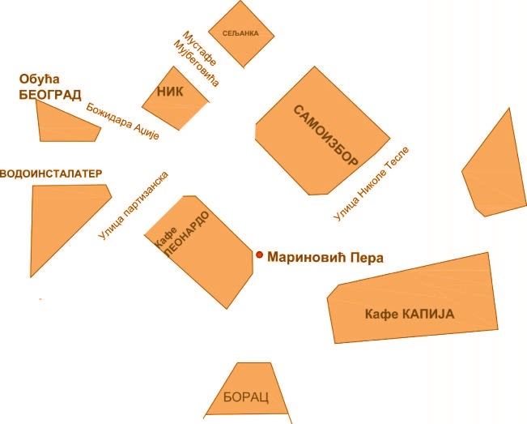
Figure 6.2.2 Red dot denotes place where the killed girl was

List of impossible events continues with Figure 6.2.3.
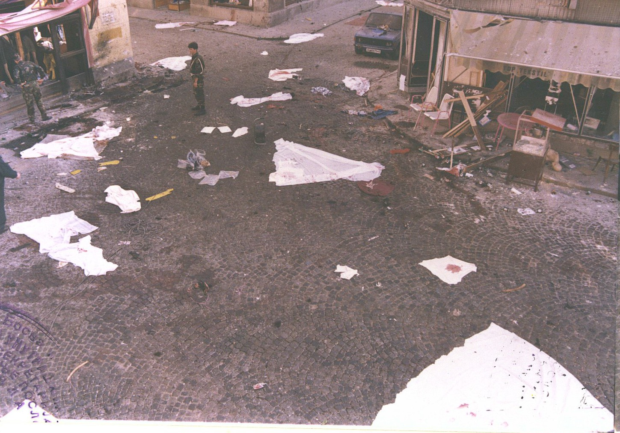
Figure 6.2.3. Right– door of the "Samoizbor" store, left upper: right corner of the "NIK" building. The left side of the visible white sheet (left) vith oil stains around, aprox. center of the explosion
At a distance of 2 meters from the entrance in the right building (about 11m from the CE) the blue car is parked. This car is almost intact despite it was facing the explosion, but 6m behind the same car 4 people and one child were killed in sitting position around the tables of the "Gulam" cafe shop. Can't forget that even here the space was filled with huge numbers of people whose bodies were obscureing the space between the explosion and the mentioned "Gulam" cafe shop, as well as space between PD (detonating point) and the blue car.

It is needless to mention that the photos from the CSB Tuzla archives show that the table in the mentioned café is punctured in direction from ground to up to the table plate, which will be better explained in other analysis related to this case.

One truth can't be avoided and that truth obliges all to the court and the prosecution in this case.
Whoever takes some of the documents from the said case must see at least one undeniable fact which appears as a powerful contra indicator.

This fact is demonstrated through the persistent attempts of prosecution to prove that the effects of explosions are bigger and more harmful to the environment if the distance from the explosion increases.

Such a claim is nowhere explicitly stated, but is accepted in all situations where it should be decisively rejected. No one has dealt with the character of the wounds that people have suffered. To the Court and prosecution personnel as experienced professionals such things are simply not allowed to miss.

After the above-mentioned and proven facts and evidence further proving must be regarded as irrelevant and unnecessary.

The main facts have long been proven and according to them, the main inanimate actor in this drama, artillery projectile of 130mm must necessarily be excluded as well as a secondary- Golf Mk1 car because this vehicle on many grounds provokes deep-founded suspicion.

Unfortunately only the most important of all could not be excluded. This is the ending of lifes of numerous young people.

The court did not prove whose vehicle it was.

Nobody asked why this vehicle has a license plate of the former, a long time non-existent state, different from all the other cars on the site of the tragedy.

All these data could easily be checked. On several places in the court documents it is shown that the subject Golf Mk1 vehicle license plate was marked TZ 110-777.

These marks are the marks of the former SFR Yugoslavia in the following format: the first two letters for the city, followed by a five-pointed star, after which come numbers (five or six numbers depending on the size of the registration area). The numbers are divided by a central dash.

It is reasonable to assume that such license plates were in use in BiH for certain period of time during 1992. because there was no other.

However, in the B&H territory these license plates would have been replaced during 1992. and 1993. year and were probably valid no later than April 1993. In the meantime all three entities replaced their license plates, as can be seen from the following figures from that period.

During the year 1994. on the part of the territory that has been under the control of the B&H Army, new license plates were introduced that together with all the other plates remained valid until 28th of September 1998. when the international administration for B&H introduced new plates in format 000 - X - 000 which apply today.

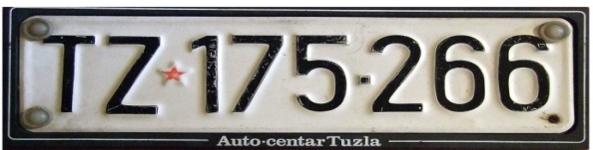 | 
Figure 6.2.4 The former SFRJ licence plate for Tuzla city until 1992. | Figure 6.2.5 The intermediate licence plate on the part of the territory that had been under the control of the B&H Army, introduced during 1994.
 | 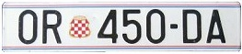
Figure 6.2.6 The Republic of Srpska licence plate,1992.-1998. | Figure 6.2.7 The Herceg-Bosnia licence plate,1992.-1998.
 | 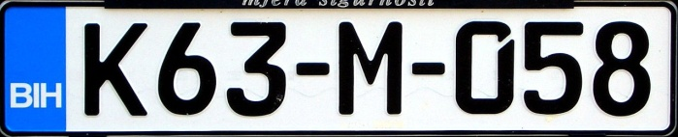
Figure 6.2.8 The intermediate licence plate on the part of the territory that had been under the control of the B&H Army, between 1992. and middle of 1994. | Figure 6.2.9 License plates in BiH which still apply

Full compliance with the above outlined license plates documenting the deep blue colored Zastava 101 car– from the real crime scene site labeled ZV-10028 A, also, in the same format as shown in Figure 6.2.8.

The Zvornik city was at the subject time under control of Republic of Srpska Army, but the refugees from Zvornik were able to use and extend the registration of their vehicles also in Tuzla city.

From the above it is easy to conclude that the present car Golf Mk1 was not registered for at least the last two years. Who dared, during the war, to face police officers in civilian clothes (according to the many present witnesses), despite the policemen in uniform, to bring unregistered vehicle (or even worse, vehicle with so called "Serbian plates") in the middle of the square in front of the "NIK" building where parking was strictly forbidden at the time? What would such a driver experience?

Who wants to know can, unfortunately, even today, after 20 years find out what would be the attitude of crowd towards him and towards such a vehicle.

After all of this can, with a high level of confidence, professional finding is confirmed, which reads:

All of the abovementioned consequences which appeared on the "Kapija" square at the time of tragedy are diametrically opposed compared to the common artillery praxis, earlier professional knowledge, and experimental data obtained by provoked explosions of more than sixteen 130mm projectiles with the same number of cars of the same brand and type.

None one of the consequences which appeared on the "Kapija" square can't be attributed to the direct action of the 130mm artillery projectile.

ОВА СТРАНА ЈЕ НАМЕРНО ОСТАВЉЕНА ПРАЗНА

НА ЊУ ДОЛАЗИ ПРИЛОГ 6.1, ОДШТАМПАН НА ФОРМАТУ А3, И ПРЕСАВИЈЕН НА ФОРМАТ А4!!!

7.1 FINDINGS, OPINIONS AND PROFESSIONAL CONCLUSION

7.1.1 FINDINGS

7.1.1.1. The comprehensive analysis of available data from the Court files and other available documents indicates:

Too many conclusions were easily derived based on extremely dubious presumptions, for example;
The determining AoF of projectiles;
The possible location of the incriminated gun;
The assessment of effects, consequences as well as the lots of clues observed on CSS;

The actual terrain and its configuration was completely ignored and thrown out of the consideration, which led to huge misjudgments and calculation out of which came also grossly wrong conclusions.

7.1.1.2. The position of car Golf Mk1 was considered with the total absence of basic elements of the blast physics like that during the explosion no external force was acting on the subject car, although that force was over 240kN. The mentioned force was at least 32 times higher than the weight of the car. (mass of the car is 750kg).

The possible AoF of the projectile was measured in relation to the observed position of the car after explosion- completely incorrect. The blast so close to the car body (<20cm) must reject the car at least a little bit. If the car will be shifted laterally for only 1cm the AoF will be changed at least for 1 degree. In subject case even an AoF of 65⁰ can't provide projectile to fly over the Golf Mk1 car. After all, prosecution expert explicitly admits such a fact in his analysis. (See page 63, 3rd paragraph above).

7.1.1.3. Ballistic calculations performed by the prosecution expert omit important parameters that define each battery FCU. Each FCU in each case necessarily takes into account many corrections (especially the very important altitude difference)which expert didn't include. The calculations derived by the prosecution expert were based on the assumption that it is not important where was the possible position of the gun, so those are invalid.

Wherever it was it still remains 30m above in respect of the detonating point at the „Kapija” square, said and written(more than 6 times) by the prosecution expert , but that is a huge mistake.

In accordance with the actual situation on the ground as well as data provided by a topographic map, the possible FPs at distances greater than 27.1km are located at elevations of 335 to 406 meters above msl, or at a height difference in relation to the plateau of the „Kapija” square from 106 to 177 meters respectively, which is 3 to 6 times greater difference than that used by the prosecution expert in his ballistic calculations.

Therefore, these ballistic calculations should be rejected as null and void, together with all the consequences that originate from these calculations.

7.1.1.4. Effects on the „Kapija” square are not consistent with the effects expected from this kind of artillery projectiles, nor with forensic even with terminally-ballistic aspect, and also do not correspond to law of destruction specified for such a type of the projectile. This law of destruction was derived from the tens of thousands of experiments carried out by the manufacturer of the original Firing Tables, gun and ammunition.

7.1.1.5. The analysis of the place of possible gun positions of the prosecution expert was superficial. The real places were not taken into consideration as well as areas where the cannons actually were. Therefore, it is natural that not one of them was detected even though remains still stand and are clearly visible on satellite image of the terrain. (On the basis of seized documents and with help of a living witnesses-participants is easy possible to found each of the real FP);

7.1.2. OPINION
7.1.2.1 Prosecution evidence are unfounded:
- Tactical;
- Technical;
- Topographical;
- From the standpoint of the theory of firing, and
- From the standpoint of external ballistics, terminal ballistics and forensic;

7.1.2.2 There is no such an artillery projectile which is able to make the multilateral wounds without any exit wounds on the bodies of the more than 30 killed.

7.1.2.3 Wherever it was located, the subject artillery 130mm M46 gun, within the pre-defined sector, in weather conditions on the 25th of May 1995, with a brand new tube and standard projectile, had the ability to target the „Kapija” square, without any need to relocate and unmask the firing position taking into account that at the time was present a direct threat of the foreign intervention;

7.1.2.4 Wherever it was located, the subject artillery 130mm M46 gun, within the defined sector, considering weather conditions on the 25th of May 1995, with a brand new tube and with standard projectile, was not able to obtain AoF, AoF =Θ≥62⁰ by targeting, which, according to the prosecution expert, was the minimum possible AoF required to fly over Golf Mk1 car.

All of the above mentioned and proven earlier, indicates a definite:

EXPERT CONCLUSION:

ON THE MAY OF 25TH 1995, AT 20:55, ON THE "KAPIJA" SQUARE IN TUZLA, DID NOT EXPLODE ANY FIRED PROJECTILE AND ESPECIALLY NOT THE ONE OF 130MM.

See court stenogram in Case: "Ђукић Новак" X-KR-07/394, from 02.12.2008
The prosecution expert analysis : Prof.dr. Berko Zečević: „Анализа увјета који су довели до масакра особа на тргу „Капија” дана 25.05. 1995. год у 20⁵⁵ сати”, page 76. Fig. 90. Table, 5th row from above
See: "Sketch of the crime scene site“, no. 20-1/02-3-9-7-175/95, from 25/26.05. 1995. by crim. technician I.Džinović
Prof.dr. Berko Zečević: “Анализа увјета који су довели до масакра особа на тргу „Капија” дана 25.05. 1995. год у 20⁵⁵ сати”
Prof.dr. Berko Zečević: “Анализа увјета који су довели до масакра особа на тргу „Капија” дана 25.05. 1995. год у 20⁵⁵ сати”
Ibid: page 75. Topographic-ballistic data
Ibid: page 75. Topographic-ballistic data, picture 90 and text below the picture- next two paragraphs
Ibid: page 79. second paragraph under picture 95
Ibid: page 93. numbers 6. 7. and 8.
The sentences used by the prosecution expert are often incomplete, and very irregular even at his native language, and difficult to translate
See court stenogram in Case: "Ђукић Новак" X-KR-07/394, од 02.12.2008
The prosecution expert analysis : Prof.dr. Berko Zečević: „Анализа увјета који су довели до масакра особа на тргу „Капија” дана 25.05. 1995. год у 20⁵⁵ сати”, page 76. Fig. 90. Table, 5th row from above
Prof.dr. Berko Zečević: „Анализа увјета који су довели до масакра особа на тргу „Капија” дана 25.05. 1995. год у 20⁵⁵ сати”, page 76. compared to the statement 7. and 13. Page 93.
Page 76. The prosecution expert analysis Prof.dr. Berko Zečević: „Анализа увјета који су довели до масакра особа на тргу „Капија” дана 25.05. 1995. год у 20⁵⁵ сати”, Fig. 90. Table, 5th row from above
Prof.dr. Berko Zečević: „Анализа увјета који су довели до масакра особа на тргу „Капија” дана 25.05. 1995. год у 20⁵⁵ сати”, page 63. above 3th paragraph above
Same: page 80 paragraph (bold) below Figure 96.
Firing Tables, cannon 130 мм М46, SSNO, UA-156/2, Military-Publishing Institute, 1984
Firing Tables, cannon 130 мм М46, SSNO, UA-156/2, Military-Publishing Institute, 1984
See stenogram in Court Case: "Ђукић Новак" X-KR-07/394, December, 2nd year 2008, page 34
It may be asked: Why FP denoted as 272_max would not be moved to the south and pushed out the forest to the wasteland? The answer is: Because there is relatively huge Musevina hamlet! (See Figures 3.1 to 3.5)
Extremely important remark:According to the Tuzla city register, acquired from local geodetic authorities, at the time of accident, the sidewalk in front of the "NIK" building was 115 to 120cm wide(carefully look at the figure 3.7. and compare how far from the building wall was Golf Mk1 vehicle after the explosion)
Acronim: TMBAM: Topographic- Meteorological -Ballistic -Atmospherical -Materiel conditions
Report on terrorism 2011, The National Counterterrorism Center of United States of America, page 13.
Explosions and Blast-Related injuries, Nabil M. Elsayed, James L. Atkins, page 26.
Ibid, page 26.
Super Quick or Mechanical Time Super Quick
Standard of National Defense (Standard Narodne Odbrane)
∗ $F\left(x\right)=\frac{ρ}{\sqrt{π}}\int_{–∞}^{x_{i}}{e^{-ρ^{2}∙x^{2}}}dx$probability distribution function, or derived$: ɸ(х)=\frac{2∙ρ}{√π}\int_{0}^{x}{e^{-ρ^{2}∙t^{2}}}dt$ Laplace function both reformulated for the probable erors in range and deflection, where the ρ is: $ρ=0,4769$
∗ Е. С. Вентцель: "Теория верояатностей", Москва 1962 pages 157 to 158 and 195 to 196
∗∗ Method of calculation belongs to the world famous Russian mathematician, member of the Russian Academy of Sciences, A.N. Kolmogorov, (1903- 1987). The same metod of hit probability calculation could be found in tutorial: "Теория стрельбы наземной артиллерии", Военная Артиллерийская Академия– Ленининград 1966, in Chapter 10, §10.11: ″Расчет показателей эффективности стрельбы способом академика А.Н. Колмогорова", pages 359 to 367, translated- ″Calculation of indicators of firing efficiency by the method of Academician A. N. Kolmogorov", as well as in widely known book: Е. С. Вентцель: "Теория верояатностей", Москва 1962 pages 157 to 158 and 195 to 196
∗∗∗ 7. Looking at the quality of the M46, 130mm shells and parameters, it can be confirmed that the old center, generally speaking, was the precise target. Therefore, no one can exclude direct "Kapija"targeting................ Direct translation from prosecution expert report i.e. Prof. Dr. Berko Zečević: "Analiza uvjeta koji su doveli do masakra osoba na trgu „Kapija“dana 25.05. 1995. god. u 20⁵⁵ sati" (.December 21 2007) page 3 second paragraph from the botom of page.
Explosions and Blast-Related injuries, Nabil M. Elsayed, James L. Atkins, page 26.
Ibid, page 26.
The court expert Dr. Eng. Mirjana Andjelkovic Lukić, expert for explosives: Findings and opinion, expert and experimental consideration of events in Tuzla "Kapija" square, which occurred on 25th of May 1995. at 20⁵⁵ h, page 61, and fourth paragraph from the top, quote.... "The largest grouping of persons killed and injured, it was the places where sitting ........" and two paragraphs behind, quote: "the analysis of the value of distance when taking into account the worst possible outcome, i.e. the case when you take into consideration the reflected shock wave, the probability of mortality of 99% is valid for distance up to 4.2 m of CE, and the border limit for damage of lungs, which is taken to the threshold of a death is at a distance of 6.5 m from the CE. Most of the victims in Tuzla "Kapija" case with blast injuries of the first order (Tables 5 and 6) can be found at distances greater than this calculated..... Unquote.

