Čj. 49-1/2016-2994

Copy No.:
Number of sheets: 144

BG Prof.Grad.Eng. Bohuslav PŘIKRYL, Ph.D.
Rector-Commander of University of Defence

Expert report
on
Tuzla’s 20:55, 25th May 1995 event

Authors:
Assoc. prof. Jan KOMENDA
Dr. Luděk JEDLIČKA
Dr. Roman VÍTEK

Brno, Czech Republic

2015

Contents
Contents 2
List of figures 4
List of tables 10
- Introduction 12
- Experiments description 13
  - Experiment No. 1 25
  - Experiment No. 2 65
  - Experiment No. 3 79
  - Partial conclusions 81
- Analysis of prof. Zečević’s expert report 82
  - Terminal ballistics domain 82
    - Projectile lethality radius 83
    - Number of people present at Kapija square 83
    - Criterions of live target resistance 84
    - Effective fragment range 86
  - External ballistics domain 87
    - Weapon system parameters (ballistic conditions) 87
    - Atmospheric conditions 88
    - Real projectile’s trajectory 89
    - Systematic errors 90
  - Others 90
  - Partial conclusions 91
- Model of fragment dispersion 92
  - Introduction 92
  - Mass fragment distribution 93
  - Spatial fragment distribution 94
  - Velocity fragment distribution 98
  - Density of fragments field 99
  - Probability of target elimination 100
  - Partial conclusions 101
- Parameters of 130 mm OF-482M projectile fragment field 102
- Analysis of wounds inflicted on victims of Tuzla’s massacre 111
  - Victims overview 111
  - Qualitative wounds analysis 112
  - Quantitative wounds analysis 115

  - Partial conclusions 119
- Regression model for the fragment field density 121
  - Comparison of the theoretical, real and experimental fragment densities 125
  - Estimation of the regression coefficients 129
  - Comparison of the regression coefficients 131
  - Partial conclusions 132
- Analysis of projectile blast effect 135
- References 137
- Conclusions 138

List of figures

Figure 2.1 Artillery projectile of calibre of 130 mm OF-482M 13
Figure 2.2 Labelling of buildings on schema of model Kapija square at Nikinci 15
Figure 2.3 View at central part of model of square Kapija during preparation of 1st experiment (in the middle building A with NIK store, on the left building E, on the right buildings B and C) 16
Figure 2.4 View from the CE at north-eastern part of model square Kapija into street Partizanska towards Café Gulam (on the left building B, on the right building C) 16
Figure 2.5 View from the CE at south-eastern part of model square Kapija towards Café Kapija (at the back, in the middle – building D); on the left building C, on the right building E 17
Figure 2.6 High-explosive projectile 130 mm OF-482M (Russian) 17
Figure 2.7 High-explosive projectile 130 mm OF-M79 (Serbian) 18
Figure 2.8 Packing of ammunition 130 mm OF-482 with UTIU M72B1 fuze 18
Figure 2.9 Measurement of the sidewalk width next to the NIK store 19
Figure 2.10 Measurement of the pavement width next to the NIK store (the distance from the wall of the building to the outer edge of the pavement is about 114 cm) 19
Figure 2.11 Set-up of the projectile into the position in the front of the VW Golf car (the orange point marks the CE) according the scheme made by Irfan Džinović 20
Figure 2.12 The detail of the set-up of the projectile into the position in the front of the VW Golf car according to the figure above 21
Figure 2.13 The detail of the set-up of the projectile into the position in the front of the VW Golf car according to the figure above – the angle of the longitudinal projectile axis deflection with respect to the horizontal plane (i.e. the angle of fall) is 86° 21
Figure 2.14 Point of impact of 130 mm HE projectile according to prof. Zečević’s report 22
Figure 2.15 Position of the 130 mm projectile (according to [1], orange patch on the ground)... 23 Figure 2.16 Placement of projectile for 1st experiment – detail (yellow arrow pointing to the original point of impact - orange patch on the ground) 24
Figure 2.17 Placement of projectile for 1st experiment - detail (angle of fall 62° with respect to the ground) 25
Figure 2.18 Dolls used during experiment No. 1 - Samoizbor 26
Figure 2.19 Dolls used during experiment No. 1 – Lutrija BiH, Café Kapija 26
Figure 2.20 Dolls used during experiment No. 1 – Caffé Leonardo 27
Figure 2.21 Doll’s dimensions (left female figure of front area 0.66 m2, right male figure of front area 0.82 m2) 27
Figure 2.22 Arrangement of scene in close proximity of CE (on the right shop NIK) 28
Figure 2.23 Static pictures from high-speed video just before explosion of 130 mm HE projectile (left) and first instants after explosion of projectile (right); view from the southeast, on the left side car VW Golf at which front right side exploded the projectile 28
Figure 2.24 Static pictures from high-speed video just before explosion of 130 mm OF projectile (left upper picture) and first instants after explosion of projectile (other 3 pictures); view from Café Kapija 29
Figure 2.25 View at the scene immediately after the 1st explosion (the CE is behind the open car door, next to the right front wheel) 30
Figure 2.26 View at the scene immediately after the 1st explosion (dolls in close proximity of the CE were thrown away by pressure wave, further dolls remained upright) 30
Figure 2.27 View at the scene immediately after the 1st explosion; area at the corner of the building and Caffé Leonardo was hit by heavy fragments of the side spray because it is situated in the direction right and perpendicular from the CE with respect to the plane of arrival 31
Figure 2.28 View at corner of building between Kapija shop and Caffé Leonardo with dolls and car Zastava hit by very effective side spray of fragments (side spray effect) 31

Figure 2.29 View at the scene immediately after the 1st explosion; view from the CE in south direction – right Caffé Leonardo with Zastava car heavily damaged by fragments; scattering of fragments from the side spray is obvious on the facade (borders of the sector are marked by yellow lines at the figure) 32
Figure 2.30 View at the scene immediately after the 1st explosion; view from the CE in the south- west direction – left Caffé Leonardo and Zastava car (borders of scattering sector of fragments from the side spray, elongated from previous figure are marked by yellow lines at the figure) .. 32 Figure 2.31 View at the scene immediately after the 1st explosion; view at frontage of NIK store building; holes at the facade are not in majority of cases circular but elongated in the direction of fragments motion 33
Figure 2.32 View at the scene immediately after the 1st explosion; view from the CE in northern direction – left Caffé Gulam, right Samoizbor; only minimum number of fragments flew in this direction 34
Figure 2.33 View at the scene immediately after the 1st explosion; view from the CE in south- eastern direction at Caffé Kapija; only minimum number of fragments flew in this direction 34
Figure 2.34 View at the scene immediately after the 1st explosion; facade of the building (Samoizbor part) was not nearly hit by fragments as well as doll standing in front of the building
................................................................................................................................................................................................ 35
Figure 2.35 View at the scene immediately after the 1st explosion; facade of the building in Kapija part was not almost hit as well as dolls standing in front of the building 35
Figure 2.36 View at right front part of car VW Golf Mk I heavily damaged by explosion 37
Figure 2.37 View at destroyed car VW Golf Mk I (all large glass panels were smashed down by explosion) 37
Figure 2.38 Detailed view at destroyed front right part of VW Golf Mk I car (tire ripped off, wheel rim and wing considerably deformed by pressure wave and perforated by number of fragments, part of wing and bonnet torn off) 38
Figure 2.39 Detail view at destroyed front right part of VW Golf Mk I 38
Figure 2.40 Detail view at destroyed front right part of VW Golf Mk I (after the bonnet opening)
................................................................................................................................................................................................ 39
Figure 2.41 Detailed view on damaged car VW Golf Mk I at “Kapija” square after 1st experiment; wheel is totally wrecked (compare with Figure 2.42) 39
Figure 2.42 Detailed view on the damaged car VW Golf Mk I on Tuzla’s “Kapija” square, evening after the explosion (compare especially with Figure 2.41) 40
Figure 2.43 Detailed view on destroyed front part of the car VW Golf Mk I that was pushed by explosion left and backwards (left front part of the car is in touch with the corner of NIK store building) 40
Figure 2.44 VW Golf Mk I car after the 1st experiment (car is moved backwards and pushed towards the wall of NIK store building) 41
Figure 2.45 View on the scene in front of NIK store building on Tuzla’s “Kapija” square, next morning after explosion (the car is in completely different position than the same car at Figure 2.44) 41
Figure 2.46 View on Tuzla’s “Kapija” square morning after explosion (VW Golf Mk I car on the left side of picture was only pushed backwards and it is about 1 m from the wall of NIK store building)
................................................................................................................................................................................................ 42
Figure 2.47 Right middle and rear part of the car VW Golf Mk I hit by higher number of fragments
................................................................................................................................................................................................ 42
Figure 2.48 View in north-eastern direction into Partizanska street with both Zastava cars; effect of fragments on the building’s facade is minimal 43

Figure 2.49 Zastava car (No. 2) in front of Caffé Gulam was damaged by the explosion only minimally (only 2 hits of fragments); car is not dirty after the explosion (compare with Figure 2.50 and Figure 2.51) 43
Figure 2.50 View at front part of the car Zastava with dirty body and shop with broken shop windows (Tuzla 1995) 44
Figure 2.51 View at car Zastava after Tuzla’s explosion; side windows are broken, car at the front part heavily begrimed by black stuff, similar to soot, of unclear origin 44
Figure 2.52 Zastava car parking across the street in front of Caffé Gulam was hit only by a few fragments 45
Figure 2.53 View at Zastava car parked in front of Café Leonardo; there are apparent significant damages caused by heavy, high-energy fragments from the side spray of fragments (compare with Figure 2.46); glass panels of side and rear windows are smashed open, windscreen contains 7 perforations caused by fragments (for detail of windscreen see Figure 2.54) 46
Figure 2.54 Detail view on damage of car Zastava windscreen caused by fragments 46
Figure 2.55 Fiat 125 PZ (car 4) with only minimal damage after the explosion at Kapija square 47 Figure 2.56 Specific fragment pattern on the area in front of Tuzla’s Kapija shop with significant circular defects caused by massive fragments at ground floor walls (Tuzla 1995, next morning after explosion) 48
Figure 2.57 View on the area in front of Kapija shop - after 3 explosions of 130 mm projectile - without any significant defects at ground floor (elongated defects can be seen on the walls at 1st floor level) 48
Figure 2.58 View on the area in front of “Caffe-slastičarna Kapija“ after explosion in the 1st experiment (there are not any apparent damages caused by fragments) 49
Figure 2.59 View at space in front of “Caffe-slastičarna Kapija” with many large defects at walls and window (compare with minimal damage to the same facade in Nikinci at Figure 2.58) 50
Figure 2.60 View on the area in front of Tuzla’s “Caffe Gulam“ next morning after explosion 50
Figure 2.61 Front view on NIK store building at “Kapija” square after 1st experiment (dolls are thrown into shop by the explosion, and are significantly damaged by fragments, frame of the shop window is pulled out from the wall) 52
Figure 2.62 View at frontage of NIK store building in close proximity to the CE; totally destroyed shop window, glass fragments and dolls thrown into room, facade on the right side hit by heavy, very effective fragments of side spray of fragments, black stain on the left part of frontage caused by motor oil 52
Figure 2.63 View at frontage and side of NIK store building from Partizanska street 53
Figure 2.64 Destroyed shop window of Modna kuča NIK shop 53
Figure 2.65 Front view on NIK store building at Tuzla’s “Kapija” square morning after the explosion (dolls are in upright positions without significant damage, shop window frame is not significantly damaged) 54
Figure 2.66 Detail of destroyed inner space of shop Modna kuča NIK in Nikinci (on the floor are wooden beams and dolls thrown into the room from the shop window by blast effect) 54
Figure 2.67 View at frontage and side of NIK store building (glass fragments in front of building come from broken windows at upper floors) 55
Figure 2.68 Detail of NIK store’s shop window with minimally damaged awning 55
Figure 2.69 View on the crater in front of NIK store building after 1st experiment (no cobblestones were pulled out, there are also parts ripped off from the car’s engine in front of the car) 56
Figure 2.70 Cobblestone pavement in place of 1st explosion directly below the projectile (apparent the minimal damage to surface of road, cobblestones were not released and thrown into space)
................................................................................................................................................................................................ 57

Figure 2.71 View on the crater after explosion at Tuzla’s “Kapija” square next morning after explosion (number of cobblestones was pulled out of road, but this big number of cobblestones is not missing in the road) 57
Figure 2.72 Maximum level of damage to doll No. 39 less than 1 m away from the CE (doll was hit by at least 10 fragments with deadly effect) 58
Figure 2.73 Damage to doll No. 39 – different point of view 59
Figure 2.74 Position of doll No. 87on the car’s bonnet before the explosion 59
Figure 2.75 Extreme damage of doll No. 87 (placed on the bonnet of VW Golf Mk I car); under real conditions at “Kapija” square the person would not survive, but in 1995 was survived 60
Figure 2.76 Extreme damage of doll No. 87 at upper part (lower part of the doll was protected by VW Golf Mk I car); level of damage caused by fragments speaks for zero chance of men on survival
................................................................................................................................................................................................ 60
Figure 2.77 Destroyed dolls No. 36 and 3 (on the right) placed 1.5 – 2.0 m away from the CE 61
Figure 2.78 Severe damage of doll No. 26 in the upper part (the person standing in this place survived the explosion) 62
Figure 2.79 Not damaged dolls in front of “Caffe-slastičarna Kapija“ after 1st experiment, in place where in real situation was larger number of death and wounded people 63
Figure 2.80 Not damaged dolls in the corner of building of Caffé Gulam (people standing at this place were killed) 64
Figure 2.81 Dolls No. 50 and 67 (correspond to killed victims Savo Stjepanovic and Adnan Zaimovic) in front of Caffé Kapija were not hit by any fragment 65
Figure 2.82 Schema of Kapija square with marked position of screens W1 - W6, A-G buildings at Kapija square, DF – direction of flight of projectile, CE – centre of explosion, VW – VW Golf car. 66 Figure 2.83 Position of screen No. 1 (W1) placed at the corner of building E (Lutrija BiH) in close proximity of Caffé Leonardo, 7 m from the CE 67
Figure 2.84 Position of screen No. 2 (W2) at corner of Building C (Samoizbor) 68
Figure 2.85 Position of screen No. 3 (W3) placed at 12 m from the CE in close proximity of buildings F a G (the screen is partially hidden behind the car VW Golf that is placed between projectile and the screen) 68
Figure 2.86 Position of screen No. 4 (W4 - left at the back) and No. 1 (W1 - right in front) placed in close proximity of building E (Lutrija BiH) 69
Figure 2.87 Position of screen No. 2 (W2 - right at corner of building C in front of Caffé Gulam) and No. 5 (W5 - back at Caffé Gulam) 69
Figure 2.88 Position of screens No. 4 (W4 - right in front) and No. 6 (W6 - left at back) capturing fragments flying towards the Kapija square into the Caffé Kapija 70
Figure 2.89 Effect of fragments on screen No. 1 (front part, distance 7 m away from the CE, 117 perforations of total 168 hits); screen is placed in the sectors of scattering of fragments from the most effective side spray 72
Figure 2.90 Rear part of the screen No. 1 with 117 perforations of wooden boards of thickness of 25 mm; in this area 9 people was killed but concurrently 12 people survived which can be, with respect to the density of field of effective fragments, absolutely excluded 72
Figure 2.91 Effect of fragments on screen No. 2 (front part, distance 10 m away from the CE, 17 perforations of total 25 hits) – screen out of reach of the side spray, minimum number of hits but by very effective fragments 73
Figure 2.92 Rear part of the screen No. 2 with 17 perforations; 8 victims were deadly hit by fragments in this direction, which is possible, but concurrently 20 people survived the explosion in this area, which is highly improbable 73

Figure 2.93 Effect of fragments on screen No. 3 (front part, distance 12 m away from the CE, 4 perforations of total 14 hits placed mainly in the centre of the screen) – screen out of reach of the side spray, minimum hits 74
Figure 2.94 Rear part of the screen No. 3 with 4 perforations; in this area died 2 people which is not quit in agreement with number of perforations in the screen (under assumption of uniform distribution of fragment hits on the screen is hit probability of standing men (0.8 m2) by a single effective fragment in this area only 40 % 74
Figure 2.95 Effect of fragments on screen No. 4 (front part, distance 16 m away from the CE, 3 perforations of total 13 hits) – screen out of reach of the side spray with minimum hits spread over the whole screen) 75
Figure 2.96 Rear side of screen No. 4 with 7 perforations, there were killed 4 people in direction of this screen at the distance from 17 to 20 m which is not in agreement with the number of perforations at the screen (hit probability of standing person by a single effective fragment in this area is about 70 %) 75
Figure 2.97 Effect of fragments on the screen No. 5 (front part, distance of 18 m away from the CE, total 15 hits, 8 perforations) – the screen out of reach of the side spray, hits at the left side but with 53 % of perforations 76
Figure 2.98 Rear part of the screen No. 5 with 8 perforations; in the sector covered with this screen was killed 5 people behind the screen and 3 people in front of the screen in the Tuzla, which is not excluded, alike is not excluded that in front of/behind the screen could survive the explosion 6/10 people 76
Figure 2.99 Effect of fragments on screen No. 6 (front part, distance 21 m away from the CE, 2 perforation of total 10 hits, all of them in right and upper part of the screen) – screen out of reach of the side spray, minimum hits 77
Figure 2.100 Rear part of screen No. 6 with 2 perforations at its upper part; in this area behind this screen was killed 6 people, which is very unrealistic in case of explosion of 130 mm projectile (hit probability is 20 %) 77
Figure 2.101 Car Zastava 128 with placed 130 mm HE Serbian projectile M79 79
Figure 2.102 Detail of placement of 130 mm Serbian HE projectile next to the car 80
Figure 2.103 Totally destroyed car Zastava in front part (compare with Figure 2.37) 80
Figure 2.104 Detail totally destroyed right front part of the car Zastava 128 81
Figure 3.1 Experimentally obtained effective fragment field density vs. fragment scattering radius [1] 83
Figure 3.2 Illustrative placement of approx. 65 people and 40 dolls on the Kapija square (view from the CE towards the Café Kapija) 84
Figure 3.3 Change of limit velocity with mass of fragment for different criterions (shape of fragment αs=4, βs=2) 86
Figure 3.4 Effective fragment range for different masses of fragment 87
Figure 3.5 Figure 104 from prof. Zečević’s expert report [1] 90
Figure 3.6 Figure 80 from prof. Zečević’s expert report [1] 90
Figure 4.1 Presentation of places in circular fence where the fragment velocity is measured 99
Figure 4.2 Hit probabilities in individual sectors by at least one effective fragment 101
Figure 5.1 Fragments found after the explosion 130 mm projectiles at Nikinci test centre 108
Figure 5.2 Placement of sectors S7 – S13 on the Kapija square 109
Figure 7.1 Theoretical fragment density with respect to the distance and sector 122
Figure 7.2 Linearized fragment densities in sector 7 126
Figure 7.3 Linearized fragment densities in sector 8 126
Figure 7.4 Linearized fragment densities in sector 9 127
Figure 7.5 Linearized fragment densities in sector 10 127

Figure 7.6 Linearized fragment densities in sector 11 128
Figure 7.7 Linearized fragment densities in sector 12 128
Figure 7.8 Linearized fragment densities in sector 13 129
Figure 8.1 Change in overpressure with distance from the CE 136
Figure 10.1 Detailed view at destroyed front right part of VW Golf Mk I car (tire ripped off, wheel rim and wing considerably deformed by pressure wave and perforated by number of fragments, part of wing and bonnet torn off). Detailed view on the damaged car VW Golf Mk I on Tuzla’s “Kapija” square, evening after the explosion 139
Figure 10.2 View on the scene in front of NIK store building on Tuzla’s “Kapija” square, next morning after explosion (left figure – the left side of the car is approximately 1 m far from the wall) comparing to VW Golf Mk I car after the 1st experiment (right figure - car is moved backwards and pushed towards the wall of NIK store building) 139
Figure 10.3 View at car Zastava after Tuzla’s explosion (left); car is at the front part heavily begrimed by black stuff, similar to soot, of unclear origin. Zastava car (No. 2) in front of Caffé Gulam was not dirty after the explosion during the experiment 140
Figure 10.4 View on Tuzla’s “Kapija” square morning after explosion (left). View at Zastava car parked in front of Café Leonardo during the experiment (right); there are apparent significant damages caused by heavy, high-energy fragments from the side spray of fragments 140
Figure 10.5 View on the crater after explosion at Tuzla’s “Kapija” square next morning after explosion (number of cobblestones was pulled out of road, but this big number of cobblestones is not missing in the road). View on the crater in front of NIK store building after 1st experiment (no cobblestones were pulled out, there are also parts ripped off from the car’s engine in front of the car) 141
Figure 10.6 Specific fragment pattern on the area in front of Tuzla’s Kapija shop (left) with significant circular defects caused by massive fragments at ground floor walls (Tuzla 1995, next morning after explosion). View on the area in front of Kapija shop (right) - after 3 explosions of 130 mm projectile - without any significant defects at ground floor (elongated defects can be seen on the walls at 1st floor level) 142
Figure 10.7 Detail of NIK store’s shop window with minimally damaged awning 142

List of tables

Table 2.1 Data from firing tables for cannon M-46, projectile OF-482M, full charge (Serbian tables [2] - brown column, Czech tables [3] - yellow column) 14
Table 2.2 Number of dolls‘ hits Nf (presented only dolls with red strip, i.e. dolls representing killed victims) 65
Table 2.3 Effects of fragments on wooden screens 2 x 4 m 78
Table 2.4 Coverage of individual screens by scattering sectors of fragments (for projectile’s angle of fall 62°) 78
Table 3.1 Table of barrel wear from firing tables [2] 88
Table 4.1 Magnitudes of coefficient Gj (height of screen 2z = 3 m) 95
Table 5.1 Fragmentation characteristics of 130 mm HE projectile No. 1 103
Table 5.2 Fragmentation characteristics of 130 mm HE projectile No. 2 103
Table 5.3 Fragmentation characteristics of 130 mm HE projectile No. 3 104
Table 5.4 Fragmentation characteristics of 130 mm HE projectile No. 4 104
Table 5.5 Fragmentation characteristics of 130 mm HE projectile No. 5 105
Table 5.6 Fragmentation characteristics of 130 mm HE projectile No. 6 105
Table 5.7 Fragmentation characteristics of 130 mm HE projectile No. 7 106
Table 5.8 Average fragmentation characteristics of 130 mm HE projectiles No. 1 – 7 106
Table 5.9 Comparison of number of fragments in individual mass classes (Nr – average magnitudes of 7 experiments according to Czech methodology, Nrmax a Nrmin – max. and min. magnitudes at individual projectiles according to Czech methodology, Nr* - magnitudes from 1 experiment according to Serbian methodology); in colour are emphasized comparable values 107
Table 5.10 Double densities Hp of field of effective fragments [number of fragments/m2] in individual scattering sectors S7 – S13 and ranges from 1 up to 30 m (densities are determined for all fragments and specific limit energy 0.5 MJ.m-2) 110
Table 6.1 Overview of victims with known distance from the CE 111
Table 6.2 Overview of selected victims with characteristics of fragmentation effect 116
Table 6.3 Magnitudes of anomalies indexes with respect to ratio of real and theoretical number of hits on victims 118
Table 6.4 Magnitudes of anomalies index of individual victims 118
Table 7.1 Theoretical fragment density with respect to the distance and sector 121
Table 7.2 Real fragment density with respect to the distance in sector 7 122
Table 7.3 Real fragment density with respect to the distance in sector 8 123
Table 7.4 Real fragment density with respect to the distance in sector 9 123
Table 7.5 Real fragment density with respect to the distance in sector 10 123
Table 7.6 Real fragment density with respect to the distance in sector 11 123
Table 7.7 Real fragment density with respect to the distance in sector 12 123
Table 7.8 Real fragment density with respect to the distance in sector 13 124
Table 7.9 Experimental fragment density with respect to the distance in sector 7 124
Table 7.10 Experimental fragment density with respect to the distance in sector 8 124
Table 7.11 Experimental fragment density with respect to the distance in sector 9 124
Table 7.12 Experimental fragment density with respect to the distance in sector 10 124
Table 7.13 Experimental fragment density with respect to the distance in sector 11 125
Table 7.14 Wall fragment density with respect to the distance 125
Table 7.15 Regression coefficient estimations for regression model of the theoretical fragment density 130
Table 7.16 Regression coefficient estimations for regression model of the real fragment density
............................................................................................................................................................................................. 130

Table 7.17 Regression coefficient estimations for regression model of the experimental fragment density 131
Table 7.18 Results of testing hypothesis Ho on regression coefficients of theoretical (βp) and real (βs) fragment density 132
Table 7.19 Results of testing hypothesis on regression coefficients of theoretical (βp) and experimental (βf) fragment density 132

Introduction

On 25th May 1995 in the evening at 20.55 a not identified device exploded in the “Kapija” square, town Tuzla, Bosna i Hercegovina. The square was crowded with people and during the explosion was 71 people killed and more than 200 people was wounded. This explosive device was later identified by courts of BiH as a standard military ammunition - 130 mm HE projectile fired from M-46 cannon from the distance about 27 km.
The basic aim of this report, with the use of a theoretical analysis and experimentally obtained data, is to verify correctness of conclusions stated in the expert report [1] by the expert prof. Berko Zečević of University of Sarajevo that were used during the trial with gen. Novak Djukić at BiH court.
For this purpose the field trails (2 individual experiments) were prepared and carried out in Serbia on 11th and 12th March 2015 in the area of TOC Nikinci (Proving ground of Serbian Army). We, authors of this expert report, attended personally these experiments. The field trials were thus especially focused on the verification of the terminal ballistic effects of the 130 mm HE projectile and their comparison with findings on the Tuzla’s “Kapija” square from 25th May 1995 evening event.
The analysis contained in this expert report is focused on the terminal ballistic domain and external ballistic domain of the event. The results of theoretical models and experiments were used for the analysis. Significant argumentative element of the expert report is mutual comparison of data obtained from information available on the Tuzla’s 25th May 1995 event, data obtained from the experiments carried out in Serbia and Czech Republic, and data obtained from the theoretical models.
This report was elaborated on the request of customer (Foundation Justice for General Novak Djukić and Novak Djukić’s team of lawyers).
It was produced 9 copies of this report:
  - Copies No. 1-5, Foundation Justice for General Novak Djukić
  - Copy No. 6 – Assoc. prof. Jan KOMENDA,
  - Copy No. 7 – Dr. Luděk JEDLIČKA,
  - Copy No. 8 – Dr. Roman VÍTEK,
  - Copy No. 9 – University of Defence.

Experiments description

The prosecution identified as a destructive element causing the massacre at Kapija square the artillery high-explosive projectile of calibre of 130 mm that was allegedly fired towards the Kapija square from cannon M-46 from the distance corresponding to maximum range of fire.
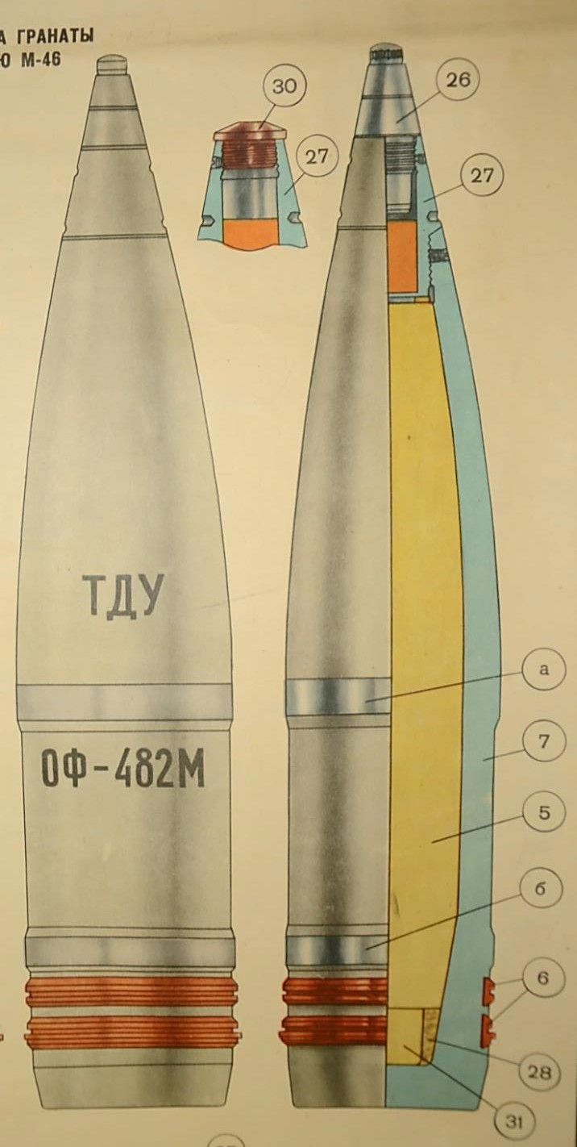The above mentioned projectile is an artillery medium calibre boat tail projectile consisting of steel body, transition insert, mechanical impact (PD) fuze, and pair of copper driving bands. Explosive charge consists of 3.6 kg of TNT explosive that is in its rear part supplemented with smoke- flash mixture. Total mass of the projectile is
33.4 kg, initial velocity of the projectile with full charge cartridge is 930 m/s, and maximum range of fire under standard conditions is 27490 m.
The effect of the projectile can be fragmentation or explosive according to way of setting of the fuze before firing. These projectiles can be equipped either with Russian impact (PD – point detonating) fuzes RGM-2, or Serbian fuzes UTIU, M72. These fuzes can be set by four ways (time of function of the fuze increases from the top):
  - cap removed, instant function,
  - cap not-removed, instant function,
  - cap-removed, delayed function,
  - cap not-removed, delayed function.
Generally it holds true that the setting of instant function of the fuze means fragmentation effect, and the setting of delayed function means explosive effect but only in case when the projectile is fired into soft terrain and it can penetrate certain depth.

Figure 2.1 Artillery projectile of calibre of 130 mm OF-482M
a – front centring ring, b – rear centring ring, v – driving bands, 7 – body of projectile, 5 – explosive charge, 26 – head fuze, 27 – transition insert, 28 – mixture of paraffin and ceresin, 31 – smoke-flash charge
In case, when the projectile hits the hard, resistant surface, e.g. continuously laid cobblestones on solid and hard subgrade, the effect will be always the fragmentation.

The following table shows extract from the Serbian and Czech firing tables with ballistic characteristics corresponding to maximum range of fire of a weapon system equipped with cannon M-46 and munition consisting of projectile OF 482M and full charge cartridge.

Table 2.1 Data from firing tables for cannon M-46, projectile OF-482M, full charge (Serbian tables [2] - brown column, Czech tables [3] - yellow column)

130 mm K M-46, projectile OF 482 M, full charge, v0 = 930 m/s | Unit | SRB | CZE
Xmax = | m | 27 481 | 27 490
Angle of elevation | deg / min | 50 / 53 | 50 / 00
Angle of fall | deg | 67.7 | 67.0
Terminal velocity | m/s | 360 | 360
Time of flight | s | 96.9 | 96.0
Height of vertex | m | 11 487 | 11 200
Drift of projectile | dc | 28 | 28
Specific height | m | 15 328 | 12 700
Probable error - range | m | 92 | 103
Probable error - height | m | 225 | 246
Probable error - side | m | 16 | 14

Both firing tables use the same artillery standard atmosphere. Differences are caused by slightly different magnitudes of ballistic coefficient used for the trajectory calculations.
Experiments with live ammunition were realized on a real Kapija square model that was, for this purpose, built in TOC Nikinci in 1:1 scale. Conditions of the experiments were in maximum possible agreement with the conditions of the explosion on the Tuzla’s Kapija square in May 1995. Goal of the experiments was to assess whether the massacre at the Kapija square could be caused by explosion of a single artillery projectile of calibre 130 mm (Figure 2.1) under the conditions defined by the prosecution.
Model of square was built in agreement with the top view of the real Kapija square in Tuzla. Buildings were elongated into side streets from the Kapija square to create the same projection from the CE as at Tuzla’s Kapija square.
Individual buildings were labelled with letters A - G due to unambiguous identification in this report in following way (Figure 2.2):
- building A – building with NIK store, closest to the CE (approx. 2 m),
- building B – building between streets Partizanska and M. Mujbekoviča, situated northerly from the CE (building with payphone),
- building C – building easterly from the CE (Samoizbor, Caffé Gulam),
- building D – building at distant part of Kapija square (Caffé Kapija),
- building E – building southerly from the CE (Lutrija BiH, Caffé Leonardo),
- building F – building between streets Partizanska and B. Adžije (vodoinstalater),
- building G – building westernly from the CE (obuča Beograd).

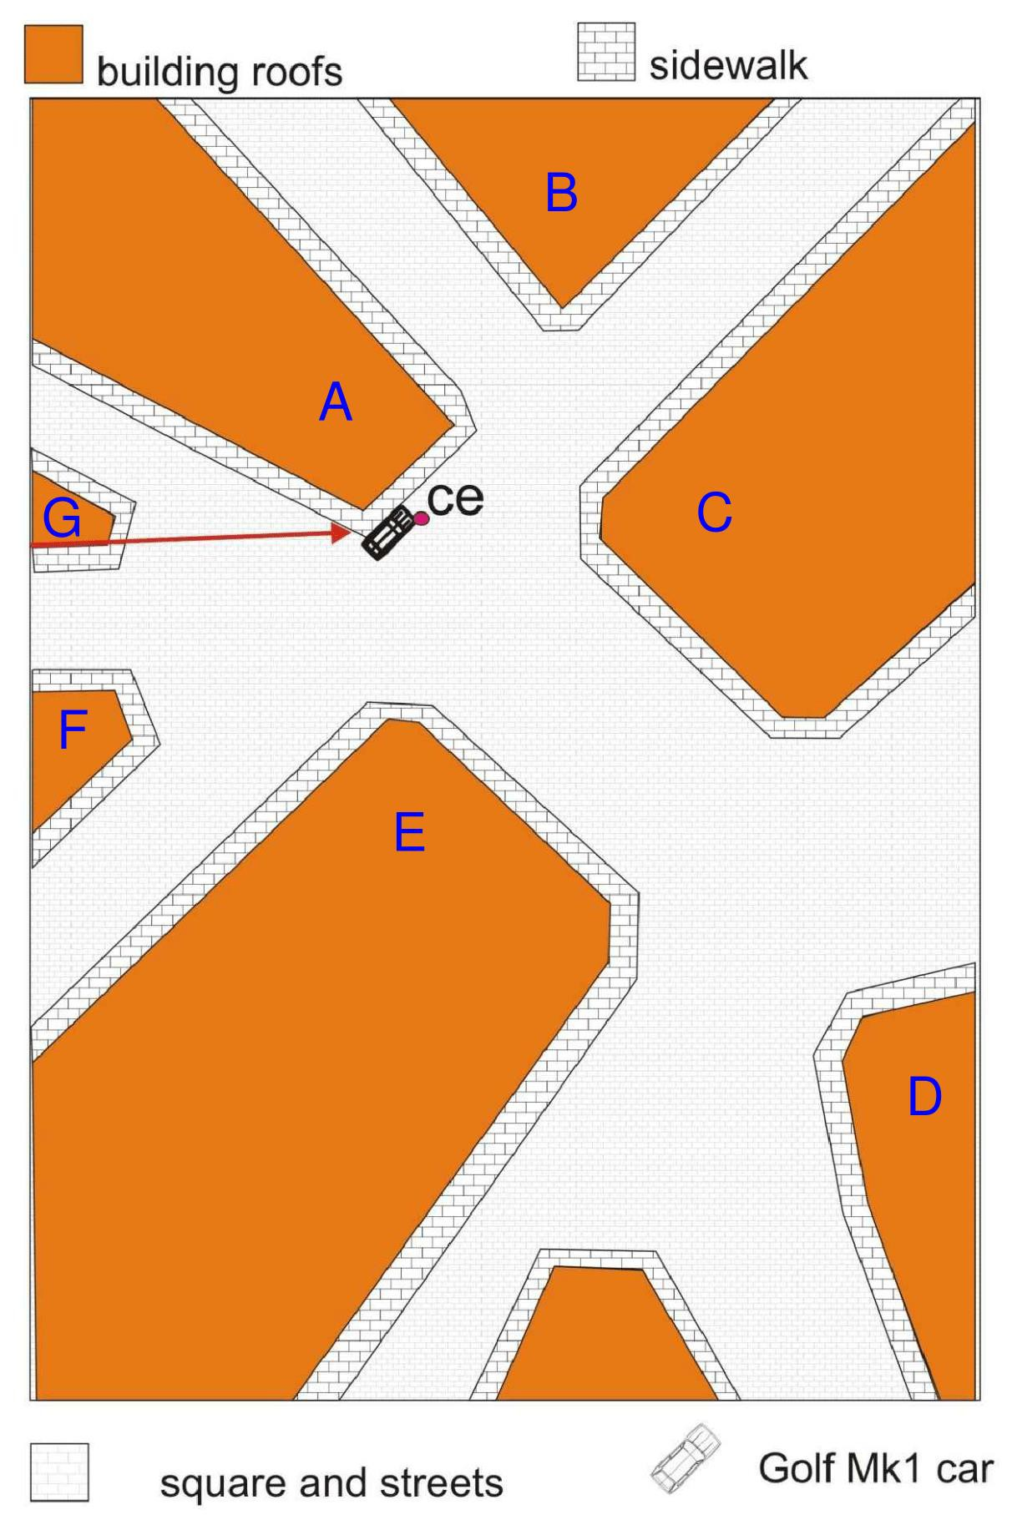

Figure 2.2 Labelling of buildings on schema of model Kapija square at Nikinci
The building closest to the centre of explosion (Modna kuča NIK) was built of bricks, other buildings were built of wood covered with thin metal sheets and their facades oriented into square were painted to imitate facades of real buildings, including doors and windows (see Figure 2.3 - Figure 2.5). Two outlying buildings F and G situated westerly from the CE were replaced only by their front walls. There were built pavements around the buildings in the model square and the road surface in proximity of about 5 - 10 m to the CE was built of cobblestones in agreement with the road surface in the Tuzla’s Kapija square. Other parts of square were covered by sand and gravel.
Real cars, substitutes of live targets (wooden dolls), and large wooden screens were used during individual experiments. Four cars of the same type like in the real explosion at Tuzla’s Kapija square were placed at the square at the same positions as they were parked at that time. Live targets substitutes were used at the scene for the first experiment. Wooden screens were used for the second and the third experiment.

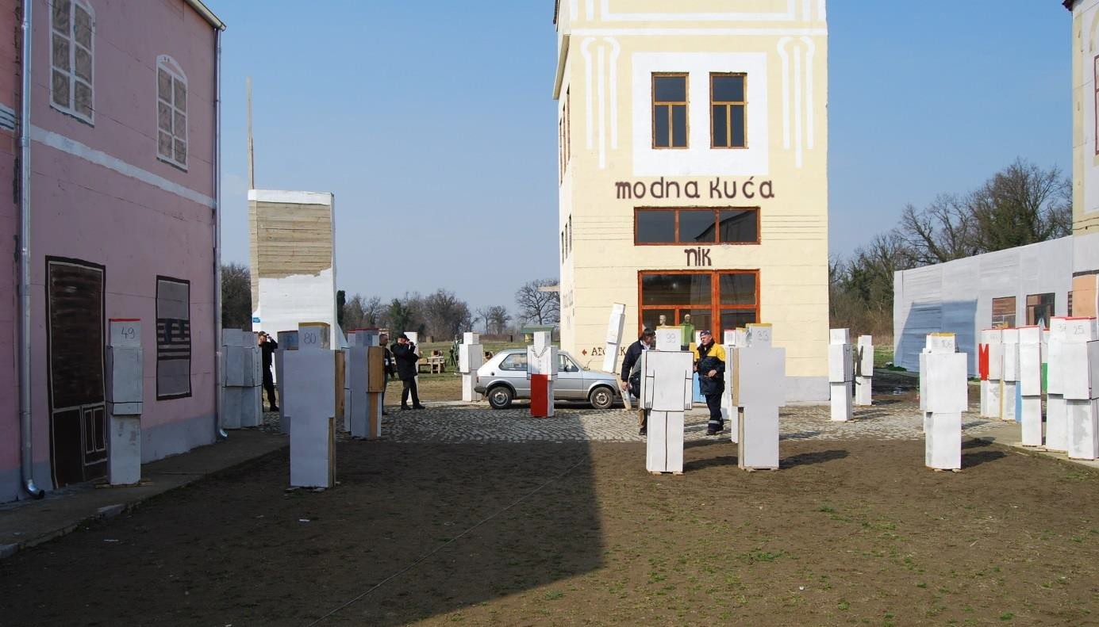

Figure 2.3 View at central part of model of square Kapija during preparation of 1st experiment (in the middle building A with NIK store, on the left building E, on the right buildings B and C)

Figure 2.4 View from the CE at north-eastern part of model square Kapija into street Partizanska towards Café Gulam (on the left building B, on the right building C)

Figure 2.5 View from the CE at south-eastern part of model square Kapija towards Café Kapija (at the back, in the middle – building D); on the left building C, on the right building E
Totally 3 pcs of 130 mm HE projectiles were fired at the model square; 2 pcs of Russian production and 1 pcs of Serbian production, (Figure 2.6 and Figure 2.7). The only bottom part of the UTIU fuze with booster was screwed into the projectile to allow the electric initiation.

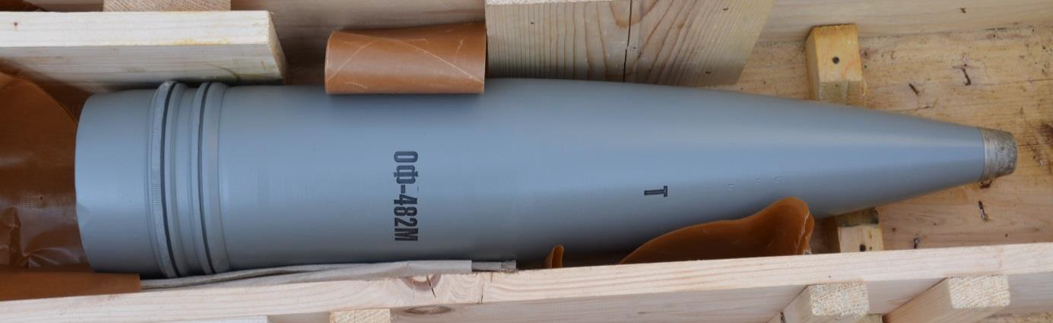

Figure 2.6 High-explosive projectile 130 mm OF-482M (Russian)

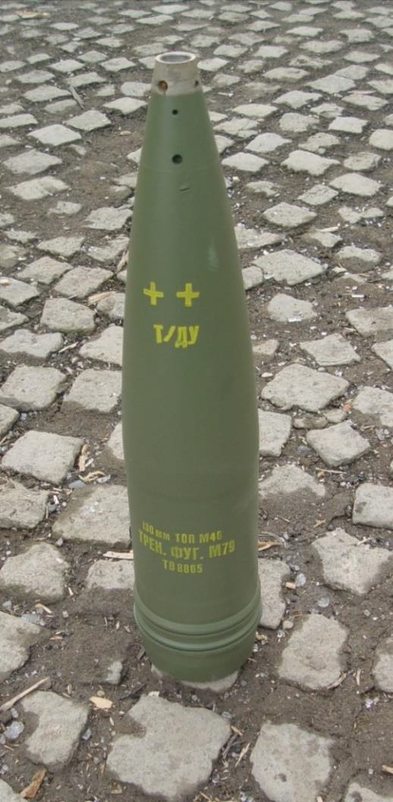

Figure 2.7 High-explosive projectile 130 mm OF-M79 (Serbian)

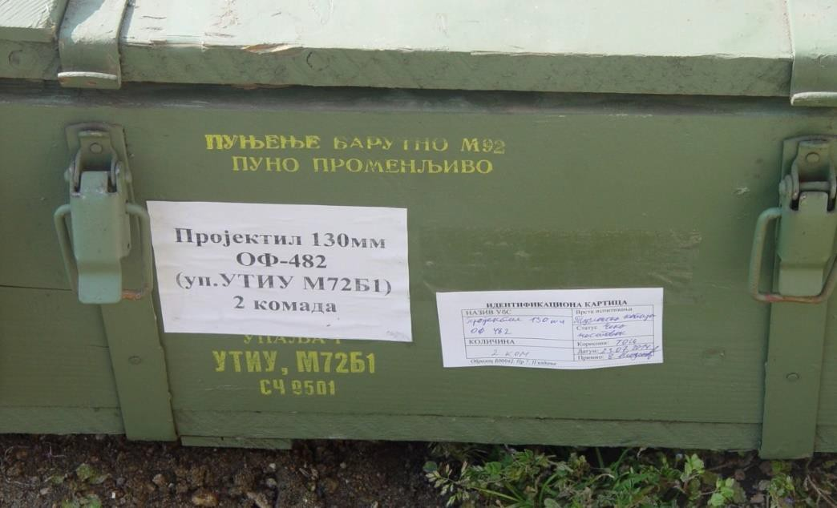

Figure 2.8 Packing of ammunition 130 mm OF-482 with UTIU M72B1 fuze
The position of the CE was characterised in the police scheme drawn by Irfan Džinović [4] as
  - m from left corner and 5.60 m from right corner of the NIK store building (width of the building 6.55 m). Position of the car after explosion can be only estimated from the scheme; the CE of explosion is placed in front of the right headlight. According to the witnesses the car was parked before the explosion along the sidewalk, which width is about 1150 – 1200 mm from the front wall of the NIK store building [1].

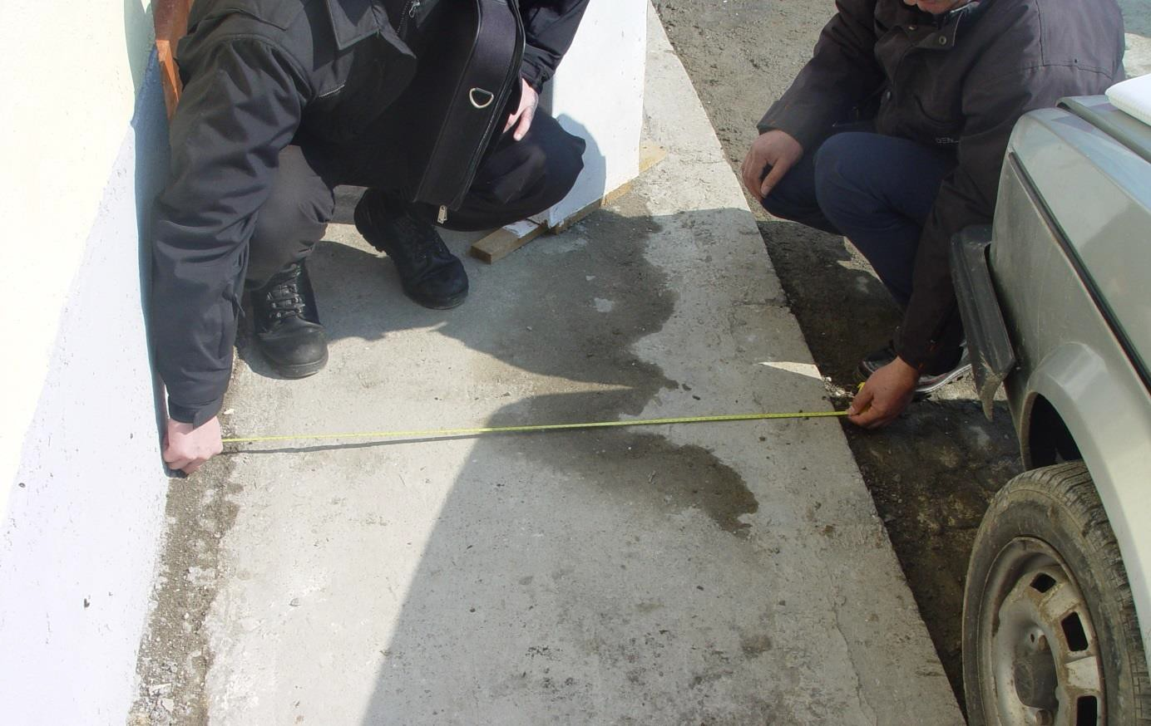

Figure 2.9 Measurement of the sidewalk width next to the NIK store

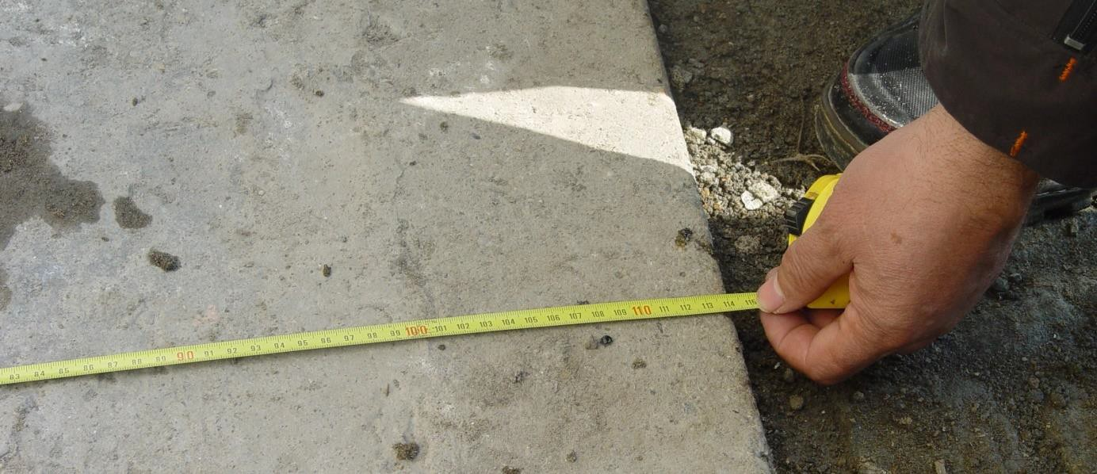

Figure 2.10 Measurement of the pavement width next to the NIK store (the distance from the wall of the building to the outer edge of the pavement is about 114 cm)

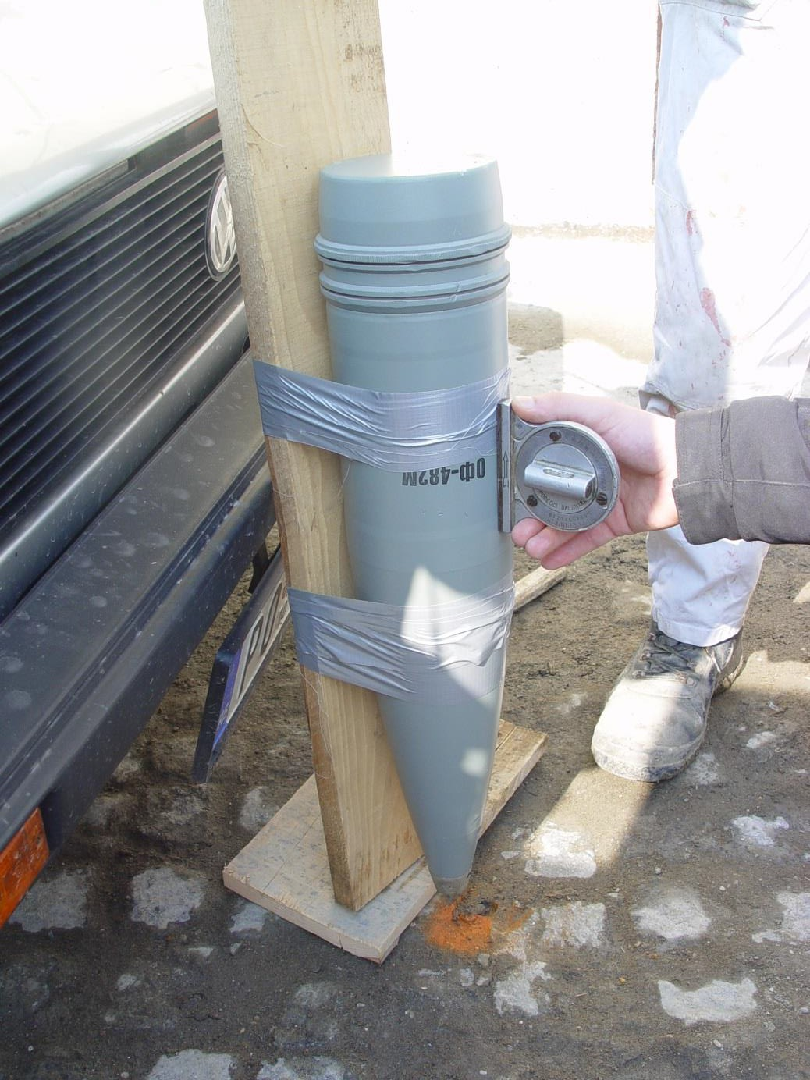

Figure 2.11 Set-up of the projectile into the position in the front of the VW Golf car (the orange point marks the CE) according the scheme made by Irfan Džinović

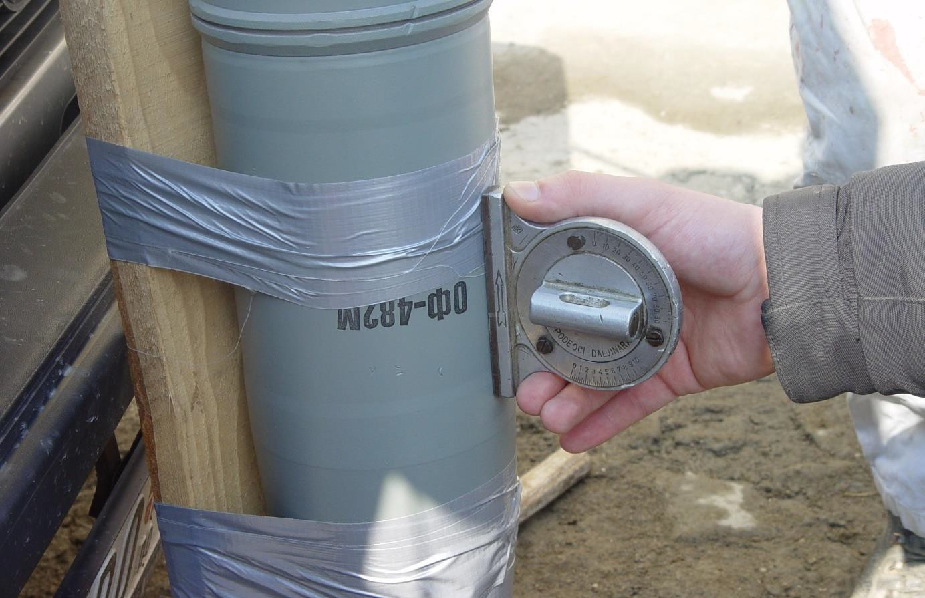

Figure 2.12 The detail of the set-up of the projectile into the position in the front of the VW Golf car according to the figure above

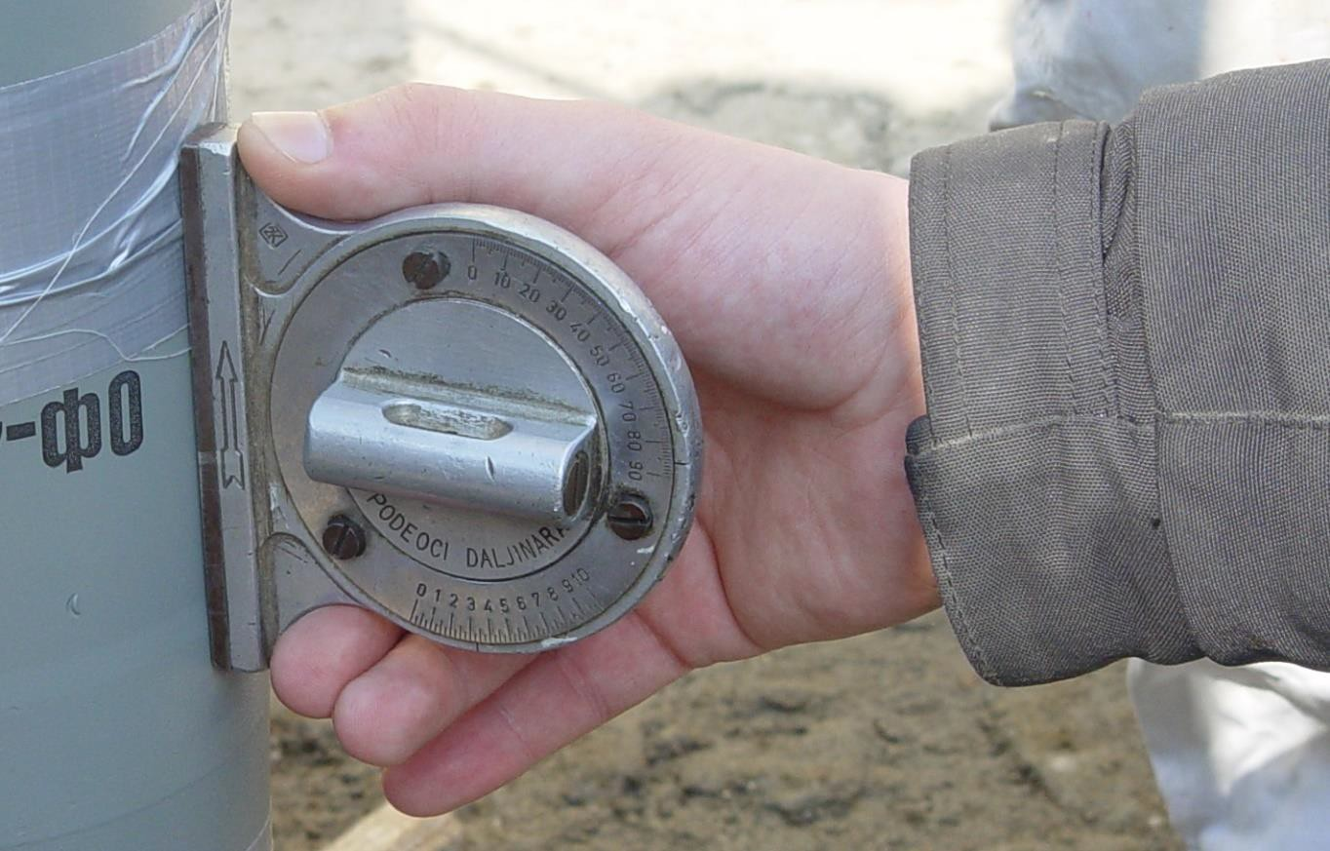

Figure 2.13 The detail of the set-up of the projectile into the position in the front of the VW Golf car according to the figure above – the angle of the longitudinal projectile axis deflection with respect to the horizontal plane (i.e. the angle of fall) is 86°

In the scope of the experiment preparation a position of the projectile was verified and measured for the projectile static initiation next to the VW Golf car. The CE is shown in front of the car in the police scheme. Therefore, the first scene was arranged in following way:
    - the car VW Golf Mk I was parked along the sidewalk and its front bumper was at the distance 135 cm from the left corner of the NIK store building, as described by witnesses and the police scheme,
    - the projectile was set in front of the car with nose pointing toward the CE and its longitudinal axis in azimuth 271° that defined by prof. Zečević as direction of projectile arrival.
However, in this position the deflection of the longitudinal axis of the projectile with respect to the horizontal plane was about 86°, Figure 2.11 - Figure 2.13. This angle of fall cannot be achieved in the real situation during the live fire from the Panjik area. The maximum achievable angle of fall at maximum range of fire 27481 m for standard conditions is nearly 68° (for angle of elevation of 51°).
Prof. Zečević used in his report [1] different dimensions (2.65 m from left corner and 5.60 m from right corner of the NIK store building, and width of the building 6.50 m). Prof. Zečević also defined the position of the car before the explosion as 470 mm from the wall of the NIK store building and 1300 mm from the left corner of the NIK store building.
Position of the side of the car VW Golf Mk I was according to [1] 470 mm from the wall of the NIK store building and 1300 mm from the left corner of the NIK store building. This position of the car was used for the experiments No. 1.
The projectile was placed on 1” wooden board and placed next to the car. It was not physically possible (due to presence of the car VW Golf Mk I) to place the projectile into position defined in the prof. Berko Zečević’s expert report (angle between projectile’s longitudinal axis and ground 62°, distances of the projectile’s nose from the corners of NIK store building 2.65 meters and 5.60 meters - Figure 2.14). The angle between projectile’s longitudinal axis and the ground was about 74° in this case.

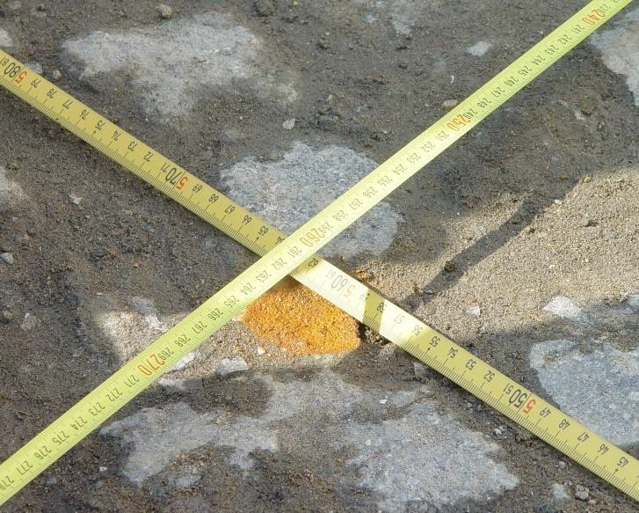

Figure 2.14 Point of impact of 130 mm HE projectile according to prof. Zečević’s report

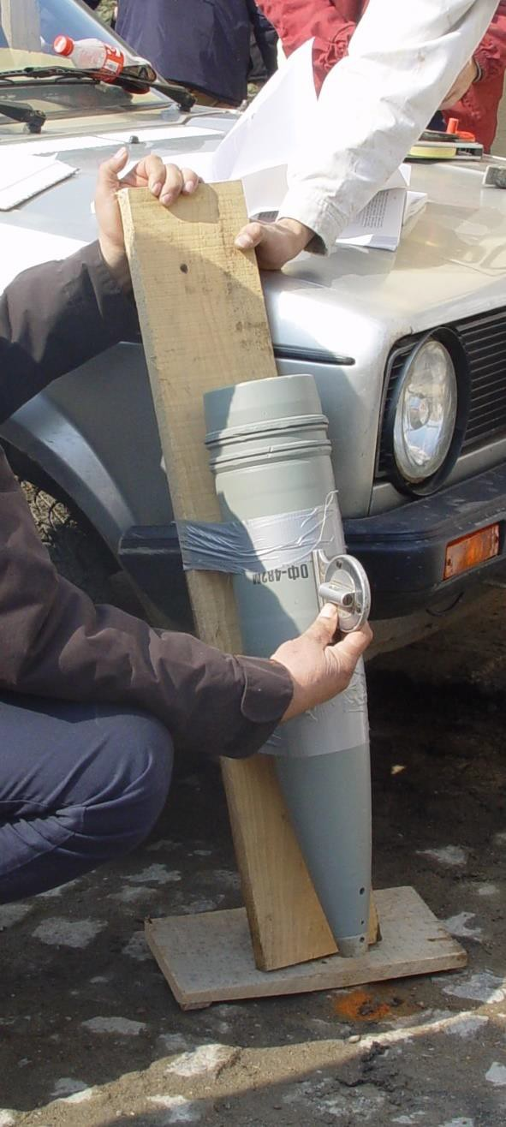

Figure 2.15 Position of the 130 mm projectile (according to [1], orange patch on the ground)

Therefore the projectile was placed into as close as possible position, nose of the projectile was placed into new point – 14 cm to the left corner of the NIK store building (in parallel direction with the building’s facade) and 23 cm perpendicularly from the facade of the NIK store building, then the angle of projectile’s longitudinal axis and ground was 62°, see Figure 2.16 and Figure 2.17.
Front part of the projectile placed just above the ground (gap between the projectile and ground surface corresponded to missing head part of the fuze). The projectiles were than electrically initiated at this position to simulate their ground explosion. The projectiles were initiated by the electric detonator No. 8.
The scene was during preparation and after each experiment continuously photographed. The video records were also taken from both static ground video cameras, including high-speed video camera, and video camera placed on the drone.

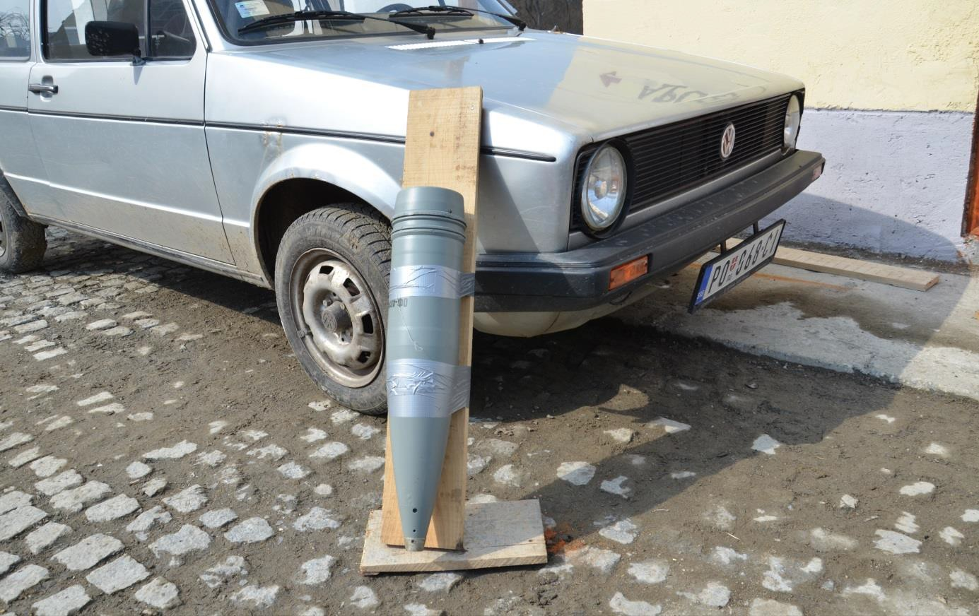

Figure 2.16 Placement of projectile for 1st experiment – detail (yellow arrow pointing to the original point of impact - orange patch on the ground)

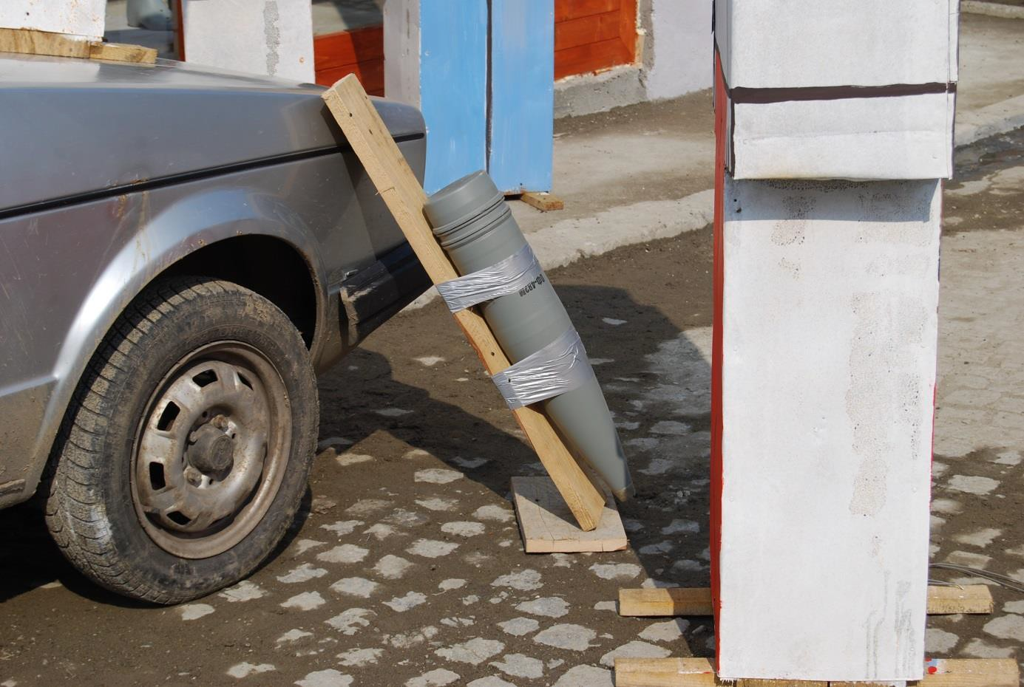

Figure 2.17 Placement of projectile for 1st experiment - detail (angle of fall 62° with respect to the ground)
The basis for the planning and realisation of the experiments was the comparative method. The experiments were prepared and carried out in such a way to provide data on fragments scattering for comparison with real situation in Tuzla in 1995. Individual experiments differed not only by the scene arrangement but also by their purpose and obtained data.

2.1 Experiment No. 1
For the 1st experiment the Russian HE projectile 130 mm OF-482M was used. Instead of real persons the dolls were used for the determination of effect and hit probability of fragments on the body. The dolls were placed into the area of “Kapija” square according to the schema based on the results of official investigation of “Kapija massacre”.
During the first experiment only dolls replacing killed and surviving victims, whose positions were known at the time of explosion, were used. For this experiment 69 dolls were used. Dolls were made of wooden boards (soft wood of thickness of 20 mm) and plated by steel sheets of thickness of 1 mm (Figure 2.18 - Figure 2.20).
For the purpose of this experiment two types of dolls varying in size, according to gender, were prepared (Figure 2.21). Female doll has height of 170 cm and front area of 0.66 m2, male doll has height of 180 cm and front area of 0.82 m2. Each doll was labelled on its head with number corresponding to the number of victim, or person who survived. Dolls introducing killed victims were labelled with red strip on its head, dolls introducing survivors were labelled with yellow strip. Overall number of 69 dolls was used (28 dolls with red strip, 41 dolls with yellow strip).
The arrangement of the scene for the first experiment is apparent from the Figure 2.18 and figures following. Car VW Golf Mk I, the same type as in case of explosion in 1995, was placed in close proximity of the CE. The projectile was placed into close proximity of undamaged car VW Golf Mk I, parked at pavement edge in front of NIK store building (Modna kuča NIK), see (Figure 2.22).

Dolls were placed into positions where both killed and surviving victims were, according to witnesses, at the time of explosion.

Figure 2.18 Dolls used during experiment No. 1 - Samoizbor

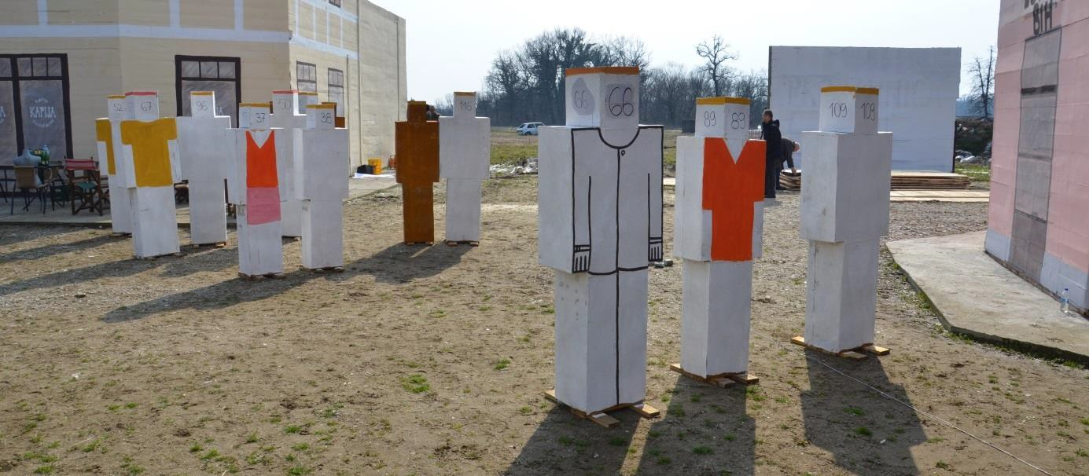

Figure 2.19 Dolls used during experiment No. 1 – Lutrija BiH, Café Kapija

Figure 2.20 Dolls used during experiment No. 1 – Caffé Leonardo

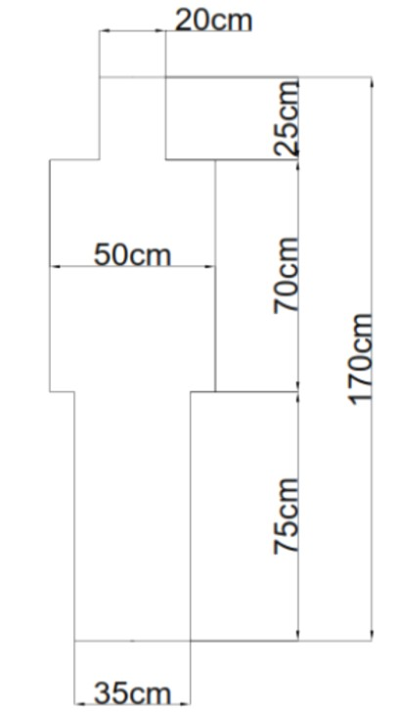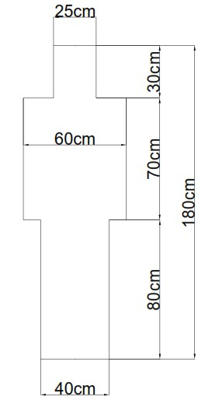

Figure 2.21 Doll’s dimensions (left female figure of front area 0.66 m2, right male figure of front area 0.82 m2)

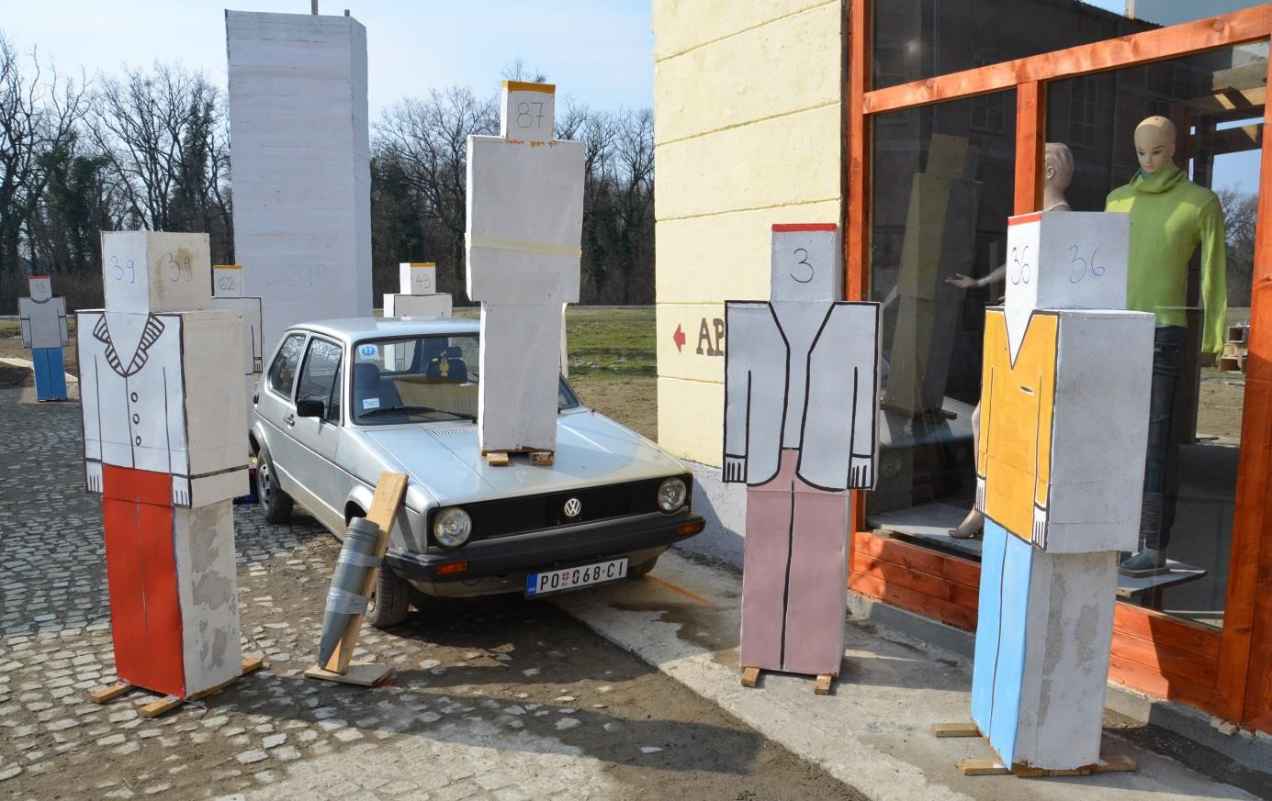

Figure 2.22 Arrangement of scene in close proximity of CE (on the right shop NIK)
Figure 2.23 and Figure 2.24 show static pictures of individual phases of projectile’s explosion from the high-speed camera record. It follows from the figures that the maximum diameter of the flash ball during explosion of the projectile is approx. 1.5 – 2.0 m.

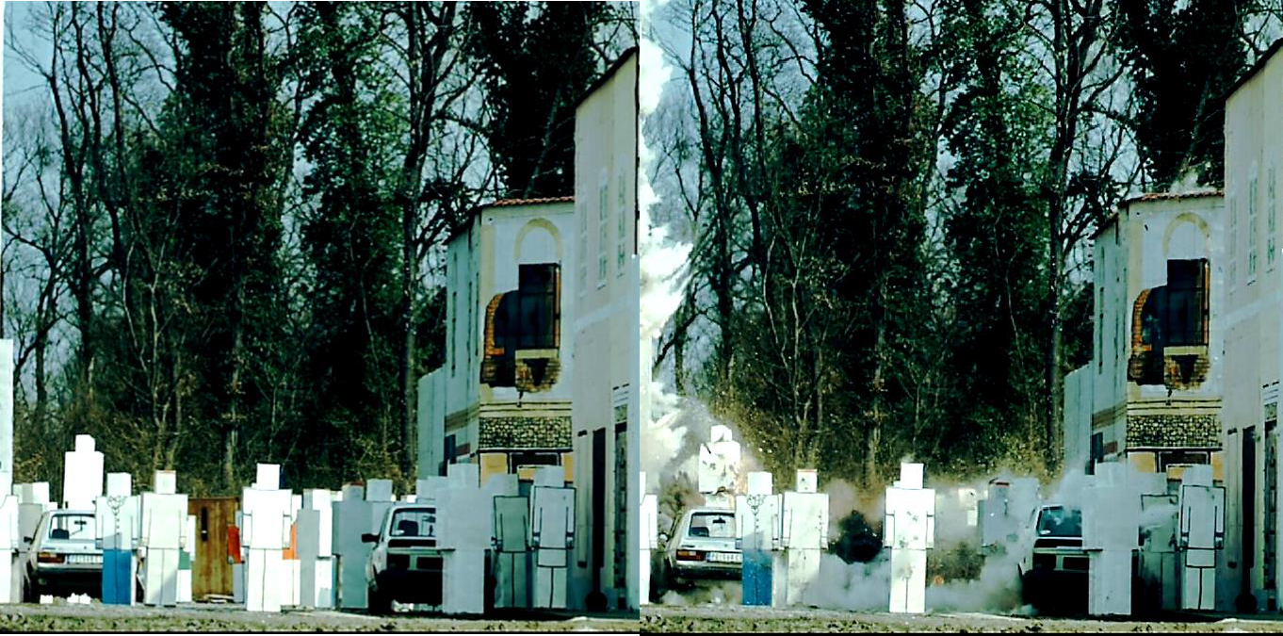

Figure 2.23 Static pictures from high-speed video just before explosion of 130 mm HE projectile (left) and first instants after explosion of projectile (right); view from the southeast, on the left side car VW Golf at which front right side exploded the projectile

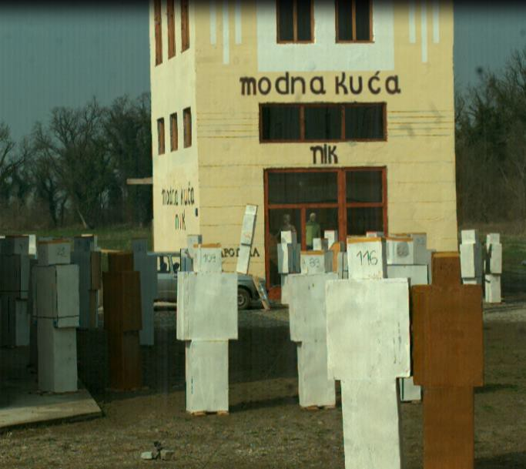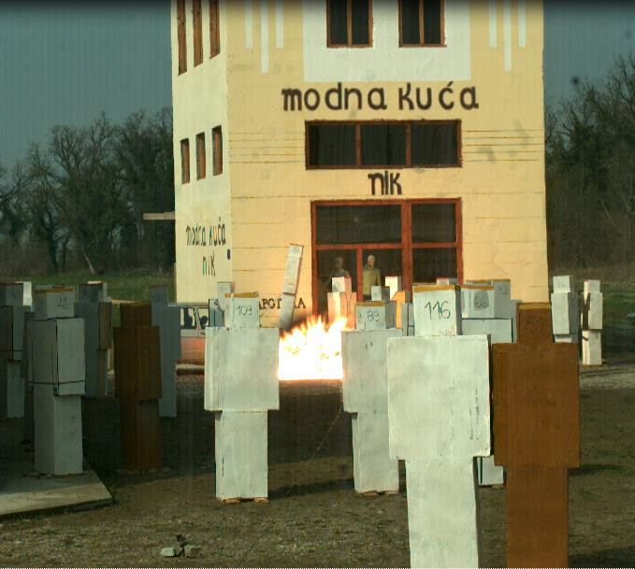

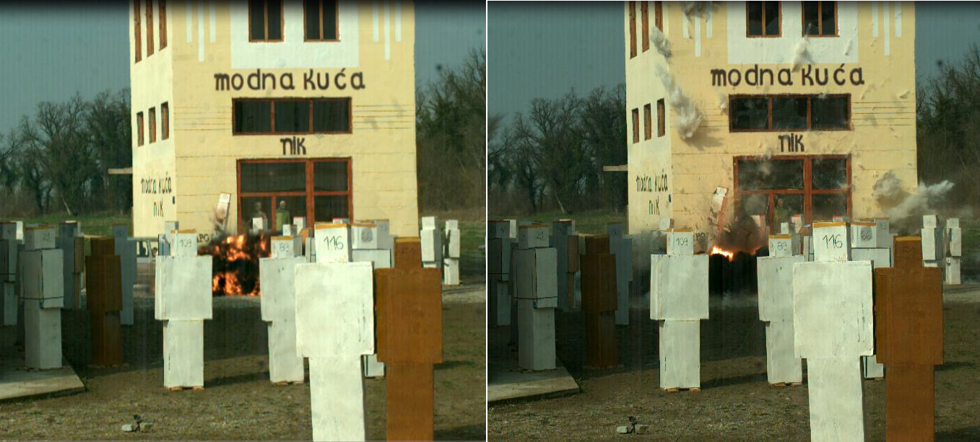

Figure 2.24 Static pictures from high-speed video just before explosion of 130 mm OF projectile (left upper picture) and first instants after explosion of projectile (other 3 pictures); view from Café Kapija
Overall views at the scene after first explosion are presented at Figure 2.25 - Figure 2.38.

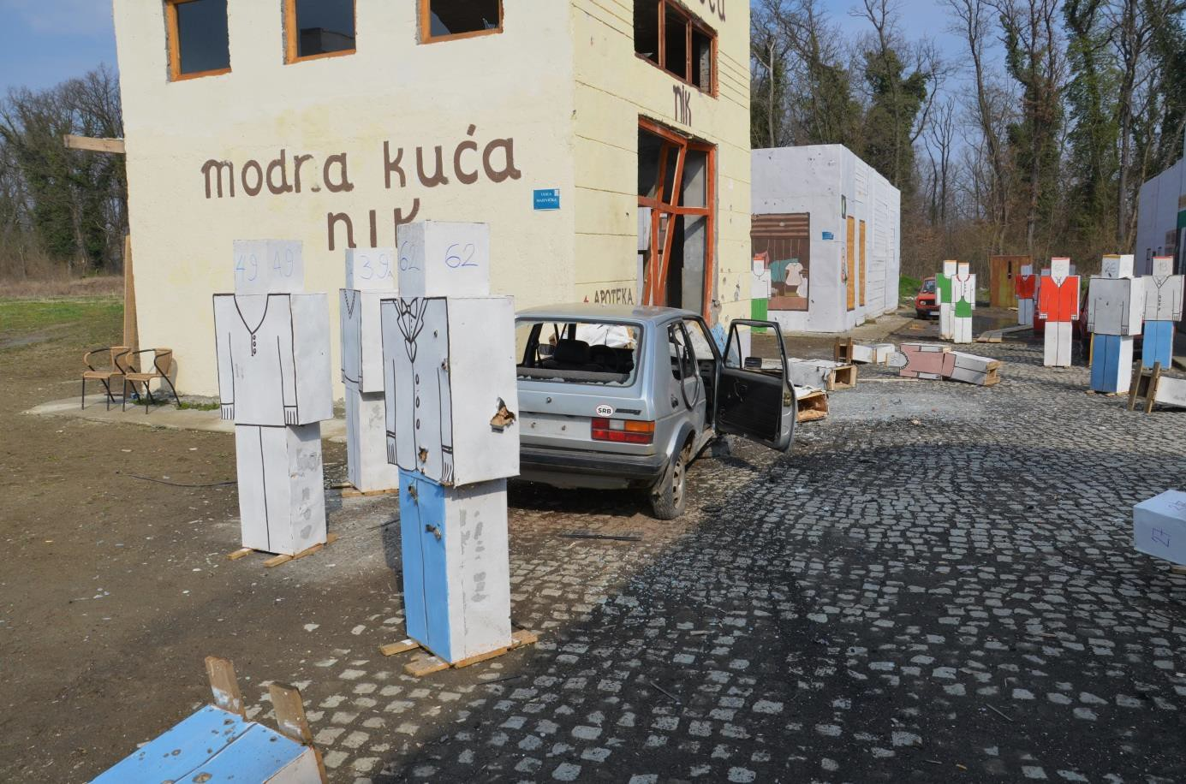

Figure 2.25 View at the scene immediately after the 1st explosion (the CE is behind the open car door, next to the right front wheel)

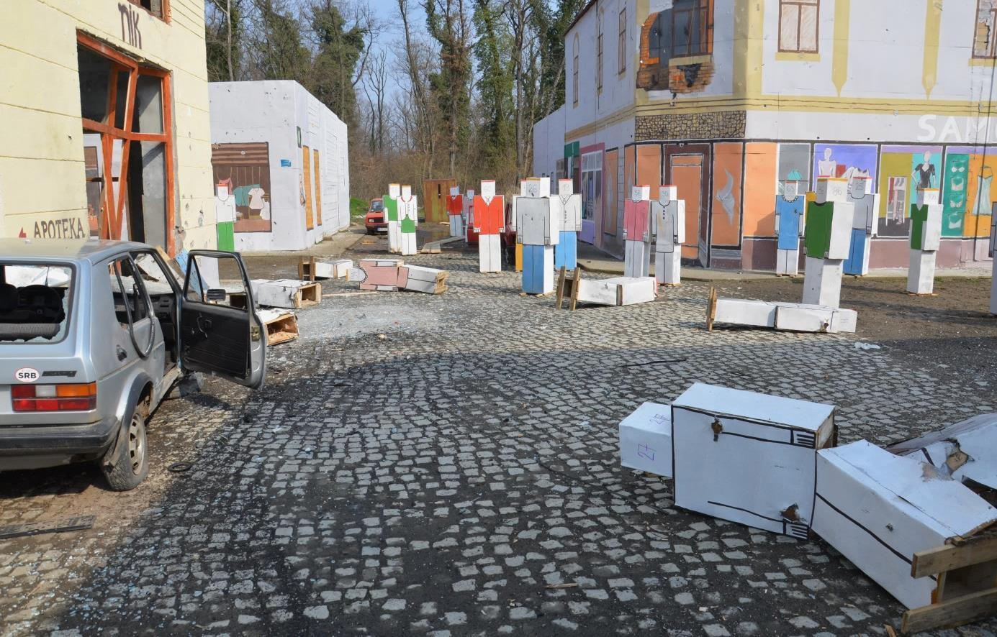

Figure 2.26 View at the scene immediately after the 1st explosion (dolls in close proximity of the CE were thrown away by pressure wave, further dolls remained upright)

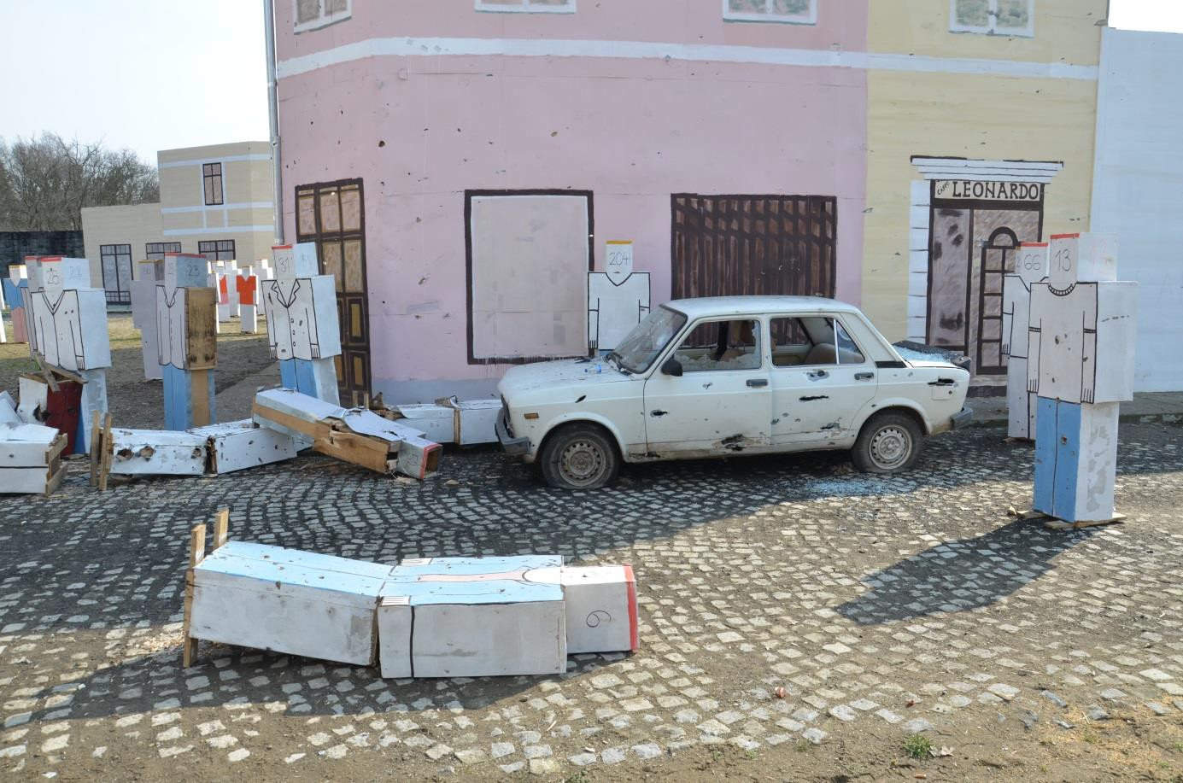

Figure 2.27 View at the scene immediately after the 1st explosion; area at the corner of the

building and Caffé Leonardo was hit by heavy fragments of the side spray because it is situated in the direction right and perpendicular from the CE with respect to the plane of arrival

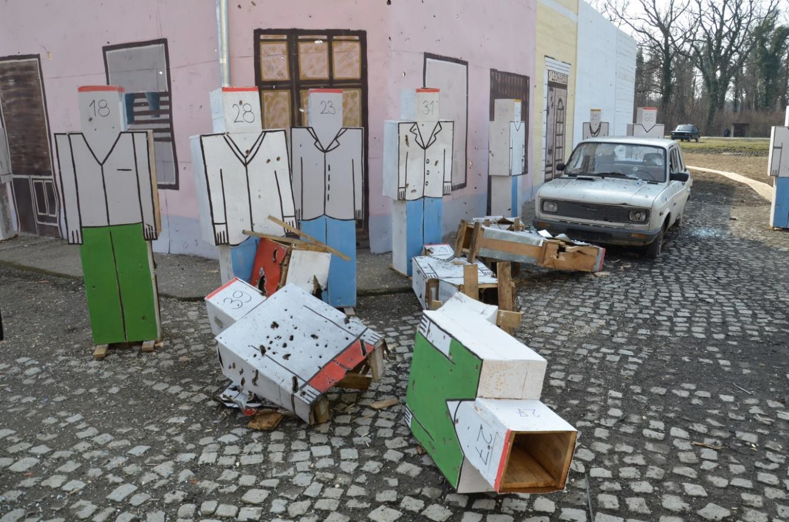

Figure 2.28 View at corner of building between Kapija shop and Caffé Leonardo with dolls and car Zastava hit by very effective side spray of fragments (side spray effect)

Figure 2.29 View at the scene immediately after the 1st explosion; view from the CE in south direction – right Caffé Leonardo with Zastava car heavily damaged by fragments; scattering of fragments from the side spray is obvious on the facade (borders of the sector are marked by yellow lines at the figure)

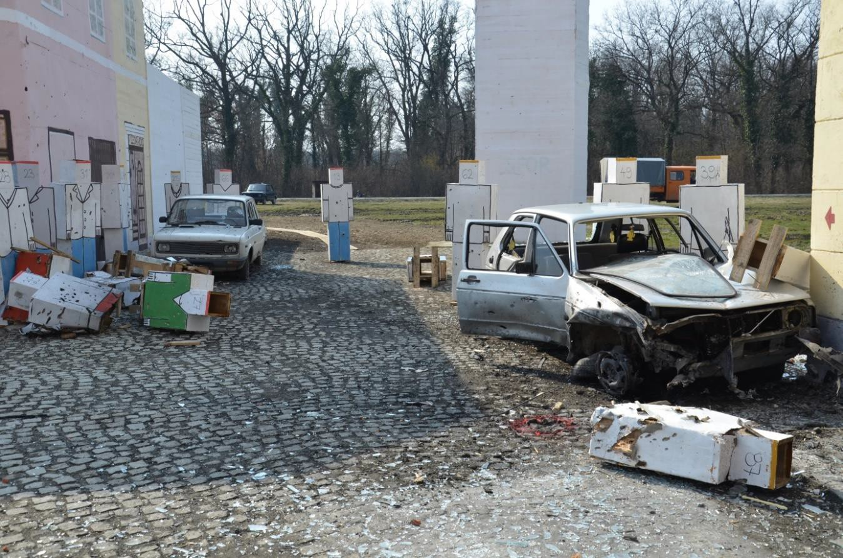
CE

Figure 2.30 View at the scene immediately after the 1st explosion; view from the CE in the south-west direction – left Caffé Leonardo and Zastava car (borders of scattering sector of fragments from the side spray, elongated from previous figure are marked by yellow lines at the figure)

The effect of the side spray of fragments which sector is approximately marked by yellow lines intersecting at the CE is obvious from Figure 2.29 and Figure 2.30. Analogous character of damage to the buildings caused by fragments was not recorded at Kapija square in Tuzla. Likewise the effect of the side spray on the building NIK are apparent (Figure 2.31). Effects of fragments in other directions, out of reach of the side spray, were minimal (Figure 2.32 - Figure 2.35).
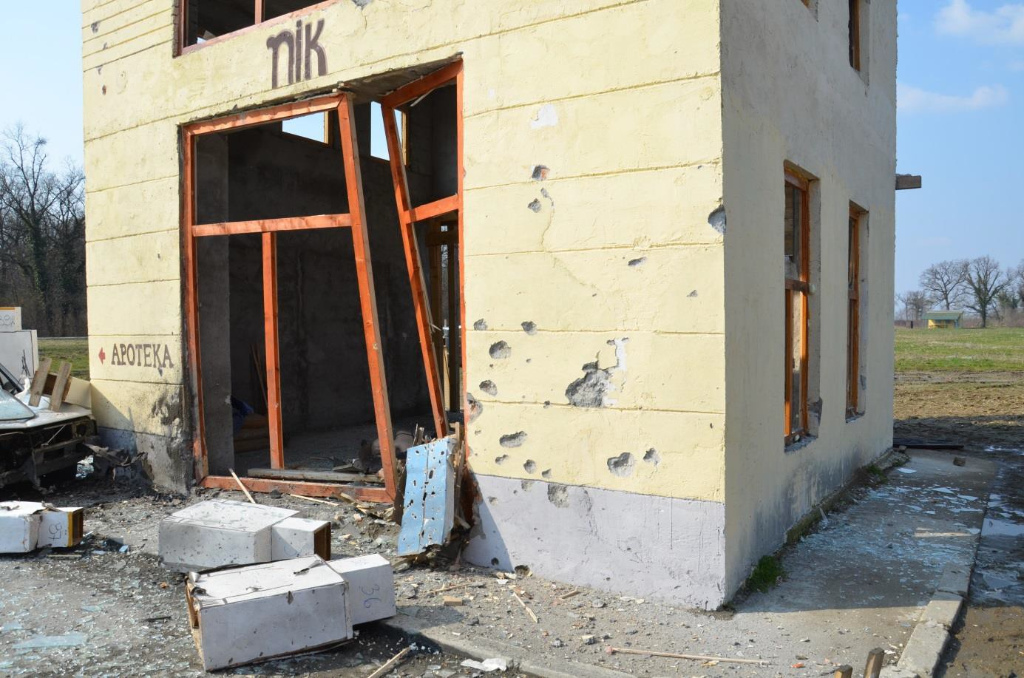

Figure 2.31 View at the scene immediately after the 1st explosion; view at frontage of NIK store building; holes at the facade are not in majority of cases circular but elongated in the direction of fragments motion

Figure 2.32 View at the scene immediately after the 1st explosion; view from the CE in

northern direction – left Caffé Gulam, right Samoizbor; only minimum number of fragments flew in this direction

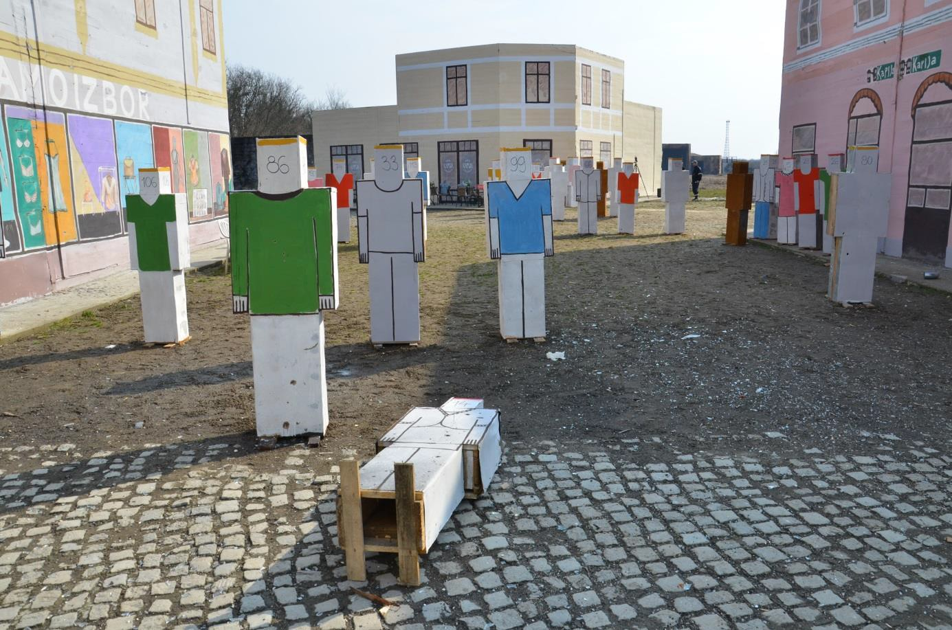

Figure 2.33 View at the scene immediately after the 1st explosion; view from the CE in south- eastern direction at Caffé Kapija; only minimum number of fragments flew in this direction

Figure 2.34 View at the scene immediately after the 1st explosion; facade of the building

(Samoizbor part) was not nearly hit by fragments as well as doll standing in front of the building

Figure 2.35 View at the scene immediately after the 1st explosion; facade of the building in Kapija part was not almost hit as well as dolls standing in front of the building

Following parts of subchapter 2.1 contain comparison of effects of explosion on individual elements of the scene obtained from experiments in Nikinci in 2015 and from the real situation in Tuzla’s Kapija square in 1995. There are analysed damages to cars and their positions, damages to buildings, especially NIK store building, and character of the crater in the CE. The biggest attention is paid to effects of fragments on dolls.

Damages and positions of cars
In contradiction with the situation recorded immediately after the event on the “Kapija” square on 25th May 1995 the result of field trials showed following significant differences:

Car No. 1 (VW Golf Mk I)
As a result of the 1st explosion of the projectile in Nikinci the car Golf was heavily damaged. The right front side of the car had a huge damage by explosive effect of the exploded projectile with a lot of penetrations caused by fragments. The front right wheel of the car suffered an extensive damage. The tire was pulled off and the wheel disk had a lot of penetrations, deformations, and cracks. The front wing of the car had a large number of penetrations to the engine compartment and inside of the crew compartment. Most of the side windows and the rear window of the car were splintered by effect of shock wave and fragments; the front window was split with several penetrations and pulled off. The front bumper was torn off on the right side of the car and warped. The front right headlight was pulled out by explosion and thrown into room of the NIK shop. The engine was hit by many fragments and was extensively damaged. All tires had penetrations and were flattened.
Figure 2.36 - Figure 2.41 show in different positions car VW Golf Mk I damaged by explosion of projectile during experiment. Damage to equivalent car VW Golf Mk I in Tuzla in 1995 was diametrically different. The VW Golf Mk I damaged at Tuzla’s explosion suffered significantly lower damage to its front part that was supposed to be next to the place of explosion (see Figure 2.42). This car had not all larger window glass panels smashed open.
Both cars were also placed into different position with respect to the assumed place of explosion after the projectile’s explosion. Due to 1st explosion of the projectile in Nikinci the car VW Golf Mk I was pushed away to the wall of the NIK shop building. It also touched by its front left part the buildings wall (Figure 2.43 and Figure 2.44). But the same car moved only minimally, and only backwards after explosion at Tuzla’s Kapija square (Figure 2.42 and Figure 2.45).

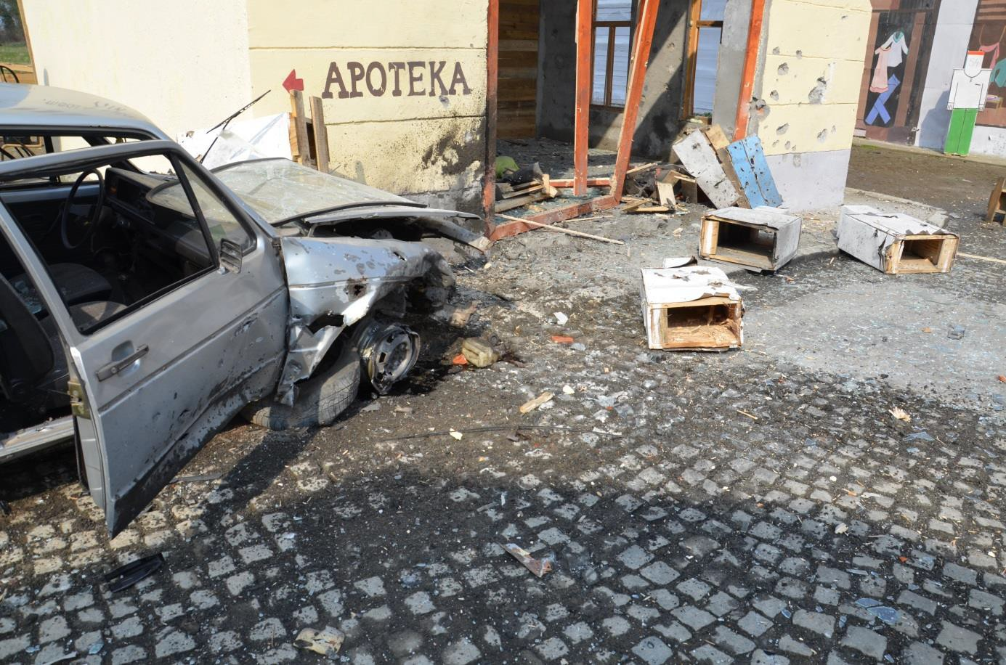

Figure 2.36 View at right front part of car VW Golf Mk I heavily damaged by explosion

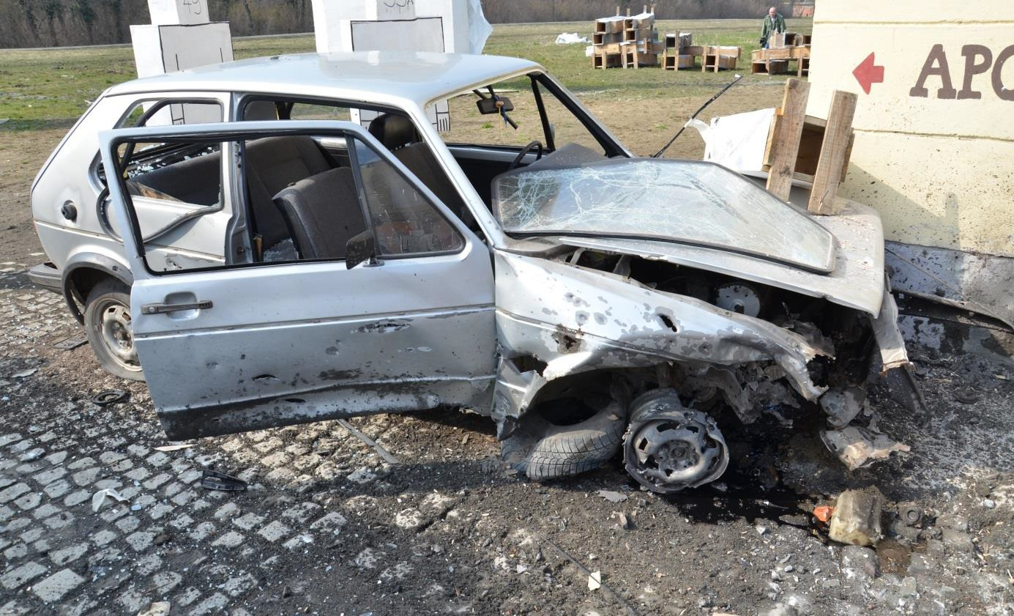

Figure 2.37 View at destroyed car VW Golf Mk I (all large glass panels were smashed down by explosion)

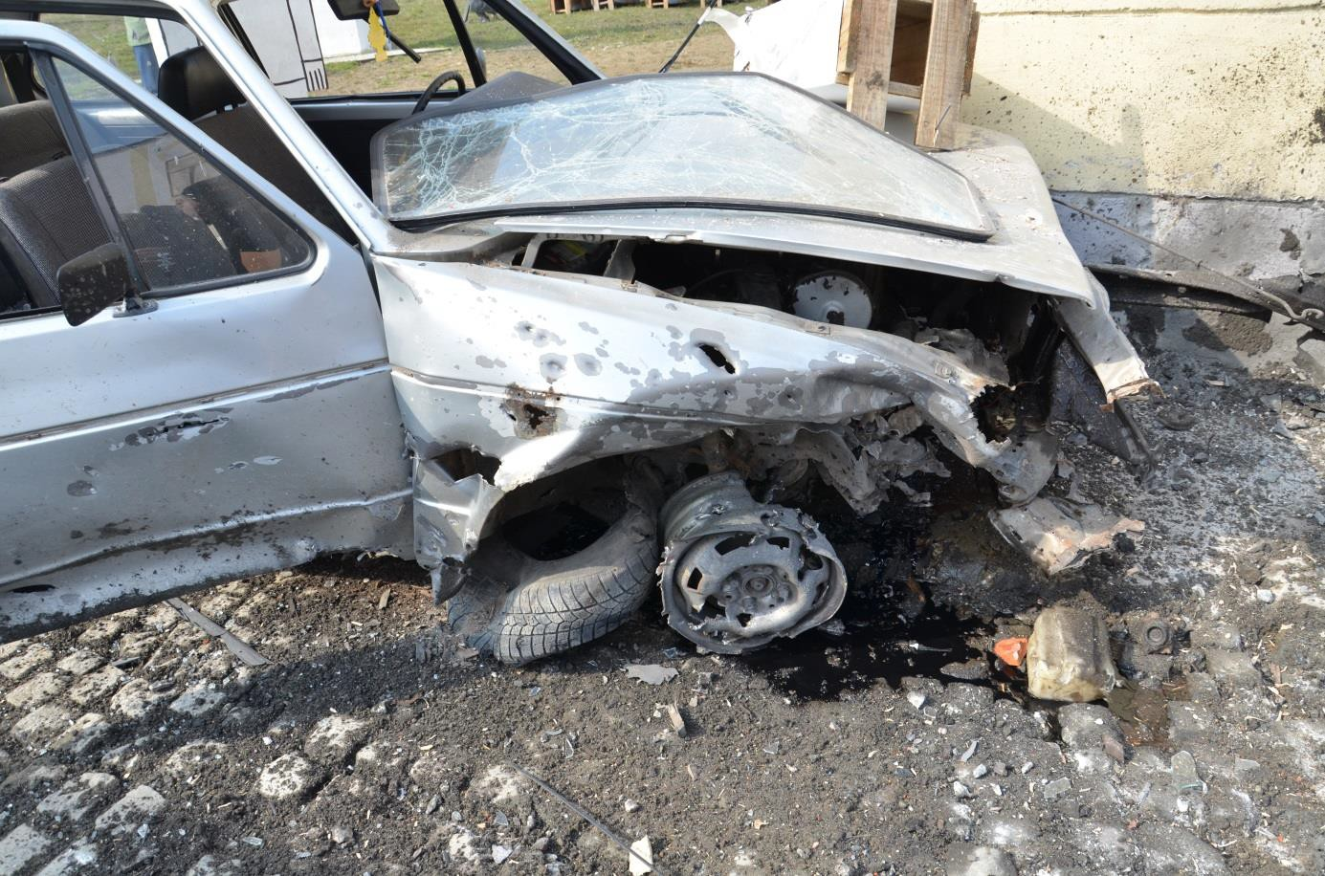

Figure 2.38 Detailed view at destroyed front right part of VW Golf Mk I car (tire ripped off, wheel rim and wing considerably deformed by pressure wave and perforated by number of fragments, part of wing and bonnet torn off)

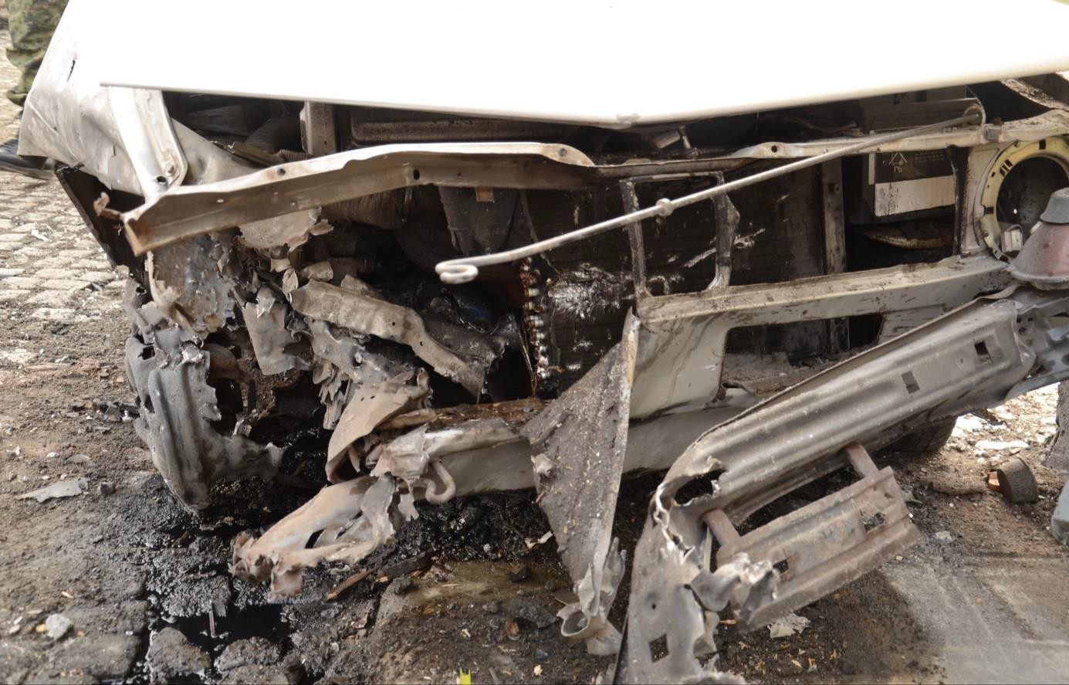

Figure 2.39 Detail view at destroyed front right part of VW Golf Mk I

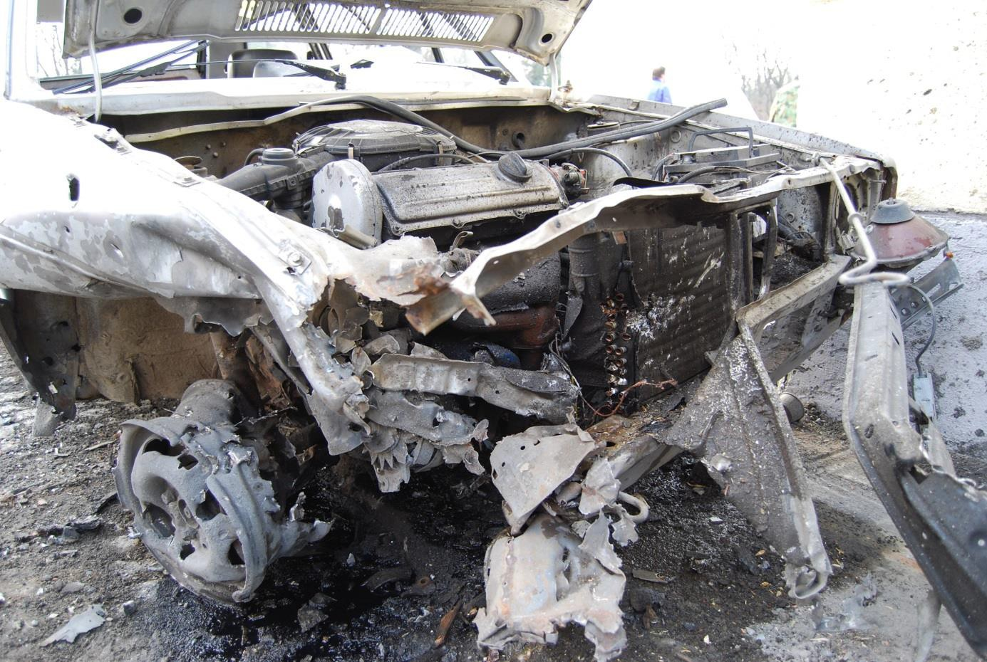

Figure 2.40 Detail view at destroyed front right part of VW Golf Mk I (after the bonnet opening)

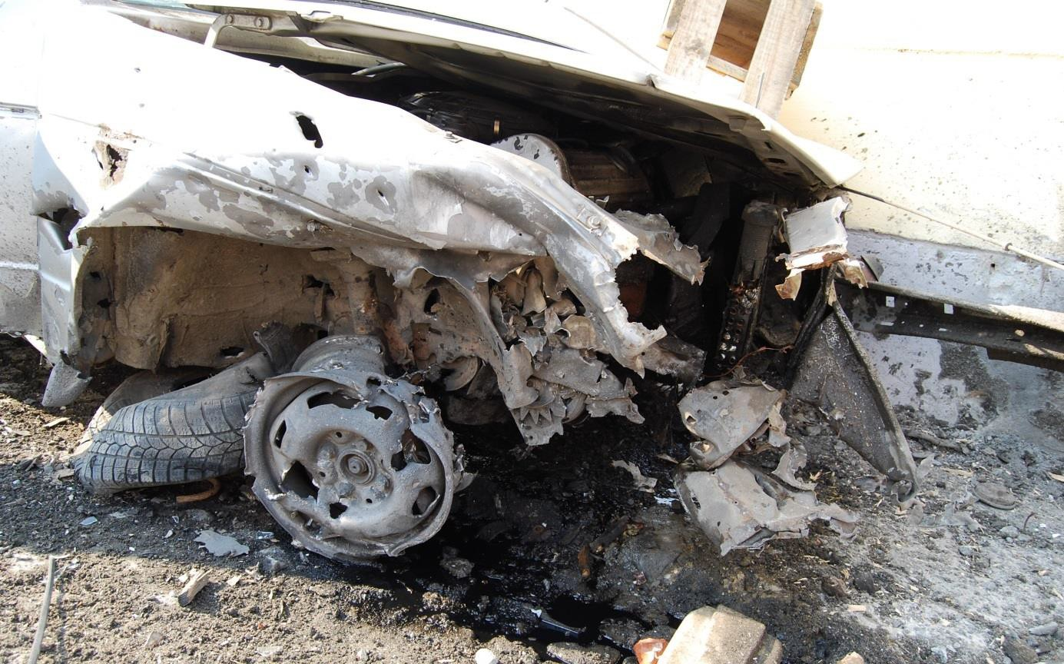

Figure 2.41 Detailed view on damaged car VW Golf Mk I at “Kapija” square after 1st experiment; wheel is totally wrecked (compare with Figure 2.42)

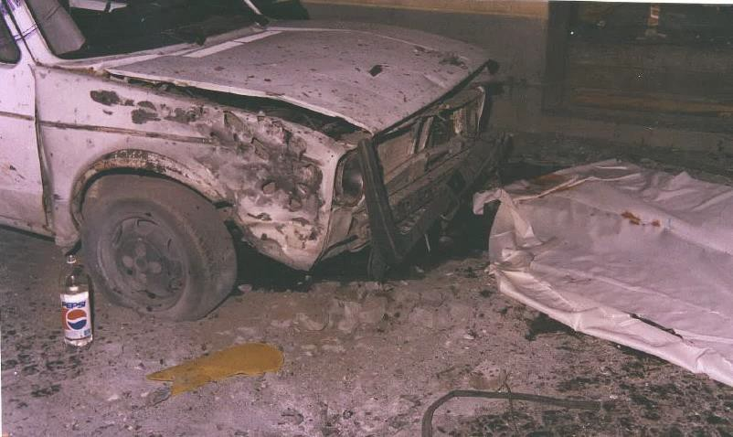

Figure 2.42 Detailed view on the damaged car VW Golf Mk I on Tuzla’s “Kapija” square, evening after the explosion (compare especially with Figure 2.41)

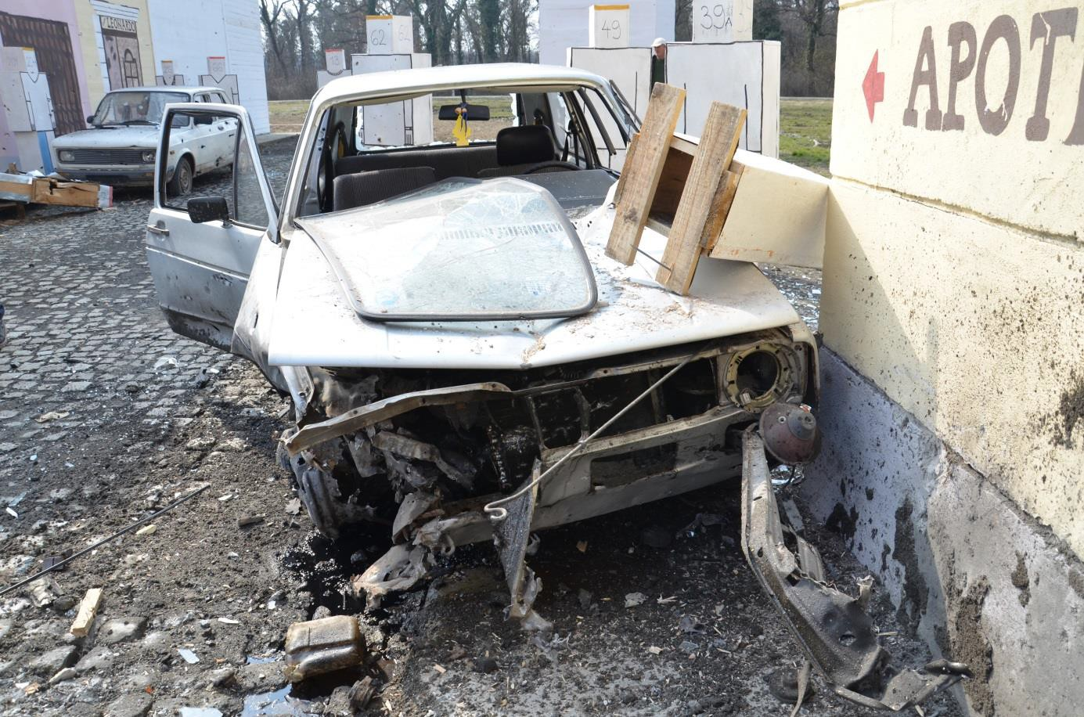

Figure 2.43 Detailed view on destroyed front part of the car VW Golf Mk I that was pushed by explosion left and backwards (left front part of the car is in touch with the corner of NIK store building)

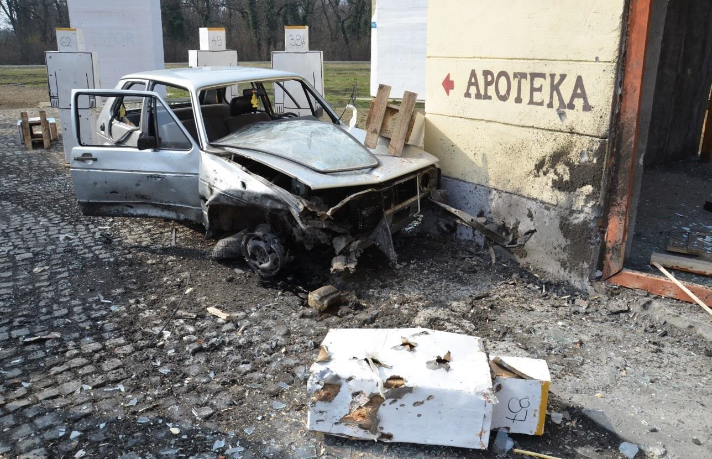

Figure 2.44 VW Golf Mk I car after the 1st experiment (car is moved backwards and pushed towards the wall of NIK store building)

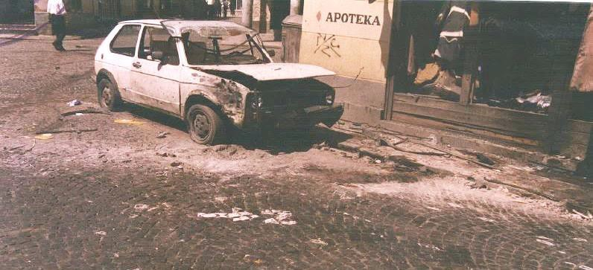

Figure 2.45 View on the scene in front of NIK store building on Tuzla’s “Kapija” square, next morning after explosion (the car is in completely different position than the same car at Figure 2.44)

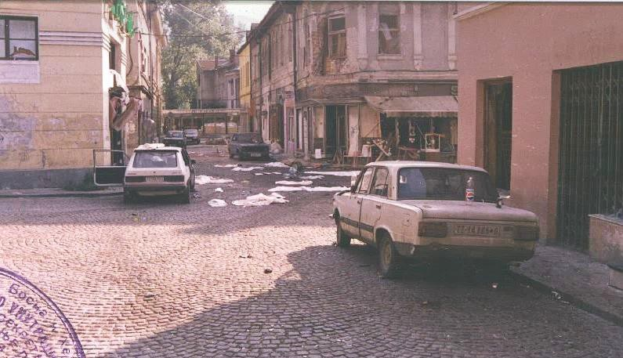

Figure 2.46 View on Tuzla’s “Kapija” square morning after explosion (VW Golf Mk I car on the left side of picture was only pushed backwards and it is about 1 m from the wall of NIK store building)
There are not apparent any hits of fragments on the right doors and the right rear part of the Tuzla’s car VW Golf Mk I (Figure 2.45). On the other hand the same car was hit by a relatively high number of fragments during the experiment at Nikinci (Figure 2.47).

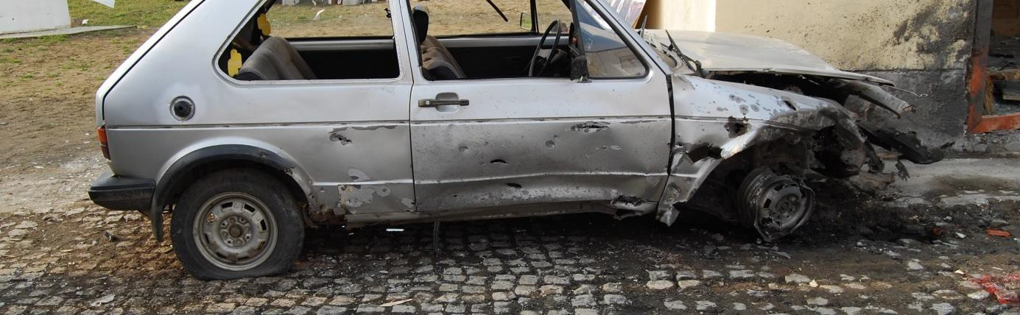

Figure 2.47 Right middle and rear part of the car VW Golf Mk I hit by higher number of fragments

Car 2 (Zastava Z 101), car 3 (Zastava Z 128)
The cars had penetration of the windscreen, but windscreen remained in a place, and each car was hit by several fragments penetrated into compartments. All tires had penetrations and were flattened. Generally, it can be stated that the damage inflicted to cars No. 2 and No. 3 was significantly lower in comparison to damage inflicted to analogous cars in Tuzla. The significantly higher extent of damage to these cars in Tuzla’s Kapija square could be caused by another close explosion. The black dirt covering the cars and victims at Tuzla’s Kapija square points out to possible use of some nonstandard explosive, Figure 2.50 and Figure 2.51.

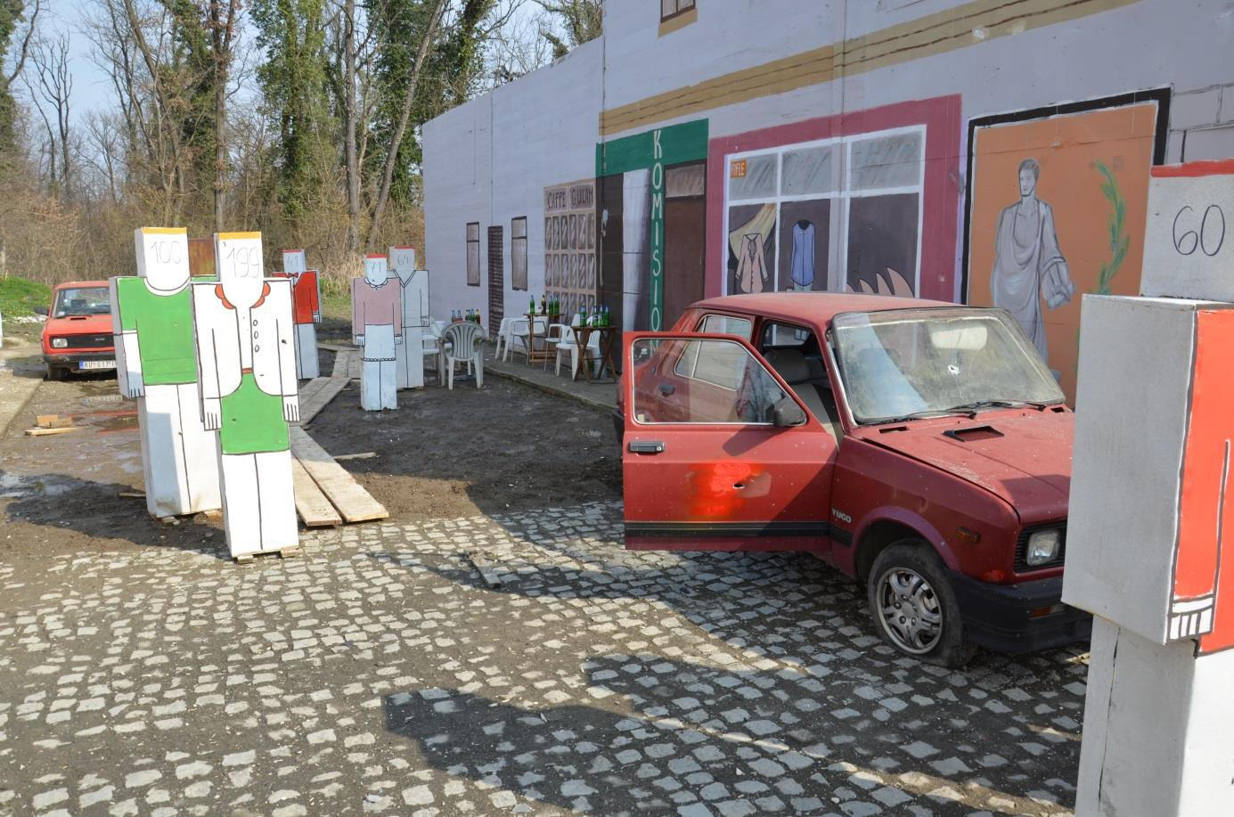

Figure 2.48 View in north-eastern direction into Partizanska street with both Zastava cars; effect of fragments on the building’s facade is minimal

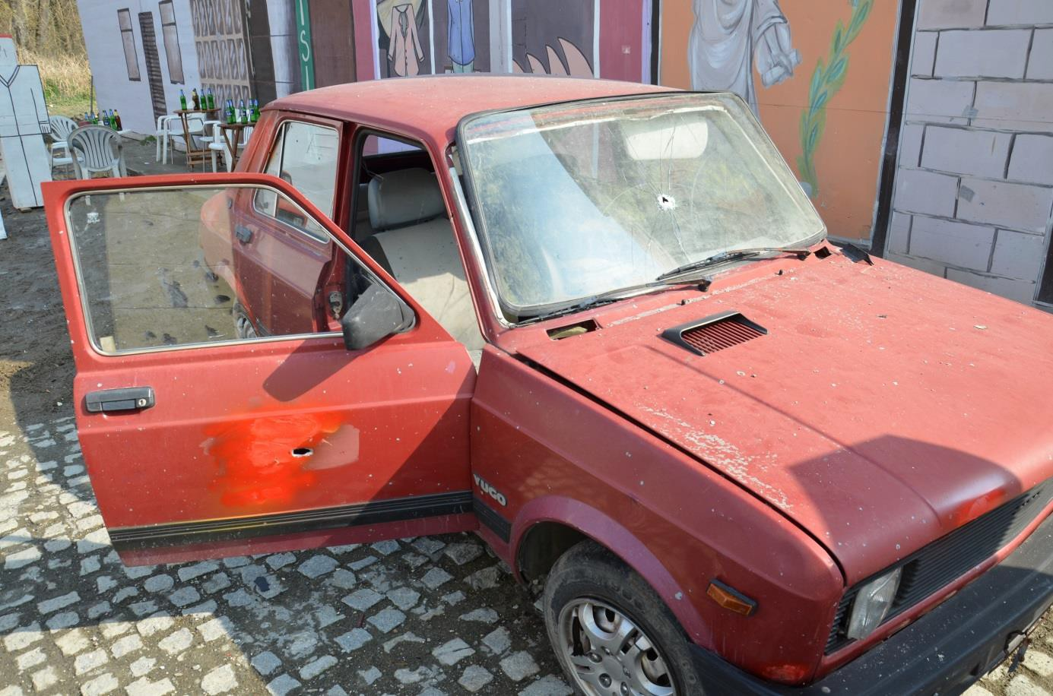

Figure 2.49 Zastava car (No. 2) in front of Caffé Gulam was damaged by the explosion only minimally (only 2 hits of fragments); car is not dirty after the explosion (compare with Figure 2.50 and Figure 2.51)

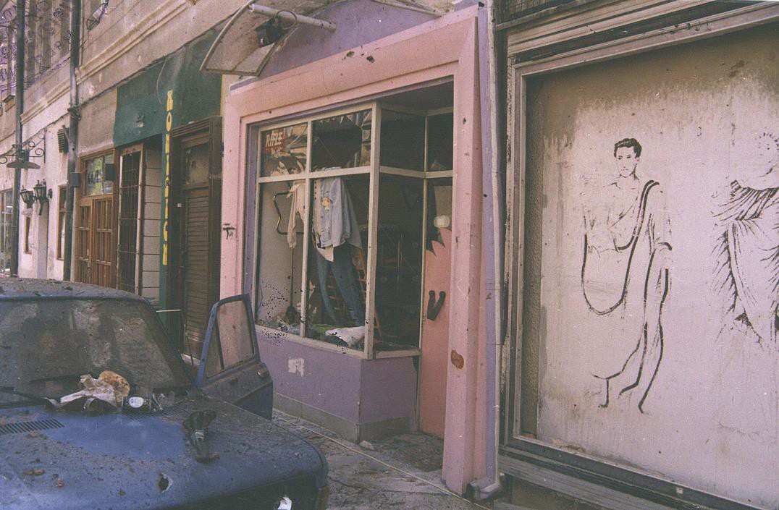

Figure 2.50 View at front part of the car Zastava with dirty body and shop with broken shop windows (Tuzla 1995)

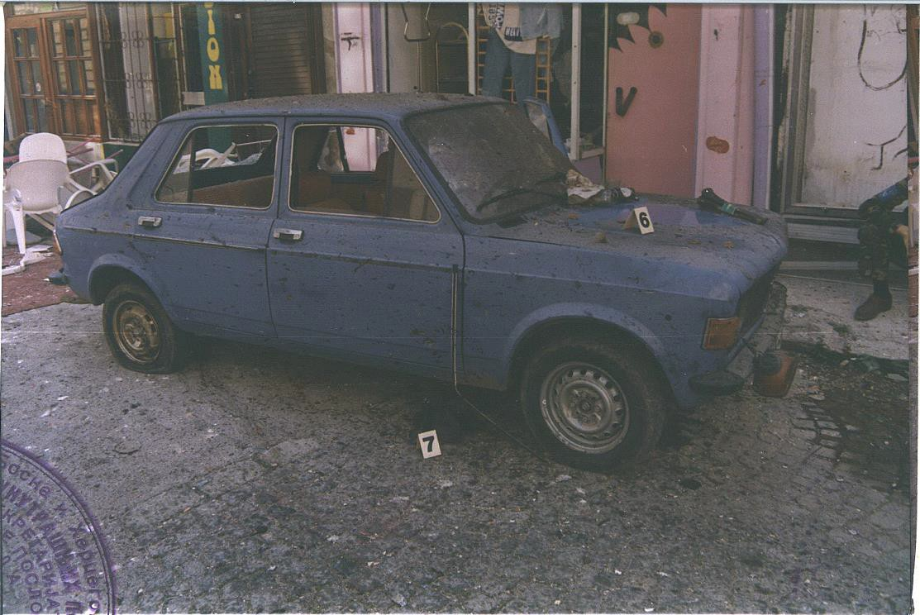

Figure 2.51 View at car Zastava after Tuzla’s explosion; side windows are broken, car at the front part heavily begrimed by black stuff, similar to soot, of unclear origin

Figure 2.52 Zastava car parking across the street in front of Caffé Gulam was hit only by a few fragments

Car 4 (originally Fiat 125 PZ, during tests was used Zastava Z 128)
In contradiction with the situation recorded immediately after the event in 1995 this car was extensively damaged with a lot of fragment hits, because the car was placed in the sector of very efficient side spray fragments (Figure 2.53). There were 7 penetrations in the windscreen remained in a place (Figure 2.54), all side and rear windows were splintered. Wheels on the left side of the car, towards to explosion site, had penetrations and were flattened. It is apparent from the Figure 2.46 and Figure 2.55 that this car at Tuzla’s Kapija square suffered only minimal damage. This finding significantly supports claim that in its close proximity could not exploded 130 mm artillery projectile under conditions defined by prosecution.

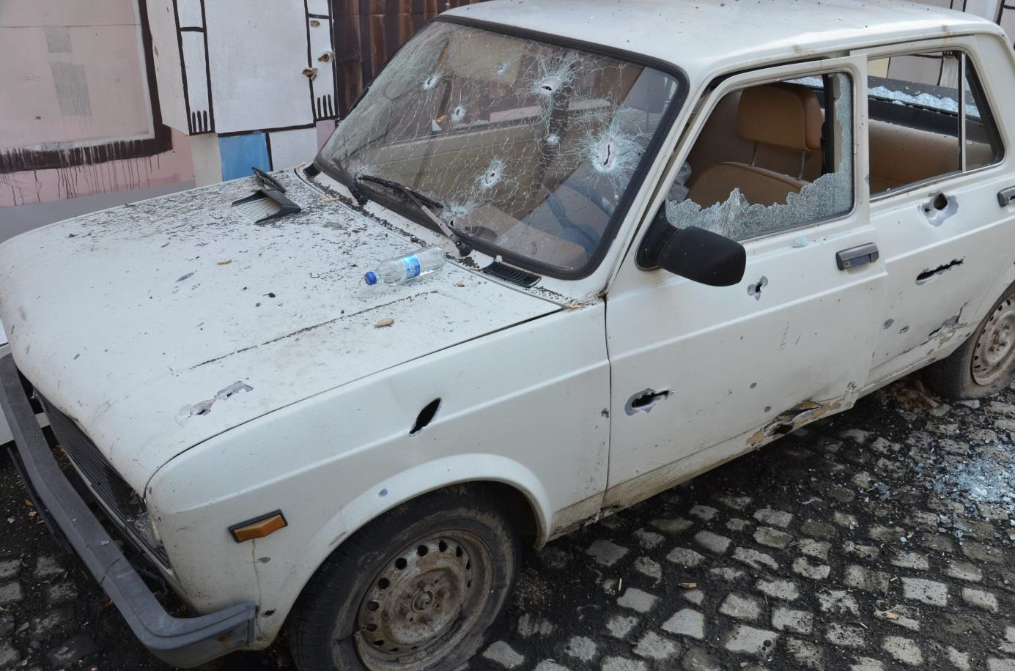

Figure 2.53 View at Zastava car parked in front of Café Leonardo; there are apparent significant damages caused by heavy, high-energy fragments from the side spray of fragments (compare with Figure 2.46); glass panels of side and rear windows are smashed open, windscreen contains 7 perforations caused by fragments (for detail of windscreen see Figure 2.54)

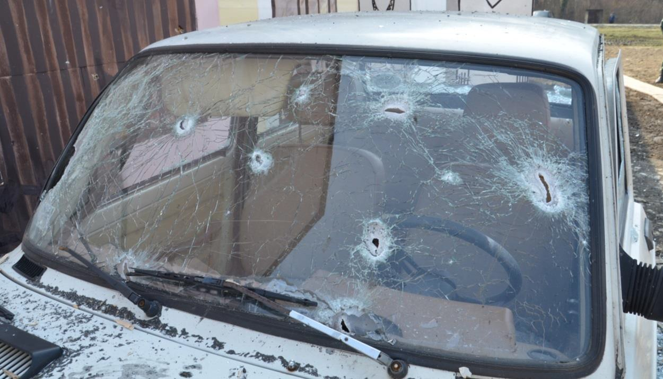

Figure 2.54 Detail view on damage of car Zastava windscreen caused by fragments

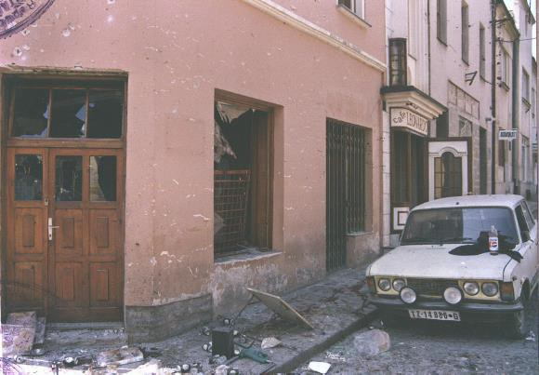

Figure 2.55 Fiat 125 PZ (car 4) with only minimal damage after the explosion at Kapija square

Damages to buildings
The way of damage caused to the facades of buildings by the fragments from the 130 mm HE projectile is also very different from the real situation at Tuzla’s “Kapija” square. Parts of facades reversed from the place of explosion place were not hit by fragments at all. Also some parts of facades near to the place of explosion were not hit despite the fact that at “Kapija” square were hit by higher number of fragments.
For example the Figure 2.56 shows facade of a building at the Tuzla’s Kapija square, 20 – 23 m away from the centre of explosion. The wall is hit by large number of fragments that cannot come from the projectile exploded in front of NIK store building. Density of fragments is high, entries on the wall are of circular shape which corresponds to perpendicular impact of fragments on the wall. This finding is in conflict with expected direction of movement of fragments from the NIK store building that is tangential; angle of expected direction of impact of fragments scattered from the CE on the facade is approximately 15° (measured from the facade plane).
Comparison with real situation in Nikinci is at following Figure 2.57. The fragments from the place of explosion hit only the upper part of the building and with significantly lower density. Entries on the wall are elongated in the direction of fragment’s movement, the fragments hit the wall nearly tangentially. It is apparent that fragments, which damaged the facade of the building at the Tuzla’s Kapija square (see Figure 2.56), could not originated from the assumed place of projectile’s explosion in front of the NIK store building.

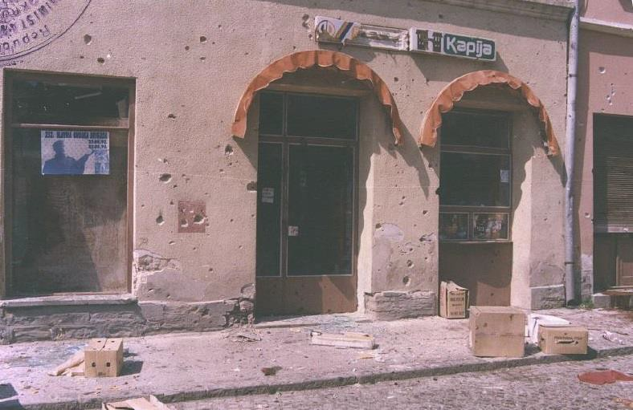

Figure 2.56 Specific fragment pattern on the area in front of Tuzla’s Kapija shop with significant circular defects caused by massive fragments at ground floor walls (Tuzla 1995, next morning after explosion)

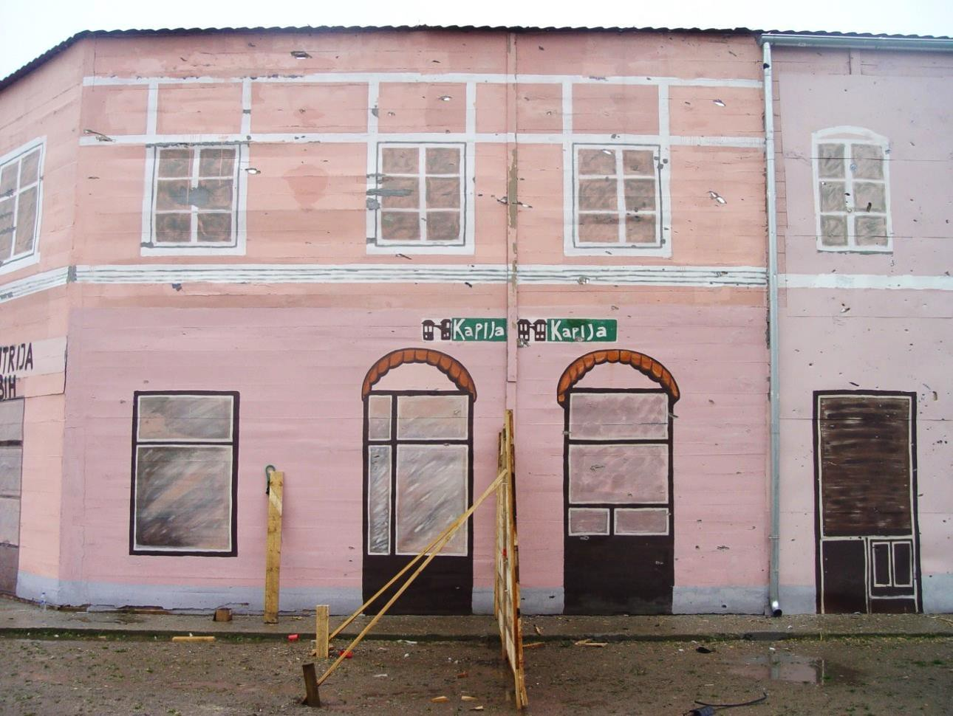

Figure 2.57 View on the area in front of Kapija shop - after 3 explosions of 130 mm projectile - without any significant defects at ground floor (elongated defects can be seen on the walls at 1st floor level)

Difference in the effect were recorded also on tables and chairs in front of cafes. There were some bottles placed on the tables in front of the Gulam Caffé and “Caffe-slastičarna Kapija“ before the 1st experiment in Nikinci. During the explosion of the 130 mm HE projectile none of the bottles were damaged by fragments nor thrown off. The tables and chairs were not thrown off or damaged (Figure 2.58).

Figure 2.58 View on the area in front of “Caffe-slastičarna Kapija“ after explosion in the 1st experiment (there are not any apparent damages caused by fragments)
The situation at Tuzla’s “Kapija” square on 25th May 1995 was very different (Figure 2.59 and Figure 2.60). Bottles and cans were thrown off from the tables. Some of the tables and chairs were also thrown off and damaged by some fragments; there are visible holes caused by the fragments moving in the vertical direction in the official photo documentation. This situation was not recorded during the field trials at Nikinci.

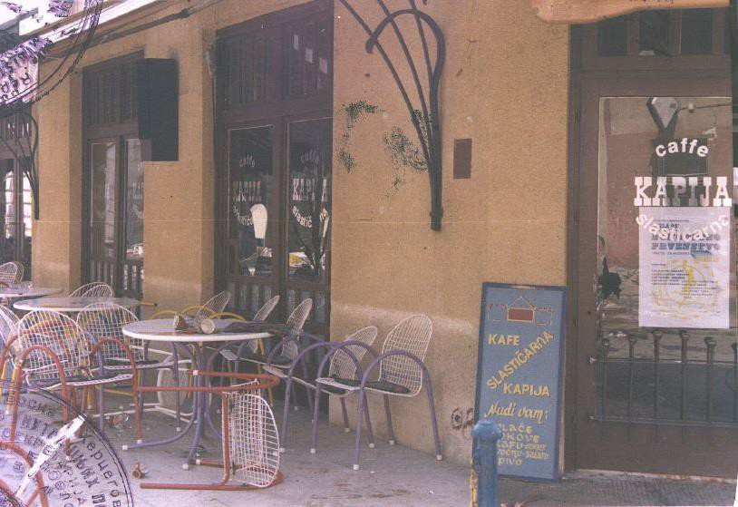

Figure 2.59 View at space in front of “Caffe-slastičarna Kapija” with many large defects at walls and window (compare with minimal damage to the same facade in Nikinci at Figure 2.58)

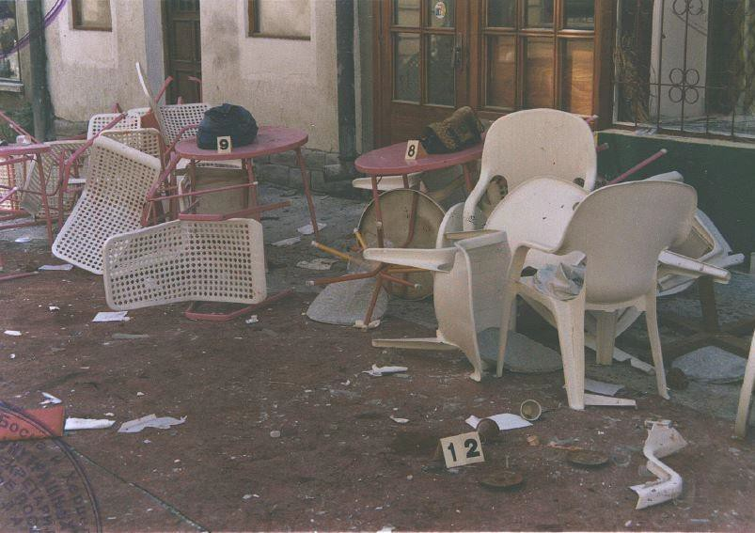

Figure 2.60 View on the area in front of Tuzla’s “Caffe Gulam“ next morning after explosion

The front facade of the NIK store building was damaged, at its upper part (1st and 2nd floor), during experiments by large fragments from the rear part of the projectile traveling upwards and creating elongated scratches. These scratches were not seen at the Tuzla’s “Kapija” square at all. Massive hit by fragments occurred only in a direction perpendicular to the plane of projectile’s arrival due to dominant effect of the side fragment beam (see Figure 2.61 - Figure 2.64).
Another anomaly in effect of fragments is apparent on side wall of the NIK store building, turned away from the explosion. After the explosion in Nikinci no fragment hits were recorded on the side walls (see Figure 2.62 and Figure 2.63). The NIK store building sustained many hits by small fragments (apparently not by fragments ricocheted from other obstacles) on both side walls of the building. This facts show that more than single one explosion occurred in 1995 at the Tuzla’s Kapija square.
The photographs from the Kapija square from 1995 shows another anomalies in fragment distributions on building facades. Especially it is locally high density of fragments in relatively small area at the distance of ten and more meters from the place of explosion. During the experiment were not confirmed these anomalies in the spacious distribution of fragments that were seen at “Kapija” square in Tuzla.

Damage to NIK store’s shop window
After comparing the damage caused to the NIK store it can be concluded the damage to this shop during the field trials is totally different in comparison to the damage caused to the real shop at “Kapija” square. During the field trials this shop was badly damaged (facade, frame of the shop window, and also the inside of the shop - Figure 2.61 - Figure 2.64); the real NIK store after the real explosion at Tuzla’s “Kapija” square had only slightly damaged frame of the shop window and broken glass at the shop window (Figure 2.65).
There should be also mentioned that the plastic dolls used for the exhibiting the selling clothes standing inside the shop were damaged by fragments and fell on the floor inside the shop (Figure 2.66); the dolls at the real NIK store after real explosion at Tuzla’s “Kapija” square were not damaged by fragments and remained standing in standard position inside the shop window (Figure 2.65). From the Figure 2.68 the minimal damage inflicted to the awning above the NIK store shop window is apparent. If the artillery projectile would exploded nearly beneath the awning, the awning will be damaged in a much larger extent. It can be expected that the awning would be ripped off the wall due to the effect of shock wave’s overpressure.

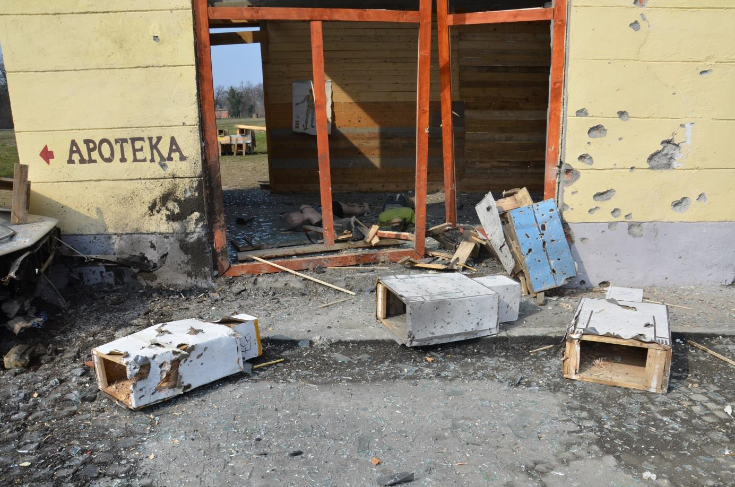

Figure 2.61 Front view on NIK store building at “Kapija” square after 1st experiment (dolls are thrown into shop by the explosion, and are significantly damaged by fragments, frame of the shop window is pulled out from the wall)

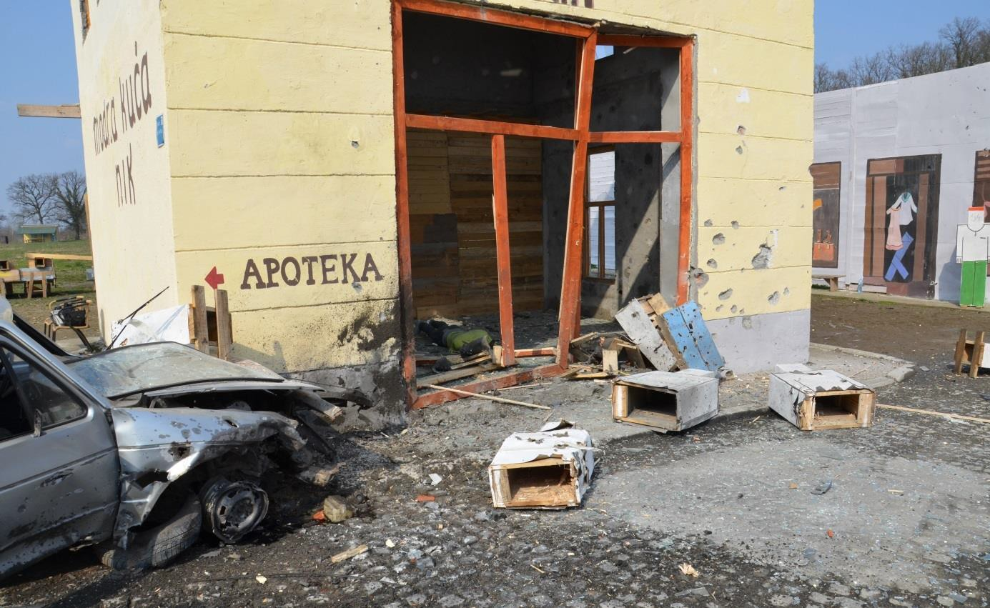

Figure 2.62 View at frontage of NIK store building in close proximity to the CE; totally destroyed shop window, glass fragments and dolls thrown into room, facade on the right side hit by heavy, very effective fragments of side spray of fragments, black stain on the left part of frontage caused by motor oil

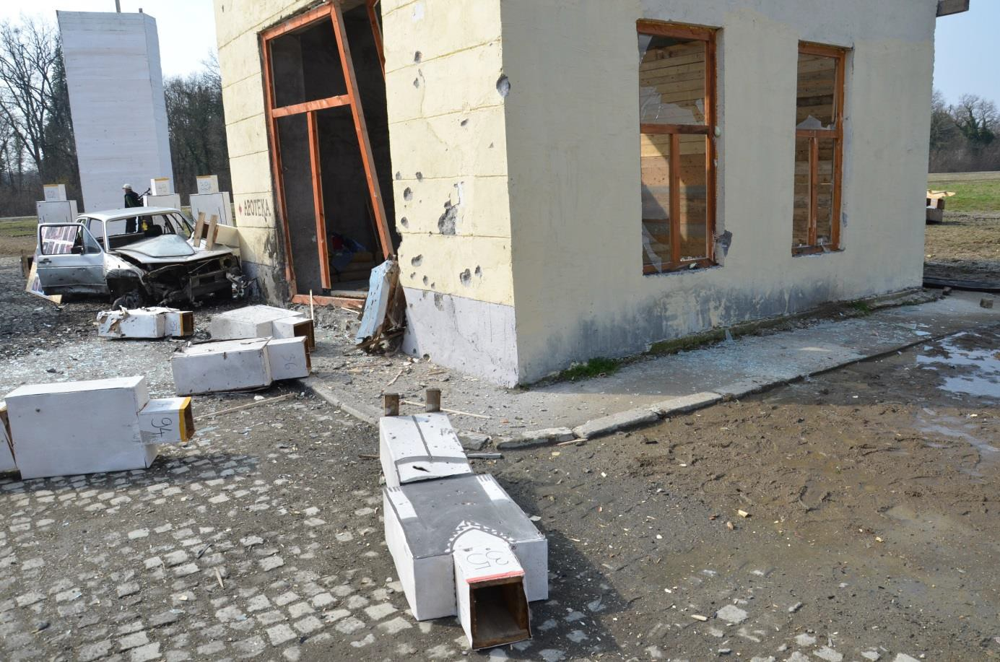

Figure 2.63 View at frontage and side of NIK store building from Partizanska street

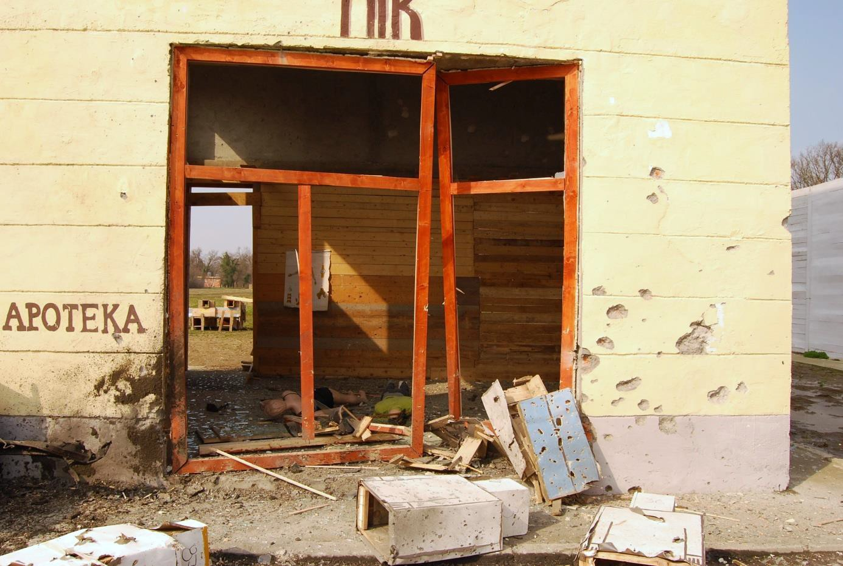

Figure 2.64 Destroyed shop window of Modna kuča NIK shop

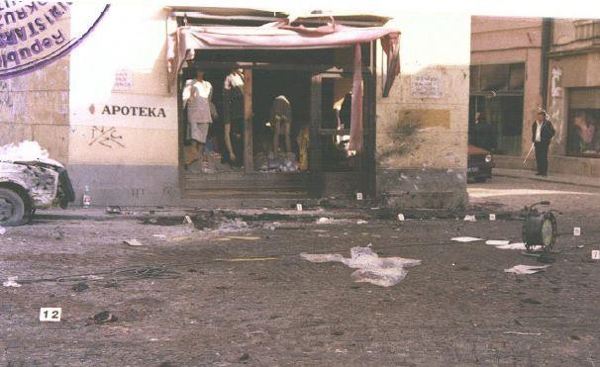

Figure 2.65 Front view on NIK store building at Tuzla’s “Kapija” square morning after the explosion (dolls are in upright positions without significant damage, shop window frame is not significantly damaged)

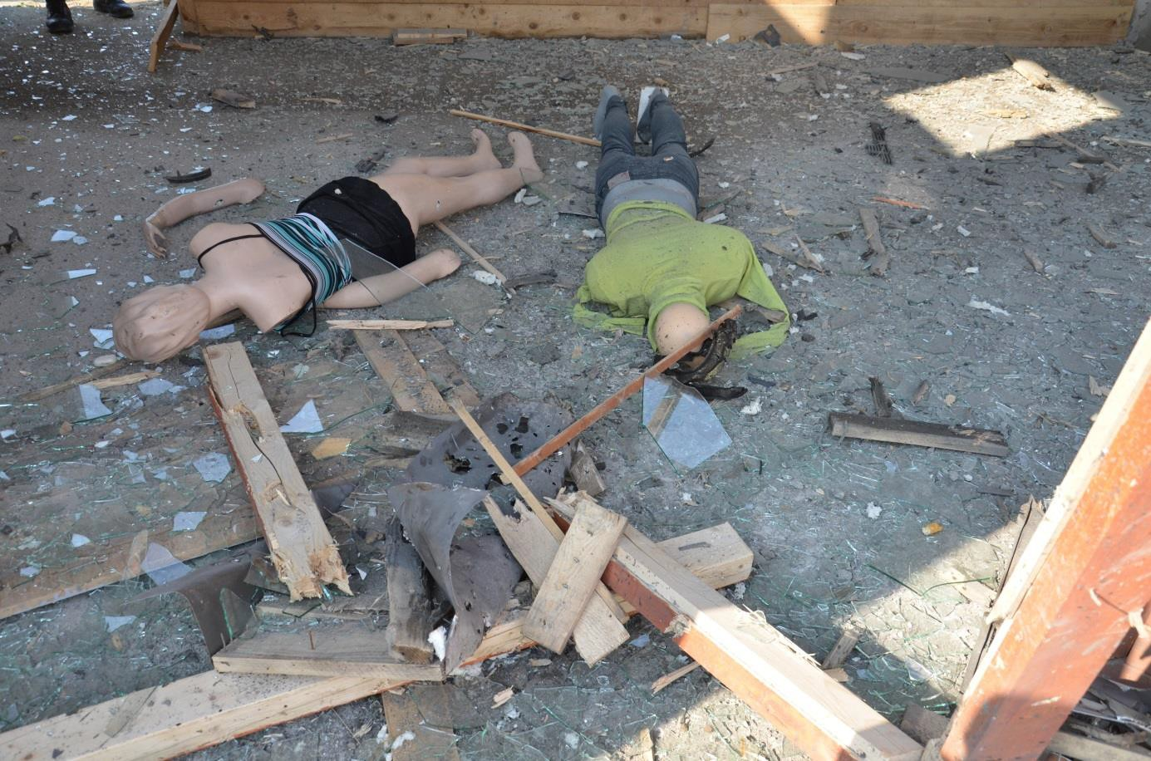

Figure 2.66 Detail of destroyed inner space of shop Modna kuča NIK in Nikinci (on the floor are wooden beams and dolls thrown into the room from the shop window by blast effect)

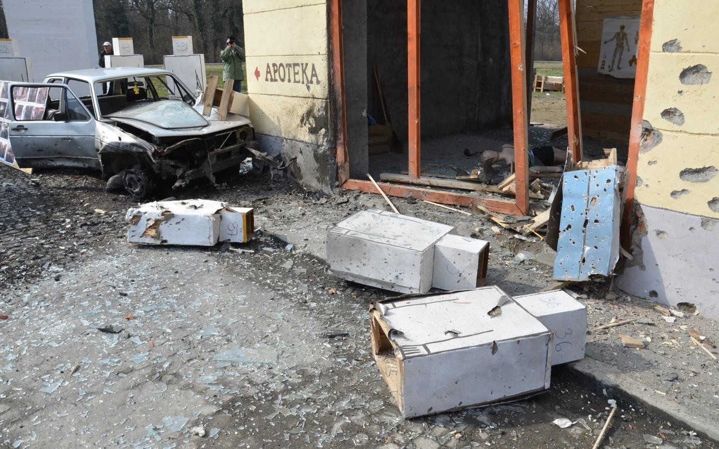

Figure 2.67 View at frontage and side of NIK store building (glass fragments in front of building come from broken windows at upper floors)

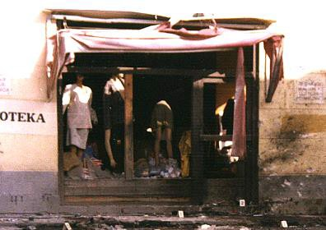

Figure 2.68 Detail of NIK store’s shop window with minimally damaged awning

Character of the crater
Size and shape of the crater after explosion at Tuzla’s Kapija square and its substitution in Nikinci were diametrically different. As a result of the explosion of 130 mm projectile OF-482M during the 1st experiment no crater was created in the granite cubes road (Figure 2.69 and Figure 2.70). Only about 3 granite cobblestones were partially damaged and no one was pulled out from the road. This situation is completely different in comparison to the Tuzla’s “Kapija” square where a higher number of free and only slightly damaged cobblestones was found around the crater that had a size of 50 x 20 cm (Figure 2.71).
Mentioned differences further deepens the fact that the cobblestone surface at the square model at Nikinci was not so compact shortly after its finishing as at the Tuzla’s Kapija square where it was used for very long time and the cobblestones were fit in, gaps between them were filled and the area thus created compact unit.
There was not possible to recognize any disengaged granite cobblestones. There were no grooves produced by the fragments from the 130 mm projectile or any part of its fuze. The curb side in front of the NIK store building next to the place of explosion had several defects by fragments in the length of about 1.2 m.

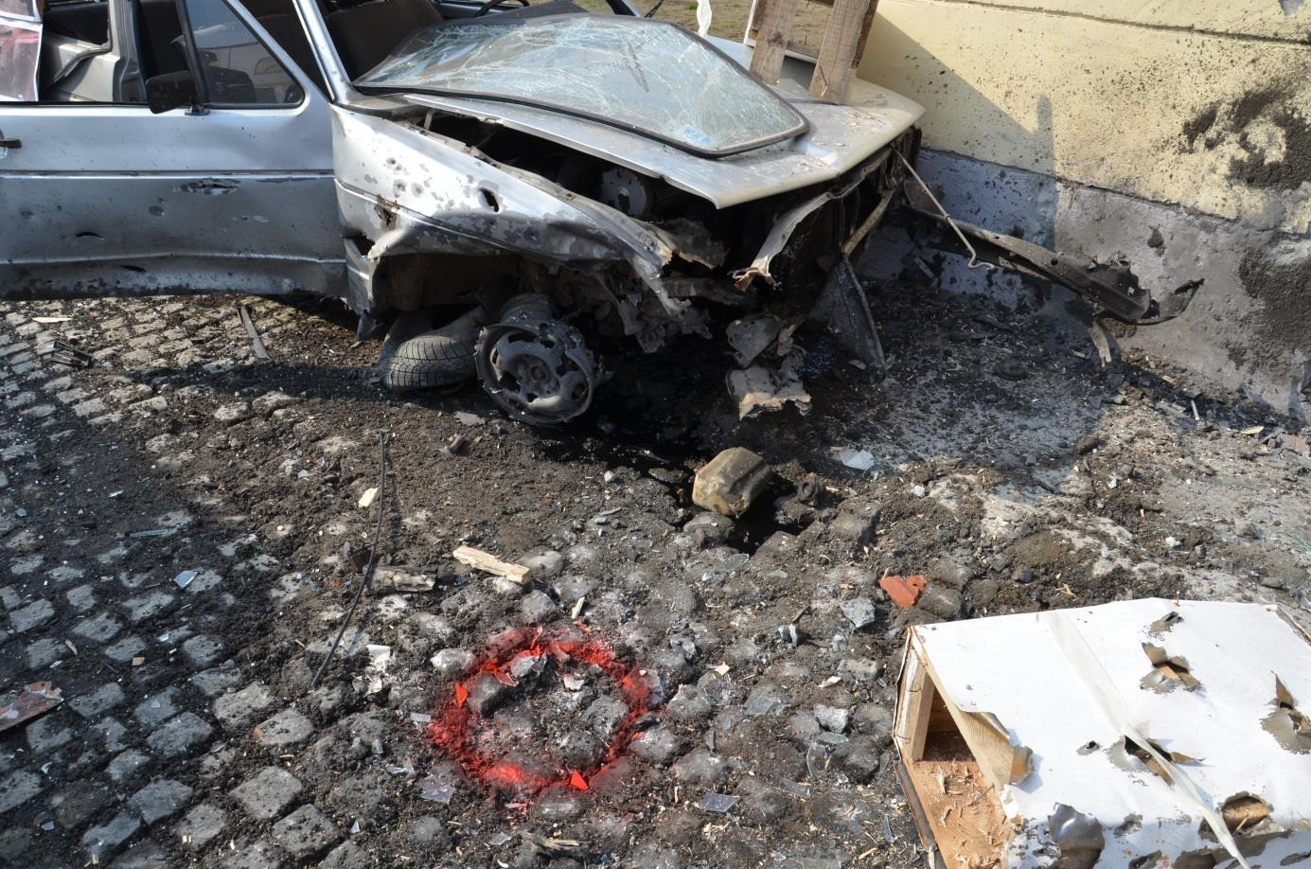

Figure 2.69 View on the crater in front of NIK store building after 1st experiment (no cobblestones were pulled out, there are also parts ripped off from the car’s engine in front of the car)

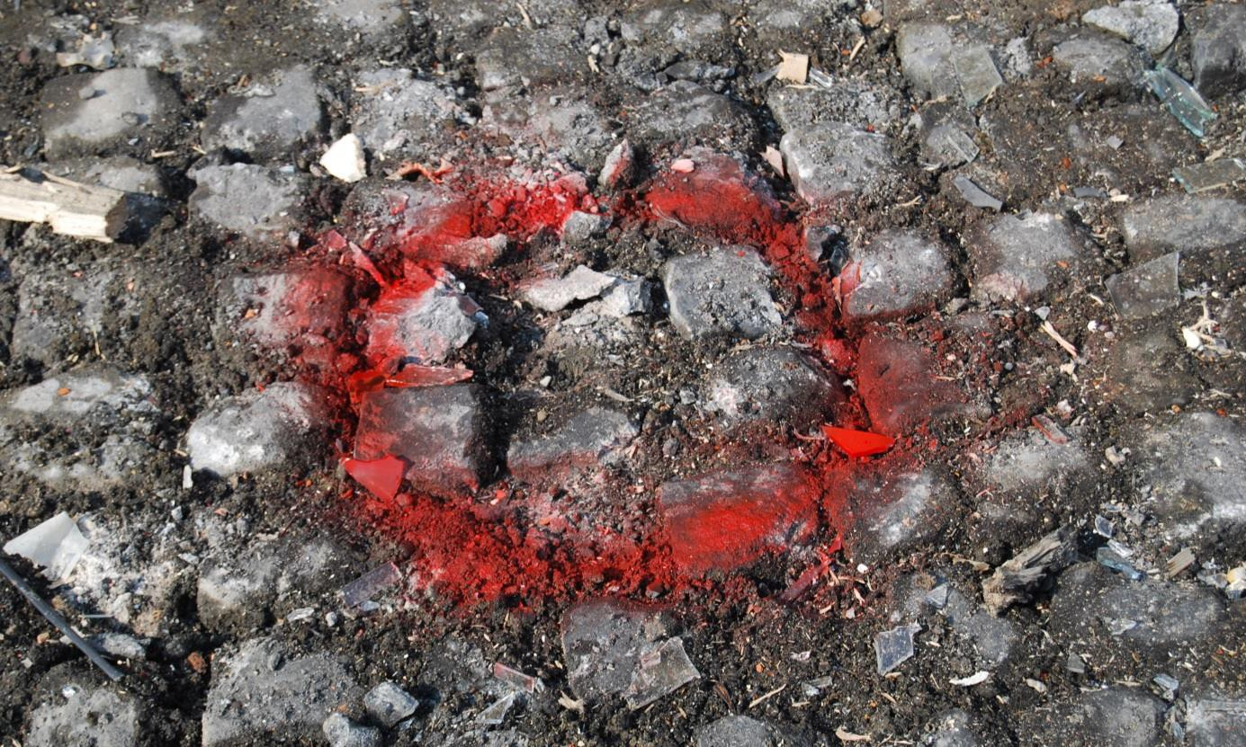

Figure 2.70 Cobblestone pavement in place of 1st explosion directly below the projectile (apparent the minimal damage to surface of road, cobblestones were not released and thrown into space)

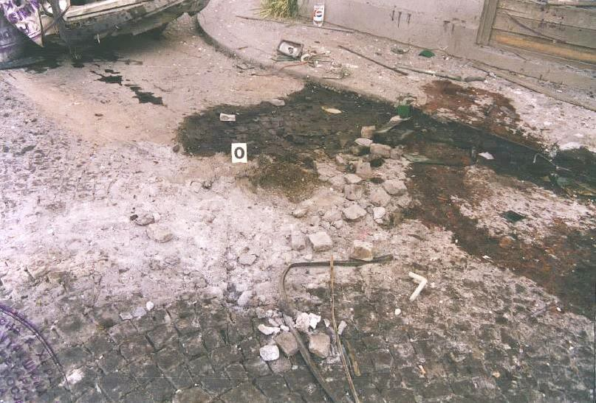

Figure 2.71 View on the crater after explosion at Tuzla’s “Kapija” square next morning after explosion (number of cobblestones was pulled out of road, but this big number of cobblestones is not missing in the road)

Effect of explosion on dolls
After the explosion of the projectile its effects on the dolls were assessed. The effects of the 130 mm HE projectile on the dolls were totally different in comparison to the situation on “Kapija” square. The dolls placed in the close proximity to the place of explosion (approximately up to 3
m) were thrown away and completely destroyed. In case of real persons serious wounds could be expected (Figure 2.72 a Figure 2.73).
Also effects of fragments and shock wave on close targets are apparent anomalies. The most marked difference in comparison to reality is in case of doll No. 87. The doll No. 87 replacing the person standing on the VW Golf Mk I car bonnet (Figure 2.74) was during explosion ejected into height and also hit by high number of heavy fragments of extremely high kinetic energy (Figure
2.75 and Figure 2.76). This person would have absolutely no chance to survive the explosion; in the real situation at “Kapija” square and according to the court materials the person dancing on the hood of the VW Golf car had survived. This finding is a significant fact disproving prosecution’s statement that at Tuzla’s Kapija square exploded 130 mm projectile under the defined conditions.

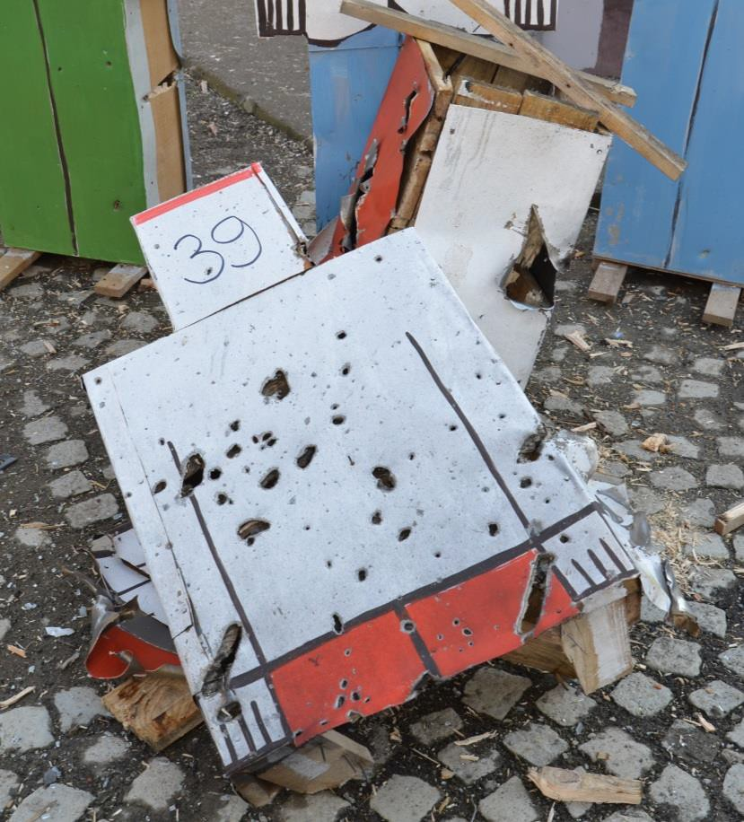

Figure 2.72 Maximum level of damage to doll No. 39 less than 1 m away from the CE (doll was hit by at least 10 fragments with deadly effect)

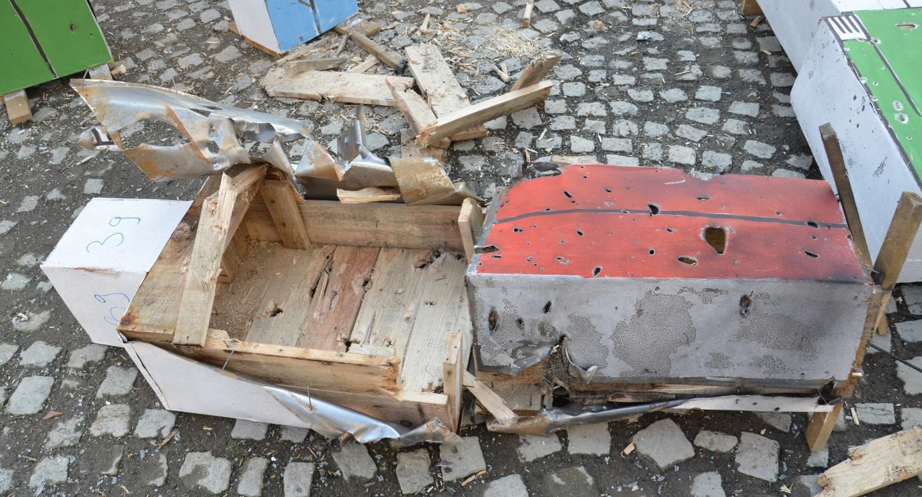

Figure 2.73 Damage to doll No. 39 – different point of view

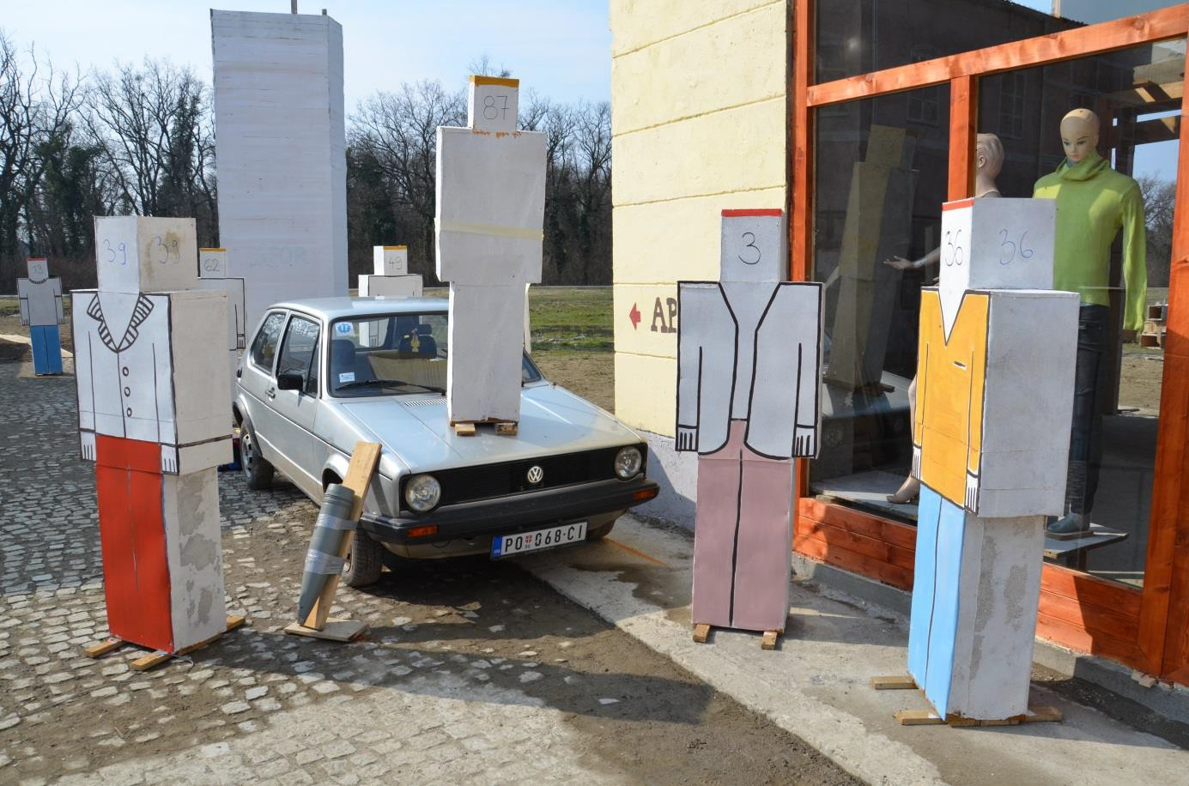

Figure 2.74 Position of doll No. 87on the car’s bonnet before the explosion

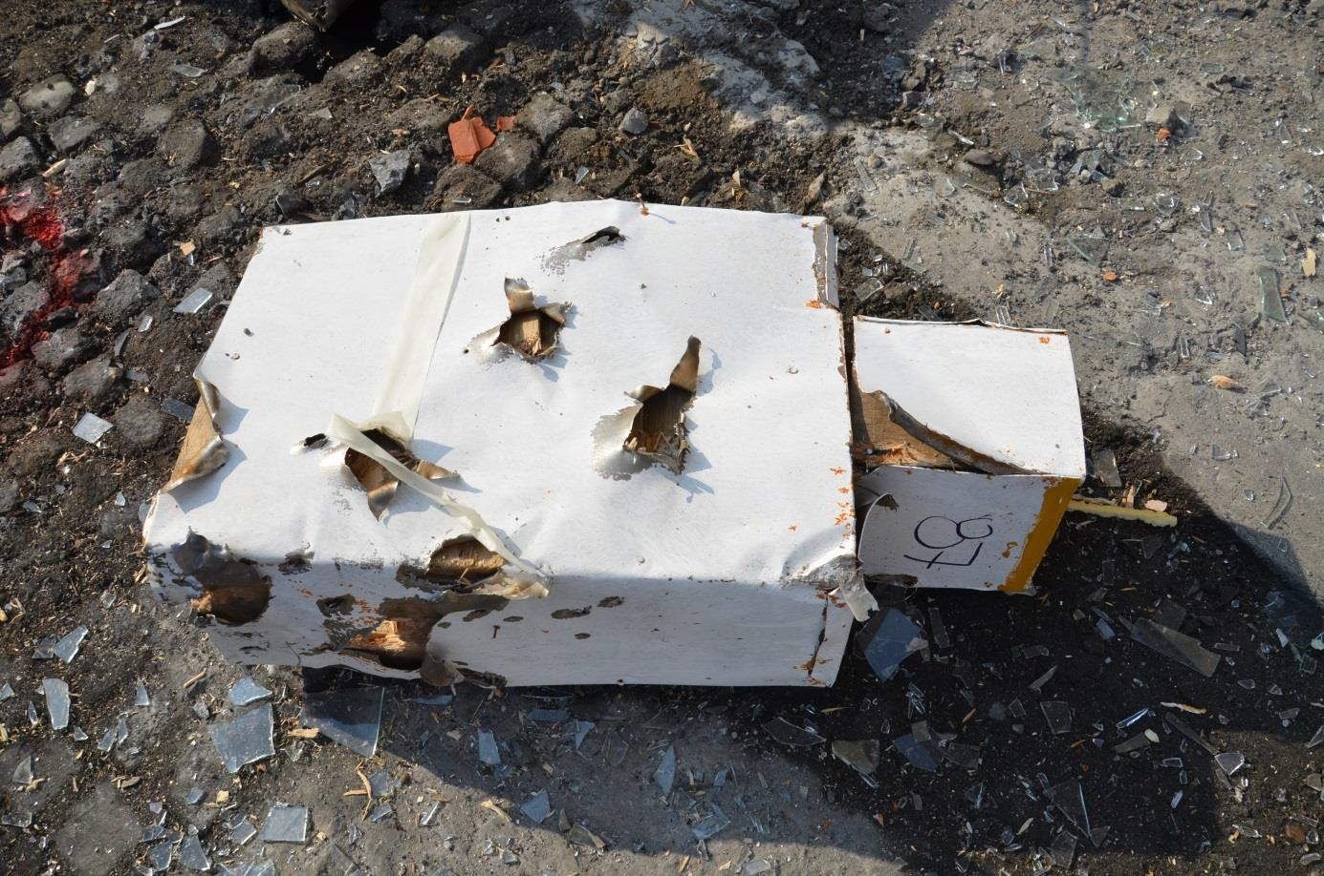

Figure 2.75 Extreme damage of doll No. 87 (placed on the bonnet of VW Golf Mk I car); under real conditions at “Kapija” square the person would not survive, but in 1995 was survived

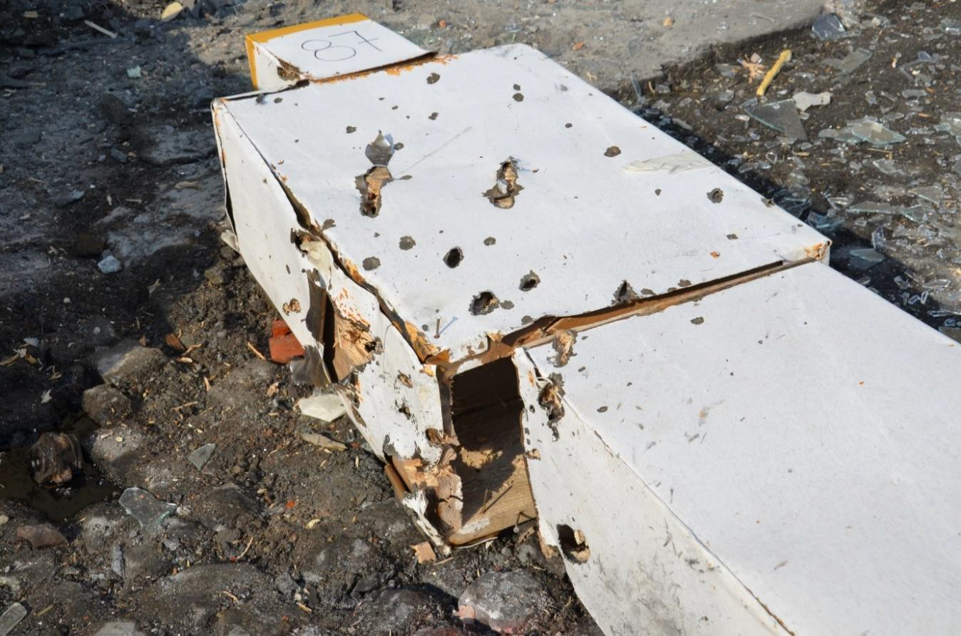

Figure 2.76 Extreme damage of doll No. 87 at upper part (lower part of the doll was protected by VW Golf Mk I car); level of damage caused by fragments speaks for zero chance of men on survival

The non-standard effect is also apparent from the comparison of projectile’s explosion effect on dolls No. 3 and 36 (see Figure 2.74) and the explosion effect on the victims that were very close to the CE. While the dolls No. 3 and 36, just as doll No. 39, were totally destroyed after the explosion of 130 mm projectile (Figure 2.77), the wounds of the Tuzla’s victims (3 – Senad Hasanovič and 36 – Alispahič Admir) do not correspond with their position with respect to the CE.
Similarly the doll No. 26 with yellow strip (Figure 2.78), standing approximately 6 m away from the CE was hit in its upper part by large number of fragments which energy can be labelled as deadly.

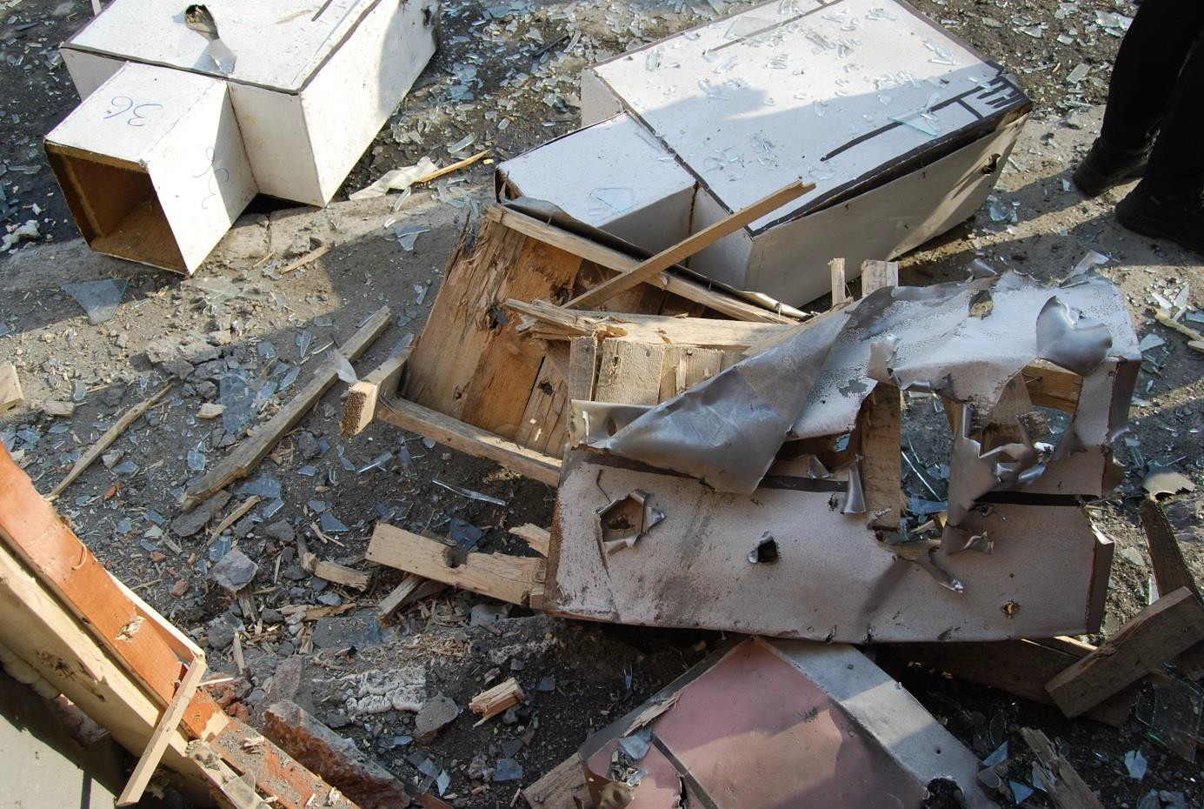

Figure 2.77 Destroyed dolls No. 36 and 3 (on the right) placed 1.5 – 2.0 m away from the CE

Figure 2.78 Severe damage of doll No. 26 in the upper part (the person standing in this place survived the explosion)
On the other hand the dolls placed at longer distance from the centre of explosion (out of reach of the side beam of fragments from the 130 mm HE projectile) are hit by the fragments very rarely; under the real conditions only minimum of deadly or serious wounds can be expected. The dolls in front of the “Caffe-slastičarna Kapija“ (at the distance more than 20 m from the place of explosion) were not hit by fragments at all. In front of the Caffe Gulam the situation was very similar. Examples are presented at following figures.

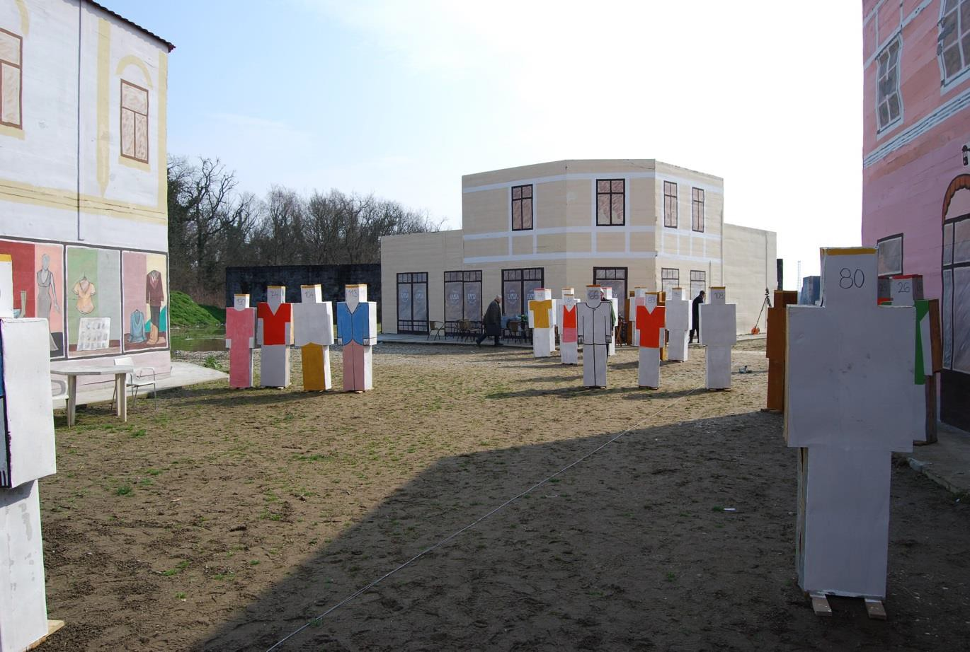

Figure 2.79 Not damaged dolls in front of “Caffe-slastičarna Kapija“ after 1st experiment, in place where in real situation was larger number of death and wounded people
Figure 2.80 shows dolls No. 55 and 60 standing at the corner of building in the street Partizanska 12 m away from the CE. These dolls with red strip are not significantly hit by fragments despite the fact they introduce killed people. Similarly the dolls No. 50 and 67 (Figure 2.81) placed at Caffé Kapija at the distance about 30 m from the CE are not hit by fragments.

Figure 2.80 Not damaged dolls in the corner of building of Caffé Gulam (people standing at this place were killed)

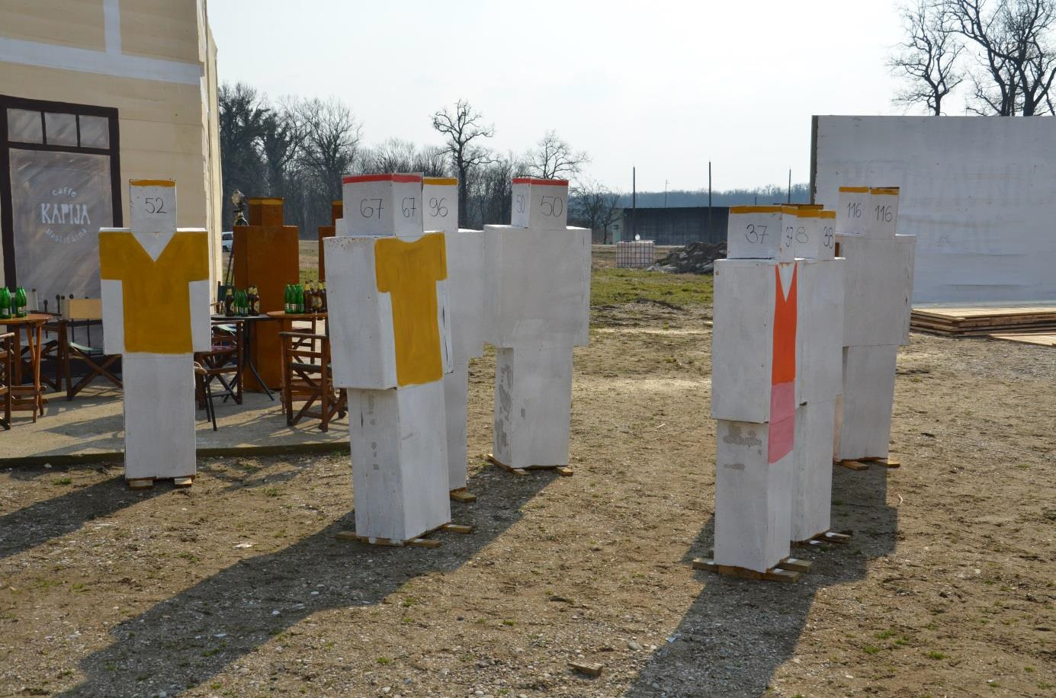

Figure 2.81 Dolls No. 50 and 67 (correspond to killed victims Savo Stjepanovic and Adnan Zaimovic) in front of Caffé Kapija were not hit by any fragment
Number of hit by fragments was determined at each doll introducing victim of explosion. These numbers are summarised in following Table 2.2. The dolls labelled with letter D in the table are dolls placed in close proximity to the CE and they were destroyed by the explosion (torn into pieces, hit by very large number of fragments, etc.). It was not objectively possible to determine the number of hits by fragment at this dolls. Presented numbers of hits of dolls are further utilised for comparison with explosion consequences in 1995 (see chapter 6.3).

Table 2.2 Number of dolls‘ hits Nf (presented only dolls with red strip, i.e. dolls representing killed victims)

No. | 3 | 5 | 6 | 12 | 13 | 18 | 19 | 24 | 25 | 27 | 28 | 29 | 30 | 31
Nf | D | 1 | D | D | 26 | 23 | 8 | 0 | 2 | D | 4 | 2 | 3 | D

No. | 36 | 37 | 39 | 41 | 49 | 54 | 55 | 57 | 59 | 60 | 63 | 64 | 66 | 71
Nf | D | 1 | D | 1 | 37 | 7 | 5 | 5 | D | 9 | 0 | 1 | 7 | 4

Experiment No. 2
Aim of the experiment No. 2 was to determine densities of fragment field in sectors of fragments scattering where the highest numbers of victims were recorded. Wooden screens were used for capturing of fragments in the areas of interest. Area between the CE and individual walls was left free contrary to the real situation at Tuzla’s Kapija square. The experimentally obtained fragment field densities are the maximum possible densities. These densities can be only lower in the real situation because large number of fragments hit victims standing between the CE and the individual screens and remained in their bodies. The role of the human shields between the CE and the screens is very difficult to quantify.
For the 2nd experiment the Russian HE projectile 130 mm OF-482M was used (the same as for experiment No. 1). The only bottom part of the UTIU fuze with booster was screwed into the

projectile to allow the electric initiation. The projectile was placed on 1” wooden board and placed into defined position (angle of fall 62° and direction corresponding to the projectile incoming direction 271° defined by prof. Berko Zečević) – the same as for experiment No. 1. The VW Golf Mk I car used here was already partially damaged by the 1st experiment but the damage of the car had not been assessed in this experiment. The projectile was initiated by the electric detonator No. 8.
During the second experiment the vertical wooden screens of height of 2 m and width of 4 m (area of 8 m2) were used instead of dolls in defined positions, see Figure 2.82. Totally 6 screens (walls - labelled W1 - W6) made of soft wood boards of thickness of 1" were placed at the square at distances from 7 to 21 m away from the centre of explosion. The plane of screens was perpendicular to connecting line of centre of screen and the centre of explosions in all cases. The screens were placed into places where higher numbers of casualties at relatively small areas were recorded.

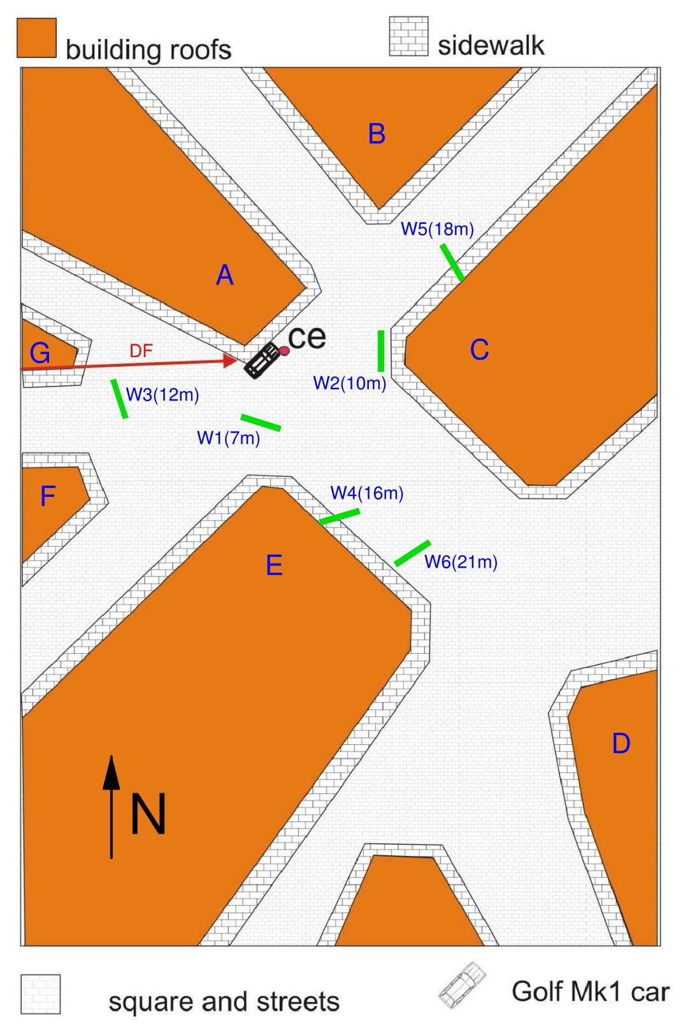

Figure 2.82 Schema of Kapija square with marked position of screens W1 - W6, A-G buildings at Kapija square, DF – direction of flight of projectile, CE – centre of explosion, VW

– VW Golf car
The screen No. 1 (W1) was placed 7 meters from the CE in front of the corner of building E with Coffee shop Leonardo. The screen No. 2 (W2) was placed 10 m away from the CE in front of the corner of building C – Samoizbor. The screen No. 3 (W3) was placed 12 m away from the CE

between the front of building G – Obuča Beograd and the CE. The screen No. 4 (W4) was placed 16 m away from the CE next to building E – Lutrija BiH, and the screen No. 5 (W5) was placed 18 m away from the CE next to building C with Caffé Gulam. Last screen No. 6 (W6) was placed 21 m away from the CE between buildings C and E in the centre of Kapija square. Figure 2.83 - Figure 2.88 show installation of screens before the explosion.

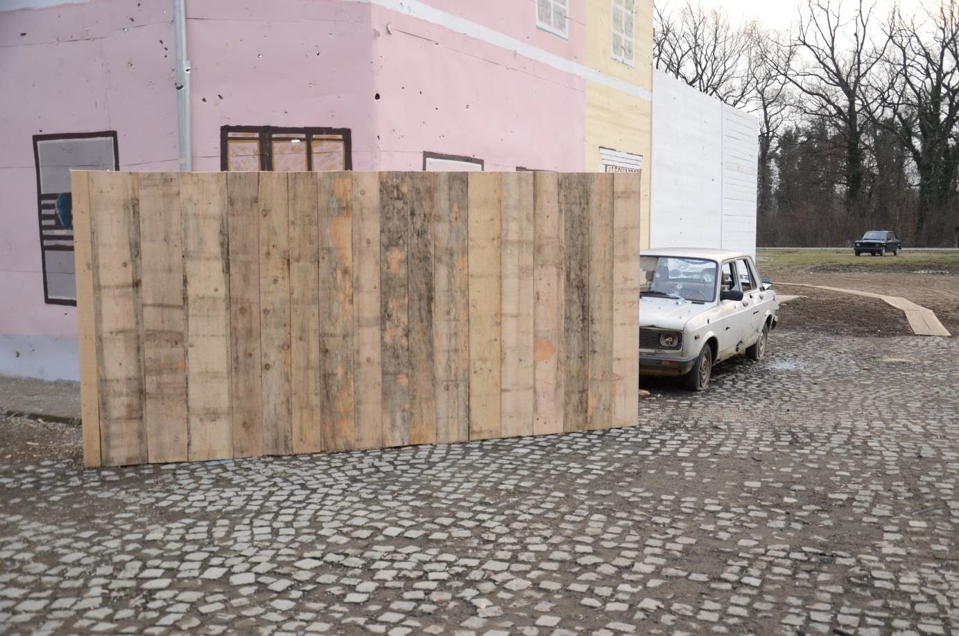

Figure 2.83 Position of screen No. 1 (W1) placed at the corner of building E (Lutrija BiH) in close proximity of Caffé Leonardo, 7 m from the CE

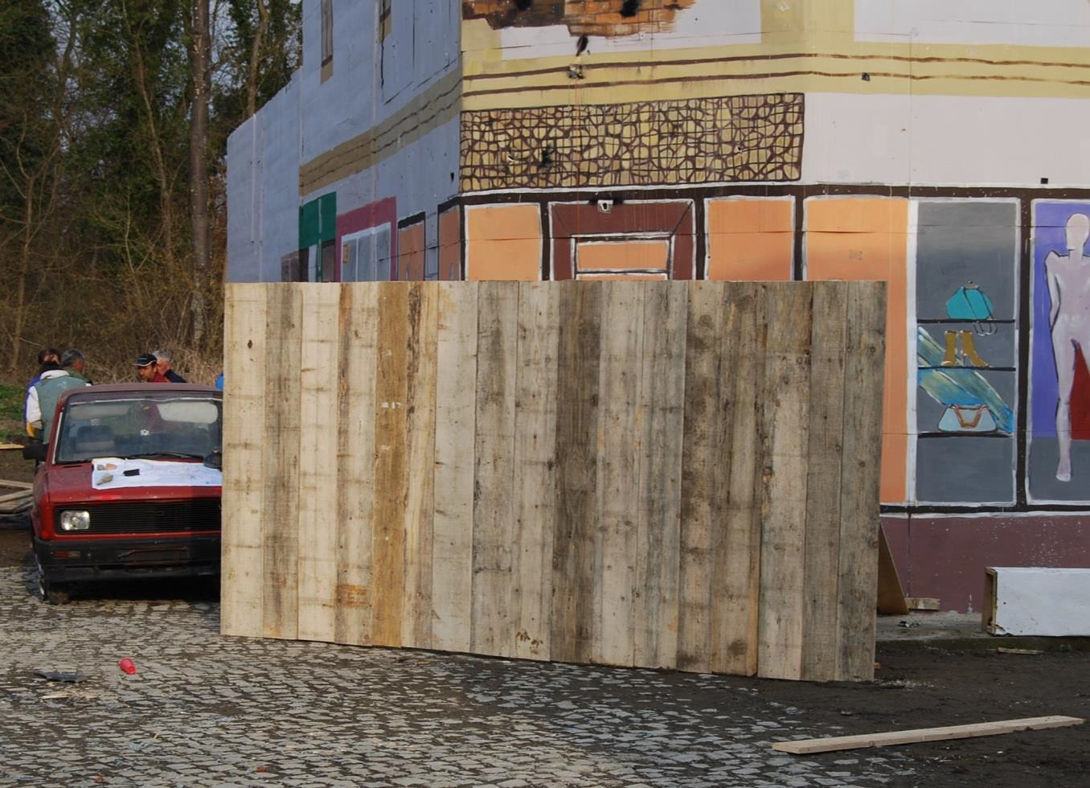

Figure 2.84 Position of screen No. 2 (W2) at corner of Building C (Samoizbor)

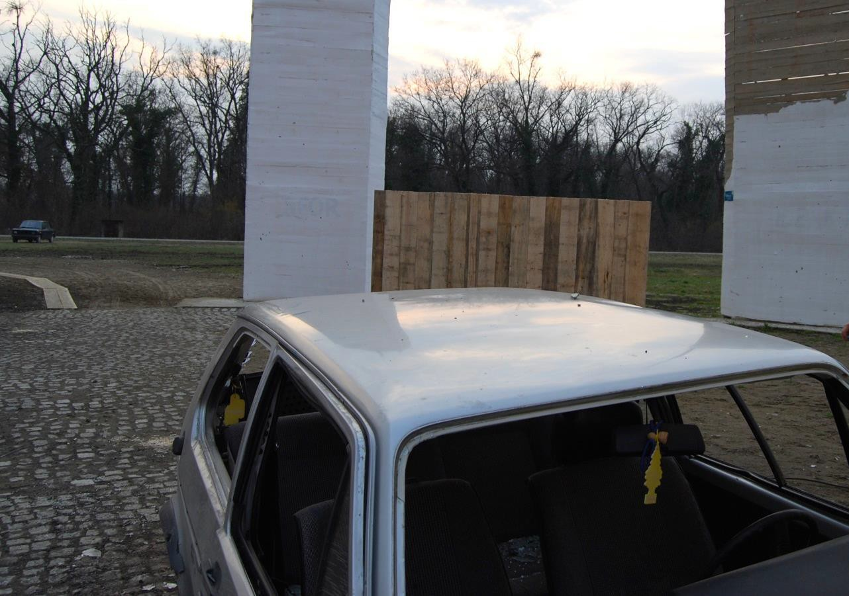

Figure 2.85 Position of screen No. 3 (W3) placed at 12 m from the CE in close proximity of buildings F a G (the screen is partially hidden behind the car VW Golf that is placed between projectile and the screen)

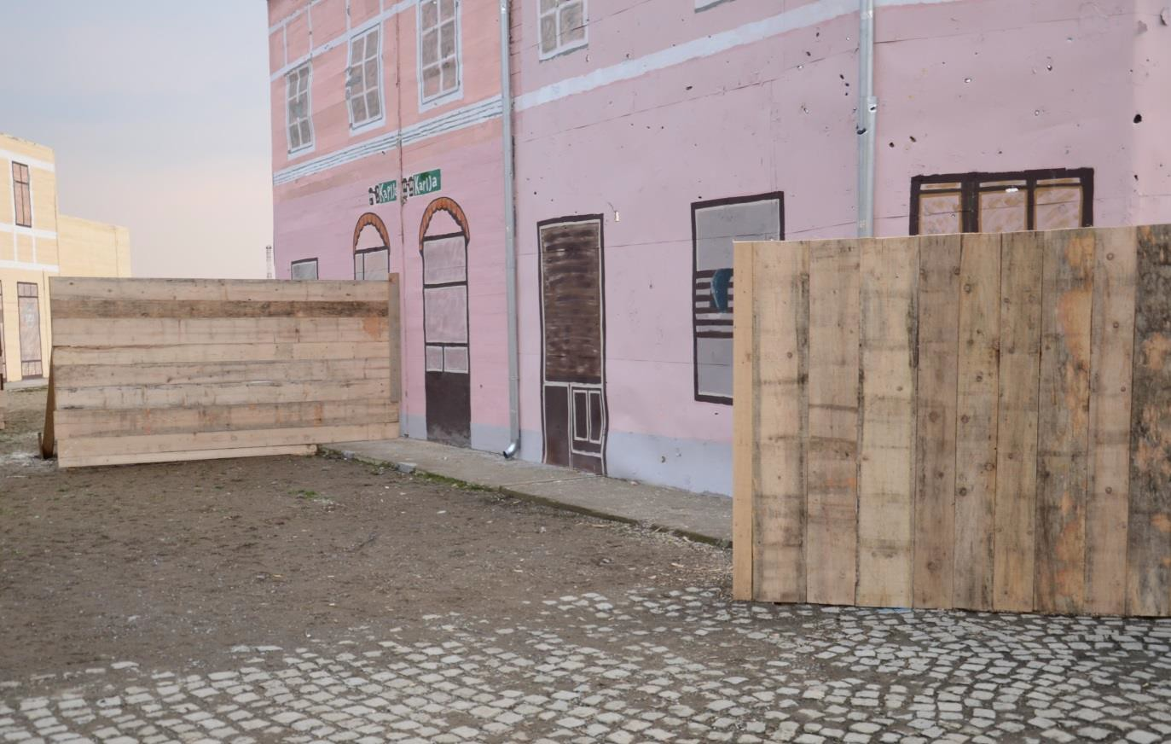

Figure 2.86 Position of screen No. 4 (W4 - left at the back) and No. 1 (W1 - right in front) placed in close proximity of building E (Lutrija BiH)

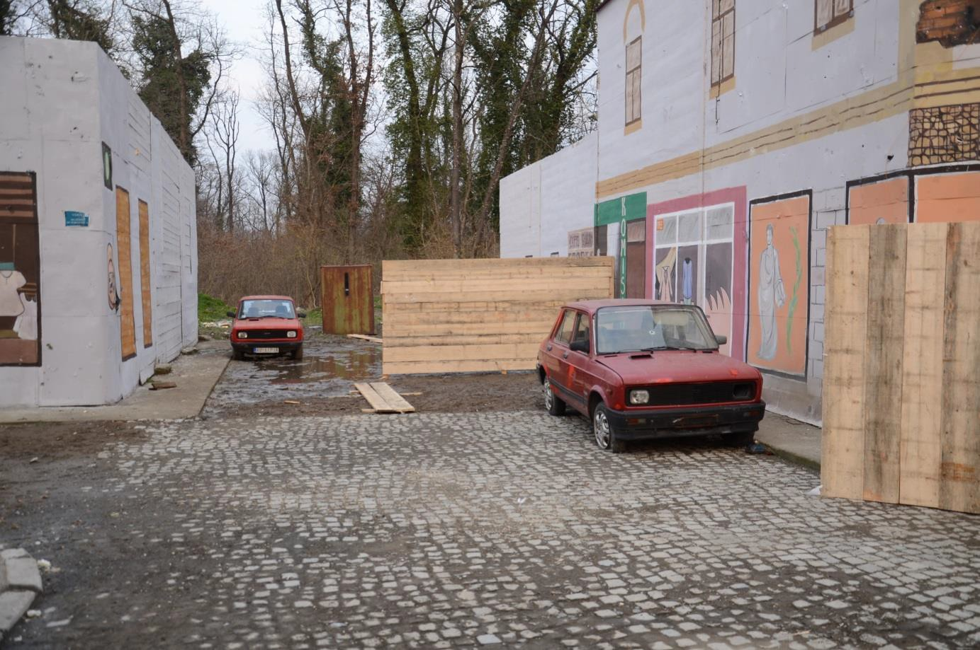

Figure 2.87 Position of screen No. 2 (W2 - right at corner of building C in front of Caffé Gulam) and No. 5 (W5 - back at Caffé Gulam)

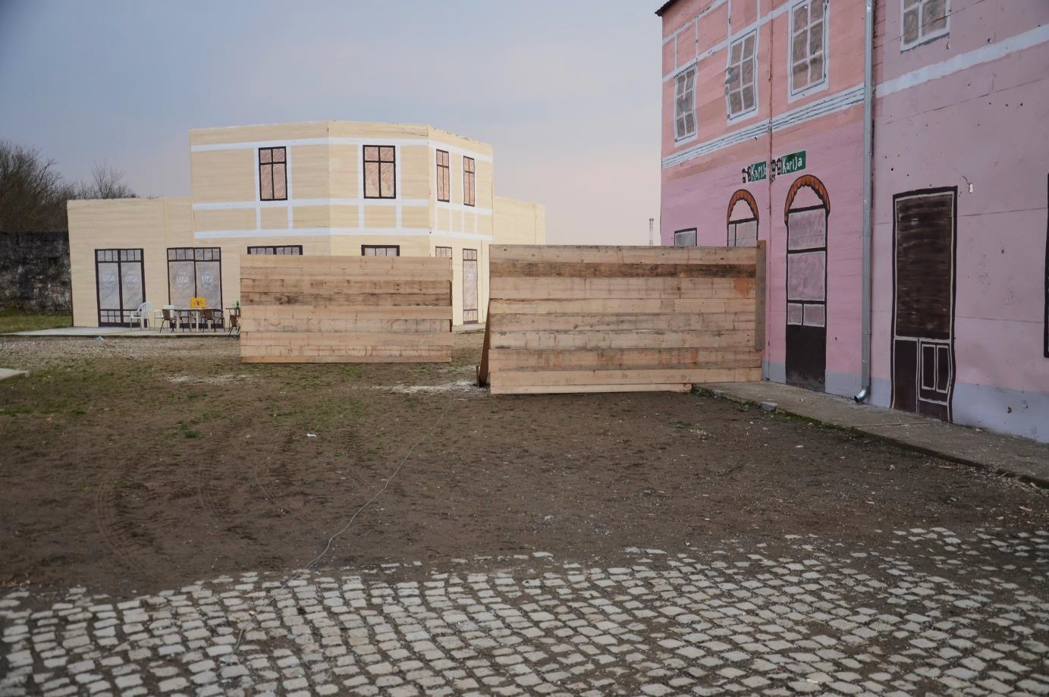

Figure 2.88 Position of screens No. 4 (W4 - right in front) and No. 6 (W6 - left at back) capturing fragments flying towards the Kapija square into the Caffé Kapija
Figure 2.89 - Figure 2.100 show screens after the explosion. Hits on their front part and perforations on the rear side were marked by red colour. The screen W1 was placed between exploding shell and the Coffee shop Leonardo. This screen shows significantly higher destructive effect of fragments (Figure 2.89 and Figure 2.90) than occurred in the real situation at this part of “Kapija” square where large number of survivor was identified. The screen W2, placed at the corner of building C was hit quite evenly by relatively smaller number of fragments and most of them perforated the screen (Figure 2.91 and Figure 2.92). There were both victims (totally 5 killed) and survivors (10 people) in the real situation at this place which does not correspond with the effect of the projectile’s explosion on the screen. The screen W3 shielded the space into street
B. Adžije between buildings F and G where 2 victims and 2 survivors were recorded. The screen S3 was hit unevenly by smaller amount of fragments, especially in its middle part (Figure 2.93 and Figure 2.94). The fragment’s effect on the screen again does not correspond with the effect of the explosion on the live targets.
Also the effects of few fragments on the screen W4 placed at the wall of building E (Figure 2.95 and Figure 2.96) are in variance with the effects of fragments at Tuzla where totally 4 people were killed and 3 people survived at this place. Screen W5 (Figure 2.97 and Figure 2.98) was hit by several fragments especially in its upper left part. Right bottom part of the screen W5 was not hit at all. This finding is not in agreement with 5 victims confirmed in this area at Tuzla’s Kapija square. The 5 victims were supposed to sit behind the tables in front of Caffe Gulam. Their position corresponds to the right bottom corner of the screen W5. On the other hand the screen W6 in front of “Caffe-slastičarna Kapija“ at the distance of 21 m away from the CE shows only several fragments hits at its higher part (Figure 2.99 and Figure 2.100). This experimental finding is not in agreement with the official photo documentation from the time of real event – in the area of the screen 6 victims were documented.

Total number of hits (penetrations) and total number of perforations were documented on each screen after explosion. Recorded values are shown in Table 2.3. Obtained fragment densities are utilised for comparison effects of experimental explosion and explosion at Tuzla’s Kapija square with results obtained from the theoretical model of fragments scattering (see chapter 3). The screens hit by fragments are shown at Figure 2.89 - Figure 2.100. The hits (penetrations) are marked by red colour on the front side, on the screen’s rear side are marked with the same colour the perforations.
The wooden screens provided expected results about the density and space positioning of fragments from the 130 mm HE projectile in chosen directions. These results are very different from the real situation recorded at the “Kapija” square.

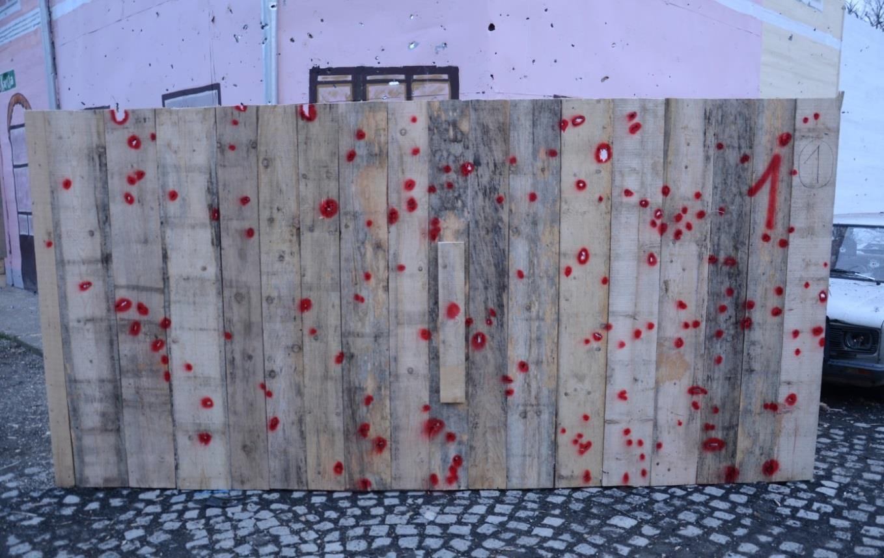

Figure 2.89 Effect of fragments on screen No. 1 (front part, distance 7 m away from the CE, 117 perforations of total 168 hits); screen is placed in the sectors of scattering of fragments from the most effective side spray

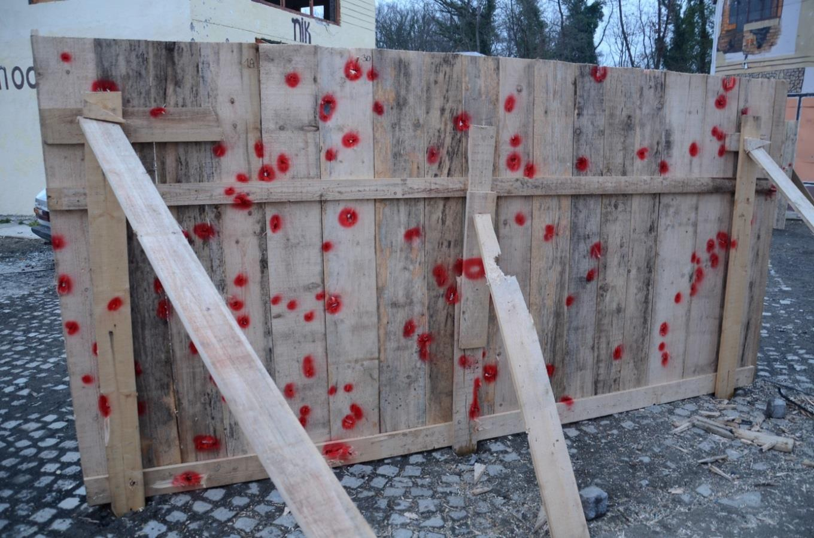

Figure 2.90 Rear part of the screen No. 1 with 117 perforations of wooden boards of thickness of 25 mm; in this area 9 people was killed but concurrently 12 people survived which can be, with respect to the density of field of effective fragments, absolutely excluded

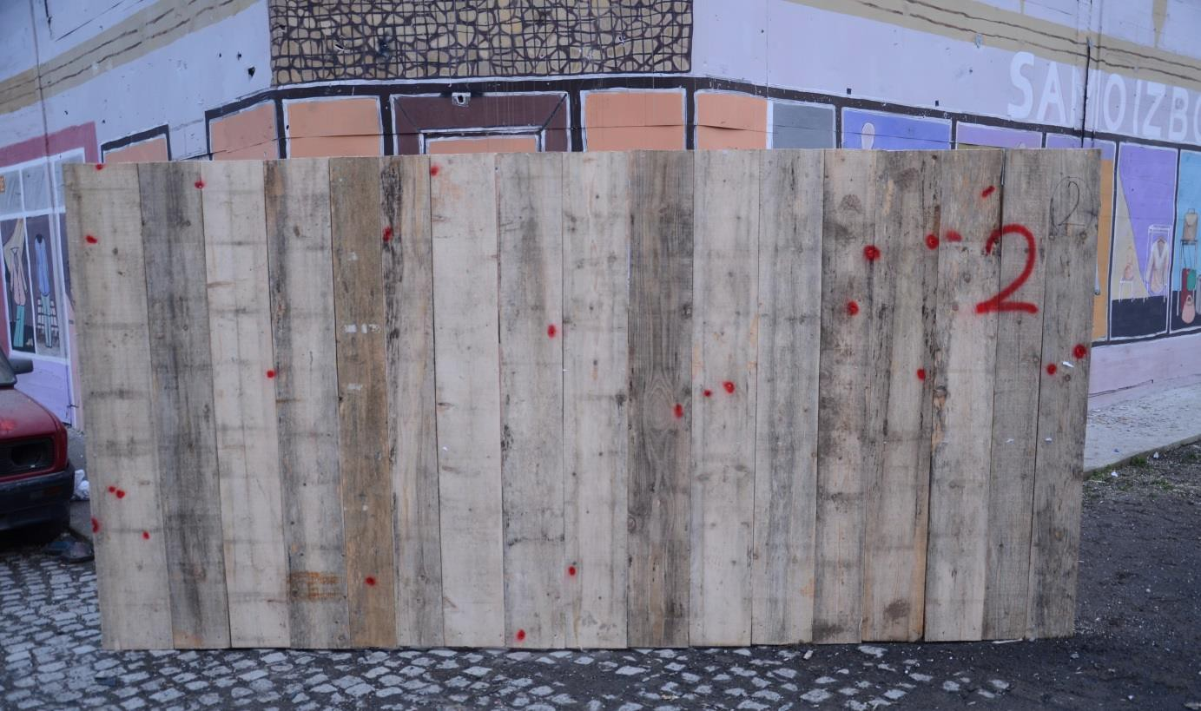

Figure 2.91 Effect of fragments on screen No. 2 (front part, distance 10 m away from the CE, 17 perforations of total 25 hits) – screen out of reach of the side spray, minimum number of hits but by very effective fragments

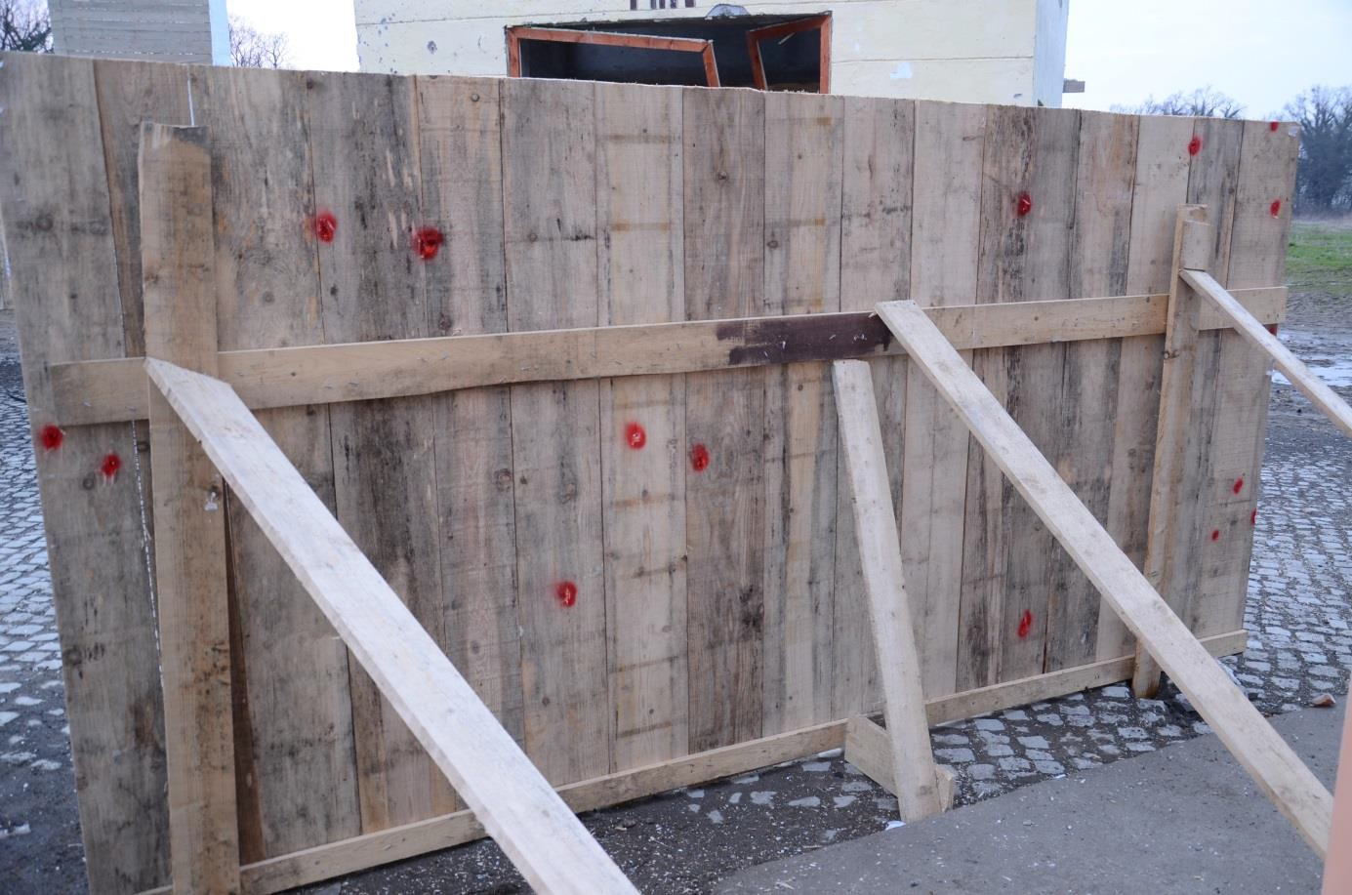

Figure 2.92 Rear part of the screen No. 2 with 17 perforations; 8 victims were deadly hit by fragments in this direction, which is possible, but concurrently 20 people survived the explosion in this area, which is highly improbable

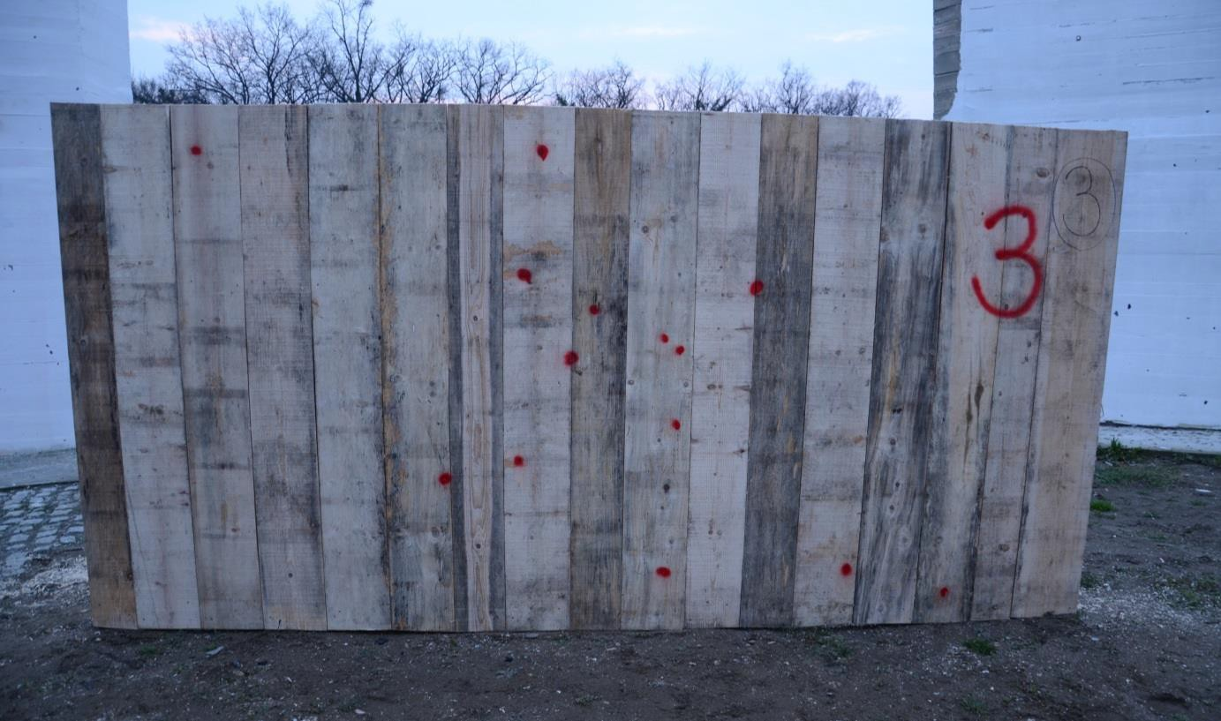

Figure 2.93 Effect of fragments on screen No. 3 (front part, distance 12 m away from the CE, 4 perforations of total 14 hits placed mainly in the centre of the screen) – screen out of reach of the side spray, minimum hits

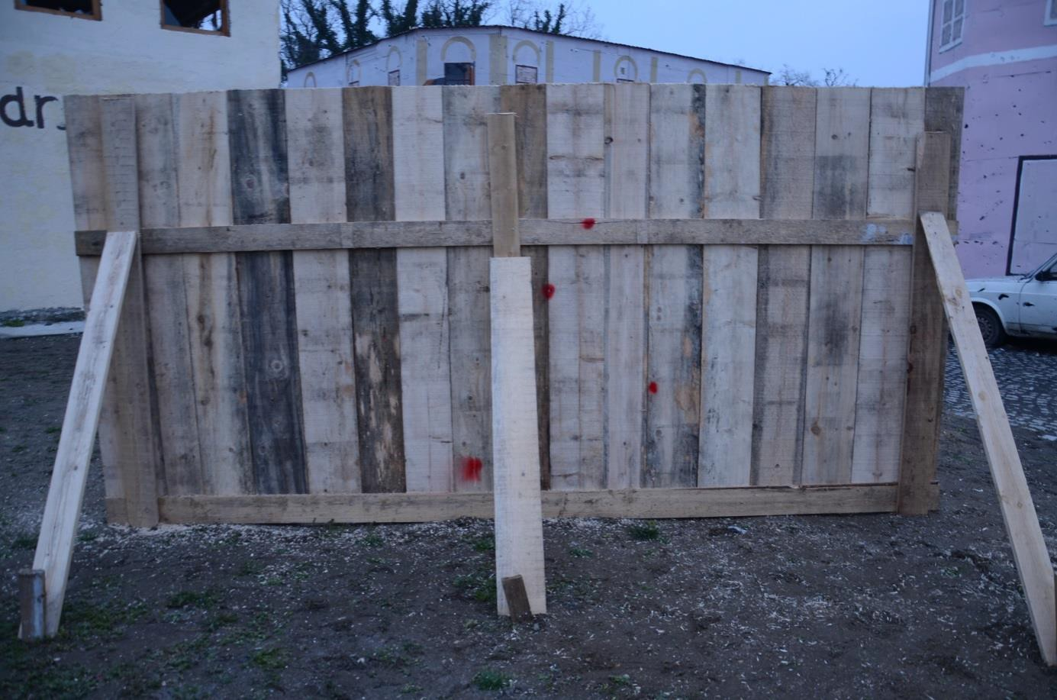

Figure 2.94 Rear part of the screen No. 3 with 4 perforations; in this area died 2 people which is not quit in agreement with number of perforations in the screen (under assumption of uniform distribution of fragment hits on the screen is hit probability of standing men (0.8 m2) by a single effective fragment in this area only 40 %

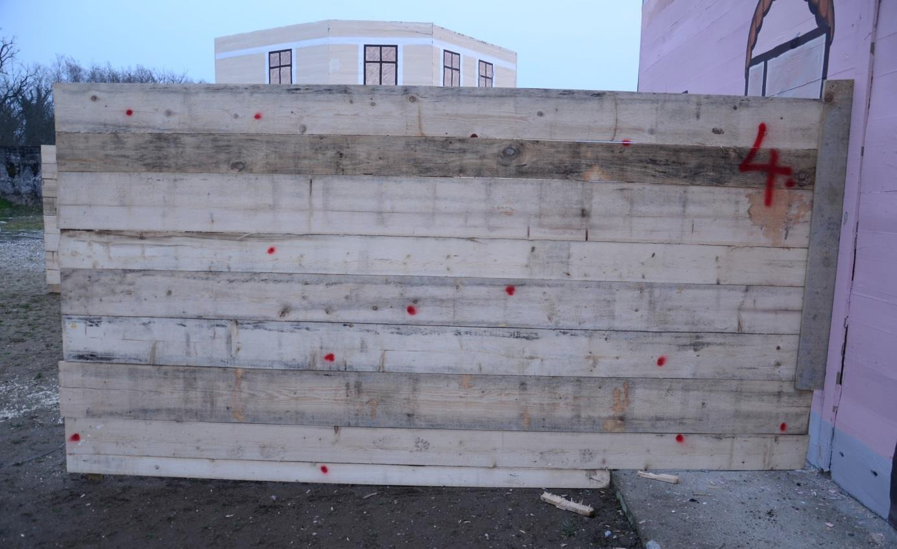

Figure 2.95 Effect of fragments on screen No. 4 (front part, distance 16 m away from the CE, 3 perforations of total 13 hits) – screen out of reach of the side spray with minimum hits spread over the whole screen)

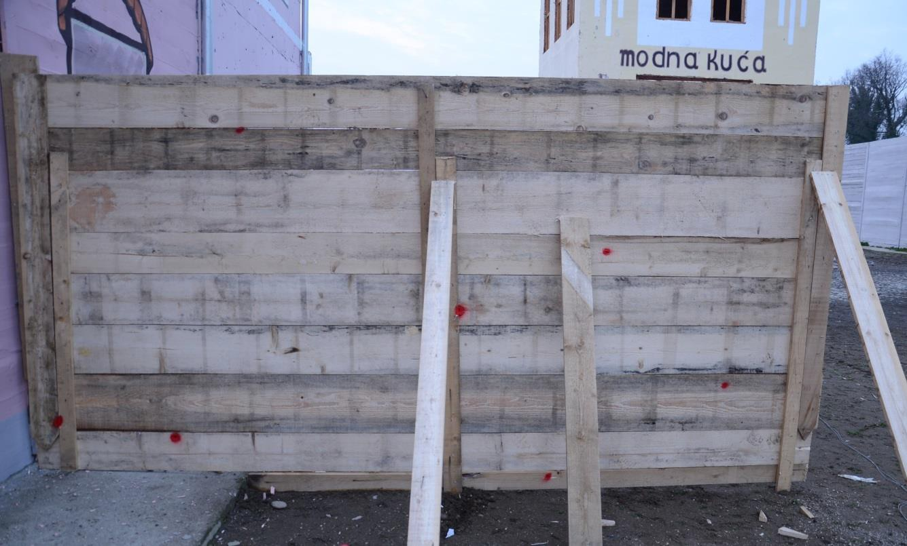

Figure 2.96 Rear side of screen No. 4 with 7 perforations, there were killed 4 people in direction of this screen at the distance from 17 to 20 m which is not in agreement with the number of perforations at the screen (hit probability of standing person by a single effective fragment in this area is about 70 %)

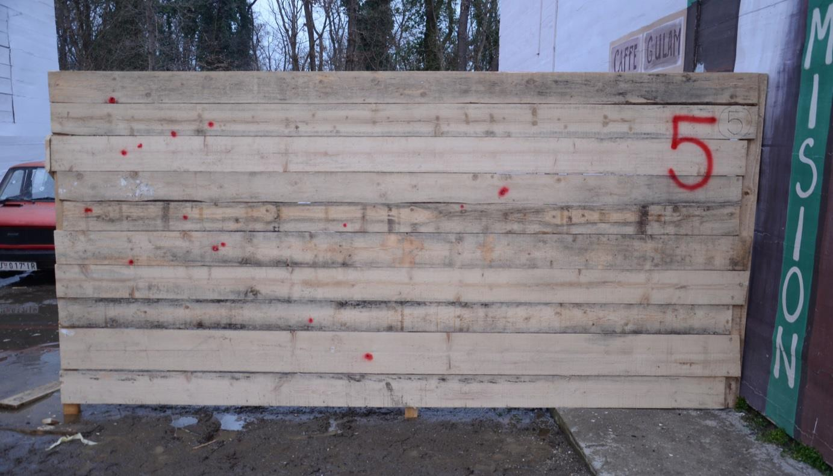

Figure 2.97 Effect of fragments on the screen No. 5 (front part, distance of 18 m away from the CE, total 15 hits, 8 perforations) – the screen out of reach of the side spray, hits at the left side but with 53 % of perforations

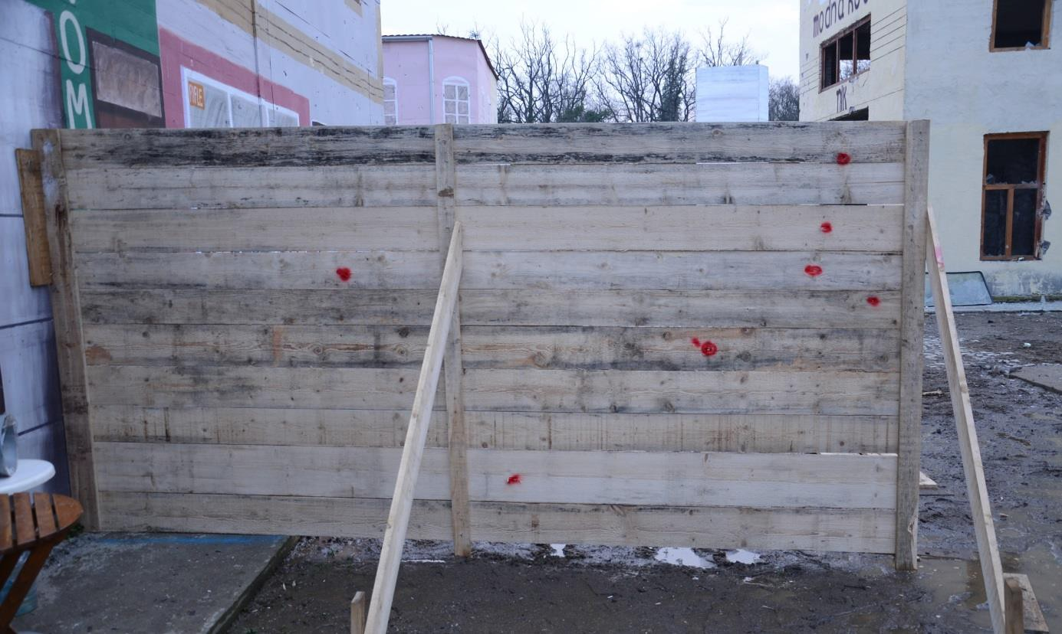

Figure 2.98 Rear part of the screen No. 5 with 8 perforations; in the sector covered with this screen was killed 5 people behind the screen and 3 people in front of the screen in the Tuzla, which is not excluded, alike is not excluded that in front of/behind the screen could survive the explosion 6/10 people

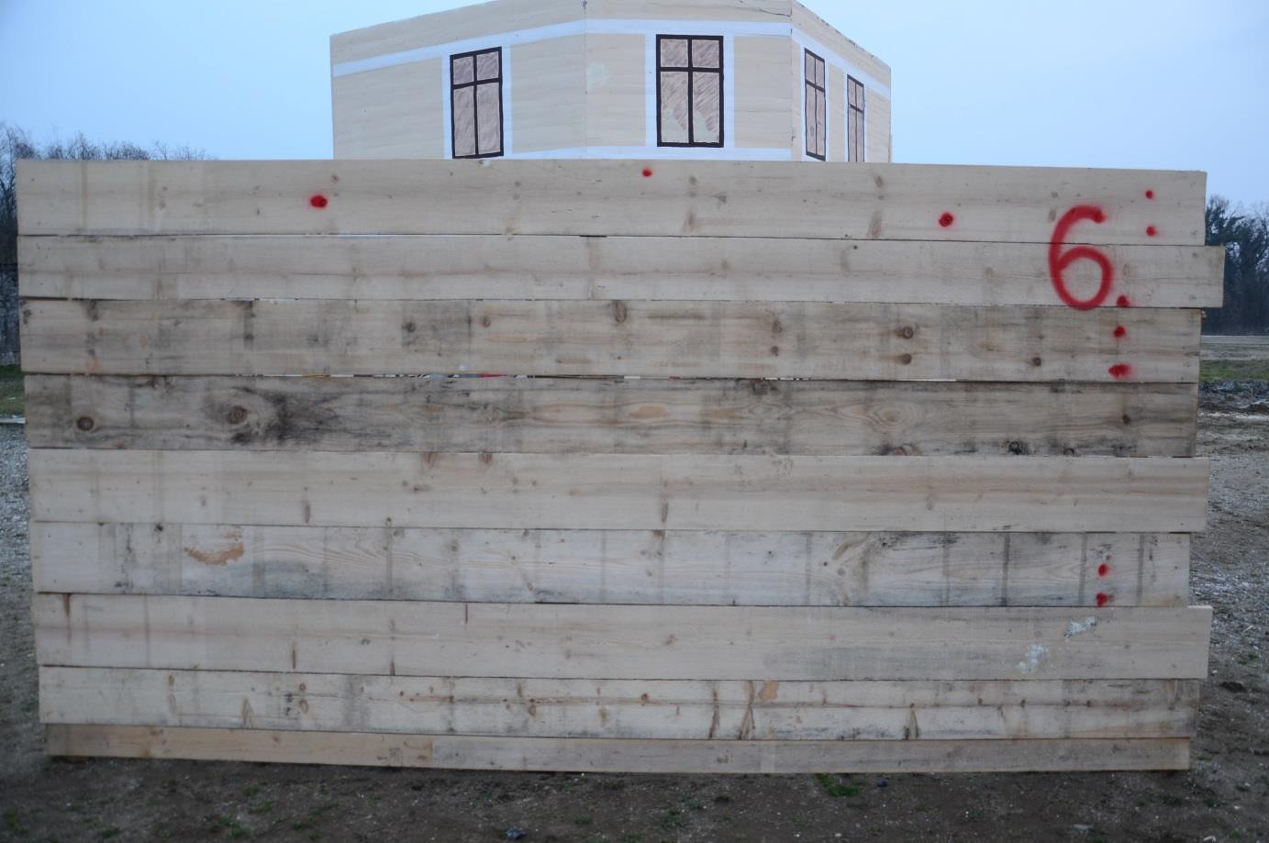

Figure 2.99 Effect of fragments on screen No. 6 (front part, distance 21 m away from the CE, 2 perforation of total 10 hits, all of them in right and upper part of the screen) – screen out of reach of the side spray, minimum hits

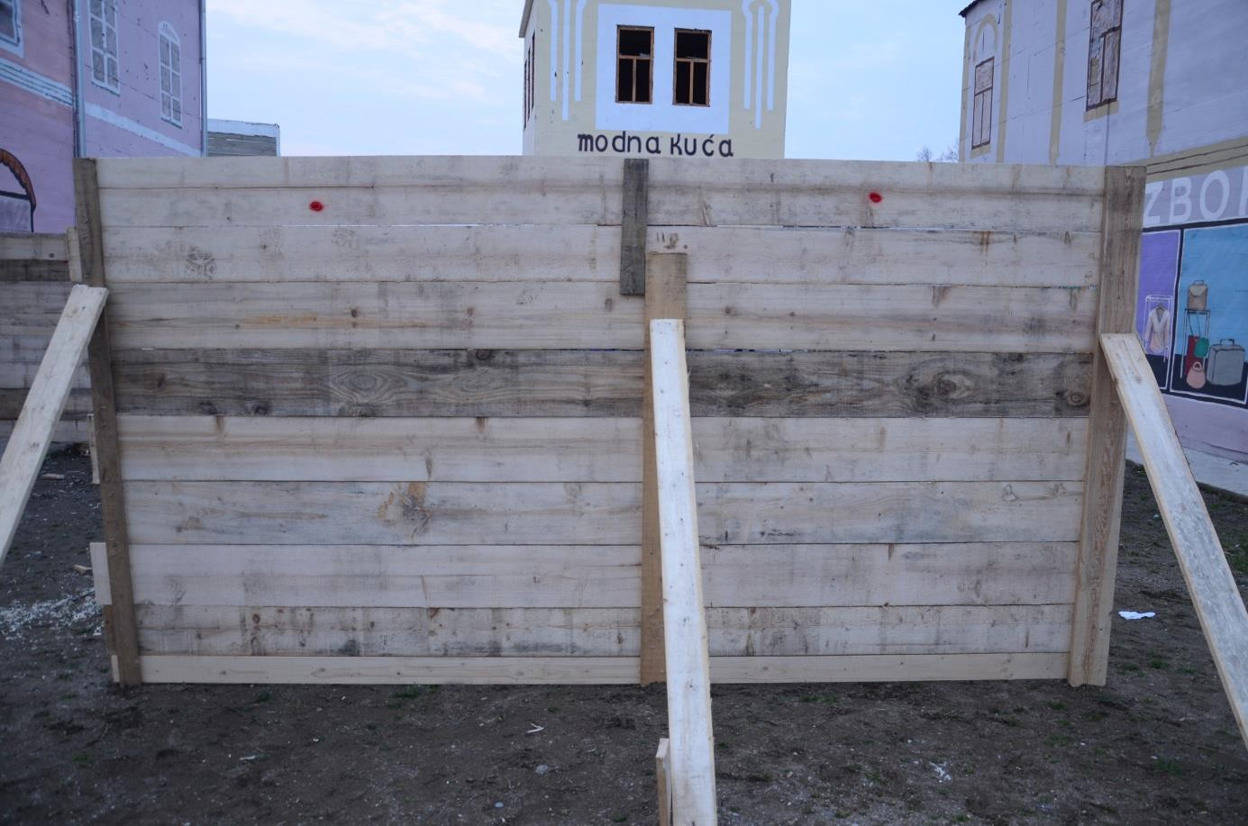

Figure 2.100 Rear part of screen No. 6 with 2 perforations at its upper part; in this area behind this screen was killed 6 people, which is very unrealistic in case of explosion of 130 mm projectile (hit probability is 20 %)

After comparing effects of fragments on screens with their real effects at Tuzla’s Kapija square, it can be stated, that the effects of fragments are in potential agreement with the reality only in case of screen No. 5 (placed 18 m away from the centre of explosion). But in all other cases there are smaller or larger differences between the experiment and the reality. The biggest disproportion is in case of screen No. 1, where the chance for survival, with respect to position of the projectile, was minimal but 12 people survived the explosion at this place in the real situation. Similar disproportion is also in case of screen No. 2. On the other hand in case of screens No. 3, 4, and especially No. 6 is the number of killed victims higher than it follows from the effect of fragments on screens during the experiment. Summary of effects of fragments on the individual screens is presented in Table 2.3.

Table 2.3 Effects of fragments on wooden screens 2 x 4 m

Scree n | Distance from CE | Total no. of hits | No. of perfora  -tions | %  perfora  -tions | No. of penetra- tions | Density of hits | Density of perfora- tions | Theoretica l density
W1 | 7 | 168 | 117 | 70 | 51 | 21 | 15 | 26
W2 | 10 | 25 | 17 | 68 | 8 | 3.1 | 2.1 | 2.6
W3 | 12 | 14 | 4 | 29 | 10 | 1.8 | 0.5 | 3.9
W4 | 16 | 13 | 7 | 54 | 6 | 1.6 | 0.9 | 0.76
W5 | 18 | 15 | 8 | 53 | 7 | 1.9 | 1 | 0.57
W6 | 21 | 10 | 2 | 20 | 8 | 1.3 | 0.25 | 0.41
Total |  | 245 | 155 | 63 | 90 | - | -

Note. From total number of 245 hits of fragments in screens occurred 155 perforations (63 %).
It is apparent from the Table 2.3 that the theoretical densities of fragments are in relatively good agreement with the real densities (see the emphasised columns of the table).
The theoretical densities of fragment field are determined by calculation with the use of fragment dispersion model described in chapter 4. For their determination were taken into account all fragments found at pit test and the specific limit energy for the target elimination 0.5 MJ.m-2.
Due to the fact that some of the screens were hit by fragments from more scattering sectors (Table 2.4) the final magnitudes of density were determined as a weighted average of densities in individual scattering sectors. The weights were equal to the relative areas of screens in individual sectors (last column of Table 2.4). For example screen No. 1 (W1) was placed in such a way that it was covered by 3 sectors S9, S10, and S11, while the sector 10 covered the largest part of the screen (65 %). On the other hand the screens No. 2 (W2) and 6 (W6) were covered by a single scattering sector.

Table 2.4 Coverage of individual screens by scattering sectors of fragments (for projectile’s angle of fall 62°)

Screen | Distance from the CE [m] | Sector S (62°)
W1 | 7 | 9 (15 %) / 10 (65 %) / 11 (20 %)
W2 | 10 | 7 (100 %)
W3 | 12 | 12 (30 %) / 13 (70 %)
W4 | 16 | 8 (40 %) / 9 (60%)
W5 | 18 | 8 (85 %) / 7 (15 %)
W6 | 21 | 8 (100 %)

Experiment No. 3
For the 3rd experiment the Serbian HE projectile 130 mm M79 was used. The only bottom part of the UTIU, M72 fuze with booster was screwed into the projectile to allow the electric initiation. The projectile was placed on 1” wooden board and placed into defined position (angle of fall 62° and direction corresponding to the projectile arrival direction 271° defined by prof. Berko Zečević). The Zastava 128 Skala 55 car (dark blue colour) was used instead of the VW Golf Mk I. The projectile was initiated by the electric detonator No. 8.
The placement of the projectile next to the car and effect of the explosion on the car are apparent from Figure 2.101 - Figure 2.104. The explosion of 130 mm projectile totally destroyed the front part of the car Zastava that showed only small resistance against explosion of projectile in close proximity. It can be stated that the damage caused by the explosion of single artillery projectile was significantly higher than damage to the VW Golf Mk I caused by explosion of 2 projectiles.

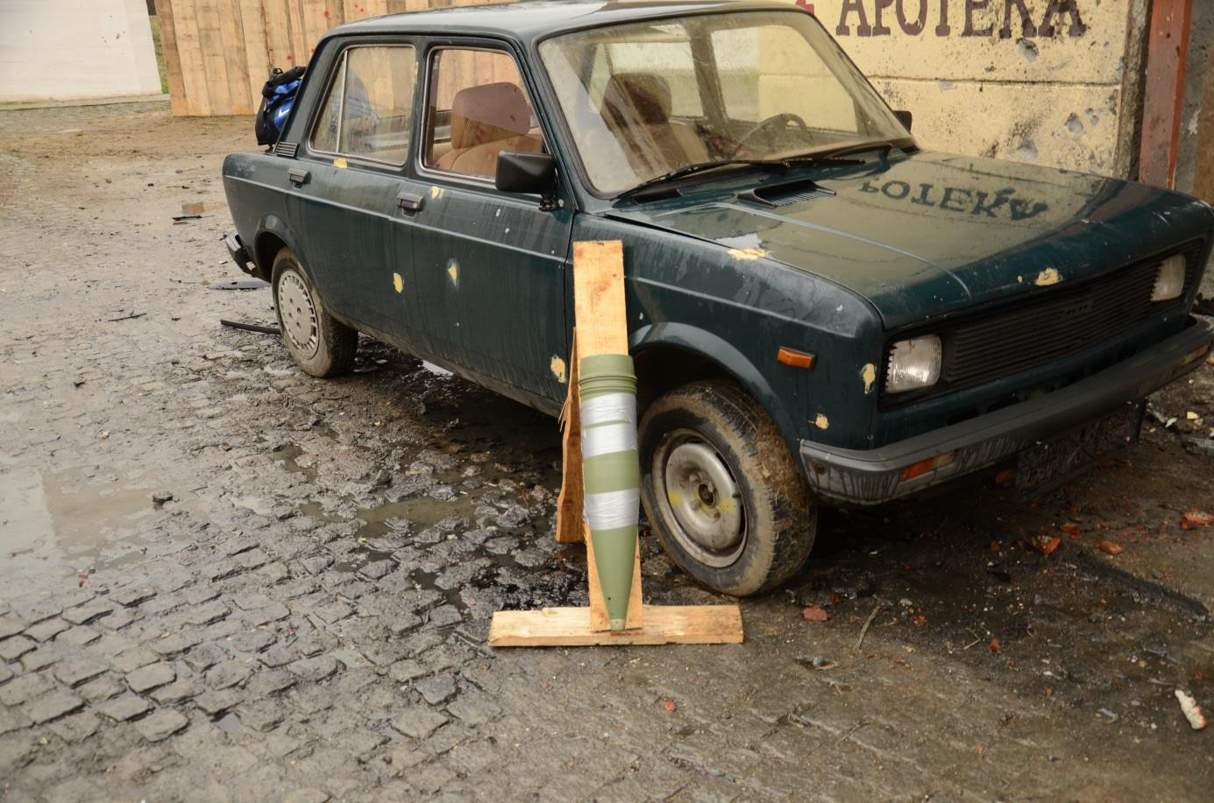

Figure 2.101 Car Zastava 128 with placed 130 mm HE Serbian projectile M79

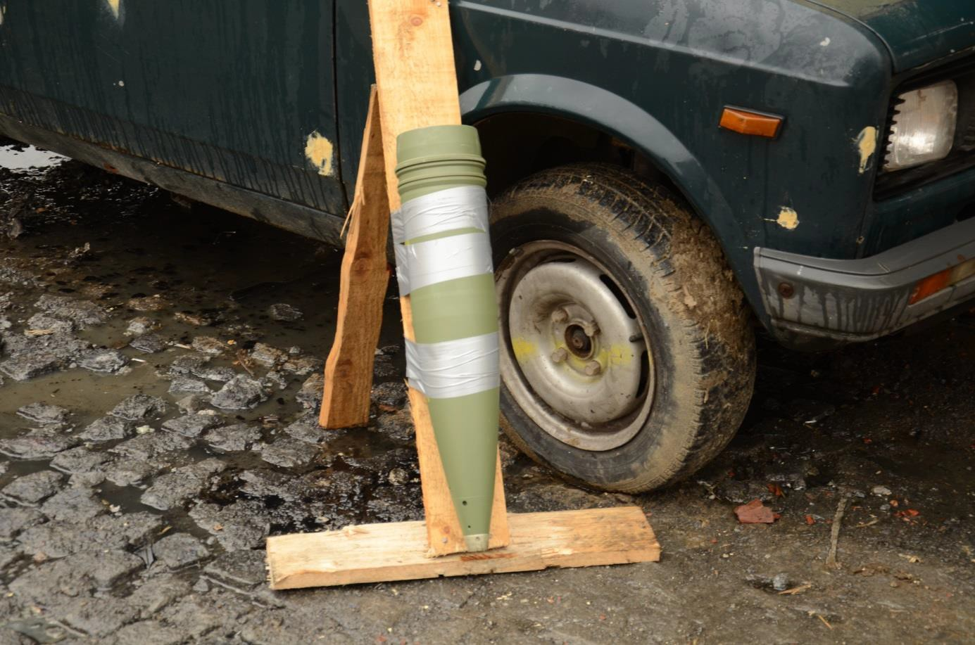

Figure 2.102 Detail of placement of 130 mm Serbian HE projectile next to the car

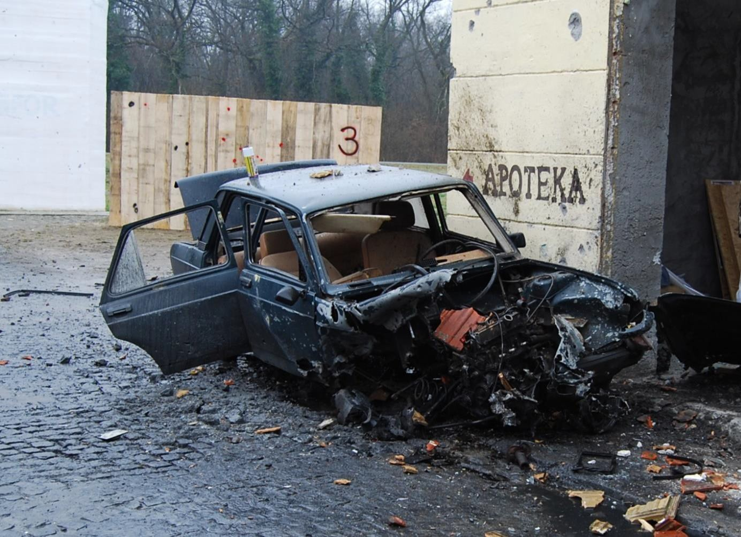

Figure 2.103 Totally destroyed car Zastava in front part (compare with Figure 2.37)

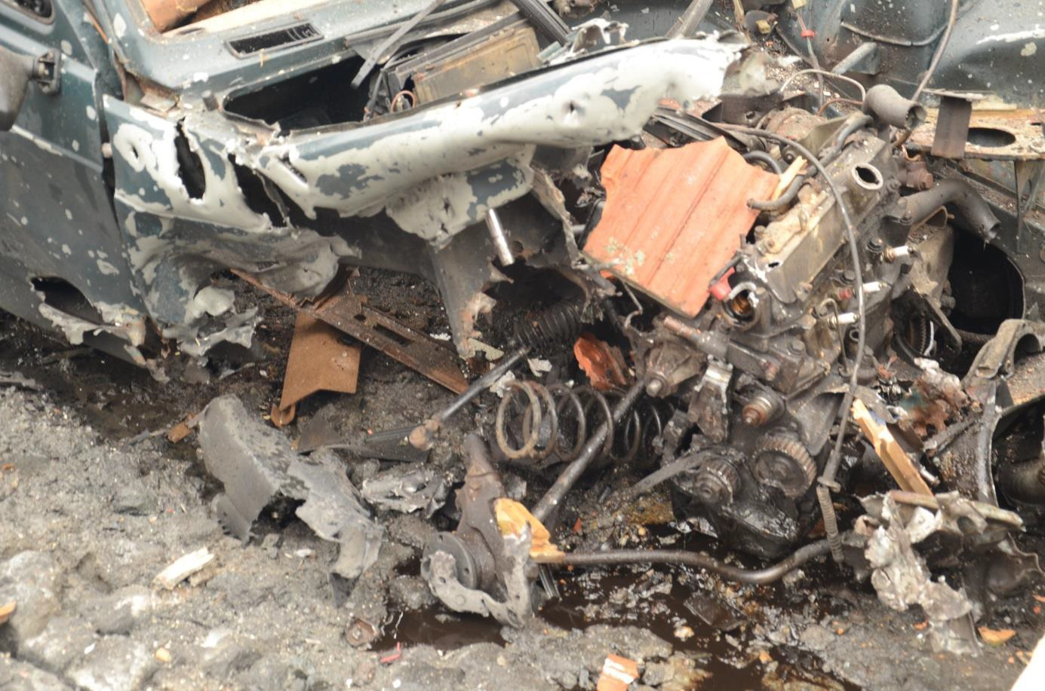

Figure 2.104 Detail totally destroyed right front part of the car Zastava 128
For 3rd experiment the wooden walls of height of 2 meters and width of 4 meters made of 1” boards were used (the same as for experiment No. 2) instead of dolls to provide better information on density and space position of the fragment beams. Effects of the projectile’s explosion on the individual elements of Kapija square model were parallel to the experiment No. 2. Numbers of fragment hits were not possible to evaluate because of screen begriming by mud and oil (3rd experiment was carried out in the rain).

Partial conclusions
Based on the analysis of experimental results presented in this chapter it is possible to state that there is number of significant discrepancies between effects of explosion at Tuzla’s Kapija square and its model in Nikinci, especially as for:
    - damage to the car No. 1 (VW Golf Mk I) caused by the explosion (see page 36 of this report),
    - position of the car No. 1 (VW Golf Mk I) after the explosion (see page 40 of this report),
    - begriming of the car No. 2 caused by the explosion (see page 44 of this report),
    - damage to the car No. 4 (Zastava) caused by the explosion (see page 45 of this report),
    - crater created by the explosion (see page 56 of this report),
    - damage to the building’s facades (see page 47 of this report),
    - damage to the NIK store shop window caused by the explosion (see page 51 of this report).
This points are in direct conflict with the prosecution’s model and do not confirm the fact that the artillery projectile fired from the position westerly from Tuzla exploded at Tuzla’s Kapija square in May 1995.

3 Analysis of prof. Zečević’s expert report

The expert report [1] labelled „Analysis of conditions that led to massacre of young people on “Kapija” square on 25 May, 1995, at 20.55“, whose authors are prof. Dr. Berko Zečević, MSc Jasmin Terzić and MSc Alan Ćatović is one of the prosecution’s base stones. It provides essential information on design and functional characteristics of 130 mm OF-482M focused on the areas of external and terminal ballistics. The report consists of 94 A4 pages and it is divided into large number of parts of following titles:
- Introduction
- Available data about the massacre of young people caused by the action of artillery projectile on Tuzlan “Kapija” square on 25 May, 1995 at 2055
- Artillery system, towed 130mm M-46 gun with ammunition
- Effects of HE (Highly Explosive) artillery projectiles action on the target
- Predicting the shockwave effect
- Natural fragmentation of HE projectiles
- Experimental methods of testing natural fragmentation of HE projectiles
- Fragment velocity
- Dynamics of fragment flight
- Damage levels
- Fuse influence on effect of projectile action on the target
- Analysis of HE projectile crater
- Research on crater location
- Determining the direction
- Projectile fragment analysis
- Instrument for determining the direction from which projectile flew in
- Identification of crater and explosion site
- Identification of direction from which projectile flew in
- Identification of projectile Angle of Fall
- Identification of calibre and projectile type
- Extent and type of damage caused by use of 130 mm artillery projectile
- Probable zone of firing 130 mm OF-482 or M79 artillery HE projectile
- Probable deviations of artillery projectiles
- 130mm M79 HE projectile velocity on trajectory and in the moment of contact with target
- The possibility of audio registering the firing of artillery projectile and projectile flight
- Possibility of visual tracing of artillery projectile
- Conclusions
The report is on a relatively high level. There are relatively often cited information from abroad (especially USA literature) in the report. But some parts of the report contain authors’ simplifications and inaccuracies that distort view on ballistic characteristics of 130 mm weapon system, especially on the effect of the 130 mm HE projectile. This chapter contains objections to some of those statements.

Terminal ballistics domain
The terminal ballistics domain is principal area which the report pays highest attention. The authors of the expert report committed following inaccuracies during the assessment of the projectile’s fragment field effect on live targets at Kapija square:

Projectile lethality radius
There is stated in several places of the expert report [1] that the projectile lethal radius is 27 m for live targets (Figure 3.1, taken from page 29 of that report). This information is distorted and has only limited validity for the vertical impact of the projectile. It is assumed that the projectile hit the Kapija square with the angle of arrival of 62° that is quite different from the angle of 90°. This radius is moreover determined for specific conditions – it corresponds to the range from the CE at which the fragment field density 1 fragment / m2 is reached, i.e. one effective (deadly) fragment will pass through each square meter at circle of radius of 27 m.
Dependency at Figure 3.1 is based on the results of the arena test standardized in the former Yugoslavia, and thus in the Serbia and BiH. During this test the projectile fire exploded in the vertical position and the effect of fragments is assessed from the quarter-circle wooden screens placed in different distances from the CE. With respect to the arrangement of the test it is apparent that the screens are exposed to the most massive side spray of fragments, which is not realistic for standard use of the weapon system (during the fire it is not possible to reach the angle of arrival higher than 80°). The results of the test are thus applicable only for the relative comparison of effect of projectiles of various calibres and designs. These tests have no meaning for practical applications. The results of these tests cannot be used as a prosecution’s argument. Realistic effect of the projectile is apparent from the Figure 4.2.

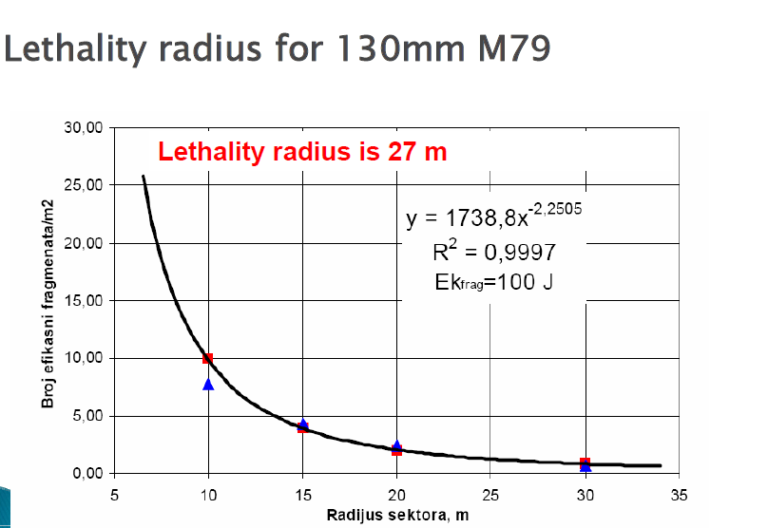

Figure 3.1 Experimentally obtained effective fragment field density vs. fragment scattering radius [1]

Number of people present at Kapija square
It is stated in [1], page 6 that 1000 – 1500 people were present at Tuzla’s Kapija square at the instant of the explosion. We consider this number of people as improbable. The Figure 3.2 shows rear (further from the CE) part of the Kapija square (Nikinci model) where 65 people and 40 dolls is present. Depicted area, where the people and dolls are dispersed, is closer to the Caffé Kapija and represent about one half of overall area of Kapija square and mouths of the adjacent streets. To reach the above mentioned number of people present at displayed part of the square the number of people would have to be 5 – 7 times higher, which is unrealistic. Majority of people and dolls at Figure 3.2 is present in the area that is only little endangered by fragments from the

explosion of 130 mm HE projectile as confirmed by experiments. Main fragment swarms – right and left side sprays were heading between buildings where the only small space and thus only a small number of people was present.

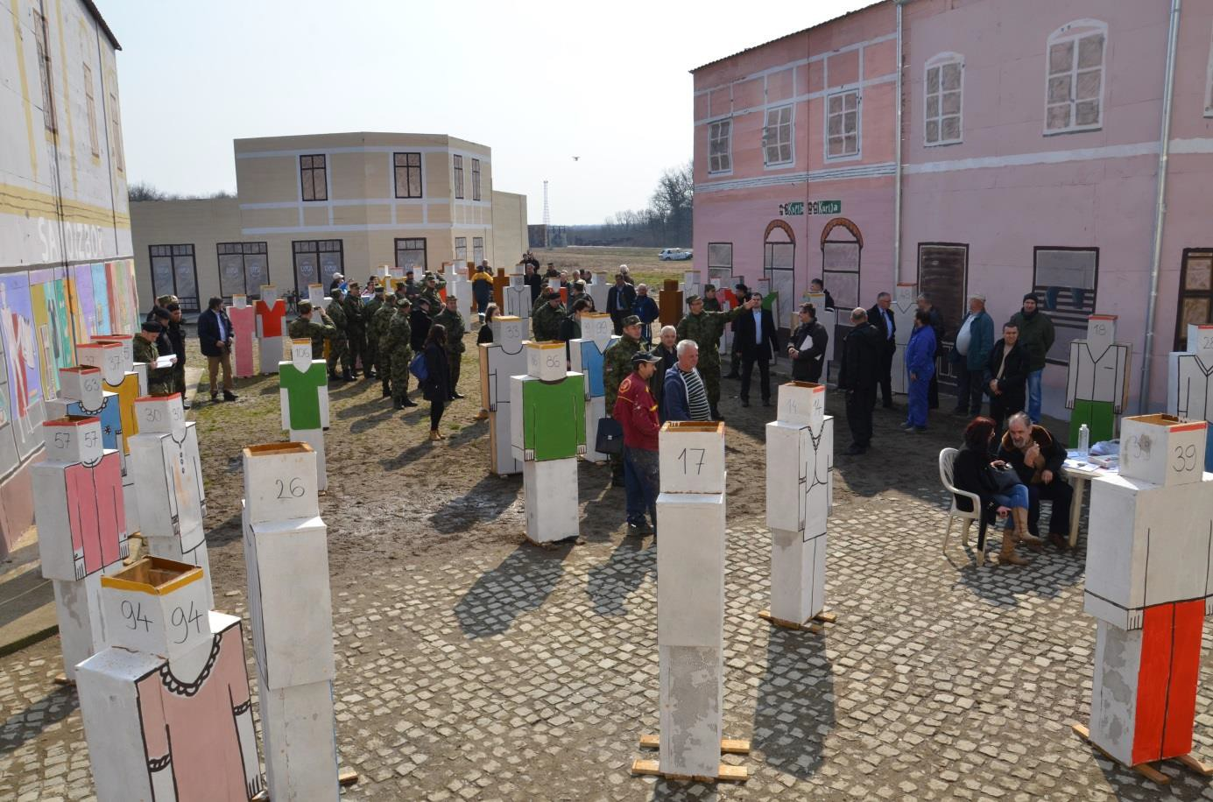

Figure 3.2 Illustrative placement of approx. 65 people and 40 dolls on the Kapija square (view from the CE towards the Café Kapija)
It must be also taken into account that in case when large number of people is present at Kapija square their bodies, in proximity of the CE, would shielded majority of the people at longer ranges from the CE from fragments. These fragments, with few exceptions, are not able simultaneously perforate several bodies and wound other people at long ranges from the CE. The fragments created by a random disintegration of homogeneous projectile body are of irregular shape and they overturns during penetration through tissues of a human body. In this way the fragments transfer majority of their energy to the hit target and when their energy is just over limit they are not capable to go through more bodies. This holds true for fragments of low mass.
The heavy fragments of mass of tenths of grams and of high, significantly over limit energy have capability to perforate simultaneously more bodies. But there is only a few of such fragments in the fragment field. In case of 130 mm HE projectile on average 120 fragments heavier than 50 g are created during the projectile’s explosion. These fragments are created mainly from the rear thick-walled part of the projectile and from the fuze and therefore they are not part of the side spray. The statement in the expert report ( [1], page 31) „Average fragment velocity i moment of explosion is 850 m/s, so it is obvious that large number of fragments can simply penetrate through human body and incapacitate next person, standing behind.“ is therefore of only limited validity.

Criterions of live target resistance
The criterions of live target resistance are the essential input parameter of all models for the fragment effect quantification. General and unambiguous characteristic of live organism mechanical properties and specification of live target resistance against fragment effects are very difficult and complex problem. Therefore during evaluation of the fragment effect on the live targets, which is the essential task of fragment terminal ballistic, it is not possible to exercise the

physiological viewpoints but purely technical viewpoints. In this case the live target is replaced with the substitution model, e.g. homogeneous model in the simplest variant, on which the mechanical resistance is assessed. So it is question, what physical quantity to choose as objective characteristic of resistance of such target. The main source of information in this area are the military experiments analysing effects of projectiles and fragments on live force.
First, historically older, opinion prefers purely energetic approach. Resistivity of live target is, in this case, characterised by the limit kinetic energy of translational movement of projectile
1 2 ,
𝐸���� = 2 �� 𝑣���
where 𝑣��� – limit fragment velocity (minimal velocity of fragment of given mass �� that just eliminates the target).
The expert report [1] repeatedly takes into account the criterion of live target resistance in the form of absolute impact kinetic energy of fragment. The energy Eslim = 100 J is considered as a limit value, i.e. when fragment possessing such energy hits the body of live target (human being) the wounds inflected would be serious (causing elimination of the target), or deadly in case of hit of vital parts of body. This criterion is not suitable for the use in the fragment terminal ballistic domain because it is out of date and inaccurate. It was adopted from the small arms projectiles terminal ballistic domain, the mass of projectiles lies in relatively narrow range (5 – 10 g) but the fragment mass lies in much wider range (from tenths to tens grams, or even hundreds grams). Therefore this criterion is suitable only for assessment of effect of fragments of mass in range 5 – 10 grams.
The second, newer, criterion takes into account except the kinetic energy also the effect of the fragment shape on the destructive effect in target. The limit specific kinetic energy of the fragment
−2

𝑒����[J. m
] is considered as an objective characteristics of target resistance, i.e. share of fragment

kinetic energy belonging to the unit of average area of fragment projection into plane perpendicular to the fragment direction of movement S; this energy is defined by relation
𝐸����
𝑒���� = � .
−2
According to [5], [6] and [7], the following magnitudes of limit specific energy 𝑒���� = 1 MJ. m
are recommended. Impact of fragment of specific energy 𝑒� = 1 MJ. m−2 on an arbitrary part of human body, protected only by a military uniform, will cause serious or deadly wounds.
Let’s compare changes of fragments limit velocities 𝑣��� with their mass �� , determined in accordance with both above mentioned criterions
−1
𝑣��� = 14.1 �� 2 (criterion 𝐸� ),
���
−1
𝑣��� = 98.0 �� 6 (criterion 𝑒� ).
���
The magnitudes of limit energies 𝐸� = 100 J and 𝑒� = 1 MJ. m−2 were chosen for comparison. Both dependencies are presented in Figure 3.3. Carried out comparison shows that between both criterions are significant differences, especially in case of border masses of fragments. Limit speed of fragment depends more strongly on the mass of fragment for criterion 𝐸���� = 100 J than for
criterion 𝑒���� = 1 MJ. m−2 . Heavier fragments have the limit velocity very low; e.g. fragments
heavier than 8 g have, according to criterion 𝐸���� = 100 J, limit velocity 50 m.s-1, in case of fragment of mass of 200 g is the limit velocity 30 m.s-1 (it corresponds to throw by hand). The statement about effectivity of these fragments is not very plausible.

There is apparent consensus of both criterions for fragment mass of 3 g, in wider interval of fragment masses from 2 to 4 g in the Figure 3.3. Change of the fragment’s limit velocity with its
−2

mass determined in accordance with criterion of specific fragment energy 𝑒����[J. m
] has

significantly more gradual course (lower dependency of the effect of fragments on fragment velocity). This course also significantly differs from the course limit velocity determined according to the criterion 𝐸����[ J ] in boarder areas of fragment masses. For example a fragment of mass of
−2

0.25 g is considered as an effective, according to the criterion 𝑒����[J. m
], when its kinetic energy

is higher than 20 J, i.e. approximately 5 times lower than required by criterion 𝐸����[ J ]. On the other hand for the heavier fragments that are decisive from the effect of a HE projectile the effect of fragments is by the criterion 𝐸���� = 100 J underestimated, i.e. lower impact velocity is sufficient for reaching of required effect on a live target.

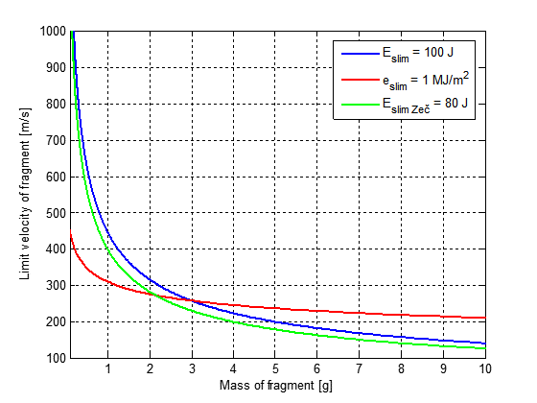

Figure 3.3 Change of limit velocity with mass of fragment for different criterions (shape of fragment αs=4, βs=2)

3.1.4 Effective fragment range
The expert report shows, page 36, dependency of effective fragment range on its mass (Figure 3.4). This dependency is again based on the criterion 𝐸���� = 100 J. With respect to the above mentioned criticism of this criterion this dependency can be considered also as distorted. The Figure 3.6 displays comparison of the effective ranges of fragments for both criterions. Presented dependencies have following analytical forms
1
6

𝑥lim =
1

𝑐𝑁
ln [𝑣0
��

√2Ф𝑒����
] for criterion 𝑒���� = 1 MJ. m−2,

𝑥lim =

1

𝑐𝑁

ln [ 𝑣0
1
��2

√2𝐸����

] for criterion 𝐸���� = 100 J.

180
e =1 MJ/m2
slim
Eslim = 100 J
prof. B. Zečevič assumption

160

140

120
Effective range [m]

100

80

60

40

20

0
0 1 2 3 4 5 6 7 8 9 10
Mass of fragment [g]

Figure 3.4 Effective fragment range for different masses of fragment

External ballistics domain

Weapon system parameters (ballistic conditions)
Maximum range of fire of every weapon system is affected by number of technical weapon system parameters. Among parameters that significantly affects the maximum range of fire are
- barrel wear,
- standard initial velocity of the cartridge.
Barrel wear
When considering the capability of the weapon system allegedly used in the analysed case, prof. Zečević takes into account only tabular characteristics describing the new weapon. But the weapons during its life get worn and its capabilities worsen. The typical example directly bonded with the case is the wear of the barrel caused by firing projectiles that erode the barrel bore. The barrel wear can be characterised by dimensional and shape changes of chamber, forcing cone, and rifling. These changes lowers the initial velocity and thus lowers the maximum range of fire.
For practical use the effect of barrel wear, expressed by means of cartridge chamber elongation, on the initial velocity is part of firing tables

Table 3.1 Table of barrel wear from firing tables [2]

Full charge
Decrease in initial velocity [%] | -1 | -2 | -3 | -4 | -5 | -6 | -7 | -8 | -9
Cartridge chamber elongation [mm] | 10 | 26 | 53 | 210 | 600 | 675 | 706 | 732 | 757

From the table and with the use firing tables it can be derived that
- initial standard velocity for new barrel 930 m/s,
- initial velocity for slightly worn barrel, 10 mm elongation of cartridge chamber, 1 % drop in initial velocity to 920,7 m/s (-9.3 m/s),
- initial velocity for badly worn barrel , 757 mm elongation of cartridge chamber, 9 % drop in initial velocity to 846.3 m/s (-83.7 m/s).
From the above mentioned information it can be concluded that the standard range of fire with new weapon and full charge 27100 m can be due to barrel wear shorter from 611 m to 5499 m.
Standard initial velocity of the projectile
The firing tables use the standard initial velocity of the projectile for calculation of trajectory characteristics presented in the firing tables. These standard initial velocity corresponds to measured velocity of certain ammunition lot.
During the production and storage of ammunition the initial velocity usually changes in order of units of percent of standard initial velocity.
Without knowledge of the real technical state of the weapon system (gun and ammunition) it is not possible to determine maximum range of fire and thus predict whether the artillery unit equipped with the weapon system was even capable to hit the Tuzla’s Kapija square from the Panjik area or not. These information is also essential for calculation of real life projectile’s trajectory.

Atmospheric conditions
The other element significantly affecting the range of fire is the atmosphere in which the projectile moves. Projectile’s trajectories can be calculated either for a standard atmosphere (e.g. Standard artillery atmosphere, ICAO, …) or for real atmospheric conditions (real air pressure, temperature, humidity, speed and direction of wind) over whole height of projectile’s trajectory (from firing position up to the trajectory vertex height). Trajectories calculated for the standard atmospheric conditions are utilised e.g. in firing tables. Trajectories calculated for real atmospheric conditions are utilised in practice, e.g. in field artillery. In this case the information on state of atmosphere in different heights is provided from atmosphere sounding (measurement of vertical distribution of physical properties of the atmospheric column such as pressure, temperature, wind speed, and wind direction).
Trajectory calculations carried out by prof. Zečević are based on the information from Federal Hydro-meteorological Service with its letter no. 04-33-2-1031/07 from 11 Dec., 2007 delivered the data on meteorological conditions on 25 May, 1995. In this letter it was stated that:
“On 25 May, 1995, meteorological station in Tuzla registered fair and stable weather, without precipitation. Average daily temperature was 18.9 °C, and at 21 hours the air temperature was 17.2° C. The pressure was within normal limits, and at 21 hours it was 980.3 mb. It was quiet – no wind, and the maximum wind speed registered on that day at 14 hours was 2 m/s (breeze), of southwest direction. Air humidity measured at 8 hours in the morning was 90%, and at 14 hours

it was 60%. At 21 hours the air humidity was not measured, but according to weather conditions and the daily humidity flow from other meteorological stations it would be approximately 60%.”
This information on the state of weather in the Tuzla region does not contain any information on weather conditions in different heights above the ground. It has to be taken into account that the projectile’s trajectory vertex is according to firing tables nearly 9500 m for the considered standard range of fire 27100 m. The ground weather conditions cannot be applied to the entire trajectory, especially wind (direction and speed) changes dramatically with the height above the ground. The wind has significant effect on the projectile’s trajectory as it can be seen from the firing tables, the ballistic wind (tail/head wind) of 10 m/s can change the range of fire by 657 m and the ballistic wind (cross wind) of 10 m/s direction by 460 m at range of 27100 m (angular correction for this wind would be 17 mils = 1.02°).
Without knowledge of real state of atmosphere (vertical profile of wind, temperature, pressure) at Tuzla region on 25th May 1995 it is not possible to calculate any real life trajectory that will be at least similar to the trajectory of the 130 mm HE projectile allegedly fired from the Panjik area towards the Tuzla.

Real projectile’s trajectory
Prof. Zečević used for his analysis and calculations 3-DoF trajectory model. This model introduces the projectile as a point mass that is exposed to the effect of only essential forces - gravity and drag during its flight. The projectile‘s aerodynamic properties are characterised only by the ballistic coefficient. The atmospheric conditions, standard atmosphere or real state of atmosphere, can be introduced into the trajectory calculations. The resulting projectile’s trajectory does not correspond to the real life trajectory because the projectile is not a point mass but a rotating body. The effect of right hand projectile rotation bends the projectile’s trajectory to the right – this effect is called drift of the projectile and the 3-DoF trajectory model is not capable to calculate this side movement because of accepted simplifications.
The model providing complex information on the projectile’s movement in the atmosphere is the 6-DoF model [8] taking into account projectile as a body, in case of spin-stabilised projectile – rotating body. It also takes into account most of forces and moments acting on the projectile during its flight. These complex model is therefore very demanding on the input projectile’s physical and aerodynamic characteristics. But in exchange it provides faithful projectile’s trajectory, including the drift of the projectile.
The calculated trajectories characteristics presented in the firing tables were obtained from the 3-DoF model and the drift of projectile was determined experimentally. The firing tables contain one column dedicated to the correction of firing angle (azimuth) due to drift of projectile, for the mentioned range of fire 27100 m the correction for the drift is 23 mils = 1.38° to the left from the line of fire because the side deflection of the projectile caused by the drift of the projectile at the range of 27100 m is according to the firing tables 623 m to the right from the line of fire. These facts are not mentioned in the prof. Zečević’s report at all.
It holds true that both models require proper information on vertical profile of atmospheric characteristics. Without this information the resulting calculated projectile’s trajectory will significantly differ from the real one.
It should be noted that prof. Zečević had not published input data (ballistic characteristics, drag law, standard atmosphere, external ballistic model used), that were used for the trajectory calculations. Thus it is not possible to recalculate and verify the presented trajectories.

Systematic errors
Table showing systematic errors for firing from cannon M-46 with projectile OF M79 (Figure 3.5) is confusing because provides magnitudes of tabular range corrections for changes of atmospheric parameters (air temperature and pressure, speed of longitudinal wind) by 10 units and range corrections for change of ballistic parameters (temperature of propellant charge and initial velocity of projectile) also by 10 units. Last summarizing column gives sum of all magnitudes on the row. This is only a hypothetic magnitude, again not usable in practice. Individual real systematic errors can be both bigger and smaller in comparison to magnitudes shown in the table but relatively often the systematic errors eliminate each other (some of them are positive, some of them are negative, and errors created by the change of the initial velocity are usually negative). Systematic errors of magnitudes in range from 890 m to 1990 m according to the range of fire will appear very rarely. With knowledge of conditions of fire it is possible with responsible calculation of aiming angles eliminate the systematic errors to minimum (theoretically to zero). Presentation of magnitudes shown in the table proves the misunderstanding of error budget of artillery fire and principles of corrections of aiming angles.

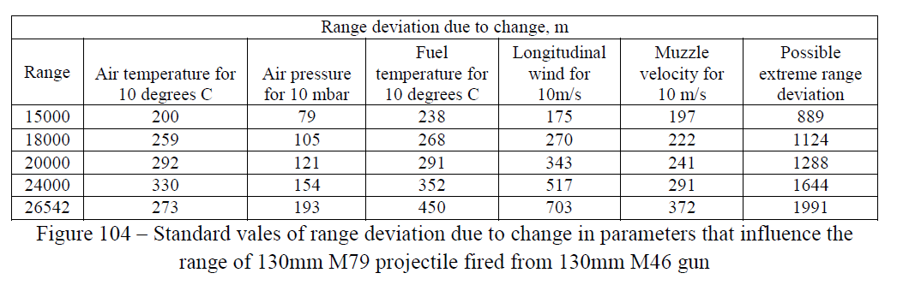

Figure 3.5 Figure 104 from prof. Zečević’s expert report [1]
With prof. Zečević’s approach it should be noted that the parameters can affect the projectile’s trajectory also in opposite direction and the range of fire can be significantly shorter. The Figure 104 contains in the table data concerning the projectile OF-482M and fuze V-90 [2].

Others
Fragments presented in the prof. Zečević’s report on page 67 (Figure 3.6) are shown without any scale and it is not possible to objectively determine their dimensions and thus their origin in 130 mm HE projectile.

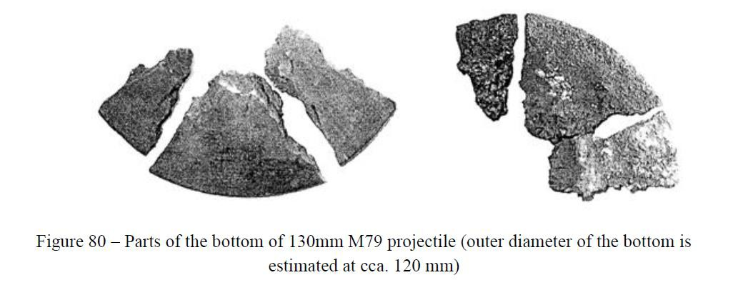

Figure 3.6 Figure 80 from prof. Zečević’s expert report [1]

Partial conclusions
The external ballistic calculations and considerations were carried out for new weapon system firing projectiles of standard initial velocity. The use of the standard trajectory characteristics from the firing tables for the estimation of the assumed firing point seems to be rather speculative.
The atmospheric conditions used for the calculations were based only on the ground meteorological message and the vertical changes of the atmosphere that could significantly change the trajectory were not taken into account.
After this analysis it is not possible to exclude situation when the previously mentioned effects negatively affected the range of fire in such extent that the weapon systems in the Panjik area were not able to hit the Tuzla’s Kapija square.
For illustration it is possible to show two extreme cases of change in range of fire for standard and previously considered range of fire 27100 m
    - new weapon with initial velocity 930 m/s (0 m), air temperature 10 °C higher than standard (+290 m), temperature of propellant charge higher by 10 °C (+445 m), tail wind 10m/s (+657 m) – range of fire 28492 m,
    - worn weapon with initial velocity 846 m/s (-5499 m), air temperature 10 °C lower than standard (-290 m), temperature of propellant charge lower by 10 °C (- 445 m), head wind 10 m/s (-657 m) – range of fire 20212 m.

Model of fragment dispersion

Introduction
Fragment scattering model, briefly described in this chapter, allows determination of basic parameters of fragment field created by explosion of artillery projectile. It was necessary to take into account the amount of available information on fragmentation of projectile, determined experimentally according to [7], during derivation of the analytical model. At the same time it was necessary to take into account the extent of mathematical apparatus used in the model that would became, after incorporation of all partial fragment effect factors (even in simplified form), very complicated and with limited usability for supposed purpose.
The mathematical model of evaluation of high-explosive projectile’s fragment effect against live targets was developed with following simplifications:
    - rotation, precession, and nutation motion of projectile is neglected (holder of impact velocity vector is identical with axis of projectile in instant of ignition),
    - impact velocity of projectile is zero,
    - initiation of projectile’s explosive charge occurs in time of first contact of projectile with ground surface,
    - fragment field is, during fragments scattering into the free space, symmetrical along axis of projectile in instant of explosion,
    - fragments scattering begins from projectile’s centre of gravity, motion of fragments is straight line,
    - distance between projectile’s centre of gravity and ground surface is neglected,
    - vectors of scattering velocity of all fragments, moving in a given sector, have constant magnitude and form a constant angle with projectile’s axis,
    - fragments mass distribution in all scattering sectors is constant and identical with overall mass distribution,
    - fragments motion from the place of initiation is solved for standard atmospheric conditions and constant drag coefficient,
    - effect of gravity on fragment’s motion is neglected,
    - ground target is placed in horizontal plane, its motion is neglected (velocity of the target is negligible with respect to fragments’ velocity),
    - targets are not covered and protected against effect of fragments,
    - destructive effect caused by shock wave created during explosion of projectile’s explosive charge is neglected.

Fragmentation effect of artillery projectiles can be quantified by means of basic projectile fragmentation characteristics that can be determined experimentally at pit and arena tests. Projectile fragmentation is characterised by mass, velocity, and spatial fragment distribution. Mass distribution of fragments is determined by pit test, velocity and spatial distribution of fragments by arena test.
The pit tests are carried out according to nearly identical methodology in majority of countries. But the Czech arena test methodology is different from the Serbian methodology. The differences in methodologies are described later in the report.
The fragment scattering model consists of following consecutive parts:
- specification of mass distribution of fragments,
- specification of spatial distribution of fragments,

- specification of velocity distribution of fragments,
- calculation of density of fragment field,
- calculation of target elimination probability.

Mass fragment distribution
Mass fragment distribution is set of data on amount of fragments of various mass from minimum to maximum. The mass distribution of fragments is determined by number of fragments in individual mass classes (groups). The mass distribution is determined for the particular projectile by the pit test. According to the Czech Pit test methodology are fragments created during explosion of projectile divided into 14 mass classes that are defined for r = 0 – 13.
- class up to 0,5 g,
- class 0.5 – 1 g,
- class 1 – 2 g,
- class 2 – 3 g,
- class 3 – 5 g,
- class 5 – 10 g,
- class 10 – 15 g,
- class 15 – 20 g,
- class 20 – 30 g,
- class 30 – 50 g,
- class 50 – 75 g,
11. class 75 – 100 g, 12. class 100 – 200 g,
13. class above 200 g.

According to the Serbian Pit test methodology the borders of individual mass classes are identical. Difference is only at maximum mass of fragment at 12th class that is 150 g; i.e. last two classes are 100 – 150 g and more than 150 g.
The fragments of lower weight than 0.5 g can be, according to some models, treated as ineffective and for calculation are then used only fragments from mass classes 1 – 13. For each rth mass class is from the pit test determined overall number of fragments Nr and their overall mass mr can be also determined; it is possible to determine the mean fragment mass �´� in rth mass class according to relation

�´� =
��
𝑁�
, r = 1 - 13. (1)

In case when the overall masses of fragments in individual mass classes are not known the magnitude of �´� can be determined as arithmetic mean of lower and upper boundary of each mass class. For the 13th class (fragments heavier than 200 g) is the magnitude of �´� determined as average mass of real fragments. For the 0th class (when it is used for the evaluation) it can be considered magnitude �´� = 0.25 g.
For the evaluation of fragment effect on live targets according to Czech methodology only the fragments heavier than 0.5 g are considered. Their number N0.5 is an important fragmentation characteristic of a particular projectile. With its use the relative number of fragments �´� in rth mass class can be determined according to relation
��

�´� =
𝑁0.5
, r = 1 - 13 (2)

Spatial fragment distribution
The spatial fragment distribution is set of data describing geometry of scattering of fragments into space around the projectile. It is determined experimentally by test in wooden vertical screen – arena test. After explosion of the projectile are evaluated numbers of penetrations and perforations in the wooden walls. It is supposed that the resistance of the wooden walls against fragment perforation is comparable with the energy required for elimination of a live target.
According to the Czech methodology the continuous circular screen of height of 3 m made of soft wood boards of 25 mm thickness. The radius of the screen is constant (for 130 mm projectile is the radius Rz = 15 m). The projectile is exploded in the centre of the screen in “prone” position,
i.e. the projectile’s longitudinal axis is in horizontal position and in height of 1.5 m above ground. Simultaneously the velocity of fragments is measured in 5 sectors.
Serbian arena test is based on the use of intermittent segmented screen made of wooden boards of thickness 20 – 25 mm and consisting of 4 quarter-arcs (sectors I - IV) with common centre and radiuses 10, 15, 20, 30 m (for 130 mm projectile). The projectile is placed on the ground in common centre of screen in “upright” position, i.e. the longitudinal projectile axis is in vertical position, and front ogive is heading towards the ground. The velocity of fragments is not measured.
The essential difference between the methods is in nature of obtained data on spatial distribution of fragments. The arena test according to the Czech methodology provides (however with limited accuracy) complex data on number of fragments in individual sectors of projectile fragment field including approximate magnitudes of fragment velocities. The arena test realised in accordance with the Serbian methodology provides only parameters of the most effective side spray of fragments along the whole circumference of the projectile. But this tests does not provide information on overall spatial fragment distribution around the projectile and from the obtained data it is not possible to carried out in-depth analysis of the fragment effect of a HE projectile on ground target, in cases when the projectile explodes in other than vertical position (angle of fall equal to 90° is in practice not achievable). The result of analysis of data determined in accordance with the Serbian methodology is the radius of efficiency of fragments determined as a distance from the centre of explosion where the density of effective fragments is just 1 effective fragment ( = fragment that is able to perforate the screen) on 1 square meter is achieved. This radius holds true only in case when the projectile is in upright position in the instant of explosion. It follows from the experiments that the radius of efficiency of 130 mm projectile is 26.9 – 27.8 m.
On the other hand the fragmentation characteristics obtained from the arena test carried out according to the Czech methodology can be used for determination of fragments effect of the HE projectile that exploded in different positions with respect to the ground. Certain disadvantage of this method is the fact that accuracy of determination of the spatial fragment distribution is the lowest for sectors containing the side spray of fragments that are the most effective. These sectors are covered by the smallest area of the screen.
The space around the projectile is, in accordance with [7], divided into 19 coaxial cones and inter- cones of scattering (further in the text only cones) which common apex lies in the centre of gravity and axis is identical to the projectile’s longitudinal axis in the instant of explosion. The individual sectors of fragments scattering are delimited in space by 18 conical surfaces of half apical angles
𝜑� defined by relation
𝜑� = 10� − 5 [°], where � = 1, . . ,18. (3)
It is necessary to determine total numbers of fragments in individual sectors from experimentally obtained data from arena test for the analysis of fragment field effects. Arrangement of the arena

test allows to catch only a certain part of fragments of individual cones of fragments scattering. Therefore the total number of fragments flying into individual cones 𝑁� can be determined by recalculation of values ���, �𝑧� on whole sector of fragments scattering. Under the condition of rotational symmetry of fragment field along the longitudinal axis of projectile it can be used the geometrical similarity: ratio of total number of fragments flying into jth sector in the level of screen to area delimited by this sector on the screen. This ratio is described for the individual sectors of

𝑧, je 𝐺
= 1, in opposite case it holds true

scattering the coefficient 𝐺� . In case when �𝑧 tan 𝜑� ≤ 2 �
𝐺� > 1.
Coefficient 𝐺� > 1 can be determined as a ratio of area of spherical layer �′𝐺 , delimited on the sphere of radius �𝑧 by jth cone and area �′′𝐺 of vertical strips of the screen corresponding to jth
�′𝐺

cone. Coefficient 𝐺� defined as ratio of both surfaces �′′
𝐺
9�𝑧
can be expressed in the form

𝐺� = (cos𝜑�−1 − cos𝜑�). (4)
𝑧
The total number of effective fragments, i.e. fragments capable to perforate the screen 𝑁� (total number of perforations) and also fragments capable to penetrate into the screen 𝑁𝑧 (total number of penetrations), in individual scattering sectors can be determined with the use of coefficient 𝐺� . The fragments capable perforate the screen (soft wood board of thickness 25 mm) can be considered as fragments potentially deadly, while fragments penetrating into the screen (not
perforating the screen) are fragments potentially capable to cause a wound, usually not live threatening. It follows from the Table 4.1 that, e.g. for side sectors of scattering 6 and 14, in case of screen of radius 15 m, is the area capable to catch fragments from any of these two sectors only 1/12 of overall area of scattering in this two sectors (G6 = G14 = 12.02). On the other hand fragments in sectors 1 and 19 are caught by the screen all (G1 = G19 = 1).
Under the condition of fragment field axial symmetry along the longitudinal axis of projectile it holds true

𝑁� = ∑19
�=1
��� 𝐺� , (5)

𝑁𝑧 = ∑19
�=1
�𝑧� 𝐺� .
(6)

Magnitudes of the coefficient 𝐺� are for commonly used dimensions of screen presented in Table 4.1.

Table 4.1 Magnitudes of coefficient Gj (height of screen 2z = 3 m)

j | 1, 19 | 2, 18 | 3, 17 | 4, 16 | 5, 15 | 6, 14 | 7, 13 | 8, 12 | 9, 11 | 10
Rz = 15 | 1 | 2.72 | 5.37 | 7.84 | 10.08 | 12.02 | 13.59 | 14.74 | 15.45 | 15.69

For the evaluation of fragment effect it is usually taken into account number of fragments of higher mass than minimal agreed mass of effective fragment 𝑁����. In case of artillery projectiles it is considered as the minimal mass of effective fragment ���� = 0.5 g, thus 𝑁���� = 𝑁0.5. Generally valid inequality follows from the analysis of data from arena test
𝑁� < 𝑁0.5 < 𝑁� + 𝑁𝑧 ,
That is given by way of evaluation of the arena test, where the number of perforations and penetrations is determined without respect to their size and mass. Penetrations are usually caused by fragments of lowest mass that are treated as ineffective and therefore to the number of perforations is added the equivalent part of penetrations to be true equality
𝑁0.5 = 𝑁� + 𝑁𝑧 𝜂𝑧 , (7)

where 𝜂𝑧 – coefficient describing equivalent relative number of penetrations determined in accordance with (6) by relation

𝜂𝑧 =
𝑁0.5−𝑁�

𝑁𝑧

. (8)

Relation (7) describes agreement between number of effective fragments determined at the pit and arena tests. The overall number of effective fragments in jth cone of scattering 𝑁0� at the centre of explosion is then
𝑁0� = 𝐺� (��� + 𝜂𝑧 �𝑧� ). (9)

This number of effective fragments decreases with increasing distance from the centre of explosion and the drop is proportional to the drop of fragment’s kinetic energy. A fragment of certain mass and initial scattering velocity 𝑣�� reaches at certain distance from the centre of explosion the limit energy required for elimination of certain target and loses thus capability to eliminate the target. The drop in the number of effective fragments is continuous in practice. The model mentioned hereinafter is based on the step change of number of effective fragments at certain ranges.
The fragment’s limit specific energy is further considered as a criterion of fragment’s efficiency against live target, i.e. energy falling on the unit of mean area of fragment’s projection into area perpendicular to the direction of motion; this energy is defined as
𝐸����

𝑒���� =
�𝑆
, (10)

where �� – area of fragment’s front cross-section, or area of fragment’s projection into area perpendicular to the direction of motion that is defined by relation

where �� – mass of fragments,

2

�� = Ф �3 , (11)
�

2

Ф – coefficient incorporating effect of shape and density of fragment [kg−3 m2].
Coefficient Ф, defined as ratio of mean area of fragment’s projection into area perpendicular to the direction of motion and stated power of mass of fragment, can be expressed, in agreement with [9], by means of density of fragment’s material and dimensional characteristics of fragment
��, ��, �� (sides of block circumscribed to fragment) in the form
���� + ���� + ����

Ф = 𝐾Ф
2 2 ,
3

2(������)3 𝜚�
where 𝐾Ф – coefficient describing effect of real shape of fragments.
According to [10] the magnitude of 𝐾Ф = 1.08 was determined experimentally. Introduction of ratios

� = ��
� ��
, � = ��
� ��

allows transfer of absolute dimensions of fragments into relative ones. Coefficient Ф can be then expressed by relation
��+��+����

Ф = 𝐾Ф
2 . (12)
3
2

(����)3 𝜚�

It follows from relation (11) that coefficient Ф is for fragments of the same shape and density constant. Magnitude of coefficient Ф for steel fragments (𝜚� = 7810 kg. m−3) of common shapes is in range of 4-6.10-3 kg-2/3m2. For shape-typical fragments with ratio of sides 1:2:4 it holds true Ф = 4.8 .10-3 kg2/3m2. This magnitude is also used for calculation of parameters of fragment field.
The absolute kinetic energy of projectile 𝐸���� is defined by relation
1 2 ,
𝐸���� = 2 �� 𝑣���
where 𝑣��� - limit velocity of fragment (minimal velocity of fragment of given mass �� that is just sufficient to eliminate the target).
Specific energy of fragment can be expressed with use of equations (10) and (11) in the form

1
3 2

𝑒���� =
−2
�� 𝑣��� . (13)
2Ф

The magnitude of 𝑒���� = 1 MJ. m
is taken as criterion of resistivity for unprotected live force

during combat activity. The fragment of this specific energy is considered to be efficient against live force. In case of impact of fragment of specific energy 𝑒� = 1 MJ.m-2 on an arbitrary part of a human body, protected only by standard military field uniform, the fragment will cause to hit human serious or deadly wounds. The literature [10] mentions this specific energy in range from
0.5 to 1.5 MJ.m-2 according to the level of personal protection and the literature [11] presents this extent between 0.8 and 1.5 MJ.m-2.
With respect to the above mentioned magnitudes of specific energy it will be taken into account, in case of unprotected man in civilian sector that is not prepared for explosion of projectile and is

not motivated for combat service, the specific energy 𝑒���� = 0.5 MJm elimination of the target, i.e. for causing serious or deadly wound.
-2
as sufficient for

Number of authors is avoiding selection of suitable criterion of live force resistance and they compare its resistance with resistance of obstacle made of substitute material of certain thickness.
E.g. literature [12] and [6] define this obstacle as soft wood board of thickness of 25 mm. This thickness was therefore chosen for boards that were used for preparation of screens used during experiments at Nikinci. According to [13] the effective fragment against live force is considered fragment that is able to perforate steel sheet of thickness of 1.5 mm, the literature [9] compares the resistance of live force to duralumin steel sheet of thickness of 5.0 mm.
Functional dependency of velocity of fragment v on trajectory x, that a fragment travelled from the centre of explosion can be expressed in the form
𝑣(𝑥) = 𝑣0 𝑒−𝑐𝑁𝑥 , (14)
where coefficient �𝑁 expressing fragment’s in-flight properties and effect of surrounding environment, through which the fragment travels is determined by relation
−1
1
3

�𝑁 = 2 �𝑥 Ф 𝜚� ��
where �𝑥 – fragment’s front drag coefficient,
𝜚� − density of air (surrounding environment).
, (15)

Utilising relations (13) and (14) it is possible to determine the limit range 𝑥��� , at which the fragment will lose its efficiency against live target. It holds generally true for this range

𝑥lim =

1

�𝑁

ln 𝑣0

1
6
�
� .
√2Ф𝑒����

With utilisation of limit range it is possible to determine for individual fragments mass classes effective diameter of scattering with respect to required resistance of the target. The overall number of effective fragments Nj in jth sector of scattering will decrease by steps with increasing range from the centre of explosion, which will be one of reasons for decrease in density of
fragment field. For each mean mass of fragment �´� in each individual mass classes and for each sector of scattering it can be determined the limit range 𝑥lim r, j at which the step drop in number of effective fragments occurs and consequently in the density of fragment field. It holds true

1
𝑥lim r,j = 𝑐

1
6
�
ln 𝑣0� ��

for r = 1-13, j = 1-19 (16)

𝑁�
√2Ф𝑒����

Initial velocities of fragments 𝑣0� in individual scattering sectors are specified in following sub- chapter.
The step changes in number of effective fragments can be expressed in following way. The maximum number of effective fragments 𝑁0� (see relation (9)) is in the centre of explosion in the individual sectors of scattering. Based on assumption of constant initial velocity of all fragments at the same sector of scattering the lightest fragments will lose their efficiency at first, gradually the fragments of higher masses are on the decrease and heaviest fragments will lose their efficiency as a last. The overall number of fragments 𝑁c moving in jth sector of scattering and
belonging into rth mass class can be determined, under the assumption of the same mass
distribution in all sectors of scattering, by means of relation
𝑁c r,j = 𝑁0j . �´� for r = 1-13, j = 1-19. (17)

The relative number of fragments �´� in rth mass class is determined by relation (2). The overall number of effective fragments in range of 𝑥lim r,j is then equal to
𝑁c r,j = 𝑁0j − ∑� 𝑁c r,j
1 . (18)

The number of effective fragments at ranges 𝑥lim 13, j is zero. These ranges are at the same time fragments efficiency diameters 𝑥max, j in individual sectors of scattering.

Velocity fragment distribution
The velocity fragment distribution is a set of data describing fragments’ initial velocities in the individual scattering sectors. The velocities 𝑣�� are determined from the arena test in five different directions (k = 1 - 5), the velocity 𝑣�3 corresponding to side spray is an arithmetic mean of two measured velocities on both sides of side spray. These five velocities are considered to be a mean value of initial velocities in given directions, see Figure 4.1.

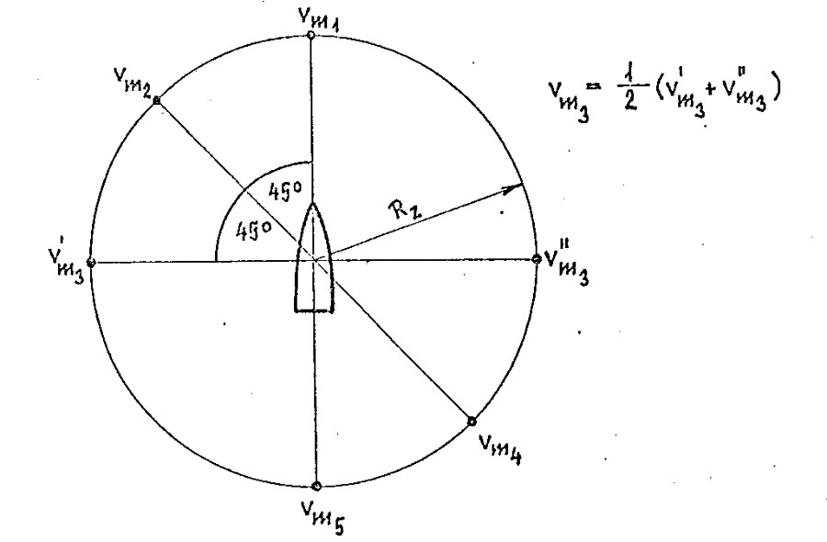

Figure 4.1 Presentation of places in circular fence where the fragment velocity is measured
Utilizing experimentally determined velocities 𝑣�� it is possible to determine the static initial velocities 𝑣�� in individual scattering sectors by means of linear interpolation. It holds true for the individual scattering sectors j = 1 – 19:
𝑣�� = 𝑣�1 + (� − 1)(𝑣�2 − 𝑣�1)/4.5 | for � = 1, … 5, | (19)
𝑣�� = 𝑣�3 − (10 − �)(𝑣�3 − 𝑣�2)/4.5 | for � = 6, … 9, | (20)
𝑣�� = 𝑣�3 + (� − 10)(𝑣�4 − 𝑣�3)/4.5 | for � = 10, … 14, | (21)
𝑣�� = 𝑣�5 − (19 − �)(𝑣�5 − 𝑣�4)/4.5 | for � = 15, … 19. | (22)
It is assumed for the static scattering of fragments that the fragments begin their movement from the centre of gravity of the projectile. Although this assumption is not in agreement with the reality, the accuracy of results will not be affected because the dimensions of the projectile are, in comparison to diameters of fragments efficiency, negligible.
Further it is assumed that all fragments in the jth cone move, in case of static scattering, in constant velocity. The velocity vector is tilted with respect to projectile’s positive half-axis (part of longitudinal axis beginning gat the projectile’s centre of gravity and heading towards the front part of projectile – to the fuze) by constant angle that is determined for individual cones by relation

𝜑′� =
1 (𝜑′ + 𝜑′ ) = 10� − 10 [°] for � = 1, … , 19 ,
2
� �−1

The angles 𝜑′� are called static angles of fragments scattering. The attribute “static” depicts in this case zero velocity of the projectile; the impact velocity of the projectile is thus neglected.

Density of fragments field
The density of fragment field, precisely the density of field of effective fragments, is at certain distance from the centre of explosion determined by number of effective fragments allotted to unitary area of scattering. The density of fragments field steeply decreases with increasing distance 𝑥 from the centre of explosion due to increasing scattering area and lose of fragments’ energy during their movement, i.e. drop in number of effective fragments.
Density of field of effective fragments 𝛥� in jth sector of scattering in range of 𝑥 from the centre of explosion is given by relation
𝑁�(𝑥)

𝛥�(𝑥) = 𝛺
�
, (23)
(𝑥)

where total area of fragments scattering at range 𝑥 is given by relation

𝛺� = 2𝜋𝑥2 (cos 𝜑

Probability of target elimination

�−1
- cos 𝜑
. (24)
�
)

It is assumed that for elimination (dead, serious wound) of a live target a hit by at least one efficient fragment is sufficient. Number of fragments that hit the target has character of random variable of below mentioned properties when considering at certain distance from the projectile’s centre of explosion constant density of fragment field inside individual sectors of scattering:
  - number of fragments that hit the target at certain distance from the centre of explosion depends only on the area of the target and is not affected by number of fragments the do not hit the target
  - hit probability of elementary area of the target by single fragment is big in comparison with hit probability of this area by two or more fragments.
Discrete random variable of above mentioned properties is governed by Poisson distribution according to which the probability of hit of the target by m fragments is defined by

𝑝 = 𝜀� 𝑒
�
� !

−𝜀
(25)

where 𝜀 – mean value of number of fragments that hit the target at given density of fragment field.
Variable 𝜀 is, in this case, defined as a product of fragment field density at the position of the target and reduced area of the target. It holds true, in case when the target lies inside the jth sector of scattering at the range x from the projectile’s centre of explosion and where the density of fragment field 𝛥� is defined by relation (22)
𝜀 = 𝜀�� = 𝛥� �𝑐 , (26)
where �𝑐 - area of target.
Magnitudes of the area of targets of type of live force depend on the size of part of interest and orientation of the human figure with respect to the projectile in the instant of its explosion. For evaluation of wounding effect of fragments it can be taken into account whole front standing human figure, which area of projection is about �𝑐 = 0.5 – 0.8 m2 (in dependency on type of figure and its height). For evaluation of deadly effect of fragments it is possible to take into account only vital parts of human body which area is approximately �𝑐 = 0.25 m2. The area of the target �𝑐 =
0.8 m2 was used for calculations of fragment field parameters.
Assuming that for reaching the required level of live force elimination a hit by a single effective fragment is sufficient, the probability of elimination is equal to hit probability of target area of interest by at least one effective fragment. Substituting into relation (25) � = 0 it is obtained the probability that the target will not be hit by any fragment
𝑝0 = 𝑒−𝜀 .
The probability of opposite phenomenon, i.e. hit of the target by at least single fragment, is determined by relation
𝑝1 = 1 − 𝑒−𝜀 . (27)
It is possible to express, in agreement with relation (26), the probability of the live force elimination 𝑝1 in jth sector of scattering as a function of distance from the projectile’s centre of explosion 𝑥 in the form

𝑝1�(𝑥) = 1 − 𝑒−𝛥��𝐶 . (28)
From the obtained data on elimination probability 𝑝1�(𝑥) it is possible to draw areas of differentiated target hit probability in individual scattering sectors.

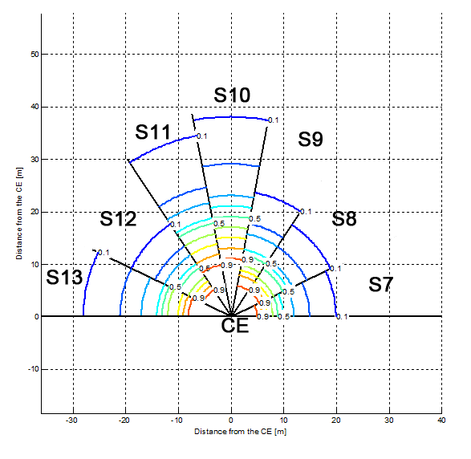

Figure 4.2 Hit probabilities in individual sectors by at least one effective fragment

4.7 Partial conclusions
Presented analytical model allows to utilise experimentally determined data from pit and arena tests for determination of fragment field parameters of interest for the HE 130 mm projectile. This model was also used for the determination of densities of field of effective fragments shown in chapter 5.

Parameters of 130 mm OF-482M projectile fragment field

Software based on the analytical model described in the chapter 4 was developed and used for the calculation of characteristics of fragments scattering after explosion of 130 mm HE projectile (Russian marking OF-482M). Following data were used for the calculation:
  - number of fragments in individual mass classes Nr (see Table 5.1 - Table 5.8),
  - total number of fragments heavier than 0.5 g N0.5 (see Table 5.1– Table 5.8),
  - total number of fragments lighter than 0.5 g Nto0.5 (see Table 5.1– Table 5.8),
  - total mass of fragments in individual mass classes mr, replaced with mean value of mass class,
  - velocities of fragments vmk (see Table 5.1– Table 5.8),
  - number of perforations in individual sectors of the screen npj (see Table 5.1– Table 5.8),
  - number of penetrations in individual sectors of the screen nzj (see Table 5.1– Table 5.8),
  - diameter of screen Rz = 15 m,
  - height of screen 2z = 3 m,
  - front area of target Sc = 0.8 m2 (front standing man),
  - drag coefficient of fragment cx = 1.0,
  - coefficient Ф = 4.8 .10-3 kg-2/3m2 (corresponds to fragments with ratio of sides 1:2:4),
  - limit specific energy of fragment eslim = 0.5 MJ.m-2,
  - angle of fall of projectile θc = 62° (it is considered instantaneous initiation of the projectile after impact).

Following tables Table 5.1 – Table 5.8 contain data experimentally obtained in 70th of last century in Czechoslovakia for the original Soviet projectiles 130 mm OF-482M. It was fired totally 14 projectiles, during the pit test 7 projectiles were fired and also 7 projectiles were fired during arena tests. From the pit tests the characteristics Nr were determined, and from the arena tests the characteristics vmk, npj and nzj were determined. Table 5.1 - Table 5.7 present data for individual projectiles, Table 5.8 presents average values for all 7 projectiles. Scattering velocities of the fragments are the same in all tables – they corresponds to average values in Table 5.8. The reason for this simplification is the deficiency of values of fragment’s velocities dispersion of individual projectiles because after the explosion of certain projectile some of the measuring targets in the screen were not hit.

Table 5.1 Fragmentation characteristics of 130 mm HE projectile No. 1

N0.5 |  | 3140 |  | PROJECTILE NO. 1
Nto 0.5 |  | 4944
Rz [m] |  | 15
2z [m] |  | 3
Nr | r=1-7 | 761 |  |  | 570 |  | 339 |  | 314 |  | 428 |  | 217 | 129
 | r=8-13 | 117 |  |  | 139 |  | 83 |  | 32 |  | 11 |  | 0
vmk [ms-1] | k=1-5 | 171 |  |  | 242 |  | 620 |  | 317 |  | 625
npj | j=1-10 | 3 | 2 |  | 0.5 | 0 | 1.5 | 0.5 | 0.5 | 5.5 | 7 | 19
 | j=11- 19 | 22.5 | 2 |  | 0 | 1 | 0 | 0 | 6 | 11 | 21
nzj | j=1-10 | 9 | 8 |  | 4.5 | 5 | 6 | 6.5 | 7.5 | 10 | 10 | 28.5
 | j=11-19 | 24 | 12.5 |  | 11.5 | 15 | 11 | 16 | 20 | 65.5 | 91

Table 5.2 Fragmentation characteristics of 130 mm HE projectile No. 2

N0.5 |  | 3303 |  | PROJECTILE NO. 2
Nto 0.5 |  | 6832
Rz [m] |  | 15
2z [m] |  | 3
Nr | r=1-7 | 821 |  |  | 595 |  | 323 |  | 345 |  | 392 |  | 323 | 140
 | r=8-13 | 85 |  |  | 175 |  | 65 |  | 25 |  | 14 |  | 0
vmk [ms-1] | k=1-5 | 171 |  |  | 242 |  | 620 |  | 317 |  | 625
npj | j=1-10 | 1 | 2.5 |  | 1.5 | 1 | 2.5 | 0.5 | 0.5 | 7.5 | 9.5 | 29
 | j=11- 19 | 23.5 | 6.5 |  | 1.5 | 0 | 0.5 | 0.5 | 2 | 13 | 21
nzj | j=1-10 | 10 | 5.5 |  | 7 | 3.5 | 7 | 5 | 4.5 | 10.5 | 18 | 30.5
 | j=11- 19 | 35 | 22 |  | 14.5 | 19 | 11.5 | 13 | 22 | 56 | 100

Table 5.3 Fragmentation characteristics of 130 mm HE projectile No. 3

N0.5 |  | 2939 |  | PROJECTILE NO. 3
Nto 0.5 |  | 5428
Rz [m] |  | 15
2z [m] |  | 3
Nr | r=1-7 | 688 |  |  | 465 |  | 372 |  | 332 |  | 385 |  | 175 | 121
 | r=8-13 | 119 |  |  | 152 |  | 82 |  | 31 |  | 17 |  | 0
vmk [ms-1] | k=1-5 | 171 |  |  | 242 |  | 620 |  | 317 |  | 625
npj | j=1-10 | 1 | 2 |  | 1.5 | 1.5 | 0 | 1.5 | 2 | 6.5 | 6 | 25.5
 | j=11- 19 | 22.5 | 5.5 |  | 1 | 0 | 0 | 0 | 0 | 6.5 | 22
nzj | j=1-10 | 10 | 10 |  | 10 | 5 | 2.5 | 4.5 | 4 | 14 | 12 | 24.5
 | j=11- 19 | 31.5 | 12.5 |  | 11.5 | 14 | 11 | 10.5 | 23 | 46 | 100

Table 5.4 Fragmentation characteristics of 130 mm HE projectile No. 4

N0.5 |  | 2998 |  | PROJECTILE NO. 4
Nto 0.5 |  | 5657
Rz [m] |  | 15
2z [m] |  | 3
Nr | r=1-7 | 725 |  |  | 465 |  | 289 |  | 345 |  | 467 |  | 200 | 148
 | r=8-13 | 128 |  |  | 114 |  | 70 |  | 29 |  | 18 |  | 0
vmk [ms-1] | k=1-5 | 171 |  |  | 242 |  | 620 |  | 317 |  | 625
npj | j=1-10 | 1 | 2 |  | 1.5 | 0 | 1 | 1.5 | 0.5 | 7.5 | 7.5 | 27
 | j=11- 19 | 23 | 2.5 |  | 2 | 0 | 0 | 0 | 0.5 | 8 | 22
nzj | j=1-10 | 10 | 8 |  | 6.5 | 4 | 5 | 7 | 8 | 11.5 | 15.5 | 33
 | j=11- 19 | 33 | 16.5 |  | 10.5 | 16.5 | 16.5 | 14.5 | 16 | 79.5 | 128

Table 5.5 Fragmentation characteristics of 130 mm HE projectile No. 5

N0.5 |  | 3087 |  | PROJECTILE NO. 5
Nto 0.5 |  | 5655
Rz [m] |  | 15
2z [m] |  | 3
Nr | r=1-7 | 769 |  |  | 555 |  | 340 |  | 348 |  | 356 |  | 170 | 138
 | r=8-13 | 168 |  |  | 133 |  | 68 |  | 37 |  | 5 |  | 0
vmk [ms-1] | k=1-5 | 171 |  |  | 242 |  | 620 |  | 317 |  | 625
npj | j=1-10 | 2 | 2 |  | 2 | 1 | 1 | 2 | 1 | 8.5 | 6.5 | 37.5
 | j=11- 19 | 21.5 | 3 |  | 0 | 1 | 0.5 | 0 | 1 | 12 | 19
nzj | j=1-10 | 9 | 13 |  | 7.5 | 5.5 | 8 | 6 | 6 | 12.5 | 19.5 | 36.5
 | j=11- 19 | 32.5 | 19.5 |  | 23.5 | 20 | 15 | 13 | 23 | 53 | 134

Table 5.6 Fragmentation characteristics of 130 mm HE projectile No. 6

N0.5 |  | 3050 |  | PROJECTILE NO. 6
Nto 0.5 |  | 5570
Rz [m] |  | 15
2z [m] |  | 3
Nr | r=1-7 | 690 |  |  | 567 |  | 377 |  | 331 |  | 332 |  | 226 | 125
 | r=8-13 | 150 |  |  | 152 |  | 64 |  | 28 |  | 8 |  | 0
vmk [ms-1] | k=1-5 | 171 |  |  | 242 |  | 620 |  | 317 |  | 625
npj | j=1-10 | 2 | 1.5 |  | 0 | 0 | 0 | 0.5 | 1.5 | 7.5 | 9.5 | 33
 | j=11- 19 | 19.5 | 5 |  | 0.5 | 1.5 | 0 | 0 | 2.5 | 13 | 21
nzj | j=1-10 | 9 | 7.5 |  | 5 | 2.5 | 5 | 7 | 9 | 15.5 | 15.5 | 39
 | j=11- 19 | 37.5 | 16 |  | 10.5 | 24 | 22 | 17 | 24 | 64 | 134

Table 5.7 Fragmentation characteristics of 130 mm HE projectile No. 7

N0.5 |  | 3014 |  | PROJECTILE NO.7
Nto 0.5 |  | 5198
Rz [m] |  | 15
2z [m] |  | 3
Nr | r=1-7 | 747 |  |  | 480 |  | 328 |  | 334 |  | 380 |  | 228 | 130
 | r=8-13 | 151 |  |  | 105 |  | 82 |  | 34 |  | 15 |  | 0
vmk [ms-1] | k=1-5 | 171 |  |  | 242 |  | 620 |  | 317 |  | 625
npj | j=1-10 | 2 | 2 |  | 2.5 | 0.5 | 0.5 | 1 | 1 | 7 | 10.5 | 21.5
 | j=11- 19 | 20 | 4.5 |  | 2 | 1 | 0 | 1 | 2 | 11 | 33
nzj | j=1-10 | 5 | 4 |  | 11 | 5.5 | 3.5 | 5 | 7 | 14.5 | 13 | 36
 | j=11- 19 | 31.5 | 17 |  | 18 | 18.5 | 15.5 | 13.5 | 30.5 | 90 | 127

Table 5.8 Average fragmentation characteristics of 130 mm HE projectiles No. 1 – 7

N0.5 |  | 3076 | Average OF 7 PROJECTILES
Nto 0.5 |  | 5612
Rz [m] |  | 15
2z [m] |  | 3
Nr | r=1-7 | 743 |  | 528 |  | 338 |  | 336 |  | 391 |  | 220 | 133
 | r=8-13 | 131 |  | 139 |  | 73 |  | 31 |  | 13 |  | 0
vmk [ms-1] | k=1-5 | 171 |  | 242 |  | 620 |  | 317 |  | 625
npj | j=1-10 | 1.7 | 2 | 1.3 | 0.6 | 1 | 1.1 | 1 | 7.3 | 8.1 | 27.9
 | j=11- 19 | 21.8 | 4.2 | 1 | 0.7 | 0.2 | 0.2 | 2 | 10.7 | 22.7
nzj | j=1-10 | 8.9 | 8 | 7.4 | 4.6 | 5.3 | 5.8 | 6.6 | 12.7 | 14.8 | 32.6
 | j=11- 19 | 32.4 | 16.6 | 14.3 | 18.2 | 14.7 | 14.1 | 22.6 | 64.7 | 116.3

Note: Data presented in Table 5.8 is average value from 7 entries shown in Table 5.1 - Table 5.7 and introduces thus the average projectile.
It is not possible to compare the above mentioned characteristics due to differences in the Czech and Serbian methodology of fragmentation characteristics determination. It is possible only in

case of mass distribution (Table 5.9). The Table 5.9 compares the characteristics of mass distribution from the Czech tests (first three rows) and from Serbian test (last row Nr*). It follows from the mentioned magnitudes that the total number of fragments is lower at the Serbian test in comparison with the Czech tests (in case of fragments of mass lower than 0.5 g is the number 4817
/ 5612, in case of fragments of mass higher than 0.5 g is the number 2617 / 3076). The numbers of fragments obtained from the Serbian test do not reach even the minimal magnitudes of fragment numbers obtained from the Czech tests in half of higher mass classes. Last two mass classes are not completely comparable, because their borders are defined differently in corresponding methodologies.
Following tables show calculated magnitudes of fragment field densities in individual ranges from 1 m up to 30 m. Due to further use of these results (comparison of real fragment field densities obtained from the analysis of fragment wounds inflicted on victims’ bodies and from experiments) the total number of fragments that is equal to sum of number of fragments of mass lower than 0.5 g and also number of fragments of mass higher than 0.5 g is taken into account for the calculation. The fragments considered as ineffective for the evaluation of projectile’s fragmentation effect were thus taken into account for the calculation of fragment field densities.

Table 5.9 Comparison of number of fragments in individual mass classes (Nr – average magnitudes of 7 experiments according to Czech methodology, Nrmax a Nrmin – max. and min. magnitudes at individual projectiles according to Czech methodology, Nr* - magnitudes from 1 experiment according to Serbian methodology); in colour are emphasized comparable values

r = | 0 | 1 | 2 | 3 | 4 | 5 | 6 | 7 | 8 | 9 | 10 | 11 | 12 | 13 | ∑(1-13)
Nr | 5612 | 743 | 528 | 338 | 336 | 391 | 220 | 133 | 131 | 139 | 73 | 31 | 13 | 0 | 3076
Nrmax | 6832 | 821 | 595 | 377 | 348 | 467 | 323 | 148 | 168 | 175 | 83 | 37 | 18 | 0 | -
Nrmin | 4944 | 688 | 465 | 289 | 314 | 332 | 170 | 121 | 85 | 105 | 64 | 25 | 5 | 0 | -
Nr* | 4817 | 503 | 503 | 210 | 281 | 363 | 250 | 107 | 127 | 145 | 81 | 25 | 16 | 6 | 2617

Figure 5.1 shows fragments randomly found near the CE after explosions of 130 mm HE projectiles during experiments at Nikinci. Typical fragments created during uncontrolled disintegration of steel homogeneous body of an artillery projectile were found.

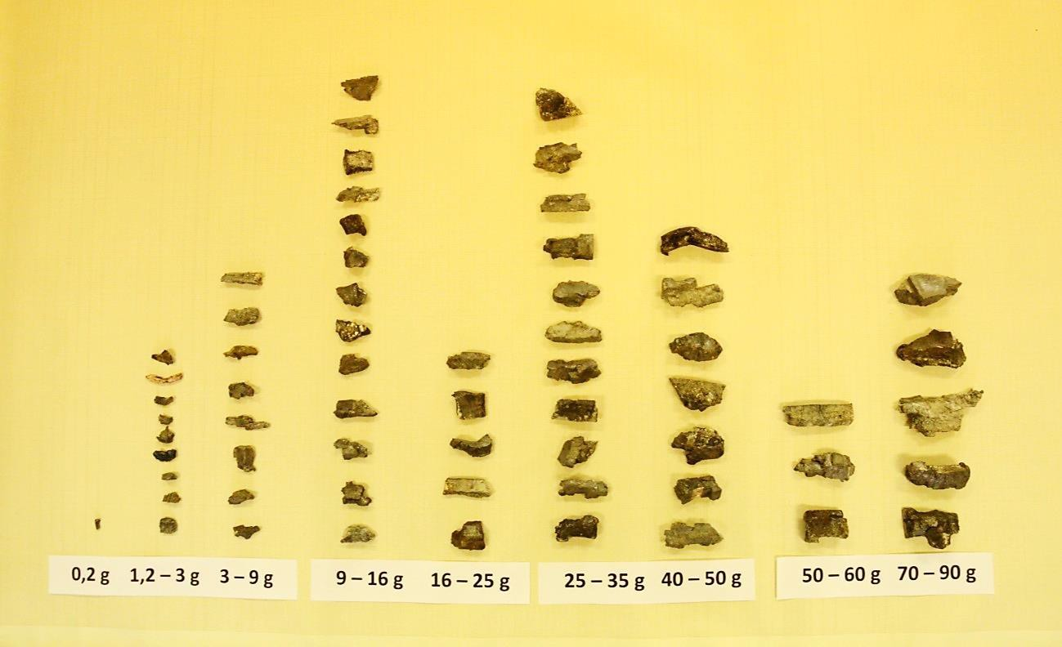

Figure 5.1 Fragments found after the explosion 130 mm projectiles at Nikinci test centre

Result of the calculation are theoretical densities of fragment field (numbers of effective fragments on unit of scattering area) in ranges of interest for individual scattering sectors. Calculated densities are presented in Table 5.10. These densities are doubled and thus the possibility of ricochets of fragments from solid surface of the ground in close proximity of the centre of explosion is incorporated (cobblestones at Kapija square).

The fragmentation effect of the projectile on its surroundings is limited on 7 scattering sectors S7
– S13 in case of angle of fall 62° (see Figure 5.2). Fragments from these sectors can hit the targets at horizontal plane. Fragments from the front sectors S1 – S6 move forward to the ground and enters the ground, or in case of surface covered with the cobblestones they ricochet from them. The fragments from the rear sectors S14 – S19 move upwards and backwards and their effect on live targets on the ground is minimal. To take into account the ricochets from the ground the theoretical densities presented in following table, Table 5.10, were doubled.

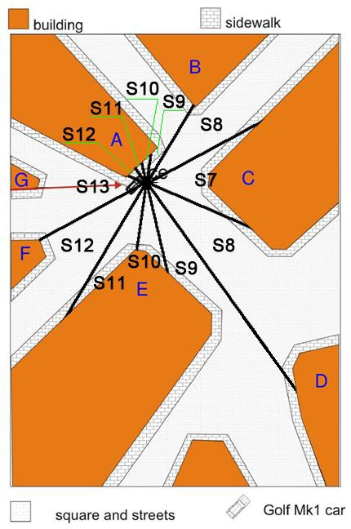

Figure 5.2 Placement of sectors S7 – S13 on the Kapija square
It follows from the Figure 5.2 that the most effective parts of the projectile’s fragments field, i.e. scattering sectors S9 – S11 – the side spray, were oriented into surrounding buildings – on the left side into building A (2 – 6 m away from the CE) and on the right side into building E (12 – 20 m away from the CE). Fragments of these sectors (the only exception was the right part of the sector
9) were not able to cause any wounds at longer distances from the CE.

Table 5.10 Double densities Hp of field of effective fragments [number of fragments/m2] in individual scattering sectors S7 – S13 and ranges from 1 up to 30 m (densities are determined for all fragments and specific limit energy 0.5 MJ.m-2)

Range [m] | 1 | 2 | 3 | 4 | 5 | 6 | 7 | 8 | 9 | 10 | 11 | 12 | 13 | 14 | 15
S7 | 741 | 185 | 82 | 46 | 30 | 21 | 5.4 | 4.1 | 3.2 | 2.6 | 2.2 | 1.8 | 1.6 | 1.3 | 1.2
S8 | 509 | 127 | 57 | 32 | 20 | 14 | 10 | 8.0 | 6.3 | 5.1 | 4.2 | 1.3 | 1.1 | 0.92 | 0.80
S9 | 595 | 149 | 66 | 37 | 24 | 17 | 12 | 9.3 | 7.3 | 5.9 | 4.9 | 4.1 | 3.5 | 3.0 | 2.6
S10 | 1440 | 360 | 160 | 90 | 58 | 40 | 29 | 23 | 18 | 14 | 12 | 10 | 8.5 | 7.3 | 6.4
S11 | 1347 | 337 | 150 | 84 | 54 | 37 | 27 | 21 | 17 | 13 | 11 | 9.4 | 8.0 | 6.9 | 6.0
S12 | 600 | 150 | 67 | 38 | 24 | 17 | 12 | 9.4 | 7.4 | 6.0 | 5.0 | 4.2 | 3.6 | 1.1 | 0.94
S13 | 1556 | 389 | 173 | 97 | 62 | 43 | 32 | 24 | 19 | 5.5 | 4.6 | 3.8 | 3.3 | 2.8 | 2.4
Range [m] | 16 | 17 | 18 | 19 | 20 | 21 | 22 | 23 | 24 | 25 | 26 | 27 | 28 | 29 | 30
S7 | 0.78 | 0.69 | 0.61 | 0.55 | 0.50 | 0.45 | 0.32 | 0.29 | 0.27 | 0.25 | 0.23 | 0.21 | 0.20 | 0.18 | 0.17
S8 | 0.70 | 0.62 | 0.56 | 0.50 | 0.45 | 0.41 | 0.37 | 0.26 | 0.24 | 0.22 | 0.20 | 0.19 | 0.17 | 0.16 | 0.12
S9 | 0.82 | 0.73 | 0.65 | 0.58 | 0.53 | 0.48 | 0.44 | 0.40 | 0.37 | 0.34 | 0.31 | 0.29 | 0.27 | 0.19 | 0.18
S10 | 5.6 | 5.0 | 4.4 | 1.4 | 1.3 | 1.2 | 1.1 | 0.96 | 0.89 | 0.82 | 0.75 | 0.70 | 0.65 | 0.61 | 0.57
S11 | 5.3 | 1.7 | 1.5 | 1.3 | 1.2 | 1.1 | 0.99 | 0.90 | 0.83 | 0.76 | 0.71 | 0.65 | 0.61 | 0.43 | 0.40
S12 | 0.83 | 0.74 | 0.66 | 0.59 | 0.53 | 0.48 | 0.44 | 0.40 | 0.37 | 0.26 | 0.24 | 0.22 | 0.21 | 0.19 | 0.18
S13 | 2.2 | 1.9 | 1.7 | 1.5 | 1.0 | 0.95 | 0.86 | 0.79 | 0.73 | 0.67 | 0.62 | 0.44 | 0.41 | 0.38 | 0.36

Magnitudes presented in Table 5.10 are used for comparison of real and theoretical effects of fragments.
The authors of this report could also use characteristics of fragmentation of 130 mm OF-482M projectile determined in the 2011 in accordance with Serbian methodology (arena and pit tests). This set of data is not suitable for the analysis of effect of projectile at Kapija square because the set of arena test data is based on perpendicular position of the projectile with respect to the ground (angle of fall 90°) but the supposed angle of fall is 62°. This results can be used only for approximate comparison of projectile’s effect of fragments (see chapter 6.3) that is relatively far from the reality.

Analysis of wounds inflicted on victims of Tuzla’s massacre

With the use of available information, especially brief photographic documentation from the post- mortem examination of victims’ dead bodies, experimentally obtained fragmentation characteristics of 130 mm HE projectile, effects of fragments from this projectile on substitute targets analysed during experiments in test centre Nikinci, the qualitative and quantitative analysis was carried out. Qualitative analysis verbally presented in paragraphs of following sub- chapter 6.2. This sub-chapter is followed by the quantitative which results are presented in sub- chapter 6.3 in Table 6.2 and Table 6.4 together with the verbal description. With respect to the specialisation of the authors of this report the emphasis is laid on the wound ballistic and technical criteria and not on the medical criteria during the analysis.

Victims overview
Totally 71 persons (60 man, 10 woman, and 1 child) died at Tuzla’s massacre. It was possible to define, on basis of surviving witnesses’ testimonies, positions of more than a half of victims at Kapija square at the moment of explosion. It was not possible to determine neither position at Kapija square, nor the distance from the CE for some victims. The Table 6.1 contains list of 37 victims with known position with respect to the CE. The table contains identification number, name, sex, and distance of victim from the CE Dex in metres determined from the testimonies of witnesses surviving the massacre.

Table 6.1 Overview of victims with known distance from the CE

No. | Surname, first name | Sex | Dex
3 | Hasanovic Senad | M | 3
4 | Ramic Fahrudin | M | 15
5 | Marinovic Pera | F | 18
6 | Mostačevič Saban | M | 4
12 | Djapo Amir | M | 7
13 | Djuzel Amir | M | 15
18 | Vukovic Mustafa | M | 11
19 | Hujdurovic Adnan | M | 6
24 | Kalesic Sandro | M | 18
25 | Hodzic Nedim | M | 8
26 | Boric Indira | F | 16
27 | Mehanovic Sulejman | M | 6
28 | Kurbasic Damir | M | 6
29 | Tadic Ilinka | F | 17
30 | Nuhanovic Selma | F | 5
31 | Mehmedovic Edin | M | 8
35 | Bosnjakovic Ilvana | F | 5
36 | Alispahic Admir | M | 3
37 | Rosic Jasminko | M | 6
39 | Mujic Samir | M | 3
40 | Rahmani Raif | M | 28
41 | Jahic Almir | M | 17
43 | Mujbasic Azur | M | 9

No. | Surname, first name | Sex | Dex
48 | Markovic Nenad | M | 9
49 | Hakic Hemdija | M | 17
50 | Stjepanovic Savo | M | 30
54 | Ponjavic Rusimiir | M | 10
55 | Hidanovic Alem | M | 8
57 | Kurbegovic Vanja | F | 5
58 | Stojicic Jelena | F | 16
59 | Hrustanovic Hasan | M | 4
60 | Hadzic Ago | M | 8
61 | Causevic Selma | F | 8
63 | Milic Adrijana | F | 8
64 | Cirak Samir | M | 16
66 | Murselovic Elvir | M | 17
71 | Ninic Dijana | F | 17

Qualitative wounds analysis
The basis for this analysis was the photographic documentation from the post mortem examination of victims’ bodies carried out by forensic examiners from the May 1995 that was part of the official case documentation. Information value of these documents lowers low quality of pictures and also the fact that number of serious wounds is not photographically documented in detail at most victims – especially victims No. 10, 20, 31, 40, 55, and 60. There are apparent different levels of wounds caused by explosion from hit by a single fragment, through multiple fragment wounds, massive tissue blow offs, to total body devastations at individual victims.
The number of abnormalities follows from the analysis of individual victim’s wounds:
    - uneven distribution of fragments’ hits on victims’ bodies that is in conflict with standard effect of artillery high-explosive projectile, especially at longer distances,
    - hits on victims’ bodies from more directions, which is unusual after explosion of a single projectile,
    - extremely devastating wounds on bodies of some victims that do not correspond to the wound potential of 130 mm artillery projectile,
    - skin and cloth begriming (charring) on some victims that is difficult to explain. Details to individual above mentioned points:
- uneven distribution of fragments’ hits on victims’ bodies showed by local hits of certain parts of bodies by higher number of fragments, while other parts of body were hit by minimal number of fragments or were not hit at all. This anomaly was observed at higher or lower extent on victims No. 3, 6, 10, 11, 14, 22, 26, 28, 30, 36, 42, and 61. Uneven cover of some bodies by fragments could be caused besides other things by partial shielding of victim’s body by random obstacles (furniture, building walls, car), by shielding by other people present at square, or also by victim’s position at the instant of explosion (e.g. sitting,, kneeling, bending,
...). Covering of all above mention victims, or their different position during the explosion (from the prone position) are highly improbable causes of this anomaly.

- hits on victims’ bodies received from more directions are apparent at victims No. 2, 5, 6, 7, 12, 13, 14, 22, 25, 33, 46, 55, and 61. The assessment of this phenomenon can be distorted by the

fact that it is not possible to unequivocally identify penetrations and perforations caused by fragments from the available photo documentation and plots of wounds.

- many victims’ bodies show extremely devastating wounds, often sharply bordered that are not typical for wounds caused by fragments, resp. wounds caused by explosion of HE projectile. Especially victims, found at longer distance away from the centre of explosion, show serious wounds that are very difficult to explain. Namely it is possible to state:
  - relatively large number of extreme wounds accompanied by massive tissues losses (victims No. 2, 10, 20, 23, 31, 32, 33, 37, 43, 45, 47, 50, 55, 57, and 61),
  - numerous devastating wounds on lower limbs, e.g. victims No. 1, 7, 13, 14, 22, 30, 34, 35, 38, and 39,
  - traumatic amputations of both lower limbs (35 and 39),
  - traumatic amputations of both upper limbs (33 and 37),
  - extreme head wounds, side, and lower limb of victim No. 57, there are not apparent hits by fragments on the body (typical effect of IED with explosives placed into container that does not create fragments); the artillery projectile cannot cause these wounds to live target because the target must be in close proximity to the CE to suffer the wounds from the shock wave and thus must be also hit by fragments over whole body because the density of fragment field at these distances is extremely high (hundreds of fragments per square meter),
  - extreme head wound of victim No. 58, although the body does not show any hit by fragments,
  - victim No. 45 shows extensive open wound of thorax and abdominal cavity,
  - victim No. 37 shows separation of
  - victim No. 11 shows total head devastation,
  - victims No. 53, 56, and 62 suffered total devastation of entire body, similarly like a suicide bombers; the distance from the centre of explosions is not known for these victims – but extent of their wounds corresponds to the close proximity from the CE,
  - total devastation of body of victim No. 63 that was 8 m away from the CE – this effect is excluded with respect to the character of fragments scattering and the effect of shock wave created by explosion of nearly 4 kg of explosives,
  - total devastation of entire body of victim No. 64 that was 16.5 m away from the CE – this effect is totally excluded due to reasons given above.
Extreme wounds of victims accompanied by significant soft tissue losses can be caused either by effect of the shock wave or by big and heavy fragments. Heavy fragments of mass of 50 g and more are represented in fragment swarm relatively rarely – explosion of 130 mm projectile creates about 100 fragments of mass of higher than 50 g (10th – 13th mass class), i.e. approx. 2 % of all fragments and approx. 3 % of all effective fragments. Hit probability by this fragment is thus very low, besides other things due to fact that big fragments arise especially at rear part of 130 mm projectile and after explosion of the projectile move backwards approximately in the direction of projectile’s longitudinal axis (askew upwards against projectile motion direction) out of area of interest. These fragments could not hit victims at Tuzla’s Kapija square.
- many victims suffered skin and cloth begriming (charring) by black agent on some body parts (victims No. 2, 3, 6, 14, 16, 34, 35, 44, 52, 55, 60, and 63). This begriming can be caused either by dispersion of a dirt from the place of explosion (improbable variant), or scorching and charring of bodies during the explosion. The second variant can be taken into account only in case when the victim is not too far from the place of explosion of projectile, i.e. in the reach of fireball and smoke products of explosive charge detonation (approximately 3 m). But it is

excluded at number of begrimed victims. After this it can be taken into account begriming by explosion of other explosive device containing a non-standard explosive (e.g. ANFO - ammonium nitrate/fuel oil).
Large number of victims does not correspond to explosion of a single medium calibre artillery projectile besides other things due to:
  - it is supposed that the projectile exploded after impact in close proximity of parked car, that would acted as protecting shield against fragments of lower kinetic energy; death of victims No. 43 and 48 standing behind the car is therefore in conflict with presumptions,
  - the centre of explosion was at the same time very close to the brick building that would also shielded the swarm of fragments by its solid walls,
  - the projectile exploded at open space, which also limited the effect of shock wave on the live targets,
  - relatively small space between buildings at Kapija square and in adjacent streets do not allowed gathering of large number of people. Number of people at Kapija square in the time of explosion, according to the prosecution 1000 – 1500 people, does not seem to be realistic, see illustrative Figure 3.2 from experiment in Nikinci. Total area of the square (including the corresponding street mouths) is about 1200 m2, which means for the assumed 1000 – 1500 people presented at the time of explosion average density 1 person per square meter. This density is rather characteristic for election meeting than for a Friday evening when the people have a good time in separate groups on streets in front of cafés. There is also limited pass through the square at this density.
  - in case of admitting that above mentioned number of people was present at Kapija square in the time of explosion, the people close to the CE would act as human shields and this fact would exclude killing of people at longer distance away from the CE. A heavy fragment of high kinetic energy is capable to perforate two or more bodies but there is only a relatively small number of such fragments in the swarm of fragments.
  - the lethal zone covered by deadly fragments is relatively small, limited by walls of close buildings, in particular sectors covered by very efficient side spray moving from the CE left and right horizontally (related to the direction of assumed projectile’s plane of arrival). If an artillery projectile hits the square with angle of arrival of 62° than the fragments from the rear part (heading towards the VW Golf Mk I) of side spray hit the ground (they would probably ricochet from ground into car VW Golf Mk I). Fragments from the front part (heading towards the Kapija square) of side spray would move upwards (their effect is apparent on upper part of facade of model building E).
  - in side sectors is the efficiency of the fragment field maximal and lives of people present here would be extremely endangered by fragments of the artillery projectile. While there was quite a few people in the sector of right side spray, the left side spray was oriented nearly entire into the building A (NIK store building).
  - fragments of the right part of the side spray hit the area of corner of building and Café Leonardo in Partizanska Street. There surprisingly survived approximately 8 people in the range up to 10 m from the CE at three the most effective right side spray sectors (approximately 40 people survived in the range up to 10 m from the CE).
  - fragments of the left part of the side spray effect hit the wall of NIK store building, mouth of street of Mustafe Mujbegoviča and opposite building with payphone. There was presented only a minimum of people in this direction because there was not any café (totally 4 people were killed in this direction).

  - there were many killed victims in close proximity of the building’s corner towards Samoizbor and Caffé Gulam (totally 8 victims), in the direction of projectile’s axis with relatively low efficiency of projectile’s fragment field,
  - the killing of 8 people in the direction towards Caffé Kapija is apparently unrealistic; 8 people were killed at the distance over 20 m from the CE and near the Caffé Kapija, which is out of capability of 130 mm HE projectile.
Summarizing results of qualitative analysis it can be stated that from total 71 killed victims of the massacre no anomaly was observed only at 26 victims, i.e. 37 % of victims. At remaining 45 victims (63 %) some of the above mentioned anomalies were observed. At 18 victims the anomalies found were multiple. This is unusually high number that does not confirm prosecution’s version of cause of deadly wounds documented at Kapija square in May 1995.

Quantitative wounds analysis
The quantitative analysis of wounds is based on enumeration of quantitative indexes of fragment effects and their mutual comparison. The quantitative analysis was carried out only for victims of known position with respect to the assumed centre of explosion (totally 37 victims).
On the basis of results of qualitative assessment the model of quantitative assessment of wounds, based on partial quantification of individual types of anomalies, was created. Index of wounds anomalies i, defined by below mentioned sum, was chosen for the quantification
�=1 �� ,
� = ∑
5
where ik - partial indexes of wound anomalies enumerated according to five chosen criterions. Each index can reach whole number from 1 (state without any recorded anomalies) up to maximum (corresponding to non-standard, very anomalous findings); partial indexes are defined in a following way:
    - index i1 – level of uneven cover of victim by fragment hits (i1 = 1 - 3),
    - index i2 – level of victim’s hit by fragments from multiple directions (i2 = 1 - 3),
    - index i3 – level of agreement of victim’s wounds, efficiency of projectile, and position of victim with respect to the CE (i3 = 1 - 5),
    - index i4 – level of begriming of victim’s body surface (i4 = 1 - 5),
    - index i5 – level of agreement of real fragment density with theoretical density with respect to the victim’s position (i5 = 1 - 10).
Indexes i1 – i4 were enumerated with the use of information from chapter 6.1 and are shown in Table 6.4. It is apparent that the enumeration of these indexes is affected by the subjective approach of authors.
It was necessary to determine quantitative indexes of fragment effect and carried out their mutual comparison for determination of the index i5 for individual victims. Number of fragment hits in victims’ bodies, or density of field of effective fragments were chosen as a basic comparative parameter. Approximate numbers of real fragment hits NS at victims’ bodies were determined from the available victims photo documentation. Symbol no* marks victims for which it was not possible to determine number of fragment hits due to extremely devastating wounds. Densities HS were calculated with the use of estimated area of victims’ bodies that were hit by fragments.
Magnitudes of theoretical density of fragment field HP were calculated with the use of the analytical model described in chapter 4. Following values were taken as input parameters for that model:
    - angle of arrival 62° (this angle defines position of the projectile at the time of explosion),

    - fragmentation characteristics for the 130 mm HE projectile determined experimentally according to the Czech methodology in 70’s of last century in the former Czechoslovakia (details in chapter 4). All fragments, including fragments of mass lower than 0.5 g considered as potentially ineffective, were taken into calculation,
    - specific limit energy as a criterion of “resistivity” of the live target against effect of fragments is taken into account with magnitude 0.5 MJ.m-2, i.e. one half of the standard (lowering target resistivity means increasing the density of the fragment field in practice).

Magnitudes of HP presented in table are taken over from the table of resulting densities (Table 7.1). Calculated densities were utilized for determination of theoretical number of fragment victims hits Np.
The Table 6.2 shows magnitude of Nf, i.e. numbers of hits in individual dolls that were used as substitute of victims at Nikinci’s experiments.
On basis of knowledge of fragment field of 130 mm HE projectile parameters the theoretical (calculated) densities of fragment field Hp, in places where the victims were situated at time of the explosion, were calculated. For each victim, in dependency on its position with respect to the centre of explosion, the scattering sector (corresponding to the projectile’s angle of arrival), where the victim was situated, was determined. The theoretical (calculated) density of fragment field Hp was determined for this scattering sector and defined distance from the centre of explosion Dex.
Following Table 6.2 contains magnitudes of Nf, i.e. numbers of hits in individual dolls that were used as victims substitutes at Nikinci experiments. Totally 37 dolls were used, 7 of them was damaged during the projectile’s explosion by the shock wave or the fragments in such a way that it was not possible to appraise the number of hits Nf. The letter D is used instead of number of hits at these dolls.
The ratios Hs/Hp = Ns/Np and Ns/Nf were calculated for comparison of fragments effect on victims, theoretical model, and experiments. The ratios are presented in last two columns of the Table 6.2. The average magnitude of the ratio Ns/Np is 9.1, i.e. the victims were hit, on average, by nine times higher number of fragments than predicted by the theoretical model. The average magnitude of the ratio Ns/Nf is 3.1, i.e. the assessed victims were hit, on average, by three times higher number of fragments than their corresponding dolls during the experiment.

Table 6.2 Overview of selected victims with characteristics of fragmentation effect

No. | Dex | SB | SF | Ns | Np | Hs | Nf | Si | Hp | Hs/Hp | Ns/Nf
3 | 3 | 0.4 | 0.82 | 25 | 9.6 | 63 | D | 12 | 67 | 0.9 | -
4 | 15 | 0.6 | 0.82 | 1 | 0.4 | 1.7 | - | 8 | 0.8 | 2.1 | -
5 | 18 | 0.2 | 0.66 | 6 | 0.1 | 30 | 1 | 9 | 0.65 | 46.2 | 6.0
6 | 4 | 0.7 | 0.82 | 25 | 9.1 | 36 | D | 12 | 36 | 1.0 | -
12 | 7 | 0.8 | 0.82 | 10 | 9.6 | 13 | D | 10 | 29 | 0.43 | -
13 | 15 | 0.6 | 0.82 | 10 | 1.4 | 17 | 26 | 11 | 6.0 | 2.8 | 0.4
18 | 11 | 0.7 | 0.82 | 22 | 3.3 | 31 | 23 | 10 | 12 | 2.6 | 1.0
19 | 6 | 0.7 | 0.82 | 46 | 4.0 | 66 | 8 | 7 | 21 | 3.1 | 5.8
24 | 18 | 0.3 | 0.40 | 1 | 0.1 | 3.3 | 0 | 8 | 0.56 | 6.0 | ∞
25 | 8 | 0.7 | 0.82 | 10 | 2.2 | 14 | 2 | 7 | 4.1 | 3.5 | 5.0
26 | 16 | 0.2 | 0.66 | 3 | 0.2 | 15 | - | 9 | 0.82 | 18.3 | -
27 | 6 | 0.6 | 0.82 | 5 | 9.6 | 8.3 | D | 10 | 40 | 0.2 | -
28 | 6 | 0.7 | 0.82 | 7 | 11 | 10 | 4 | 10 | 40 | 0.3 | 1.8

No. | Dex | SB | SF | Ns | Np | Hs | Nf | Si | Hp | Hs/Hp | Ns/Nf
29 | 17 | 0.6 | 0.66 | 5 | 0.5 | 8.3 | 2 | 9 | 0.73 | 11.4 | 2.5
30 | 5 | 0.7 | 0.66 | 15 | 5.7 | 21 | 3 | 7 | 30 | 0.7 | 5.0
31 | 8 | 0.8 | 0.82 | 7 | 7.1 | 8.8 | D | 10 | 23 | 0.38 | -
35 | 5 | 0.7 | 0.66 | 17 | 5.5 | 24 | - | 8 | 20 | 1.2 | -
36 | 3 | 0.8 | 0.82 | 70 | 46 | 88 | - | 11 | 150 | 0.6 | -
37 | 6 | 0.7 | 0.82 | 12 | 4.0 | 17 | 1 | 7 | 21 | 0.8 | 12.0
39 | 3 | 0.6 | 0.82 | 30 | 38 | 50 | D | 10 | 160 | 0.3 | -
40 | 28 | 0.5 | 0.82 | 4 | 0.05 | 8.0 | - | 8 | 0.17 | 47.1 | -
41 | 17 | 0.6 | 0.82 | 2 | 0.2 | 3.3 | 1 | 8 | 0.62 | 5.4 | 2.0
43 | 9 | 0.8 | 0.82 | 10 | 4.1 | 13 | - | 13 | 19 | 0.7 | -
48 | 9 | 0.5 | 0.82 | 8 | 2.6 | 16 | - | 13 | 19 | 0.8 | -
49 | 17 | 0.6 | 0.82 | 4 | 0.5 | 6.7 | 3 | 9 | 0.73 | 9.1 | 1.3
50 | 30 | 0.2 | 0.82 | 2 | 0.02 | 10 | - | 8 | 0.12 | 83.3 | -
54 | 10 | 0.6 | 0.82 | 10 | 1.4 | 17 | 7 | 9 | 6.0 | 2.8 | 1.4
55 | 8 | 0.6 | 0.82 | 8 | 1.9 | 13 | 5 | 7 | 4.1 | 3.3 | 1.6
57 | 5 | - | 0.66 | no* | 0 | ne* | 5 | 7 | 30 | ne | -
58 | 16 | - | 0.66 | no* | 0 | ne* | - | 8 | 0.7 | ne | -
59 | 4 | 0.8 | 0.82 | 6 | 29 | 7.5 | D | 10 | 90 | 0.1 | -
60 | 8 | 0.6 | 0.82 | 12 | 1.9 | 20 | 9 | 8 | 8.0 | 2.5 | 1.3
61 | 8 | 0.5 | 0.66 | 12 | 1.6 | 24 | - | 7 | 4.1 | 5.9 | -
63 | 8 | 0.8 | 0.66 | 10 | 2.6 | 13 | 0 | 7 | 4.1 | 3.0 | ∞
64 | 16 | 0.3 | 0.82 | 3 | 0.2 | 10 | 1 | 8 | 0.7 | 14.3 | 3.0
66 | 17 | 0.6 | 0.82 | 8 | 1.1 | 13 | 7 | 11 | 1.7 | 8.3 | 1.1
71 | 17 | 0.4 | 0.66 | 7 | 0.2 | 18 | 4 | 8 | 0.62 | 28.2 | 1.8

Meaning of abbreviations used in the table:
Dex – distance of victim from the CE,
Ns – approximate number of fragments that really hit victim’s body,
SB – approximate area of t victims body hit by fragments (max. considered area of body 0.8 m2),
SF – area of doll (man 0.82 m2, woman 0.66 m2),
Si – fragment scattering sector (i = 7 - 13),
Hs – real density of fragments determined from number of hits in victim’s body (Hs = Ns/SB),
Hp – theoretical (calculated) density of fragments, corresponding to victim’s position, determined by calculation with the use of model of fragment scattering,
Np – theoretical number of fragments that could hit victim’s body,
Nf – real number of fragments that hit the doll.
Comparison of magnitudes Ns and Np, i.e. calculation of ratio Ns / Np for individual victims, provides magnitudes of index i5 in accordance with Table 6.3 . Results are presented in Table 6.4.

Table 6.3 Magnitudes of anomalies indexes with respect to ratio of real and theoretical number of hits on victims

i5 = | Ns / Np
1 | less than 1
2 | 1 - 2
3 | 2 - 4
4 | 4 - 6
5 | 6 - 8
6 | 8 - 10
7 | 10 - 25
8 | 25 - 50
9 | 50 - 100
10 | more than 100

Table 6.4 Magnitudes of anomalies index of individual victims

No. | i1 | i2 | i3 | i4 | i5 | i
3 | 2 | 1 | 1 | 4 | 1 | 9
4 | 1 | 1 | 1 | 1 | 3 | 7
5 | 1 | 2 | 1 | 1 | 8 | 13
6 | 2 | 3 | 1 | 2 | 1 | 9
12 | 1 | 2 | 1 | 1 | 1 | 6
13 | 1 | 2 | 3 | 1 | 3 | 10
18 | 1 | 1 | 1 | 1 | 3 | 7
19 | 1 | 1 | 1 | 1 | 3 | 7
24 | 1 | 1 | 1 | 1 | 4 | 8
25 | 1 | 2 | 2 | 1 | 3 | 9
26 | 2 | 1 | 1 | 1 | 7 | 12
27 | 1 | 1 | 1 | 1 | 1 | 5
28 | 2 | 1 | 1 | 1 | 1 | 6
29 | 1 | 1 | 1 | 1 | 7 | 11
30 | 3 | 1 | 1 | 1 | 1 | 7
31 | 1 | 1 | 4 | 1 | 1 | 8
35 | 1 | 1 | 3 | 5 | 2 | 12
36 | 2 | 1 | 1 | 1 | 1 | 6
37 | 1 | 1 | 4 | 1 | 1 | 8
39 | 1 | 1 | 5 | 1 | 1 | 9
40 | 1 | 1 | 1 | 1 | 8 | 12
41 | 1 | 1 | 1 | 1 | 4 | 8
43 | 1 | 1 | 2 | 1 | 1 | 6
48 | 1 | 1 | 1 | 1 | 1 | 5
49 | 1 | 1 | 1 | 1 | 6 | 10
50 | 1 | 1 | 1 | 1 | 9 | 13
54 | 1 | 1 | 1 | 1 | 3 | 7
55 | 1 | 2 | 3 | 2 | 3 | 11
57 | 1 | 1 | 5 | 1 | 1 | 9
58 | 1 | 1 | 3 | 1 | 1 | 7

No. | i1 | i2 | i3 | i4 | i5 | i
59 | 1 | 1 | 1 | 1 | 1 | 5
60 | 2 | 1 | 2 | 2 | 3 | 10
61 | 2 | 2 | 3 | 1 | 4 | 12
63 | 1 | 1 | 5 | 2 | 3 | 12
64 | 1 | 1 | 3 | 1 | 7 | 13
66 | 1 | 1 | 1 | 1 | 6 | 10
71 | 1 | 1 | 1 | 1 | 8 | 12

Magnitudes of resulting anomalies index i are between 5 and 26. The colour of the cell containing the resulting index i shows difference from the normal (white colour – no anomalies found, yellow colour – insignificant anomalies found, red colour – multiple anomalies in effect of fragments found). Magnitudes of index i can be subjectively interpreted in the following way:
    - i = 5 – 7 – without apparent anomalies in victim’s wounds, standard effect of projectile,
    - i = 8 – 10 – less significant anomalies in victim’s wounds, slightly non-standard effect of projectile,
    - i = 11 – 16 - significant anomalies in victim’s wounds, non-standard effect of projectile,
    - i = 17 – 26 – very significant anomalies in victim’s wounds, excess, very non-standard effect of projectile.
Average index i is 8.9, which points to the non-standard effect of projectile on victims’ bodies. No anomalies in effect of projectile on body were recorded only at three victims (No. 27, 48, and 59) of 37 victims evaluated. On the other hand one quarter of all assessed victims was evaluated with significant anomalies.
  - Partial conclusions
Number of discrepancies and anomalies in destructive effects of explosion on some victims (fragments, shock wave, and heat impulse) follows from the analysis of victims’ wounds. There is apparent discrepancy between real numbers of fragments that hit the victims’ bodies and theoretical numbers of fragments that could hit the bodies. The real number of hits by fragments in victims’ bodies is on average 9 times higher than theoretical number of hits in victims’ bodies that resulted from the application of the analytical model of fragment scattering on the Tuzla’s Kapija square. Differences between the theory and practice deepen with increasing distance from the CE. These are signposts pointing toward fact that a different, more powerful type of ammunition or improvised explosive device, or even several smaller charges exploded at the Kapija square.
Use of nonstandard explosive confirms wounds of victims No. 53, 56, and 62 who suffered total devastation of entire body, similarly like suicide bombers. Unfortunately the distance from the centre of explosions is not known for these victims. The extent of their wounds corresponds to the close proximity from the CE.
Results of the analysis can be biased by inaccuracies due to use of incomplete information on wounds of individual victims (incomplete photo documentation, lack of verbal description of wounds, subjectivity of the assessment, …). But despite all these possible inaccuracies it is possible the results of the analysis take into consideration as a sufficiently representative sample confirming bellow presented expert statement.
On basis of available information, especially photo documentation from the post mortem examination of victims’ bodies, it is possible with respect to results of qualitative and quantitative

analysis presented in this chapter, stated that number of victims’ bodies show non-standard effects of fragments and other destructive factors of explosion that do not confirm prosecution’s conclusions that the cause of death of 71 people at Tuzla’s Kapija square on 25th May 1995 was a ground explosion of a single artillery projectile of calibre 130 mm fired from the distance of about 27 km. With respect to the results presented in this chapter it is possible to state that the fragments distribution in the area of Kapija square during the massacre is different from the fragments distributions obtained from the experiments.

7 Regression model for the fragment field density

Using the mathematical model of the fragment density [14], the theoretical values of the fragment density were obtained for the angle of departure 62°. These values are shown in Table 7.1.

Table 7.1 Theoretical fragment density with respect to the distance and sector

Distance [m] | Fragment density in sector 7 [1/m2] | Fragment density in sector 8 [1/m2] | Fragment density in sector 9 [1/m2] | Fragment density in sector 10 [1/m2] | Fragment density in sector 11 [1/m2] | Fragment density in sector 12  [1/m2] | Fragment density in sector 13  [1/m2]
1 | 732.38 | 510.97 | 595.59 | 1433.01 | 1354.69 | 603.86 | 1545.83
2 | 183.09 | 127.74 | 148.90 | 358.25 | 338.67 | 150.96 | 386.46
3 | 81.38 | 56.77 | 66.18 | 159.22 | 150.52 | 67.10 | 171.76
4 | 45.77 | 31.94 | 37.22 | 89.56 | 84.67 | 37.74 | 96.61
5 | 29.30 | 20.44 | 23.82 | 57.32 | 54.19 | 24.15 | 61.83
6 | 20.34 | 14.19 | 16.54 | 39.81 | 37.63 | 16.77 | 42.94
7 | 5.34 | 10.43 | 12.15 | 29.25 | 27.65 | 12.32 | 31.55
8 | 4.08 | 7.98 | 9.31 | 22.39 | 21.17 | 9.44 | 24.15
9 | 3.23 | 6.31 | 7.35 | 17.69 | 16.72 | 7.46 | 19.08
10 | 2.61 | 5.11 | 5.96 | 14.33 | 13.55 | 6.04 | 5.48
11 | 2.16 | 4.22 | 4.92 | 11.84 | 11.20 | 4.99 | 4.53
12 | 1.82 | 1.26 | 4.14 | 9.95 | 9.41 | 4.19 | 3.80
13 | 1.55 | 1.07 | 3.52 | 8.48 | 8.02 | 3.57 | 3.24
14 | 1.33 | 0.92 | 3.04 | 7.31 | 6.91 | 1.08 | 2.79
15 | 1.16 | 0.81 | 2.65 | 6.37 | 6.02 | 0.94 | 2.43
16 | 0.78 | 0.71 | 0.82 | 5.60 | 5.29 | 0.83 | 2.14
17 | 0.69 | 0.63 | 0.73 | 4.96 | 1.66 | 0.74 | 1.89
18 | 0.61 | 0.56 | 0.65 | 4.42 | 1.48 | 0.66 | 1.69
19 | 0.55 | 0.50 | 0.58 | 1.41 | 1.33 | 0.59 | 1.52
20 | 0.50 | 0.45 | 0.52 | 1.27 | 1.20 | 0.53 | 1.04
21 | 0.45 | 0.41 | 0.48 | 1.15 | 1.09 | 0.48 | 0.94
22 | 0.32 | 0.37 | 0.43 | 1.05 | 0.99 | 0.44 | 0.86
23 | 0.29 | 0.26 | 0.40 | 0.96 | 0.90 | 0.40 | 0.78
24 | 0.27 | 0.24 | 0.36 | 0.88 | 0.83 | 0.37 | 0.72
25 | 0.25 | 0.22 | 0.34 | 0.81 | 0.77 | 0.26 | 0.66
26 | 0.23 | 0.20 | 0.31 | 0.75 | 0.71 | 0.24 | 0.61
27 | 0.21 | 0.19 | 0.29 | 0.70 | 0.66 | 0.22 | 0.44
28 | 0.20 | 0.18 | 0.27 | 0.65 | 0.61 | 0.21 | 0.41
29 | 0.18 | 0.16 | 0.19 | 0.60 | 0.43 | 0.19 | 0.38
30 | 0.17 | 0.12 | 0.18 | 0.56 | 0.40 | 0.18 | 0.36

For the courses of the fragment densities are displayed in the Figure 7.1. It is obvious from Table
7.1 and Figure 7.1 that fragment densities differs in different sectors. For this reason the fragment density will be assessed in each individual sector separately.

1600
Sector 7
Sector 8
Sector 9
Sector 10
Sector 11
Sector 12
Sector 13

1400

1200

1000
Fragment desnity [1/m2]

800

600

400

200

0
0 5 10 15 20 25 30
Distance [m]

Figure 7.1 Theoretical fragment density with respect to the distance and sector
Because in [14] the dependence of the fragment density in given sector on the distance was not explicitly expressed, the regression model has been assumed for this purpose in the form

z = α l α1
0
, (1)

where l is the predictor variable (the distance in this case), z is the response variable (the fragment density in this case) and α0, α1 are the regression parameters.
From the coroner’s report, the real fragment densities were obtained. These real fragment densities are shown in Table 7.2 - Table 7.8.

Table 7.2 Real fragment density with respect to the distance in sector 7

Distance x [m] | Real fragment density Hs  [1/m2]
6.00 | 65.71
8.00 | 14.29
5.00 | 21.43
6.00 | 17.14
8.00 | 13.33
8.00 | 24.00
8.00 | 12.50

Table 7.3 Real fragment density with respect to the distance in sector 8

Distance x [m] | Real fragment density Hs  [1/m2]
15.00 | 1.67
18.00 | 3.33
5.00 | 24.29
28.00 | 8.00
17.00 | 3.33
30.00 | 10.00
8.00 | 20.00
16.00 | 10.00
17.00 | 17.50

Table 7.4 Real fragment density with respect to the distance in sector 9

Distance x [m] | Real fragment density Hs  [1/m2]
18.00 | 30.00
16.00 | 15.00
17.00 | 8.33
17.00 | 6.67
10.00 | 16.67

Table 7.5 Real fragment density with respect to the distance in sector 10

Distance x [m] | Real fragment density Hs  [1/m2]
7.00 | 12.50
11.00 | 31.43
6.00 | 8.33
6.00 | 10.00
8.00 | 8.75
3.00 | 50.00
4.00 | 7.50

Table 7.6 Real fragment density with respect to the distance in sector 11

Distance x [m] | Real fragment density Hs  [1/m2]
15.00 | 16.67
3.00 | 87.50
17.00 | 13.33

Table 7.7 Real fragment density with respect to the distance in sector 12

Distance x [m] | Real fragment density Hs  [1/m2]
3.00 | 62.50
4.00 | 35.71

Table 7.8 Real fragment density with respect to the distance in sector 13

Distance x [m] | Real fragment density Hs  [1/m2]
9.00 | 12.50
9.00 | 16.00

Furthermore, the experiment using the dolls has been carried out to verify the real fragment density. The obtained experimental fragment densities using the figures are shown in Table 7.9 - Table 7.13.

Table 7.9 Experimental fragment density with respect to the distance in sector 7

Distance x [m] | Experimental fragment density Hf [1/m2]
6.00 | 9.76
8.00 | 2.44
5.00 | 4.55
6.00 | 1.22
8.00 | 6.10
5.00 | 7.58
8.00 | 0.00

Table 7.10 Experimental fragment density with respect to the distance in sector 8

Distance x [m] | Experimental fragment density Hf [1/m2]
18.00 | 0.00
17.00 | 1.22
8,00 | 10.98
16.00 | 1.22
17.00 | 6.06

Table 7.11 Experimental fragment density with respect to the distance in sector 9

Distance x [m] | Experimental fragment density Hf [1/m2]
18.00 | 1.52
17.00 | 3.03
17.00 | 3.66
10.00 | 8.54

Table 7.12 Experimental fragment density with respect to the distance in sector 10

Distance x [m] | Experimental fragment density Hf [1/m2]
11.00 | 28.05
6.00 | 4.88

Table 7.13 Experimental fragment density with respect to the distance in sector 11

Distance x [m] | Experimental fragment density Hf [1/m2]
15.00 | 31.71
17.00 | 8.54

Unfortunately, the dolls in the sectors 12 and 13 were not hit.
Finally, the fragment densities in the walls were determined. Unfortunately, only six walls were used, and not all sectors were covered. The resulting fragment densities, obtained from the walls, are shown in Table 7.14.

Table 7.14 Wall fragment density with respect to the distance

Sector | Distance x [m] | Experimental fragment density Hz [1/m2]
7 | 10.00 | 3.10
8 | 18 | 1.90
8 | 21 | 1.30
9 | 16 | 1,60
10 | 7 | 21.00
13 | 12 | 1.8

The basic idea was to estimate the regression models for the individual sets of fragment densities and compare these regression models. If the regression model for the theoretical model is equal to regression model of the experimental density, it could mean that the theoretical model of the fragment density is correct. If the regression model of the theoretical fragment density is equal to regression model of the real fragment density, it could mean that the real fragment density is in accord with the theoretical fragment density. Otherwise, the real fragment density differs from the theoretical fragment density in the statistical meaning.
  - Comparison of the theoretical, real and experimental fragment densities
The comparison of the regression models is based on the comparison of the coefficient model coefficients.
To compare the regression coefficients of the individual regression models, the linearized form of the model (1) was used in form

y = β
0 1
+ β x , (2)

where y = log10 z is the response variable, β0 = log10 α0, β1 = α1, x = log10 l is the predictor variable.
The courses of the linearized regression models of the theoretical, real, experimental, and wall fragment densities are shown in Figure 7.3 - Figure 7.8.
Remark: In sectors 7 and 8 the dolls with no hit occurs, it means that the experimental fragment density was zero in these cases. Because log10 0 = -Infinity, for purpose of linearization of the regression model according to (1) the evaluated zero experimental fragment density was replace by Hf = 0.0001 = 1.10-4 1/m2. Therefore, log10(Hf) = -4 for Hf = 0, as it can be seen in Figure 7.2 and Figure 7.3.

3
theory bodies figures walls

2

1
2
Fragment desnity [log10(1/m )]

0

-1

-2

-3

-4
0 0.5 1 1.5

Distance [log
10
(m)]

Figure 7.2 Linearized fragment densities in sector 7

3
theory bodies figures walls

2

1
Fragment desnity [log10(1/m2)]

0

-1

-2

-3

-4
0 0.5 1 1.5
Distance [log10(m)]

Figure 7.3 Linearized fragment densities in sector 8

3
theory bodies figures walls

2.5

2
Fragment desnity [log10(1/m2)]

1.5

1

0.5

0

-0.5

-1
0 0.5 1 1.5
Distance [log10(m)]

Figure 7.4 Linearized fragment densities in sector 9

3.5
theory bodies figures walls

3

2.5
Fragment desnity [log10(1/m2)]

2

1.5

1

0.5

0

-0.5

0 0.5 1 1.5
Distance [log10(m)]

Figure 7.5 Linearized fragment densities in sector 10

3.5
theory bodies figures

3

2.5
Fragment desnity [log10(1/m2)]

2

1.5

1

0.5

0

-0.5

0 0.5 1 1.5
Distance [log10(m)]

Figure 7.6 Linearized fragment densities in sector 11

3
theory bodies

2.5

2
Fragment desnity [log10(1/m2)]

1.5

1

0.5

0

-0.5

-1
0 0.5 1 1.5
Distance [log10(m)]

Figure 7.7 Linearized fragment densities in sector 12

3.5
theory bodies walls

3

2.5
Fragment desnity [log10(1/m2)]

2

1.5

1

0.5

0

-0.5

-1
0 0.5 1 1.5
Distance [log10(m)]

Figure 7.8 Linearized fragment densities in sector 13
  - Estimation of the regression coefficients
The estimation of the regression coefficients β0, β1 was done using the least squares fitting method minimizing the sum of the squares of the deviations between the fitted data and the regression model [15] according to the formulas

n n n n

∑ xi yi ∑ xi
2
- ∑ xi ∑ yi

(3)

b0 =
i =1
i =1
⎛ n ⎞
2
i =1
n
i =1

⎜ ∑ i ⎟ ∑ i

x
⎝ i =1 ⎠
- n x2
i =1

n n n
n∑ xi yi − ∑ xi ∑ yi
b = i =1 i =1 i =1

(4)

1 n n ⎞2
⎛
∑ i ⎜ ∑ i ⎟

n x2 −
i =1
x
⎝ i =1 ⎠

where b0, b1 are estimations of the regression coefficients β0, β1, xi are samples of the predictor variable, yi are samples of the response variable and n is the number of samples.
Standard deviations of the regression coefficient estimations can be expressed using formulas

n
∑ xi
2

s = s2 i =1
(5)

b0 R n
2
∑ i
n
⎜ ∑ i ⎟
⎛
⎞

n x2 −
i =1
x
⎝ i =1 ⎠

sb1

= s2
R n
∑ i
n
n
⎛
2
⎞
⎜ ∑ i ⎟
(6)

n x2 −
i =1
x
⎝ i =1 ⎠

where sR is residual standard deviation, which can be expressed using the formula
n − 2 ∑
1
n
( yi − b0 − b1xi
)2
i =1

sR =
(7)

Using the estimations of the regression coefficient standard deviation we can express the confidence interval of the regression coefficients β0 and β1 in form
b0 − tα (n − 2)sb0 ≤ β0 ≤ b0 + tα (n − 2)sb0 and (8)
b1 − tα (n − 2)sb1 ≤ β1 ≤ b1 + tα (n − 2)sb1 , (9)
where tα(n - 2) is an α-quantile of the Student probability distribution with n – 2 degrees of freedom, whereas α is a confidence level.
The quality of regression model can be assessed using the ratio of the squares explained by the regression model R, which can be expressed using the formula

2
n ⎛ 1 n ⎞

∑⎜b0 + b1x i −
∑(b0 + b1x j )⎟

R = i =1 ⎝ n j =1 ⎠
2
. (10)

n ⎛ 1 n ⎞
∑⎜ y i − n ∑ y j ⎟
i =1 ⎝ j =1 ⎠

If R equals 1, it means that tested regression model explains 100 % of predicted values.
The regression coefficient estimations b0 and b1, their standard deviations, the confidence intervals for confidence level 0.05 and R parameters are presented in Table 7.15 - Table 7.17.

Table 7.15 Regression coefficient estimations for regression model of the theoretical fragment density

Sector | b0 | sb0 | b0 CI low | b0 CI high | b1 | sb1 | b1 CI low | b1 CI high | R
7 | 3.08 | 0.05 | 2.97 | 3.19 | -2.62 | 0.05 | -2.72 | -2.52 | 0.99
8 | 3.02 | 0.08 | 2.85 | 3.18 | -2.58 | 0.07 | -2.73 | -2.44 | 0.98
9 | 3.07 | 0.09 | 2.89 | 3.26 | -2.49 | 0.08 | -2.66 | -2.33 | 0.97
10 | 3.43 | 0.10 | 3.23 | 3.62 | -2.42 | 0.08 | -2.59 | -2.24 | 0.97
11 | 3.43 | 0.09 | 3.23 | 3.62 | -2.48 | 0.08 | -2.65 | -2.31 | 0.97
12 | 3.10 | 0.09 | 2.92 | 3.28 | -2.55 | 0.08 | -2.71 | -2.40 | 0.98
13 | 3.49 | 0.07 | 3.34 | 3.63 | -2.62 | 0.06 | -2.75 | -2.49 | 0.98

Table 7.16 Regression coefficient estimations for regression model of the real fragment density

Sector | b0 | sb0 | b0 CI low | b0 CI high | b1 | sb1 | b1 CI low | b1 CI high | R
7 | 2.47 | 0.97 | -0.03 | 4.96 | -1.39 | 1.15 | -4.35 | 1.58 | 0.22
8 | 1.74 | 0.67 | 0.15 | 3.32 | -0.71 | 0.56 | -2.02 | 0.61 | 0.19
9 | 1.54 | 1.68 | -3.82 | 6.89 | -0.35 | 1.42 | -4.86 | 4.16 | 0.02
10 | 1.35 | 0.60 | -0.20 | 2.89 | -0.26 | 0.76 | -2.21 | 1.68 | 0.02
11 | 2.45 | 0.05 | 1.84 | 3.06 | -1.06 | 0.05 | -1.66 | -0.47 | 1.00
12 | 2.72 | Infinity | - | - | -1.95 | Infinity | - | - | 1.00
13 | - | - | - | - | - | - | - | - | -

Table 7.17 Regression coefficient estimations for regression model of the experimental fragment density

Sector | b0 | sb0 | b0 CI low | b0 CI high | b1 | sb1 | b1 CI low | b1 CI high | R
7 | 7.16 | 6.10 | -8.51 | 22.84 | -8.89 | 7.49 | -28.15 | 10.37 | 0.22
8 | 7.30 | 8.32 | -19.17 | 33.76 | -6.61 | 7.09 | -29.19 | 15.97 | 0.22
9 | 3.25 | 0.97 | -0.92 | 7.42 | -2.30 | 0.82 | -5.83 | 1.23 | 0.80
10 | -1.56 | Infinity | - | - | 2.89 | Infinity | - | - | 1.00
11 | 13.83 | Infinity | - | - | -10.48 | Infinity | - | - | 1.00
12 | - | - | - | - | - | - | - | - | -
13 | - | - | - | - | - | - | - | - | -

  - Comparison of the regression coefficients
The mutual comparison of the regression coefficients between the regression models of the theoretical, real and experimental fragment density is carried out using the test of the statistical hypothesis on the given statistical characteristics difference importance [16], [17], [18], [19].
If there are two statistical models y = β0 + β1x and y* = β0* + β1*x* at disposal, we can evaluate the null hypothesis

H : β = β *
0 0 0
(11)

against the alternative hypothesis

H : β ≠ β *
1 0 0

(12)

using the testing characteristic T in form

b −b *

= 0 0
T
0 s
(13)

b 0b 0*

where b0, b0* are estimations of the regression coefficients using formula (5) and sb0b0* is the standard deviation of the coefficient estimation, which can be expressed using the formula
1
n
+ +
n*
1
(
x 2
n −1 s
)
2
x
+
x *2
(
n −1 s
*
)
2
x *

sb 0b 0* = s
(14)

where n, n* are numbers of samples used in every regression model, x , x *
are mean values of the

predictor values x, x* , s2x, s2 are variances of the predictor values x, x* and s is the residual
x*

standard deviation, which can be expressed using the formula
s 2 + s 2
R R *
n + n * − 4

s =

(15)

where s2R, s2R* are residual standard deviation of individual regression models using the formula (7).
The critical value of the test is T0CV, which can be expressed using the formula

0CV
T
= tα
(n + n *
− 4)

. (16)

If T0 > T0CV, the null hypothesis H0 is rejected at significance level α and the alternative hypothesis
H1 is accepted.
In case of the regression coefficients β1, β1* the procedure is the same, except the computation of the standard deviation of the coefficient estimation sb1b1*, which is computed as follows
1 + 1
( )
n −1 s
2
x
(
n −1 s
*
)
2
x *

sb 1b 1* = s
. (17)

The results of testing the individual statistical hypothesis and their p-values are shown in Table
7.18. The sectors, which contains a number of samples sufficient for statistical processing, are highlighted with yellow colour.

Table 7.18 Results of testing hypothesis Ho on regression coefficients of theoretical (βp) and real (βs) fragment density

Sector | H0: βp0 = βs0 | p-value | H0: βp1 = βs1 | p-value
7 | 0 | 0.249 | 0 | 0.055
8 | 1 | 0.002 | 1 | 1.58.10-6
9 | 0 | 0.140 | 1 | 0.018
10 | 1 | 3.48.10-6 | 1 | 4.33.10-5
11 | 1 | 0.002 | 1 | 2.86.10-5
12 | 0 | 0.696 | 0 | 0.729
13 | - | - | - | -
0 – H0 was accepted, 1 – H0 was rejected

Table 7.19 Results of testing hypothesis on regression coefficients of theoretical (βp) and experimental (βf) fragment density

Sector | H0: βp0 = βf0 | p-value | H0: βp1 = βf1 | p-value
7 | 0 | 0.102 | 1 | 0.042
8 | 0 | 0.119 | 0 | 0.087
9 | 0 | 0.847 | 0 | 0.806
10 | 1 | 1.80.10-6 | 1 | 2.47.10-6
11 | 0 | 0.054 | 0 | 0.073
12 | - | - | - | -
13 | - | - | - | -
0 – H0 was accepted, 1 – H0 was rejected Highlights in tables explanation:
- Yellow colour – sector of higher information value – sectors with higher numbers (more than 2) assessed real and experimental obtained fragment densities,
- Green colour – result of test of the statistical hypothesis does not confirm theory that at Tuzla’s Kapija square exploded 130 mm HE artillery projectile,
- Pink colour - result of test of the statistical hypothesis confirms theory that at Tuzla’s Kapija square exploded 130 mm HE artillery projectile.
  - Partial conclusions
With respect to the regression coefficient estimation it can be said, that the regression model of the theoretical fragment density is very good conditioned in all seven sectors of fragment departure. It can be seen according to the results mentioned in Table 7.15 that standard deviations

of the estimated regression coefficient are close to zero, the confidence intervals of the both β0
and β1 are narrow and residual parameter R is close to 1.0.
Different situation is in the case of the regression coefficient estimation of the regression models of the real fragment density, obtained from the coroner report, and the experimental fragment density, obtained from the figures.
As it can be seen from the Table 7.16 (real fragment density), only first five sectors data can be used form further assessment, because in sector 12 only two values of the fragment density were at disposal, it means that the regression coefficients is determined unambiguously and no statistical processing can be done. In sector 13 two values are at disposal as well, but both of them are in the same distance, it means, that it is impossible to determine the regression coefficients. The similar situation is in the case of the regression model of the experimental fragment density (Table 7.17), except the fact that only for first three sectors the regression coefficients can be determined and statistically evaluated – in the 10th and 11th sector only two values of the experimental fragment density were at disposal, so the regression coefficients are determined unambiguously and no statistical processing can be done. In sectors 12 and 13 no data were at disposal.
As it can be seen from Table 7.16 and Table 7.17, in both cases the regression models are poorly conditioned – the standard deviations of the regression coefficient estimations are relatively high, the confidence intervals are relatively wide and in many case these intervals include the zero – it means that the hypothesis, that touched regression coefficient can be equal to zero at the significance level 0.05 and the mentioned regression coefficient is at low importance level in the statistical meaning. The only “nonzero” regression coefficient is bs0 in sector 2. Furthermore, the residual parameter R achieves relatively low values except the experimental fragment density, sector 9 (see Table 7.17).
The poor conditionality of the regression models of the real and experimental fragment density is caused by low number of data was at disposal for statistical processing.
Even though the regression models of the real and experimental seems to be insufficiently conditioned, the mutual comparison of these regression models has been carried out.
With respect to the results of comparison of the individual regression models of fragment density, it can be said, that the theoretical model of fragment density shows relatively good conformity with experimentally obtained data. As it can be seen in Table 7.19, in sectors 8 and 9 both for both regression coefficients β0 and β1 the null hypothesis H0 cannot be rejected at significance level 0.05, it means that with probability 0.95 the regression coefficients of the theoretical fragment density and the experimental fragment density in sectors 8 and 9 are equal. In sector 7 the null hypothesis cannot be rejected for regression coefficient β0, it means that the predicted initial experimental fragment density is equal to initial theoretical fragment density with probability
0.95. For regression coefficient β1 the null hypothesis was rejected at significance level 0.05, but the p-value was still relatively high (it was only for 0.08 lower than significance level – see Table 7.19), so it can be supposed that for higher number of samples the null hypothesis could not be rejected as well. Unfortunately, for sectors 10, 11, 12, 13 these tests cannot be carried out due to insufficient of missing data. It is necessary to said, that due to low number of evaluated samples the power of test for sectors 7, 8 and 9 is relatively low – it means, that the null hypothesis was not rejected at given significance level, even though it was wrong.
As it can be seen in Table 7.18, in the most cases the null hypothesis claiming the equality between the regression models of the theoretical and real fragment density was rejected at significance level 0.05 – both coefficients differs in sector 8, 10, 11, only β1 coefficients differs in sector 9. Good

conformity between the theoretical and real fragment density was approved in sectors 7 and 12, also at significance level 0.05.
The last group of hypothesis test was carried out for regression models of the real and experimental densities. Contrary to the results of the previously mentioned tests, in all considered cases (it means fragment density in sectors 7, 8 and 9) the null hypothesis about the equality of the regression coefficients cannot be rejected at the significance level 0.05 - it means, that the regression models of the real and experimental fragment density are equal with probability 0.95. Again, it is necessary to say, that due to the low number of evaluated samples (see Table 7.2 - Table 7.13), the power of these test is relatively low, what means that the null hypothesis was not be rejected, even though it was wrong. In sectors 10, 11, 12 and 13 these test were not carried out due to insufficient or missing data.
With respect to the results of statistical analysis mentioned above it can be said, that the theoretical model of fragment density shows relatively good conformity with experimental data obtained from dolls. This conclusion is negatively affected by low number of available samples of experimentally obtained data.
Furthermore, it can be said that the real fragment densities, obtained from the bodies of victims, differ with relatively high probability from the theoretical fragment densities, expected in given sectors and given distances. Again, this conclusion is negatively affected by low number of available data.
Real fragment densities, used in this statistical analysis, do not consider number of fragments that hit the walls of buildings, windows, and furniture of the cafes.

8 Analysis of projectile blast effect

During the explosion of the projectile’s explosive charge the blast effect, depending on the overpressure on front of shock wave acts on targets in close proximity of the centre of explosion. The overpressure on the shock wave front higher than 100 kPa is deadly for unprotected men, primarily due to lungs injuries. The overpressure 100 kPa causes death after several days, the overpressure 500 kPa causes immediate death.
The overpressure at the shock wave reaches magnitudes up to 40 GPa in the centre of explosion. The overpressure steeply decreases with increasing distance from the CE. Relation describing the change of overpressure with the distance from the CE Δp = f(R) has published number of authors. The most widespread form of the relation is
𝛥𝑝 = �𝑧 + �𝑧2 + �𝑧3 , where

1/3
�
𝑧 = 𝜔 ,
�
where mω – mass of explosive charge, R – distance from the centre of explosion of the explosive charge.
It holds true, according to [20] for TNT A = 93195, B = 382590, and C = 1275300 (overpressure in Pa), see Figure 8.1, line - Overpressure 1. According to [21] under the condition 0.067 ≤ 𝑧 ≤
1.0 it holds true A = 0.076, B = 0.255, and C = 0.65 (overpressure in MPa), see Figure 8.1, line - Overpressure 2.
Above mentioned relations are valid for the air explosion of free explosive charge (i.e. explosion of explosive charge without casing above terrain). In case of ground explosion when the shock wave reflects from the ground surface the doubled mass of explosive charge is introduced into the relations. On the other hand, the projectile’s body decreases the overpressure on the front of the shock wave. The effect of the projectile’s body on blasting effect is involved into solution by means of equivalent mass of explosive charge that is determined by relation [22]
2
�
∗ 𝜔

�𝜔 = 0.6
�
�
.
−1.5 �𝜔

The equivalent mass of explosive charge 2�𝜔 = 0.55 kg is valid for the ground explosion of the 130 mm HE projectile (mq = 33.4 kg, mω = 3.6 kg). The Figure 8.1 shows both above mentioned dependencies of the overpressure on the front of the shockwave with distance from the CE for 130 mm HE projectile. It follows from the Figure 8.1 the limit magnitudes of the overpressures 100 kPa are reached at distances 2.69 m - Overpressure 1 and 2.17 m - Overpressure 2, or and
∗
500 kPa at distance 1.34 m – Overpressure 1 and 1.07 m – Overpressure 2. These distances correspond with the deadly potential of the overpressure. From the mentioned magnitudes it is obvious that the effect of the shock wave is from the point of view of coverage of target area negligible in comparison with the fragment effect.

3
10
Overpessure 1
Overpressure 2

Limit overpressure 100 kPa
Limit overpressure 500 kPa

2
10

1
10
Overpressure [MPa]

0
10

-1
10

-2
10

-3
10
-1 0 1 2
10 10 10 10
Distance from centre of explosion [m]

Figure 8.1 Change in overpressure with distance from the CE

9 References
1. | ZEČEVIć, B. TERZIć, J. a ĆATOVIć, A. Analysis of conditions that led to massacre of young people on “Kapija” square on 25 May, 1995, at …. Sarajevo: 21. 12. 2007.
2. | Tablice gadanja za TOP 130 mm M 46. Beograd: Vojnoizdavački zavod, 1984, 322 s.. ISRC UA- 156/2.
3. | Tabulky střelby pro 130mm kanón M-46. Praha: Ministerstvo národní obrany, 1985. ISRC Děl- 11-78.
4. | DŽINOVIć, I. Crtež lica mjesta (Granatiranje - skica kratera) [online]. 25. 5. 1995, Broj -20-1/02- 3-9-7-175/95.
5. | LEBEDĚV, V. J. Spravočnik oficera nazemnoj artillerii. Moskva: Vojenizdat, 1977.
6. | Metodika poligonnych ispitanij snarjadov i min na oskoločnosť i oskoločnoje dějstvije. S-Děl-27- 31.
7. | Metodika zkoušek tříštivosti a střepinového účinku granátů, raket a min od ráže 57 mm. Slavičín: VÚ, 1979. TP-VD-660-79.
8. | MCCOY, R. L. Modern Exterior Ballistics: The Launch and Flight Dynamics of Symmetric Projectiles.. New York: Schiffer Aviation History, 1999. ISBN 07-643-0720-7.
9. | DOROFEJEV, A. N. Aviacionnyje bojepripasy. Moskva: VAA, 1960.
10. | BARKAN, S. A. Ustrojstvo i dějstvije artillerijskich snarjadov. Moskva: AIA, 1956.
11. | OGARKOV, N. V. Sovjetskaja vojennaja enciklopedija. Moskva: Vojenizdat, 1978.
12. | JEFIMOV, M. G. Teorija projektirovanija artillerijskich snarjadov. Leningrad: VAA, 1935.
13. | BACKSTEIN, G. Waffentechnisches Taschenbuch. Düsseldorf: Rheinmetal, 1972.
14. | KOMENDA, J. a JEDLICKA, L. Model of fragments scattering. Brno: University of Defense, 2015.
15. | KOLEKTIV. Statistické metody v průmyslové praxi II. Závislosti mezi náhodnými veličinami - korelace a regrese. Praha: Vydavatelství ÚNM, 1975. ČSN 01 0252.
16. | ANTOCH, J. a VORLÍČKOVÁ, D. Vybrané metody statistické analýzy dat. Praha: Academia, 1992.
17. | ANDĚL, J. Matematická statistika. Praha: SNTL, 1978.
18. | HÁTLE, J. a LIKEŠ, J. Základy počtu pravděpodobnosti a matematické statistiky. Praha: SNTL, 1974.
19. | MELOUN, M. a MILITKÝ, J. Statistická nalýza experimentálních dat. Praha: Academia, 2004.
20. | GREXA J. Munice I. Brno: VAAZ, 1972.
21. | SADOVSKIJ, M. A. Mechaničeskoje dějstvije vozdušnych udarnych voln vzryva po dannym eksperiemntalnych issledovanij, sv. No. 1. Fyzika vzryva. AN SSSR, 1952.
22. | HENRYCH, J. Dynamika výbuchu a její užití. Praha: Academia, 1973.

10 Conclusions

The final report provides information that we regard as significant for assessment of the possibility that the massacre at Tuzla’s Kapija square was caused by explosion of a single 130 mm HE artillery projectile. Individual chapters of the report contain general information, experimentally obtained data, and theoretical analysis focused on evaluation of the fragment effects. Separate parts of the report are a ballistic analysis of wounds that suffered the victims with identification of apparent anomalies, statistical analysis of determined data, and critical assessment of prof. Zečević’s expert report „Analysis of conditions that led to massacre of young people on “Kapija” square on 25 May, 1995, at 20.55“.
The core of the report is comprised by results of experiments that were carried out under our supervision at Nikinci’s test centre in March 2015. These experiments utilised the full-scale model of Tuzla’s Kapija square on which three 130 mm HE artillery projectiles were statically exploded. After individual explosions the effect of fragment field on targets of interest (dolls, cars, models of buildings) were assessed. Obtained experimental results were subsequently compared with results of theoretical analysis utilising own mathematical model of fragments scattering.
Within the statistical analysis are compared densities of fragment field, namely theoretical density of fragment field, density calculated by means of the mathematical model, real density of fragment field determined from the coroner’s report, and experimentally determined density of fragment field obtained from the analysis of effect of fragments on dolls and screens. The regression model, expressing dependency of the fragments’ field density on the range from the centre of explosion in a given sector of fragments scattering, is defined. The statistical significance of differences between magnitudes of coefficients of individual regression models for defined risk of mistake are assessed by methods of testing of statistical hypothesis.
On basis of reached results, especially comparison of comparable data on effects of explosions from the Tuzla’s Kapija square, data from experiments, and theoretical models it is possible to state that significant differences in the ballistic effects of explosions and following scattering of fragments on real and substitute objects (people, buildings, and cars) exist.
Contradicting the prosecution’s conclusion are especially the following facts disproving statements about explosion of the 130 mm artillery projectile at Tuzla’s Kapija square:

damage to the car No. 1 (VW Golf Mk I) caused by the explosion
Figure 10.1 show in different levels of damage of car VW Golf Mk I on Tuzla’s “Kapija” square, evening after the explosion and of the car VW Golf Mk I damaged by explosion of projectile 130 mm during experiment. Damage to equivalent car VW Golf Mk I in Tuzla in 1995 was diametrically different. The VW Golf Mk I damaged at Tuzla’s explosion suffered significantly lower damage to its front part that was supposed to be next to the place of explosion.

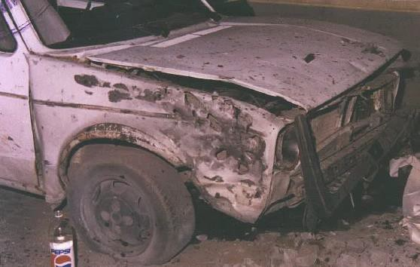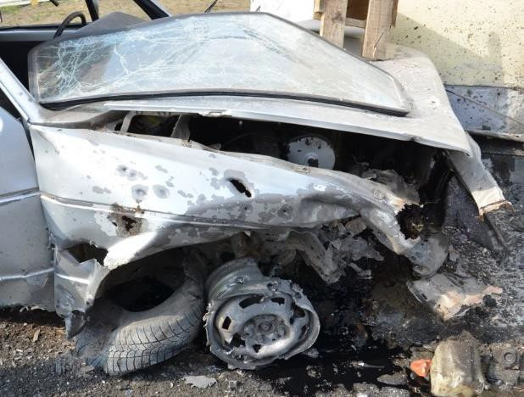

Figure 10.1 Detailed view at destroyed front right part of VW Golf Mk I car (tire ripped off, wheel rim and wing considerably deformed by pressure wave and perforated by number of fragments, part of wing and bonnet torn off). Detailed view on the damaged car VW Golf Mk I on Tuzla’s “Kapija” square, evening after the explosion

position of the car No. 1 (VW Golf Mk I) after the explosion
Both cars mentioned above were placed into different position with respect to the assumed place of explosion after the projectile’s explosion. The car VW Golf Mk I was moved only minimally, and only backwards after explosion at Tuzla’s Kapija square. But the same car in Nikinci’s trials was pushed away to the wall of the NIK shop building. It also touched by its front left part the buildings wall (Figure 10.2).

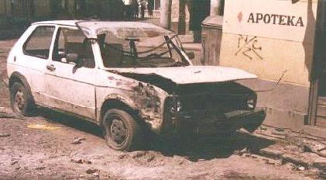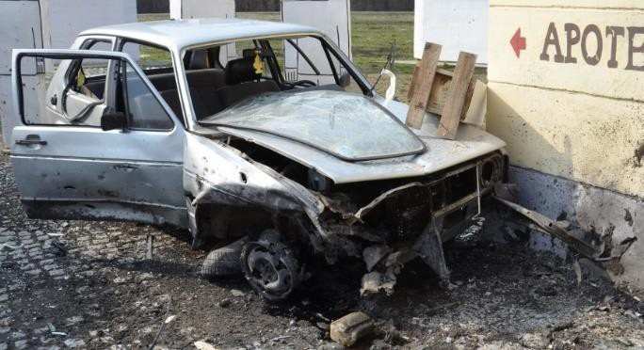

Figure 10.2 View on the scene in front of NIK store building on Tuzla’s “Kapija” square, next morning after explosion (left figure – the left side of the car is approximately 1 m far from the wall) comparing to VW Golf Mk I car after the 1st experiment (right figure - car is moved backwards and pushed towards the wall of NIK store building)

begriming of the car No. 2 caused by the explosion
The cars at Tuzla’s Kapija square in the front of the Gulam Café were covered by the unspecified black dust (like a soot). It points out to possible use of some nonstandard explosive, Figure 10.3.

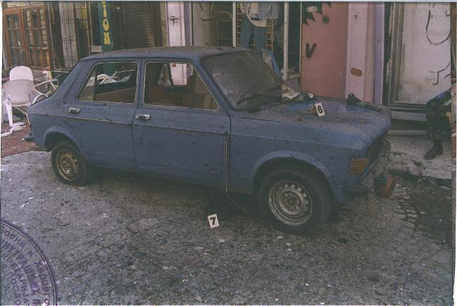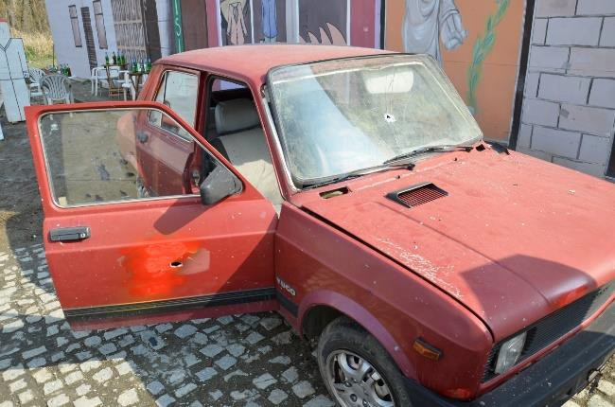

Figure 10.3 View at car Zastava after Tuzla’s explosion (left); car is at the front part heavily begrimed by black stuff, similar to soot, of unclear origin. Zastava car (No. 2) in front of Caffé Gulam was not dirty after the explosion during the experiment

damage to the car No. 4 (Zastava) caused by the explosion
In contradiction with the situation recorded immediately after the event in 1995 this car was extensively damaged with a lot of fragment hits, because the car was placed in the sector of very efficient side spray fragments, Figure 10.4. There were 7 penetrations in the windscreen remained in a place, all side and rear windows were splintered. Wheels on the left side of the car, towards to explosion site, had penetrations and were flattened. It is apparent from the Figure 10.4 that this car at Tuzla’s Kapija square suffered only minimal damage. This finding significantly supports claim that in its close proximity could not exploded 130 mm artillery projectile under conditions defined by prosecution.
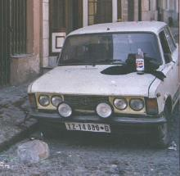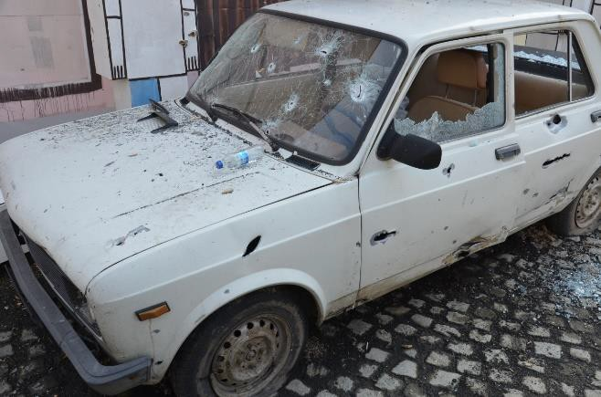

Figure 10.4 View on Tuzla’s “Kapija” square morning after explosion (left). View at Zastava car parked in front of Café Leonardo during the experiment (right); there are apparent significant damages caused by heavy, high-energy fragments from the side spray of fragments

analysis of the crater
Size and shape of the crater after explosion at Tuzla’s Kapija square and its substitution in Nikinci were diametrically different. As a result of the explosion of 130 mm projectile OF-482M during the 1st experiment no crater was created in the granite cubes road (Figure 10.5). Only about 3 granite cobblestones were partially damaged and no one was pulled out from the road. This situation is completely different in comparison to the Tuzla’s “Kapija” square where a higher number of free and only slightly damaged cobblestones was found around the crater that had a size of 50 x 20 cm (Figure 10.5).

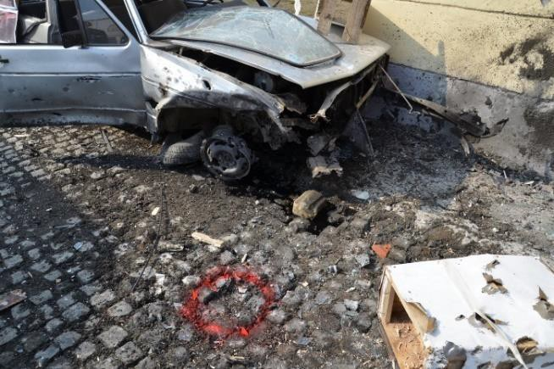

Figure 10.5 View on the crater after explosion at Tuzla’s “Kapija” square next morning after explosion (number of cobblestones was pulled out of road, but this big number of cobblestones is not missing in the road). View on the crater in front of NIK store building after 1st experiment (no cobblestones were pulled out, there are also parts ripped off from the car’s engine in front of the car)

damage to the building’s facades
The way of damage caused to the facades of buildings by the fragments from the 130 mm HE projectile is also very different from the real situation at Tuzla’s “Kapija” square. Parts of facades reversed from the place of explosion place were not hit by fragments at all. Also some parts of facades near to the place of explosion were not hit despite the fact that at “Kapija” square were hit by higher number of fragments. The Figure 10.6 shows facade of a building at the Tuzla’s Kapija square, 20 – 23 m away from the centre of explosion. The wall is hit by large number of fragments that cannot come from the projectile exploded in front of NIK store building. Density of fragments is high, entries on the wall are of circular shape which corresponds to perpendicular impact of fragments on the wall. This finding is in conflict with expected direction of movement of fragments from the NIK store building that is tangential; angle of expected direction of impact of fragments scattered from the CE on the facade is approximately 15° (measured from the facade plane). Comparison with real situation in Nikinci is at following Figure 10.6. The fragments from the place of explosion hit only the upper part of the building and with significantly lower density. Entries on the wall are elongated in the direction of fragment’s movement, the fragments hit the wall nearly tangentially. It is apparent that fragments, which damaged the facade of the building at the Tuzla’s Kapija square (see Figure 10.6), could not originated from the assumed place of projectile’s explosion in front of the NIK store building.

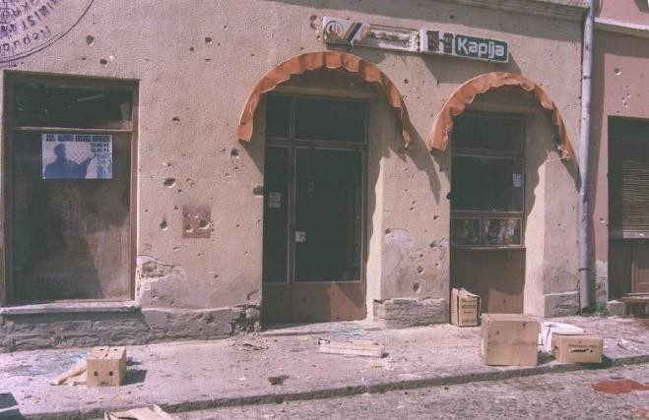

Figure 10.6 Specific fragment pattern on the area in front of Tuzla’s Kapija shop (left) with significant circular defects caused by massive fragments at ground floor walls (Tuzla 1995, next morning after explosion). View on the area in front of Kapija shop (right) - after 3 explosions of 130 mm projectile - without any significant defects at ground floor (elongated defects can be seen on the walls at 1st floor level)

damage to the NIK store shop window caused by the explosion
Damage caused to the NIK store during the field trials is totally different in comparison to the damage caused to the real shop at “Kapija” square. During the field trials this shop was badly damaged (facade, frame of the shop window, and also the inside of the shop - Figure 10.7); the real NIK store after the real explosion at Tuzla’s “Kapija” square had only slightly damaged frame of the shop window and broken glass at the shop window (Figure 10.7). There should be also mentioned that the plastic dolls used for the exhibiting the selling clothes standing inside the shop were damaged by fragments and fell on the floor inside the shop (Figure 10.7); the dolls at the real NIK store after real explosion at Tuzla’s “Kapija” square were not damaged by fragments and remained standing in standard position inside the shop window (Figure 10.7). From the Figure
  - the minimal damage inflicted to the awning above the NIK store shop window is apparent. If the artillery projectile would exploded nearly beneath the awning, the awning will be damaged in a much larger extent. It can be expected that the awning would be ripped off the wall due to the effect of shock wave’s overpressure.

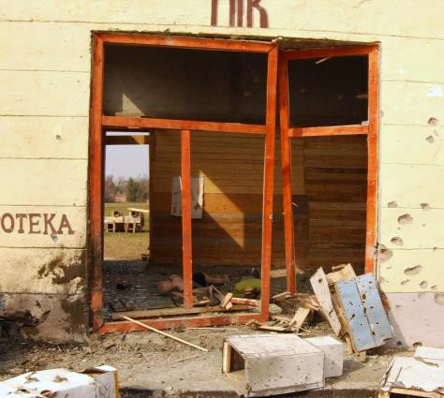

Figure 10.7 Detail of NIK store’s shop window with minimally damaged awning

damage of dolls and its relation to wounds of corresponding victims
During the experiments in TOC Nikinci the different effects of the fragments on the dolls substituting the real victims were recorded. The quantification of this differences is obvious from the chapter 6, especially from the Table 6.4.

large number of anomalies at victims’ fragment wounds
From the analysis of victims’ wounds the number of discrepancies and anomalies in destructive effects of explosion on some victims (fragments, shock wave, and heat impulse) was identified. There is apparent discrepancy between real numbers of fragments that hit the victims’ bodies and theoretical numbers of fragments that could hit the bodies. The real number of hits by fragments in victims’ bodies is on average 9 times higher than theoretical number of hits in victims’ bodies that resulted from the application of the analytical model of fragment scattering on the Tuzla’s Kapija square. Differences between the theory and practice deepen with increasing distance from the CE. These are signposts pointing toward fact that a different, more powerful type of ammunition or improvised explosive device, or even several smaller charges exploded at the Kapija square. Use of the nonstandard explosive confirms wounds of victims No. 53, 56, and 62 who suffered total devastation of entire body, similarly like suicide bombers. Unfortunately the distance from the centre of explosions is not known for these victims. The extent of their wounds corresponds to the close proximity from the CE.

results of the regression analysis of statistical data
According to the results of statistical analysis mentioned above it can be said, that the theoretical model of fragment density shows relatively good conformity with experimental data obtained from dolls. This conclusion is negatively affected by low number of available samples of experimentally obtained data. Furthermore, it can be said that the real fragment densities, obtained from the bodies of victims, differ with relatively high probability from the theoretical fragment densities, expected in given sectors and given distances. Again, this conclusion is negatively affected by low number of available data. Real fragment densities, used in this statistical analysis, do not consider number of fragments that hit the walls of buildings, windows, and furniture of the cafes.

external ballistics
The external ballistic calculations and considerations were carried out for new weapon system firing projectiles of standard initial velocity. The use of the standard trajectory characteristics from the firing tables for the estimation of the assumed firing point seems to be rather speculative. The atmospheric conditions used for the calculations were based only on the ground meteorological message and the vertical changes of the atmosphere that could significantly change the trajectory were not taken into account. After this analysis it is not possible to exclude situation when the previously mentioned effects negatively affected the range of fire in such extent that the weapon systems in the Panjik area were not able to hit the Tuzla’s Kapija square.
Prof. Berko Zečević’s expert report defines the projectile’s angle of fall 62°, distances of the projectile’s nose from the corners of NIK store building 2.65 meters and 5.60 meters. During the experiments preparation it was not physically possible (due to presence of the car VW Golf Mk I) to place the projectile into defined position. The angle between projectile’s longitudinal axis and the ground was about 74° in this case. Therefore the projectile was placed into as close as possible position, nose of the projectile was placed into new point – 14 cm to the left corner of the NIK store building (in parallel direction with the building’s facade) and 23 cm perpendicularly from the facade of the NIK store building, then the angle of projectile’s longitudinal axis and ground was 62°.

On basis of above mentioned facts we state that the massacre at the Tuzla’s “Kapija” square at 20:55 on 25th May 1995 was not with high probability caused by the explosion of 130 mm HE artillery projectile fired from the M-46 cannon.

Brno, 31st July 2015

Assoc. prof. Jan KOMENDA court expert

Court expert clause – Jan KOMENDA
I have drawn up the expert opinion as a court expert appointed by decision of the Minister of Justice of the Czech Republic on 17/7/1997, Čj. M-591/97 for domain cartridges and explosives, branch cartridges and explosives, specialisation munition, ballistics, and firing ranges. I am aware of consequences of giving deliberately false expert opinion.
The expert opinion is written down in the Expert diary under No. 111/15. Reward and compensation of cost is billed on basis of attached liquidation (Invoice No. 6/15).

Brno, 31st July 2015

Dr. Luděk JEDLIČKA court expert

Court expert clause – Luděk JEDLIČKA
I have drawn up the expert opinion as a court expert appointed by decision of the Minister of Justice of the Czech Republic on 20/2/2013, Čj. 67/2012-OSD-SZN/7 for domain cartridges and explosives, branch cartridges and explosives, specialisation munition, ballistics, and firing ranges. I am aware of consequences of giving deliberately false expert opinion.
The expert opinion is written down in the Expert diary under No. 003-2/15. Reward and compensation of cost is billed on basis of attached liquidation (Invoice No. 115001).

Brno, 31st July 2015
Dr. Roman VÍTEK

